Water

In this part, you will include elements of the water system and water cycle. Since the water cycle passes through land (via precipitation that falls on land and evapotranspiration, groundwater recharge and water runoff that goes through the land), the water system model will be tightly connected to the land technologies you have already created.
Crucial data for your country can be found here: AQUASTAT database. It is a very slow website so let's use it now to find all the relevant data for this session in one sweep:
You need to find the data for these listed variables for the most recent year for your country:
- Long-term average annual precipitation in volume
- Area equipped for full control irrigation: total (1000 ha)
- Irrigation water requirement
- Irrigation water withdrawal
- Industrial water withdrawal
- Municipal water withdrawal
- Irrigation Potential
- % of irrigation potential equipped for irrigation
- Total renewable surface water
- Total renewable ground water
- Total water withdrawal
Now click ‘show data’ (top right)
Now click ‘download’ - so you have a copy and a semi ready-made table for your future ‘data in brief’ appendix.
NOTE: sometimes there is missing data for countries, if so let us know on the google group and we will try to help you work around it.

Step 1: Adding Water Technologies and Commodities
Add five new commodities (WTRPRC, AGRWAT, WTREVT, WTRGWT, WTRSUR) and one new technology (MINPRC).
In the Technology tab:
- Ensure you have MINPRC producing WTRPRC as an output
- and WTRPRC as an input for all technologies beginning “LND”.
- The output, for all the technologies beginning with LND, are the three water commodities WTREVT, WTRGWT, WTRSUR.
(The definition and description for all these Commodities & Techs can be found in HO7 page 7+) Now complete this parameter in your model:
Technology | Commodity | Value | Parameter
MINPRC | WTRPRC | 1 | Output Activity Ratio

Step 2
Now we need to work out the two key water input activity ratios for your country. The first refers to rain or the precipitation volume for your country per unit of land. Use the FAO AQUASTAT link provided to find ‘Long-term average annual precipitation in volume’ for the latest year in your country’s data set.
AQUASTAT database (The unit ‘volume’ used in this database is 10⁹m³ )
Divide this digit by your total land area - for Zambia approximately 767.66 (10⁹m³) / 743(10³km²) = 1.0 (rounded to significant figure)
Note: If your unit is smaller than 0.1, convert the rainfall to 10⁶m³ throughout your model.
This number will now be referred to as ‘X’ and is now your input activity ratio water commodity (WTRPRC) value.
Insert this value ‘X’ as the input activity ratio for all WTRPRC to all LND technologies. In the example below, for Zambia, this figure is 1.
Note: This step means that you are assuming precipitation falls uniformly (same quantity per unit of area) on all land areas/types in the whole country. Of course, this is only an approximation and in a more detailed model you may want to change it.
The second water input is used for irrigation (AGRWAT). Add this as an input for all your irrigated crops using the technology tab.
For the input activity ratio number:
- convert the figure for “Area equipped for full control irrigation: total (1000 ha)” from 1000 ha unit to 1000 km2 unit.
- Divide the “Irrigation water withdrawal” (in 10^9 m3, or in 10^6 m3 if you set this as the water unit) by “Area equipped for full control irrigation: total” (in 1000 km2).
For example, in Zambia the area equipped for full control irrigation is 55.39 (1000 ha) = 0.5539 (1000 km2).
The irrigation water withdrawal is: 1.15 (10^9 m3). So the input activity ratio is: 1.15 / 0.5539. So the is figure is: 2.08 (Y).

Note: with this, you are assuming that every irrigated crop requires the same amount of water, equal to the average water need for irrigation in the country. With more detailed data, you could differentiate the irrigation water need by crop.

Input water commodities |  |  | (LND****)
WTRPRC | AGRWAT | Total  (not for UI) | (LND****)
X (1) |  | 1 | Crop 1 Rain-fed
X (1) | Y (2.08) | 3.08 | Crop 1, Irrigated
x |  | 1 | Crop 2, Rainfed
x | Y | 3.08 | Crop 2, Irrigated
x |  | 1 | Crop 3, Rain-fed
x | Y | 3.08 | Crop 3, Irrigated
x |  | 1 | Crop 4, other crops
x |  | 1 | LFOR
x |  | 1 | LBLT
x |  | 1 | LWAT
x |  | 1 | LOTH

Step 3

Now we need to add the Output activity ratio value for WTREVT, WTRGWT, WTRSUR for crop type. In reality this value will be quite different for each crop type and land use. For simplification, however, we will use the averages shown in the table below: work out the correct Output Activity Ratios as a percentage of value X or (X + Y) for irrigated crops).
(For slightly more precise figures, we may have the global average for some of your crops on this document: Water Use Averages for Crops for you to use instead.)

Feel free to round figures up and down to make the maths easier, however make sure WTREVT, WTRGWT and WTRSUR all add up to X (100%) in total ( or X + Y for irrigated crops). This is a useful resource for this: https://percentagecalculator.net/)

For example:
Zambia | Output activity ration for water commodities
Zambia | WTREVT  (Evapotranspiration) | WTRGWT  (Groundwater recharge) | WTRSUR  (Surface Runoff)
Rainfed crops | 42% of X (which in  Zambia’s case is 42 % of  1 so: 0.42) | 6% (of X): ? | 52% (of X): ?
Irrigated crops | 42% of X+ Y (which is 42 % of 3.08 in Zambia’s  case): 1.3 | 6% of (X +Y ): ? | 52% (of X + Y ): ?
(Forests) | 71% (of x): | 2.5%(of x): ? | 26.5%(of x): ?
(Built-up land) | 63%(of x): ? | 3%(of x): ? | 34%(of x): ?
(Water bodies) | 33%(of x): ? | 7%(of x): ? | 60%(of x): ?
(Other Land) | 71%(of x): ? | 2%(of x): ? | 27%(of x): ?
Create this table and do the sums for your own data so you can keep track.
Note: that these % are blunt averages - in ‘real’ CLEWs models you would have to research the specific % for each country and crop (even the same crops in different countries have very different %).

Step 4
In this next step we include one new commodity PUBWAT, this represents our water demand.
Use the FAO AQUASTAT database to find this figure out (e.g. add together industrial water withdrawal and municipal water withdrawal to get your demand figure (enter this into Accumulated Annual Demand for PUBWAT).
For demand in future years, increase this figure by the rate of GDP growth. Use statista.com ‘(GDP) growth rate Statista’ and the projected ‘stable’ figure (for example Zambia = 1.45%).

Step 5
Now add four new technologies DEMAGRSURWAT, DEMAGRGWTWAT, DEMPUBSURWAT,
DEMPUBGWTWAT. Add the correct inputs (WTRSUR/WTRGWT) and outputs (AGRWAT/PUBWAT) with these new techs accordingly:
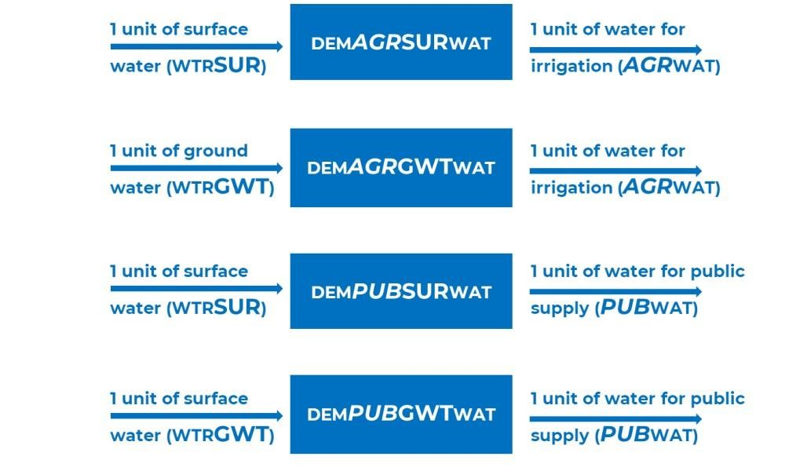
As highlighted by the image above, the input/output ratios are 1.
Now run your model. If it’s successful, copy it before proceeding (this is a good habit to have whilst modelling using the UI).

Step 6
A constraint we can use is in relation to 'renewable water’. Find the variable “Total renewable surface water” for your country and half this figure. Then use this figure on both the annual activity of DEMAGRSURWAT and DEMPUBSURWAT using the parameter “Total Technology Annual Activity Upper Limit” to limit it appropriately.
Repeat this process again with “Total renewable groundwater” (Halved) and the technologies
DEMPUBGWTWAT, DEMAGRGWTWAT.
Run your model, save and copy it if it runs successfully.
The graph for Water Balance should be beautifully symmetrical either side of 0 throughout all years i.e. the water going into the system (Precipitation and Irrigation), is equal to the water going out (Evapotranspiration, Groundwater and Surface Water Run Off).
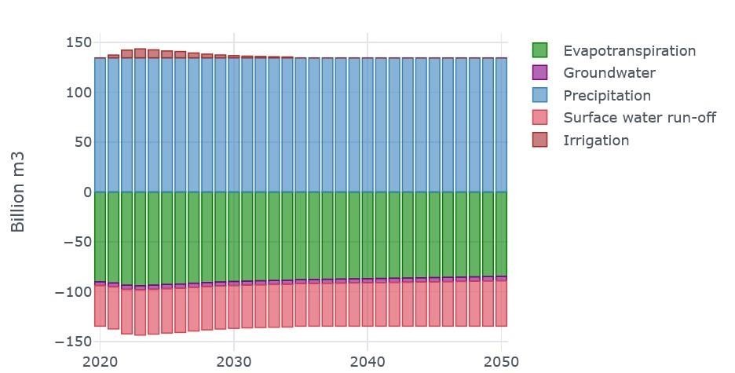
From this graph, water for irrigation is only needed up to 2034, peaking in 2023 in the models cost optimal solution.

