Scenario Testing
Congratulations- you have built your first (of many I hope) CLEWs country baseline model. Now the fun starts! With this baseline model now up and ready we can begin to experiment and start developing scenarios that can help inform policy. Indeed, the results from these scenarios will inform your report.
The baseline model, sometimes referred to as ‘business as usual’ (BAU), is what we use to compare our other models (other ‘futures’/scenarios) against. Simply put, we need it for context.
For example, if we were policy makers that wanted to explore how to reach NetZero by 2050, and we only created one CLEWs run that emits no emissions by 2050, this would only provide us with limited information. It would not be very helpful from a policy perspective if we don’t know what power plants (trajectory) we are already currently scheduled to invest in i.e. a BAU run.
Indeed, suppose a net zero future scenario/results suggest that a significant investment in solar energy is required to reach NetZero. This recommendation carries different implications for policy depending on the context provided by the baseline business as usual model. For example:
- If the BAU model shows minimal or no existing solar energy utilization: In this case, the recommendation to invest heavily in solar energy represents a major shift from the current trajectory. It indicates a need for substantial changes in infrastructure, policy, and possibly public perception. The contrast between the BAU and the net zero scenario highlights the extent of transformation required to achieve the emissions target. This could also imply a need for substantial investments in training and development for the workforce, as well as potential challenges in phasing out existing energy sources that are more prevalent in the BAU scenario.
- If the BAU model already includes a significant adoption of solar energy: Here, the recommendation to focus on solar energy may not represent a dramatic shift from the current path. It could indicate that current policies and trends are already aligned with the goals of a net zero future, albeit perhaps not at the pace or scale required. The comparison in this scenario might suggest that while the direction is correct, the pace of adoption needs to be accelerated. It also implies that resources could be more efficiently allocated to enhance and optimize existing solar energy initiatives rather than starting from scratch.
In both cases, the comparison with the BAU model provides crucial context. It helps policymakers understand not just what needs to be done to achieve a certain future state, but also how far off the current path this future state lies. This insight is invaluable for planning, resource allocation, and managing the transition in a way that is both effective and feasible.
In this document, we will explore the baseline results and then three different scenarios. This will form the results section of your assessment report.
Baseline Results (Scenario 1)
Policy/Research question: What are the cost optimal options for continuing a business-as-usual approach to energy and land resources for [country]?
Energy
Take a look at your country’s sources of electricity (use the IEA website IEA LINK ) Compare this to the corresponding year in your Power Generation graph on the OSeMOSYS cloud.
- What are the differences?
- Why are there differences, if any? (Remember OSeMOSYS picks the cost optimal solution form the available powerplants you provided in the model).
- Is your country currently cost optimal? i.e. does it match the OSeMOSYS results?
- What would it need to do (invest in) to become cost optimal?
Now compare 2020, to 2035 to 2050 in your Power Generation graph.
- How has the % share of energy supply changed over time ?
- Which are the most important power sources in 2020, 2035 and 2050
- Do they change?
- What would your country need to invest in to remain cost optimal? Is it a realistic ambition to follow the cost optimal solution proposed by the model?
Land
This time take a look at area by land cover type in the OSeMOSYS cloud baseline run.
- Compare 2020 land use breakdown to your country’s actual data- what are the differences? why is there a difference/similarity?
- How does the area by land cover type graph change over time? Why is the model making these changes
- Is there anything notable occurring in land use change?
Now examine Crop production and Agricultural Imports
- When does crop production peak? And what are the highest values (Million tonnes) produced by each crop?
- Does your baseline model ever need to import agriculture in the model’s timespan? Yes, or no? and why?
- If your model does import agriculture, what year does it start to do this? Why would this be a key year from a policy perspective?
Now examine Area by Crop Irrigated and Area by Crop Rainfed
- What is the relationship between the two? Explain using years.
- Remember the model will always try to use rainfed as it is a cheaper land use and uses less water resources; but will invest in irrigated if it needs to increase output (productivity) or use less land for agriculture due to other pressures.
Water
We will compare the water withdrawal by source graph from the OSeMOSYS cloud with the Aquastat data for water availability in your country. And lets contrast this availability figure with the water withdrawal by source graph. In other words, copy the OSeMOSYS graph into word/paint and add the ‘flat line’ availability figure to it. For example:
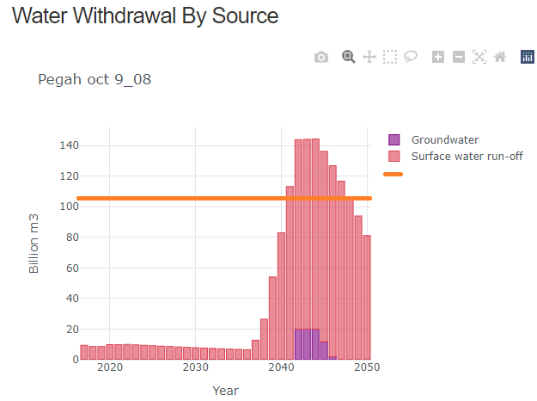
Availability 107 (source: FAO) Aquastat)

- At what year does it exceed (if it does at all) the total availability of freshwater in your country?
- What does this graph mean for policy makers regarding water?
Please note, when analysing graphs on the cloud, you can use the cursor to obtain specific data in figures and click on the ‘key’ to manipulate what is shown - which you can then use in your report.

Scenario 2: Biomass
Policy/Research Question: In the context of achieving SDGs, should [your country] have a commitment to meeting its transport energy demands (partially or fully), through use of biofuels?
To answer this question, we need to simulate a scenario where [country] no longer uses land to create biofuels for comparison with our baseline that does include biofuels.
Step 1: Copy your baseline model and rename it ‘No Biofuel’.
Step 2: In this model Remove your biofuel from your model entirely- delete all the relevant technologies and commodities. However, copy your biofuel demand (the Accumulated Annual Demand for TRABIO) for use in Step 3.
Step 3: Increase the specified annual demand (energy demand) for ELC002 by adding the now deleted transport demand -all units should be in PJ. In other words, your powerplants not biofuel, is now fulfilling transport demand – assume electric vehicles!
Step 4: Compare the biofuel scenario results with your baseline results.
The OSeMOSYS cloud has a comparison feature you can use by copying url of one cloud result into the results of another:
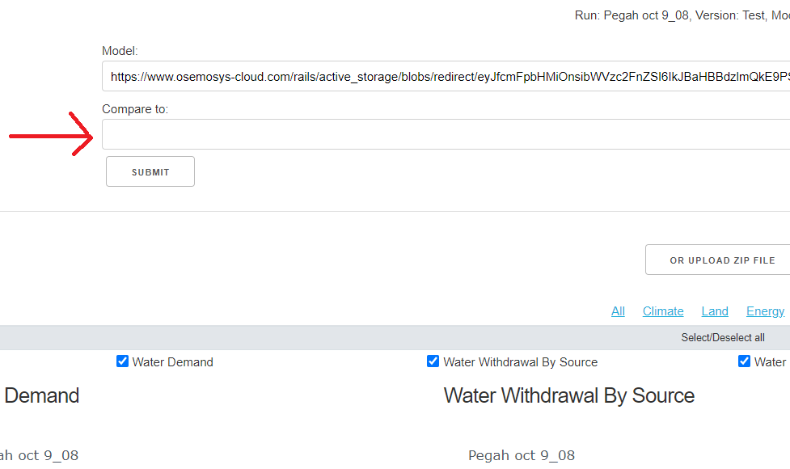

Step 5: In particular, focus on power generation and area by land cover type graphs, to help to respond to this research question - but it’s always worth checking the other graphs to see if there are any other significant changes you could comment on. For a more effective response, try and connect your policy suggestions with current and relevant academic biomass literature.

Scenario 3:
Policy/Research question: What are the projected impacts of the IPCC’s A2 climate change scenarios on land use, crop patterns and water usage for [country].
Next, we look at how climate change impacts can be represented in a CLEWs model and how the model adapts accordingly. In this case, we’ll do so by considering the IPCC’s ‘A2’ Climate change scenario.
Create a copy of the baseline model, renamed as A2. The data to be updated for each of the climate scenarios is shown below.
The A2 Climate Scenario
In this scenario we explore what happens when more water is needed, and crop production decreases due to drought.
Similar to the previous climate scenario, first create a copy of your baseline model. Then, edit the Input- and OutputActivityRatios as shown in the tables below to represent the A2 climate future. Copy the existing data into an Excel table. Then recalculate new values based on the information in the tables below. Replace the previous values in the model with the recalculated values.
Technology | Value | Parameter
Rainfed Crop  Technologies | 1 unit of land produces 25% less from 2035 | OutputActivityRatio
Irrigated Crop Technologies | 1 unit of land produces 25% less from 2035 | OutputActivityRatio

You can change the % of a range of numbers very quickly in excel – don’t do it manually – follow the steps outlined here. This will be useful in this 2nd table:
Input Water Commodities  (Parameter: InputActivityRatio) |  | Output Water Commodities  (Parameter: OutputActivityRatio)
WTRPRC | AGRWAT (for irrigated crops) | WTREVT | WTRGWT | WTRSUR
Decrease by 15 % from 2035 | Increase by 15 % from 2035 | Decrease by 15 % from 2035 | Decrease by 15 % from 2035 | Decrease by 15 % from 2035

(do not decrease by 15% accumulative for every year - a flat number from 2035 onwards)
Make sure every data entry is consistent with 2035 being the year of change.
Compare the results from each of the above climate scenarios to the baseline:
Figures/graphs to perhaps consider on the cloud (have they changed from baseline? make note of the units on the axis)
- Area By Land Cover Type
- Water Demand
- Area by crop (Rainfed), Area by crop (Irrigated)
- Agricultural Imports (if this graph appears)

