Energy System
Modelling Using OSeMOSYS
Development of a national energy system model – Activity 7
Please use the following citation for:
- This Activity
Plazas-Niño, F., Alexander K. (2024, April). Energy System Modelling Using OSeMOSYS: Development of a national energy system model – Activity 7 (Version 1.0).
- OSeMOSYS UI Software
Climate Compatible Growth. (2024). MUIO (Version v5.0.0). GitHub. https://github.com/ClimateCompatibleGrowth/MUIO
- OSeMOSYS Google Forum
If you are stuck, please ask questions here. If you get ahead, please answer questions in the same forum. Please state that you are using the ‘OSeMOSYS UI’ and not ‘ClicSAND’.
____________________________________________________________________________

1. Including Reserve Margin Data

MAKE A COPY OF YOUR MODEL!!!
The reserve margin quantifies the surplus power supply available in a specific region beyond the anticipated peak demand. This metric is vital for maintaining reliability during periods of high demand, adverse weather conditions leading to renewable generation loss, unforeseen transmission line or power plant outages, and facilitating scheduled maintenance of infrastructure.
In OSeMOSYS, we use different parameters to indicate the minimum level of the reserve margin required to be provided for all the tagged commodities, by the tagged technologies. If no reserve margin is required, the parameter will have value 1; if, for instance, 20% reserve margin is required, the parameter will have value 1.2.

Reserve Margin Value
TRY IT: add reserve margin values.
1. You do not need to add anything new to the model, except the data for reserve margin. You need to go the data entry tab again and search ‘Reserve Margin’.
2. Add a 15% Reserve Margin (value of 1.15) for all years. Save and update the model.

Reserve Margin Tags (technologies and fuels)
TRY IT: add reserve margin tags for technologies contributing to the reserve margin.
1. This parameter relates to all the technologies that are listed below (if applicable):
• BACKSTOP – Backstop Technology for electricity production
• PWRCOA – Coal power plants
• PWROHC – Diesel or fuel oil power plants
• PWRNGS – Natural gas power plants
• PWRHYD – Hydropower plants
• PWRBIO – Biomass power plants
• PWRGEO – Geothermal power plants
• PWRNUC – Nuclear power plants

2. You must use the data entry tab to search ‘ReserveMarginTagTechnology’ and add the data.
3. Add 1 in all the years if a technology is contributing to the reserve margin.
4. Then once you have saved and update the model. Search for ‘ReserveMarginTagFuel’ in the data entry tab. You then need to add 1 for all years for only ELC003.

SAVE DATA!!! UPDATE MODEL!!! RUN YOUR MODEL!!!

2. Calibration of Transport Sector

MAKE A COPY OF YOUR MODEL!!!
In this section, we will model a simplified RES for the transport sector. The focus will be on road transport, with the following disaggregation by mode:
- Cars: Gasoline and Electric
- Motorcycles: Gasoline and Electric
- Buses: Diesel and Electric
- Trucks: Diesel and Electric
Depending on the available information, you can decide to aggregate or disaggregate such technologies. An example of the proposed RES is shown in Figure 1.
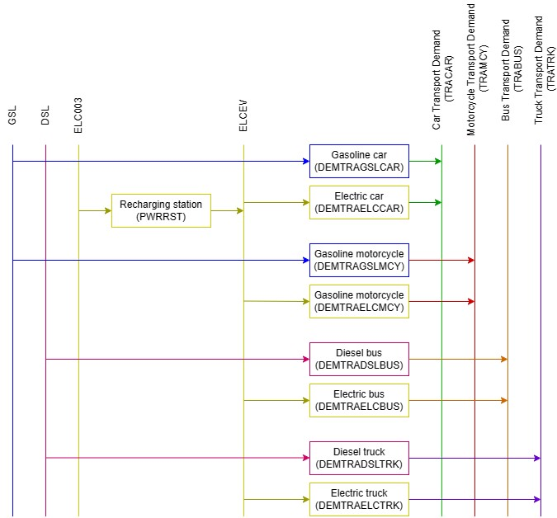
Figure 1. Proposed RES for transport sector.

Task: Incorporate the transport sector into your initial RES along with the power sector for your country.

2.1. Define commodities and technologies
As we have done in previous steps, we will create commodities and technologies to represent the transport sector according to the designed RES.
For gasoline and diesel vehicles, we need to create commodities for Gasoline (GSL) and Diesel (DSL). Similarly, we need to create the primary sources for these fuels, either through imports (IMPGSL, IMPDSL) or through domestic production (MINOIL + Refinery-UPSREF). Please refer to sections 7 and 8 of the second week to review how to add these if needed.
For electric vehicles, we will start by adding the commodity 'Electricity for Vehicles,' named as ELCEV. It will be the input fuel for all electric vehicles. In terms of technologies, we will create a technology of recharging station for converting ELC003 into ELCEV. Please complete the parameters of Capital Cost, Fixed Cost, Input Activity Ratio, Output Activity Ratio, and Operational Life for this technology based on the database used before [Link].
Regarding transport technologies, we need to add a commodity for each type of transport demand: Car transport demand (TRACAR), Motorcycle transport demand (TRAMCY), Bus transport demand (TRABUS), and Truck transport demand (TRATRK). These commodities represent the final energy demands of transport in units of Gpkm for passenger transport and Gtkm for freight transport. Finally, we need to create the technologies for each type of vehicle as necessary, inputting the same parameters as the recharging stations.

Try the example: Let’s add DEMTRAGSLCAR - the technology representing gasoline cars.
- Go to the technologies tab of the model configuration page and add ‘DEMTRAGSLCAR’.
- In this way, we added the technology which will be transforming gasoline (GSL) into Car Transport Demand (TRACAR) to the model. So, add the relevant inputs and outputs on the technologies tab.
- Next, you must enter the data through the data entry tab on the side of the model configuration page for DEMTRAGSLCAR (as done previously with other technologies).
- Add the data for DEMTRAGSLCAR as given in the database.

Repeat the process for the rest of vehicles in your model.
SAVE DATA!!! UPDATE MODEL!!! RUN YOUR MODEL!!!

2.2. Define energy demands
MAKE A COPY OF YOUR MODEL!!!
Your next task will be to input the demands for each transport service. We will use the AccumulatedAnnualDemand parameter, as we do not need to provide an exact point in time for the demand. NOTE: There is no need to modify the Specified Demand Profile when we use the Accumulated Annual Demand.
Task: Use the equations outlined in the Guide 'Modelling the Road Transport Sector (Theory)' to estimate transport demand in historical years, either through the energy balance or the fleet stock depending on available data for your country. Subsequently, use the average growth rate of GDP to project transport demands from the initial year to 2055.
After completing this task, you can generate a table similar to the one found in the file 'Calibration_Transport Sector_Template' on the 'Demand' sheet. These values will be entered into the 'Accumulated Annual Demand' parameter in the OSeMOSYS UI.
Try It: Add the demand for Car Transport (TRACAR).
1. Click on the data entry button and in the search bar type ‘Accumulated Annual Demand’, then go to that parameter.
2. You should see TRACAR.
3. Copy-paste the car transport demand data for the years in your model.
Repeat the process for the rest of demands in your model.
SAVE DATA!!! UPDATE MODEL!!! RUN YOUR MODEL!!!

2.3. Calibrate the transport sector data
MAKE A COPY OF YOUR MODEL!!!
Firstly, we need to calculate the residual capacity for the transport technologies. Use equations 6 and 7 from the Guide 'Modelling the Road Transport Sector (Theory)' to calculate the residual capacity in the first year(s) of your modelling based on your available data. Once we have the initial value(s), we will assume constant capacities until 2025, and subsequently, implement a linear decrease until reaching 0 in 2050. This aligns with the average lifetime of vehicles, which typically ranges between 15 and 25 years for most technologies.
After completing these steps, you can generate a table similar to the one found in the file 'Calibration_Transport Sector_Template' on the 'Capacity (Existing)' sheet. These values will be entered into the 'Residual Capacity' parameter [link] in the OSeMOSYS UI, representing the existing installed capacity of a technology for each year.
These values will also represent the energy productions for each technology, as the capacity factor is assumed to be equal to 1 for transport technologies. It will be the same table as exemplified in the table in the 'Calibration_Transport Sector_Template' file on the 'Generation (Existing)' sheet. These values will be inserted into the 'Total Technology Annual Activity Lower Limit' parameter [link], representing the minimum transport demand required to be produced for each technology in each year.
With this information, we can instruct the model to incorporate these capacities by using the parameter ‘Total Annual Min Capacity Investment’ [link]. For each technology and in the corresponding year, we will add the New Planned Installed Capacity. For example, if a new solar PV power plant with a capacity of 0.2 GW is under construction and intended to be operational in 2025, we can input the value of 0.2 for the year 2025 for the technology PWRSOL001.
SAVE DATA!!! UPDATE MODEL!!! RUN YOUR MODEL!!!

3. Adding Emissions

MAKE A COPY OF YOUR MODEL!!!
In this section, we will include the 'Emission Activity Ratio' parameter for each technology, representing the rate of emissions per unit of activity. For this purpose, we will use the equivalent CO2 factors associated with each fossil fuel, as shown in Table 1.
Table 1. Fuel emission factors.
Fuel | Equivalent emission factor (ktCO2e/PJ)
Coal | 88.8
Fuel oil | 80.7
Diesel | 75.4
Natural gas | 58.9
Gasoline | 71.1
LPG | 67.4
Jet fuel-Kerosene | 74.7

First, we need to calculate the emission activity ratios for each technology using equation 1. This involves dividing the corresponding emission factor of the input fuel for the technology by the efficiency of that technology.
$$Emission factor by technology\left[\frac{kt{CO}_{2}e}{PJ}\right]=\frac{Fuel Emission factor\left[\frac{kt{CO}_{2}e}{PJ}\right]}{Technology efficiency}$$ | (1)
For example, let’s consider a coal power plant with an efficiency of 35%. In this case, the emission factor would be calculated as follows:
$$Emission factor by technology\left[\frac{kt{CO}_{2}e}{PJ}\right]=\frac{88.8 \left[\frac{kt{CO}_{2}e}{PJ}\right]}{0.35}=253.71$$
You need to calculate the emission activity ratios for all technologies whose input fuel is a fossil fuel, including coal, natural gas, diesel, gasoline, fuel oil, etc. This encompasses fossil fuel power plants and gasoline/diesel vehicles.
Once you have calculated the emission activity ratios for all technologies, please follow the next steps:
- We will NOT add any new technologies or fuels in this exercise. But we will add an emission this time.
- You can change the name of the default emission as shown below (or to CO2eq):

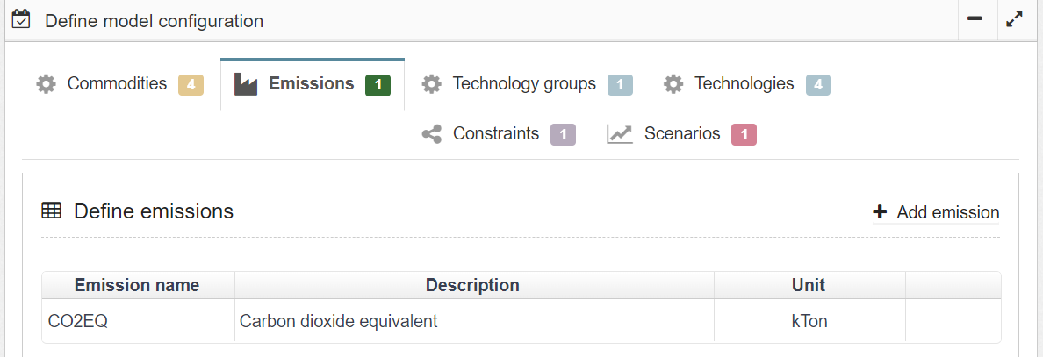
- Then you must then add the emission to ‘Emission Activity Ratio’ on the technologies tab of the model configuration page, as shown below (example of coal power plant):

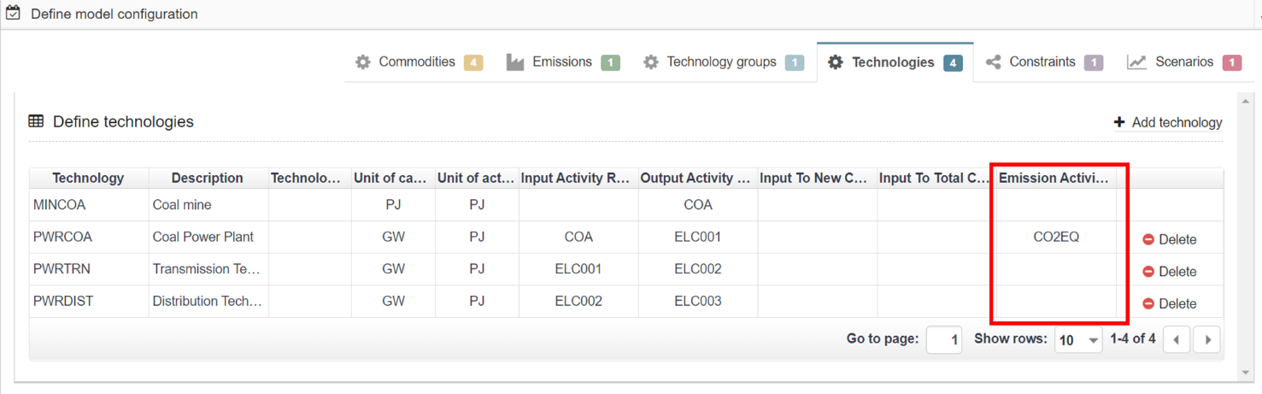
- Make sure you have updated the model with the new emissions and connections made on the technologies tab for all fossil fuel technologies.

- You now need to go to the data entry tab, as you have before, and search ‘Emissions Activity Ratio’ and then add the data for each technology for all years. Use the calculated values previously.

- SAVE AND UPDATE!

- For the moment, this is the only Parameter related to Emissions that we will employ.

SAVE DATA!!! UPDATE MODEL!!! RUN YOUR MODEL!!!

