Energy System
Modelling Using OSeMOSYS
Development of a national energy system model – Activity 6
Please use the following citation for:
- This Activity
Plazas-Niño, F., Martindale L. (2024, April). Energy System Modelling Using OSeMOSYS: Development of a national energy system model – Activity 6 (Version 1.0).
- OSeMOSYS UI Software
Climate Compatible Growth. (2024). MUIO (Version v5.0.0). GitHub. https://github.com/ClimateCompatibleGrowth/MUIO
- OSeMOSYS Google Forum
If you are stuck, please ask questions here. If you get ahead, please answer questions in the same forum. Please state that you are using the ‘OSeMOSYS UI’ and not ‘ClicSAND’.
____________________________________________________________________________

1. Calibration of Existing Installed Capacities in the Power Sector

MAKE A COPY OF YOUR MODEL!!!
Using historical reports on installed capacities in the power sector, we will create a table (See table 1 as an example). Please take into consideration that capacities are aggregated, and there is no representation of individual power plants. In most countries, this information can be found on the webpage of the national electricity authority. You will need to conduct some research to find the specific information for your country.

Table 1. Example of historical installed capacities in the power sector for a country.
Code | Technology | Installed Capacity (GW) - Historical
Code | Technology | 2020 | 2021 | 2022
PWRBIO001 | Biomass Power Plant | 0.0962 | 0.0962 | 0.1117
PWRCOA001 | Coal Power Plant | 0.1 | 0.092 | 0.092
PWROHC001 | Light Fuel Oil Power Plant | 0.2 | 0.2 | 0.2
PWROHC002 | Oil Fired Gas Turbine (SCGT) | 0.5 | 0.5 | 0.5
PWRNGS001 | Gas Power Plant (CCGT) | 1.2 | 1.2 | 1.2
PWRNGS002 | Gas Power Plant (SCGT) | 1.6 | 1.8 | 1.8
PWRSOL001 | Solar PV (Utility) | 0.05 | 0.06 | 0.06
PWRHYD001 | Large Hydropower Plant (Dam) (>100MW) | 0.813 | 0.813 | 0.813
PWRWND001 | Onshore Wind | 0 | 0 | 0.3

Now, if we have information on decommissioning for various power plants, it becomes possible to estimate the evolution of the existing installed capacity for the upcoming years. However, this information is often unavailable, requiring the use of certain assumptions. In this course, we have made two assumptions:
- For hydro technologies, we assume that the existing installed capacity remains constant until the end of the modelling horizon (2055).
- For other technologies, we assume a constant existing installed capacity until 2030. Subsequently, we implement a linear decrease until reaching 0 GW in 2050. This aligns with the average lifetime of power plants, which typically ranges between 20 and 40 years for most technologies.
After completing these steps, you can generate a table similar to the one found in the file 'Calibration_Power sector_Template' on the 'Capacity (Existing)' sheet. These values will be entered into the 'Residual Capacity' parameter [link] in the OSeMOSYS UI, representing the existing installed capacity of a technology for each year.
SAVE DATA!!! UPDATE MODEL!!! RUN YOUR MODEL!!!

2. Calibration of New Planned Installed Capacities

MAKE A COPY OF YOUR MODEL!!!
Countries typically have a pipeline of new power plants expected to come online in the next few years as part of their power sector expansion plans. If information about the installed capacity, type of power plant, and year of start operation is available, we can incorporate this data into our model.
With this information, we can instruct the model to incorporate these capacities by using the parameter ‘Total Annual Min Capacity Investment’ [link]. For each technology and in the corresponding year, we will add the New Planned Installed Capacity. For example, if a new solar PV power plant with a capacity of 0.2 GW is under construction and intended to be operational in 2025, we can input the value of 0.2 for the year 2025 for the technology PWRSOL001.
SAVE DATA!!! UPDATE MODEL!!! RUN YOUR MODEL!!!

3. Calibration of Electricity Generation

MAKE A COPY OF YOUR MODEL!!!
In the next step, we will create a table similar to Table 1, but this time using historical data about electricity production. Table 2 presents the information on power generation for the example. Once again, you will need to conduct some research to find specific information for your country. Remember to convert the units to PJ, as this information is typically reported in GWh.
Table 2. Example of historical power generation for a country.
Code | Technology | Power Generation (PJ) - Historical
Code | Technology | 2020 | 2021 | 2022
PWRBIO001 | Biomass Power Plant | 1.516882 | 1.516882 | 1.761286
PWRCOA001 | Coal Power Plant | 2.68056 | 2.466115 | 2.466115
PWROHC001 | Light Fuel Oil Power Plant | 0.2 | 0.2 | 0.2
PWROHC002 | Oil Fired Gas Turbine (SCGT) | 0.5 | 0.5 | 0.5
PWRNGS001 | Gas Power Plant (CCGT) | 1.2 | 1.2 | 1.2
PWRNGS002 | Gas Power Plant (SCGT) | 1.6 | 1.8 | 1.8
PWRSOL001 | Solar PV (Utility) | 0.05 | 0.06 | 0.06
PWRHYD001 | Large Hydropower Plant (Dam) (>100MW) | 0.813 | 0.813 | 0.813
PWRWND001 | Onshore Wind | 0 | 0 | 0.3

Now, let’s remember that OSeMOSYS is an optimization model, so it selects the cheapest combination of technologies to satisfy the energy demand. This could mean suggesting the closure of all fossil fuel power plants and the installation of hydro and solar to meet the demand in one year, which is unrealistic in the real world. Since the future generation is unknown, but we need to avoid the model abruptly eliminating power generation from installed capacity, we will estimate electricity production using the residual capacity for each technology. In this case, we will follow Equation 1, and you can review the Excel formulas used in the file 'Calibration_Power sector_Template' on the 'Generation (Existing)' sheet. Note: Please be aware that we are not including the planned new projects in the estimation of this future power generation. This approach enables us to evaluate if the current expansion plans might result in stranded assets.

$$Estimated power generation \left(PJ\right)=Residual Capacity \left(GW\right)*Average Capacity Factor*31.536 \left(\frac{PJ}{GW}\right)$$ | (1)

After completing these steps, you can create an entire table resembling the one in the 'Calibration_Power sector_Template' file on the 'Generation (Existing)' sheet. These values will be inserted into the 'Total Technology Annual Activity Lower Limit' parameter [link], representing the minimum electricity production required for each technology in each year.
SAVE DATA!!! UPDATE MODEL!!! RUN YOUR MODEL!!!

4. Calibration of Electricity Imports and Exports

MAKE A COPY OF YOUR MODEL!!!
Similar to the previous step, we will collect information about historical electricity imports and exports, which can be found in the national energy balance of your country. For the baseline model, we will assume the following conditions if applicable:
- Electricity imports remain constant until 2025 and then decrease linearly to become zero in 2035 as part of the strategy to achieve energy sovereignty.
- Electricity exports remain constant until 2030 and then increase by 0.5% annually.
Based on the historical data and the described assumptions, we can create a table similar to the one presented in the file 'Calibration_Power sector_Template' on the 'Imports-Exports' sheet. These values will be inserted into the 'Total Technology Annual Activity Lower Limit' and 'Total Technology Annual Activity Upper Limit' parameters for the corresponding technologies.
SAVE DATA!!! UPDATE MODEL!!! RUN YOUR MODEL!!!

5. Calibration of Transmission and Distribution

MAKE A COPY OF YOUR MODEL!!!
Since we are using different data sources for electricity production and consumption, it's advisable to analyze any possible differences. To facilitate this comparison, please refer to the file 'Calibration_Power sector_Template' on the 'Demands' sheet, where Excel formulas outline the calculations. The disparities between these values should range between 0% and 5%. To achieve these error percentages, you'll need to vary the efficiencies of transmission and distribution technologies. Once you have reached these targets, you can update the ‘Input Activity Ratio’ of the corresponding technologies in OSeMOSYS.
SAVE DATA!!! UPDATE MODEL!!! RUN YOUR MODEL!!!
MAKE A COPY OF YOUR MODEL!!!
If you have available data regarding the installed capacity of transmission and distribution systems in your country, please create a table equivalent to the one in the file 'Calibration_Power sector_Template' on the 'T&D' sheet. However, if the data is unavailable, we can use the results from the previous run to obtain the required installed capacity. Follow these steps:
- Go to the 'Results' option on the left menu of the OSeMOSYS UI.
- Select the variable 'Total Annual Capacity' from the drop-down menu.
- Check the table of results in the lower part of the window and locate the values for the historical years for the technologies of transmission (PWRTRN) and distribution (PWRDIST).
- Copy the data to the table in the file 'Calibration_Power sector_Template' on the 'T&D' sheet.
- Assume that the installed capacity remains constant from 2022 and beyond (Residual). The model will determine grid expansion levels based on the later modelling assumptions.
- Enter these values into the 'Residual Capacity' parameter of the corresponding technologies. Please refer to the image below for a visual guide to this process.

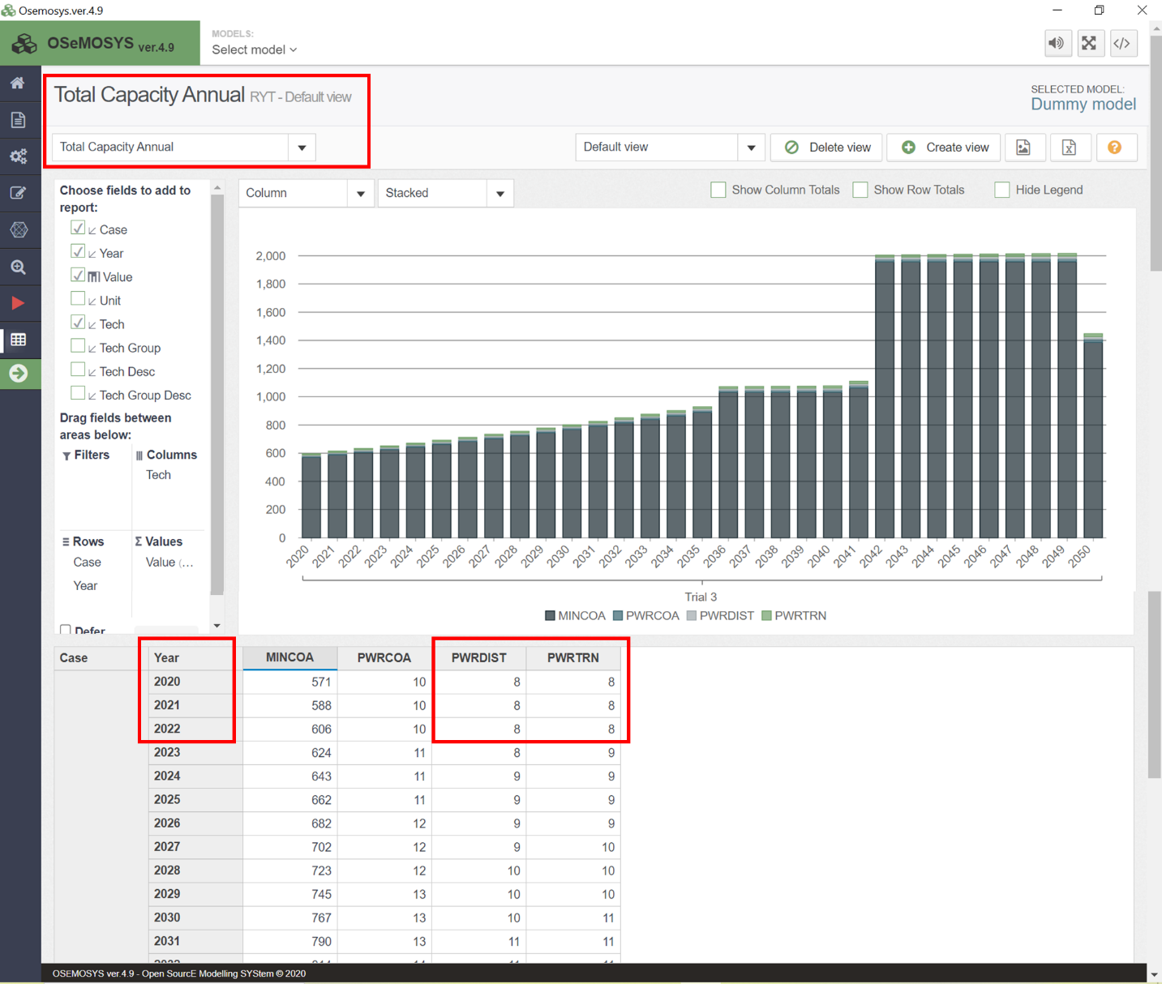
SAVE DATA!!! UPDATE MODEL!!! RUN YOUR MODEL!!!

6. Calibration of Fossil Fuel Reserves

MAKE A COPY OF YOUR MODEL!!!
As fossil fuels are finite resources, it is necessary to establish the quantity of reserves for each fuel, including crude oil, natural gas, coal, and uranium. You will need to conduct some research to find the specific information for your country. In the country case, the available data is for the year 2021. Therefore, it is necessary to add the sum of annual productions from 2020 or other previous years, as these amounts were part of the reserves at the beginning of the modelling horizon. Using this information, we can create Table 3.
Table 3. Example of Fossil fuel reserves calculation.
Fuel | Technology | Historical production (PJ) |  |  |  |  |  | Reserves (2021) | Total reserves for modelling
Fuel | Technology | 2015 | 2016 | 2017 | 2018 | 2019 | 2020 | Reserves (2021) | Total reserves for modelling
Crude oil | MINOIL | 40.8 | 40.9 | 45.6 | 43.8 | 47.9 | 55.4 | 6500 | 6774.4
Natural gas | MINNGS | 12 | 11 | 14 | 16 | 17 | 17 | 610 | 697
Coal | MINCOA | 0 | 0 | 0 | 0 | 0 | 0 | 0 | 0
Uranium | MINURN | 0 | 0 | 0 | 0 | 0 | 0 | 3000 | 3000

Notice that, in this example, the country has been producing crude oil and natural gas from the beginning of the modelling horizon. It does not have domestic reserves of coal, hence there is no historical production. Moreover, it possesses some uranium reserves, but there has been no production yet. Consider that the units of production and reserves for fossil fuels are typically in volume/weight; therefore, it is necessary to convert it to PJ. You can find a table of conversion factors below as a reference (Table 4).
Table 4. Reference conversion factors
Original unit | Equivalence in PJ
1 million barrels of crude oil | 6.09
1 billion cubic feet of natural gas | 1.01
1 million tonnes of coal | 28.76
1 tonne of uranium | 1.53

After obtaining this information, you can enter these values into the ‘Total Technology Model Period Activity Upper Limit’ parameter [link], representing the maximum amount of energy produced during the entire modelling horizon.
Additionally, it's important to include a maximum potential production for these technologies. We can use the maximum historical production data for this purpose. For example, in Table 3, we find the maximum oil production to be 55.4 PJ/year and the maximum natural gas production as 17 PJ/year. Assuming a potential increase in fossil fuel production, we estimate an additional 25% over these quantities, resulting in 69.25 PJ/year for oil and 21.25 PJ/year for natural gas. These values will be inserted into the 'Total Technology Annual Activity Upper Limit' parameters for the corresponding technologies for all years.
SAVE DATA!!! UPDATE MODEL!!! RUN YOUR MODEL!!!

7. Calibration of the Renewable Energy Potentials

MAKE A COPY OF YOUR MODEL!!!
In the case of renewable energy sources, it is necessary to set a limit on the maximum available energy per year. Additional research is required to find these values for each type of renewable energy. National studies usually estimate potentials in installed capacity (GW) or energy production (PJ). You should complete a table similar to Table 5.
Table 5. Renewable energy potentials
Fuel | Technology | Annual potential
Solar | MINSOL or PWRSOL | 3500 PJ
Hydro | MINHYD or PWRHYD | 120 PJ
Wind | PWRWND001 (Onshore) | 12 GW
Wind | PWRWND002 (Offshore) | 20 GW
Biomass | MINBIO or PWRBIO | 650 PJ
Geothermal | MINGEO or PWRGEO | 50 PJ

If data is available in capacity units, we can estimate the energy produced using the average capacity factor of the technology following Equation 2.

$$Estimated energy production \left(PJ\right)=Maximum Installed Capacity \left(GW\right)*Average Capacity Factor*31.536 \left(\frac{PJ}{GW}\right)$$ | (2)

If the data represents maximum potential in generation units (PJ), we should insert the value into the 'Total Technology Annual Activity Upper Limit' parameters for the corresponding technologies for all years. Conversely, if the data is in capacity units (GW), we should insert the value into the 'Total Annual Max Capacity' parameters for the corresponding technologies for all years.
SAVE DATA!!! UPDATE MODEL!!! RUN YOUR MODEL!!!

For the different technologies, you can follow the next guidelines to estimate the potentials:
Step 1: Solar
Visit this website- https://globalsolaratlas.info/global-pv-potential-study and enter your country
With the generated PDF find these statistics:
- Total area / Evaluated area (eg. 51,100km2)
- Average practical potential, level 1 / rank (eg. 4.093 kWh/kWp )
- PV equivalent area (eg. 0.09% or use 0.1% if N/A)
- Panel density is also needed but is not provided- we will assume that utility-scale solar farms are about 100 kWp per hectare (or 0.01 kWp/m²), (but this can vary based on technology and installation specifics).
We then need to make a formula to get the possible PV potential for a country.
1. Calculate the potential PV Installable Area in km²: (Multiply the total area by the PV equivalent area percentage).

- PV Installable Area (km²) = Total Area (km²) × PV Equivalent Area %
- PV Installable Area (km²) = 51,100km² x (0.09 / 100)
= 46 km²

2. Convert the PV Installable Area to m²:
- Since solar irradiance and practical potential are given per square meter or per kWp, convert the total area into square meters.

- PV Installable Area (m²) = PV Installable Area (km²) × 1,000,000
= 46 x 1000,000
= 46,000,000

3. Calculate the Annual Energy Production in kWh: Use the average practical potential, which reflects the specific yield of the PV system in kWh/kWp/day, and multiply it by the number of days in a year and by the PV installable area adjusted for kWp capacity.

- Annual Energy Production (kWh) = PV Installable Area (m²) × Panel Density (kWp/m²) × Average Practical Potential (kWh/kWp/day) × 365 days

- = 46,000,000 x 0.01 kWp/m² x 4.093 x 365 = 687,214,700

4. Convert to PJ:

- Annual Energy Production (GWh per year) = Annual Energy Production (kWh) / 1,000,000

- Annual Energy Production (GW per year) = 687,214,700 / 1,000,000 = 687 GWh per year

- GWh into PJ Convert here (687 = 2.47PJ)

5. Add this figure as a constraint to your model
- Go to your Country model for the parameter: ‘TotalTechnologyAnnualActivityUpperLimit’ and apply it to PWRSOL tech for all years

SAVE DATA!!! UPDATE MODEL!!! RUN YOUR MODEL!!!

Step 2: Wind Potential

- Use this resource for offshore - (use the total GW)
https://energydata.info/dataset/offshore-wind-technical-potential

- For onshore capacity- multiply by 10 the current/highest ever onshore capacity total for your country (assumption to be revised for each case) - Wind energy

- To calculate GWh (per year) into GW- divide GWh by 8760.

- With these two acquired figures - input into TotalAnnualMaxCapacity for the correct PWRWND (offshore/onshore) tech.

SAVE DATA!!! UPDATE MODEL!!! RUN YOUR MODEL!!!

Step 3: Hydro Potential

- For hydropower- multiply by 4 the current/highest ever hydropower capacity total for your country (assumption to be revised for each case)- Hydropower
- With this calculated figure - input into TotalAnnualMaxCapacity for the PWRHYD tech.
(some resources on the topic of hydro potential for country)
- Top 20 countries with the highest hydropower potential per capita.
- Hydro potential for large countries and regions

SAVE DATA!!! UPDATE MODEL!!! RUN YOUR MODEL!!!

Step 4: Biomass Potential

- Go to https://www.irena.org/Energy-Transition/Technology/Bioenergy-and-biofuels and find your country (use electricity generation graphs)
- Identify ‘bioenergy’ in the graph and find the year when your country used the most energy from this source and note down the figure.
- Increase this figure by another 50% (assumption to be revised for each case).
- Convert the figure into PJ
- Go to your Country model for the parameter TotalTechnology AnnualActivityUpperLimit
- Adjust the PWRBIO techs with this figure for all years.

(https://onlinelibrary.wiley.com/doi/full/10.1111/gcbb.12141 additional resource)

SAVE DATA!!! UPDATE MODEL!!! RUN YOUR MODEL!!!

