Energy System
Modelling Using OSeMOSYS
Development of a national energy system model – Activity 5
Please use the following citation for:
- This Activity
Plazas-Niño, F., Alexander K. (2024, April). Energy System Modelling Using OSeMOSYS: Development of a national energy system model – Activity 5 (Version 1.0).
- OSeMOSYS UI Software
Climate Compatible Growth. (2024). MUIO (Version v5.0.0). GitHub. https://github.com/ClimateCompatibleGrowth/MUIO
- OSeMOSYS Google Forum
If you are stuck, please ask questions here. If you get ahead, please answer questions in the same forum. Please state that you are using the ‘OSeMOSYS UI’ and not ‘ClicSAND’.
____________________________________________________________________________

1. Create the RES for your power system

The first skill you will train during this week is drawing Reference Energy Systems (RES). A RES is a conventional aggregated representation of a real energy system.
Different tools are available for this purpose, but they vary in price and functionality. For this course, we will choose Diagram.net which is free software for diagramming.
Try It: Let’s draw the first piece of your RES:
- Open Diagram.net in your browser and click Start.

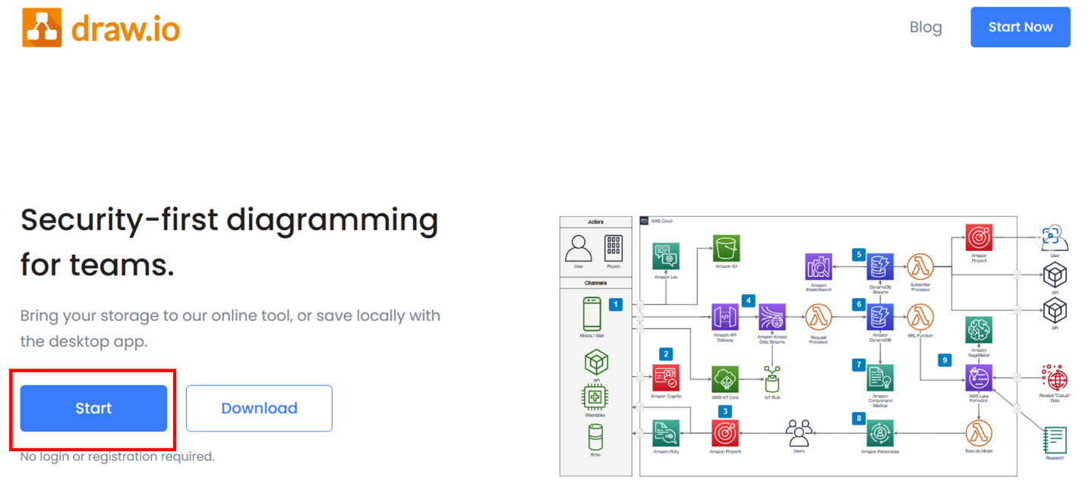

- Click Create New diagram

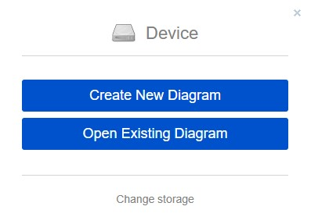

- Select Blank Diagram -> Change the name to “RES_[COUNTRY NAME].drawio” and save it in a folder of preference.

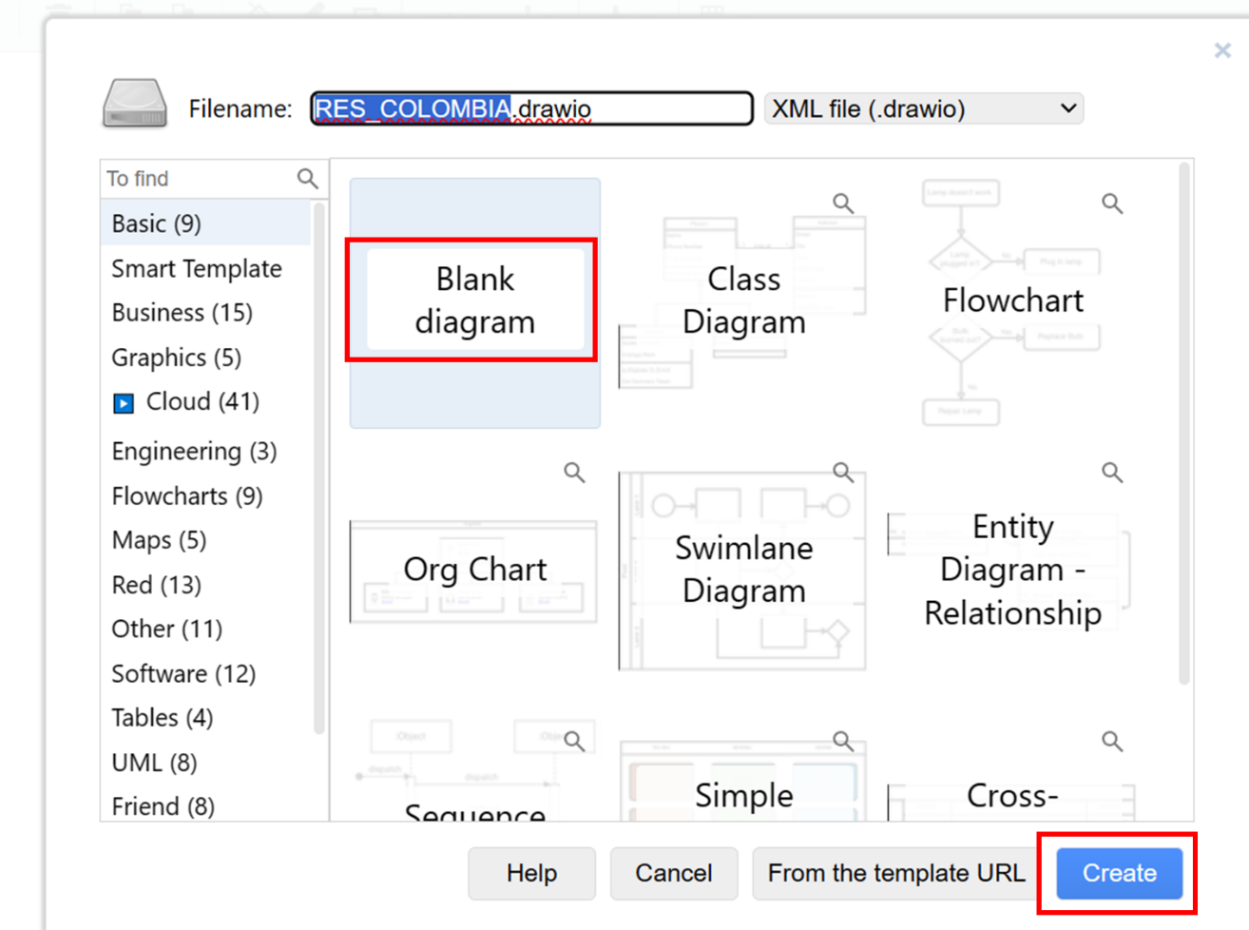

- On the left side of the tool, select a Rectangle from the General Group. Drag and drop it on the screen.
- Double click in the middle of the Rectangle to add Text. Write MINCOA.

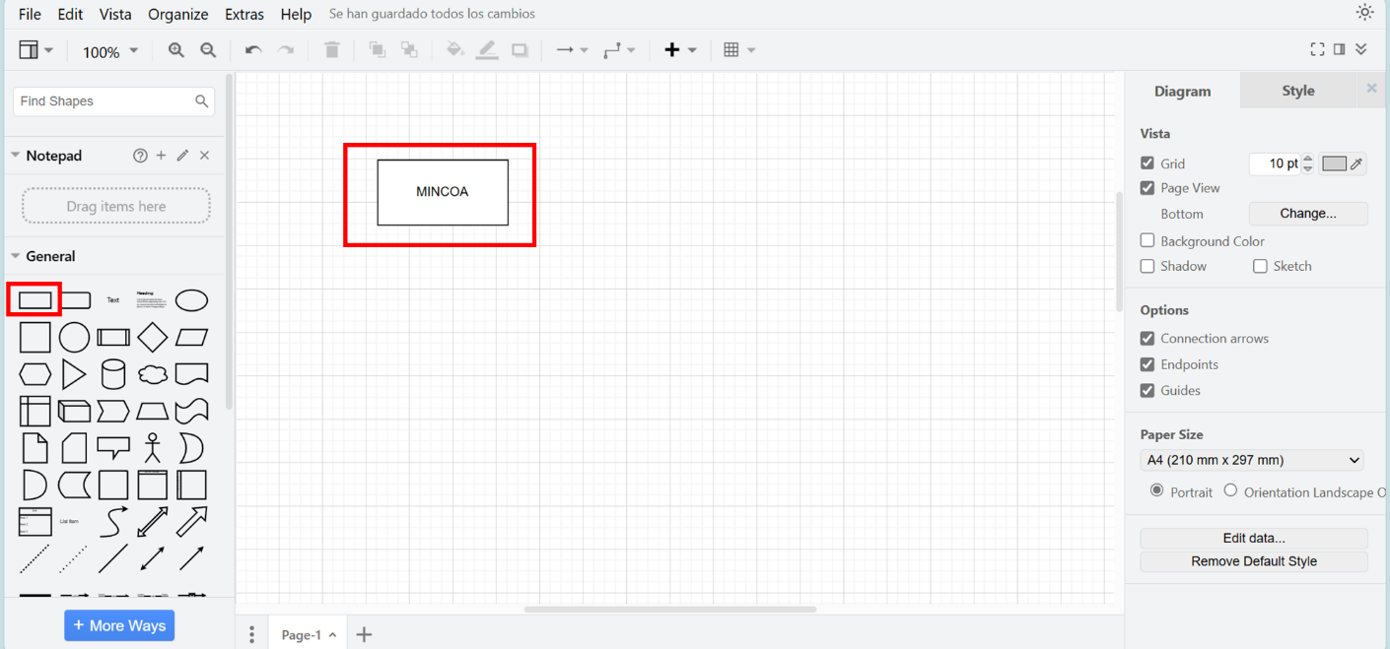

- Let’s draw the coal production. Select a line and drag and drop it on the right side of the MINCOA technology. Bring your pointer on the line on the right side of the rectangle and some blue points will appear. Click and drag until you reach the coal line drawing an arrow. Double click on top of the coal line to add the code for the COAL commodity: COA as for the naming convention guidelines using during the course.

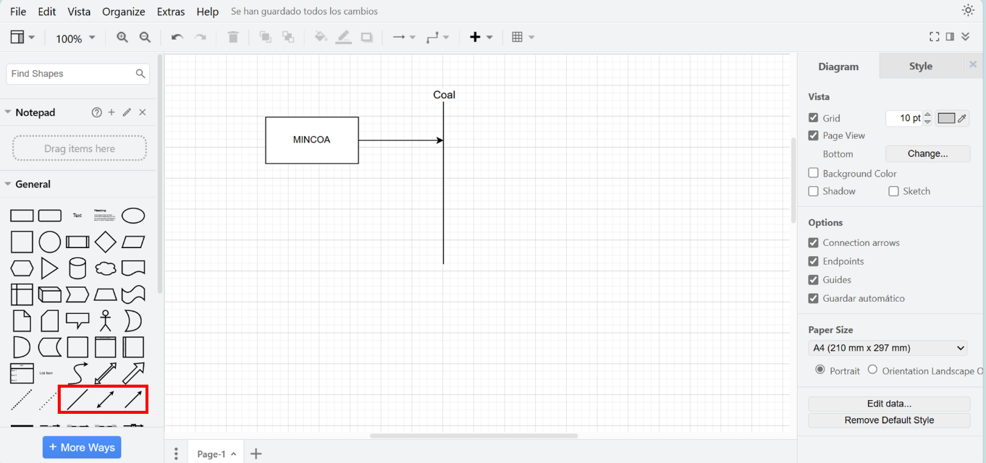

GREAT!: you now have drawn the first chain in your RES. The arrow that connects the two means that the output of the MINCOA technology will address the coal production (COA).
Task: Design a RES for your country by incorporating its current power mix and considering potential new technologies for future investment. Consider the energy profile of your country in this process [link].
For reference, an example of the expected RES is provided below:
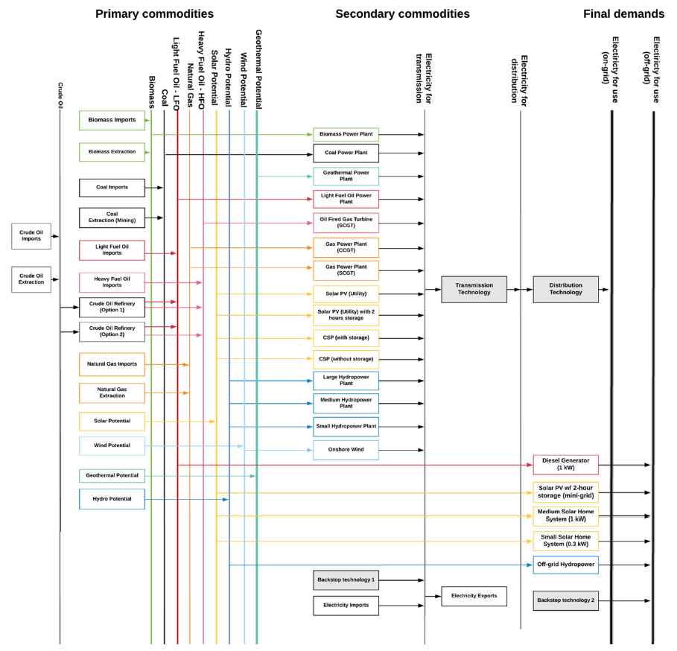

2. Build your RES using OSeMOSYS

As we learned in a previous activity, we focused on adding fossil fuel power plants. Now, we will shift our attention to creating chains for renewable power plants, and where applicable, nuclear power plants. Table 1 summarizes the commodities, primary source technologies, and power plant technologies for the most common types.
Table 1. Commodities and technologies for renewables and nuclear energy.
Commodity | Primary source | Power Plant
BIO = Biomass | MINBIO = Biomass production | PWRBIO = Biomass power plant
HYD = Hydropower | MINHYD = Hydro potential | PWRHYD = Hydro power plant  Note: You can create more technologies to represent subtypes of hydro power plants (e.g., reservoir and run-of-river)
GEO = Geothermal energy | MINGEO = Geothermal potential | PWRGEO = Geothermal power plant
SOL = Solar energy | MINSOL = Solar potential | PWRSOL = Solar PV power plant
WND = Wind energy | MINWND = Wind potential | PWRWND001 = Onshore wind power plant  PWRWND002 = Offshore wind power plant
NUC = Uranium or other nuclear input | MINNUC = Nuclear potential | PWRNUC = Nuclear power plant

Task: Create the commodities and technologies in the interface based on your designed RES.
IMPORTANT: Before you can do anything else, you must copy the model and rename it in the same way you have before.
3. Define technologies representing the domestic production of renewable energy commodities

In order to represent a primary supply technology, remember that the following parameters must be considered:
- OutputActivityRatio: defines the fuel provided (the value is 1).
- Variable Cost: defines the cost of energy extraction.
- TotalTechnologyModelPeriodActivityUpperLimit: defines the level of proven coal reserves that are available for extraction throughout the entire model period (we will express it in PJ). It applies for nuclear resources only.
- TotalActivityAnnualUpperLimit: defines the maximum annual rate of production of energy. It will help us to represent the yearly energy potential for renewable sources.
- CapacityToAcitivityUnit: It is used to convert data related to the Capacity of technology into the Activity it can generate. For primary supply technology, this value should be set to 1.
Add the data for all technologies using national information or the database available at [link].
You need to add the data for the 5 parameters that were listed previously.
NOTE: TotalActivityAnnualUpperLimit - we will leave the default number (99999) which, being very high, means that we are not constraining the installed capacity of this technology.
SAVE DATA!!! UPDATE MODEL!!!

4. Define renewable power plants taking in fuel to generate electricity

In order to represent a renewable power plant, remember that the following parameters must be considered:
- InputActivityRatio: defines the rate of fuel consumed (i.e., Hydro)
- OutputActivityRatio: defines the fuel provided (i.e., Electricity)
- CapacityToAcitivityUnit: used to convert data related to the Capacity of technology into the Activity it can generate. For power plant technology, this value should be set to 31.536.
- Fixed Cost: defines the fixed Operation & Maintenance cost ($/kW)
- CapitalCost: defines the overnight investment cost of the plant ($/kW)
- OperationalLife: defines the lifetime of the technology (in years)
- ResidualCapacity: defines the existing capacity of the technology (in GW) and its expected decommissioning
- Capacity Factors: represents the variability in generation at each point in time.
Add the data for all technologies using national information or the database available at [link].
You need to add the data for the 8 parameters that were listed previously.
The only new parameter that needs to be carefully added is the Capacity Factor. This represents the variability in generation at each point in time. You need to define capacity factors values for all the modelling years.
SAVE DATA!!! UPDATE MODEL!!!

