Energy System
Modelling Using OSeMOSYS
Development of a national energy system model – Activity 3
Please use the following citation for:
- This Activity
Plazas-Niño, F., Alexander K. (2024, April). Energy System Modelling Using OSeMOSYS: Development of a national energy system model – Activity 3 (Version 1.0).
- OSeMOSYS UI Software
Climate Compatible Growth. (2024). MUIO (Version v5.0.0). GitHub. https://github.com/ClimateCompatibleGrowth/MUIO
- OSeMOSYS Google Forum
If you are stuck, please ask questions here. If you get ahead, please answer questions in the same forum. Please state that you are using the ‘OSeMOSYS UI’ and not ‘ClicSAND’.
____________________________________________________________________________

1. Define the number and duration of timeslices

To conduct modelling work with OSeMOSYS, it's essential to assign values to a set called Timeslices, representing periods of the year with similar energy demand. Using the user interface (UI), you can create seasons and day types to define these timeslices. For simplicity, we'll consider groups of months to define seasons and periods of day (6 AM to 6 PM) and night (6 PM to 6 AM) as day types.
Task: Utilizing the Excel file ‘Timeslice structure’, copy and paste the timeseries of electricity generation for your country (hourly) and determine the appropriate number of seasons, which should range between 2 and 4. Once determined, define the number of timeslices for your model. For instance, if you identify 4 seasons, the number of timeslices will be 4 seasons x 2 day types = 8 timeslices. Update these numbers in the UI as demonstrated in the image below.
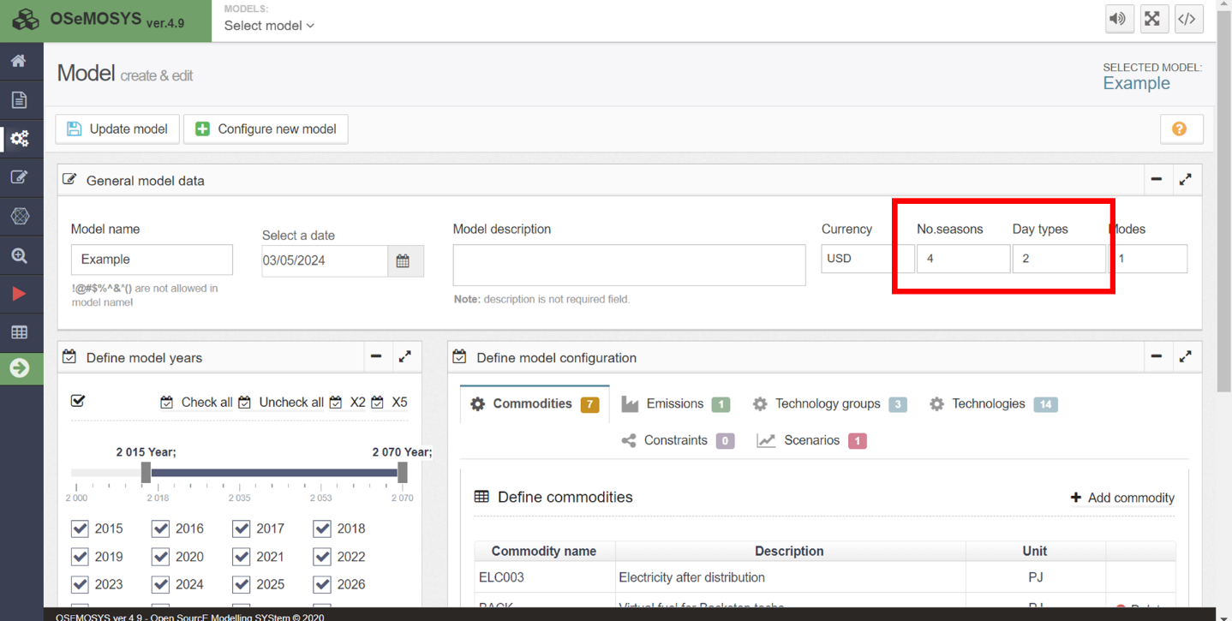

2. Add Year Split values

Considering the number of seasons and their corresponding distribution of months, the Year Split parameter can be calculated. The Year Split represents the duration of a modelled timeslice, expressed as a fraction of the year. Let’s illustrate this with the following example:
Suppose we have the following distribution of seasons: Rainy season 1 (from January to March), Dry season 2 (from April to August), and Rainy season 3 (from September to December). Assuming a year of 365 days, we can calculate the Year Split as the fraction of days for each period:
$$Year Split Season 1-Day and Night=\frac{90 days from Jan to Mar}{365 days}=0.247 ÷2=0.1235$$
$$Year Split Season 2-Day and Night=\frac{153 days from Apr to Aug}{365 days}=0.419÷2=0.2095$$
$$Year Split Season 3-Day and Night=\frac{122 days from Sep to Dec}{365 days}=0.334÷2=0.167$$

WATCH OUT! Take care to round carefully ensuring that the sum of all Year Split values is equal to 1.

After defining the duration of each time slice and calculating the Year Split profile we need to add these values in UI Interface.
Try it: let’s add the data for Year Split.
- Go back to the OSeMOSYS UI to your model. On the interface model configuration page (this is basically the home screen of your model), go to data entry as shown in the image below and search year split in the search bar. Then open that parameter.
NOTE: The ‘data entry’ button is where you can view all parameters and how you will enter data.
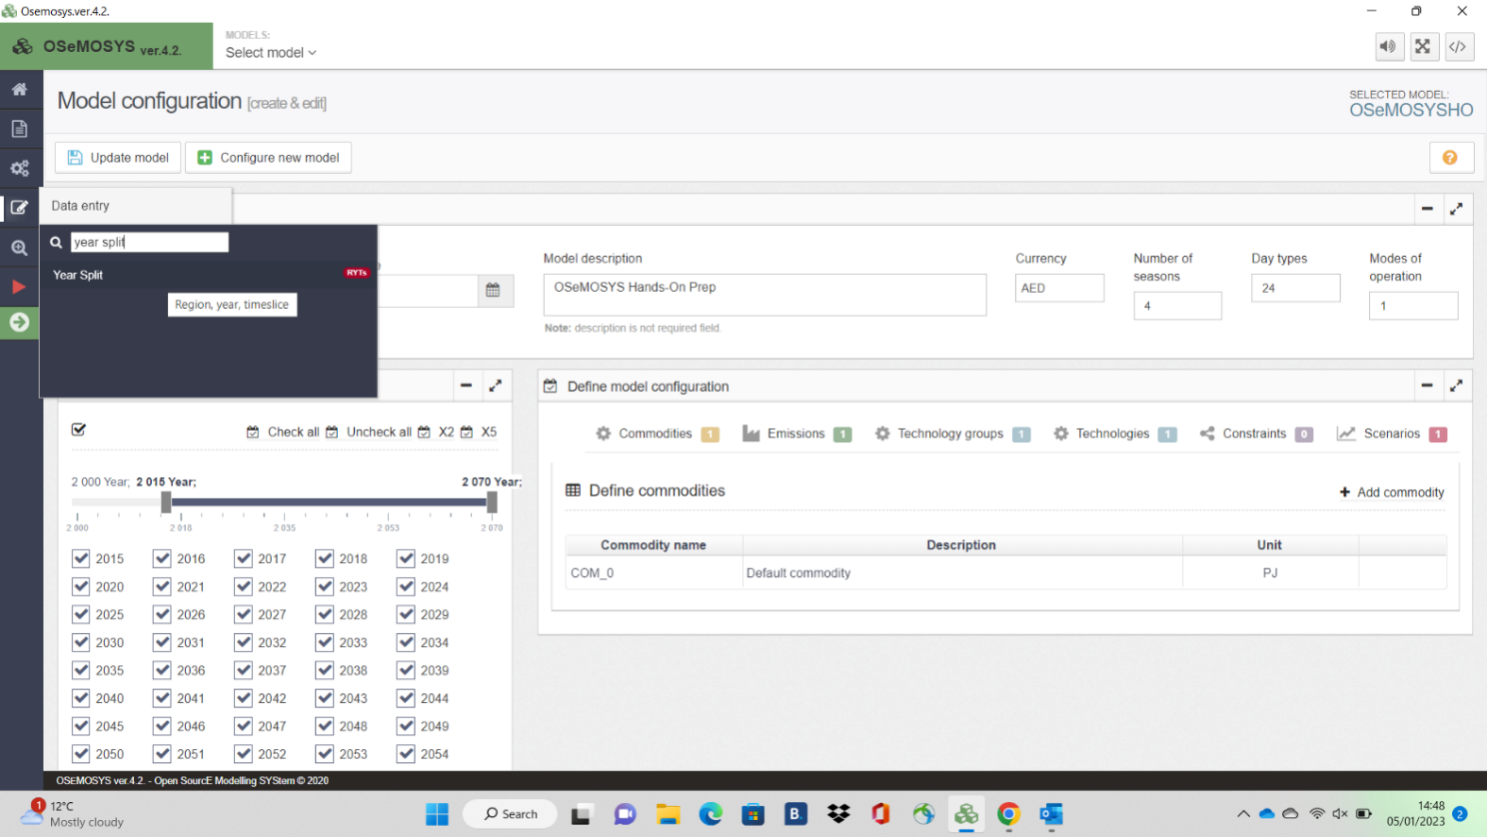

- Once you click on Year Split, you will see this page:

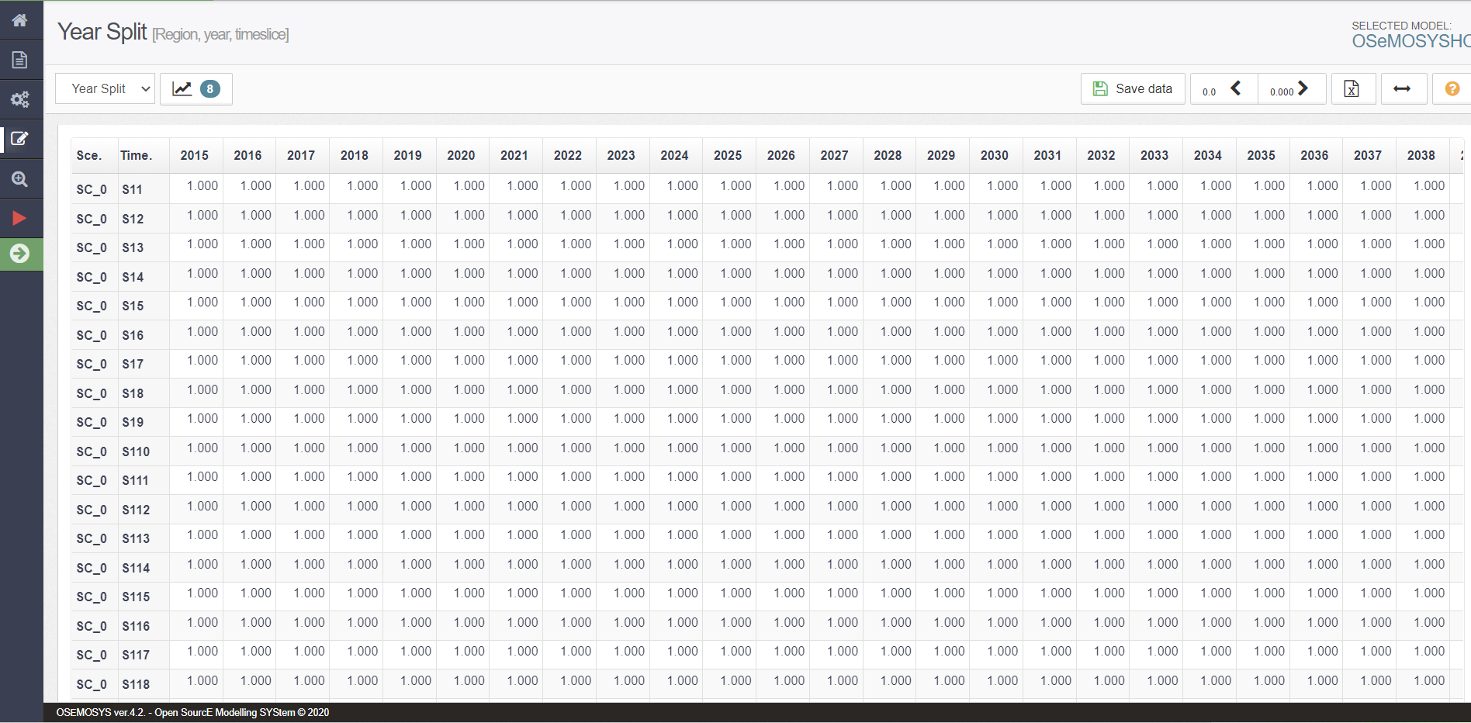

- Complete the data into the data tile underneath 2015 or your initial year and next to S11, as shown in the image above. It will then look like the image below:
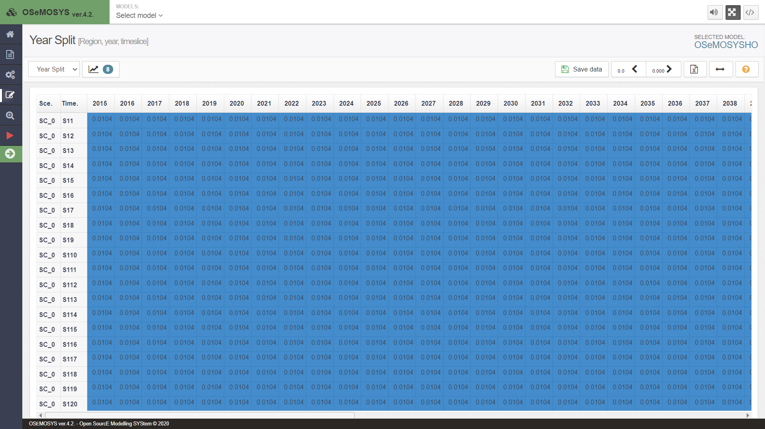
- You must then press the ‘save data’ button as shown in the image above.
Important: Each time you enter/edit data you MUST press this button before returning to the homepage.
NOTE: Next to the ‘save data’ button you can increase or decrease decimal places to view the data how you wish (as the default is 3, so it may appear as if the data hasn’t copied correctly but it should have).
- Finally, return to the homepage and press ‘update model’. You will have now successfully changed the values for year split.
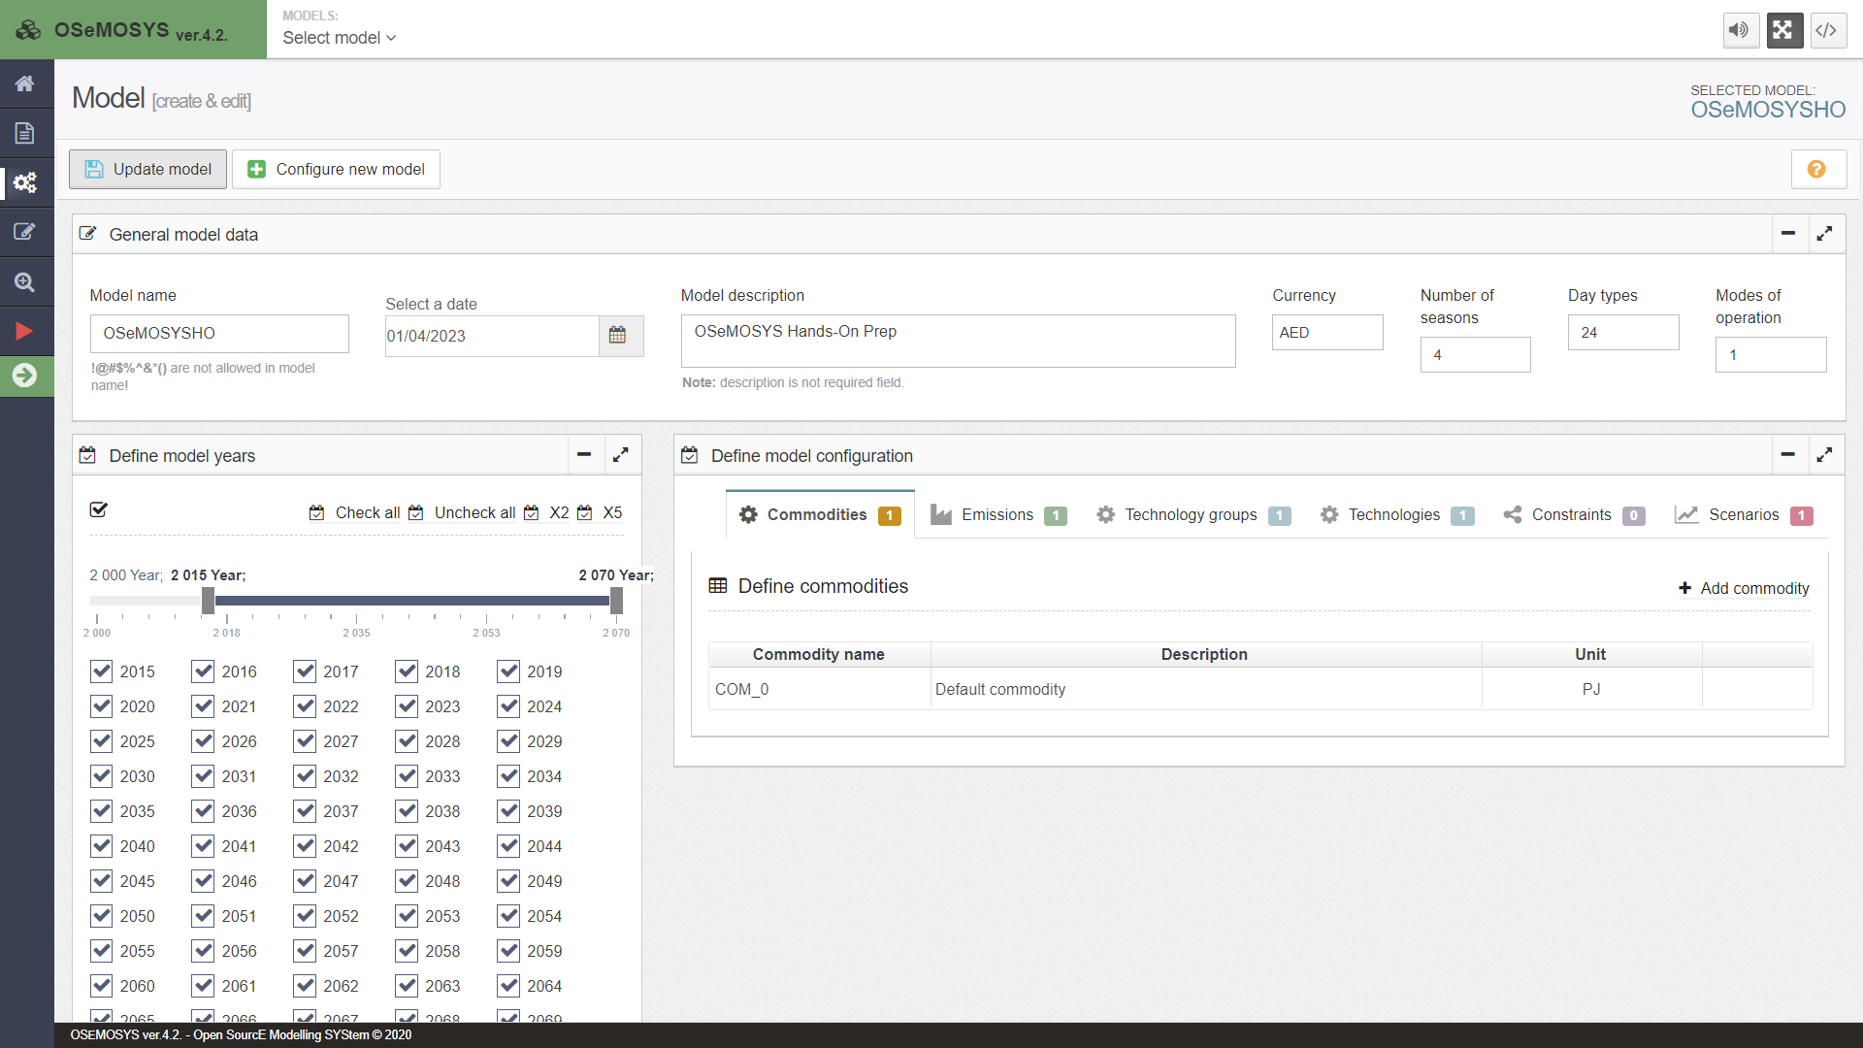

Important: Each time you enter/edit data, and/or add commodities/technologies to the model, you must press this button.

3. Check discount rate values

1. You can change the discount value by following the same process as with year split. Change the default value of 0.05 to 0.1.

Important: Make sure you save data and update the model every time you do this.

4. Define commodities

The next step is to begin to add the names of our commodities (fuels) into the OSeMOSYS interface.
IMPORTANT: make copies when you move to the next steps and do not make edits on the same file. In this way if there is a problem, there is always a backup version to easily find the error.
- You can add your first commodity. There will be a default commodity in your model, change the name of this to ELC003 from COM_0.
- Add a description for each commodity if you would like to. Such as: Electricity after distribution for ELC003.
- When adding commodities, you must press the button on the config page (as shown in the image below). You can also make the ‘define model configuration’ section full screen when you have added too many commodities/technologies to see on the page (as shown in the image below):
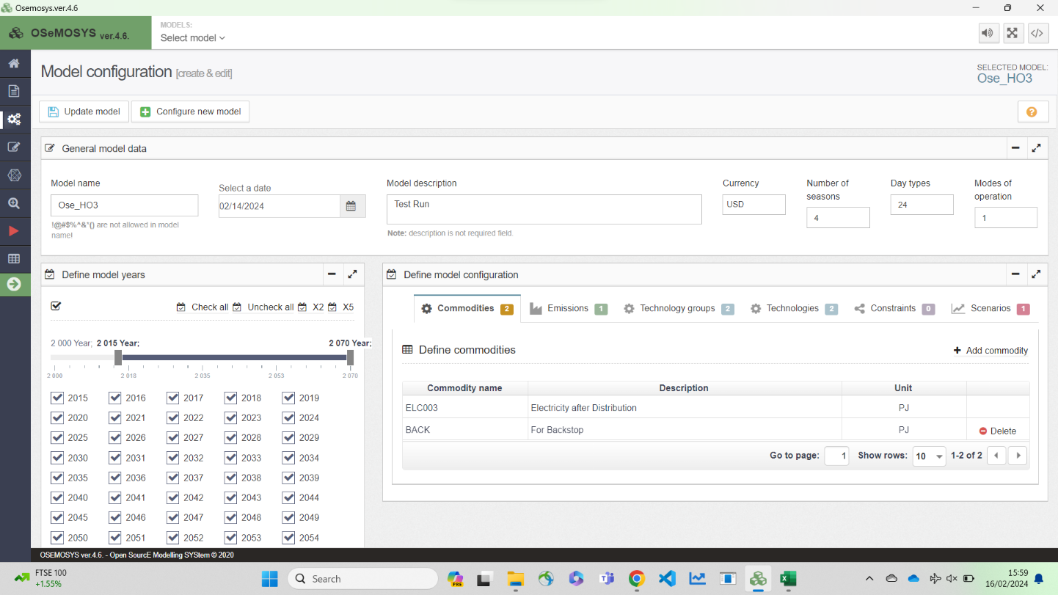
IMPORTANT: Repeat this process in the future to add names for other Commodities (Fuels). Like in the image above where another commodity has been added under ELC003.
5. Define energy demands for a specific fuel

Your next task will be to choose the demand type. You have two options for demand type:
● SpecifiedAnnualDemand -used for fuels whose demand varies within the year/day (e.g., electricity).
● AccumulatedAnnualDemand –used for fuels that do not necessarily have to be provided at an exact point in time (e.g., passenger transport demand).
Try It: Add the demand for Electricity after distribution (ELC003).
- Click on the data entry button and in the search bar type ‘Specified Annual Demand’, then go to that parameter.
- You should see ELC003 (and maybe another commodity if you changed the name of the default and added another).
Task: Use historical GDP growth data to calculate the average growth rate for the period 2010-2019. With this rate, project electricity demand from the initial year to 2050. Ensure to derive the baseline electricity demand from the national energy balance for the respective year.
- Copy-paste the ELC003 demand data for the years in your model.
- It should then look like the image below.
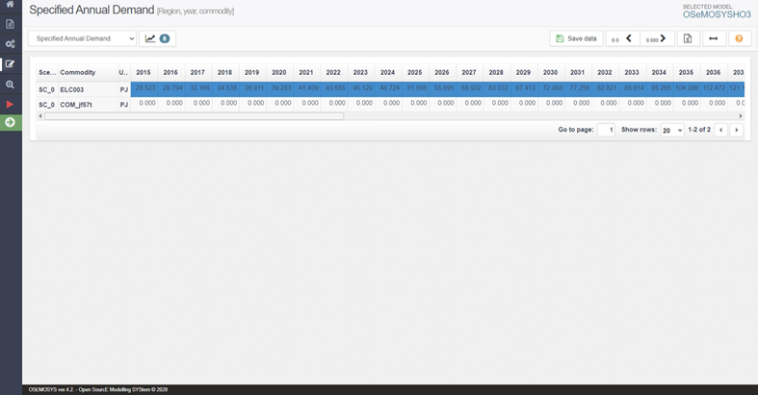
NOTE: Again, make sure you save data and update the model each time you follow this process.
WATCH OUT: For the same Commodity (Fuel) you should never add data for both SpecifiedAnnualDemand and AccumulatedAnnualDemand.

6. Define the temporal profile of energy demands

As said before, SpecifiedAnnualDemand is the parameter used to define a demand that changes within the year, as for the final electricity demand just seen (ELC003). Therefore, it now important to represent this time variability, and to do so we will use the SpecifiedDemandProfile parameter.

Task: Use the Excel file ‘Timeslice structure’ in the tab ‘D_Analysis’ for calculating the proportion of electricity generation in each timeslice.
Try it: Let’s add the demand profile to the OSeMOSYS interface.
- Like previously, go to the data entry button and this time search for the parameter ‘Specified Demand Profile’.
- Remember to change the number of rows from 20 to 100 as done previously.
- Then copy the data found in the Excel file.
- Then go back to the OSeMOSYS interface and click on the tile underneath 2015 (value should be 0.000), then paste all the data.
- Save data and then update the model. IMPORTANT: Reminder to do this every time.
NOTE: The sum of all the Year Split values for the timeslices should always be 1. The same is valid for the SpecifiedDemandProfile values. Take care at the moment of rounding.

7. Define technologies representing the domestic production of energy commodities

In Lecture 4 of the Open Course we learnt how to represent a technology in OSeMOSYS, and which parameters characterize the primary energy supply technologies. As said, these technologies can represent domestic production/extraction or importation of fuels such as coal, natural gas, and oil.
In order to represent a primary supply technology, remember that the following parameters must be considered:
- OutputActivityRatio: defines the fuel provided (in this first example Coal).
- Variable Cost: defines the cost of coal extraction.
- TotalTechnologyModelPeriodActivityUpperLimit: defines the level of proven coal reserves that are available for extraction throughout the entire model period (we will express it in PJ).
- TotalAnnualMaxCapacity: defines the maximum annual rate of production of coal.
- CapacityToAcitivityUnit: It is used to convert data related to the Capacity of technology into the Activity it can generate. For primary supply technology, this value should be set to 1.
Try the following example: Let’s add MINCOA - the technology representing the domestic extraction of coal.
- Before you do this. Follow the same process as before and copy your previous model. Then rename it (e.g., primary sources). This is so that if there are any errors, you can go back to your old working model if necessary.
- Now go to the model configuration page. Firstly, add a commodity called ‘COA’ (coal).
- Then add a technology called ‘MINCOA’. From this you need the output of MINCOA to be COA, but there is no input.
- Now you have added the technology and commodity. You need to add the relevant data. REMEMBER TO UPDATE YOUR MODEL.
- Add the data for MINCOA using national information or the database available at [link]
You need to add the data for the 5 parameters that were listed previously.
NOTE: TotalAnnualMaxCapacity - we will leave the default number (99999) which, being very high, means that we are not constraining the installed capacity of this technology.
SAVE DATA!!! UPDATE MODEL!!!
- Repeat steps 2-5 for any other domestic source applicable for your country.

8. Define technologies representing the import of energy commodities

We will repeat the exercise once more giving the example of a technology which represents the import of coal (IMPCOA). When representing an Import technology, the following parameters must be considered:
- OutputActivityRatio: defines the rate of fuel provided (in this first example).
- VariableCost: defines the cost of importing the fuel.
- CapacityToActivityUnit: used to convert data related to the Capacity of technology into the Activity it can generate. For primary supply technologies, this value should be set to 1.
Try it: let’s add this technology in the model.
- Go to the model configuration page and add a new technology called ‘IMPCOA’.
- You should not add any new fuel as COA was defined in the previous section. However, the output of IMPCOA needs to be COA, just like MINCOA.
IMPORTANT: Remember to update your model each time you add data, technologies, or commodities. As well as saving data each time.
- Add data for OutputActivityRatio, VariableCost and CapacityToActivityUnit using own information or data available at [link].
- Repeat the same steps for any other import technologies applicable to your country.
- Your model configuration page for commodities and technologies, should now look like the example images below:

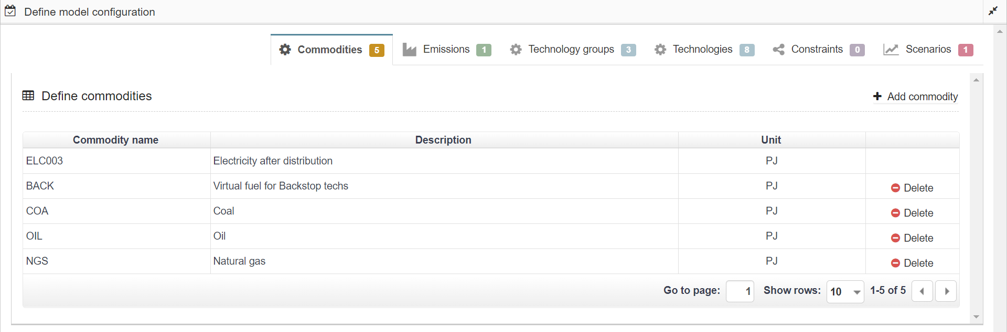
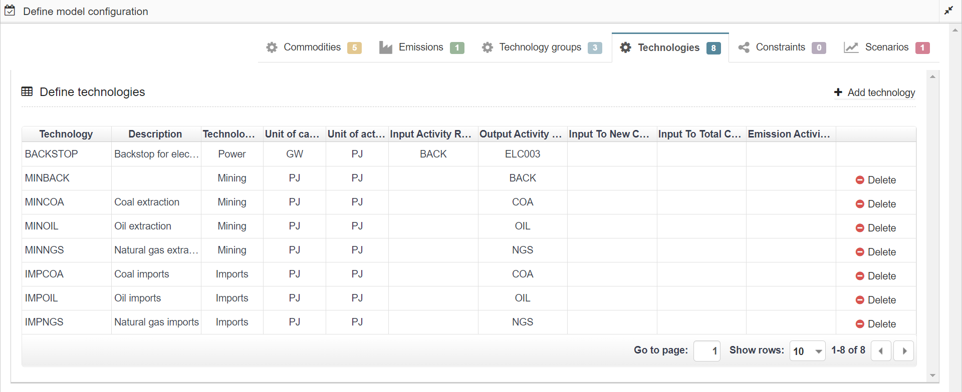
- Finally! As discussed in previous lectures, you can add technology groups. Now as this isn’t a necessity, it won’t be discussed again after this section. But you could set it up similar to the following:
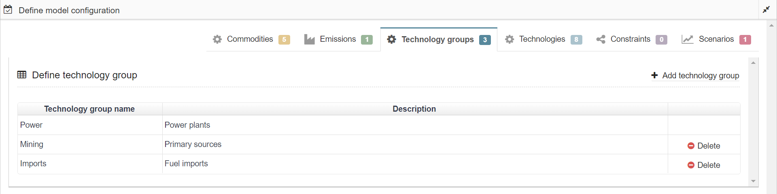

9. Define thermal power plants taking in fuel to generate electricity

In Lecture 6, we learnt how to represent a technology in OSeMOSYS, and which parameters characterize thermal power plants and transmission and distribution technologies.
In this section, we will add the technologies for thermal power plants, 1 technology representing the transmission system and 1 for the distribution network. Two new fuels will be added to the model: ELC001 (Electricity coming directly from power plants) and ELC002 (Electricity after transmission).
In order to represent a thermal power plant, remember that the following parameters must be considered:
- InputActivityRatio: defines the rate of fuel consumed (i.e., Coal)
- OutputActivityRatio: defines the fuel provided (i.e., Electricity)
- CapacityToAcitivityUnit: used to convert data related to the Capacity of technology into the Activity it can generate (for power technology, e.g., PWRCOA, this value should be set to 31.536).
- Fixed Cost: defines the fixed Operation & Maintenance cost ($/kW)
- CapitalCost: defines the overnight investment cost of the plant ($/kW)
- OperationalLife: defines the lifetime of the technology (in years)
- ResidualCapacity: defines the existing capacity of the technology (in GW) and its expected decommissioning.
- Capacity Factors: represents the variability in generation at each point in time.
IMPORTANT: Before you can do anything else, you must copy the model and rename it in the same way you have before.
Try the example: Let’s add PWRCOA - the technology representing a coal power plant.
- Firstly, as you have already added ‘COA’ as a commodity, you do not need to do this again.
- Now let’s add ‘ELC001’ (Description: Electricity from Power plants) as a commodity.
- Then go to the technologies tab of the model configuration page and add ‘PWRCOA’.
- In this way, we added the technology which will be transforming Coal (COA) into electricity (ELC001) to the model. So, add the relevant inputs and outputs on the technologies tab.
- Next, you must enter the data through the data entry tab on the side of the model configuration page for PWRCOA (as done previously with other technologies).
- Add the data for PRWCOA as given in the database.
With all 8 parameters that need data listed above.
IMPORTANT: ResidualCapacity will be 0 by now. We will review this part in a future activity.
NOTE: With Capacity Factor, you have to select rows at the bottom and select 1000 rows. Unfortunately, you cannot yet filter out technologies on the data entry tab. So, follow these steps:
- Scroll down to find PWRCOA. When you find it, you will see S11 next to PWRCOA below another technology. ADD the data to the next tile along (should be a value of 1). If you copy-paste correctly, it should fill all the capacity factor data for PWRCOA.
- When you add the data, it will take you back to the top of the page (a current flaw in the UI). But at least it reminds you to SAVE DATA!
- Follow the previous steps when you add other power plants such as PWROHC, PWRNGS001 and PWRNGS002.
- Then update your model after adding all the techs.

- Repeat the same steps for other thermal power plants as applicable.

10. Define the existing transmission network

We will repeat the exercise once more giving the example of a technology which represents the transmission network (PWRTRN). When representing the transmission technology, the following parameters must be considered:
- InputActivityRatio: defines the rate of fuel consumed (i.e., Electricity from power plants)
- OutputActivityRatio: defines the fuel provided (i.e., Electricity)
- CapacityToAcitivityUnit: It is used to convert data related to the Capacity of technology into the Activity it can generate. For power technology, this value should be set to 31.536.
- Fixed Cost: defines the fixed Operation & Maintenance cost ($/kW)
- CapitalCost: defines the overnight investment cost of the plant ($/kW)
- OperationalLife: defines the lifetime of the technology (in years)
- ResidualCapacity: defines the existing capacity of the technology (in GW) and its expected decommissioning
Try it: Let’s add PWRTRN - the technology representing the transmission grid.
- Firstly, you need to add a new commodity which is ‘ELC002’. As PWRTRN has an input of ELC001 and output of ELC002 (electricity after transmission).
- Now you need to add the technology ‘PWRTRN’.
- With the input being ELC001 and output ELC002. Update the model.
- Add the data for PWRTRN as given in the database, in the same way you have previously. Remembering to save data and update model each time.
NOTE: Add data to all 7 parameters listed above. This time you do not need to add capacity factors like you did in the previous section.

11. Define the existing distribution network

We will repeat the exercise once more giving the example of a technology which represents the distribution network (PWRDIST). (Very similar to PWRTRN)
Try it: Let’s add PWRDST - the technology representing the distribution network
- As you already have ELC002 and ELC003, you do not need to add anymore commodities for this hands-on.
- You just need to add the technology ‘PWRDST’.
- Then you must set the input as ELC002 and output as ELC003.
- Add the data for PWRDST as for the database.

NOTE: Add data to all 7 parameters listed above. This time you do not need to add capacity factors like you did in previous sections (this is the same as PWRTRN).

12. Run the model and check results on production by technology

You are now ready to run the model. Before doing so, make sure you have saved all the data added and updated the model. The visualization is quite simple.
- Click the red play button as shown in the image below:
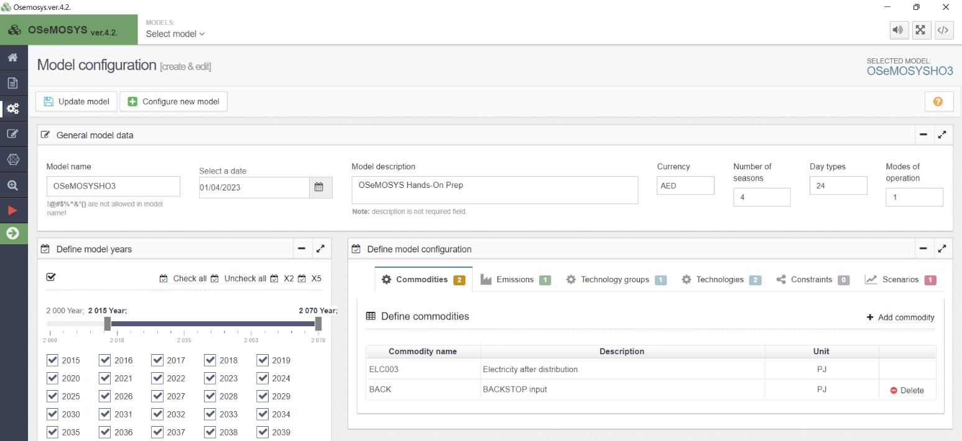
- You must then give it a name (OSeHO3 was chosen for this run) and a description if you want to. Then you must create a case and generate a data file.
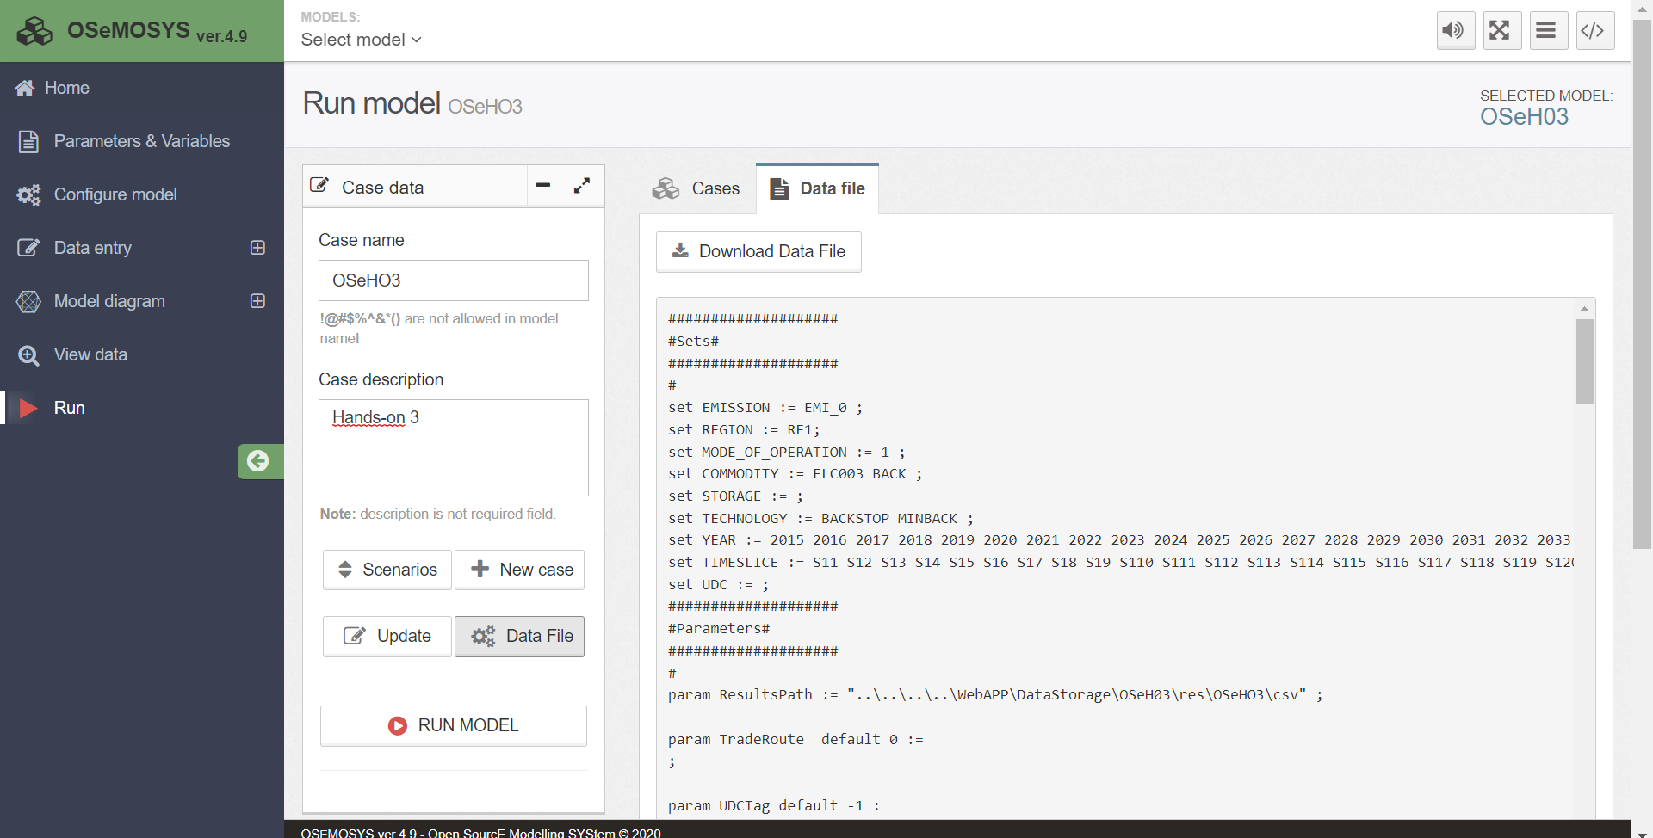
- Then you must RUN MODEL. You will see it complete the optimization process:

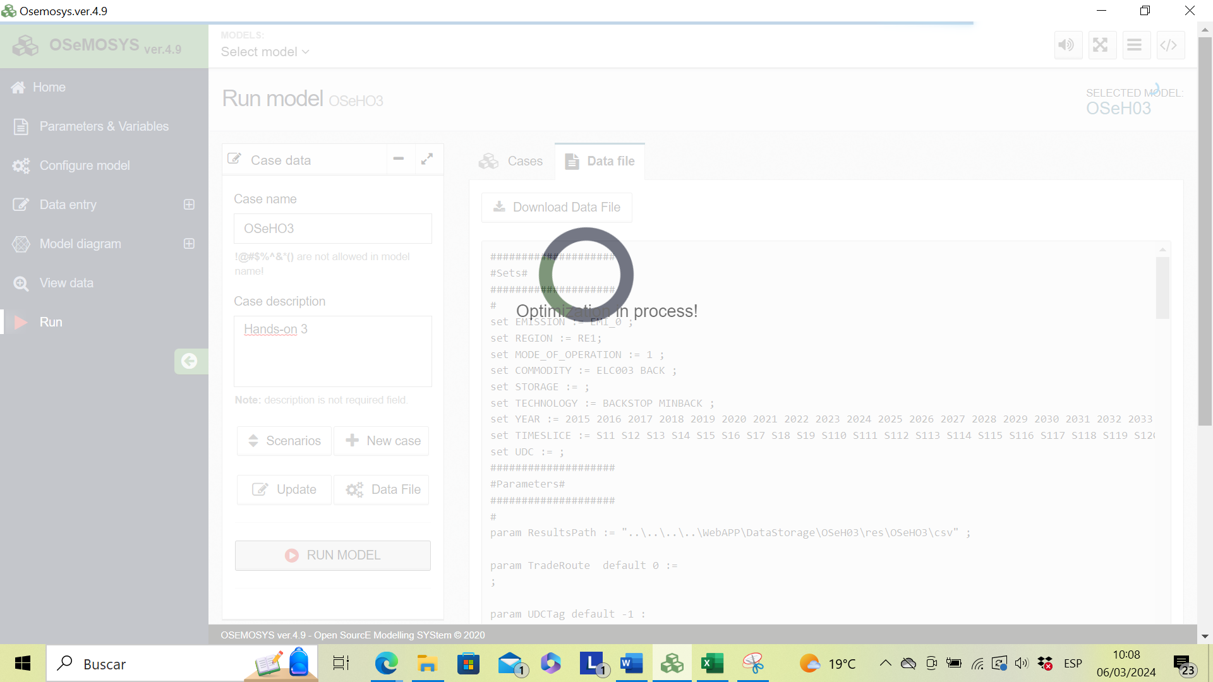
- You will see many files created and you can view the results by pressing the table button as shown in the image below:
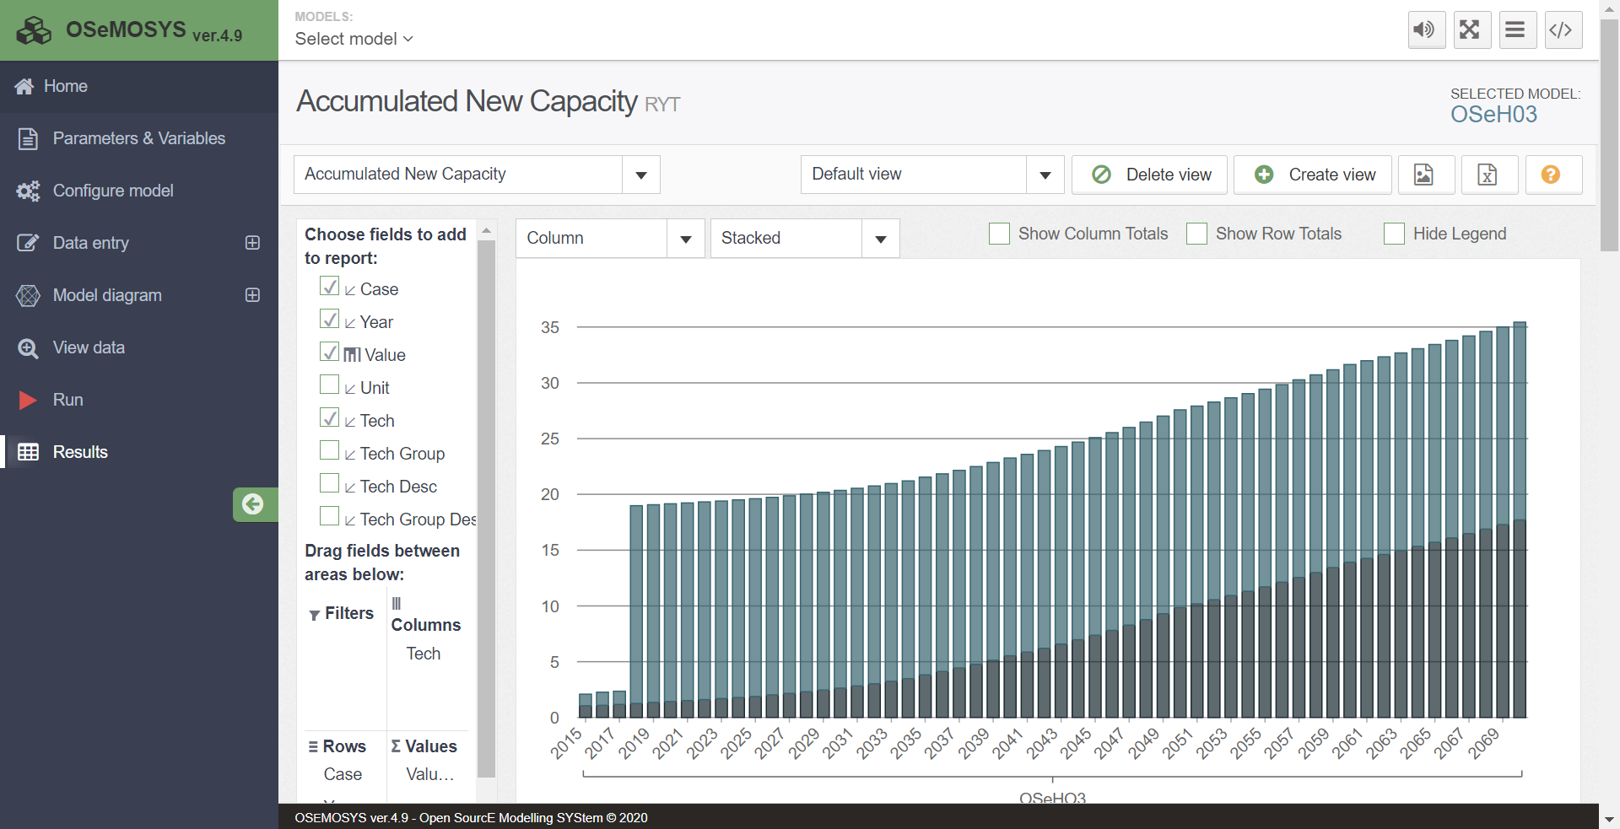
- You will now be on the results page as shown below:

- It will automatically appear with the Accumulated New Capacity graph; therefore, you must click on the arrow highlighted above and choose the parameter Production by Technology by Mode. It will then appear like the image below:
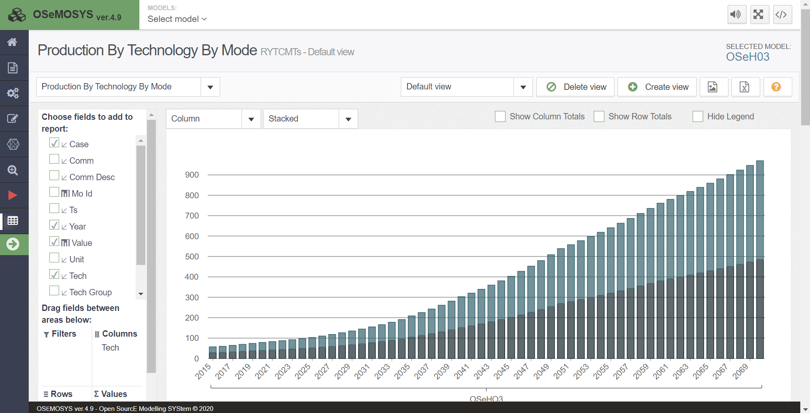

- To filter out an unwanted technology (e.g.), you need to right click on ‘tech’ in the columns tab and select the ‘Field Settings’ option, and a box will pop up on your screen like the image below:

