Land
When following the guidance, make sure you read the entire step before commencing.
You have already added energy to your model, now it is time to accompany it with Land-Use data. Please note it is important that units are consistent, if mathematical units are unfamiliar to you, visit the ‘Units’ resource (supplementary file).
Before beginning these steps, copy and save your energy-only model and rename the new model EnergyLand[country]

Step 1: Country Size
First, add the ‘technology’ MINLND to your model and the ‘commodity’ LND. Then find out how large your country is in km² using this link: world in data
In our OSeMOSYS model 1 unit is = to 1000sq km if you are using the unit 10³km². So work out how many units your MINLND is worth and round it up or down appropriately. E.g. Zambia 743,390 km² = 743 units (10³km²).
It is important to remain consistent with your units throughout this Land Use stage. In other words, whenever you add land use data it must be converted to 10³km^{2 if} that's the unit you’ve chosen to represent your land in your model.

Step 2
You then need to apply this figure (total land units) to your model, for all years, using the parameter ‘total technology annual activity upper limit’ and apply it to MINLND. (E.g.) For Zambia this is 743.

Step 3: Including Crops
Now we need to decide which crops to add to our country’s ‘Land Use’. We will have four major categories: the two largest crops in your country by area harvested, a biofuel crop and then we will group together the remaining crops. The table below is a good way to group all this data together before inputting it into the model; you can set it up in excel.

Zambia | Crop Name | Crop Naming Convention | Area Harvested  10³km² | Production Quantity (mTon) | Output  Activity  Ratio | Capital Costs  Million Dollars per 10³km² | Operational Life (Years)
Crop1 Rainfed | Grapes |  | 3448464 | 87855 |  | 10 | 15
Crop 1 Irrigated | Grapes |  |  |  |  | 80 | 15
Crop 2 Rainfed | Other |  |  |  |  | 10 | 15
Crop 2  Irrigated | Other |  |  |  |  | 80 | 15
Crop 3 Biofuel Rainfed |  |  |  |  |  | 10 | 15
Crop 3 Biofuel Irrigated |  |  |  |  |  | 80 | 15
Crop 4 | All other Crops | CRPOTHHR |  |  |  | 10 | 15
Step 3a:
We need to add seven different crop types to our model, and we will separate crops 1-3 into rainfed and irrigated.
Using the resource provided find out which is your country’s two ‘largest’ crops in terms of Area Harvested (FAOSTAT) for the first year in your model (2020). E.g. In Zambia 2019, this was Maize & Groundnut.
Input this data into your table:
Crop 1 Name: This is the largest crop in your country in terms of Area Harvested. For example, in Zambia for 2019, this was ‘Maize’.
Note: if your ‘biggest’ crop is described as “Cereals n.e.c.” this refers to ‘Teff’.
Crop 2 Name: As above, but for the 2nd largest crop
Crop 3 Name: This will be a crop that can be converted into a biofuel – so include one of these ‘biofuel’ crops into your model that your country currently grows (it cannot be the same as Crop 1 or 2): Maize, Rapeseed/Canola, Sugarcane, Palm Oil, Jatropha, Soybeans, Cottonseed, Sunflowers, Wheat or Switchgrass.
For the Zambia example below, Sugarcane (SGC) has been chosen.
Crop Naming Convention: The name of your Crop that can be read and used by the model i.e Rainfed Maize becomes ‘CRPMAIHR’; Other crops becomes CRPOTHHR. To find out what naming convention your crop uses search this spreadsheet: Cloud Naming Convention Table
Area Harvested: Using the data from FAOSTAT find out the amount of land that is used for that crop. The figure is provided in Ha, we need to convert it into 10³km²
This conversion needs to be done correctly so take care- here is an example from Zambia:
841693 ha of land = 8417km² of land = 8.417³km²
For crop 4 you will need to sum up the entire area harvested, minus the area harvested of crops 1-3.
Production Quantity: Again, for production quantity calculate the amount via FAOSTAT and then convert the units correctly from tonnes in Million Tonnes:
Eg. Zambia 2019 Maize: 2004389.36 tonnes = 2 mTon
For crop 4 you will need to sum up the entire tonnes produced, minus the tonnes produced by crops 1-3.
Step 3b:
Once completed your table should look something like this:

Zambia | Crop Name | Naming Convention | Area Harvested 10³km² | Production Quantity (mTon) | Output  Activity Ratio | Capital Costs  Million Dollars per 10³km² | Operational Life (Years)
Crop1 Rainfed | Maize | CRPMAIHR | 8.42 | 2 |  | 10 | 15
Crop 1 Irrigated | Maize | CRPMAIHI | 8.42 | 2 |  | 80 | 15
Crop 2 Rainfed | Groundnut | CRPGROHR | 2.1 | 0.13 |  | 10 | 15
Crop 2  Irrigated | Groundnut | CRPGROHI | 2.1 | 0.13 |  | 80 | 15
Crop 3 Bio- fuel Rainfed | Sugarcane | CRPSGCHR | 0.5 | 4.69 |  | 10 | 15
Crop 3 Bio-fuel Irrigated | Sugarcane | CRPSCGHI | 0.5 | 4.69 |  | 80 | 15
Other Crops | All other Crops | CRPOTHHR | 0.6 | 0.03 |  | 10 | 15

Step 4: Output Activity Ratios
The most important figure for our crops in the model is, arguably, the output activity ratio, i.e. how many crops can be produced from 1 unit of our country's agricultural land. Thus, to work out an output activity ratio for any crop we need to know how much land (Area Harvested) was used to produce (production quantity) that much crop. For example, in 2019, Zambia cultivated Maize in 841693 ha of land and produced 2004389 tonnes of maize from that land in that year.

We have already converted these units correctly for our model:
- 841693 ha of land = 8417km² of land = 8.417³km²
- 2004389 tonnes = 2 mTon.
We now need a ratio of what one unit of land (10³km²) can produce. In the example outlined above this would be = 2/8.4 = 0.238

So the output activity ratio is = 0.24 mTon of produce (per 1 unit of land)
However, we want to amend this ratio to account for the differences between rainfed and irrigated land – especially as Irrigated land produces more crop (but is more costly and water intensive).
To work this out we need to do some maths!
First, we need to find out how much more efficient irrigated land is at producing crops (in your chosen country) and also how much of your arable land is currently irrigated. These figures are available at FAO AQUASTAT database under the parameters ‘Ratio between irrigated and rainfed yields’ and “% of the cultivated area equipped for irrigation”.
So, to continue the Zambia maize example let's assume that in Zambia that there is 6 % of the cultivated area equipped for irrigation and that the Ratio between irrigated and rainfed yields is 2.3 i.e. irrigated crops are 2.3 x more productive then rainfed. Thus, if we assume that 6% of all Maize has been irrigated in Zambia, then rainfed land has instead an efficiency of:
Output Activity Ratio =
- 6% of 8.417³km² = 0.505³km² of irrigated land -update your table with this figure
- 94% of 8.417³km² = 7.912 ³km² of rainfed land-update your table with this figure
- Rainfed yield = Production / ((Irrigated land x 2.3) + (Rainfed land))
- = 2 / ((0.505 x 2.3) + (7.912))
- = 0.22 mTons per 10³km²
- Irrigated yield = 0.22 x 2.3
- = 0.51 mTons per 10³km²
We now have two key output activity ratios for our model Rainfed Maize = 0.22 and Irrigated Maize = 0.51 mTons per 10³km².

Now using this example as a template, work out the Output Activity Ratio for crops 1-3 in your table, both rainfed and irrigated, and add the relevant figures to your table.
The data in your table for ‘production quantity’ should also change based on the maths done, i.e. Production Quantity is = to Output Activity Ratio x Area Harvested

For example, crop 1 would look like this:

Zambia | Crop Name | Naming Convention | Area Harvested 10³km² | Production Quantity (mTon) | Output  Activity Ratio | Capital Costs  Million Dollars per 10³km² | Operational Life (Years)
Crop 1 Rainfed | Maize | CRPMAIHR | 7.912 | 1.74 | 0.22 | 10 | 15
Crop 1 Irrigated | Maize | CRPMAIHI | 0.505 | 0.26 | 0.51 | 80 | 15

Step 5
For Crop 4- ‘all other crops’ we will just have a rainfed calculation. Simply divide the production quantity by area harvested of all remaining crops to acquire the OAR.

Step 6: Developing the Model
Now the table is complete we will add these crops to our model one at a time, making sure we run the model first, before adding another.
The model structure we will now use and create for our models is:
MINLND -> LND -> LNDMAIHR/HI -> CRPMAI (but use your own crop 1).
So, you need to add two technologies ‘MINLND’ and ‘LND***HR’ and two Commodities ‘LND’ and ‘CRPMAI’ and create the output input relationship between them.
Also, insert the output activity ratio into the model that you calculated, and the input activity ratio as ‘1’.
Do this for Crop 1 rainfed only. And then proceed to step 7- demand.
Step 7
Before you can run your model, we need to add a demand for crops. Using a different FAO stat webpage: FAOSTAT2, search for the parameters “production” “export” and “imports” alongside your chosen crop for the first year (2020) of your model.
To work out demand use this formule: Demand = production + imports - exports.
Important: note that the data provided by FAO stats here is presented in Ktons (1000 tonnes) – you need to convert this to Mtons to match the units used to calculate the OAR
For example, 213 ‘1000 tonnes’ is = 0.213 mTon - add your specific figure into Accumulated Annual Demand for your Crop 1
Initially just do this for crop 1- later we will add crops-2-4
(For crop 4 ‘all other crops’ or for crops missing data import/export data, just use the total production quantity figure for the first year (2020) of your model – from the first FAO webpage resource – as the starting demand).
Step 7b
We currently only have demand for 1 year. For future demand we will need to make a forecast by considering population increase. Research the population stats for your country and discover the current % increase:. world population review.
Now apply this % increase to the 2020 (or most recent) demand figure. Do this continually across all years (for example you might be increasing the 2020 demand by 1.5% every year until 2050 etc). Use Excel to do this quickly using a formula and then drag the formula across relevant cells (see Excel % > e.g. =SUM(1+1.5%)*[2020 demand]) . Once you have done this, input the demand figure into Accumulated Annual Demand in your model for that Crop for all years.
Now run your model for your first crop. Don’t continue until the model has successfully run.
Note: This is a very blunt measurement for demand. Ideally you should do more research into estimating crop demand.
Step 7c
Now repeats Steps 6 & 7 for crops 2-4: do one at a the time to make troubleshooting easier.
As with energy demand, you need to create a table summarizing this demand for all your different crops across 10-year intervals (2020; 2030; 2040; 2050) and the unit used (i.e. mTon). This may be helpful to monitor data used and if you ever need it for future work.
For example:
 | Accumulated Annual Demand (MTon)
Crops | 2020 | 2030 | 2040 | 2050 | 2060 | 2070
[Crop 1]
[Crop 2]
[Biofuel]
[Other Crops]

Step 8
We now need to input some additional data to our crop (regarding costs). This is added to the relevant LND***HI/R technology (e.g. LNDMAIHR) in these parameters:
Capital Costs: Rainfed: 10 (million dollars per 1000Km2)
Irrigated: 80 (million dollars per 1000Km2)
Operational life: 15 years (both rainfed and irrigated)
Also include:
Residual Capacity- this figure is the area harvested (see the workings out in step 5) in the first year of your model – i.e. 2020 (use the correct unit/decimal place). You then need to taper/slowly reduce this figure to zero over 15 years i.e. in 2035 this figure needs to be 0 (you can apply a linear reduction).
Now run your model. However, on the online cloud platform make sure you select LARGE Server (your model is likely too big now to run on the small server - over 28 technologies). Note that if you do not select LARGE server the model may fail to run. This may happen also in a previous step if you have added more data and technologies to your model than we suggested.

Step 9
Save and copy your model. Repeat Steps 6 & 7 for all your other crops (irrigated and rainfed). Run your model regularly to spot data input errors early.

Step 10: Non-Agricultural Land-Use
In this activity, you will add four more Land use technologies (and their respective commodity) to include other non-agricultural land cover types: forests, built-up land, water bodies and other land.
Add to your model the new Technologies and Commodities highlighted:

- MINLND -> LND -> LNDFOR-> LFOR

- MINLND -> LND -> LNDBLT-> LBLT

- MINLND -> LND -> LNDWAT-> LWAT

- MINLND -> LND -> LNDOTH-> LOTH

For ‘input’ and ‘output activity ratio’ use the unit ‘1’ for all the above.

Next, let’s add some Variable Costs to these four new LND technologies:

LNDFOR = -2 (minus USD million)
LNDBLT = 2 (USD million)
LNDWAT = 2 (USD million)
LNDOTH = 0 (USD million)

Now run your model and look at the Land use graphs.
If you followed the instructions regarding variable costs, it is likely your forests dominated your countries land use.
The model is showing high forest land use because we have made it the most economically lucrative option based on how we entered variable costs. There is also a little agricultural land too because there is a demand for the model to produce crops- however, there is no demand for BLT or WAT and they are expensive to have relative to forests (forests provide income due to the minus number applied in ‘variable costs”), thus they are not shown in the graphs.
Remember the model does not produce reality – it produces the most 'economically viable’ solution based on the assets (technologies) and data the model has available to use.

Step 11: Adding Constraints
To compensate for this high level of forest land-use, we will now add similar parameters/constraints to our country models as we did with the hands-on exercises. Save and copy your model first!
Using ‘stats OECD’ - Land cover in countries and regions, discover what the rate of change for artificial surfaces (Built up land) is in your country (note that the units in this resource are 10³km²). On this website choose the measure as Square km (located on the top of the page) then find your country information for the earliest year to the most recent .
For example, Zambia’s artificial surfaces increased from 0.5 (10³km²) in 2005 to 1 in 2019. (a 100% increase in 14 years). Add this information to your model via the parameter ‘Accumulated Annual Demand’ for LBLT for all years i.e. project this % increase into the future.
You can use this: percentage-increase-calculator (then divide by year gap) to work out how much to increase the % by each year.

Step 11
Do the same as above with water bodies (referred to as ‘inland water’) but keep the figure stable throughout your time period in the parameter ‘Accumulated Annual Demand’. Now run your model and compare your land use graphs with the previous.

Step 12
You should also add data to the parameter ‘‘Total Technology Annual Activity Lower Limit’’ for forests. Use the tree cover data in ‘OECDstat’ – for the most recent year half it (to provide the model flexibility) and apply it as a flat rate across all years. This will put a minimum requirement on how much land for forests your model will use, but also allow flexibility for land use allocation when we start applying scenarios. Remember that because LFOR has been given a negative cost in land use (i.e. it makes money for the model) it will always default (allocate land use) to forests when possible.

Step 13
We will now put in some data for LNDOTH. Go back to this resource: ‘stats OECD’ - Land cover in countries and regions (it takes a while to load) and change the top field to “square kilometres”. Find your country and the data for 2019 (or the latest year available). Add together the data for Grassland, Wetland, Shrubland & Sparse Vegetation, Bare area and use this figure for “LNDOTH- Total Technology Annual Activity Lower Limit”.

The ‘Area by Land Cover Type’ graph should appear ‘full’- there should be a flat line across the top and it should correspond to the value you first inputted for MINLND.

The model in this graph (i.e. the model's solution) implies that as crop demand increases, the more economically viable forest land has to give way to agricultural land.

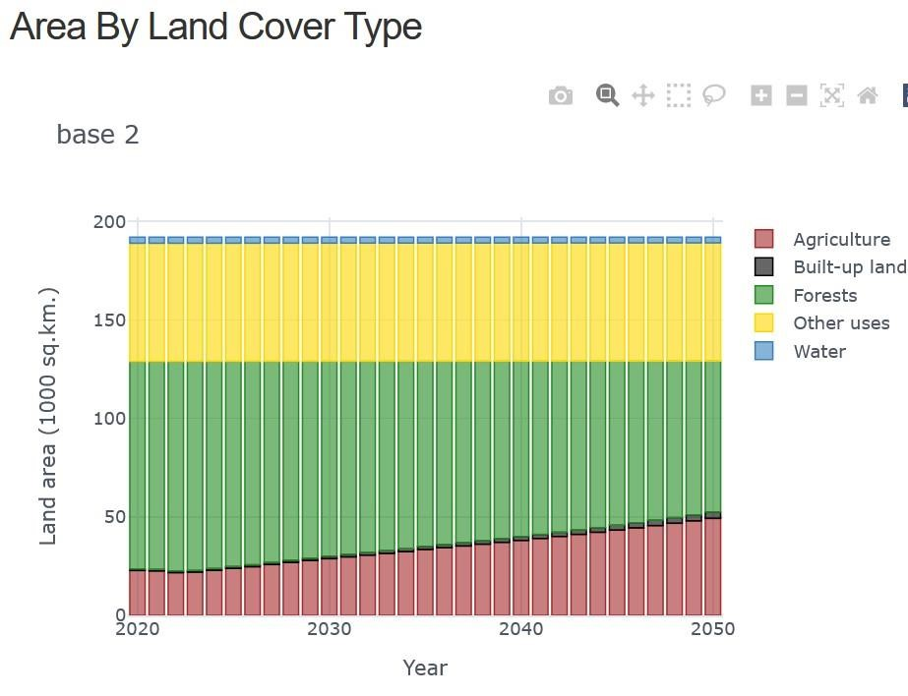

Check the rest of your graphs are showing and are not logical; now save your model (using the ‘backup model’ tool) and then copy it before proceeding further.

