Energy System Modelling Using OSeMOSYS
Hands-on 9
Please use the following citation for:
- This exercise
Plazas-Niño, F., Richardson, E. (2025, February). Hands-on 9: Energy System Modelling Using OSeMOSYS (Version 1.0.). Climate Compatible Growth. DOI: 10.5281/zenodo.14871427

- OSeMOSYS UI software
Climate Compatible Growth. (2024). MUIO (Version v5.0.0). GitHub. https://github.com/OSeMOSYS/MUIO/releases
____________________________________________________________________________

Learning outcomes

By the end of this exercise, you will be able to represent the following in OSeMOSYS:

1) Emissions

2) Reserve Margin

Emissions representation

As we learnt in Lecture 10, we account for emissions in OSeMOSYS using the parameter:
- EmissionActivityRatio [Mt/PJ]: defines the rate of emission by each technology.

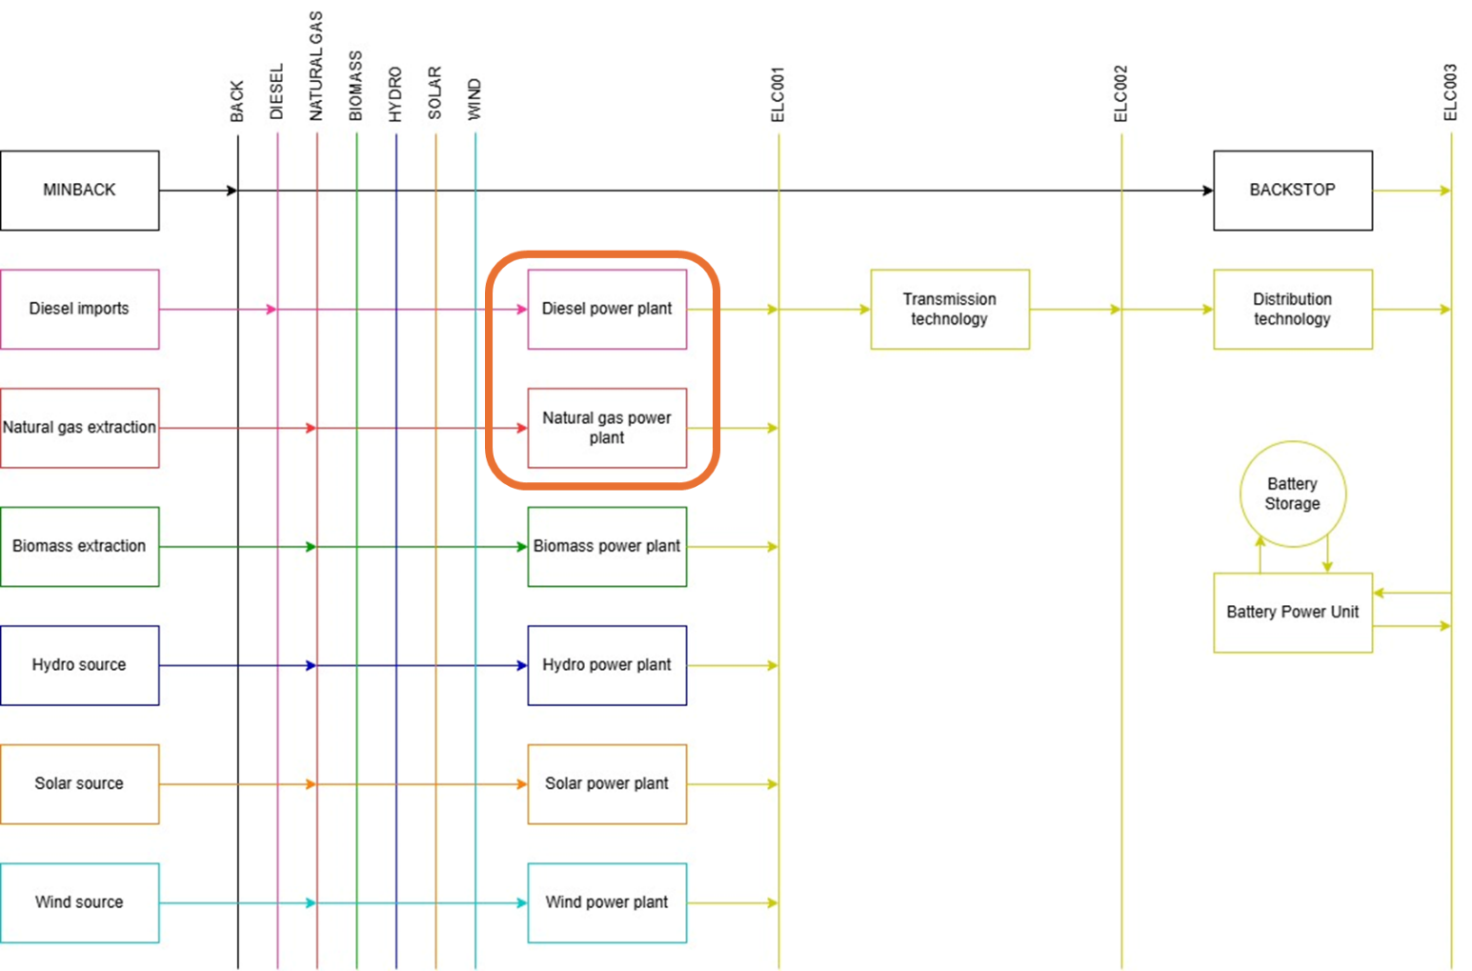
In this exercise, we will incorporate technology-dependent carbon dioxide emissions by associating emission flows with power plant technologies. Specifically, we will address emissions from diesel and natural gas power plants. For the biomass power plant, which also produces carbon dioxide emissions through biomass combustion, we will assume carbon compensation, accounting for the carbon dioxide absorbed during the cultivation and growth of biomass resources.

We will start by calculating the emission activity ratio for the two power plants using Equation 1. Since the emissions are relatively small, we will work in kt/PJ. The values from the table below, including the fuel emission factors and efficiencies, are used for these calculations.
$$Emission Activity Ratio \left[\frac{kt}{PJ}\right]=\frac{Fuel Emission Factor \left[\frac{kt}{PJ}\right]}{Technology efficiency}$$ | (1)

Technology | Fuel emission factor [kt/PJ] | Efficiency | Emission Activity Ratio [kt/PJ]
Diesel power plant | 74.23 (Diesel) | 35% | 74.23/0.35=212.09
Natural gas power plant | 55.54 (Natural gas) | 48% | 55.54/0.48=115.71

TRY IT: Add Emissions Activity Ratios for the following power plant technologies.
- We will NOT add any new technologies or fuels in this exercise. We will add emissions data for existing technologies.

- On the model configuration page, go to the 'Emissions' tab and change the default emission’s info to match the image below:

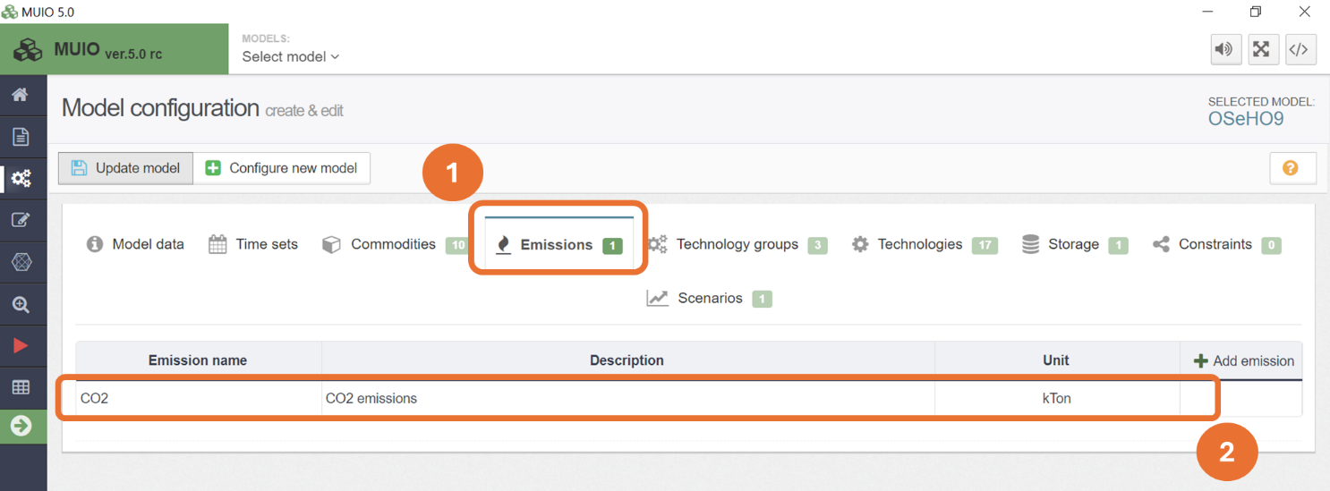

- Then, still in the model configuration page, go to the ‘Technologies’ tab, and add data to the Emission Activity Ratio column for the following technologies:
  - PWRDSL
  - PWRNGS
Note: We will add the CO₂ emission factors to the production technologies instead of the primary sources. However, it is also common to account for these emissions through the primary sources as discussed in Lecture 10.
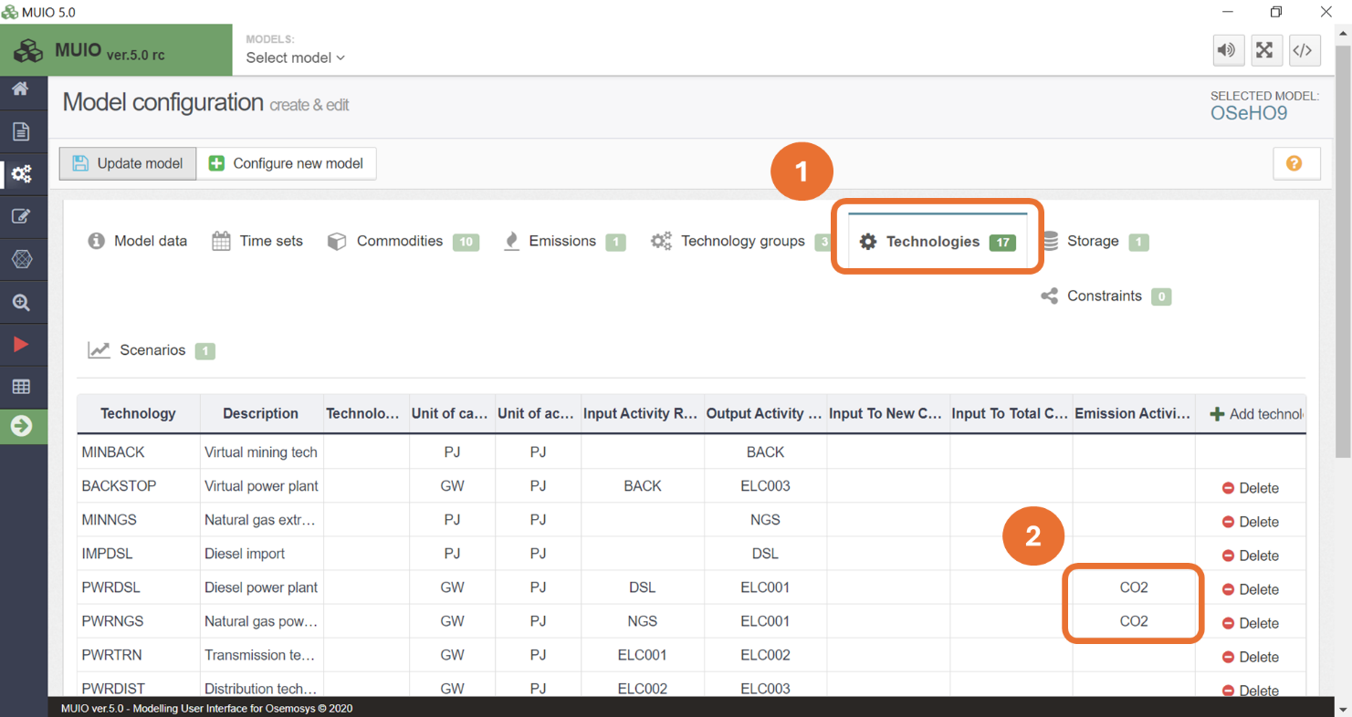

- Important: update the model.
- In data entry page, go to ‘Emissions Activity Ratio’, and then add the data from 2021 to 2035 for each technology listed above in mode of operation 1 only. You will find the data in the Data Preparation File OSeHO9. The values are the same as calculated from Equation 1.
- Your page should look like the image below.

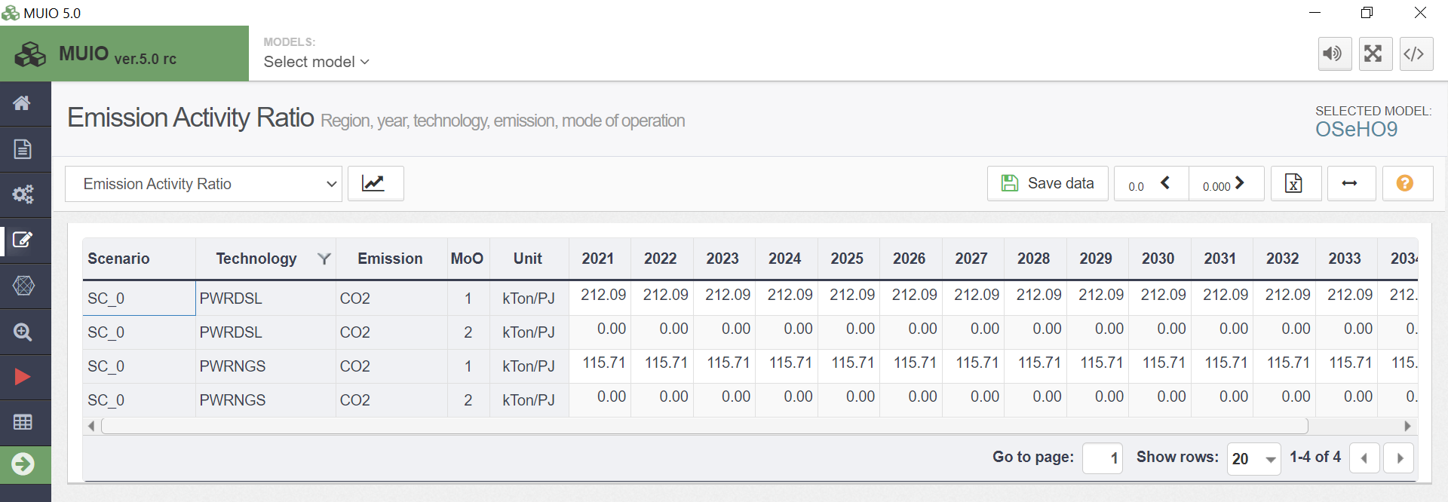

- SAVE AND UPDATE!

Reserve margin

The first step in representing the reserve margin is to create a User Defined Constraint (UDC).
TRY IT: Add a UDC
- On the model configuration page, navigate to the 'Constraints' tab and click on ‘+ Add Constraint.’ This constraint will be an inequality, as explained in Lecture 10. Select the relevant technologies for this constraint, which include:
  - On-grid power technologies: BACKSTOP, PWRDSL, PWRNGS, PWRHYD, PWRBIO, PWRSOL, PWRWND, and BATTPWR.
  - The transmission system: PWRTRN

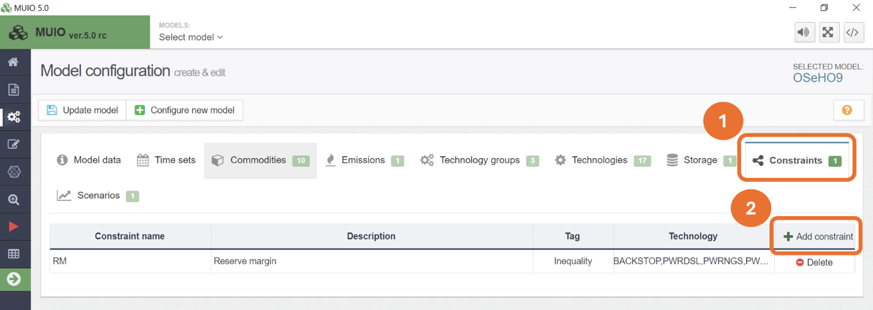

- Update the model.

In order to represent a UDC, the following parameters must be considered:
- UDC Constant: Defines the right-hand side of the equation or inequality.
- UDC Multiplier Total Capacity: Defines the set of multipliers for the Total Capacity variable on the left side of the equation or inequality.
- UDC Multiplier New Capacity: Defines the set of multipliers for the New Capacity variable on the left side of the equation or inequality.
- UDC Multiplier Activity: Defines the set of multipliers for the Activity variable on the left side of the equation or inequality.

IMPORTANT: Typically, we use a single set of multipliers in each constraint.
For the reserve margin, we are evaluating the total capacity of the system to meet this margin. Therefore, we will apply the set of UDC multipliers exclusively to the total capacity. For the multipliers associated with new capacity and activity, we will keep the default values of zero.
$$Transmission Capacity*\left(\frac{1}{Transmission efficiency}\right)*\left(1+Reserve Margin\right)-\sum_{t}{\left(On-grid technology capacity*Capacity credit\right)}<0$$ | (2)
As discussed in Lecture 10, the reserve margin is defined by Equation 2. The multiplier for the transmission technology is calculated by multiplying the inverse of the efficiency (equivalent to the input activity ratio) by one plus the reserve margin.
In this case, we use a reserve margin of 15%. The calculation is as follows: 1.05×(1+0.15)=1.2075.
For power generation technologies, the multipliers will correspond to the capacity credits, as indicated in the table below. These multipliers will be added as negative values due to the minus sign in the inequality.
Technology | Capacity credit
BACKSTOP | 100%
PWRDSL | 90%
PWRNGS | 80%
PWRHYD | 36%
PWRBIO | 85%
PWRSOL | 9%
PWRWND | 35%
BATTPWR | 85%

TRY IT: Add UDC multipliers.
- Add the data through the data entry tab on the side of the model configuration page for UDC Multiplier Total Capacity parameter. Add the data as given in the Data Preparation File OSeHO9. Keep the UDC constant parameter as zero, which is the default value.

- Save and update the model.

Run and check results

Run the model in the user interface as demonstrated in previous exercises. Next, we will check the graph of a new variable, Annual Technology Emission. This plot displays the CO₂ emissions produced by each technology. In our case, the natural gas power plant is the only fossil fuel unit supplying electricity and, consequently, the sole source of emissions.

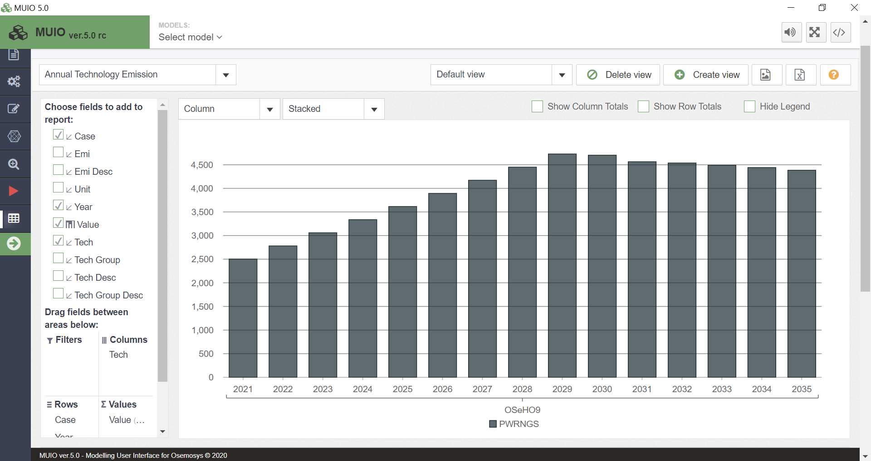

The Production graph below shows that adding the reserve margin has altered the electricity mix. Wind penetration has accelerated, replacing the contribution from solar and hydro. This is likely due to a favourable combination of relatively low costs and higher capacity credits than solar, enabling wind to better support the reserve margin.
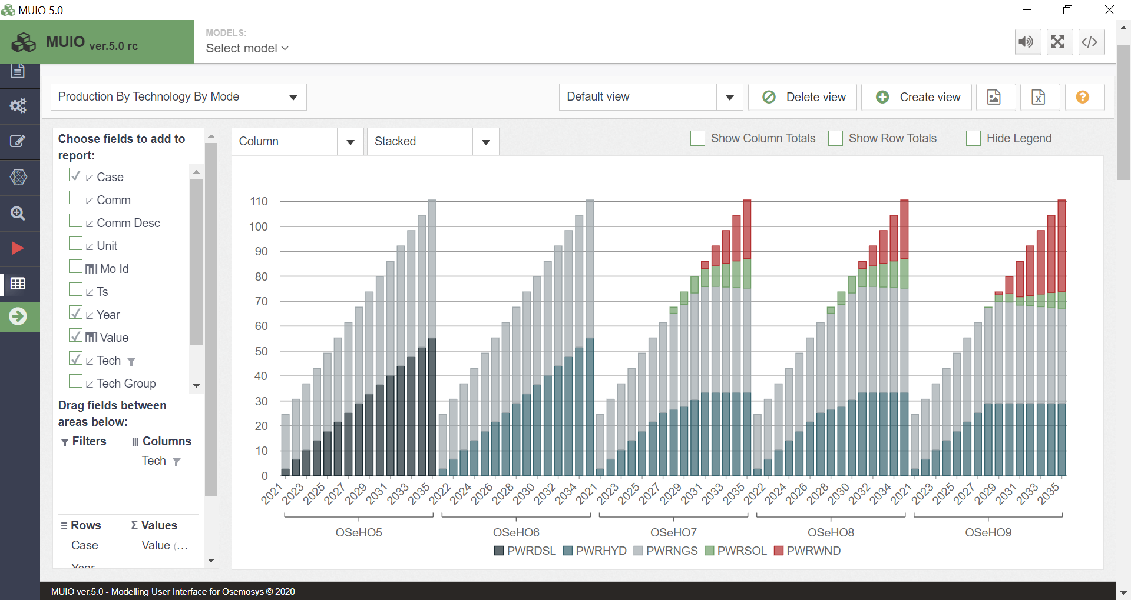

The Total Capacity by Technology graph shows that the addition of a reserve margin increases the surplus capacity, compared to the scenario without the reserve margin. Notably, investment in the power component of battery systems starts in the first year, despite batteries not being used, as shown in the production graph. It is important to note that this system violates one of the initial assumptions regarding the transmission technology, as the residual capacity of transmission is oversized in the early years. We will delve further into how to calibrate these results during Hands-On 13.
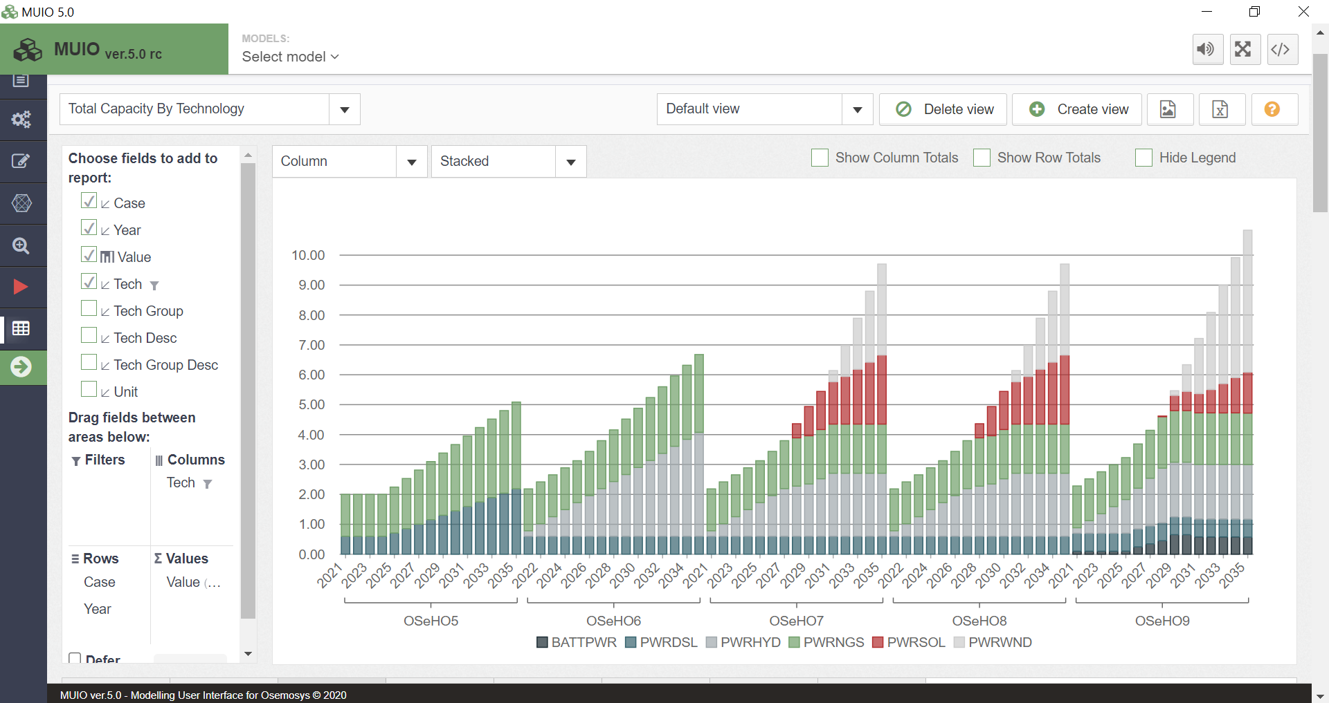
Question to consider: If the capacity credits for variable renewable energy sources (solar and wind) were 0%, how would this affect the electricity mix?

