Model for Analysis of Energy Demand (MAED)
Hands-on 9: Inputting Data to MAED-EL
Licence:
This work is licensed under the Creative Commons Attribution 4.0 International License (CC BY 4.0). To view a copy of this license, visit https://creativecommons.org/licenses/by/4.0/.
Attribution:
Please cite as: Kiley, F. (2025) An Introduction to Simulating Energy Demand with MAED. Version 1. Climate Compatible Growth Teaching Kit Website, Climate Compatible Growth.

Learning outcomes
By the end of this exercise, you will be able to:
1) Input electricity system assumptions into MAED-EL
2) Input calendar information into MAED-EL
3) Input modulating coefficients into MAED-EL
4) View MAED-EL calculation results in several formats

Activity 1: General Information
As in the module MAED-D, the first window displayed once the MAED-EL module is selected, is the window for handling the cases. When you open this window for the first time, you should see a case called “Demo MAEDEL.” Click on this case to open it.
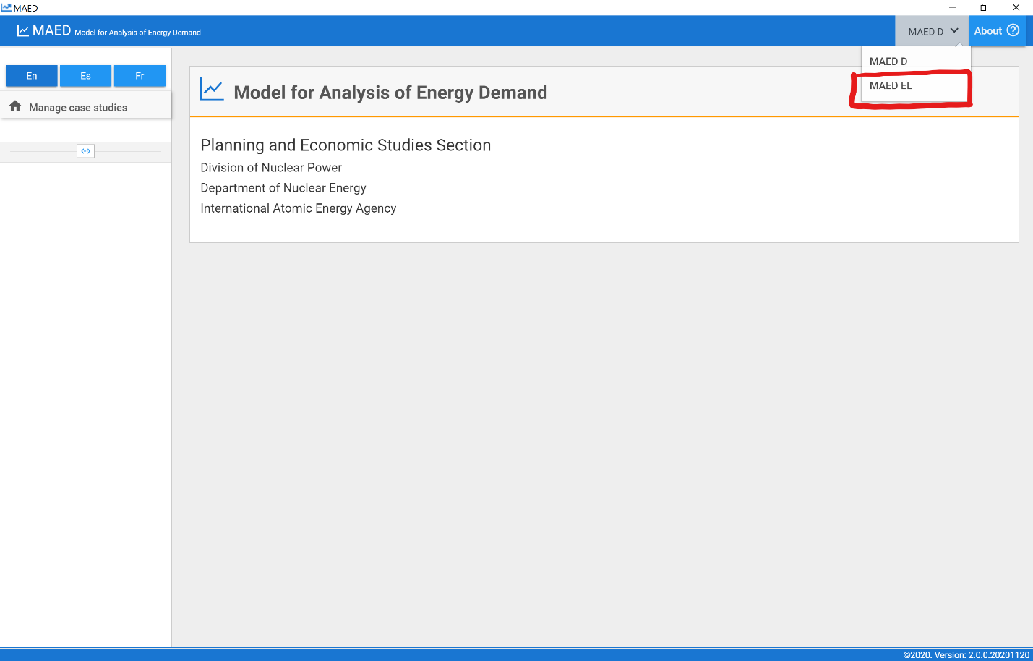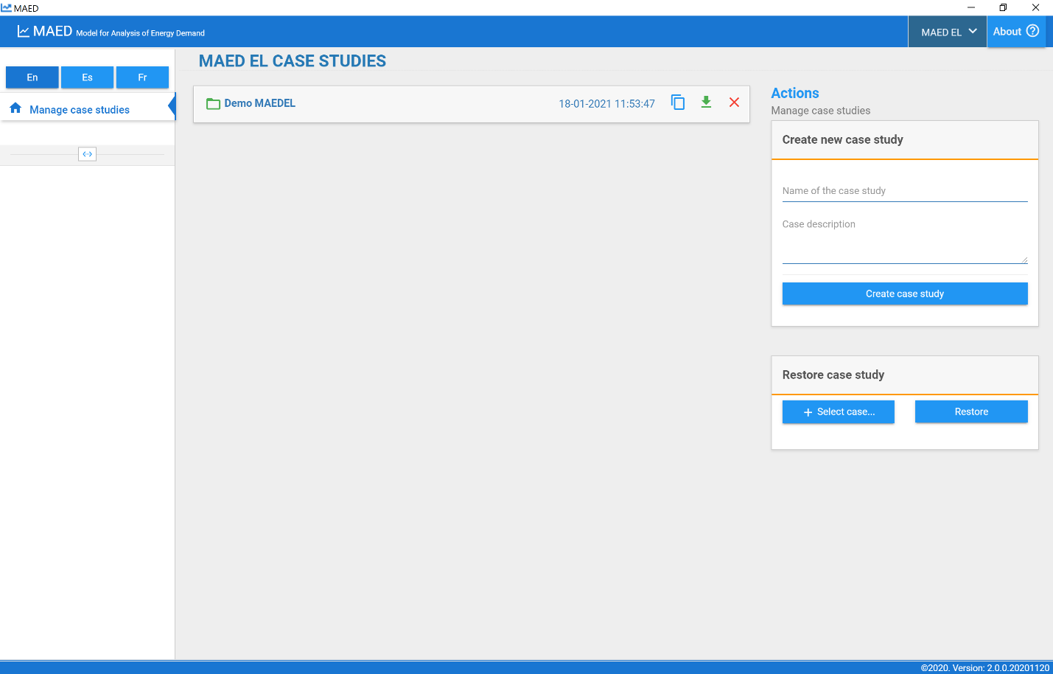
The information in MAED-EL is organized into four groups: general information provided by the user, the coefficients provided by the user, calculate, and the results of the model. You can navigate between this information using the menu on the left side of the screen.
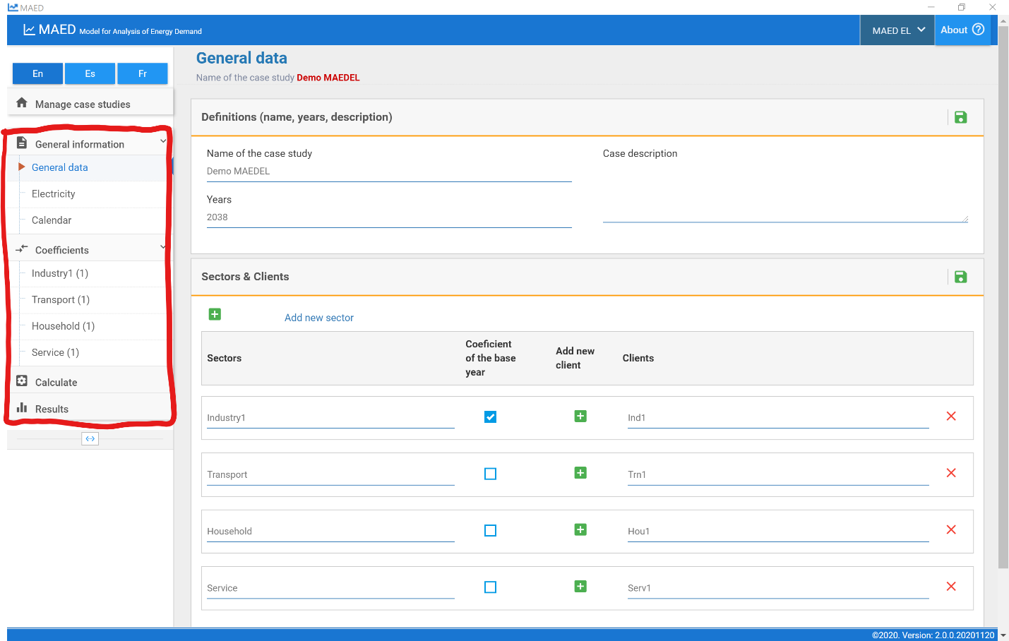
The input data that the user must provide are:
- The general information of the case
- The sectors to be evaluated
- Clients within each sector
- The annual electricity demand by sectors and how much of it is supplied by the network
- The structure of the electricity demand by clients
- Transmission and distribution losses
- Time divisions of the year
- The modulating coefficients of the load curve for each of the clients.
We will start at the top of the navigation menu on the left to fill in this information.
Start on the “General data” page under the “General information” tab. First go to the top box with the heading “Definitions (name, years, description)”. The first information that the user must provide is the years of the study period, which must be input consecutively and separated by commas. The first year is the base year of the study. It is good to recall that each time interval must be equal to or greater than the interval preceding it. In this demo case, the only year considered is 2038. To save the information in each box and go to the next step, use the Save Data button, which is the green floppy disc icon on the top right of every box. You can also edit the name of the case study and case description in this box.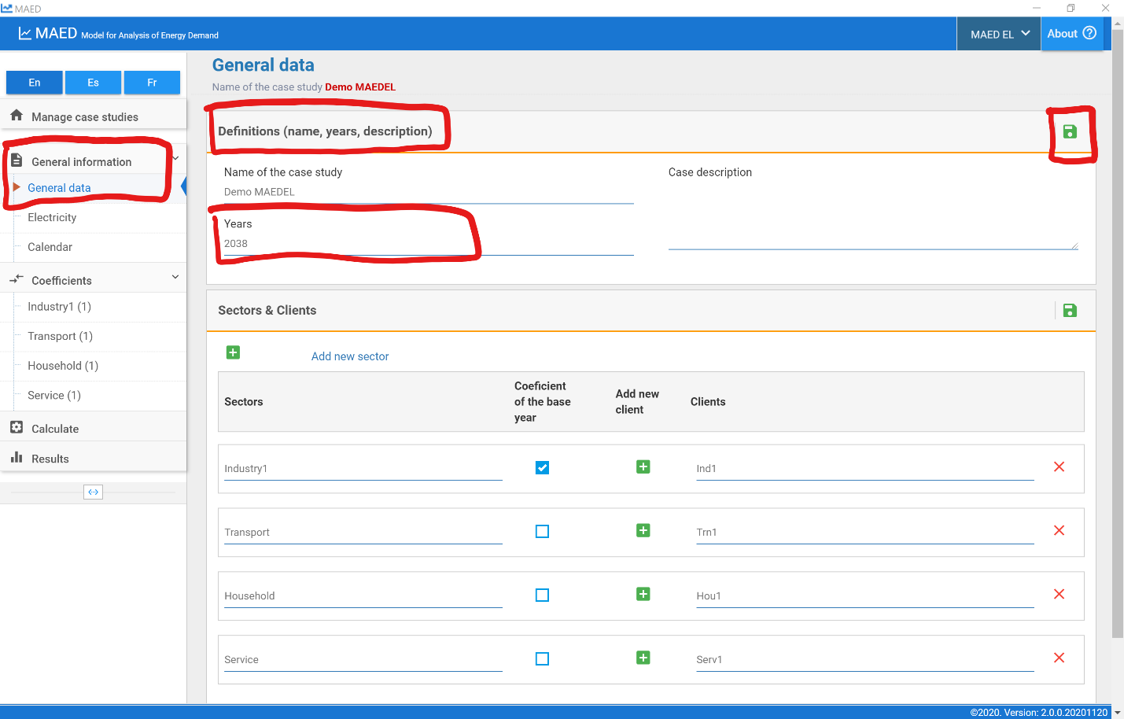
On the same page, the next box is “Sectors & Clients”. This demo case already has 4 sectors with 1 client each, but you can use the green plus icon at the top of the box to add a new sector. You can also edit the name of each sector and check the box to see if the modulating coefficients of the base year should be used to calculate the hourly demand in the other years of the study.
Clients are defined for each sector. The green plus to the right of each sector allows you to add new clients, and the editable list of clients appears to the right of the add button. By default all sectors must have at least one client to represent it, so the delete option is not available for the first client in each sector. The red X on the right of each sector allows you to delete that client or sector.

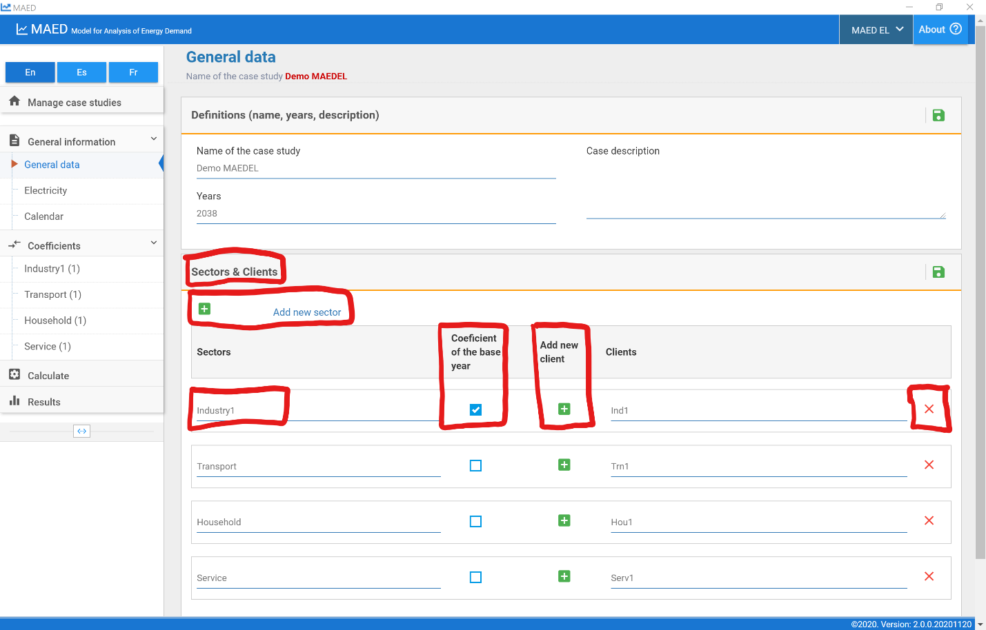
Next, click on “Electricity” page under the “General information” tab on the navigation menu on the left. Starting on the “Annual electricity demand” tab on the top of the page, you can input the annual electricity demand for each sector for each year in the model, and the programme calculates the total demand per year.
The buttons on the top right of the box allow you to chart the data with the “chart” cell checked, increase or decrease the number of decimal places, download the data to excel, save the data, and open a window with more information about the data to be input in this box.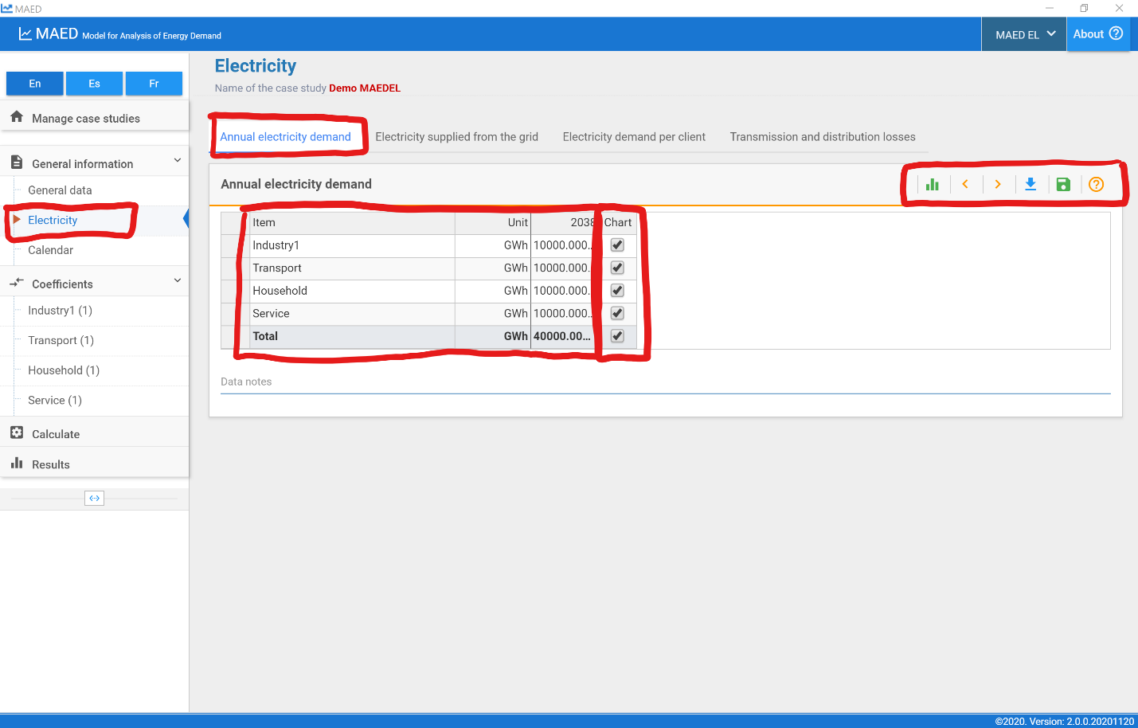
Next, click on the “Electricity supplied from the grid” tab at the top of the page. This box is where you can define how much of the total electricity demand must be supplied by the main grid. Because MAED calculates the hourly electricity demand to be supplied by the grid, isolated or self-production systems are not included in the model.
We must define how much of the electricity demand must be satisfied by the main grid for each of the sectors for each model year. The values are entered in percentage, where 100% means that all the demand of the sector must be met by the grid.
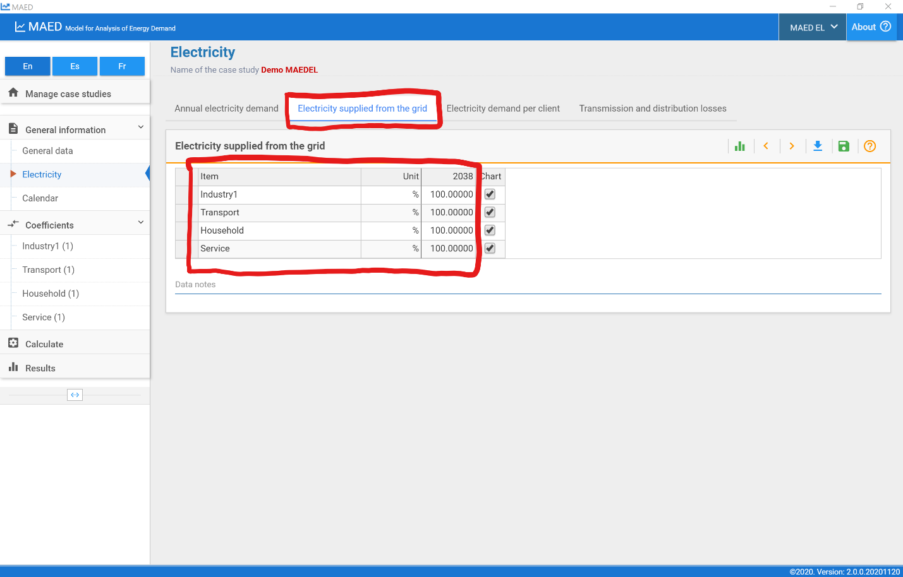
Now click on the “Electricity demand per client” tab at the top of the page. You can define the share of sector demand from each client in this box. If the sector has a single client the value is equal to 100%. The model calculates the total to verify that the defined values add up 100%, otherwise it will point to it as an error.
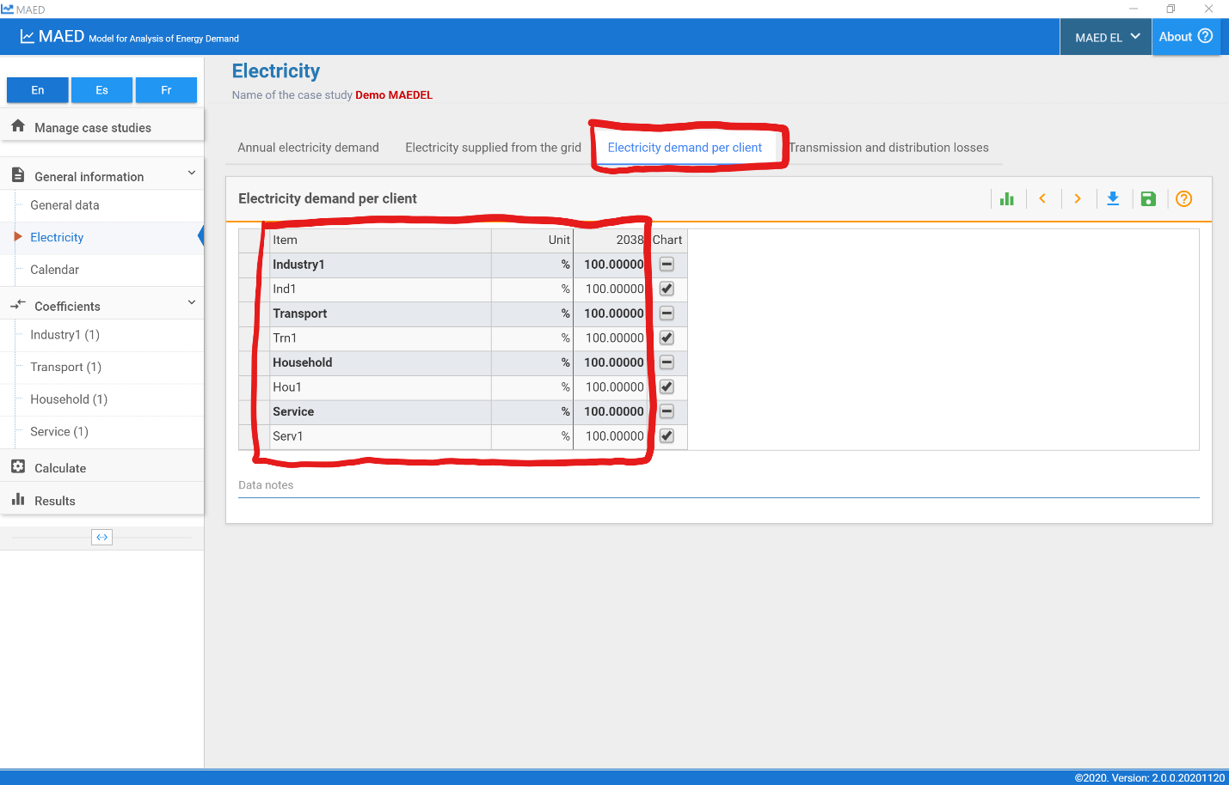
Next click on the “Transmission and distribution losses” tab at the top of the page. You can input the transmission and distribution losses for each year of the study in this box. The transmission losses are defined at system level, while the distribution losses are by sectors.
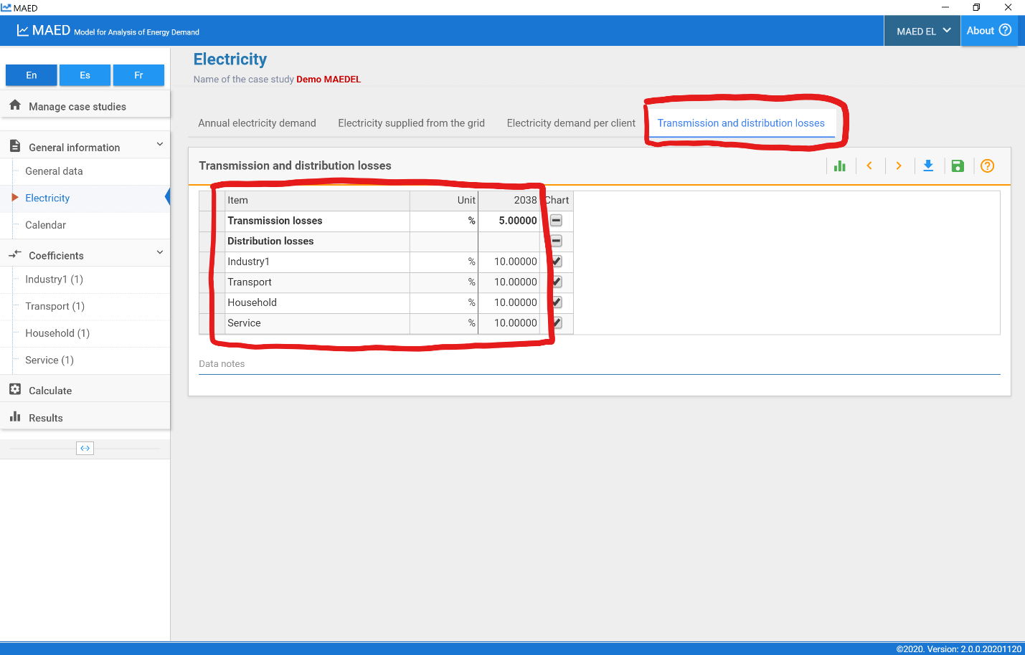
Next, click on the “Calendar” page under the “General information” tab in the navigation menu on the left side of the page.
First, go to the “Days” box in the upper left. In the top table of this box, you can define the types of days to be modelled. In this demo case, Day type 1 is prefilled with Working days and Day type 2 is prefilled with Saturday-Sunday-Holiday. This means that every day of the year will be modelled as either a working day or a holiday, with no differentiation between weekdays. You can define up to 7 typical days. MAED has 11 typical days predefined: each day of the week separately, grouped working days, weekends, Sundays together with holidays, and any day grouping the 7 weekdays. The option any day can be used when there are no differences in the demand pattern of the days of the week.
At the bottom of this box you can also select the first day of the week from a drop-down menu.
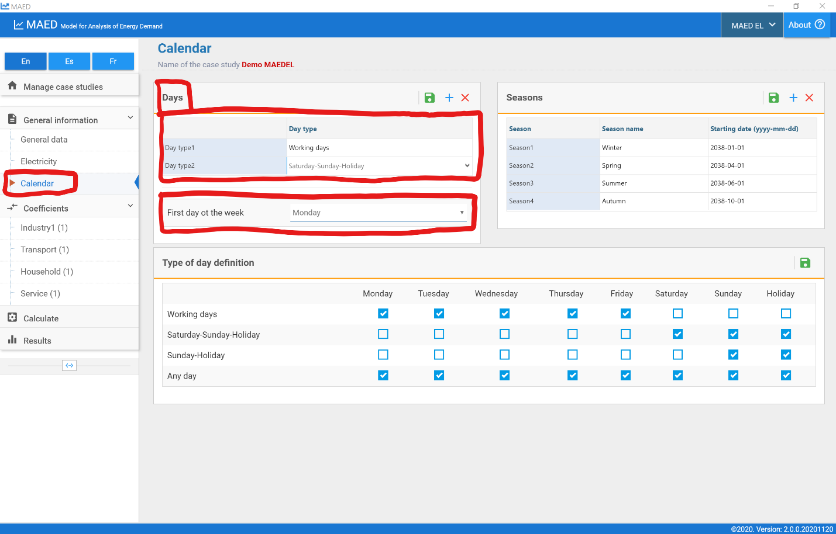
Next, go to the “Seasons” box in the upper right. This box is where you can input the starting date of each season or period, with the format: year, month, day, and name of each season. You can define up to 12 seasons.
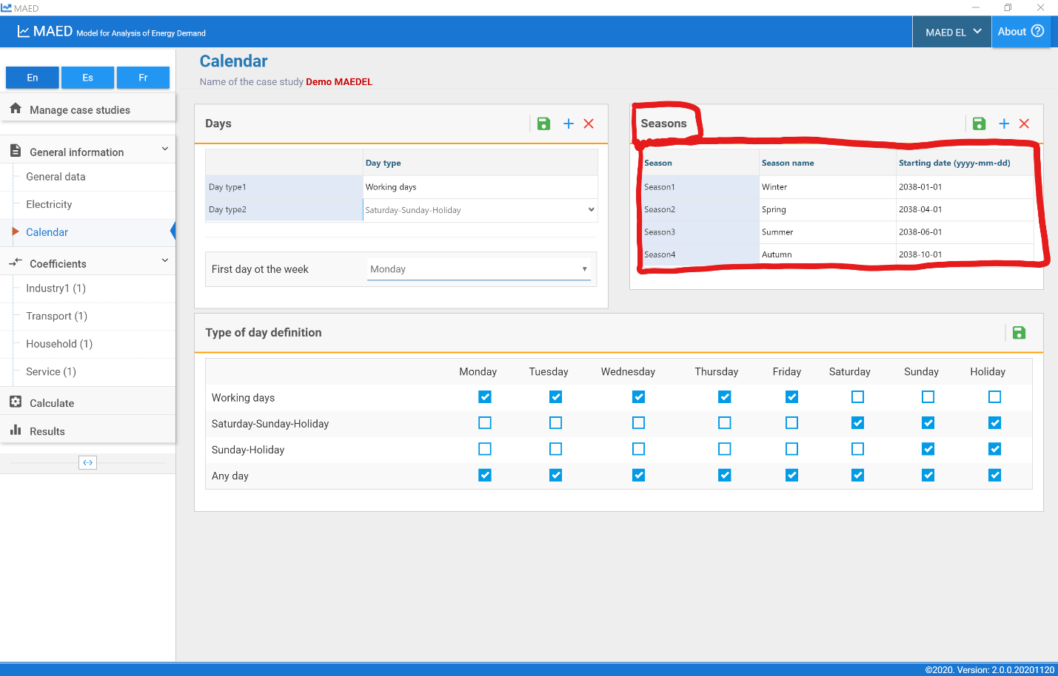
In the box at the bottom of the page named “Type of day definition” you can edit the definitions of typical days. In this box there is a table that shows which days are included in each category. The column on the left shows the names of the typical days that can be selected and in the upper row the days of the week. To change the selection, the days are marked or not according to the desired typical day. If the user wants to make a new selection, they should be careful not to select a day more than once or to omit some of them.
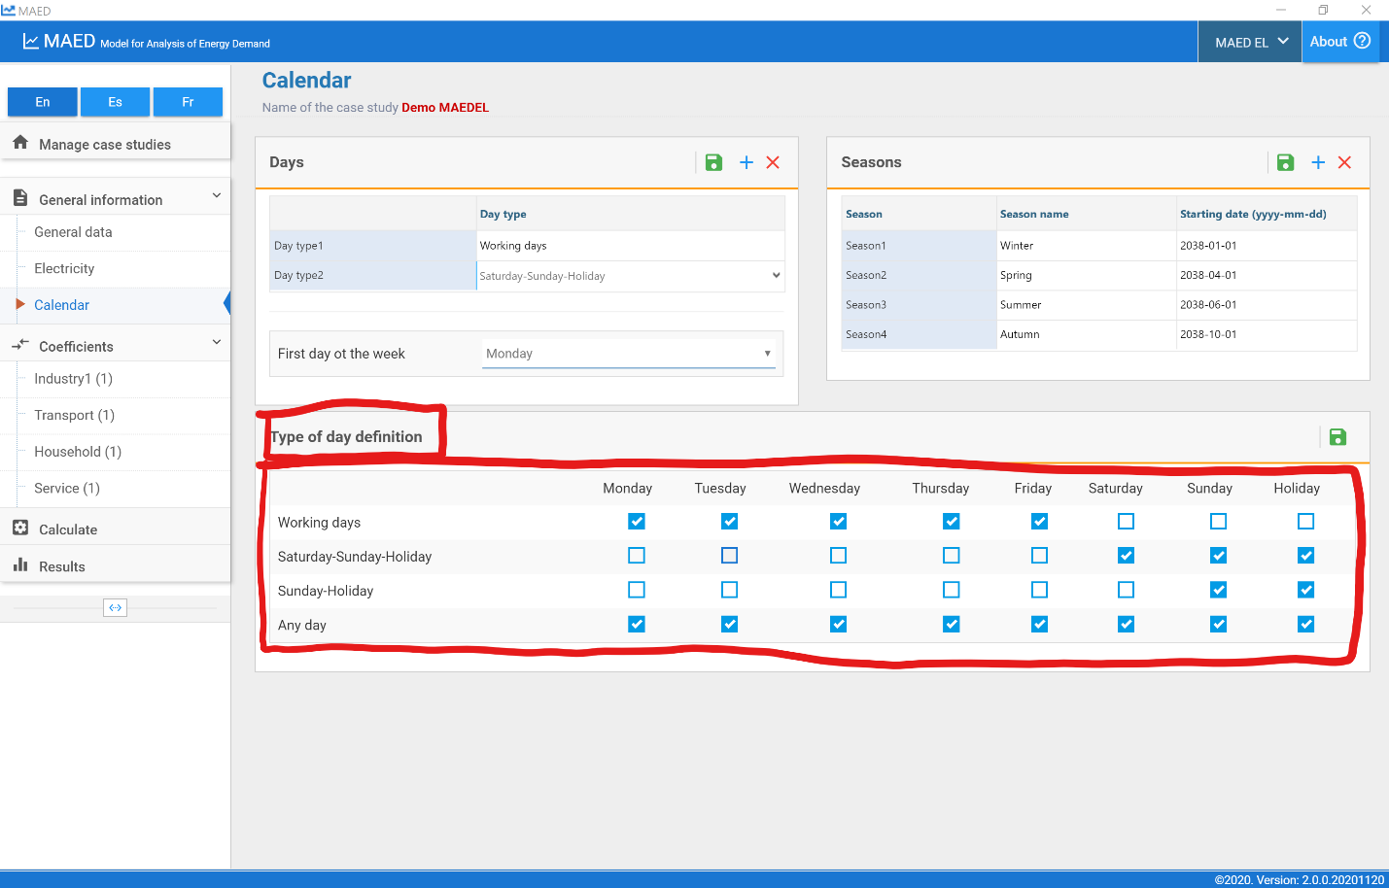

Activity 2: Modulating coefficients
Now click on the first sector in the “Coefficients” tab in the navigation menu on the left. In this demo case, the first sector is “Industry1.” At the top of the page, select the “Weekly coefficients” tab. This table is where you can input the weekly coefficients for each year in the model. You can switch between clients using the dropdown menu in the upper right of the box. However, for this demo case, there is only one client per sector.
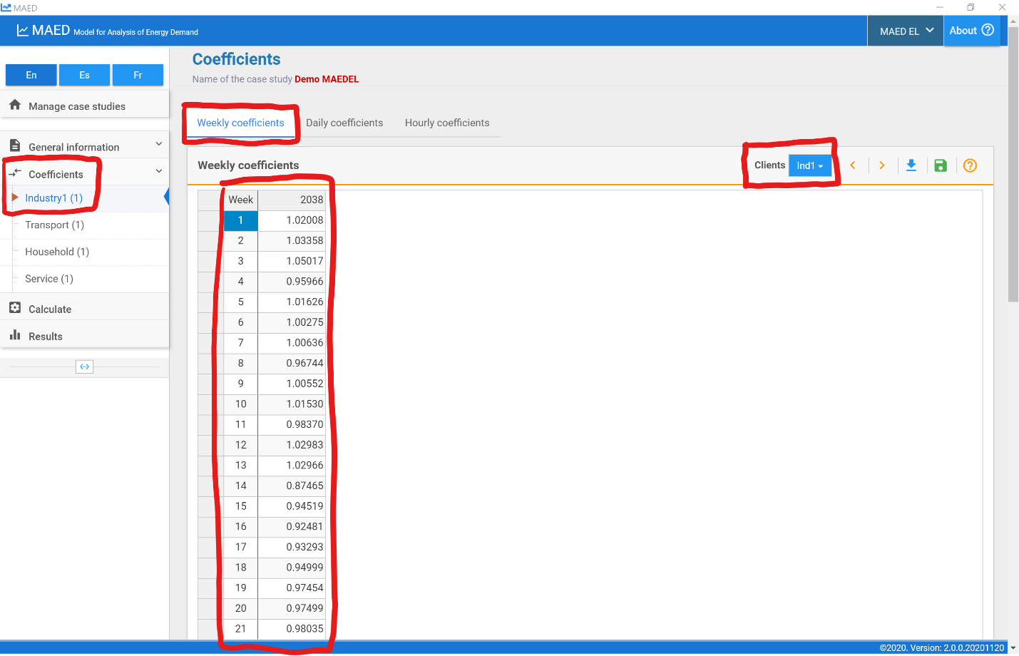
Now click on the tab labelled “Daily coefficients” at the top of the page. On this page, you can input the daily coefficients for each week and day of the week in the table. You can select the model year and client in the dropdown menus on the upper right.
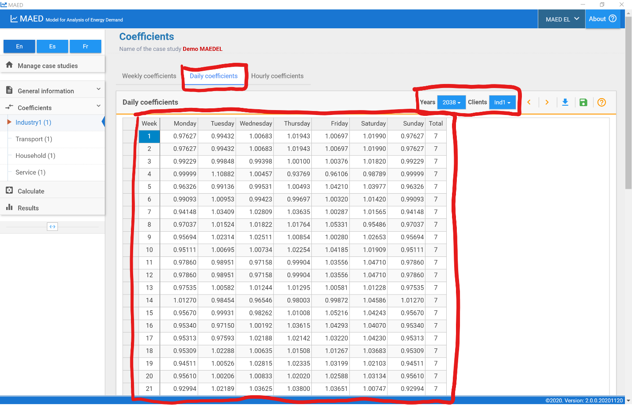
Now click on the tab labelled “Hourly coefficients” at the top of the page. In this table, you can input hourly coefficients for each typical day in each of the seasons. Again, you can select the model year and client in the dropdown menus on the upper right.
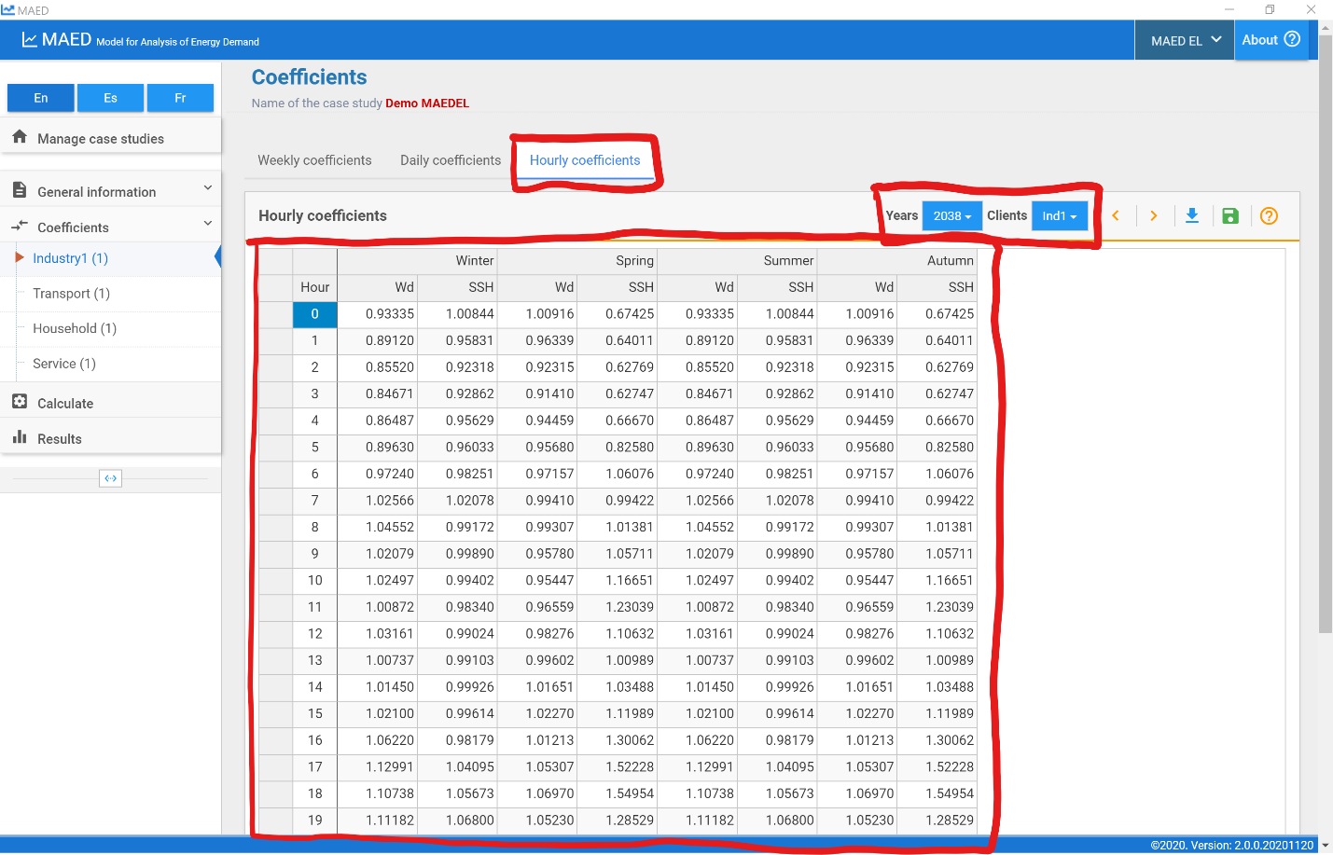

Activity 3: Calculate and results
Once all the input data have been defined, MAED-EL can calculate the hourly electricity demand. To do this, click on the “Calculate” tab that is in the navigation menu on the left side of the page. This operation may take a few minutes.
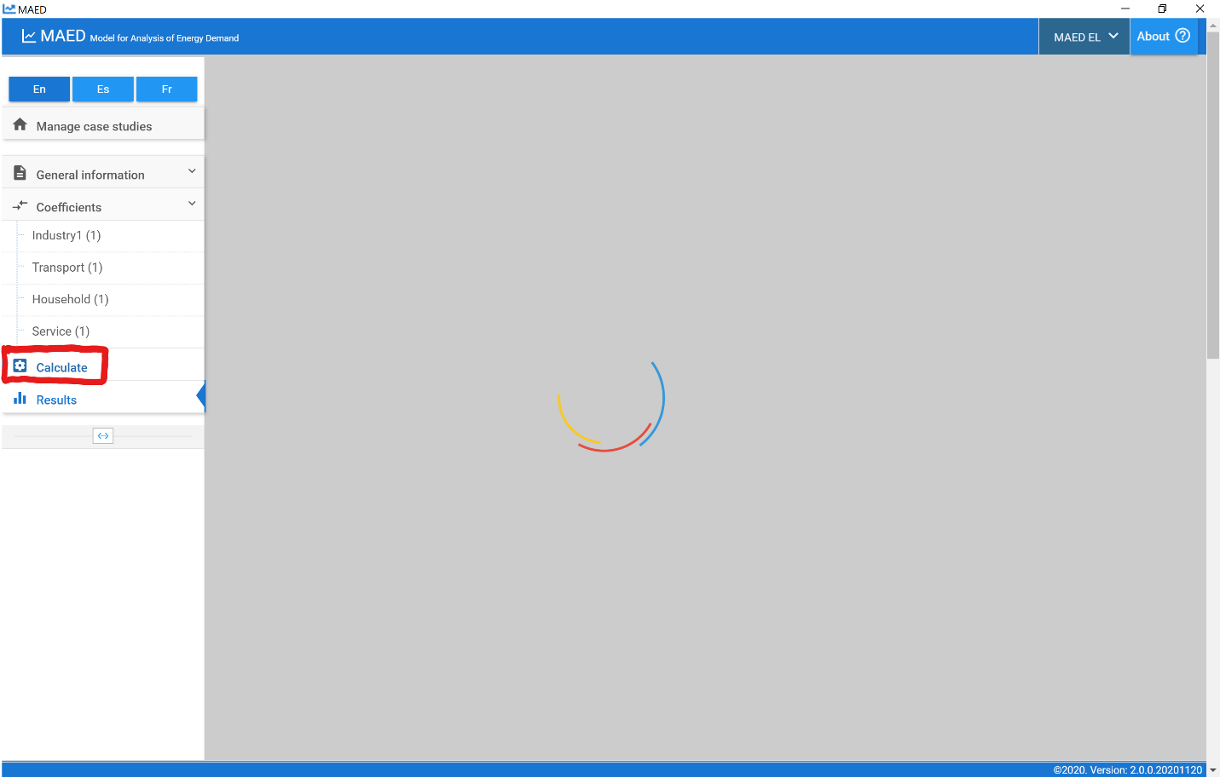
After the calculation is complete, MAED-EL will automatically take you to the “Results” tab in the navigation menu on the left side of the screen. First, click on the “Summary” tab on the top of the page. This shows a table that summarizes your results with key statistics about energy demand, including the annual and by season peak demands, the total electricity demands, the load factors, as well as the difference between the total electricity demand calculated from the coefficients and the one defined by user in the input data. You can use the buttons on the upper right part of the box to export the results to loadsy, the format required by the WASP model, increase and decrease the number of decimal places, and download the data to Excel.
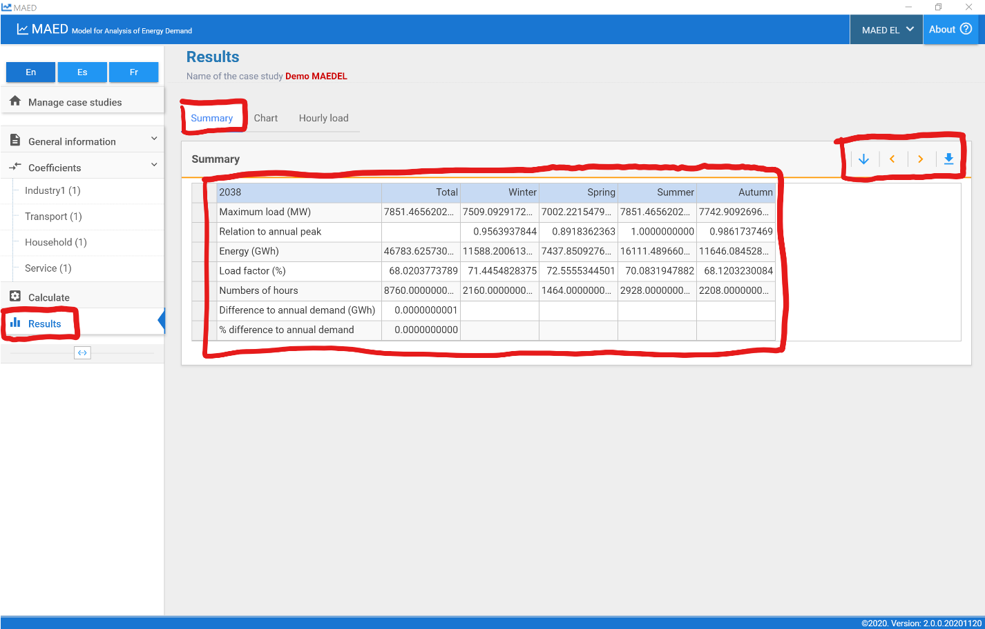
Now click on the “Chart” tab at the top of the page. Here you can see a plot of hourly demand. Charts can be created for each year of the study and you can adjust the portion of the year displayed using the sliders on the bottom mini-graph. Using the buttons on the upper right, you can switch between the annual load curve, the load duration curve, and the normalized load duration curve, as well as downloading the chart as an image.
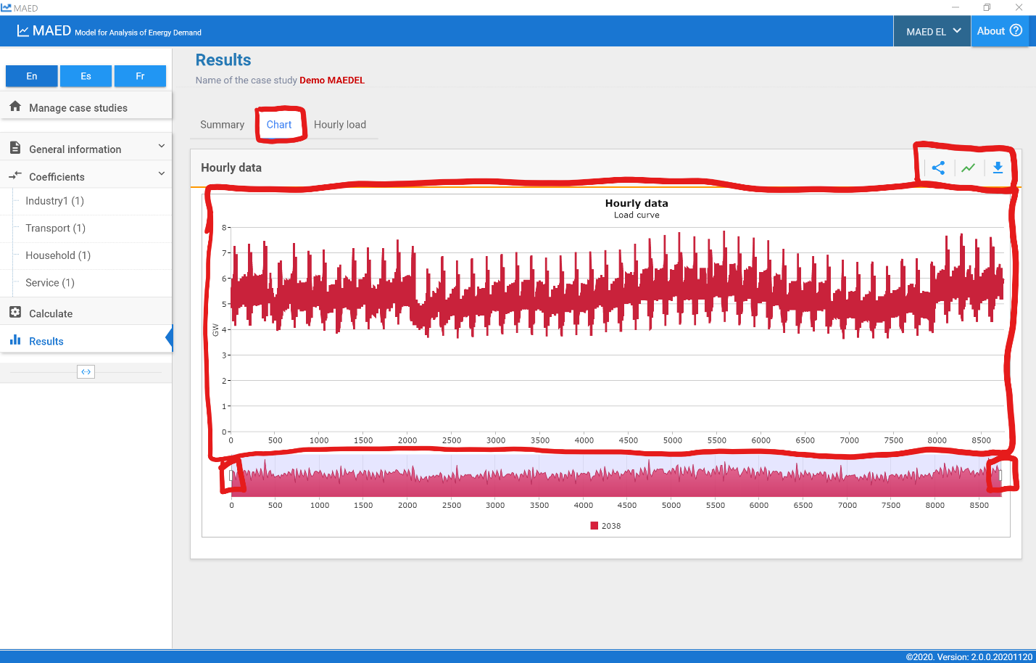
Now click on the “Hourly load” tab at the top of the page. You may need to expand the table by clicking on the arrow next to the “Year” cell. This will allow you to view the projected hourly demand for each client and sector. You can use the buttons on the upper right to increase or decrease the number of decimal places and export the table to Excel.

