Energy System Modelling Using OSeMOSYS
Hands-on 8
Please use the following citation for:
- This exercise
Plazas-Niño, F., Lubello, P. (2025, February). Hands-on 8: Energy System Modelling Using OSeMOSYS (Version 1.0.). Climate Compatible Growth. DOI: 10.5281/zenodo.14871381

- OSeMOSYS UI software
Climate Compatible Growth. (2024). MUIO (Version v5.0.0). GitHub. https://github.com/OSeMOSYS/MUIO/releases
____________________________________________________________________________

Learning outcomes

By the end of this exercise, you will be able to:
- Represent storage technologies

Storage modelling

In Lecture 9, we learnt how to represent a storage technology in OSeMOSYS, and which parameters characterize storage technologies such as Battery Energy Storage Systems (BESS) and Pumped Hydro Energy Storage plants (PHES).
In this Hands-on, we will model a utility-scale battery system connected to the distribution network adding 2 technologies: 1 storage technology to represent the energy component and 1 conventional technology to represent the power component. No new fuels will be added to the model. We will build the highlighted parts of the RES below. Note: Update your RES in diagrams.net.
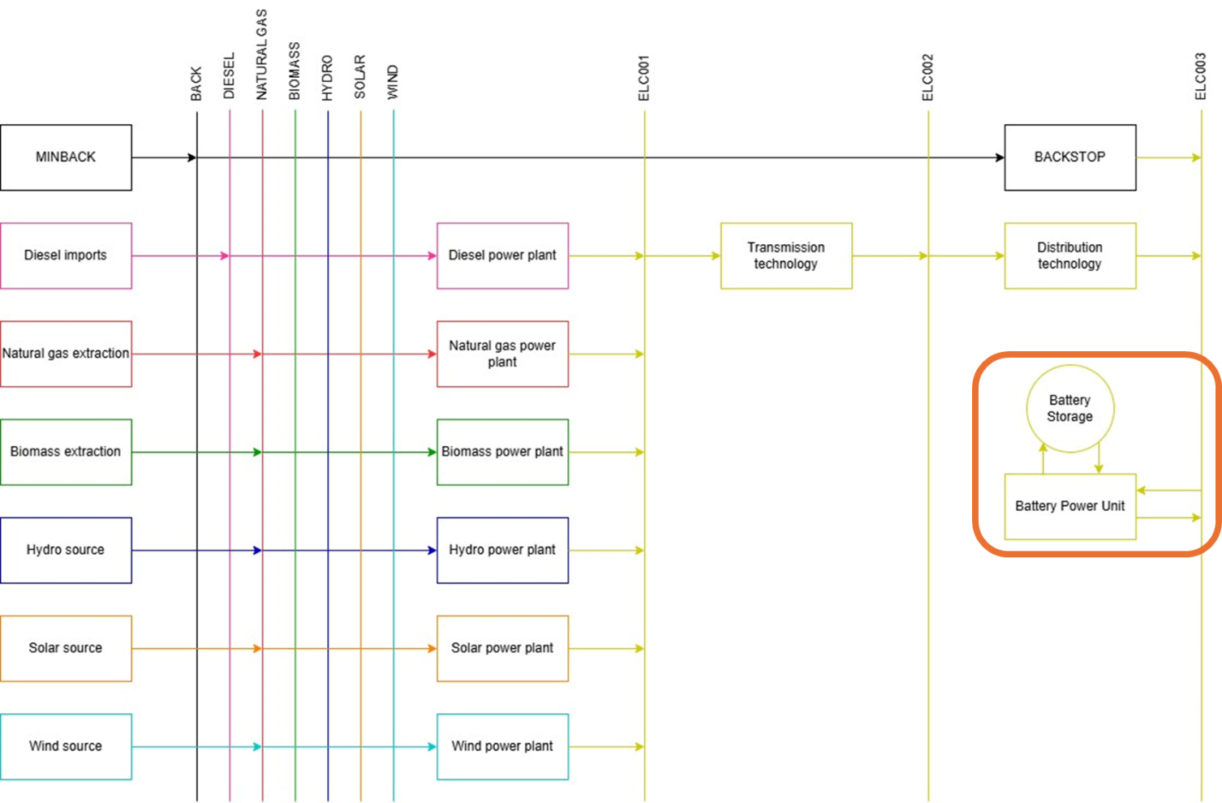
IMPORTANT: Before you can do anything else, you must copy the model and rename it in the same way you have before (OSeHO8 this time).
As studied in the lecture 9, the storage systems must charge and discharge in two different modes of operation when we use a same technology for the power component, as OSeMOSYS does not allow a single technology to perform two opposite actions within the same mode. Therefore, the first step is to create an additional mode of operation by changing the value from 1 to 2 in the Modes of operation field within the model configuration tab. Afterwards, click on Update model to save the change.
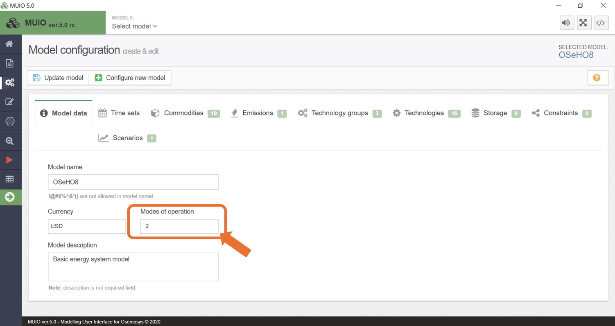

Define power technology

Firstly, we will add the technology BATTPWR to represent the power component of the battery system. We can use the same steps covered in hands-on exercises 5 and 6. When representing a power technology, the following parameters must be considered:
- InputActivityRatio: defines the rate of fuel consumed based on the efficiency of charging (i.e., electricity)
- OutputActivityRatio: defines the fuel provided based on the efficiency of discharging (i.e., Electricity)
- CapacityToActivityUnit: used to convert data related to the Capacity of technology into the Activity it can generate (this value should be set to 31.536).
- Fixed Cost: defines the fixed Operation & Maintenance cost ($/kW)
- CapitalCost: defines the overnight investment cost of the unit ($/kW)
- OperationalLife: defines the lifetime of the technology (in years)
- ResidualCapacity: defines the existing capacity of the technology (in GW) and its expected decommissioning.
Try it: let’s add this technology in the model.
- Go to the model configuration page and add a new technology called ‘BATTPWR’. The capacity unit is GW and the activity unit is PJ. Since this battery system is connected to the distribution network, the input and output fuels are ELC003.
IMPORTANT: Remember to update your model each time you add data, technologies, or commodities. As well as saving data each time.
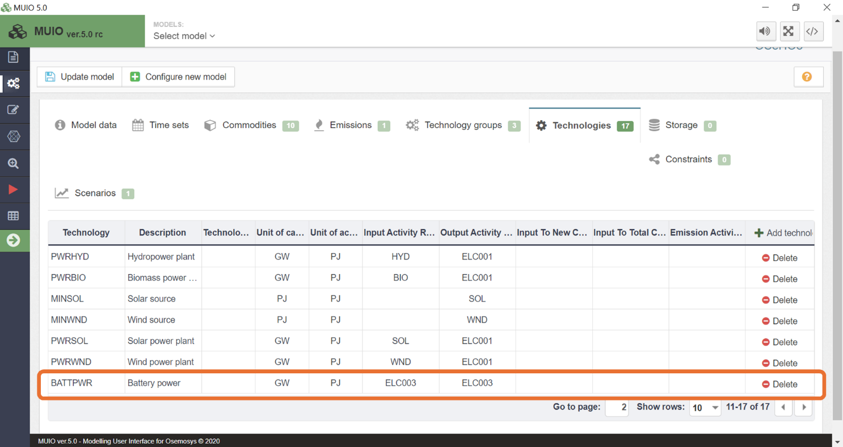

- Add data for BATTPWR as presented in the Data Preparation File OSeHO8.
NOTE: Notice that the input activity ratio corresponds to Mode of Operation 1, while the output activity ratio applies to Mode of Operation 2.

Define storage technologies

We will incorporate the energy component of the storage system using the Storage tab on the model configuration page. Let’s remember that this component represents the process of storing energy within the battery system.
Try it: Add BATTSTO storage technology
- On the model configuration page, you must click the 'Storage' tab and then add a storage by pressing '+ Add Storage' (similar to how you add a commodity) . As shown in the image below:

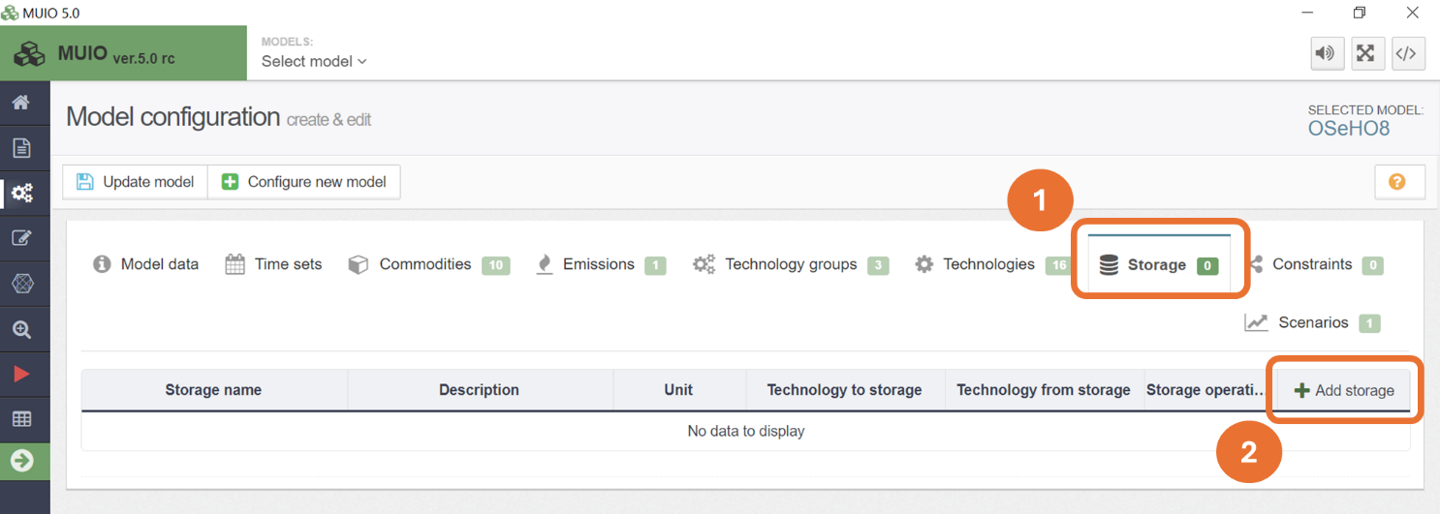

- You need to add a new one, but in this case change the names of the default technology to ‘BATTSTO’. The unit is PJ, and the technologies for both charging to and discharging from storage are 'BATTPWR'. The storage operation should be set to ‘daily’, as batteries are designed for short-duration energy storage. For seasonal storage solutions, such as hydrogen systems, the storage operation can be set to ‘yearly’. Once you have done this, make sure you update the model, as it will only add the new update when you do this.
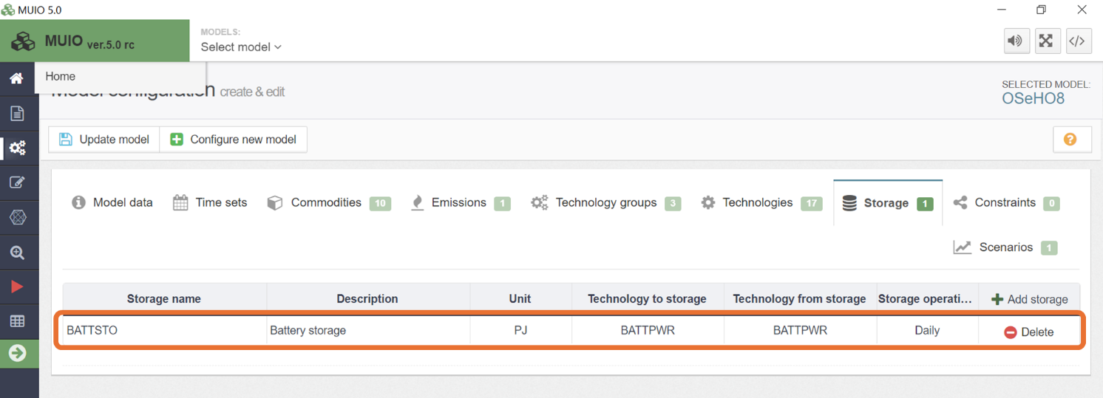

- You must add the data for the following parameters according to the Data Preparation File OSeHO8. (as you have done in the data entry section of the MUIO previously): Day Split, Technology to Storage, Technology from Storage, Capital Cost Storage, and Operational Life Storage.
- Each time you add data to a different parameter, you must save the data before adding data to another parameter.
- You must then update the model (again, it is recommended to do this as often as possible).

Run the model and check the results

Run the model in the user interface as demonstrated in previous exercises. The Production by Technology by Mode (PJ) graph you obtain after running the Hands-On 8 model is displayed below.
In this case, the system behaves exactly as it did in Hands-On 7, demonstrating that batteries are not cost-efficient under the given conditions.
Challenge: Using the parameter TotalTechnologyModelPeriodActivityUpperLimit set to zero, deactivate all power plants except for the solar power plant (i.e., deactivate PWRDSL, PWRNGS, PWRHYD, PWRBIO, and PWRWND) and rerun the model. Observe how batteries collaborate with solar power plants to meet the electricity demand.

