Model for Analysis of Energy Demand (MAED)
Hands-on 8: MAED-EL Input Data Preparation
Licence:
This work is licensed under the Creative Commons Attribution 4.0 International License (CC BY 4.0). To view a copy of this license, visit https://creativecommons.org/licenses/by/4.0/.
Attribution:
Please cite as: Kiley, F. (2025) An Introduction to Simulating Energy Demand with MAED. Version 1. Climate Compatible Growth Teaching Kit Website, Climate Compatible Growth.

Learning outcomes
By the end of this exercise you will be able to:
1) Account for demand growth within your base year
2) Calculate the seasonal coefficients for each week
3) Calculate the daily coefficients for each day of each week
4) Calculate the hourly coefficients for each day of each season

Activity 1: Seasonal coefficients
To calculate the modulating coefficients, you need hourly electricity demand data for the base year. For this hands-on session, we have provided a Microsoft Excel file with sample hourly demand data named Base year load data.xlsx. You can prepare your input data for MAED-el in the software of your choice, we have just chosen Excel for its simplicity and universality.
Follow this link to access the data file: https://zenodo.org/records/11242025
To calculate the seasonal coefficients, it is necessary to know the electricity demand growth rate, r, between the base year and the preceding year. Once this value is known, it is possible to calculate the growth trend deflator T for each week of the year, using the equation following equation:
$$T_{i}={(1+\frac{r}{100})}^{\frac{i-26}{52}}$$
Let us assume that the growth rate is 1%. In the “Load by Week” tab of the workbook, input this value in the growth rate column.
Then, use the equation above to calculate the growth trend deflator for each week in the column labelled T_{i}. Be sure to put a dollar sign in the formula before the row number of the growth rate r, so that the same value is used for the calculation in each row.
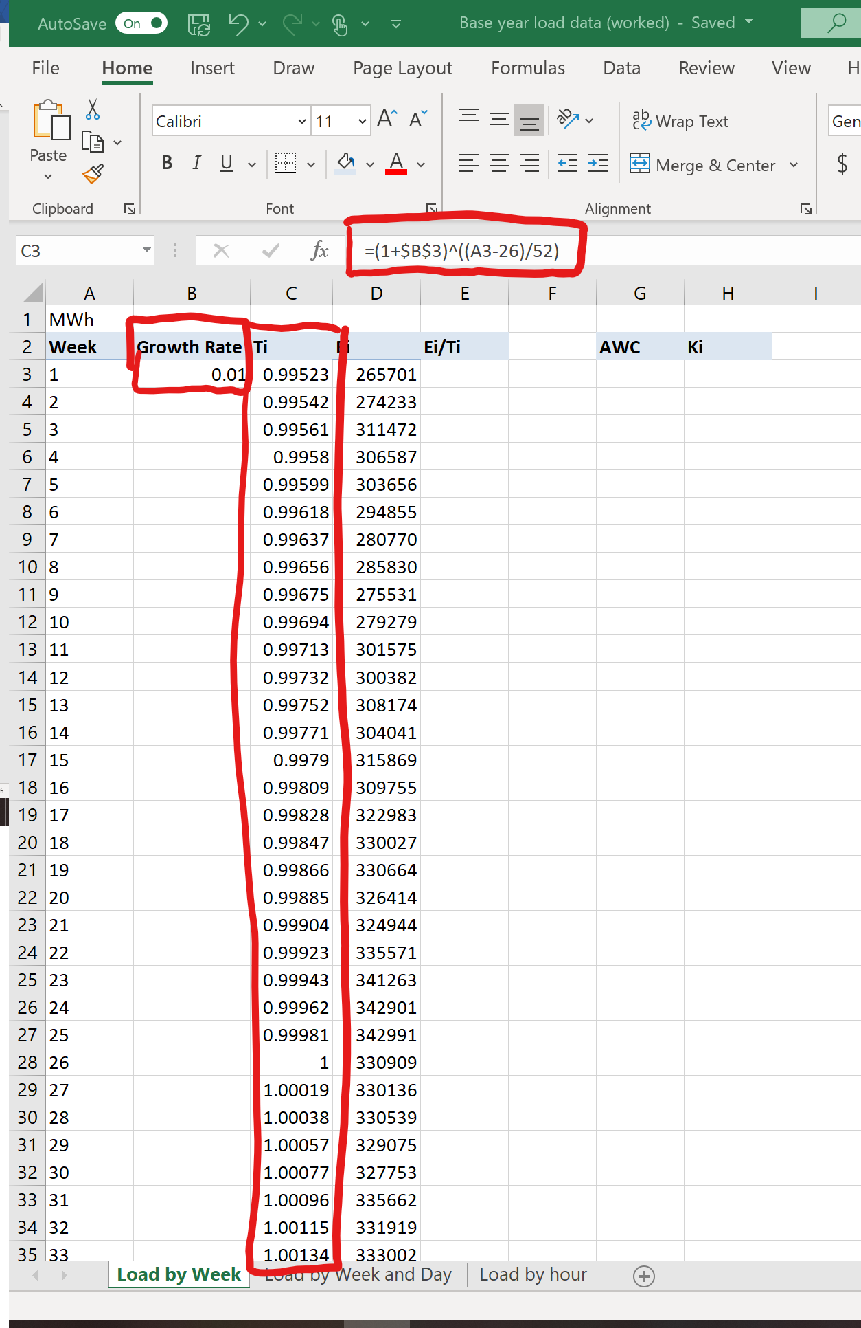
The second step is to calculate the seasonal coefficients. To do so, the electricity demand for each week “Ei” should be divided by the corresponding growth trend deflator Ti.
Then find the average weekly consumption (AWC). This is the sum of all the new values for weekly electricity demand “Ei/Ti”, divided by 53, the total number of weeks in the study.
Next, calculate the seasonal coefficients “Ki” as the weekly electricity demand without the growth trend “Ei/Ti”, divided by the average weekly consumption “AWC”. You should calculate 53 values.
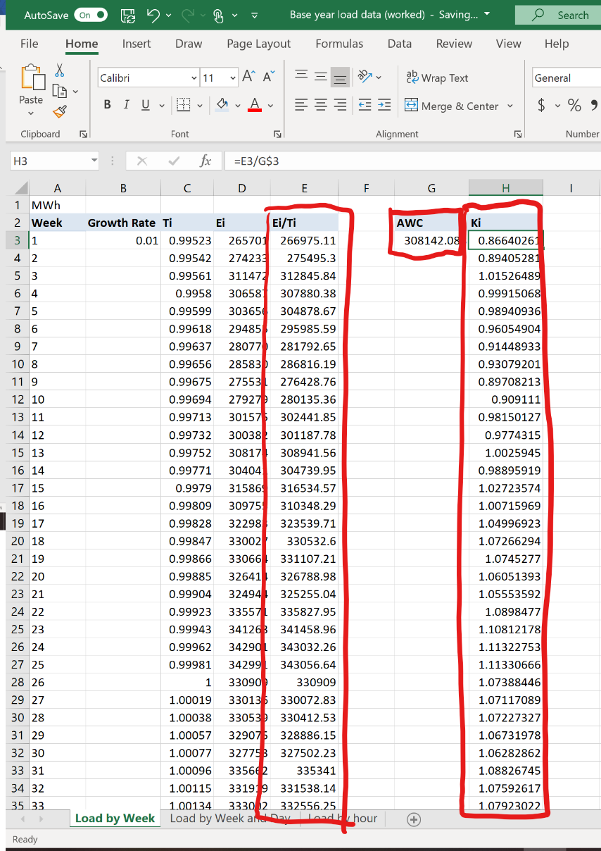

Activity 2: Daily coefficients
Now go to the “Load by Week and Day” tab of the workbook. First, calculate the average daily consumption in each week, “Pave”, as the sum of the electricity consumption in the week, given in the column “Ei”, divided by 7, the number of days in a week.
The daily coefficients are obtained by dividing the electricity consumption for each day by the average daily consumption for the corresponding week.
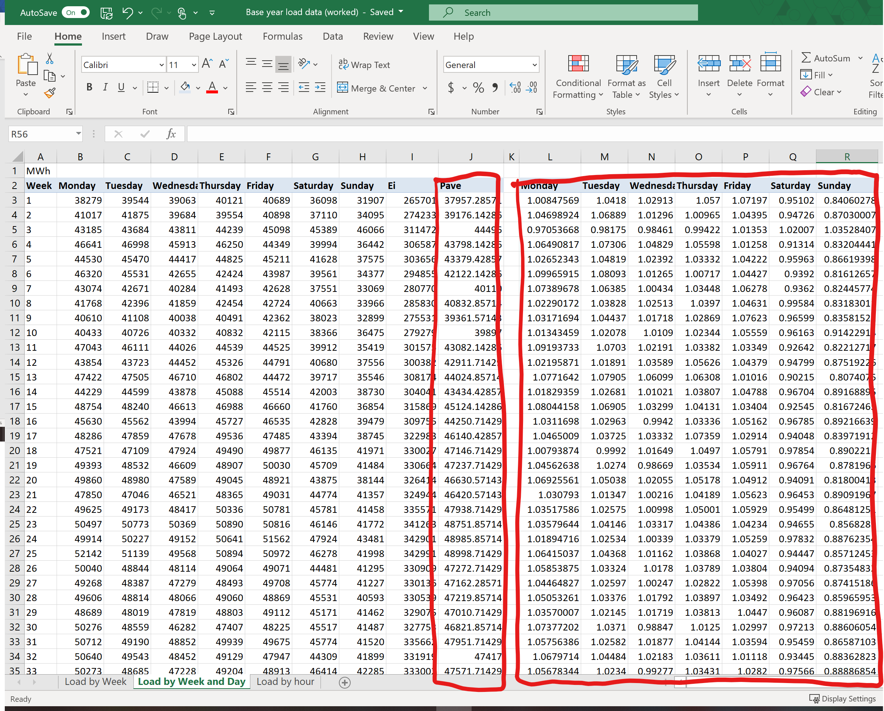

Activity 3: Hourly coefficients
The hourly coefficients are calculated for each type of day (e.g. Monday, Tuesday) in each season for each sector or client, if available. For example, let us assume that we have identified the following three seasons using monthly consumption data:
- Season 1: From January 1st to March 30th
- Season 2: From April 1st to October 31st
- Season 3: From November 1st to December 31st
Let us focus on Mondays in Season 3, during November and December. We assume that the hourly demand in the “Load by hour” tab of the workbook is the demand of a hypothetical sector without any clients, so the whole sector is modelled as a single client.
To calculate the hourly coefficients for Mondays, we first find the average demand for each hour over the season. Using the pivot table feature in the “Insert” tab of Excel, we can use the data in the “Load by hour” tab to create a table with the average electricity demand for each of the 24 hours in every Monday in November and December.
We also need to calculate the average hourly demand as the sum of all electricity demand for each Monday divided by 24, the total number of hours in a day. Conveniently, this value appears in the bottom of the pivot table in the row labelled “Grand Total.”
To find the hourly coefficients for each hour, we divide the average demand for that hour by the average demand for all hours in that day in that season, which is in the “Grand Total” row. This technique is used to calculate the hourly coefficients for each hour of Monday in Season 3.
.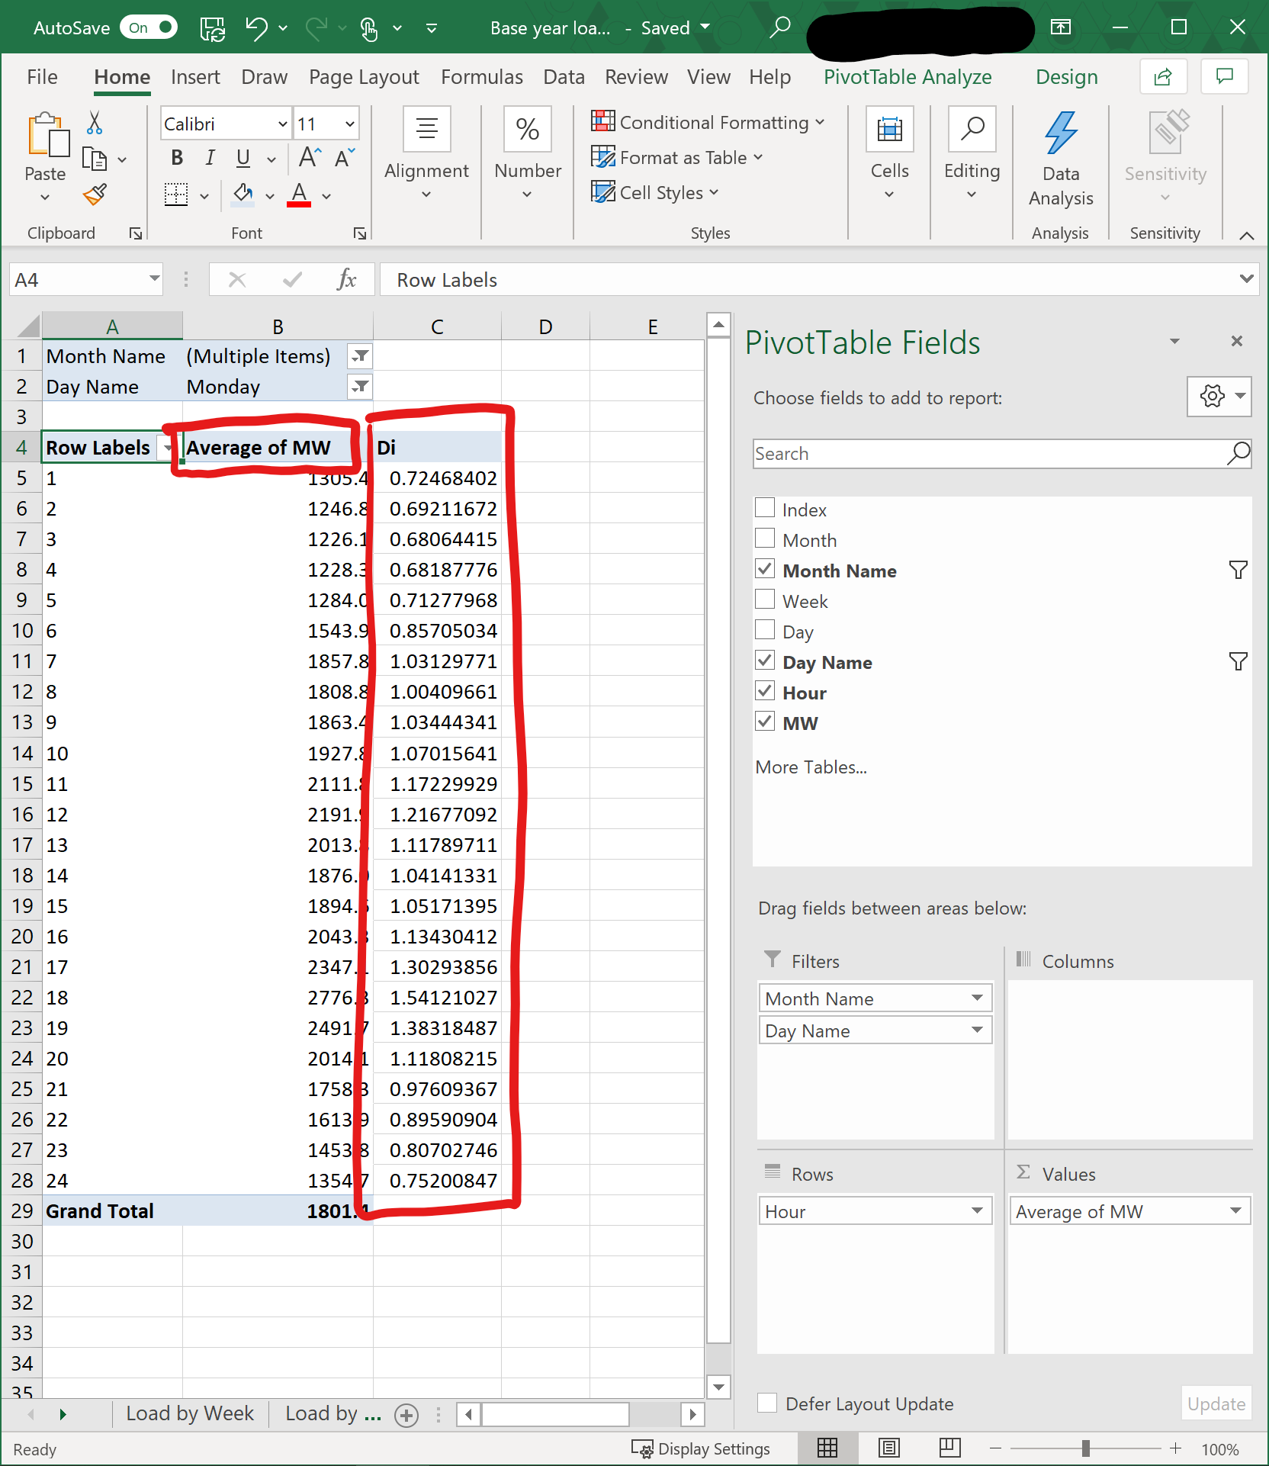
To calculate the input data for MAED-EL, these steps would have to be repeated for each day of the week in every season, for each client in each sector. Thus, you need data on the hourly demand for at least each sector you wish to model in the base year and the reference years of the study period. Because typically reference years have not happened yet, these data represent your scenario assumptions.

