Energy System Modelling Using OSeMOSYS
Hands-on 7
Please use the following citation for:
- This exercise
Plazas-Niño, F., Alexander, K. (2025, February). Hands-on 7: Energy System Modelling Using OSeMOSYS (Version 1.0.). Climate Compatible Growth. DOI: 10.5281/zenodo.14871306

- OSeMOSYS UI software
Climate Compatible Growth. (2024). MUIO (Version v5.0.0). GitHub. https://github.com/OSeMOSYS/MUIO/releases
____________________________________________________________________________

Learning outcomes

By the end of this exercise, you will be able to represent the following in OSeMOSYS:
- Solar power plants and the solar primary supply technology
- Wind power plants and the wind primary supply technology

Add Solar and Wind Technologies

In this Hands-on we will add 4 technologies in total: 2 power plants (PWRSOL, PWRWND) and 2 primary supply technologies (MINSOL, MINWND). Two new fuels (commodities) will be added to the model: SOL (Solar energy) and WND (Wind energy). We will build the highlighted parts of the RES below. Note: Update your RES in diagrams.net.

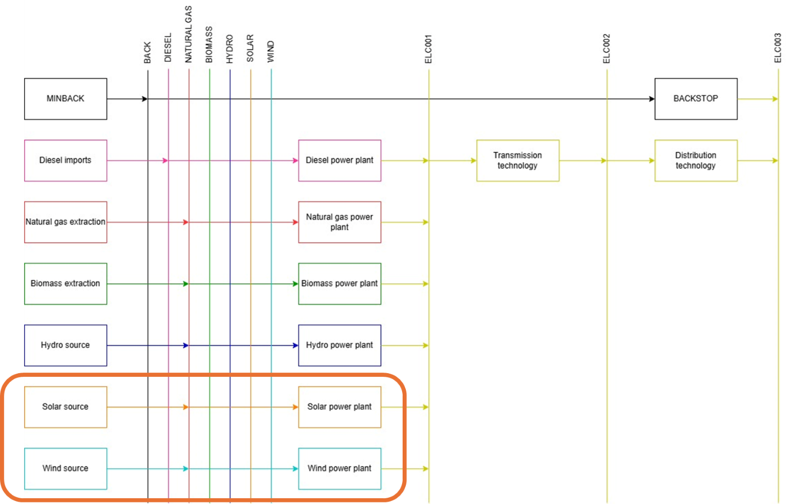

IMPORTANT: Before you can do anything else, you must copy the model and rename it in the same way you have before (OSeHO7 this time).

We will add the new technologies and commodities using the same steps covered in hands-on exercises 5 and 6.
Try it: Add 4 new technologies using the Data Preparation File OSeHO7.
- MINSOL – Solar Source
- MINWND – Wind Source
- PWRSOL – Solar PV Power Plant
- PWRWND – Onshore Wind Power Plant

Repeat the same steps shown for Primary Supply Technology and Power Plants in Hands-on 6. Don’t forget to add Capacity Factors! And of course, two new Commodities into the model config page: SOL and WND!
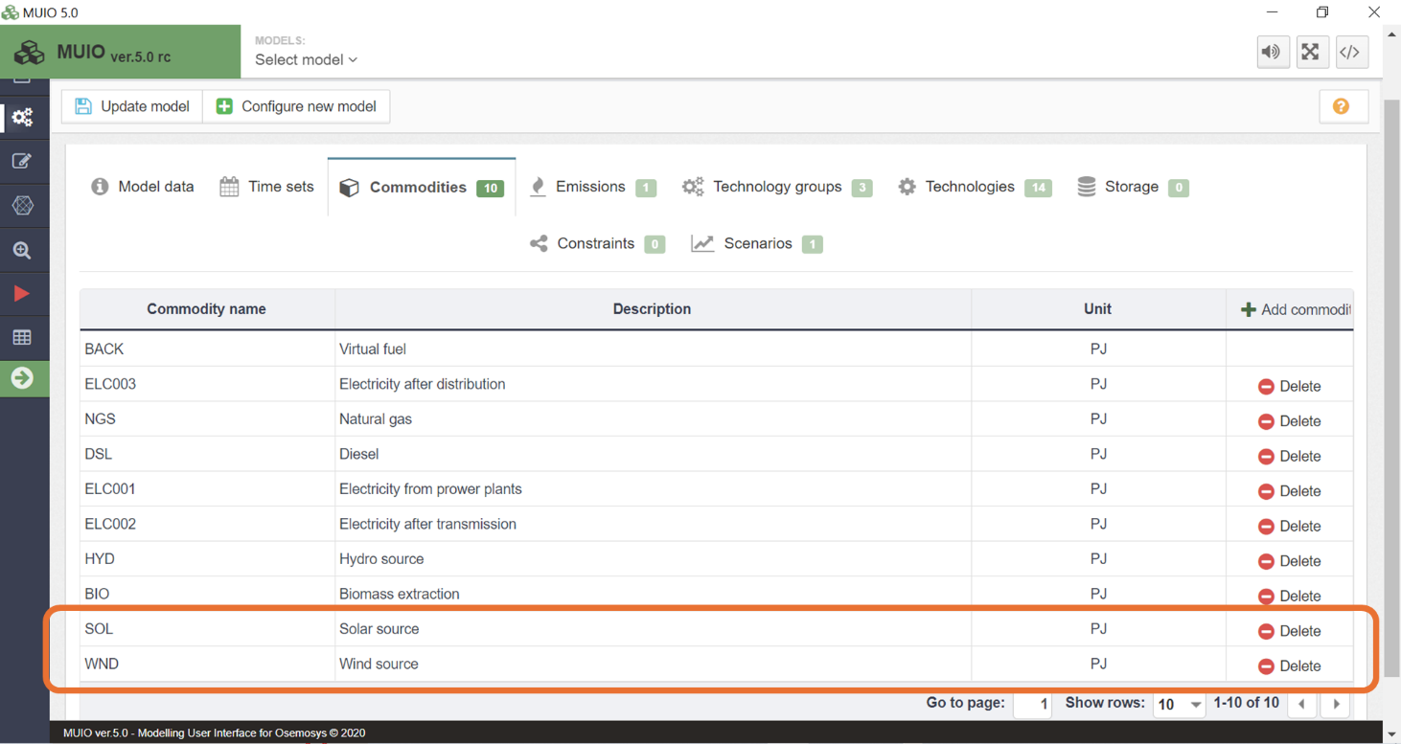

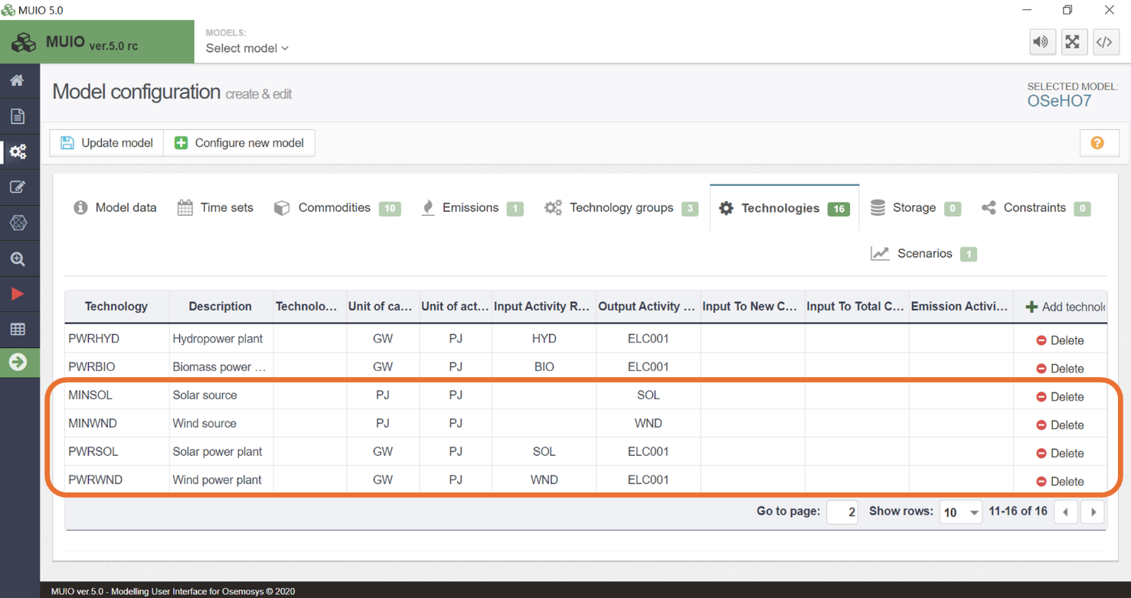

Run the model and check the results

Run the model in the user interface as demonstrated in hands-on 3 to obtain the results. The Production by Technology by Mode (PJ) graph you should get after running the hands-on 7 model is shown below.
In this case, wind and solar power plants are initially not competitive with hydropower. However, starting in 2028, solar power plants begin contributing to the energy mix, with wind power making significant contributions from 2031 onward. These new renewable energy sources also reduce the reliance on natural gas for electricity production.

Question to consider: If hydropower were not available, which technology do you think would become the main power supplier? How can we model this situation?
