Model for Analysis of Energy Demand (MAED)
Hands-on 7: Entering Scenario Data for the case study
Licence:
This work is licensed under the Creative Commons Attribution 4.0 International License (CC BY 4.0). To view a copy of this license, visit https://creativecommons.org/licenses/by/4.0/.
Attribution:
Please cite as: Kiley, F. (2025) An Introduction to Simulating Energy Demand with MAED. Version 1. Climate Compatible Growth Teaching Kit Website, Climate Compatible Growth.

Learning outcomes
By the end of this exercise, you will be able to:
- Enter Scenario Data
- View Results

Activity 1: Adding Scenario Data
Let us move on to the scenario data. We shall start with the population and other parameters of the demographic data. The base year data have already been entered. We are now going to enter data for future years; these are referred to as the scenario data.
To add population scenario data in MAED-D, we need to enter the assumed population average annual growth rates for future years.
If we do not enter any data, the model interprets the growth rate as zero and assumes that the population remains constant.
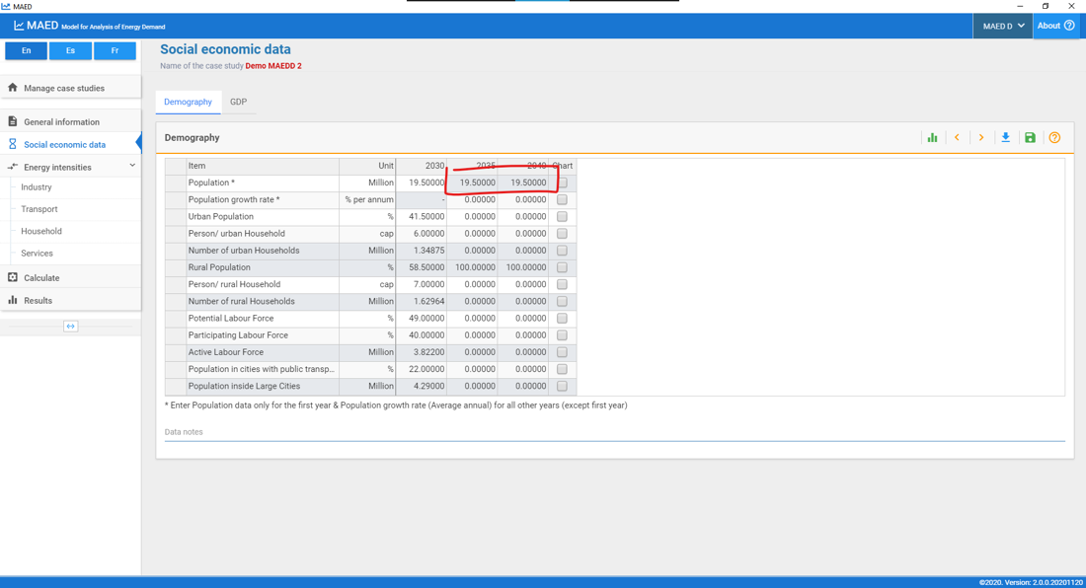
Note that the growth values for each interval are the average growth rates. In our case, the values are the average growth rates over the 5-year intervals. The model calculates the total population in the future.
Columns for the years 2035 and 2040 will contain the scenario data for the corresponding parameters. For example, according to this scenario, the size of the households in the urban area will be reduced, from 6 persons per dwelling in the base year, to 5.2 persons per dwelling at the end of the study period. At the same time, the proportion of potential labour is considered constant in this scenario.
Please, enter all these data shown below.
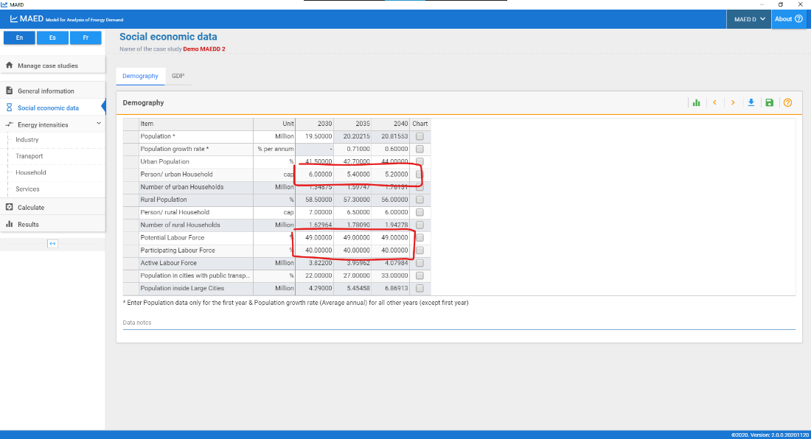
We are now going to enter the scenario data for GDP growth and structure. Just like with the population, future GDP data is introduced using annual average GDP growth rates.
The data corresponding to the future GDP structure must be introduced in their respective blank cells. Enter the following data in the GDP and Distribution of GDP by Subsectors tables.

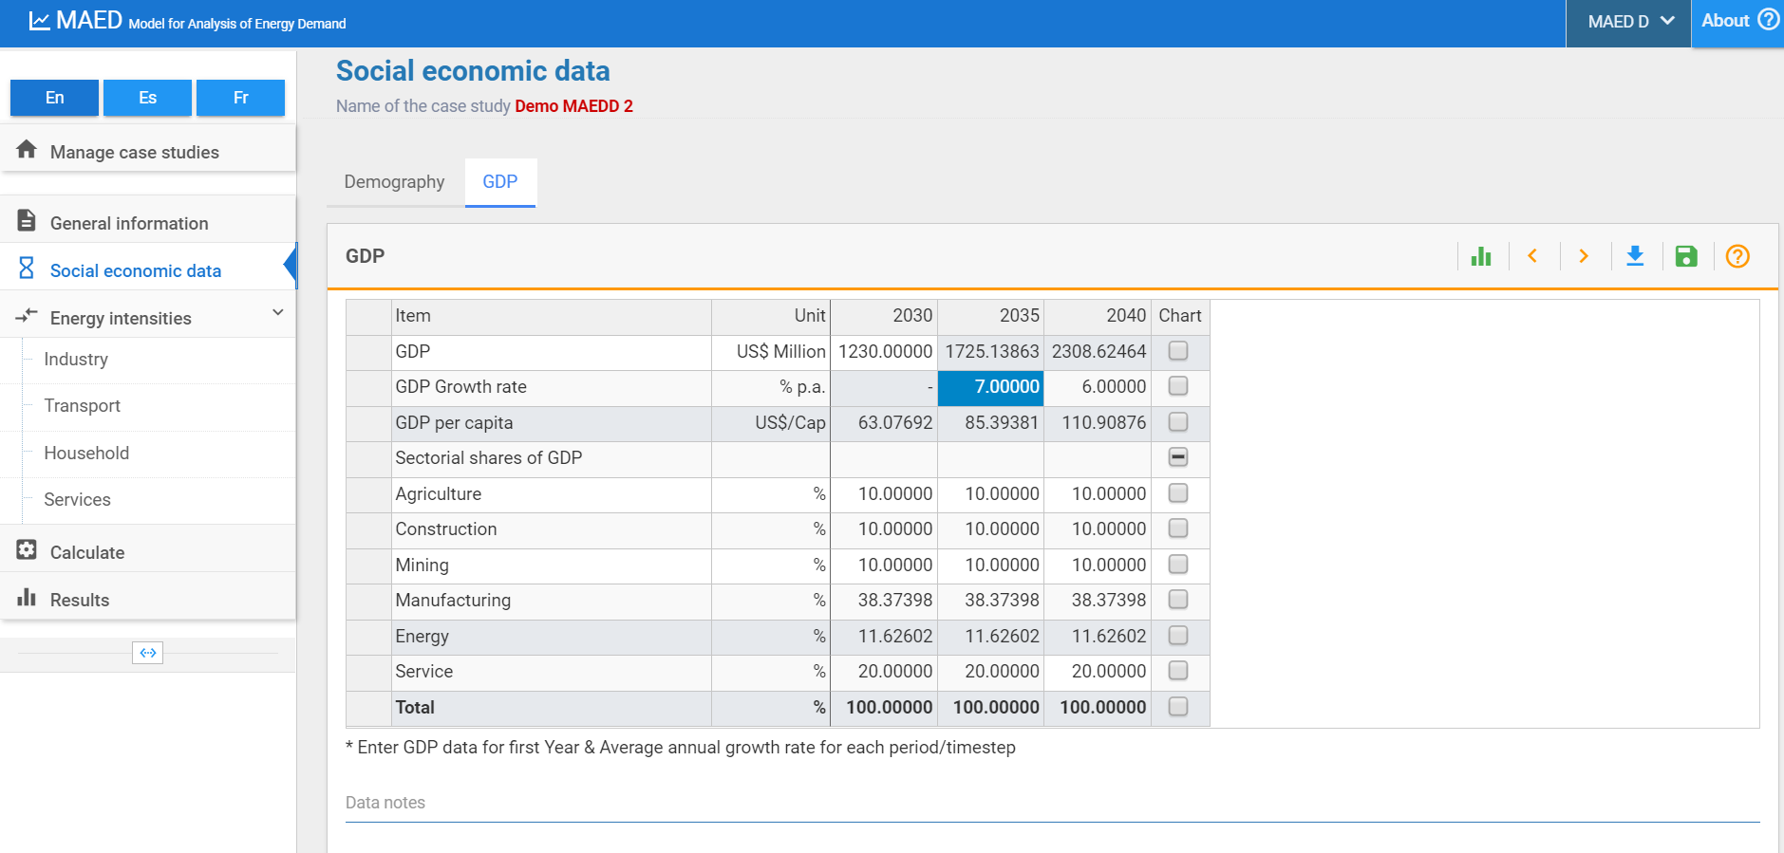

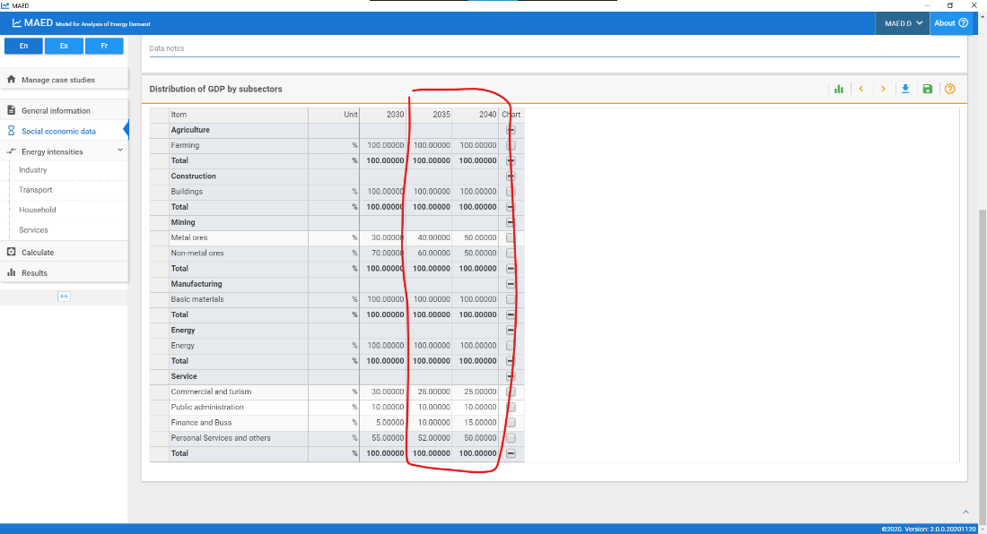
We shall now enter the scenario data for the energy intensities of motive power, specific electricity use and thermal use for all the sectors. As done in the previous Hands-on we will have to calculate these data for the future years. To do so you can use a support Excel template.
Once you are done repeating the same steps of the previous Hands-on for the future years, you will be able to enter the data that you have calculated where shown below. However, as this is a time consuming and more advanced skill, we will not ask you to do in this online course. It will be useful for you to know when you will work on your real country case-study.

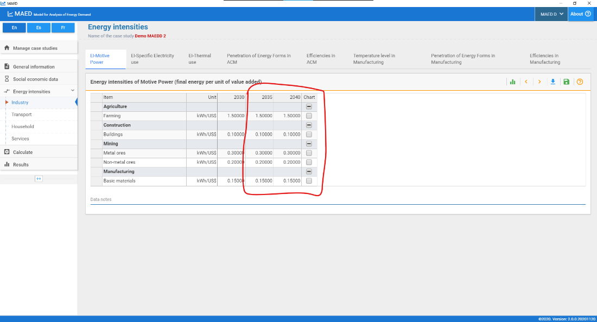
N.B. Therefore, remember to take advantage and use the Data Collection and Manipulation template EXTENDED to reconstruct the Base Year for each sector and to calculate scenario data. This template is available here and has a similar structure that the previous template you have used:
https://doi.org/10.5281/zenodo.7717393
Use v3.0.0 of this template.
You will now be able to calculate and look at the results for the years 2035 and 2040.
Congratulations, you now know how to enter data into the MAED-D model.

