Energy System Modelling Using OSeMOSYS
Hands-on 6
Please use the following citation for:
- This exercise
Plazas-Niño, F., Alexander, K. (2025, February). Hands-on 6: Energy System Modelling Using OSeMOSYS (Version 1.0.). Climate Compatible Growth. DOI: 10.5281/zenodo.14871248

- OSeMOSYS UI software
Climate Compatible Growth. (2024). MUIO (Version v5.0.0). GitHub. https://github.com/OSeMOSYS/MUIO/releases
____________________________________________________________________________

Learning outcomes

By the end of this exercise, you will be able to represent the following in OSeMOSYS:
- Biomass-fueled power plants in and biomass primary supply
- Hydropower technologies and hydropower primary supply

Define the Hydropower Primary Supply Technology

In Lecture 7 we learnt how to represent a technology in OSeMOSYS, and which parameters characterize biomass-fueled, geothermal, hydropower and nuclear power plants. In this hands-on, we will focus on an example for hydropower plants. The same process should be used for biomass power plants.
In this Hands-on, we will add 4 technologies in total: 2 power plants (PWRBIO, PWRHYD) and 2 primary supply technologies (MINBIO and MINHYD). Two new fuels (commodities) will also be added to the model: BIO (Biomass) and HYD (Hydro). We will build the highlighted parts of the RES below. Note: Update your RES in diagrams.net.
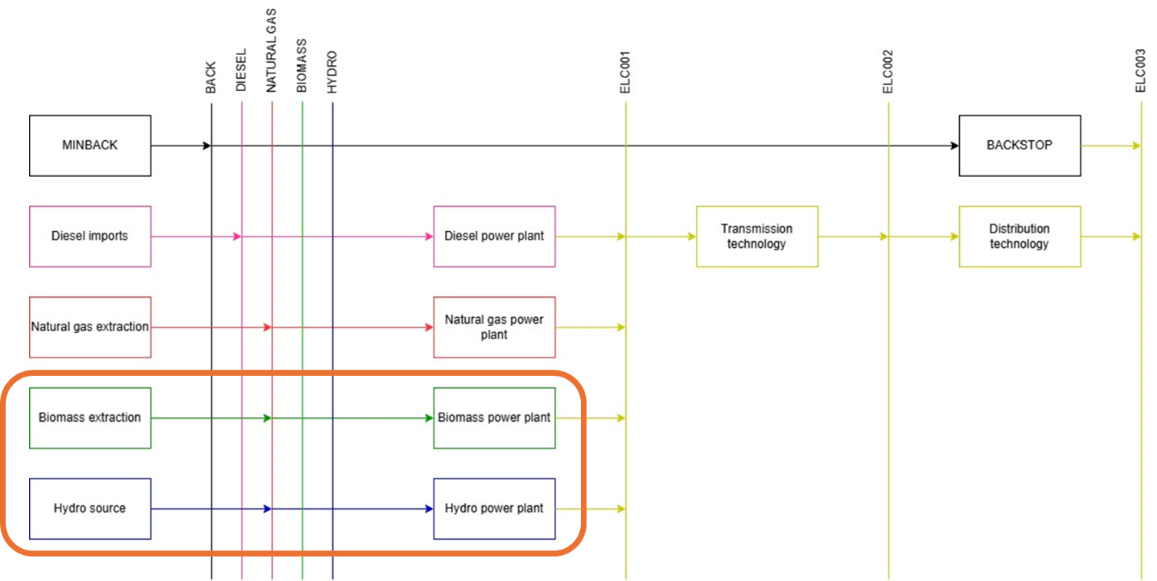
IMPORTANT: Before you can do anything else, you must copy the model and rename it in the same way you have before (OSeHO6 this time).

In order to represent a primary supply technology for renewable sources, the only parameter that needs to be considered for all technologies is OutputActivityRatio, which defines the fuel provided (i.e., Hydro or Biomass). All other values within the user interface can be left as the default. However, Variable Cost and Total Technology Annual Activity Upper Limit must also be considered for MINBIO. Additionally, we will assign a value of 0.001 for CapitalCost and 100 for OperationalLife to prevent the model from installing unnecessary capacity.
Try it: Let’s add MINHYD - the technology representing the primary supply of water MINHYD (Hydro Potential) and the correspondent fuel HYD (Hydro) following the steps explained in Hands-on 4 and using the data provided in the Data Preparation File OSeHO6.

Repeat the same steps for:
- MINBIO - Biomass Extraction and BIO – Biomass fuel

Voilà: You have now added 2 primary supply technologies (MINBIO and MINHYD) and 2 fuels (BIO and HYD) to your model.

Add a Hydropower plant

In order to represent a power plant, remember that the following parameters must be considered:
− | InputActivityRatio: defines the rate of fuel consumed (i.e., Hydro)
− | OutputActivityRatio: defines the fuel provided (i.e., Electricity)
− | CapacityToActivityUnit: used to convert data related to the Capacity of technology into the Activity it can generate. For power generation, e.g., PWRHYD, this value should be set to 31.536.
− | Fixed Cost: defines the fixed Operation & Maintenance cost ($/kW)
− | CapitalCost: defines the overnight investment cost of the plant ($/kW)
− | OperationalLife: defines the lifetime of the technology (in years)
− ResidualCapacity: defines the existing capacity of the technology (in GW) and its expected decommissioning. Not applicable for this case since there are no hydro or biomass power plants installed in the current system.
− Capacity Factors: represents the variability in generation at each point in time.
Note: We will include an additional parameter for PWRHYD, named Total Annual Max Capacity, which represents the technical maximum potential for the country to deploy up to 5 GW of hydropower plants, based on prior assessments of hydrological resources.

Try it: Let’s add PWRHYD - the technology representing a run-of-river hydro power plant following the steps presented in Hands-on 5 and using the data provided in the Data Preparation File OSeHO6.
Repeat the same steps for:
- PWRBIO - Biomass Power Plant
Voilà: You now have added 2 power technologies (PWRBIO, PWRHYD) to your model.
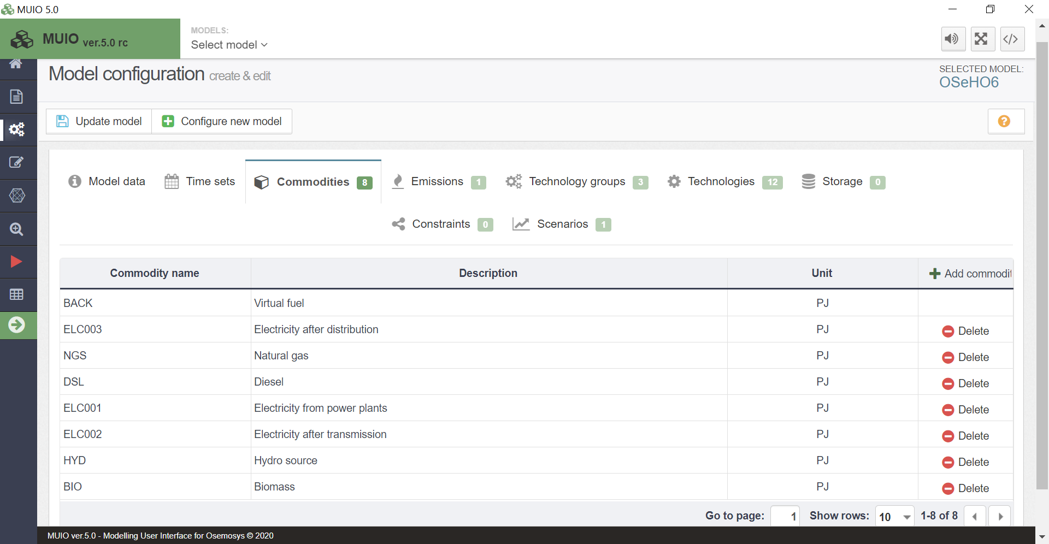
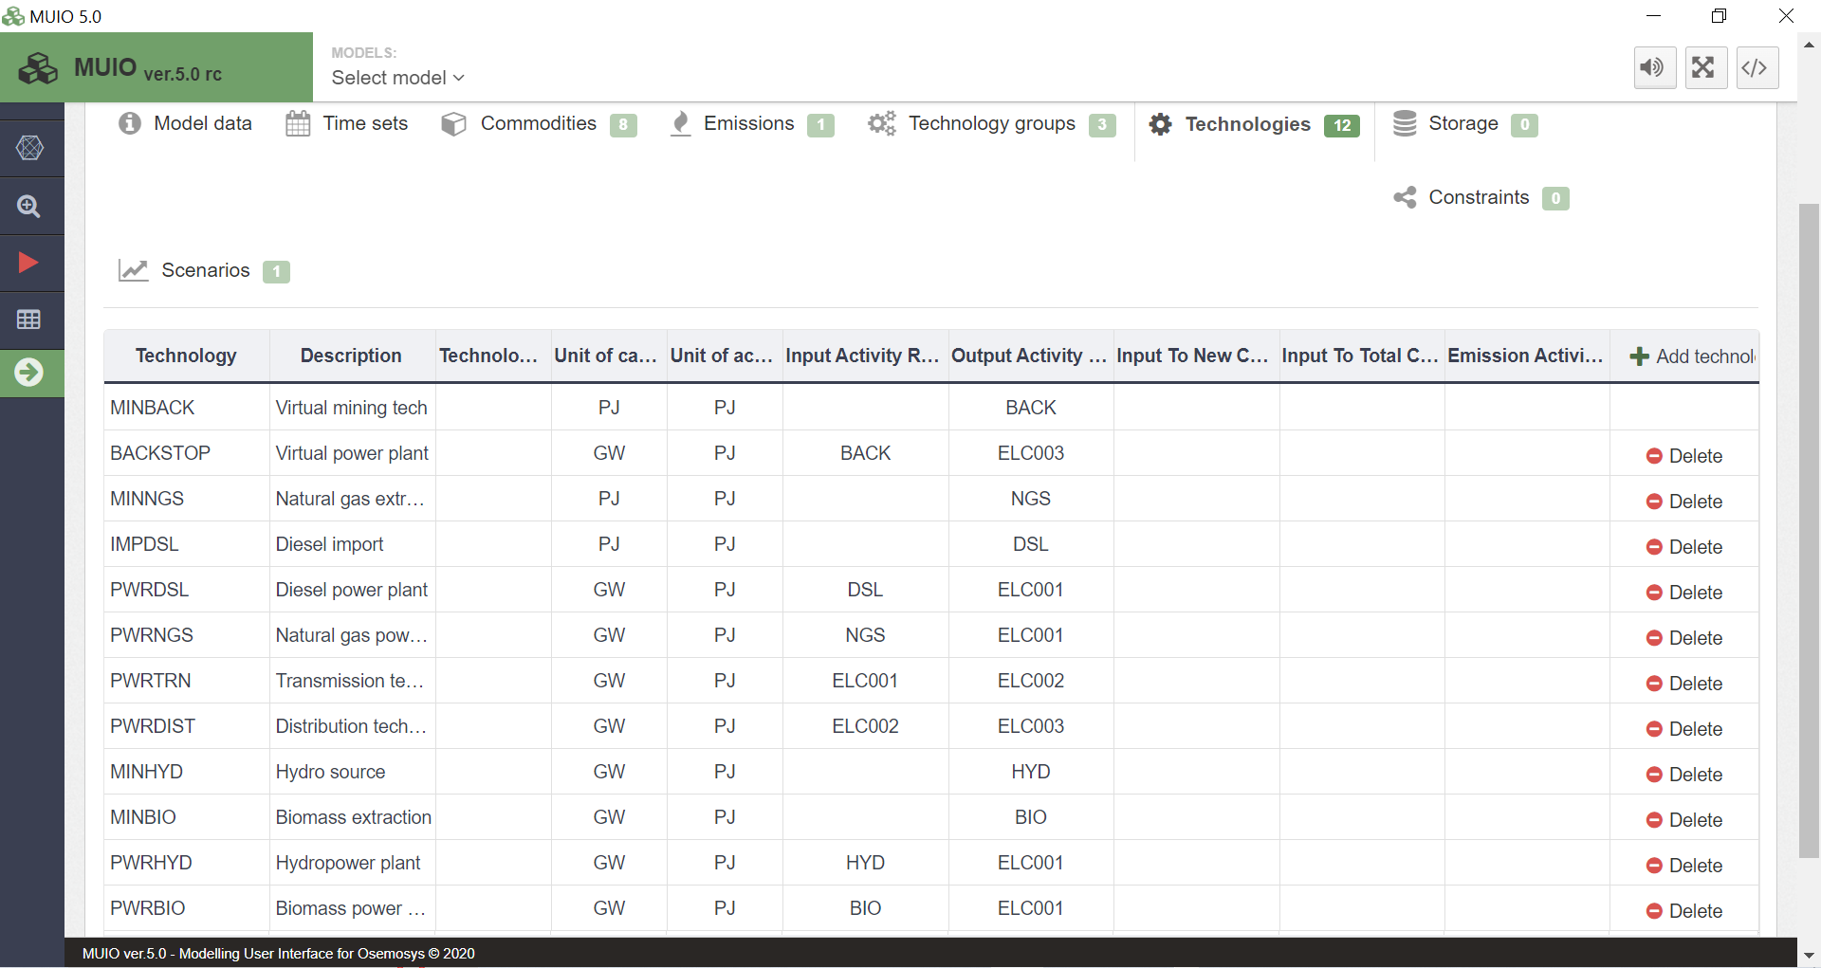

Run the model and check the results

This graph below is how the Production by Technology By Mode (in PJ) you obtain at the end of this hands-on exercise (6) should look. Again, filter out for the case you want and only the energy producing technologies (not PWRTRN and PWRDST). As observed in comparison to HO05, PWRDSL has been replaced by PWRHYD, indicating that hydropower plants are cheaper to install and operate than the current diesel power plants. However, this result is not entirely realistic, as hydropower plants would typically require a construction period of around three years, making their installation unlikely in the early years of the modelling horizon. Additionally, it is improbable that the existing installed diesel capacity would remain unused until decommissioning, considering potential mid-term contracts.
We will address how to calibrate the model to better reflect such real-world constraints in hands-on exercise 13. For now, we will work with these results from a purely mathematical perspective.
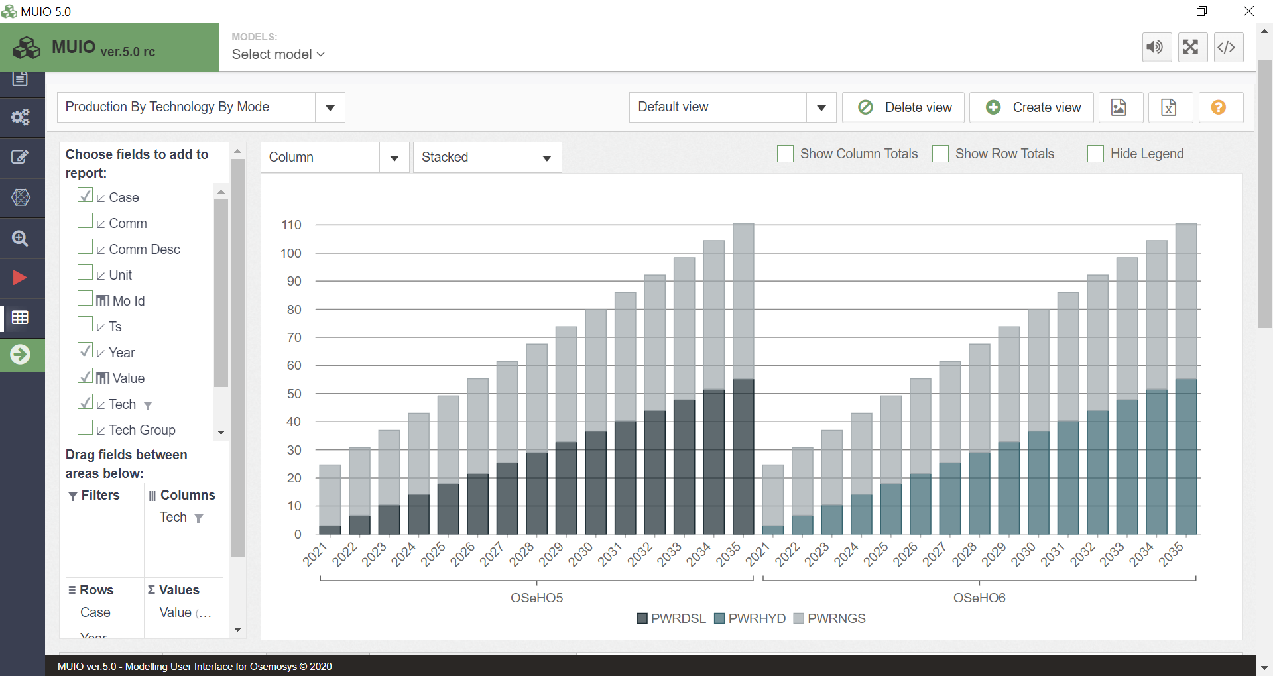

Question to consider: What is the impact on the newly required installed capacities? Do we need more or fewer gigawatts (GW) from hydropower plants to meet the electricity demand?

