Model for Analysis of Energy Demand (MAED)
Hands-on 6: Base Year Reconstruction Part II
Licence:
This work is licensed under the Creative Commons Attribution 4.0 International License (CC BY 4.0). To view a copy of this license, visit https://creativecommons.org/licenses/by/4.0/.
Attribution:
Please cite as: Kiley, F. (2025) An Introduction to Simulating Energy Demand with MAED. Version 1. Climate Compatible Growth Teaching Kit Website, Climate Compatible Growth.

Learning outcomes
By the end of this exercise you will be able to:
- Point at the specific requirements of the Manufacturing Sector
- Point at the specific requirement of the Household Sector.

Activity 1: Specific requirements of the Manufacturing Sector
As previously explained, the Manufacturing sector which is part of the Industry sector has a similar structure to the Agriculture, Mining and Construction (AMC) which we have seen in the previous Hands-on. There are a couple of additions: a) the demands for thermal uses are split into High Temperature, Medium Temperature and Low Temperature and b) we need to collect additional cogeneration factors. In Zenodo, you can find an updated Excel template here with a super simple fictitious example for the reconstruction of the Manufacturing sector.
https://doi.org/10.5281/zenodo.7750263

As previously done, now go to IND_MAN_RawData Sheet. You can see that the Final Energy Demands have been divided into three temperatures level as well as the Efficiencies. Then, the cogeneration data have been collected as well as the Driving Parameter which is the GDP for Manufacturing.
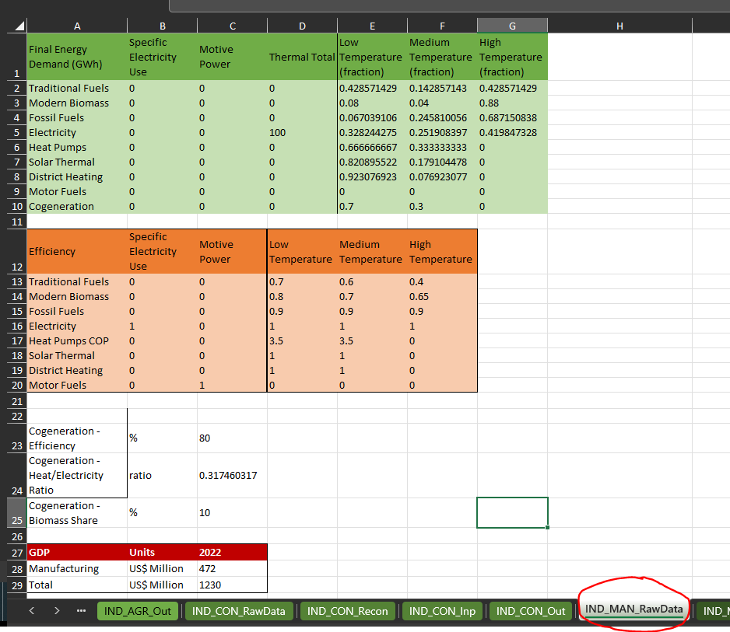

Then move to IND_MAN_Reco Sheet to repeat the calculation for obtaining the Useful Energy Demand and the Penetration of the Energy Forms.

Finally you should be able to fill in the table on the Specific Energy Consumption as shown below:
Then move to IND_MAN_Inp sheet to copy paste the data into MAED and update the data in the picture below to tell MAED about the Temperature level in Manufacturing.
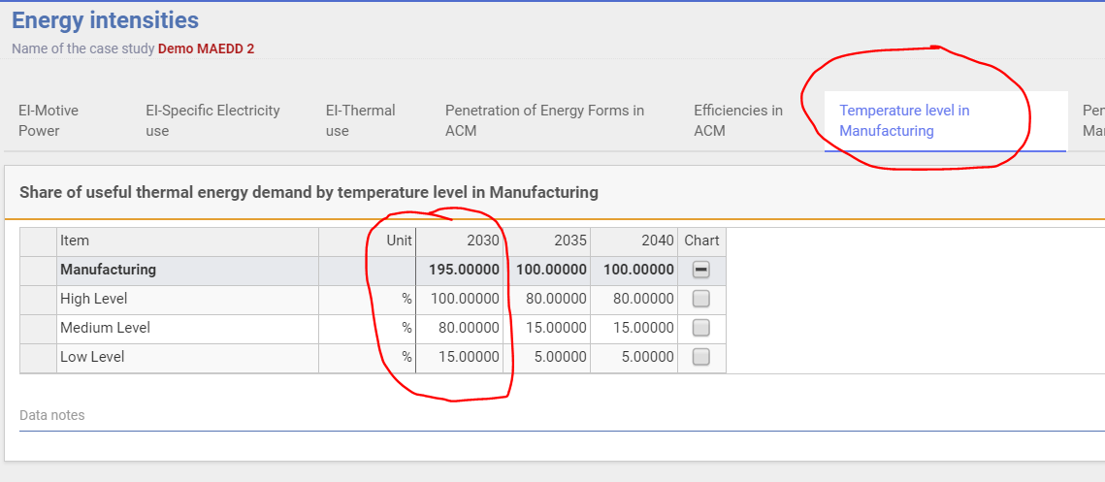
Then, you need to add the Penetration of Energy Forms in Manufacturing for 2030 and with your own data.
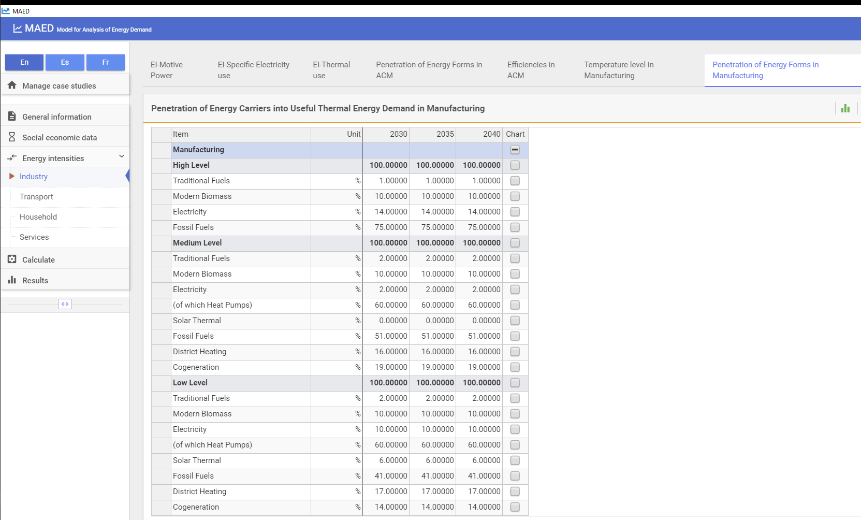
Finally, you will need to add data for the Efficiencies in Manufacturing as shown in the example.
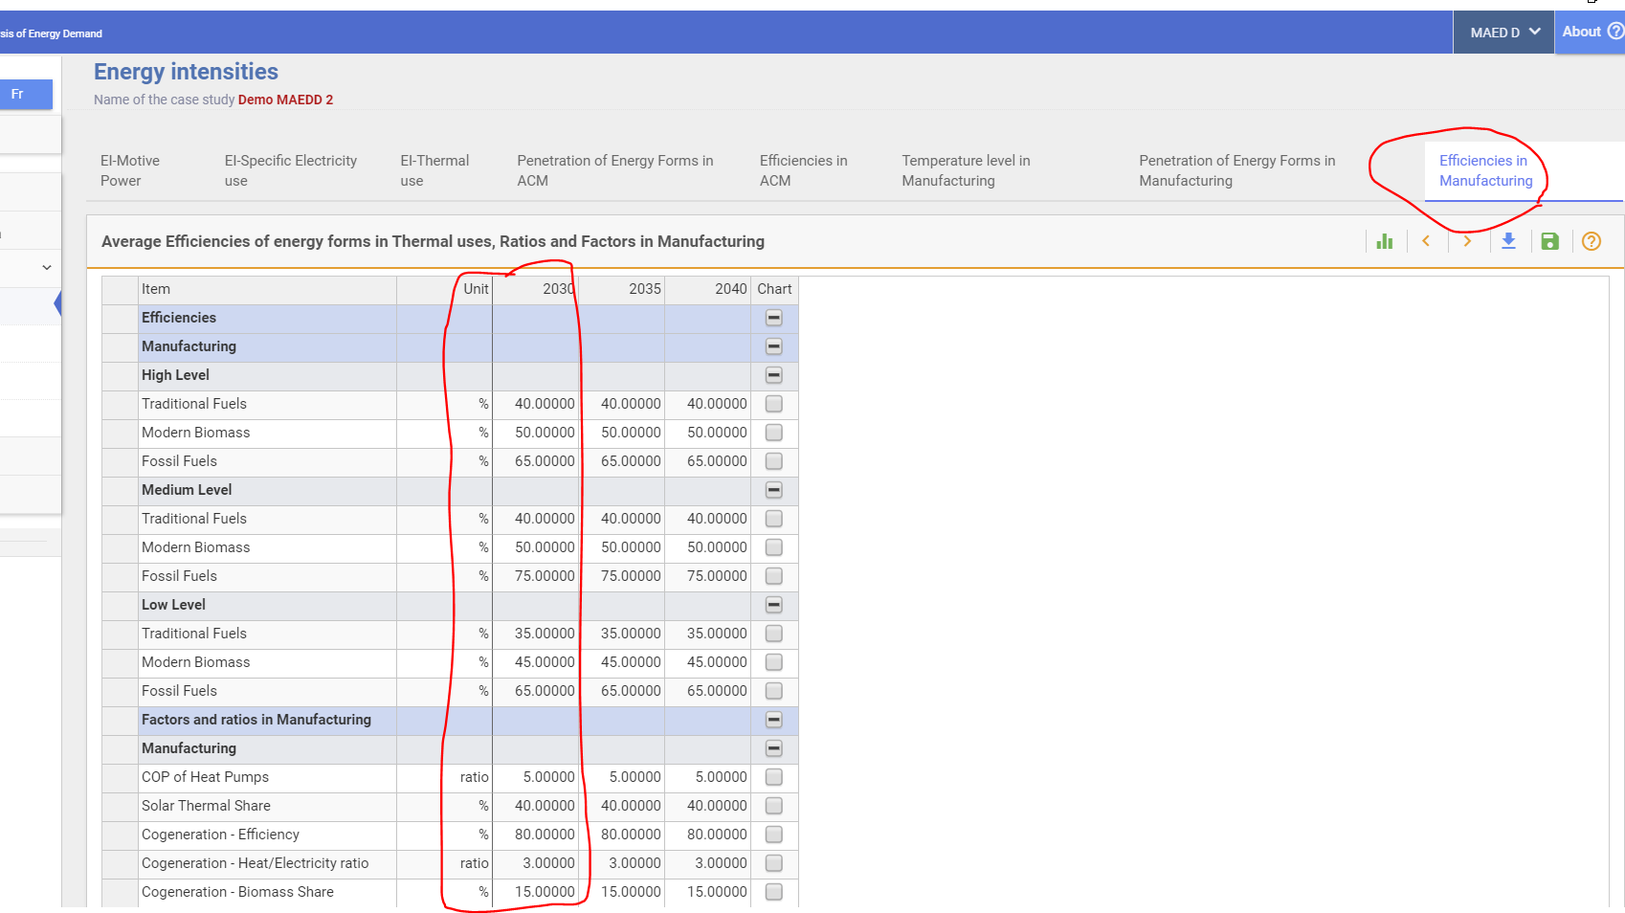

Then as done for the Agriculture sector, you will have to check that your MAED results are the same as the data in your Excel Template. Go to Results, then to 2.3.4. Total Final Energy Demand in Manufacturing (absolute) in 2030. If the results are the same, you have successfully reconstructed the Base Year for Manufacturing.

Activity 2: Specific requirements of the Household Sector
The first thing we need to do is to add the Socio-Economic Data for the Household sector for Demography. In particular, for the Demography data you will have to fill in all the white cells such as Urban Population, Person/ urban Household, Person/ rural Household etc, specific to your case study.
Then we move on to the Energy Intensities data.
The Household sector is divided into two subsectors: Urban and Rural. Then, we have six end-uses: Specific Electricity Use, Lightening, Air Conditioning, Cooking, Space Heating and Water Heating.
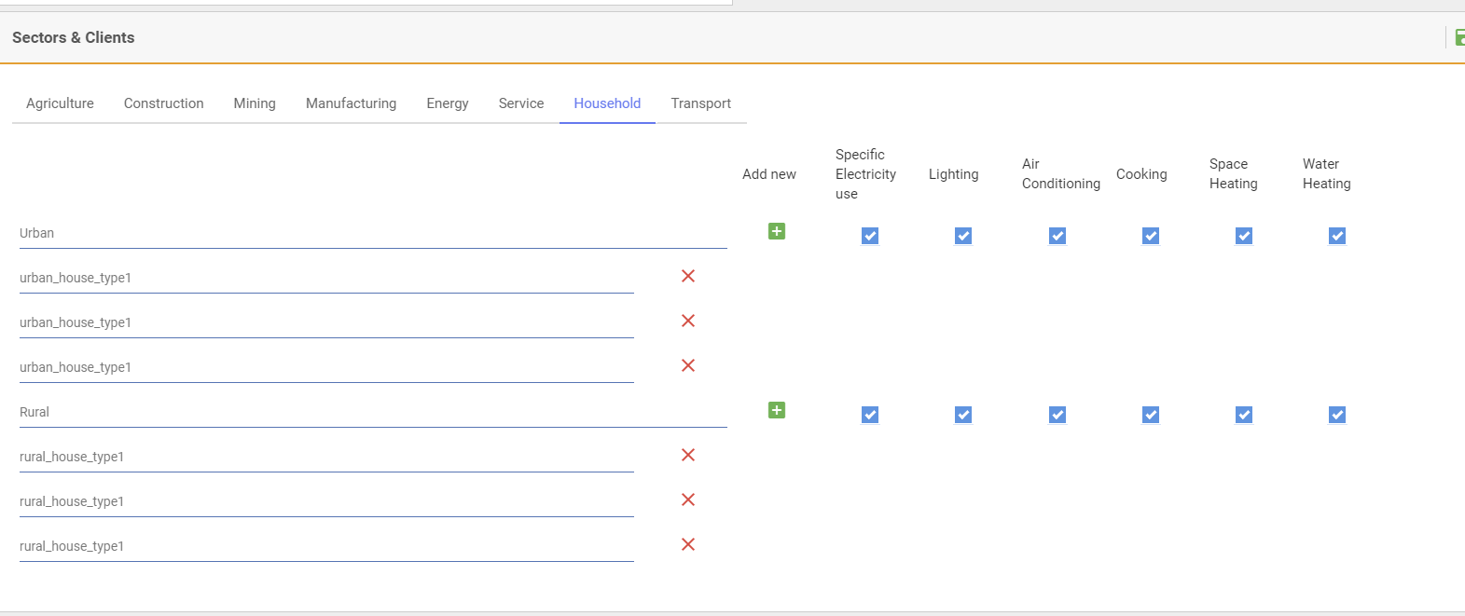
Please download the updated template with the structure needed to collect and reconstruct the Household sector Urban and Rural. As an example we will see the Urban, but the same applies to Rural.
The first data we’ll have to collect are the Shares by dwelling type, so for example how many apartments (in percentage) there are compared to the total number of dwellings? Then we need to add the Dwelling sizes by dwelling type in m2, so how big is each type of dwelling?
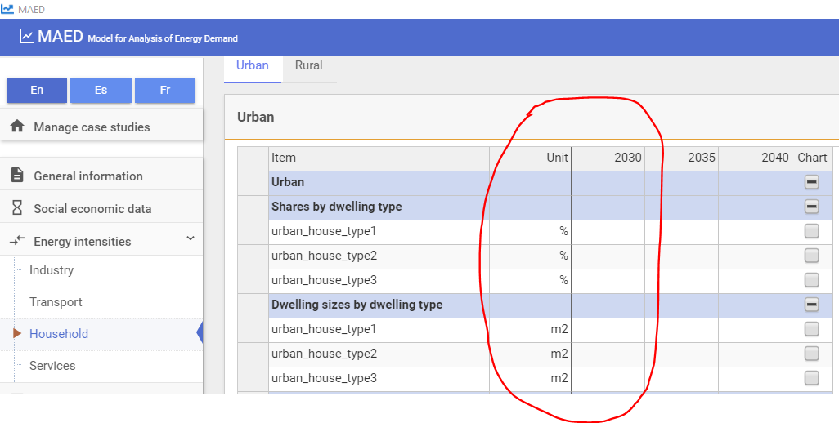
Now we need to move on to collect and calculate the data required by each end use. Let’s start from Space Heating. Firstly, we need to know the Dwelling Factors for Space Heating, so how many dwelling in percentage require Space Heating and the Degree Days. Then we move on to the Area Heated in percentage and the Heat Losses Rate per each type of dwelling in Wh/m2/C/h. Then, as done in the past we will have to calculate (using the Excel template as a support) the Penetration of Energy Forms which now are: Traditional fuels, Modern Biomass, , District heating, Substitutable Fossils, Solar Thermal and Electricity (of which a certain percentage will be used for Heat Pumps). Finally, we input data for Efficiencies and other factors for Traditional Fuels, Modern Biomass, Fossil Fuels, Solar Thermal Share and the Coefficient of Performance (COP) for the Heat Pumps.

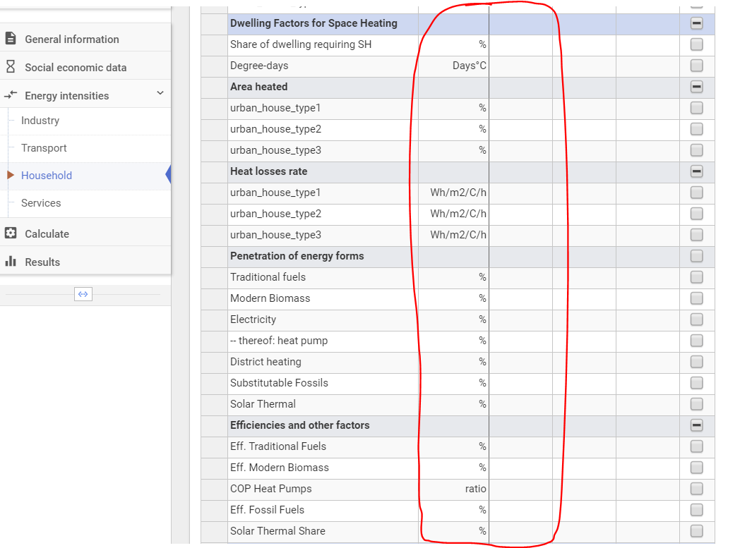
Similarly we move on and input all the data for the other end uses of the Household Sector (Urban) such as Water Heating, Cooking, Air Conditioning, Appliances and Lightening.
Remember to SAVE before leaving this page!
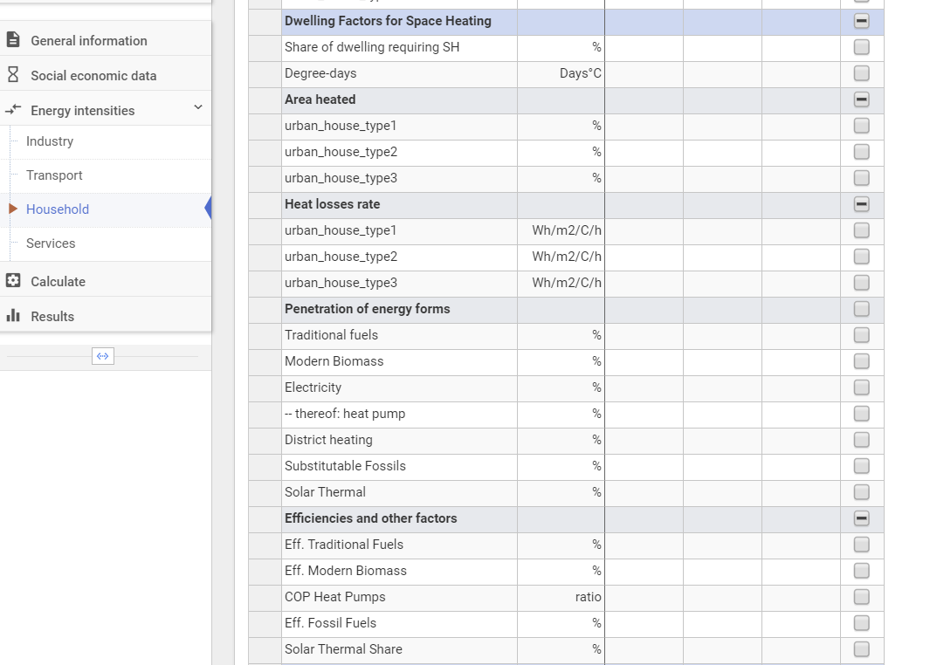
Now repeat the same steps for the Rural Subsector, which is really like the Urban one.
