Energy System Modelling Using OSeMOSYS
Hands-on 5
Please use the following citation for:
- This exercise
Plazas-Niño, F., Alexander, K. (2025, February). Hands-on 5: Energy System Modelling Using OSeMOSYS (Version 1.0.). Climate Compatible Growth. DOI: 10.5281/zenodo.14871174

- OSeMOSYS UI software
Climate Compatible Growth. (2024). MUIO (Version v5.0.0). GitHub. https://github.com/OSeMOSYS/MUIO/releases
____________________________________________________________________________

Learning outcomes
By the end of this exercise, you will be able to:
- Define existing thermal power plants taking in fuel to generate electricity
- Define the existing transmission network
- Define the existing distribution network
- Run the model and check results on production by technology and installed capacity of each technology

Define existing thermal power plants taking in fuel to generate electricity

In Lecture 6, we learnt how to represent a technology in OSeMOSYS, and which parameters characterize thermal power plants and transmission and distribution technologies.
In this Hands-on, we will add 4 technologies in total: 2 thermal power plants, 1 technology representing the transmission system and 1 for the distribution network. Two new fuels will be added to the model: ELC001 (Electricity coming directly from power plants) and ELC002 (Electricity after transmission). We will build the part of the RES highlighted below. Note: Update your RES in diagrams.net.
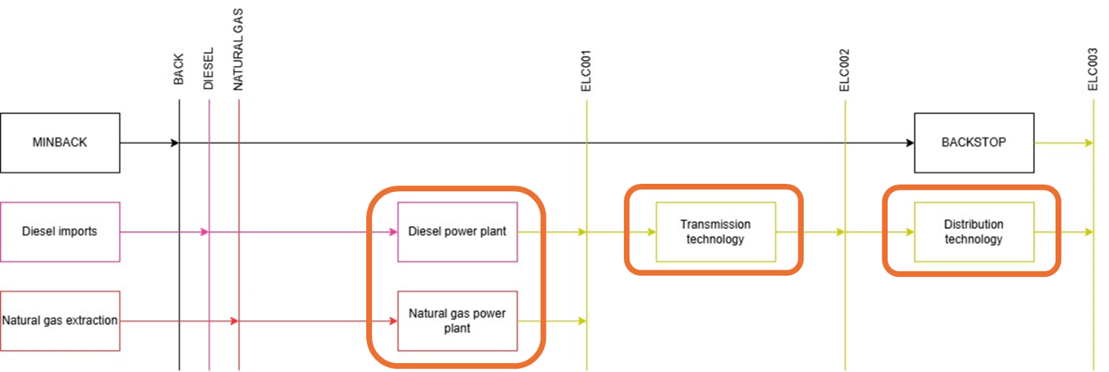

In order to represent a thermal power plant, remember that the following parameters must be considered:
- InputActivityRatio: defines the rate of fuel consumed (e.g., diesel)
- OutputActivityRatio: defines the fuel provided (i.e., Electricity)
- CapacityToActivityUnit: used to convert data related to the Capacity of technology into the Activity it can generate (for power generation, e.g., PWRDSL, this value should be set to 31.536).
- Fixed Cost: defines the fixed Operation & Maintenance cost ($/kW)
- CapitalCost: defines the overnight investment cost of the plant ($/kW)
- OperationalLife: defines the lifetime of the technology (in years)
- ResidualCapacity: defines the existing capacity of the technology (in GW) and its expected decommissioning.
- Capacity Factors: represents the variability in generation at each point in time.

IMPORTANT: Before you can do anything else, you must copy the model and rename it in the same way you have before (OSeHO5 this time).

Try it: Let’s add PWRDSL - the technology representing a diesel power plant.
- Firstly, as you have already added ‘DSL’ as a commodity (as well as NGS), you do not need to this again.
- Now let’s add ‘ELC001’ (Description: Electricity from Power plants) as a commodity.
- Then go to the technologies tab of the model configuration page and add ‘PWRDSL’.
- In this way, we added the technology which will be transforming diesel (DSL) into electricity (ELC001) to the model. So, add the relevant inputs and outputs on the technologies tab. Keep the unit of capacity as GW and the unit of activity as PJ.
- Next, you must enter the data through the data entry tab on the side of the model configuration page for PWRDSL (as done previously with other technologies).
- Add the data for PRWDSL as given in the Data Preparation File OSeHO5. Pay close attention to the CapacityFactor values, as you will need to enter the values for all four timeslices per technology.

NOTE: With Capacity Factor, you have to select rows at the bottom and select 1000 rows. Unfortunately, you cannot yet filter out technologies on the data entry tab. So, follow these steps:
  - Scroll down to find PWRDSL. When you find it, you will see RD next to PWRDSL below another technology. ADD the data to the next tile along (should be a value of 1). If you copy-paste correctly, it should fill all of the capacity factor data for PWRDSL.
  - When you add the data, it will take you back to the top of the page (a current flaw in the UI). But at least it reminds you to SAVE DATA!
  - Follow the previous steps when you add PWRNGS using the data provided in the Data Preparation File OSeHO5.
  - Then update your model after adding all 2 techs.

Voilà: You now have added 2 thermal power plants (PWRDSL, PWRNGS) and 1 commodity (ELC001) to your model.

Define the existing transmission network

We will repeat the exercise once more giving the example of a technology which represents the transmission network (PWRTRN). When representing the transmission technology, the following parameters must be considered:
- InputActivityRatio: defines the rate of fuel consumed (i.e., Electricity from power plants)
- OutputActivityRatio: defines the fuel provided (i.e., Electricity)
- CapacityToAcitivityUnit: It is used to convert data related to the Capacity of technology into the Activity it can generate. For transmission technology, this value should be set to 31.536.
- Fixed Cost: defines the fixed Operation & Maintenance cost ($/kW)
- CapitalCost: defines the overnight investment cost of installed capacity ($/kW)
- OperationalLife: defines the lifetime of the technology (in years)
- ResidualCapacity: defines the existing capacity of the technology (in GW) and its expected decommissioning

Try it: Let’s add PWRTRN - the technology representing the transmission grid.
- Firstly, you need to add a new commodity which is ‘ELC002’. As PWRTRN has an input of ELC001 and output of ELC002 (electricity after transmission).
- Now you need to add the technology ‘PWRTRN’.
- With the input being ELC001 and output ELC002. Keep the unit of capacity as GW and the unit of activity as PJ. Update the model.
- Add the data for PWRTRN as given in the Data Preparation File OSeHO5, in the same way you have previously. Remembering to save data and update model each time.

NOTE: Add data to all 7 parameters listed above. This time you do not need to add capacity factors like you did in this first part of hands-on 5.

Define the existing distribution network

We will repeat the exercise once more giving the example of a technology which represents the distribution network (PWRDIST). (Very similar to PWRTRN)
Try it: Let’s add PWRDST - the technology representing the distribution network
- As you already have ELC002 and ELC003, you do not need to add anymore commodities for this hands-on.
- You just need to add the technology ‘PWRDST’.
- Then you must set the input as ELC002 and output as ELC003. Keep the unit of capacity as GW and the unit of activity as PJ.
- Add the data for PWRDST as given in the Data Preparation File OSeHO5.

NOTE: Add data to all 7 parameters listed above. This time you do not need to add capacity factors like you did in this first part of hands-on 5 (this is the same as PWRTRN).

Your model config page for commodities and technologies, should now look like the images below (as well as the data all being correct if you have followed the steps correctly).
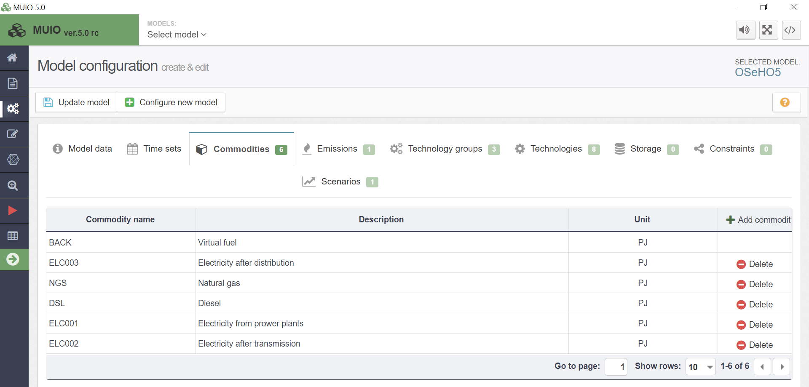
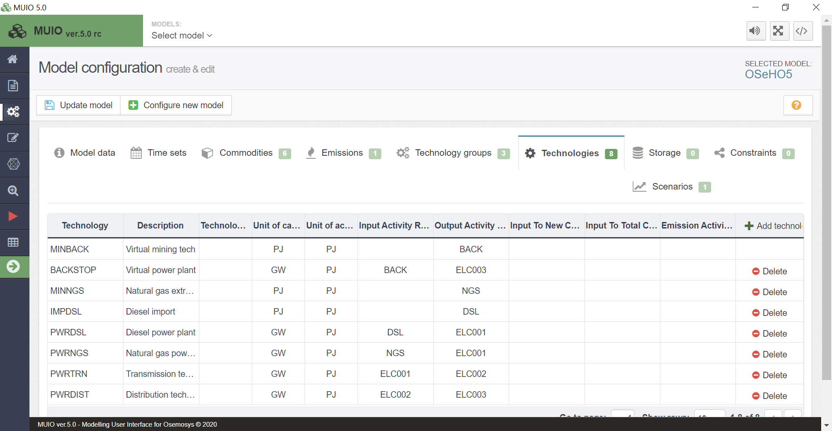

Run the model and check results on production by technology and installed capacity of each technology

You should obtain the results by running the model in the user interface as learnt in the hands-on 3.
- Firstly, you may have to filter the ‘case’ to choose only the one you just ran, as it may show all previous runs. Do this by clicking on ‘case’ in the rows tab and select the ‘Field Settings’ option, and a box will pop up on your screen. Then, you need to click edit and untick unwanted cases (e.g., OSeHO3 case).
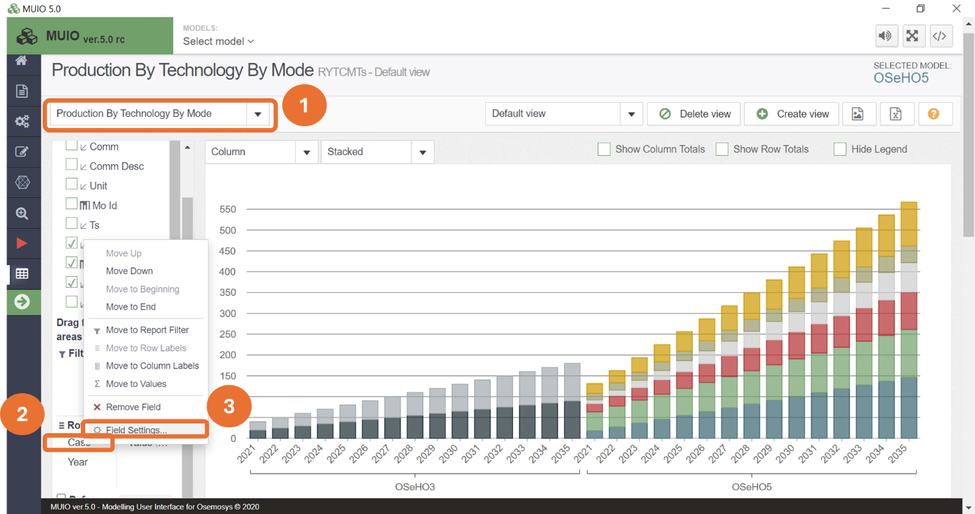
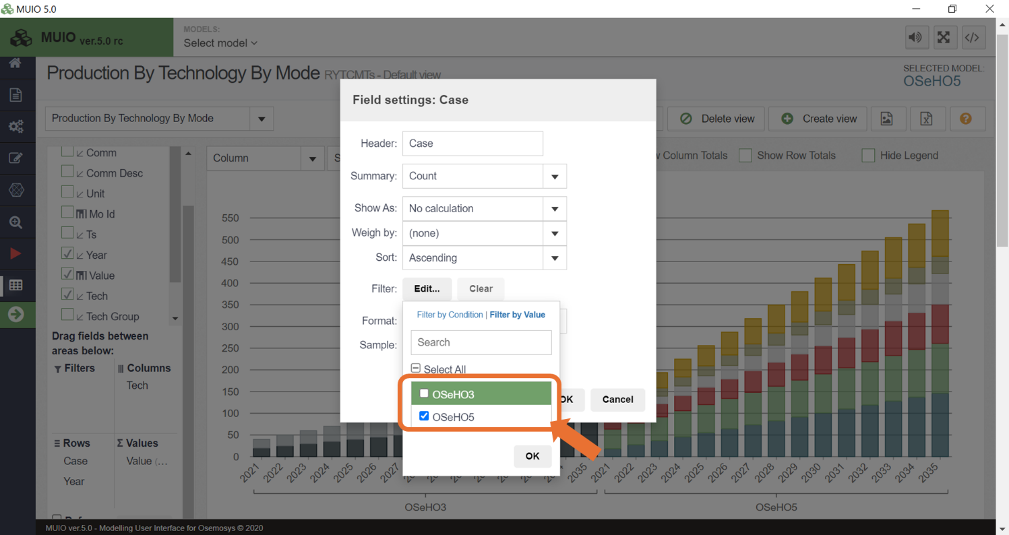
NOTE: You can also delete previous cases in the Run tab on the sidebar.

- After this, you can also filter the technologies to only PWRDSL, PWRNGS, PWRTRN, and PWRDIST. NOTE: If you cannot remember how to do this, follow the steps in hands-on 3. Your graph should look like the one below.

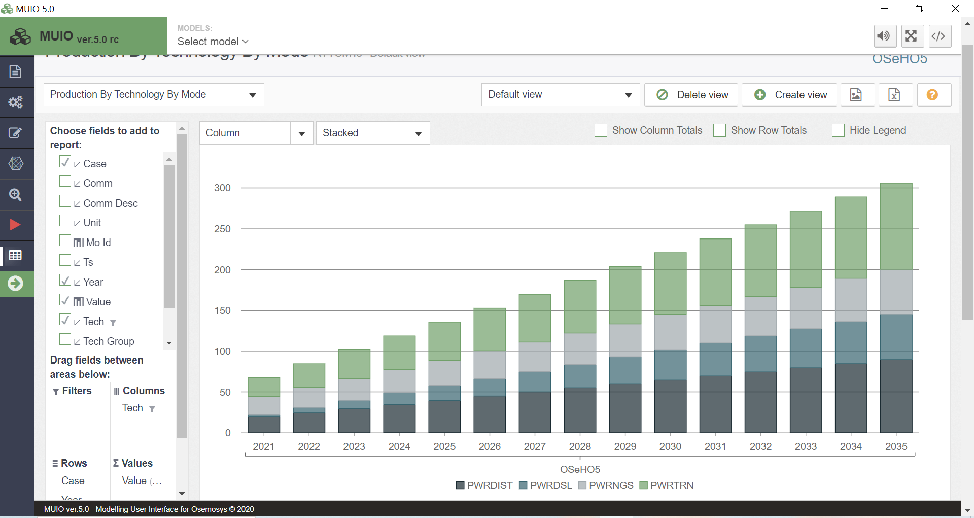
Notice that the production of PWRDIST is equivalent to the electricity demand, as this technology delivers the final electricity to the system. Conversely, you can verify that the electricity production of ELC002 by PWRTRN equals the energy demand multiplied by the input activity ratio of PWRDIST, since the transmission system must supply both the electricity demand and the losses in the distribution system.
Similarly, the combined electricity production of PWRDSL and PWRNGS equals the electricity delivered by the transmission system multiplied by the input activity ratio of PWRTRN. This is because power plants must supply electricity to the transmission system, accounting for losses within the system.

- Repeat the process to visualize the graph of New Capacity. In this case, you can observe that from 2021 to 2023, there is no need for new investments in power plants or transmission-distribution systems. This indicates that the current installed capacity is sufficient to meet the projected electricity demand for the first three years. However, starting in 2024, the need for augmenting installed capacities in both power generation and electricity transportation begins to increase progressively. By 2026, the growth in new infrastructure becomes steady, reflecting a constant increase in electricity demand and the complete utilization of all residual capacities.

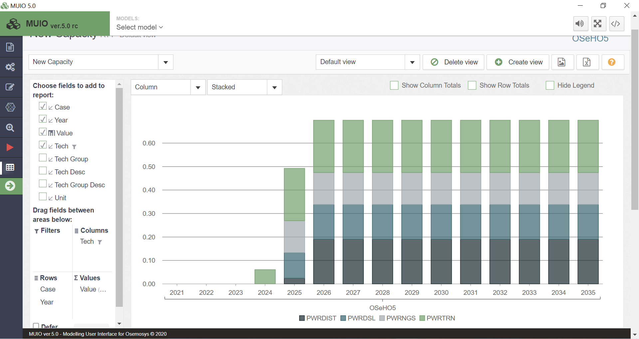
Question to consider: Why is the newly installed capacity of diesel power plants higher than that of natural gas power plants, even though the capital and fixed costs are the same, and the variable cost of importing diesel is significantly higher than producing natural gas?

Two things to note when visualizing in the UI:
1. Make sure to play around with the filters and graph types (as there is a good amount of customization options).

2. Underneath the graph you will see a table that states the values specific to the technologies on that graph. These numbers are rounded up or down to a whole number, so they may not always be most useful. Therefore, you can select the number of decimal places to be shown by changing the format in the field settings option of the filter Values in the Values tab.

