Model for Analysis of Energy Demand (MAED)
Hands-on 5: Entering Input Data for the Reconstruction of the Base Year
Licence:
This work is licensed under the Creative Commons Attribution 4.0 International License (CC BY 4.0). To view a copy of this license, visit https://creativecommons.org/licenses/by/4.0/.
Attribution:
Please cite as: Kiley, F. (2025) An Introduction to Simulating Energy Demand with MAED. Version 1. Climate Compatible Growth Teaching Kit Website, Climate Compatible Growth.

Learning outcomes
By the end of this exercise, you will be able to:
- Enter General Information Data for the Reconstruction of the Base Year
- Enter Socio Economic Data for the Reconstruction of the Base Year
- Visualize Socio Economic Intermediate Results
- Enter Sector Specific data (Agriculture) for the Reconstruction of the Base Year
- View Results

Activity 1: Adding Data for the Base Year Reconstruction (General Info)
In the previous Hands-on, we configured the model structure of our case study. All the input and output data tables now correspond to the defined structure. The model is now ready to be loaded with input data.
Input data are usually entered in two phases. The first phase involves reconstructing the base year. The second phase involves entering scenario data, which are data with the assumptions about future years – we will learn how to input these future data in Hands-on 7.
When phase one is completed and the reconstructed data for the base year are entered, it should not be changed. To test multiple scenarios, we need only repeat phase two and enter new scenario data based on new assumptions about future years.
N.B. The Base Year must be reconstructed for each Sector, to check that all the assumptions for that sector are correct. We will now learn how to do it for the Agriculture and the Manufacturing Sector. In Hands-on 6, we will learn how to reconstruct the Household sector. Then, you must apply the same methodology to all the other sectors in your case.
We shall practise this procedure by entering some demonstration data in the two phases described above. We shall first create a copy of Demo MAED 1 and rename it Demo MAED 2. This will have the same structure as the case Demo MAED 1, because it is a copy of it. However, we shall change the planning period to practice adding new data. Change the planning years to "2030,2035,2040", as shown below. Because this is a new planning period, all input data should now be zero. This is done to avoid conflicts with the demo case data.
In this example, 2030 is our base year so we will assume we have fast-forward into the future and 2030 is a year in the past for which we have input data.
N.B. When you will develop your real country model, you must select your Base Year (if you have the full data set available, we recommend using 2018 as a Base Year, otherwise please use the most recent year for which the full dataset is available).
N.B. You must not mix data from different years for the reconstruction of the Base Year. Let’s imagine you have selected 2018 as the Base Year, and you have most of the data you need, but still some data are missing. Then you should not use the data from another year to fill in these gaps but rather select the most recent year for which you have ALL data.
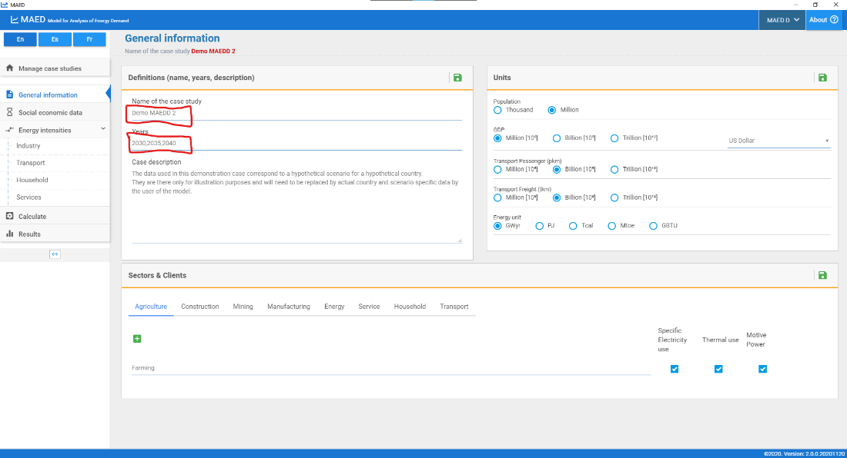

Activity 2: Adding Data for the Base Year Reconstruction (Social Economic Data)
Let us start with entering the data for demography. As the base year is 2030, we must only enter data in the white cells for that year. Enter the data given in the screenshot below. Don’t forget to click the Save button, every time you change data.
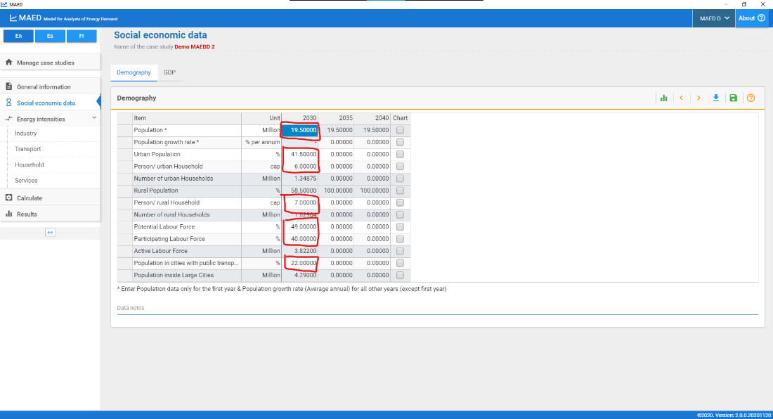

The data in the shaded cells should automatically be calculated. For example, the percentage of the rural population is calculated as the difference between 100% and the declared value of the percentage of the urban population.
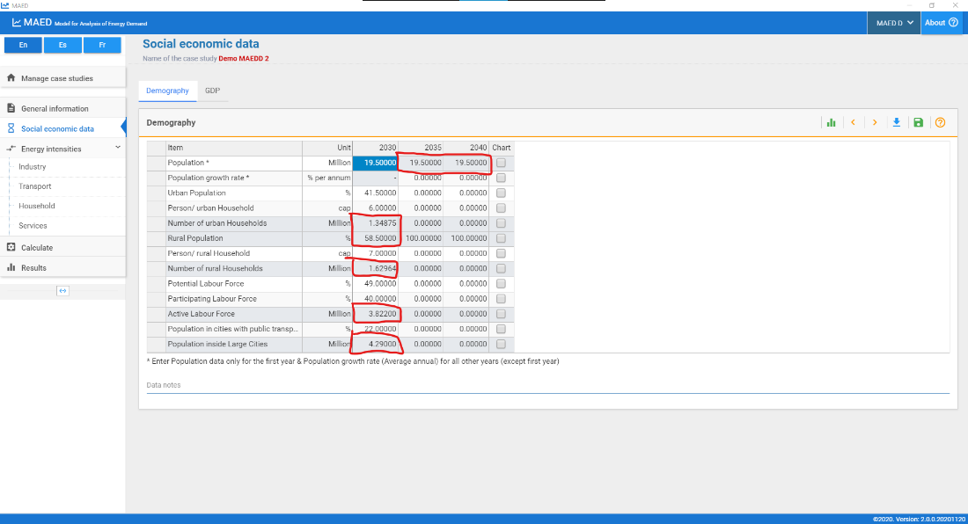

We shall similarly introduce data for the economy for the base year. Enter the data given in the screenshot below in the GDP and Distribution of GDP by subsectors tables.
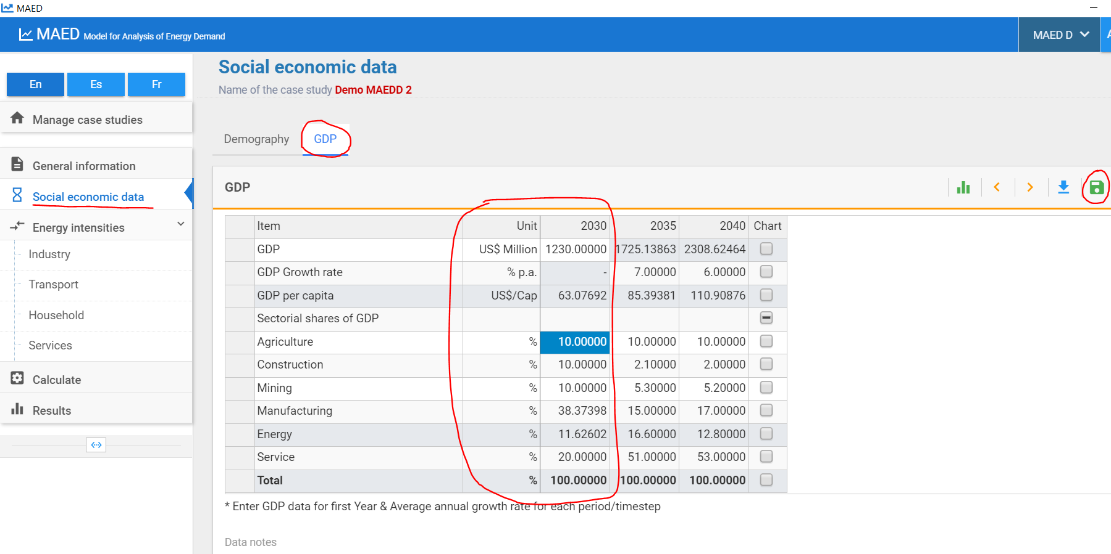

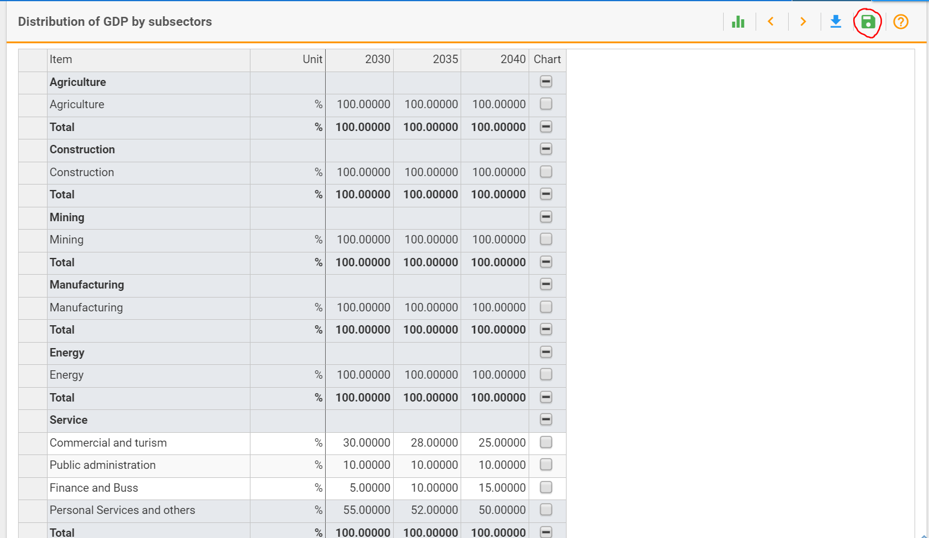
Save the data that you have entered and click the "calculate" button from the main menu.

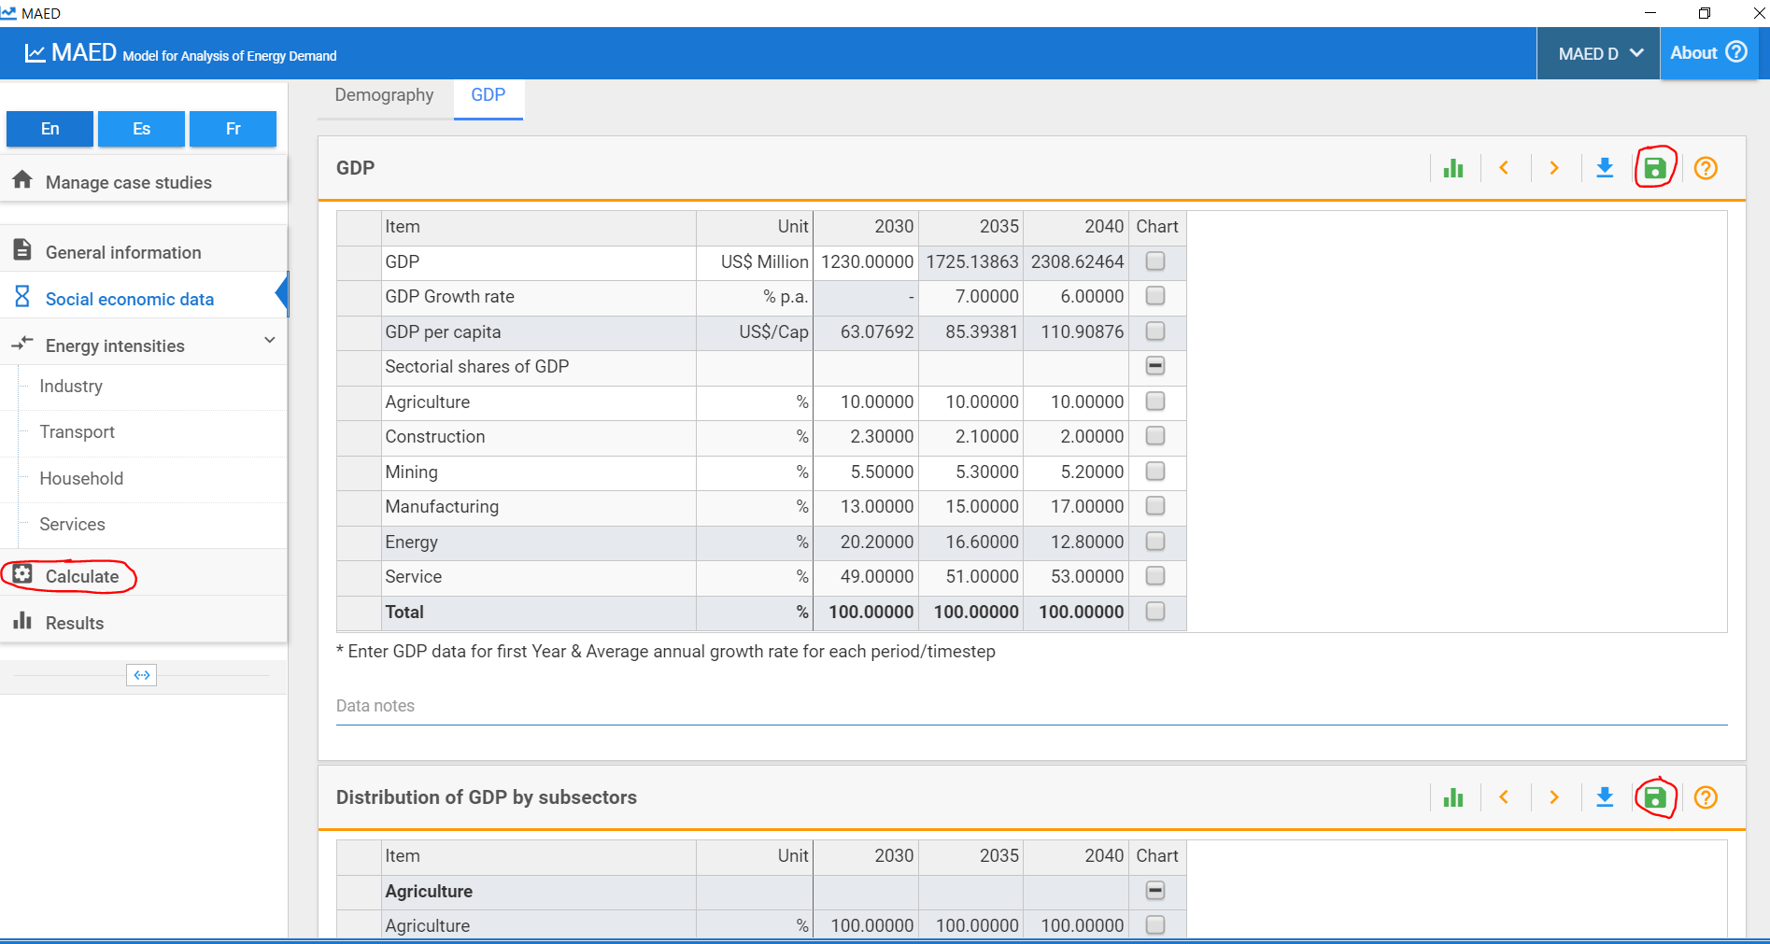

Activity 3: Visualize Socio Economic Intermediate Results
Even with the little data that we have introduced, we should be able to see some intermediate results. Clicking the calculate button should already bring you to the Results page, if not, click the results button. Now click the GDP title on the Results page. This should show sub results for the GDP. Click GDP formation by sector/subsector (absolute values).
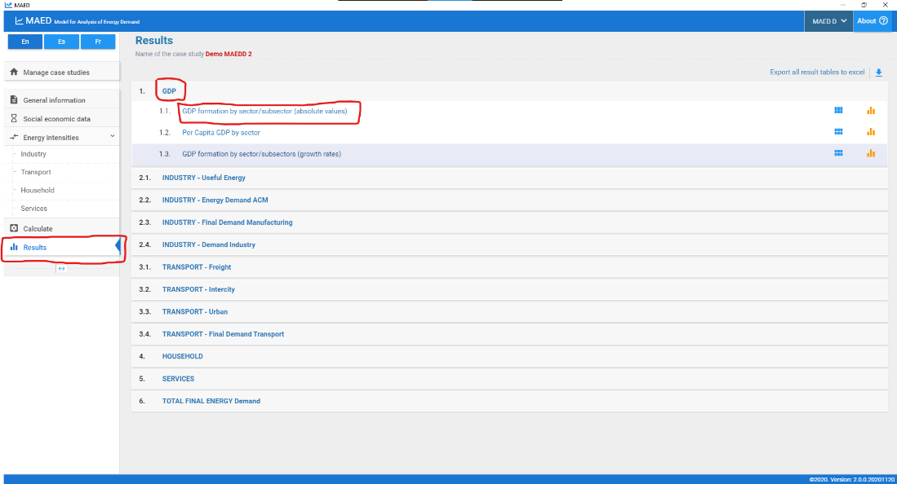
This table shows the contribution to GDP of each subsector, in the base year.
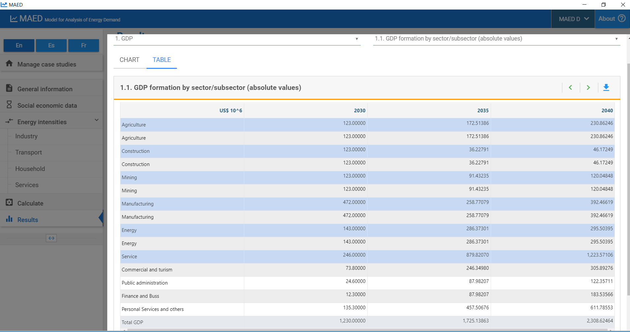

Activity 3: Calculate MAED Input Data for the Base Year Reconstruction
Let us introduce more data. We shall now introduce the Specified Energy Consumption (or Energy Intensity (EI)) for the specific electricity use, motive power and thermal uses in each subsector of the Industry. However, before being able to do so, we need to calculate the Specified Energy Consumption (or Energy Intensity (EI)). If you don’t remember how to do this please revise Lecture 5, in particular Slide 8.
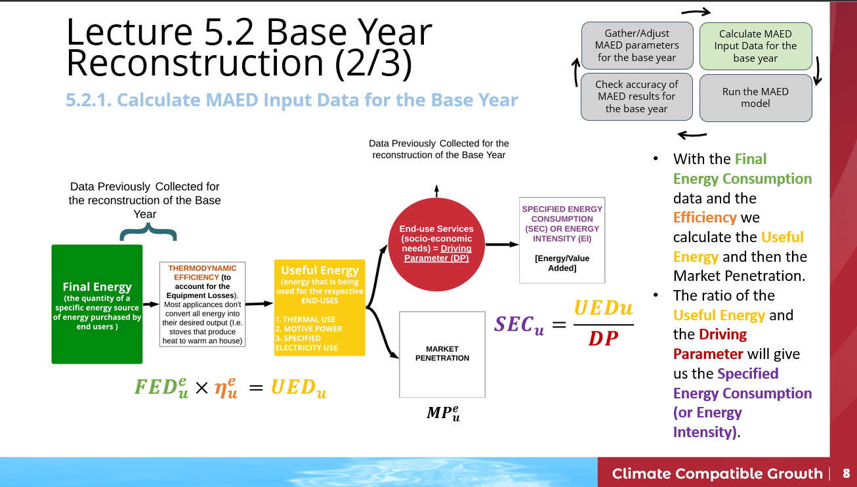
To support the calculation of the Specified Energy Consumption (or Energy Intensity (EI)) we will use a support Excel template. Please download this template available on Zenodo at this link:
https://doi.org/10.5281/zenodo.7750256
Per each sector there are 4 Tabs, in this example we have just the Agriculture Sector so in the Excel there will be:
- IND_AGR_RawData: in this Sheet we will collect the Raw data needed for the Base Year reconstruction.
- IND_AGR_Reco: in this Sheet there are tables that help you to do the calculations needed to get to the Specified Energy Consumption (or Energy Intensity (EI)).
- IND_AGR_Inp: this Sheet will have the data ready to be added into MAED.
- IND_AGR_Out: here you can calculate the expected outputs and double check that the Base Year was successfully reconstructed.

Step 1 – Raw Data Collection: The Raw Data needed for the Base Year Reconstruction for the Agriculture Sector are the Final Energy Consumption (per each energy form and per each end use) data and the Efficiency (per each energy form and per each end use). Additionally, we need the Total GDP in US$ million and the Agriculture GDP (as added in the Activity 2 of this Hands-on). Make sure that the tables in the IND_AGR_RawData Sheet in the Excel Template are populated with the following data. Then move on to Step 2.
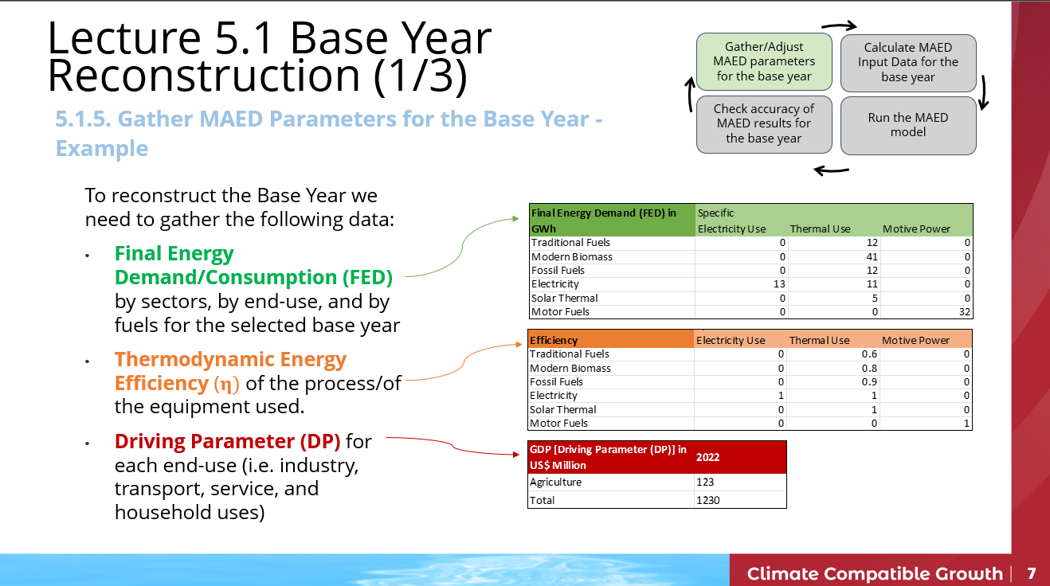

Step 2 – Calculate MAED Input Data for the Base Year: with the Raw Data collected we can now move on and calculate the Useful Energy and then the Penetration of energy forms.
Go to the IND_AGR_Reco Sheet and multiply the Final Energy Demand by the Efficiency to get the Useful Energy Demand.
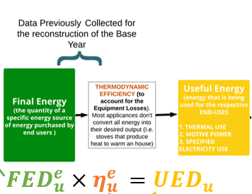

And fill in the table for Useful Energy Demand.
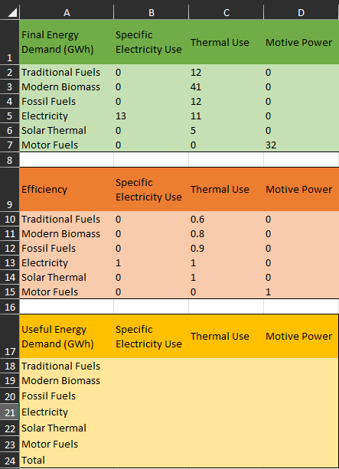
Congratulations, you have now calculated the Useful Energy Demands for each energy form (Traditional Fuels, Modern Biomass, Fossil Fuels, Electricity, Solar Thermal and Motor Fuels) for each end-use of the Agriculture Sector (Specific Electricity Use, Thermal Use, Motive Power).

Let’s move on to calculate the Penetration of Energy Forms by dividing the Useful Energy Demands of each fuel by the total Useful Energy Demand. An example for the end use “Specific Electricity Use” is shown in the picture below. Apply the same formulas and calculate the Penetration of the Energy Forms for the Thermal Use and the Motive Power (based on the Useful Energy Demand you have calculated in the previous step).

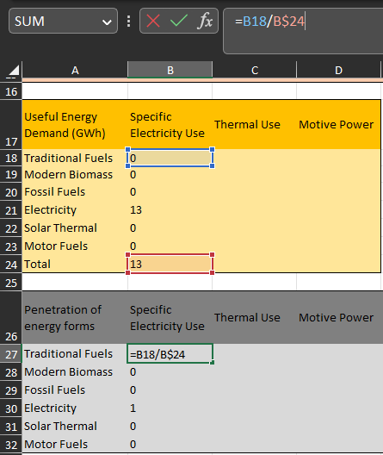

Finally, calculate the ratio of the Useful Energy and the Driving Parameter (Agriculture GDP) to obtain the Specified Energy Consumption (or Energy Intensity) per each end-use.
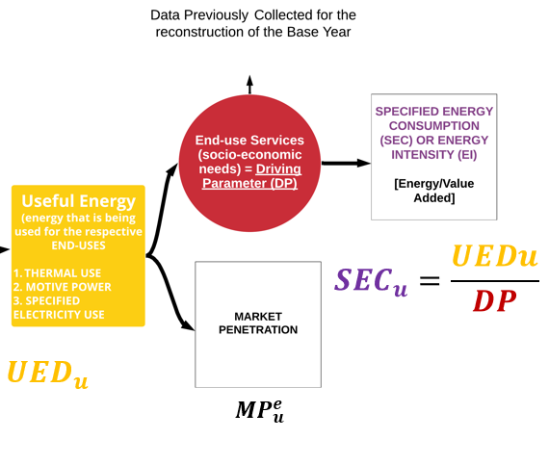
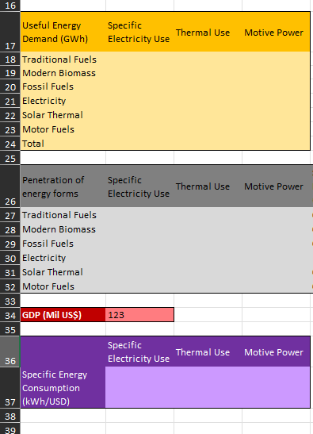
Fill this in

Congratulations, you have now calculated the three Specified Energy Consumption (Energy Intensities) for each of end-use in the Agriculture Sector.

Step 3 – Input Data for the Base Year: We now need to input the calculated and collected data into MAED. Go to IND_AGR_Inp Sheet. This tables should be now filled in with the data from IND_AGR_RawData and IND_AGR_Reco.
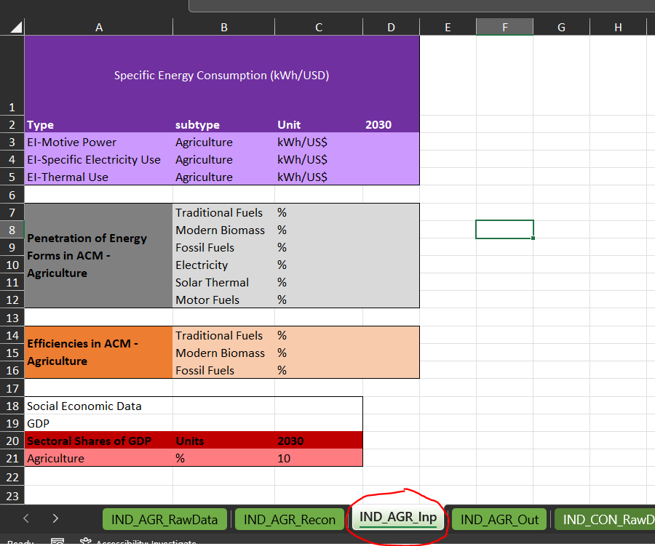
Then, go into MAED Software to the Energy Intensities for Industry page and add the data that you have calculated per each end-use. Be carefully with the energy unit, highlighted by the red box (in this case, we have kWh/US$) and with the order of the Energy Forms. Let’s start with EI for Motive Power, add the data you have calculated for 2030. N.B. Don’t forget to Save when you add data.
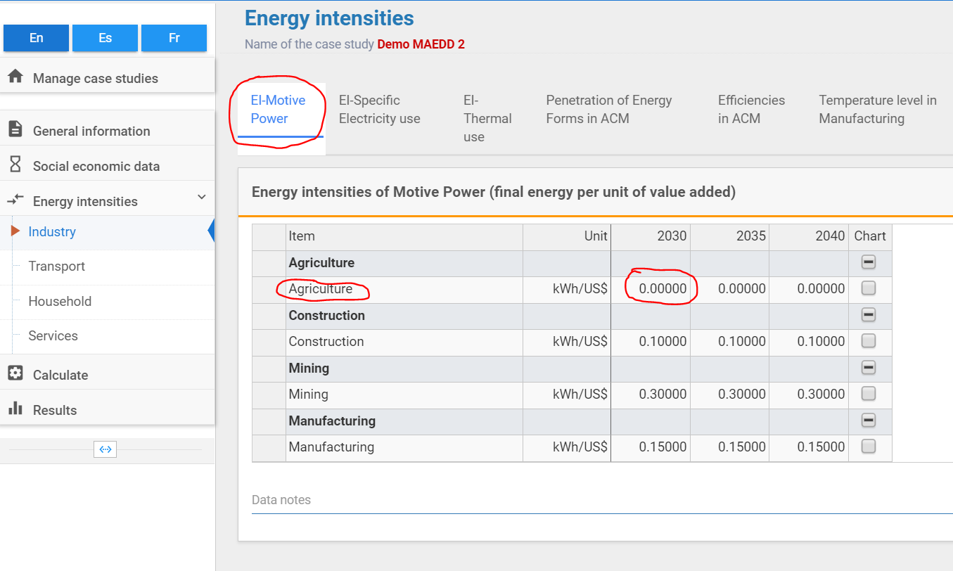

Then do the same with the EI-Specific Electricity Use. N.B. Don’t forget to Save when you add data.
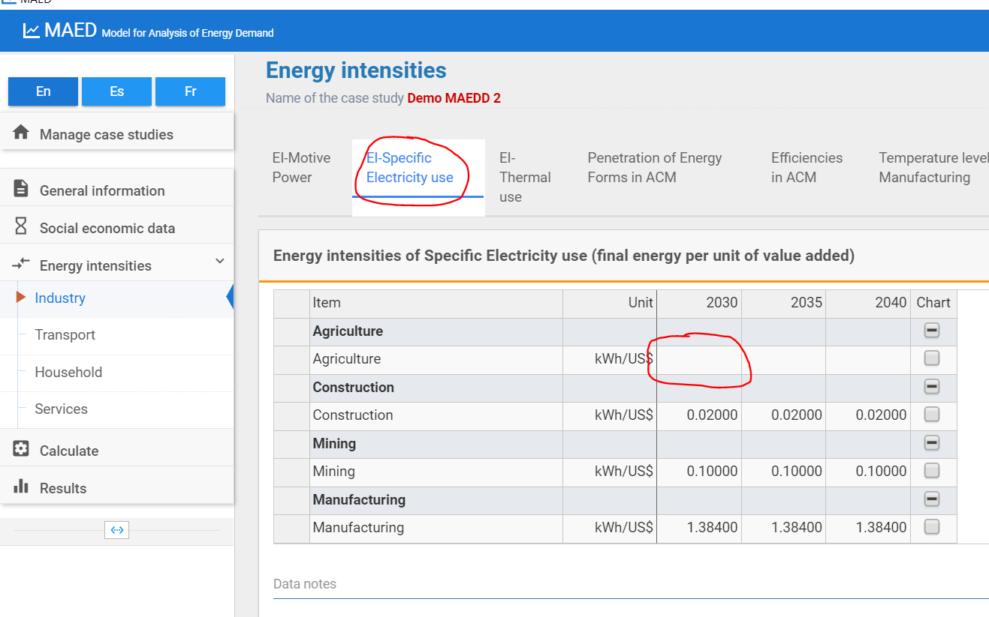
And finally for EI-Thermal Use. N.B. Don’t forget to Save when you add data.
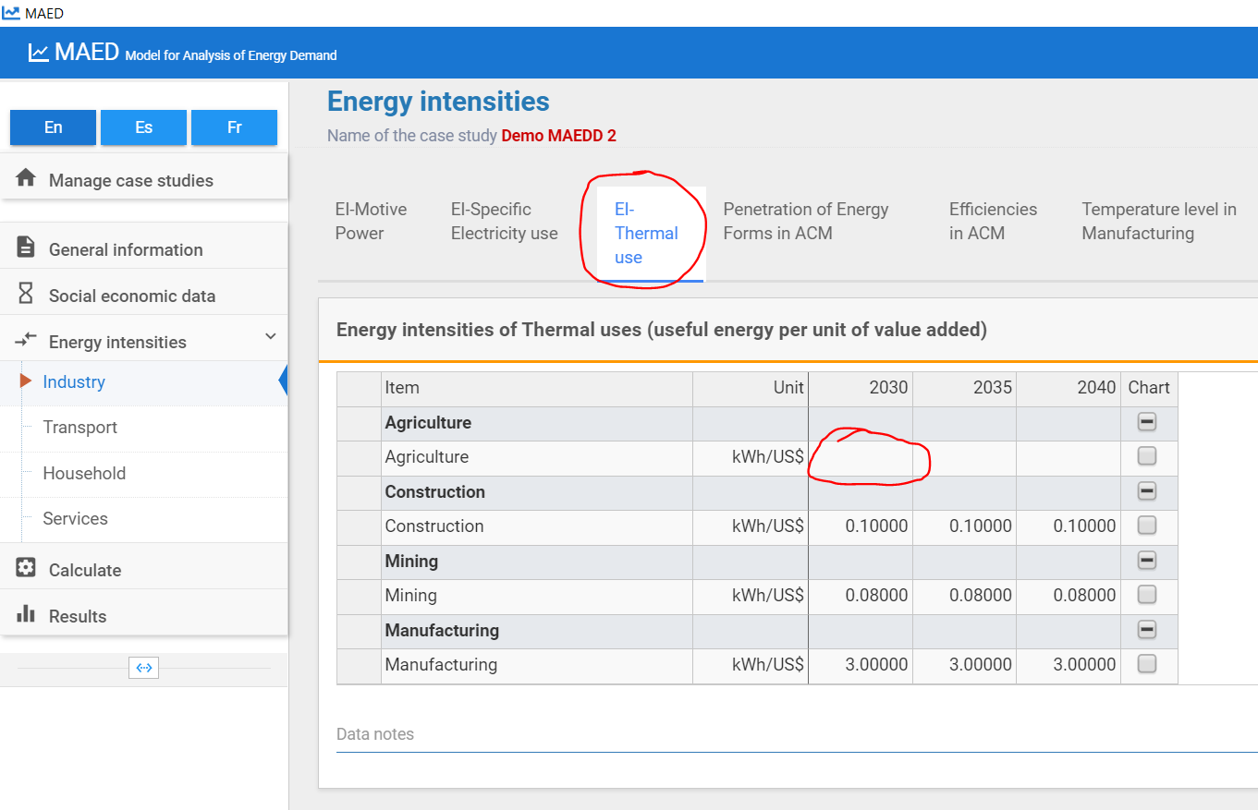

As soon as the values of the energy intensities for the motive power are introduced, some interesting results can be seen. For example, after clicking Calculate, we can see the values of the useful energy, used to produce the motive power in agriculture for the base year.
Now let’s input the Penetration of Energy Forms into MAED for the Agriculture sector in 2030 and SAVE. Remember that Penetration of Energy Forms is only relevant for the Thermal Uses end use because the other end uses (Specific Electricity Uses and Motive Power) are non-substitutional i.e. they only have one fuel (electricity and motor fuels respectively). So, by default, their Penetrations are fixed.
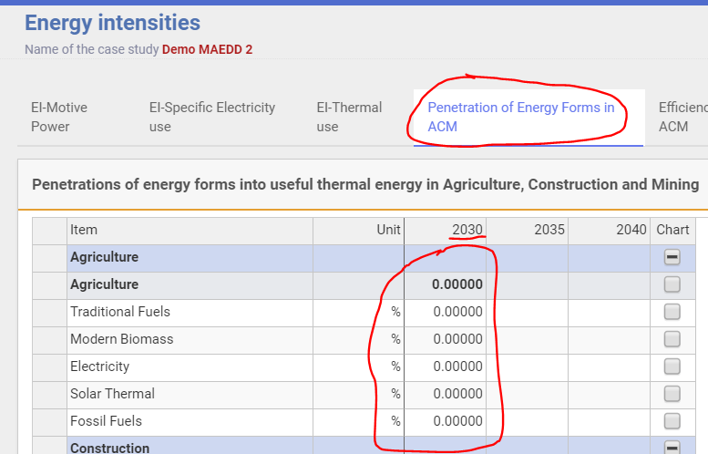

Then we move on to calculate and then add the Efficiencies for the Thermal use in PERCENTAGE (%) and then SAVE. We are only defining efficiencies for thermal uses because in the MAED model, FED=UED for Specific Electricity Uses and Motive Power i.e. efficiency = 100%. This assumption is made because those end uses are non-substitutional.
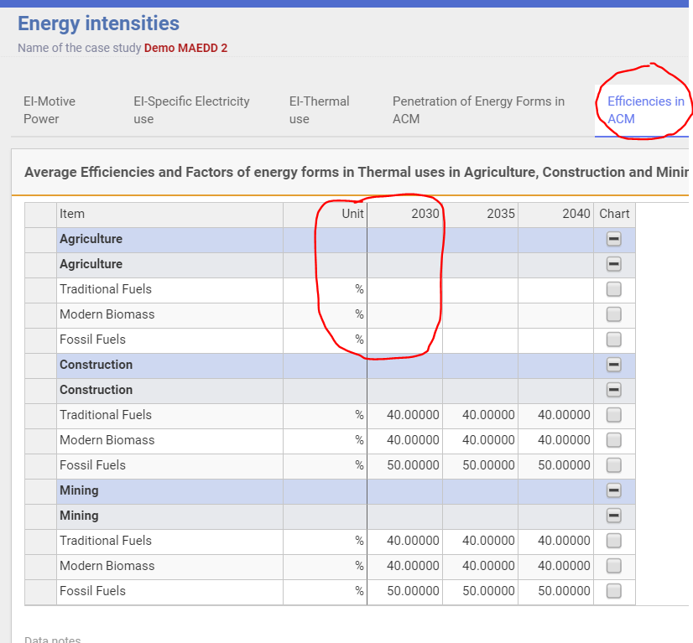
It is at this point in the process that the results from the MAED model should be compared to recorded data to confirm the accuracy of the reconstruction of the base year. Go to the Results page and then check the results in 2.2.2.
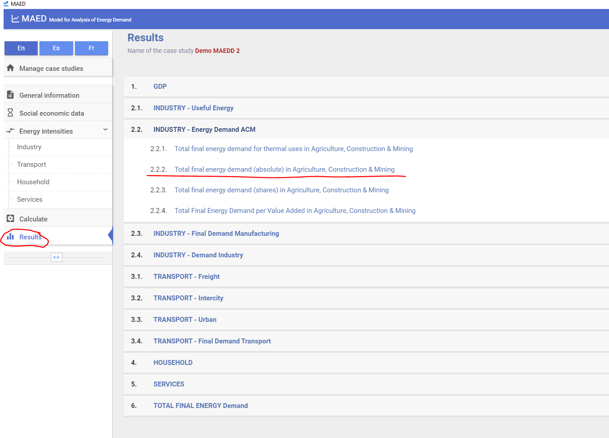

Now check the results that you have obtained for “2.2.2. Total final energy demand (absolute) in Agriculture, Construction & Mining” for 2030 (which is our Base Year for Industry) with the data in your Excel template. To do so, go into the Excel Sheet called IND_AGR_Out and check that the Excel results are the same as the ones you obtained in MAED, as explained in Lecture 5.

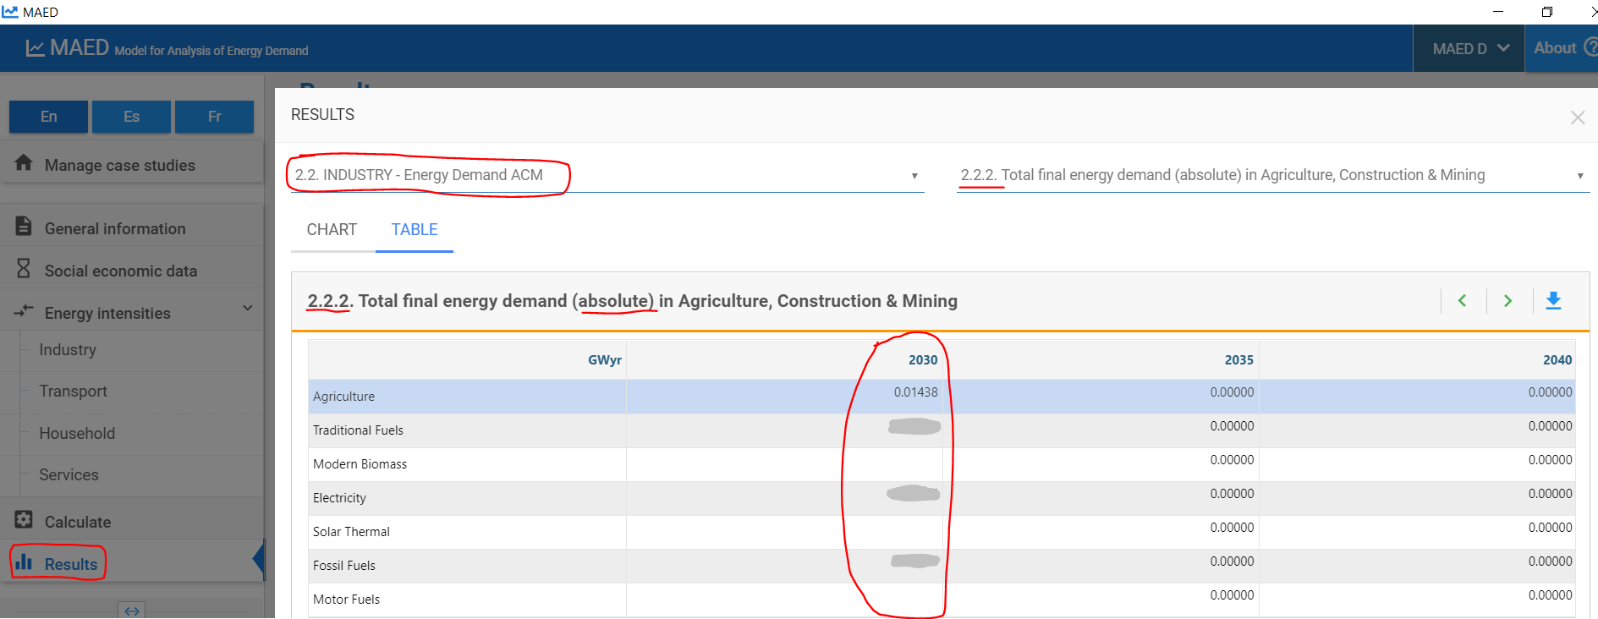
As an example, in the picture below it is shown the formula. Sum up the Final Energy Demands per each energy form for the three end uses and divide this number (which is in GWy) by the number of hours in one year which is 8760 to obtain the results in GWh.
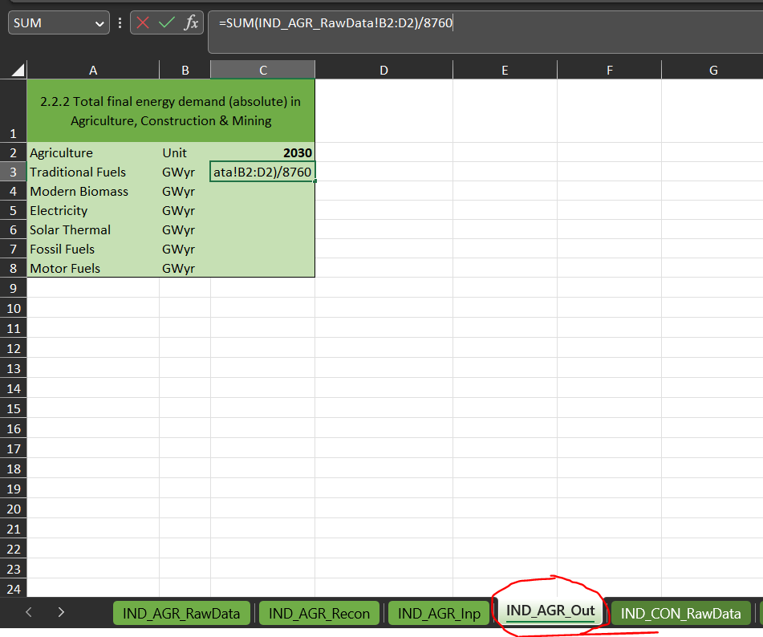
If the numbers in this table are the same as the results shown in MAED then you have successfully reconstructed the Base Year 2030 for the Agriculture Sector. If not, you need to go back and change your input data until they don’t match.
When you build your real country case study you will have to repeat the same exact steps explained for the Agriculture sector to reconstruct the Base Year for the Construction and Mining Sector. The Manufacturing sector is similar, but as seen in the previous Hands-on, the Thermal Use is split into High Temperature, Medium Temperature and Low Temperature.

