Energy System Modelling Using OSeMOSYS
Hands-on 4
Please use the following citation for:
- This exercise
Plazas-Niño, F., Alexander, K. (2025, February). Hands-on 4: Energy System Modelling Using OSeMOSYS (Version 1.0.). Climate Compatible Growth. DOI: 10.5281/zenodo.14868718

- OSeMOSYS UI software
Climate Compatible Growth. (2024). MUIO (Version v5.0.0). GitHub. https://github.com/OSeMOSYS/MUIO/releases
____________________________________________________________________________

Learning outcomes

By the end of this exercise, you will be able to:
- Define technologies representing the domestic production of energy commodities
- Define technologies representing the import of energy commodities
NOTE: We will not run the model at the end of this exercise.

Define technologies representing the primary energy supply

In Lecture 5 we learnt how to represent a technology in OSeMOSYS, and which parameters characterize the primary energy supply technologies. As said, these technologies can represent domestic production/extraction or importation of fuels such as coal, natural gas, crude oil, and oil products. In this Hands-on, we will start to create our country case adding 2 technologies: one for the import of diesel and one for the domestic production of natural gas. We will build the highlighted part of the RES below.
Note: Update your RES by adding these new components in diagrams.net, as studied in Hands-on 3.
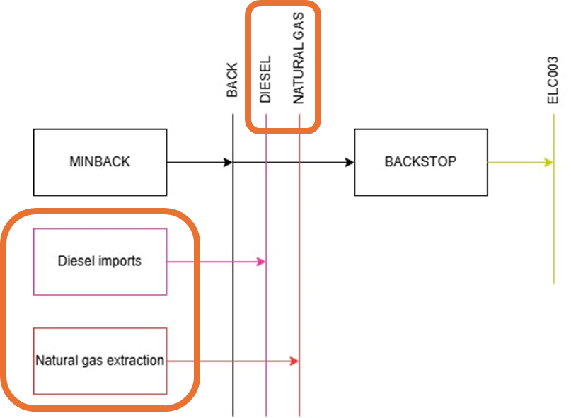

In order to represent a primary supply technology, remember that the following parameters must be considered:
- OutputActivityRatio: defines the fuel provided (in this case natural gas).
- Capital cost: defines a virtual cost for building infrastructure to supply the fuel.
- Variable cost: defines the cost of production per unit of fuel.
- Operational life: defines a default lifetime for infrastructure dedicated to supply the fuel.
- TotalTechnologyModelPeriodActivityUpperLimit: defines the level of proven fuel reserves that are available for extraction throughout the entire model period (we will express it in PJ).
- TotalTechnologyAnnualActivityUpperLimit: defines the maximum annual rate of production of fuel.

Define technologies representing the domestic production of energy commodities

Try it: Let’s add MINNGS - the technology representing the domestic extraction of natural gas.
- Before you do this. Follow the same process as before and copy your model from hands-on 3. Then rename it (i.e., OSeHO4). This is so that if there are any errors, you can go back to your old working model if necessary.
- Now go to the model configuration page. Firstly, add a commodity called ‘NGS’ (natural gas).
- Then add a technology called ‘MINNGS’. From this you need the output of MINNGS to be NGS, but there is no input (the same as when you added MINBACK). The units of capacity and activity are PJ.
- Now you have added the technology and commodity. You need to add the relevant data. REMEMBER TO UPDATE YOUR MODEL.
- Add the data for MINNGS according to the Data Preparation File OSeHO4.

You need to add the data for the 6 parameters that were listed previously.

SAVE DATA!!! UPDATE MODEL!!!

Voilà: you now have added one new technology (MINNGS) and one commodity (NGS) to your model.
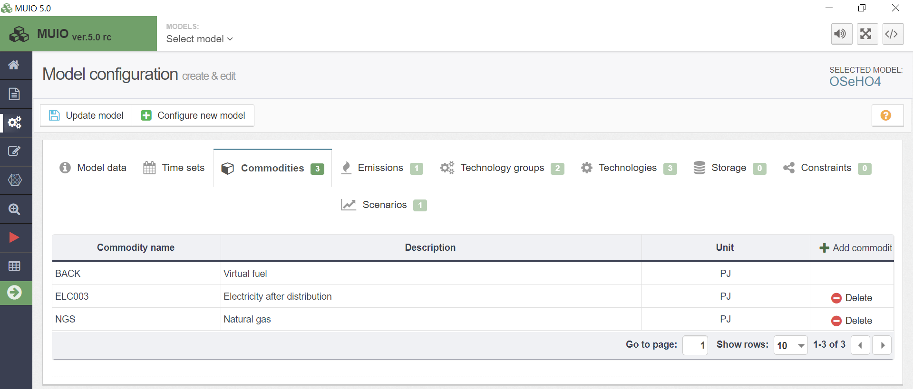
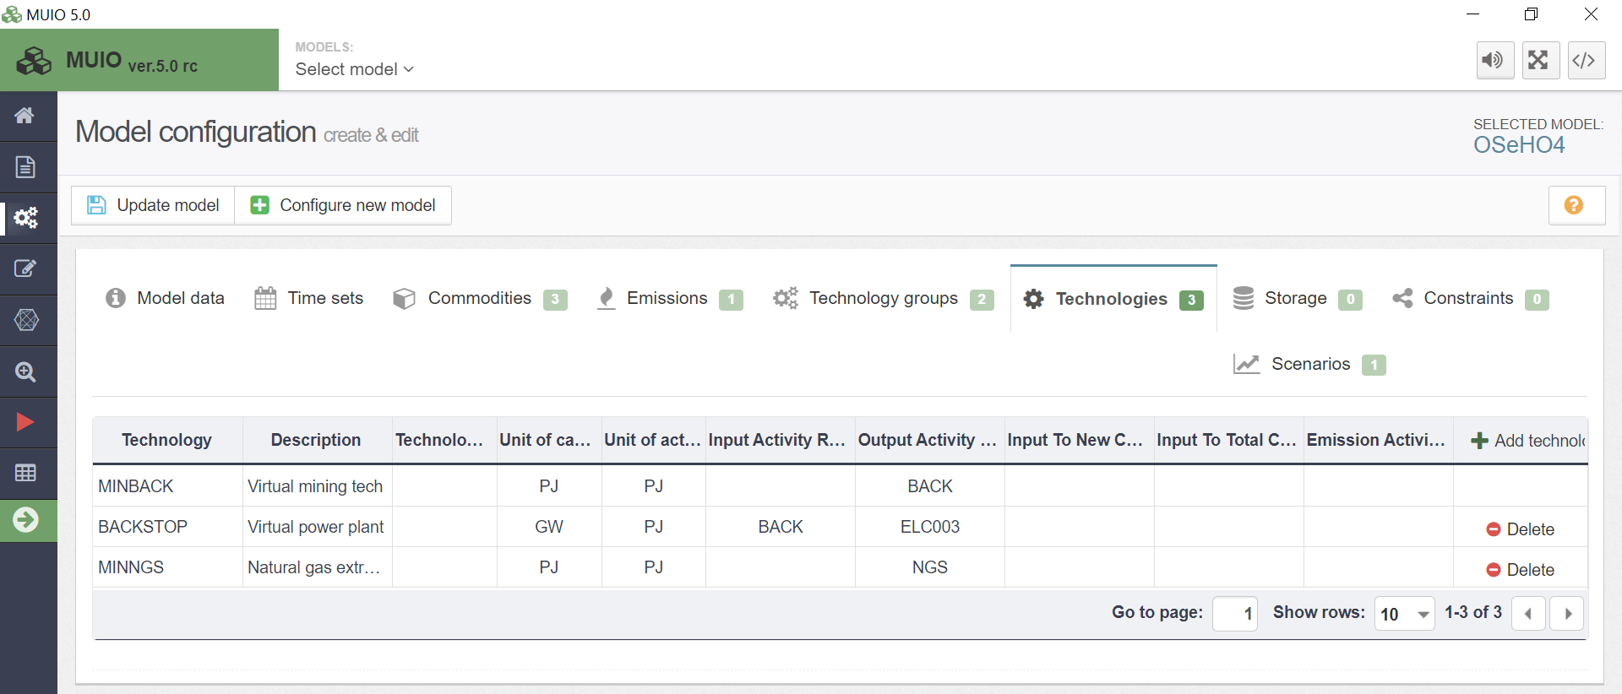

Define technologies representing the import of energy commodities

We will repeat the exercise once more giving the case of a technology which represents the import of diesel (IMPDSL). When representing an Import technology, the following parameters must be considered:
- OutputActivityRatio: defines the fuel provided (diesel in this case).
- Capital cost: defines a virtual cost for building infrastructure to import the fuel.
- VariableCost: defines the cost of importing the fuel.
- Operational life: defines a default lifetime for infrastructure dedicated to import the fuel.

Try it: let’s add this technology in the model.
- Go to the model configuration page and add a new technology called ‘IMPDSL’.
- You should add a new fuel DSL representing diesel, which is the output fuel for IMPDSL.
IMPORTANT: Remember to update your model each time you add data, technologies, or commodities. As well as saving data each time.
- Add data for IMPDSL as presented in the Data Preparation File OSeHO4.
- Your model config page for commodities and technologies, should now look like the images below (as well as the data all being correct if you have followed the steps correctly).
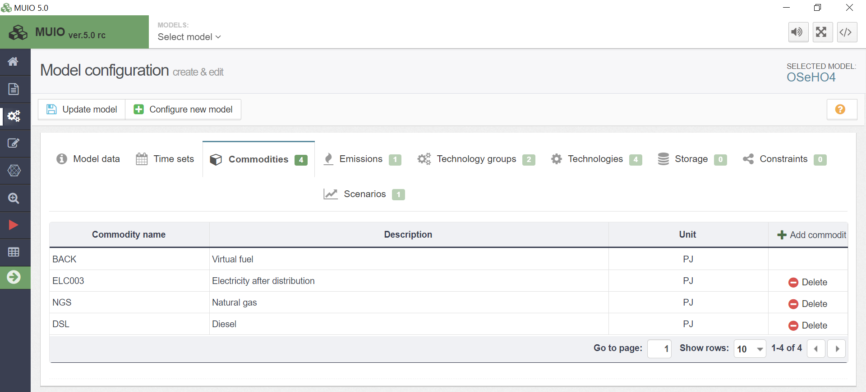
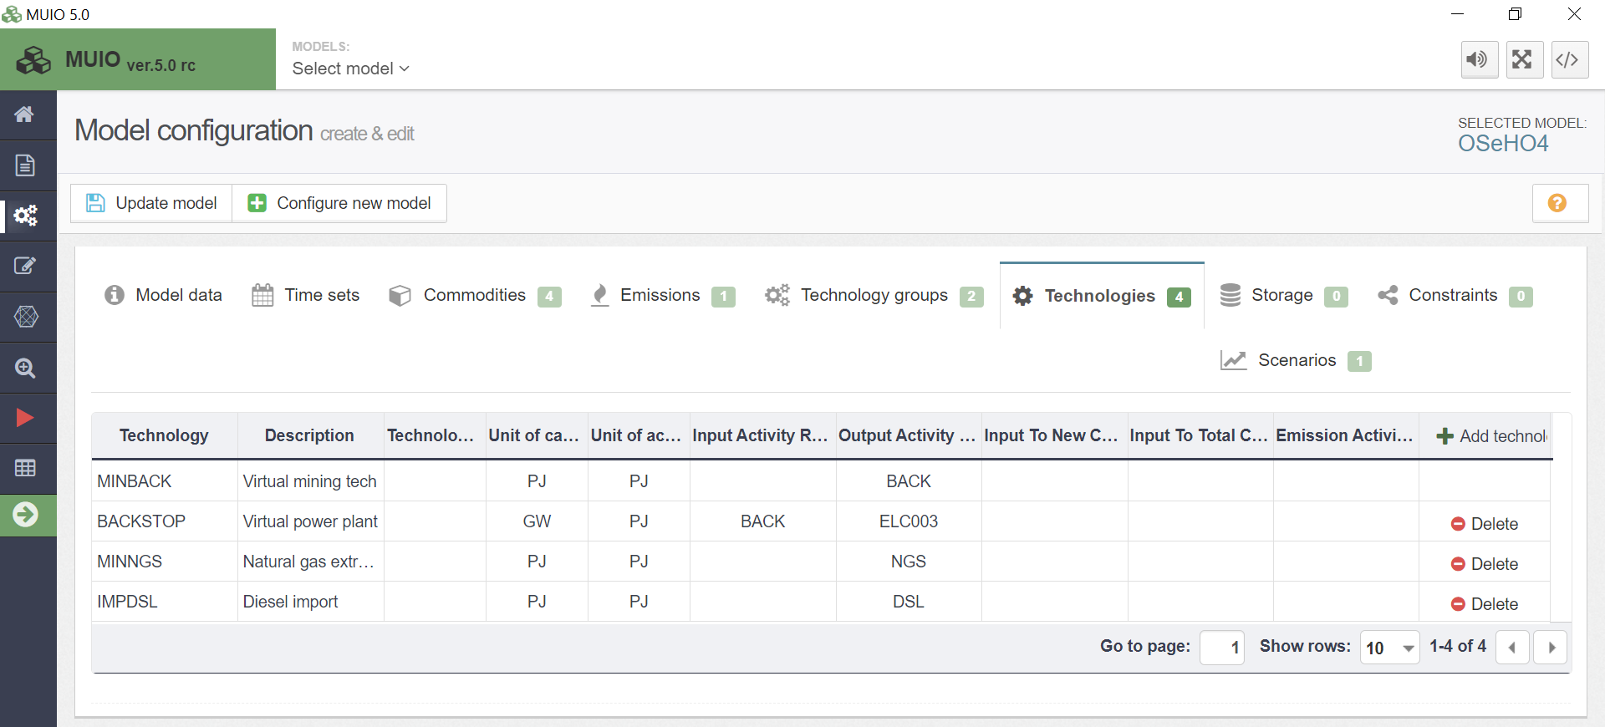

- Finally! As discussed near the end of hands-on 3, you can add technology groups. Now as this isn’t a necessity, it won’t be discussed again after this exercise. But you could set it up similar to the following:
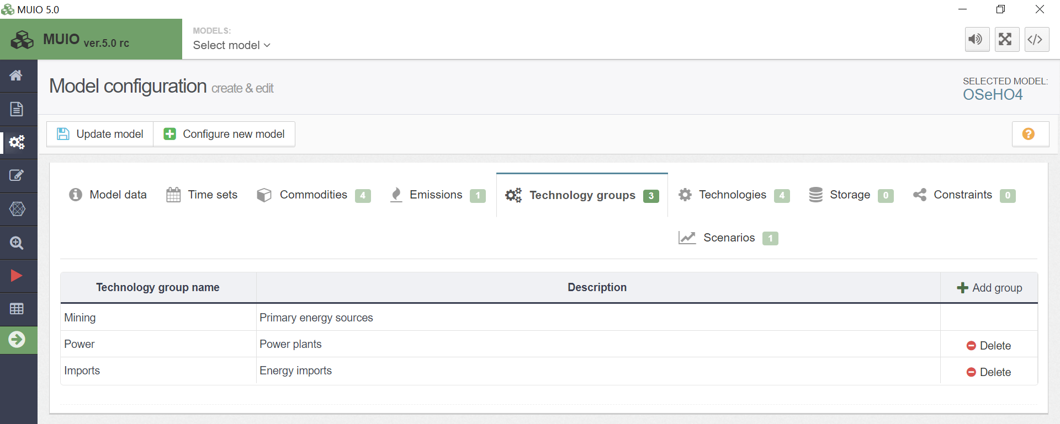

- You have completed this exercise. Save and update the model. Then you can move onto Hands-on 5.

