Energy System Modelling Using OSeMOSYS
Hands-on 3
Please use the following citation for:
- This exercise
Plazas-Niño, F., Alexander, K. (2025, February). Hands-on 3: Energy System Modelling Using OSeMOSYS (Version 1.0.). Climate Compatible Growth. DOI: 10.5281/zenodo.14868668

- OSeMOSYS UI software
Climate Compatible Growth. (2024). MUIO (Version v5.0.0). GitHub. https://github.com/OSeMOSYS/MUIO/releases
___________________________________________________________________________

Learning outcomes

By the end of this exercise, you will be able to:
- Draw a Reference Energy System (RES)
- Define fuels
- Define energy demands for a specific fuel
- Define the temporal profile of energy demands
- Define technologies that satisfies the demand
- Run the model and check results

Draw a Reference Energy System (RES)

The first skill you will train during this exercise is drawing Reference Energy Systems. As explained in Lecture 2, a Reference Energy System (RES) is a conventional aggregated representation of a real energy system.
We will create the following RES, which represents the most basic version of a system with one primary energy source (MINBACK), one intermediate energy carrier (BACK), one production technology (BACKSTOP), and one final demand (ELC003). In this initial configuration, MINBACK, BACK, and BACKSTOP are virtual components designed as a last-resort option with the highest cost for electricity production. They serve as indicators of infeasibility in your energy system, which we will analyze in future exercises.

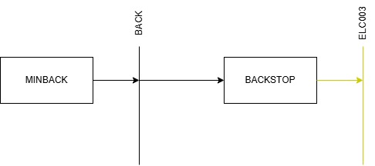

Different tools are available for this purpose, but they vary in price and functionality. For this course, we will choose Diagram.net which is free software for diagramming.
Try It: Let’s draw the first piece of your RES:
- Open Diagram.net in your browser and click Start.
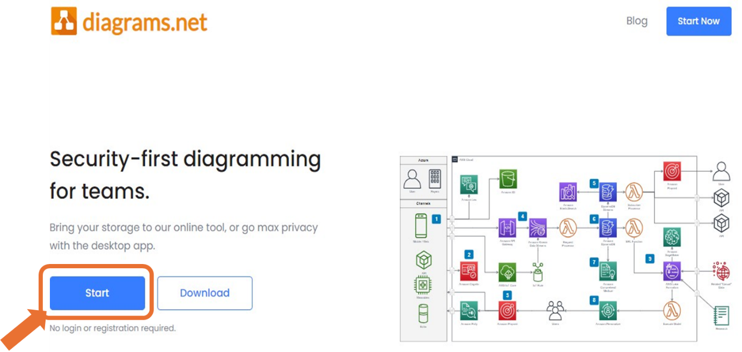

- Click Create New diagram
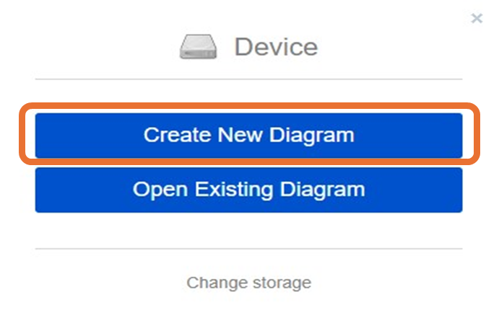
- Select Blank Diagram -> Change the name to “OSeHO3.drawio” and save it in a folder of preference.
WATCH OUT: create a folder for each hands-on exercise of this course and keep building your RES, adding every piece proposed in the exercises.
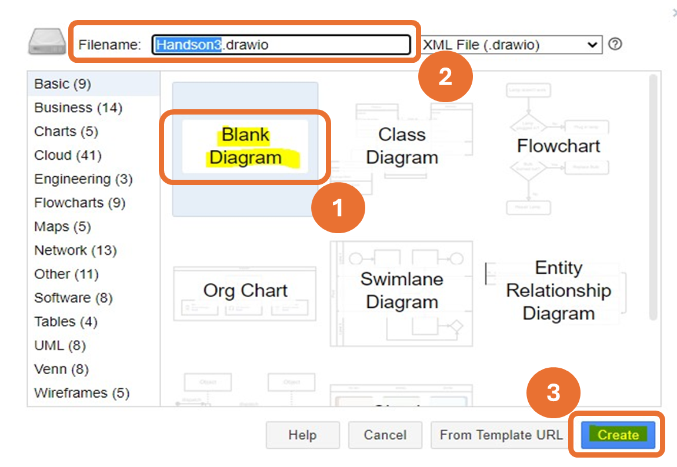

- On the left side of the tool, select a Rectangle from the General Group. Drag and drop it on the screen.
- Double click in the middle of the Rectangle to add Text. Write MINBACK.
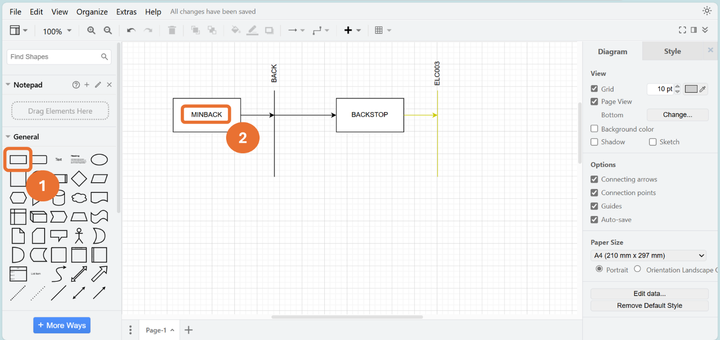
- Let’s draw the production of the virtual fuel BACK. Select a line and drag and drop it on the right side of the MINBACK technology. Bring your pointer on the line on the right side of the rectangle and some blue points will appear. Click and drag until you reach the BACK line drawing an arrow. Double click on top of the BACK line to add the code for this: BACK.

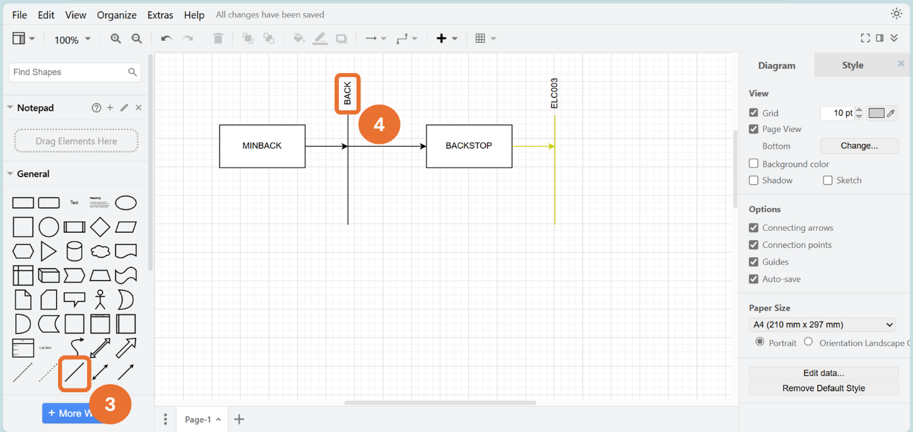
- Repeat the process to create a new technology for BACKSTOP and a new fuel for the electricity demand, ELC003, as for the naming convention guidelines explained in Lecture 3. The arrow that connects the output of the Backstop technology with the line of ELC003 represents the supply of the final electricity demand (ELC003).
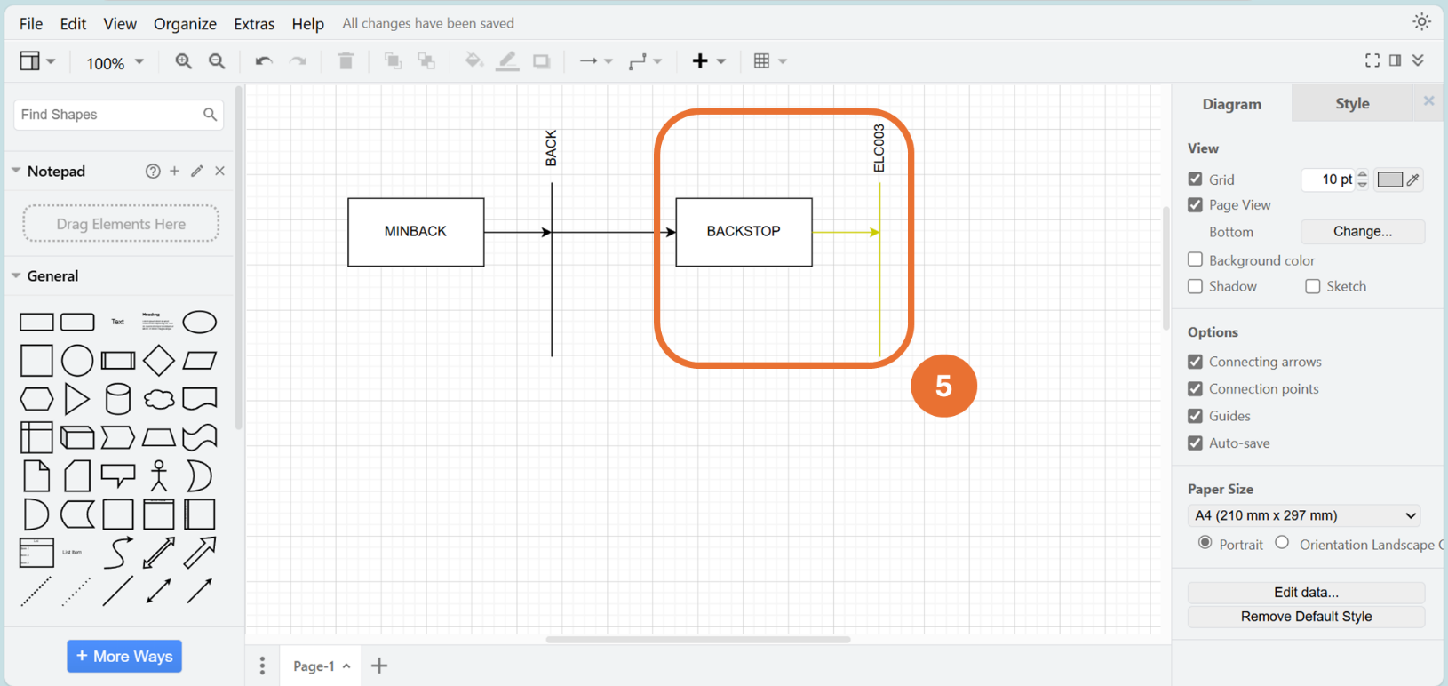
GREAT!: You now have drawn your first RES. We will add additional elements in the upcoming hands-on exercises.

Define commodities

The next step is to begin to add our commodities (fuels) into the OSeMOSYS interface.
- Firstly, go to the home page of MUIO (not the model homepage- that is the model config page). Select the OSeHO2 model on the homepage and click on the ‘Copy model’ option as learned in the hands-on 2. Select the copied model and click on ‘Configure model’ to open it.
- Rename the copy by modifying the ‘Model data’ field from OSeHO2_copy to OSeHO3.
- Press the ‘Update model’ button to save the changes.

IMPORTANT: Make copies when you move to the next HO and do not make edits on the same file. In this way if there is a problem, there is always a backup version to easily find the error.
- Now you have copied, renamed, and updated the model, you can add your first commodity. Navigate to the ‘Commodities’ tab and rename the default commodity COM_0 to BACK, keeping the unit as PJ.
- Add a description for each commodity, such as: Virtual fuel for BACK.
- When adding commodities, you must press the button on the config page ‘+ Add commodity’. Repeat the process and change the default name to ELC003 (as shown in the image below).
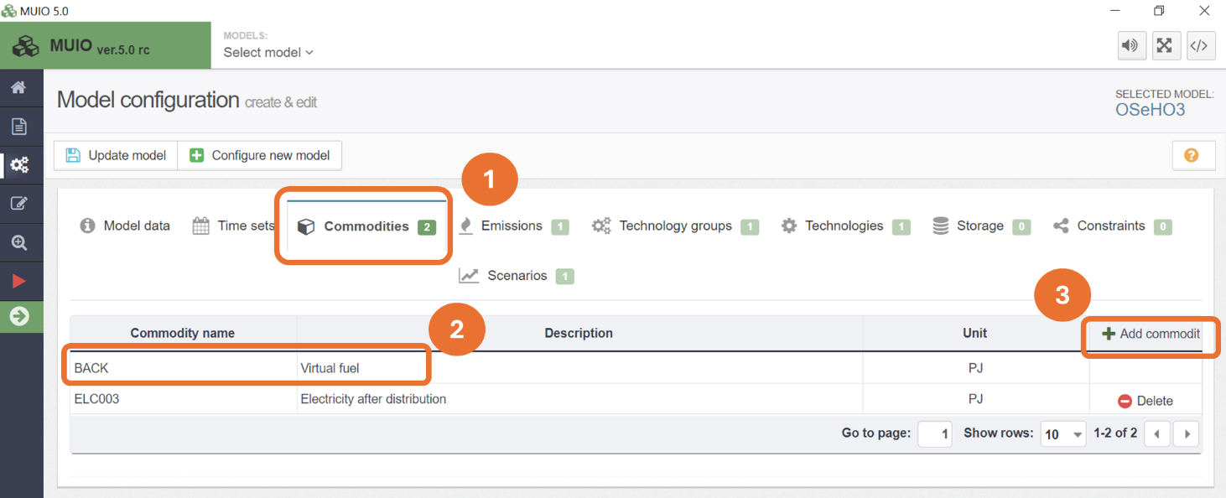
- Press the ‘Update model’ button to save your changes.

IMPORTANT: Repeat this process in the future to add new commodities (fuels).

Define energy demands for a specific fuel

Your next task will be to choose the demand type. You have two options for demand type:
- SpecifiedAnnualDemand -used for fuels whose demand varies within the year/day (e.g., electricity).
- AccumulatedAnnualDemand –used for fuels that do not necessarily have to be provided at an exact point in time (e.g., gasoline).
Try It: Add the demand for Electricity after distribution (ELC003).
- Click on the data entry button and in the search bar type ‘Specified Annual Demand’, then go to that parameter.
- You should see BACK and ELC003. Copy and paste the ELC003 demand data for the years 2021–2035 from the Data Preparation File OSeHO3. Only copy the data from cell D2 to R2. This demand increases linearly in 5 PJ steps from 20 PJ to 90 PJ.
- It should then look like the image below.

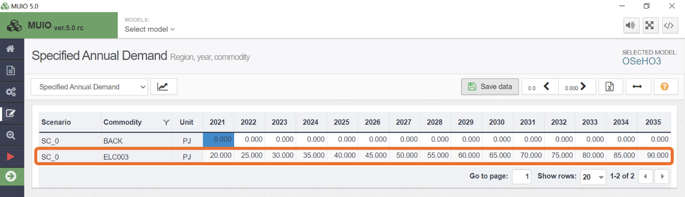
NOTE: Again, make sure you save data and update the model each time you follow this process.

WATCH OUT: For the same Commodity (Fuel) you should never add data for both
SpecifiedAnnualDemand and AccumulatedAnnualDemand. Choose the type of demand associated with that fuel following the indications given in Lecture 4.
Voilà: now you know how to add a SpecifiedAnnualDemand.

Define the temporal profile of energy demands

As said before, SpecifiedAnnualDemand is the parameter used to define a demand that changes within the year, as for the final electricity demand just seen (ELC003). Therefore, it is now important to represent this time variability, and to do so we will use the SpecifiedDemandProfile parameter (as explained in Lecture 4).

Try it: Let’s add the demand profile to the OSeMOSYS interface.
- Like previously, go to the data entry button and this time search for the parameter ‘Specified Demand Profile’.
- Then copy the data in the prep sheet from 2021-2035.
- Then go back to the OSeMOSYS interface and click on the tile underneath 2021 for ELC003-RD (value should be 0.000), then paste all of the data.

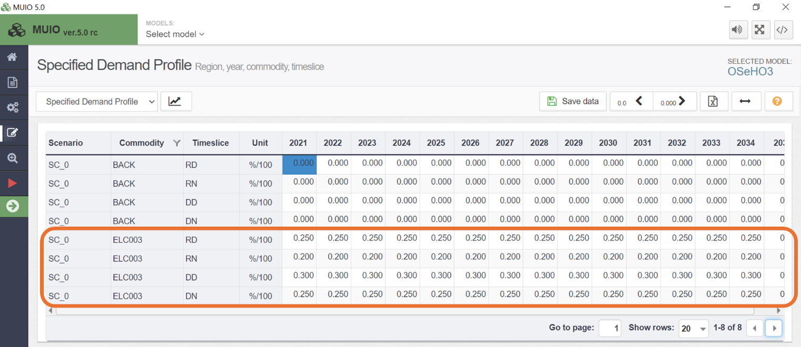
NOTE: Remember, if you want to view the data with more or less decimal places, you can click on the arrows in the upper-right corner.

- Save data and then update the model. IMPORTANT: Reminder to do this every time.

NOTE: The sum of all the Year Split values for the 4 timeslices should always be 1. The same is valid for the SpecifiedDemandProfile values.

Define technologies that satisfies the demand

As explained in Lecture 4, Backstop technologies are a last resort option for the optimization solver, being fictitious technologies with extremely high cost. We will add a simple chain of technologies to simulate the production of a virtual fuel (BACK), which will feed into a backstop technology that supplies electricity (ELC003) to meet the demand. Therefore, the backstop will be the only technology in the model capable of supplying the ELC003 demand we have added.
Try it: Add MINBACK and BACKSTOP technologies
- On the model configuration page, you must click the 'Technologies' tab and then add a technology by pressing '+ Add Technology' (similar to how you add a commodity) . As shown in the image below:

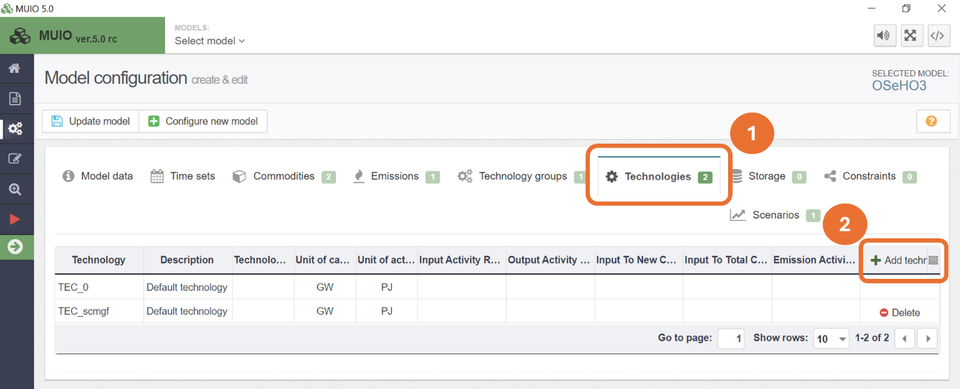

- You need to add a new one, but in this case change the names of the default technologies to ‘MINBACK’ and ‘BACKSTOP’. Once you have done this, make sure you update the model, as it will only add the new update when you do this.
- Next, you can add a description as needed and define the units for capacity and generation. For MINBACK, since this is an energy source technology, we can keep both units as PJ. However, for BACKSTOP, being a power generation technology, we will use GW as the unit for capacity. You should then set the inputs and outputs as shown in the image below. MINBACK produces BACK fuel, which is the output without any input, while BACKSTOP has BACK as the input fuel and produces electricity (ELC003) as the output. Remember to update the model after applying these changes. You are now ready to add data.

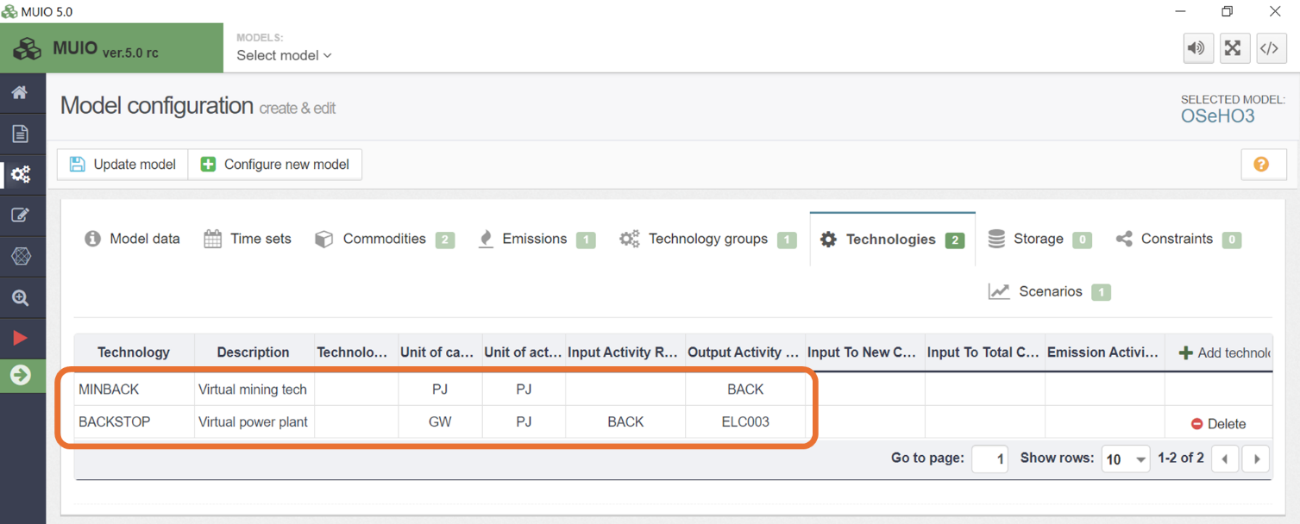
NOTE: In theory, the BACKSTOP technology represents a power plant producing energy (hence the output is ELC003). However, its primary function is to indicate a modelling failure and help accelerate the debugging process.

- You will need to add a selection of data into MUIO for the MINBACK and BACKSTOP technologies, as described in the next step. Remember to copy-paste the values until 2035 when applicable.
- You must add the data for the following parameters according to the Data Preparation File OSeHO3 (as you have done in the data entry section of the MUIO previously): Capital Cost, Fixed Cost, Variable Cost, CapacitytoActivityUnit, OperationalLife, InputActivityRatio, and OutputActivityRatio. One example for the Capital cost is shown below.

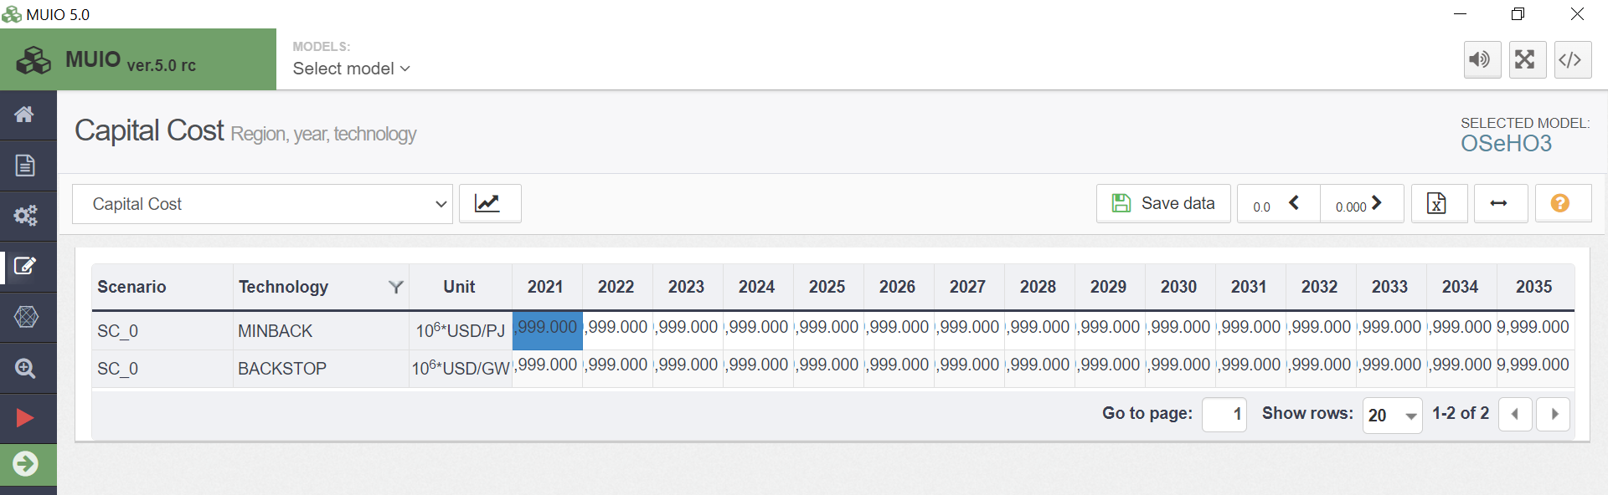

- Each time you add data to a different parameter, you must save the data before adding data to another parameter.
- You must then update the model (again, it is recommended to do this as often as possible). You will have then successfully added the MINBACK and BACKSTOP technologies with the relevant data.

Last but not least! You can create technology groups by navigating to the 'Technology Groups' tab and adding them in the same way as commodities and technologies. Once created, you can assign these groups to technologies on the Technologies tab of the model configuration page. While this isn't necessary, it can be helpful when running larger models and visualizing extensive datasets. An example is provided below.

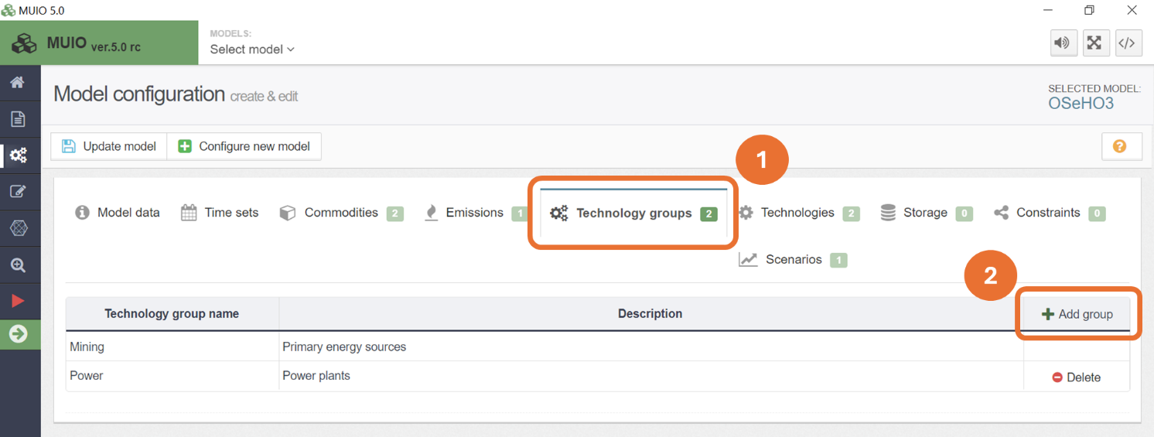

BONUS: You can use the Model Diagram tab on the left sidebar to check the reference energy system of your model. This is especially useful for verifying that all the interlinkages between technologies and commodities are correctly set. There are two visualization modes available: dynamic and simple.

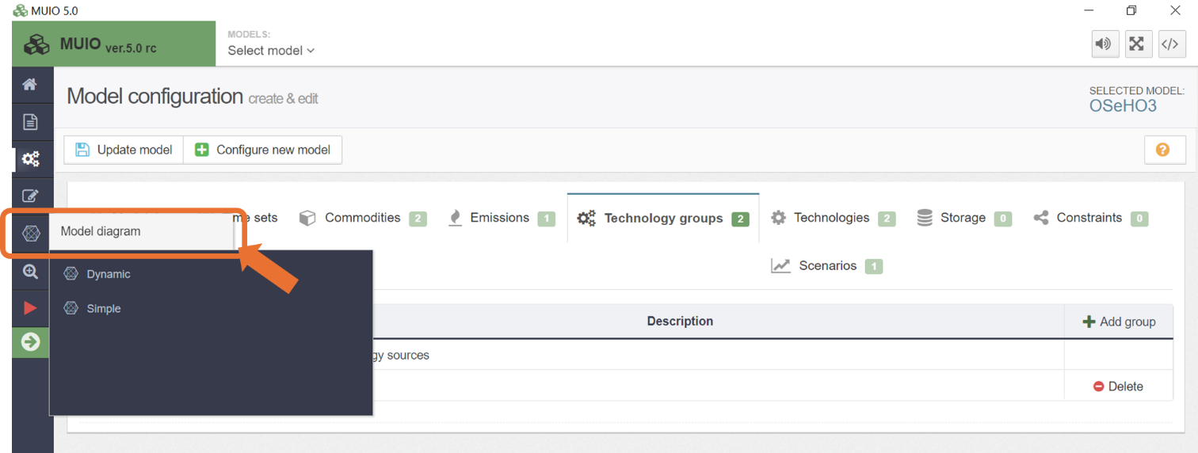

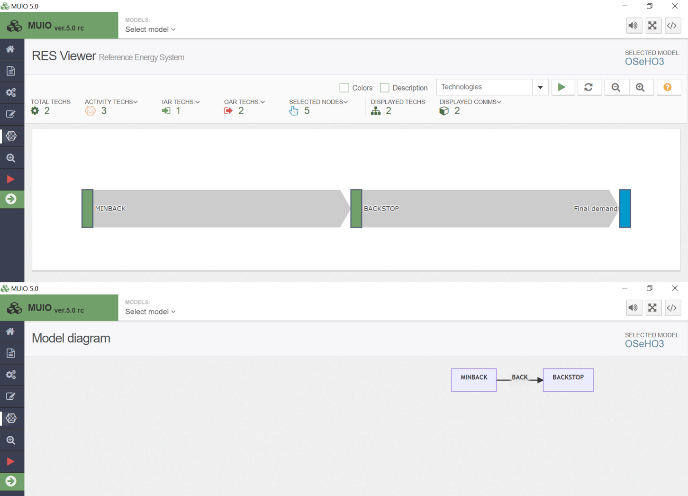

Run the model and check results on production by technology

You are now ready to run the model. Before doing so, make sure you have saved all the data added and updated the model. The visualization is quite simple.
- Click the red play button as shown in the image below:
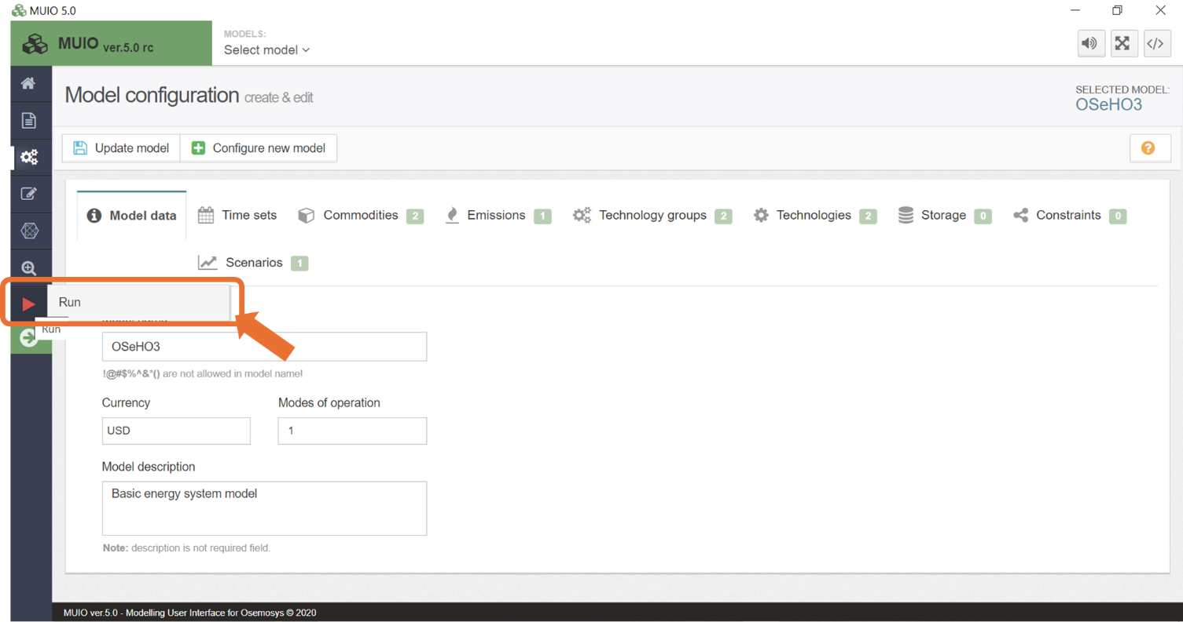
- You must then give it a name (OSeHO3 was chosen for this run) and a description if you want to. Then you must create a case by pressing the corresponding button.
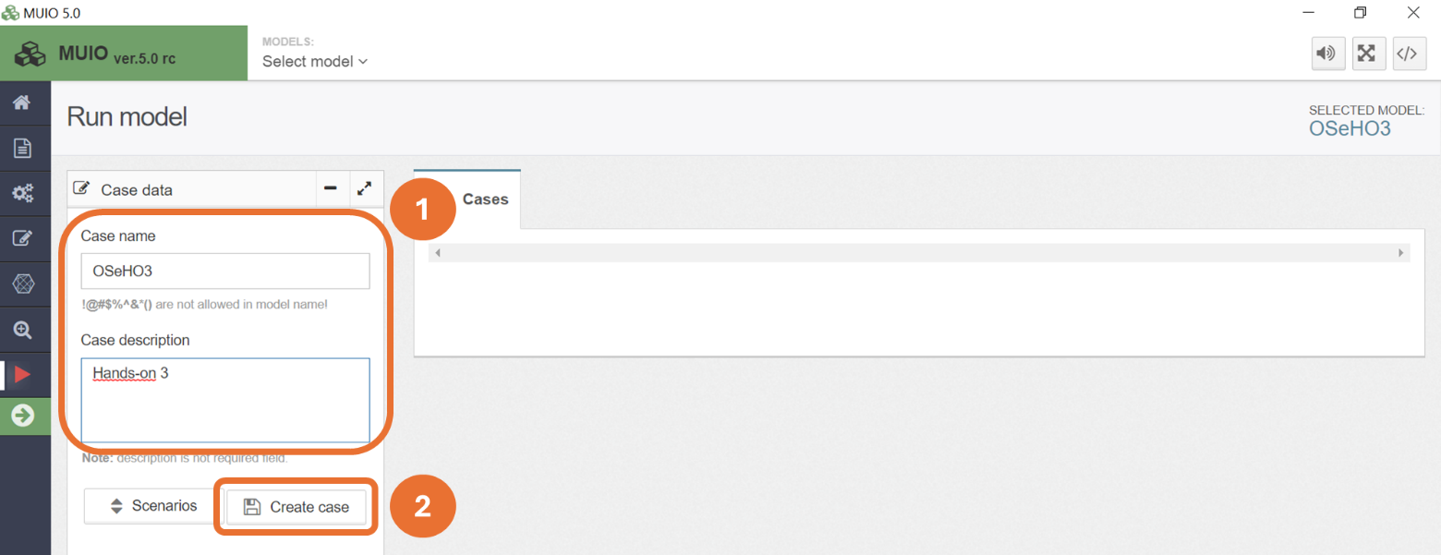
- Next, you must press the Data file button to generate the input data file for the optimization process.
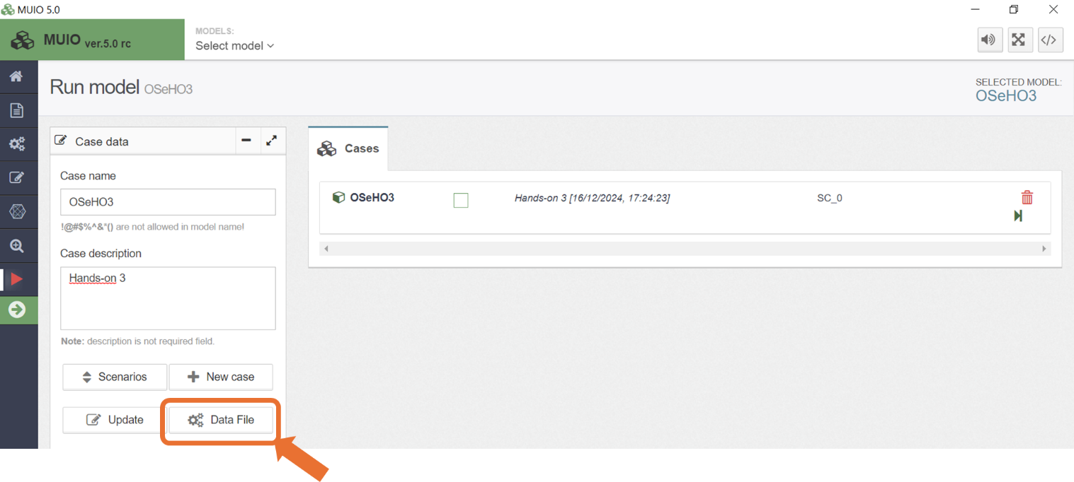
- Then you must RUN MODEL. You will see the optimization process complete, followed by a message confirming successful operation.
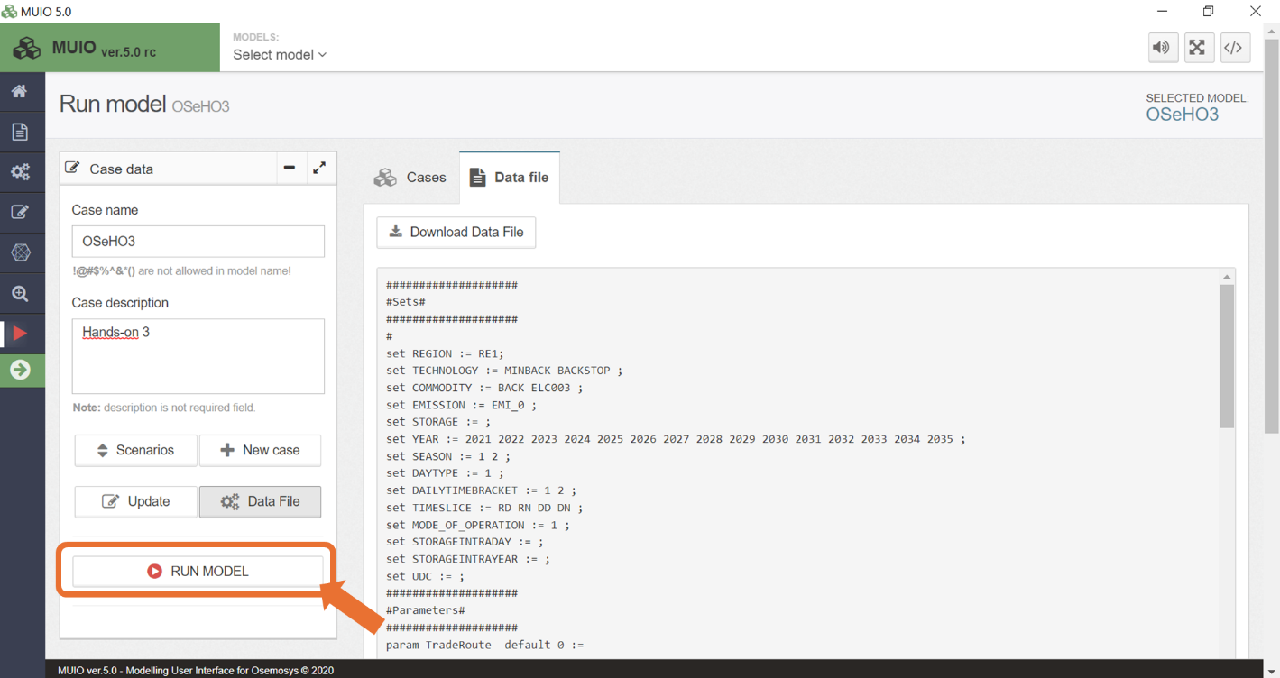

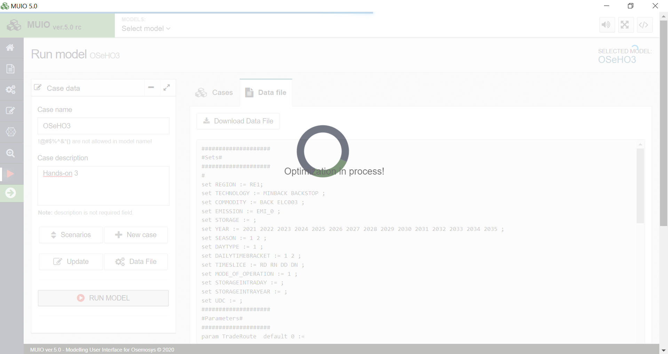

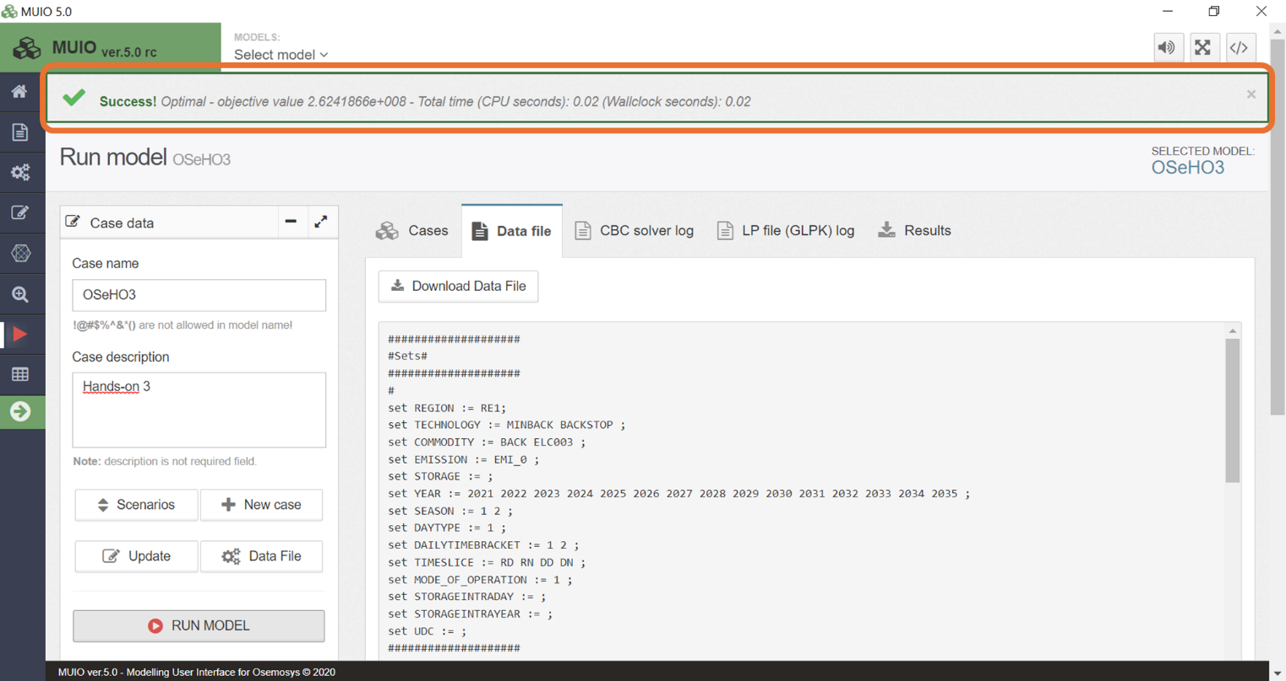
- You will see many files created and you can view the results by pressing the table button on the left sidebar as shown in the image below:
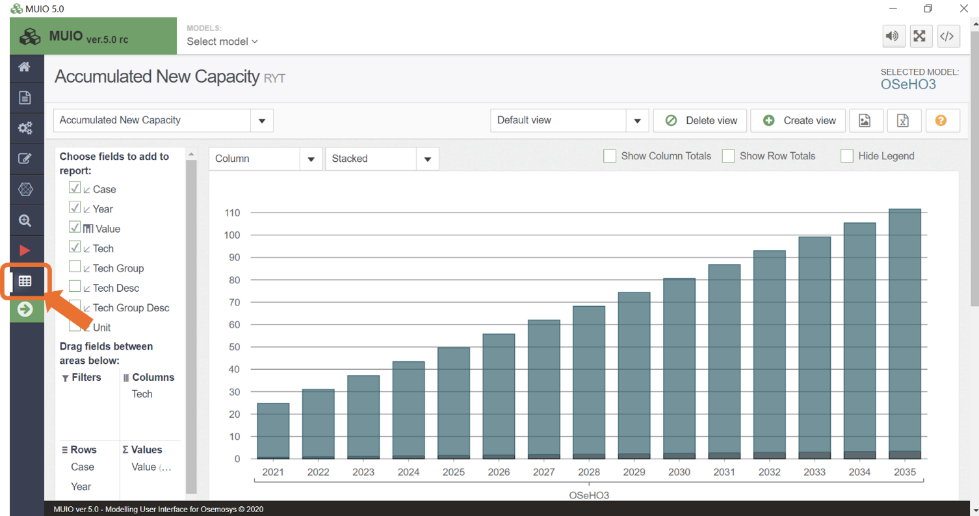
- You will now be on the results page. It will automatically appear with the Accumulated New Capacity graph; therefore, you must click on the arrow highlighted above and choose the parameter Production by Technology by Mode. It will then appear like the image below.

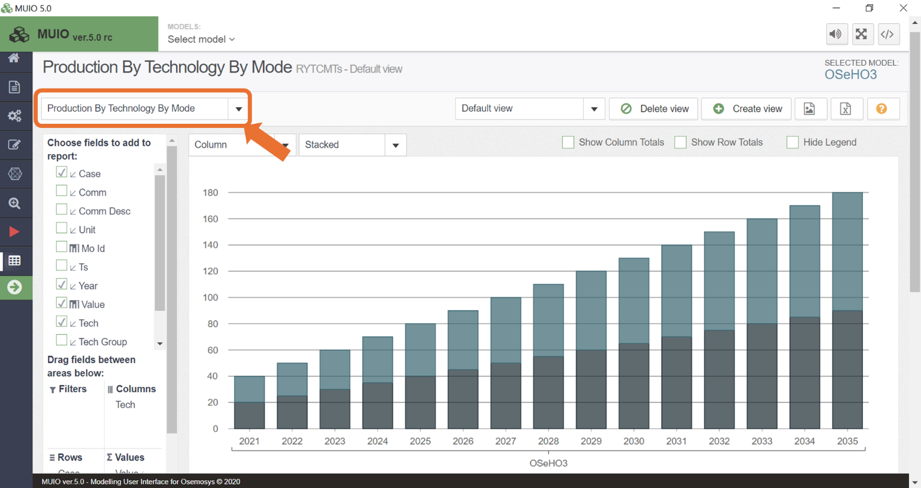

- To filter out an unwanted technology (e.g.), you need to right click on ‘tech’ in the columns tab and select the ‘Field Settings’ option, and a box will pop up on your screen.
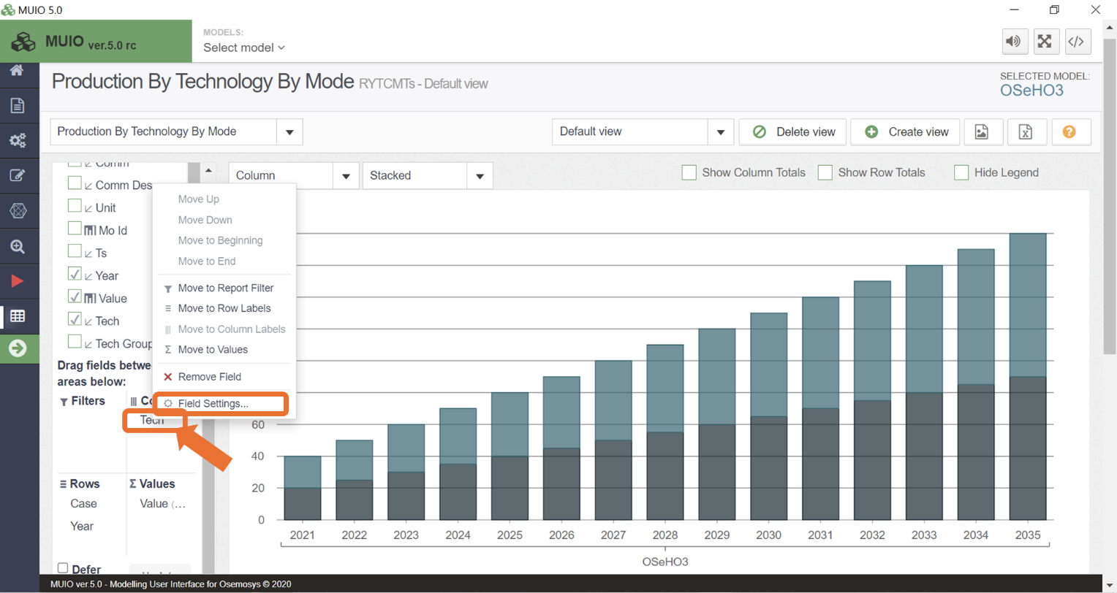
- You need to click edit and untick MINBACK, as shown below:
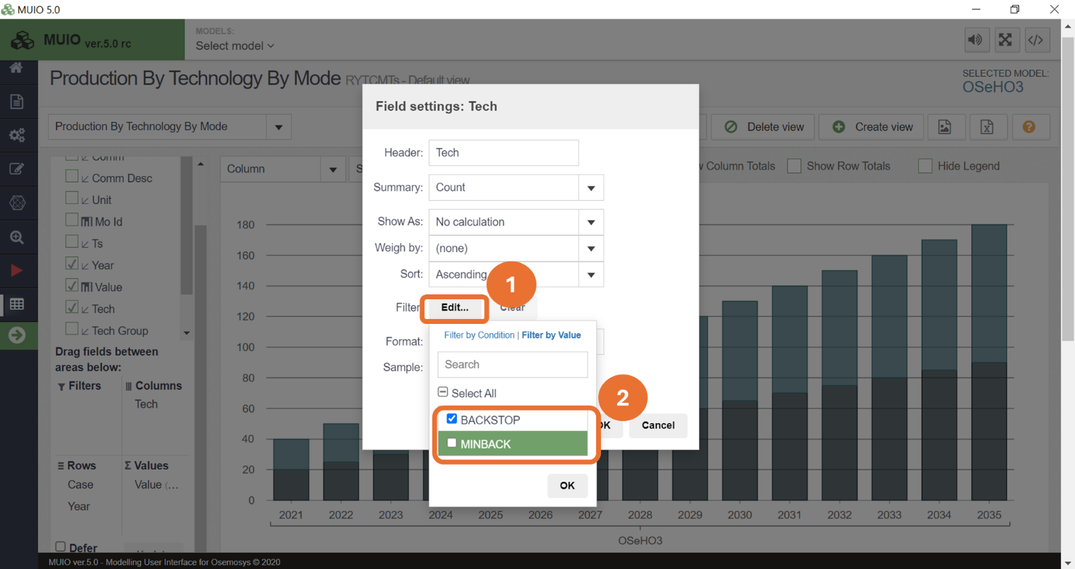
- Then, this graph will appear on your screen. If it looks like this, you have done everything correctly so far—well done! You can now run the models. Notice that the production of the Backstop technology matches the electricity demand, starting at 20 PJ in 2021 and increasing to 90 PJ by 2035.
