Energy System Modelling Using OSeMOSYS
Hands-on 2
Please use the following citation for:
- This exercise
Plazas-Niño, F., Alexander, K. (2025, February). Hands-on 2: Energy System Modelling Using OSeMOSYS (Version 1.0.). Climate Compatible Growth. DOI: 10.5281/zenodo.14868616

- OSeMOSYS UI software
Climate Compatible Growth. (2024). MUIO (Version v5.0.0). GitHub. https://github.com/OSeMOSYS/MUIO/releases
______________________________________________________________________________________

Learning outcomes

By the end of this exercise, you will be able to:
- Define the time resolution of the model
- Establish the duration of timeslices
- Add Year Split values
- Check discount rate values

Define the time resolution of the model

In this activity, we will set the planning horizon to a mid-term timeframe from 2021 to 2035. To achieve this, we will create a copy of the previous model, OSeHO1. Follow these steps:
- Open MUIO, select the OSeHO1 model on the homepage, and click on the ‘Copy model’ option.
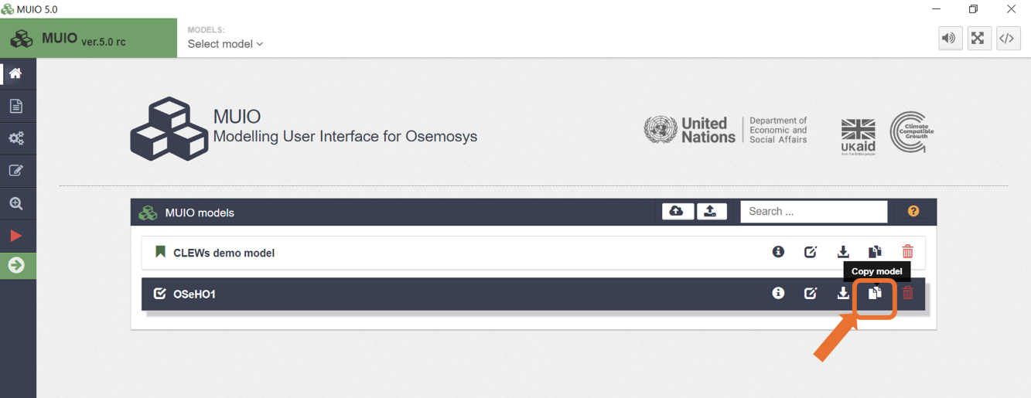
- Select the copied model and click on ‘Configure model’ to open it.
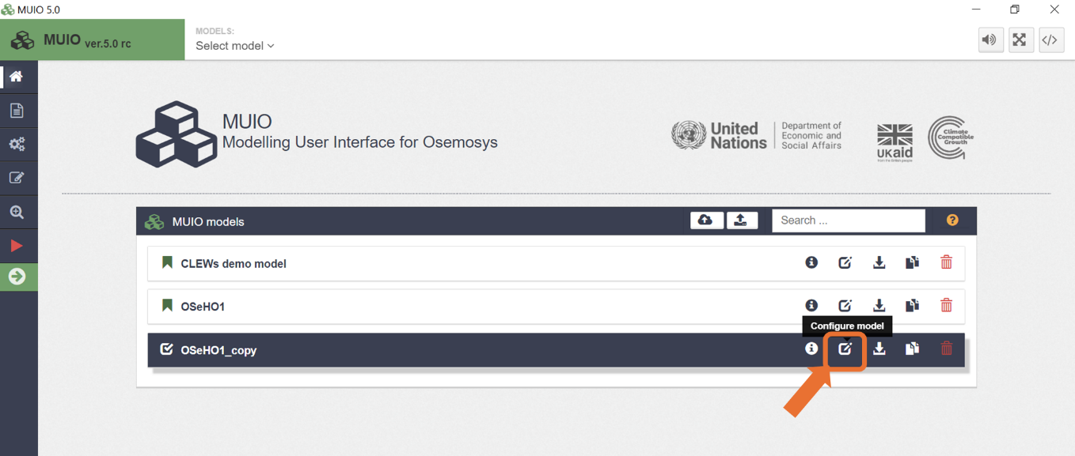
- Rename the copy by modifying the ‘Model data’ field from OSeHO1_copy to OSeHO2.
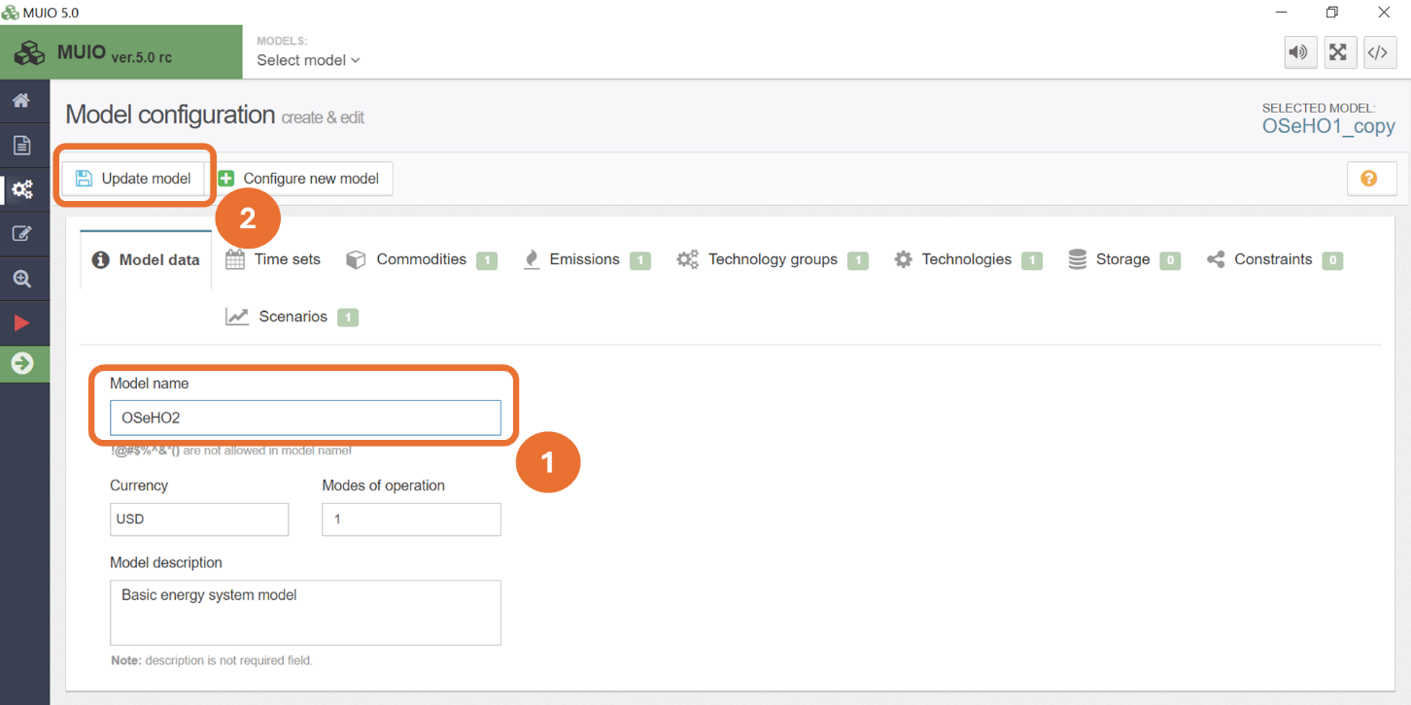
- Press the ‘Update model’ button to save the changes.
Next, navigate to the ‘Time sets’ tab. Use the slider to select the years from 2021 to 2035. Once the desired range is set, click on the ‘Update model’ button to save your changes.
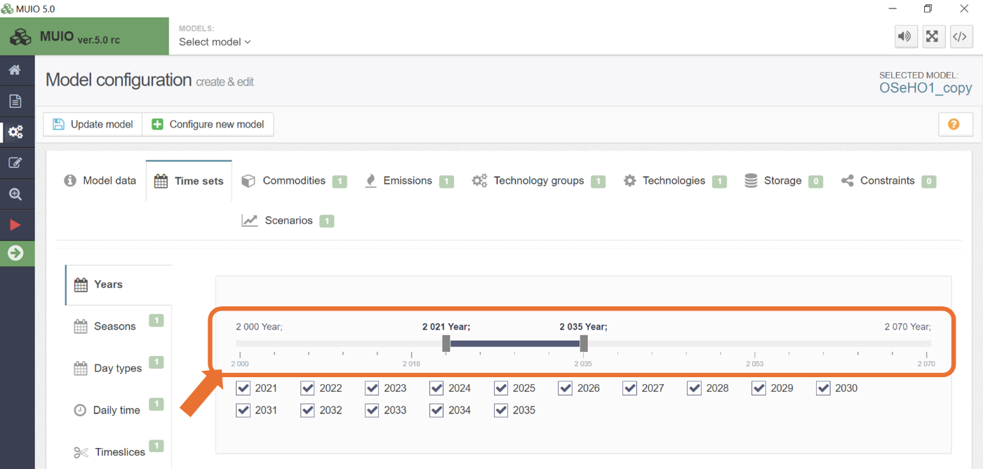
As discussed in Lecture 3, intra-year resolution can be represented through timeslices, which allow us to subdivide time into segments with similar features. These subdivisions can occur at three levels: seasons, day types, and daily time brackets. For this case, we will:

- Add 2 seasons to model the rainy and dry periods, reflecting the tropical climate of the country. Navigate to the ‘Time sets’ tab, select the option ‘Seasons,’ and click on ‘+ Add Season’ to create a second season. Rename the seasons by changing the descriptions: set Season 1 to Rainy and Season 2 to Dry.
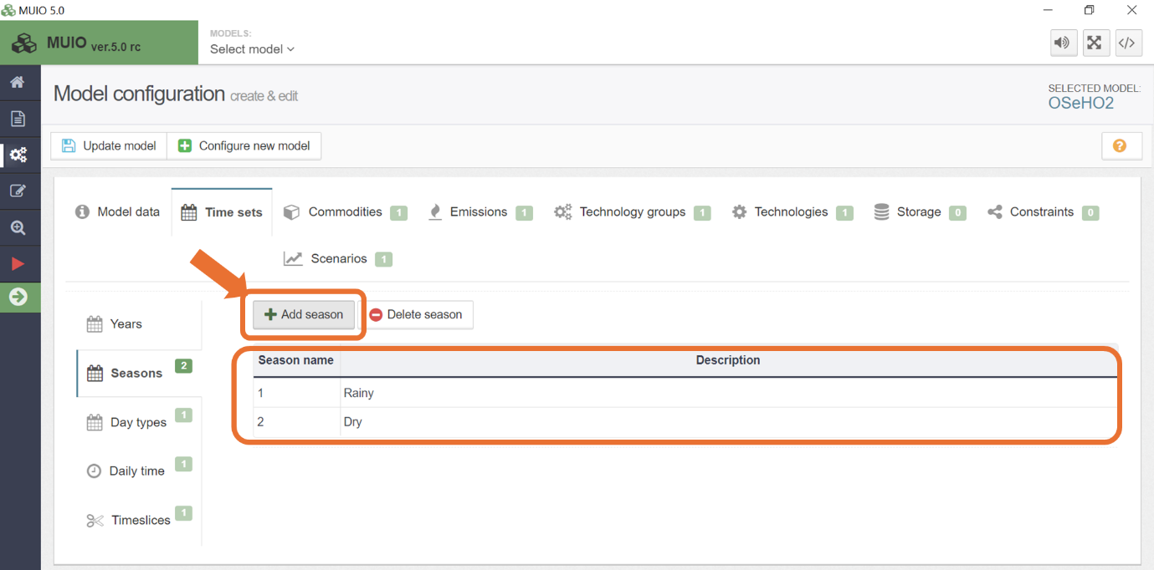
- Define 2 daily time brackets, representing day and night periods. Navigate to the ‘Time sets’ tab, select the option ‘Daily time,’ and click on ‘+ Add daily time bracket’ to create a second daily time bracket. Rename the daily time brackets by changing the descriptions: set Daily time bracket 1 to Day and Daily time bracket 2 to Night.
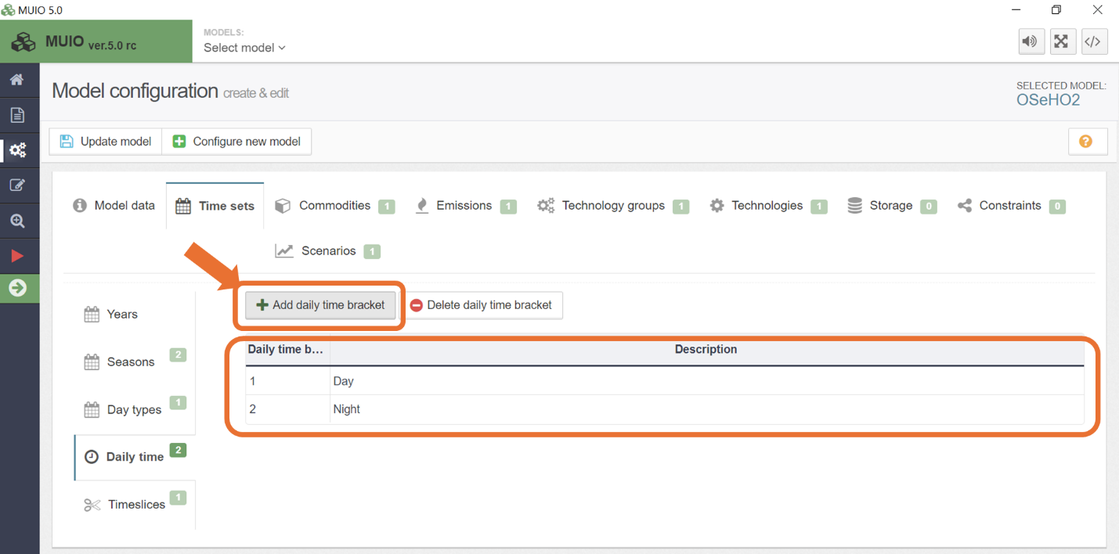

- Finally, define four timeslices corresponding to the different combinations of seasons and daily time brackets. Navigate to the ‘Time sets’ tab, select the ‘Timeslices’ option, and click on ‘+ Add year split’ to create three additional timeslices. Rename the timeslices and assign the combinations of seasons and daily time brackets as illustrated in the figure below. In this exercise, we will work with one single day type.
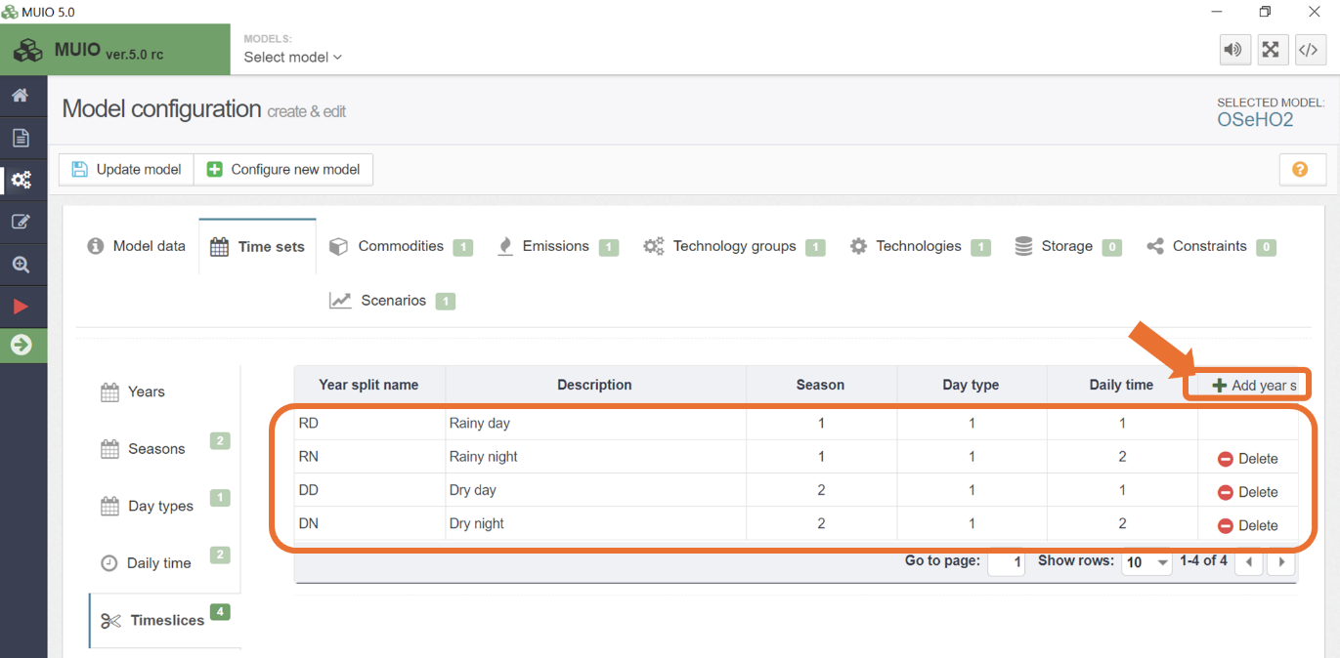

- At the top, click on ‘Update Model’ to save changes.

This setup provides a simplified disaggregation of time variability. While basic, it is suitable for learning purposes.

Establish the duration of time slices

Considering the duration of seasons, day types, and daily time periods, we can calculate the duration of each timeslice. In our case, the rainy season occurs from April to August, while the dry season spans from September to March. To simplify calculations, we will assume months are uniformly 30 days long (you can use actual month durations for your projects). For day and night, we define day as 6 AM to 6 PM and night as 6 PM to 6 AM.

For example, let’s calculate the first timeslice, RD, which represents the rainy season, daytype 1, and daytime. Since the rainy season lasts 5 months out of 12, and daytime constitutes 12 hours out of 24, the proportion is:
$$\frac{5}{12}*\frac{12}{24}=\frac{5}{24}≈0.208$$
Notice that we’ve rounded to three decimal places. As night lasts the same duration as day in this scenario, the timeslice duration for rainy season and nighttime will also be 0.208. For the other two timeslices, the difference lies in the dry season, which is 7 months long. The calculation is:
$$\frac{7}{12}*\frac{12}{24}=\frac{7}{24}≈0.292$$
A final validation is to ensure that the sum of all timeslice durations equals 1:
$$0.208*2+0.292*2=1$$
The values calculated in this step represent the YearSplit parameter in our model and will be used as input in the next step.

Add Year Split values

After defining the duration of each time slice and calculating the Year Split profile we need to add these values in the MUIO.
Try it: let’s add the data for Year Split.
- As already set previously and defined in this hands-on, you have 4 timeslices. On the interface model configuration page, go to data entry as shown in the image below and search year split in the search bar. Then open that parameter.
NOTE: The ‘data entry’ button is where you can view all parameters and how you will enter data.
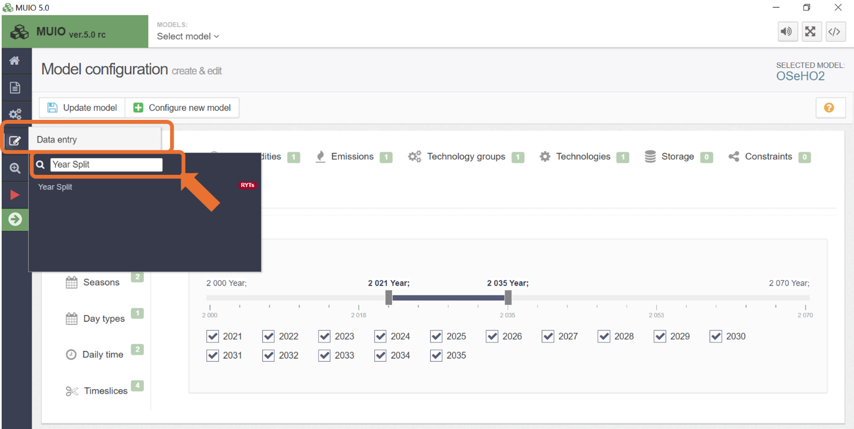
- Once you click on Year Split, you will see this page:
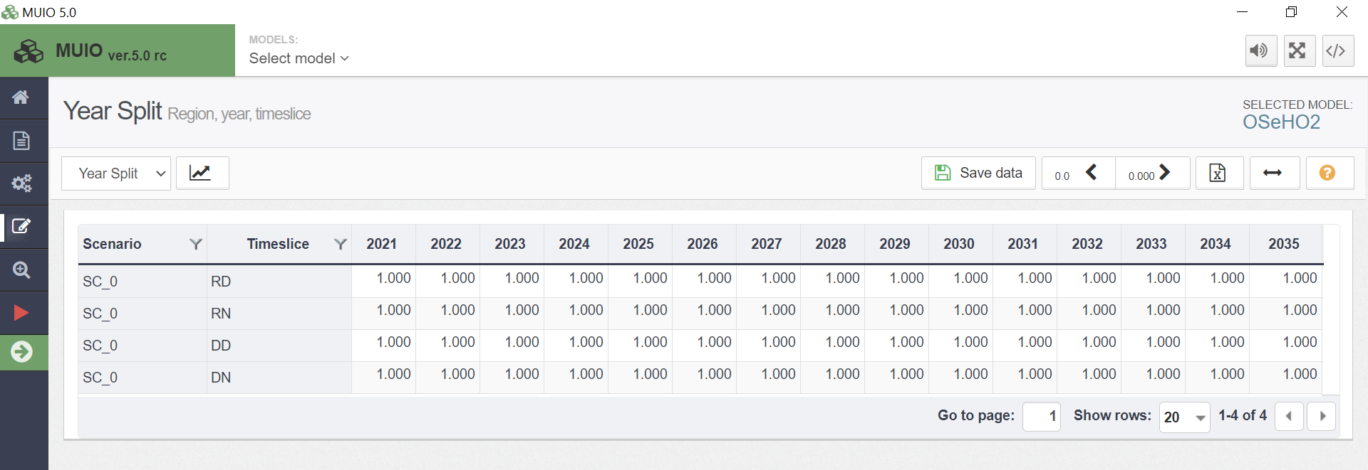
- Enter the data for each timeslice in the year 2021 based on the calculated values. Once completed for the first year, you can copy and paste the values for the remaining years as you would in any Excel program. The result should resemble the image below:
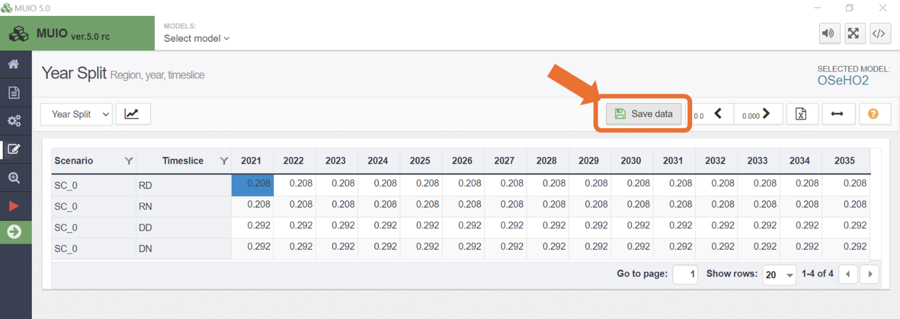
- You must then press the ‘save data’ button as shown in the image above. Important: Each time you enter/edit data you MUST press this button before returning to the homepage.
NOTE: Next to the ‘save data’ button you can increase or decrease decimal places to view the data how you wish (as the default is 3, so it may appear as if the data hasn’t copied correctly but it should have).
- Finally, return to the homepage and press ‘update model’. You will have now successfully changed the values for year split.
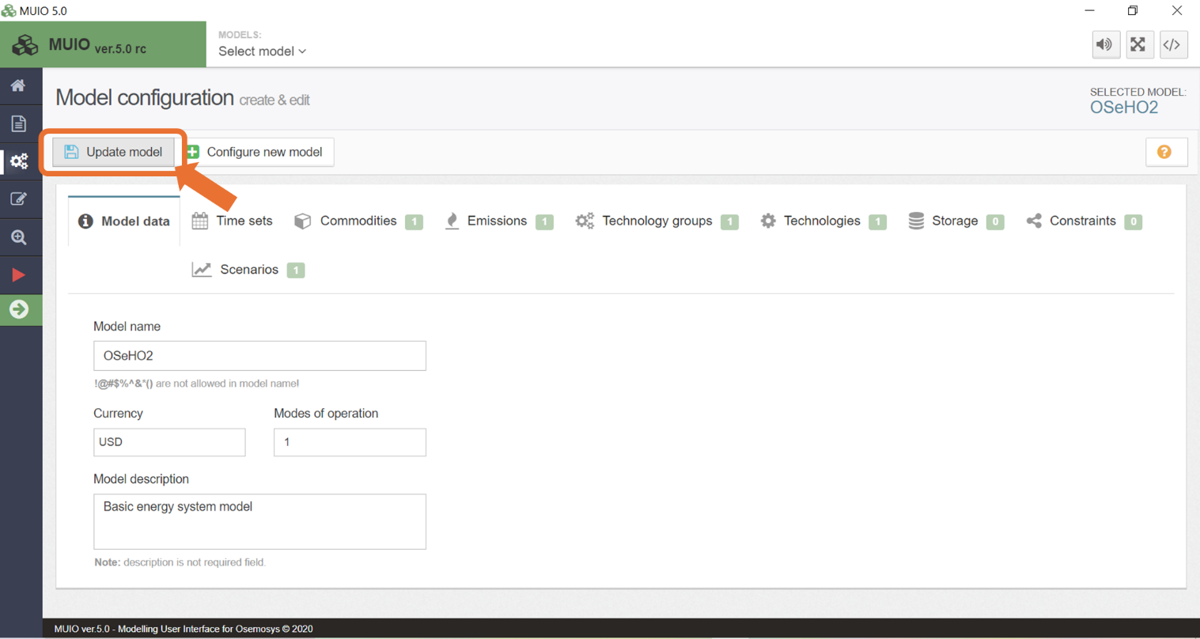
Important: Each time you enter/edit data, and/or add commodities/technologies to the model, you must press this button.

Check Discount Rate values

As discussed in Lecture 3, the model includes two types of discount rates: the global discount rate and individual discount rates. In this exercise, we will set both to 10%. To achieve this, we will modify the default values for these two parameters. This approach eliminates the need to update the values for each new model in future hands-on exercises.

- Select the second tab under ‘Parameters and Variables’ on the sidebar.

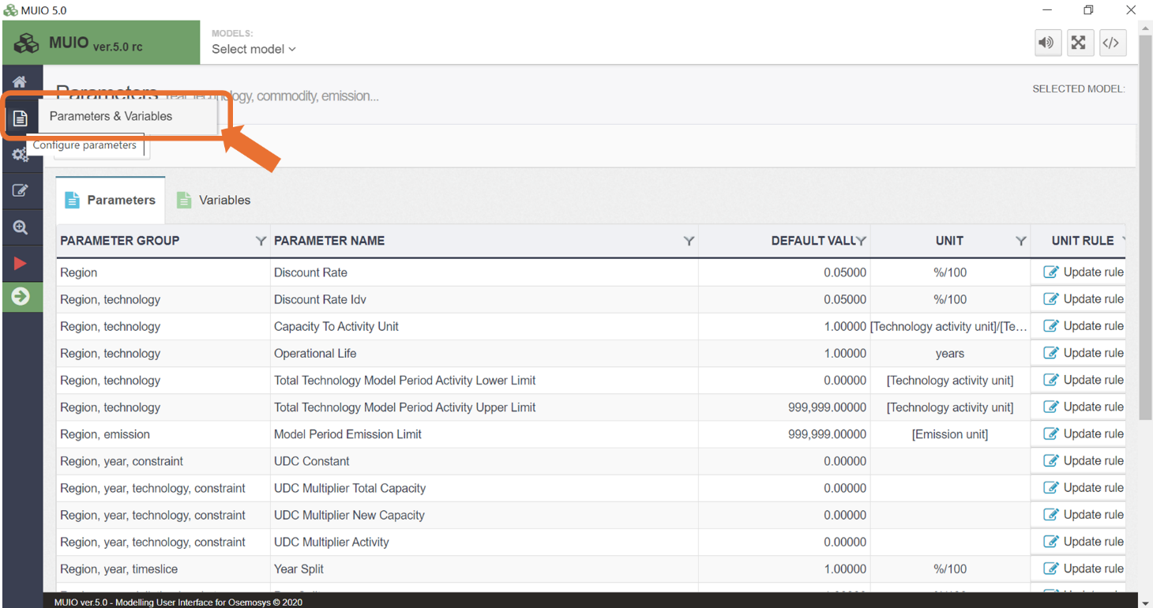

- To change the discount values, modify the third field under ‘Default value’. Update the default value from 0.05 to 0.1, as shown below.

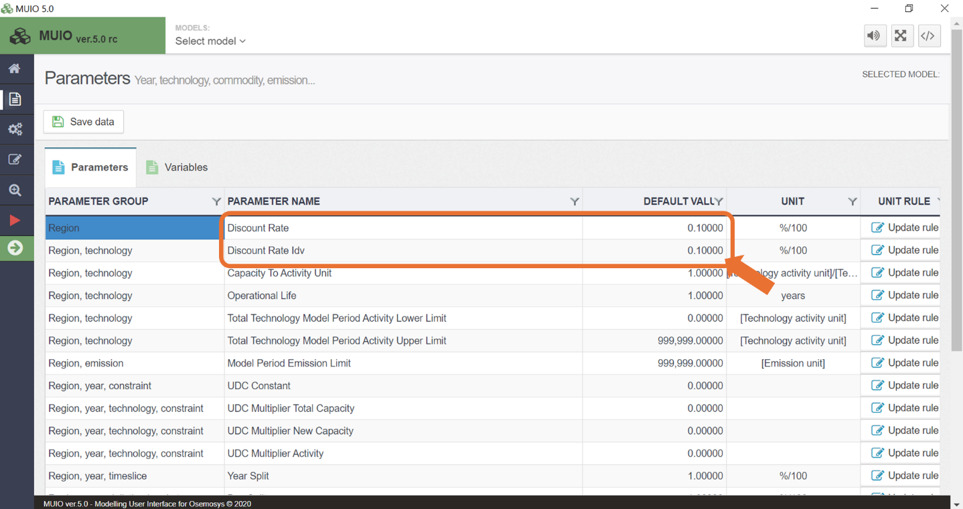

- Finally, press on ‘Save data’ and return to the homepage and press ‘update model’. You will have now successfully changed the values for discount rates.

Important: Make sure you save data and update the model every time you do this.

