Energy System Modelling Using OSeMOSYS
Hands-on 1
Please use the following citation for:
- This exercise
Plazas-Niño, F., Alexander, K. (2025, February). Hands-on 1: Energy System Modelling Using OSeMOSYS (Version 1.0.). Climate Compatible Growth. DOI: 10.5281/zenodo.14868500

- OSeMOSYS UI software
Climate Compatible Growth. (2024). MUIO (Version v5.0.0). GitHub. https://github.com/OSeMOSYS/MUIO/releases
__________________________________________________________________________

Learning outcomes

By the end of this exercise, you will learn how to:
- Install the Modelling User Interface for OSeMOSYS (MUIO).
- Understand the case study of a basic energy system that will be modelled during the course.

Activity 1 – Install the interface
N.B. In order to carry out this activity and all the ones that follow in the course, you need a computer that has Windows 10 Operating System or later.
Through this activity, you will install the Modelling User Interface for OSeMOSYS (MUIO) you will be using for creating models throughout the course.
To install the MUIO:
- Download the latest version of the user interface (OSeMOSYS-MUIO) from here.
- Move the .exe file from your download folder to a folder where you have administrator privileges. This may be for instance inside the folder: users>>name_of_the_user or any other folder you prefer.
- Right-click on osemosys.exe and click ‘Run as administrator’. This will start the installation of the MUIO. The installation may take several minutes. Once it is complete, the installation window will simply disappear.

- The App will open automatically once the installation is complete. If not, search on the Windows Taskbar for ‘’MUIO’’ and open the App.
- You will see the MUIO in a new window.
You will have to configure a new model and add some inputs. Once you have opened the MUIO:
- Go to the left panel and click on ’Configure model’.
- Enter a ‘Model name’ (in this case it was named OSeHO1), select USD as currency, insert 1 as number of Modes of operation, and write a short description of your model choosing in ‘Model description’. Press on ‘Save new model’.
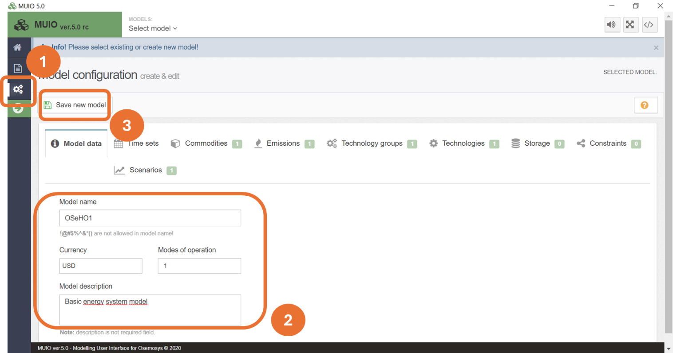
Activity 2 – Case study description
As discussed in Lecture 1, the first stage in the energy system modelling process is to formulate the policy or research question to be addressed. This requires a thorough understanding of the national or regional context, which forms the narrative behind the questions. In this section, we provide key information about the fictional energy system:
- Demographics and Economy: A small, landlocked country with a population of 7 million, 70% of whom live in urban areas. The population growth rate is 1.5%, with urbanization increasing by 1% per year. The GDP is 121 billion USD, with a GDP per capita of just over 9,000 USD, growing at an annual rate of 3.5%.
- Electricity Sector: The electricity sector relies on diesel and natural gas power plants connected to a centralized grid. However, 15% of the population lacks access to electricity, and distributed generation is non-existent. The country has potential for renewable energy production via run-of-river hydropower, biomass, wind, and solar photovoltaic systems.
- Residential sector: The tropical climate eliminates the need for heating systems. Cooking is predominantly done using biomass and liquefied petroleum gas (LPG).
- Industry sector: The economy is primarily based on agriculture and services, with a nascent industrial sector. Some small companies process crops into final products, representing a modest demand for indirect heat.
- Transportation Sector: The country has approximately 120,000 cars. Heavy long-haul freight transport accounts for a marginal share of fuel consumption.
In the upcoming hands-on sessions, we will translate these conditions into modelling features and explore how different parameters are used to assess optimal pathways for the future development of this energy system.

