Model for Analysis of Energy Demand (MAED)
Hands-on 1: MAED Software Installation
License:
This work is licensed under the Creative Commons Attribution 4.0 International License (CC BY 4.0). To view a copy of this license, visit https://creativecommons.org/licenses/by/4.0/.
Attribution:
Please cite as: Kiley, F. (2025) An Introduction to Simulating Energy Demand with MAED. Version 1. Climate Compatible Growth Teaching Kit Website, Climate Compatible Growth.

Learning outcomes
This exercise will help you set up the MAED tool on your system. MAED is available for download locally and used offline on Windows operating systems. Currently, MAED is unavailable for use on Apple OS.
By the end of this exercise, you will be able to:
- Install and access MAED_D and MAED_EL tools offline on Windows systems.
- Navigate the MAED home page to edit existing case studies, add new ones, and restore old ones.

1. Installing MAED for Offline Use
The MAED tools may be installed locally for offline use. This could be useful when internet access is limited or even restricted due to sensitive data. The offline version of MAED is currently only available for Windows operating systems.
- To install MAED on Windows, you need to ensure that Microsoft Visual C++ Redistributable for Visual Studio 2019 is installed on your computer. If it is not installed on your computer, please use this link to install the x64 (for 64-bit OS) or x86 (for 32-bit OS) version, depending on the version of windows installed on your computer.

https://visualstudio.microsoft.com/downloads/
Microsoft Visual C++ Redistributable for Visual Studio 2019 should be under the "Other Tools, Frameworks, and Redistributables" tab on the website.
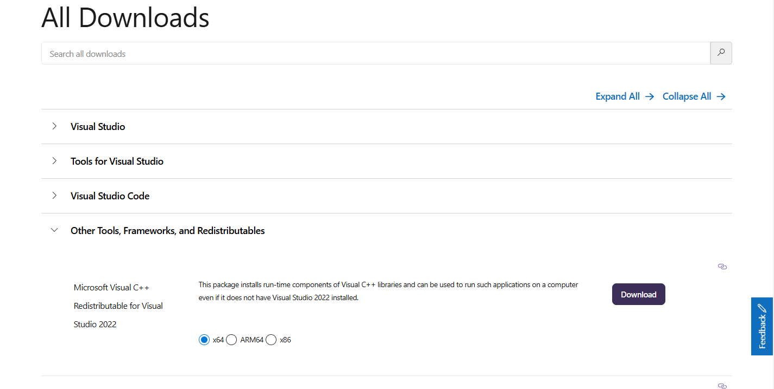

- Once you have ensured that Microsoft Visual C++ Redistributable for Visual Studio 2019 is installed on your computer, click on this link to download the software.

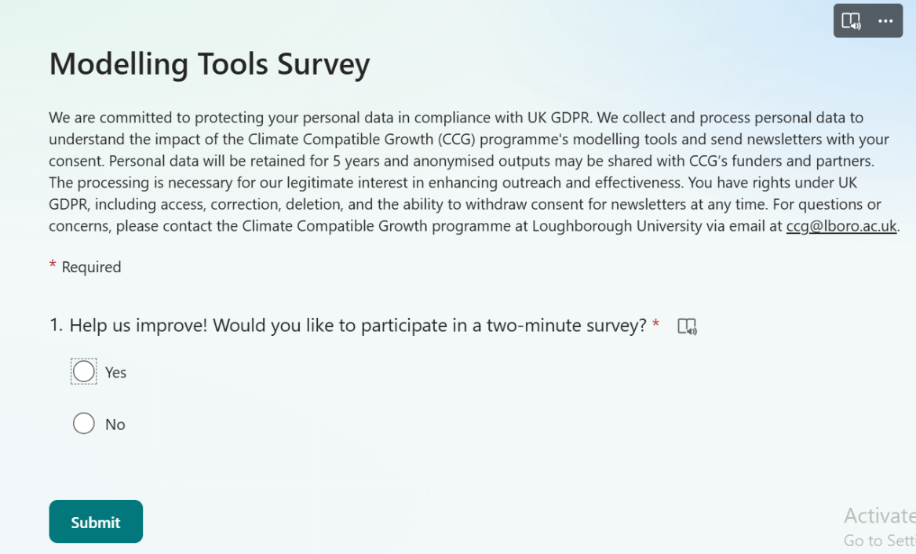
Once you click on that link, you will see the following page:

The purpose of the survey is for CCG to understand the impact of the modelling tools. As mentioned in the survey, your data will be collected for reporting purposes only and will not be shared. If you would like to complete the short survey, click on “Yes”. If you do not want to complete the survey, click on “No”.
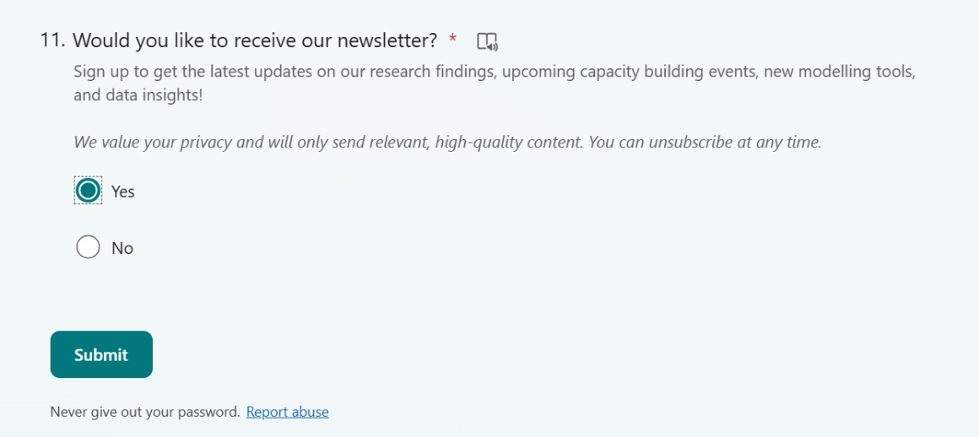
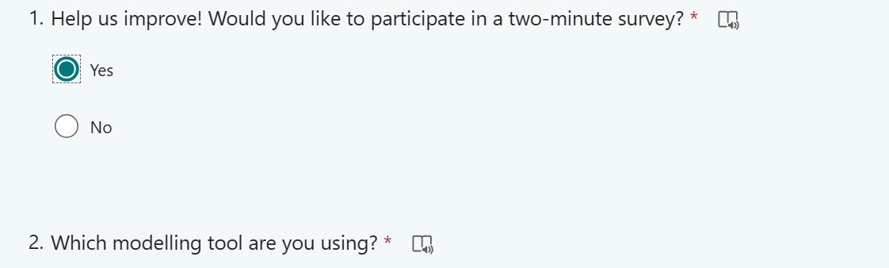
If you click on “Yes”, 10 more questions will appear. Answer all the questions accordingly and click on “Submit” at the bottom of the page. The link to MAED will then be provided immediately.

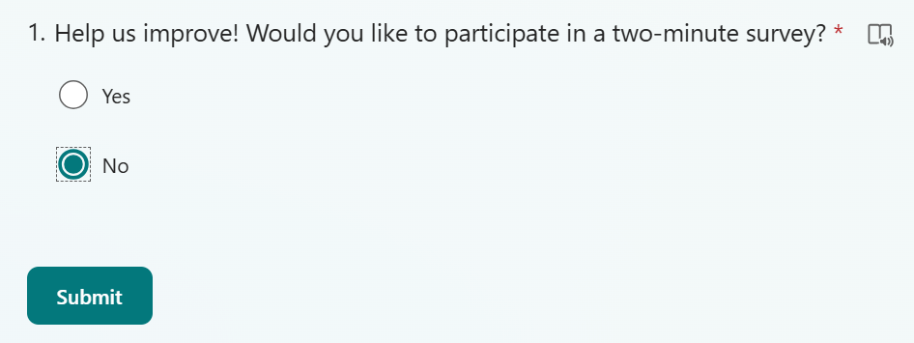
If you click on “No”, click on the “Submit” button below it. The link to the MAED executable will be provided straight after.
Upon clicking on the respective FINPLAN link, you will be directed to GitHub, where you can see the MAED executable (maed.2.0.0_setup.exe). Download this file onto your machine by clicking it.
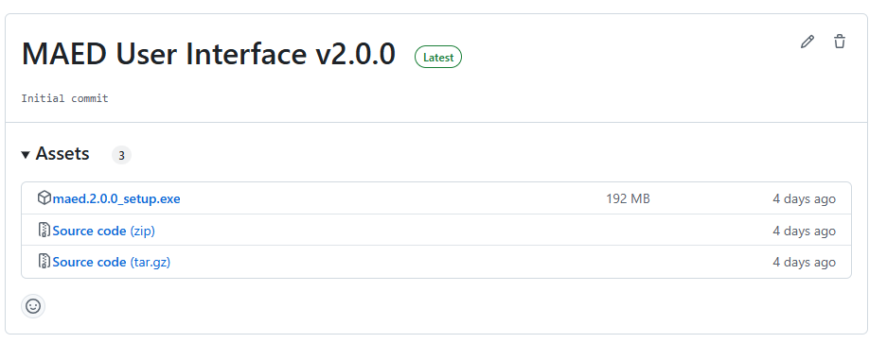
A prompt may show up. Click on “Download Anyway”.
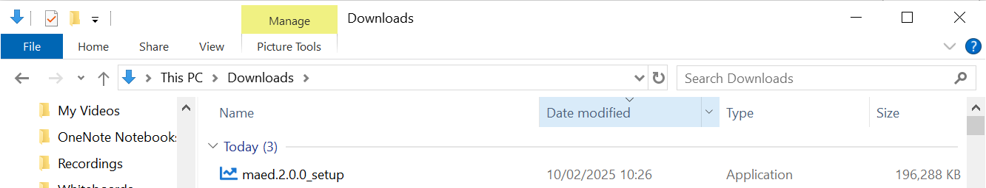
Once downloaded, you will see the MAED executable file in your “Downloads” folder. Double click on it.
A pop-up will show. Click on “More info”, then click on “Run anyway”. This will install MAED on your computer.

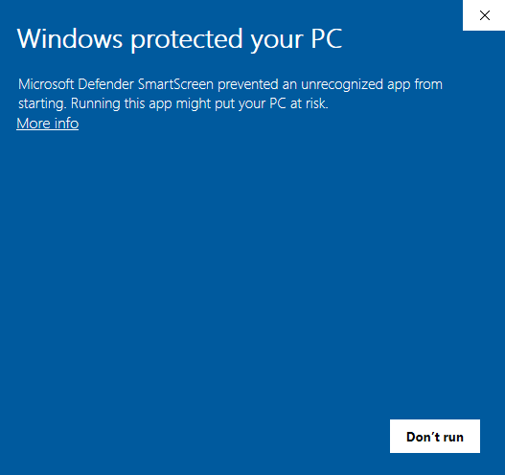
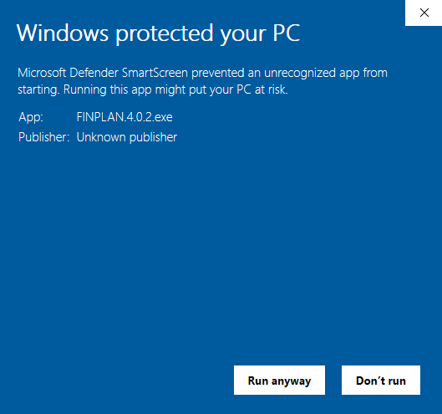

MAED will now be ready to run. A window like the one below will appear:

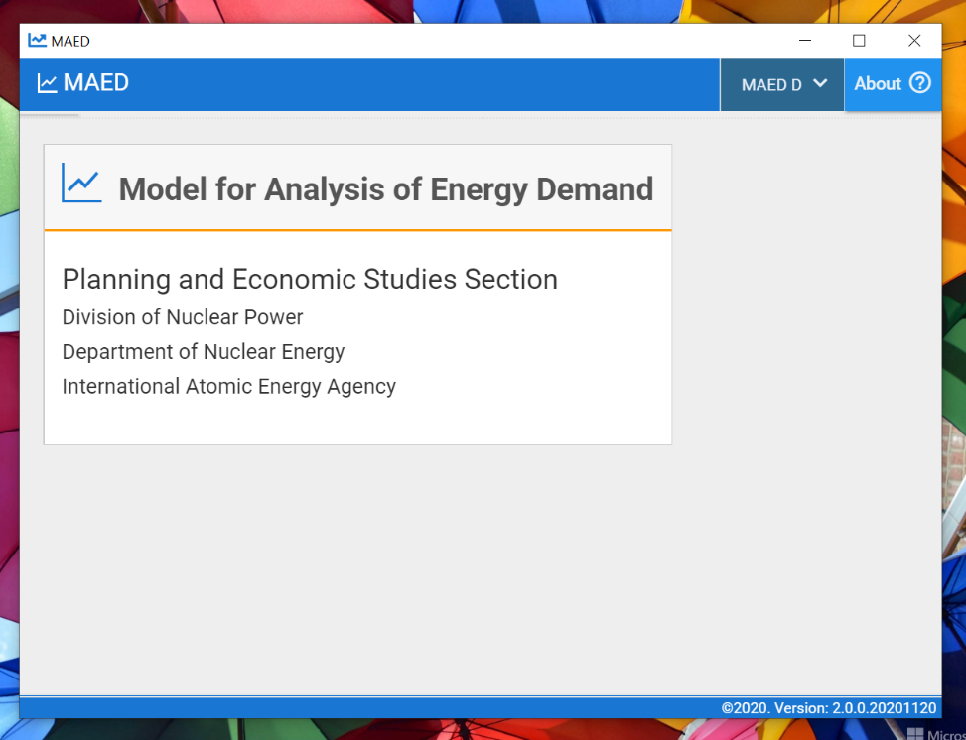
A shortcut to MAED should also be created on your desktop by default.

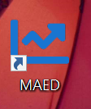
Well done! You now know how to install MAED and open it.
N.B. every time you download MAED, your previous data files will be deleted. Thus, should you reinstall MAED, do not forget to export your case studies to somewhere easily accessible, like your Desktop.

2. Navigating the MAED UI
- Ensure your page is maximized to full screen to view all the contents of MAED. Clicking the "square" maximize window button should show the remaining menus as shown below:
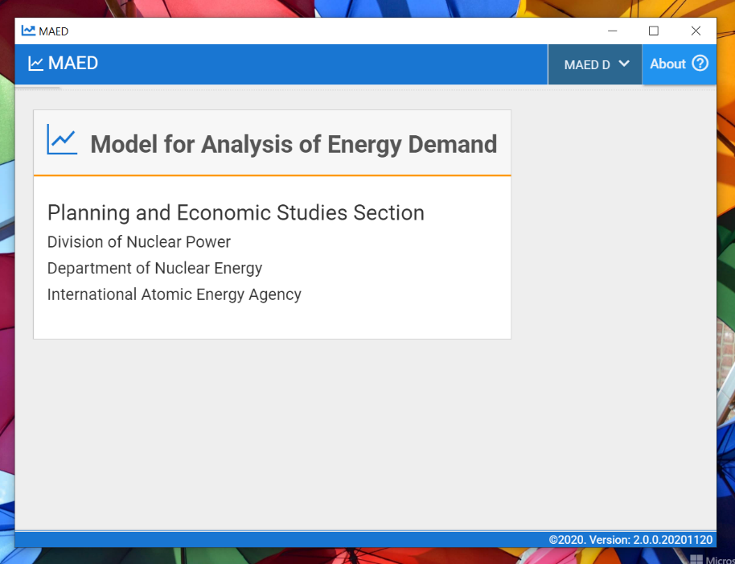
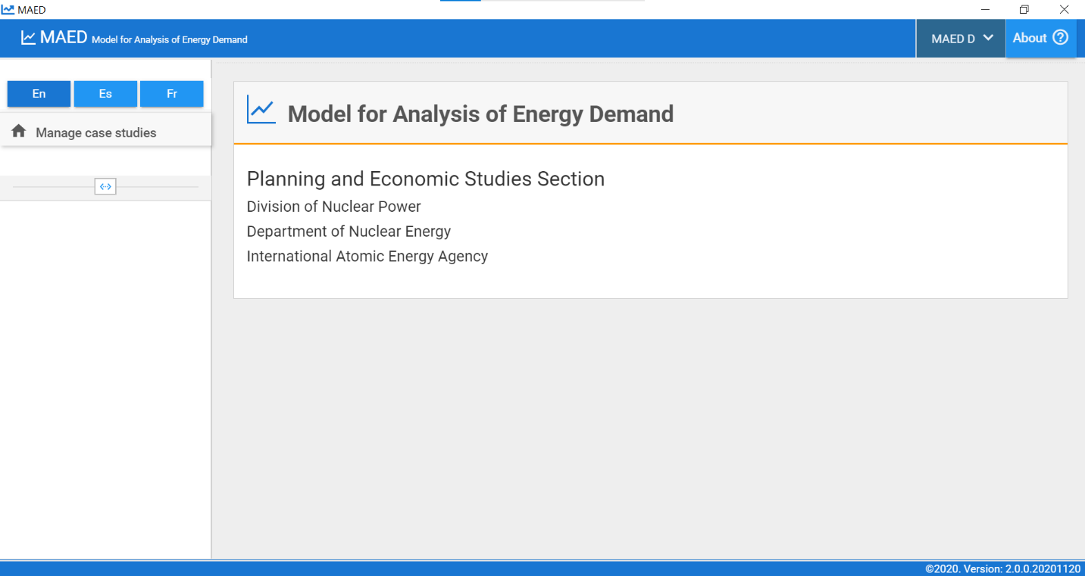

- This will bring you to the main menu of MAED. The MAED_D or MAED_EL modules can be selected using the dropdown menu on the top right. Clicking the MAED_D option should bring you to the main menu for the MAED_D module as follows:
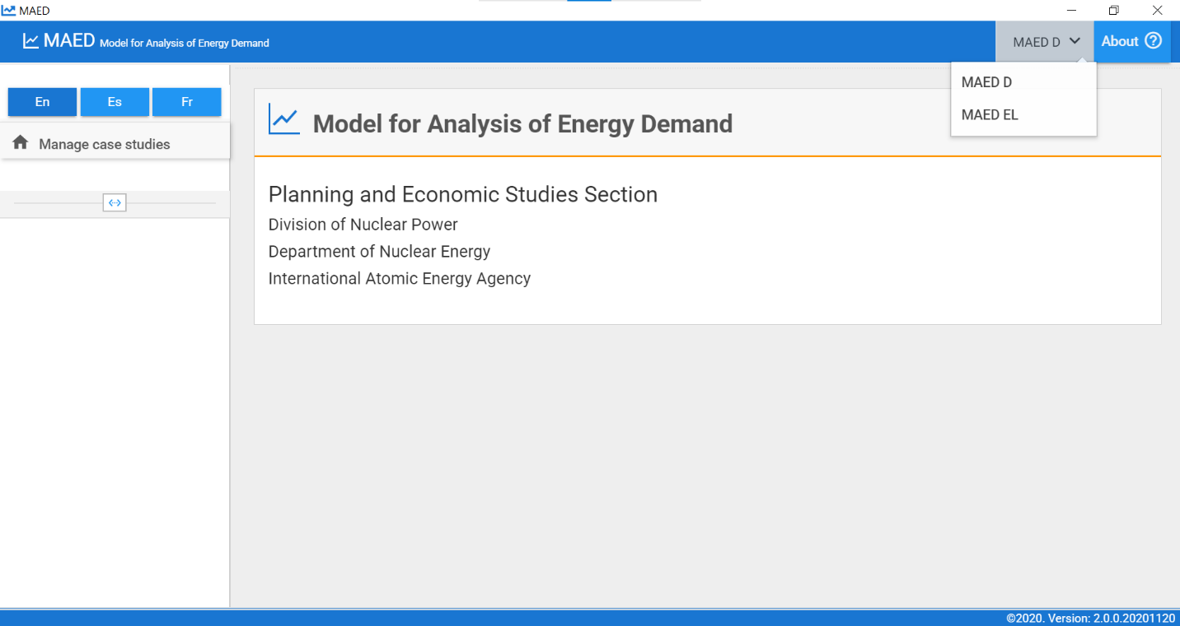
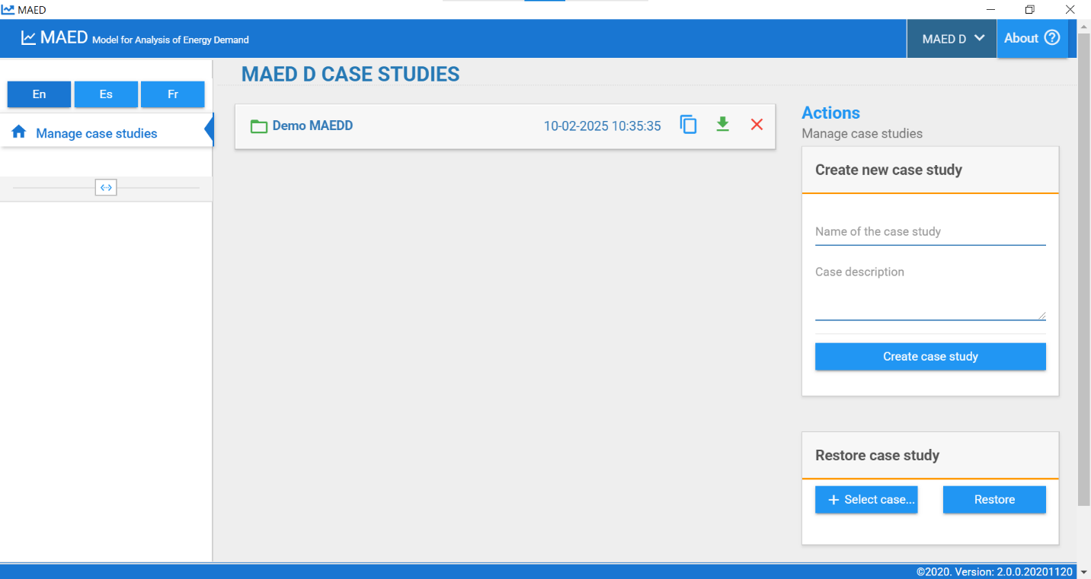
The main menu for the MAED_EL module looks as follows:
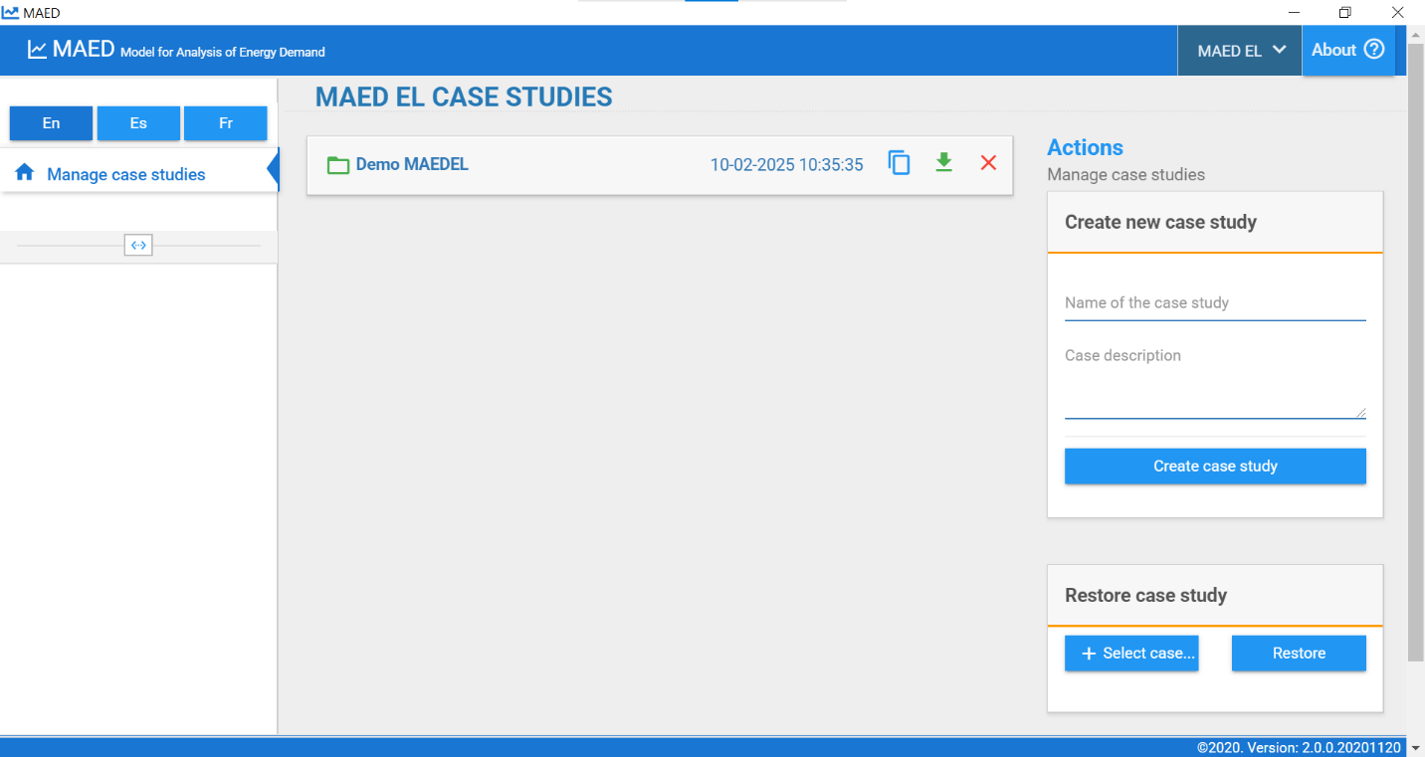

- From the module home page, you can access the case studies you are working on, create new case studies, or restore saved case studies.
  - To access and edit an existing case study, simply click on the name and you will be taken to the General Information tab where you will be able to change various parameters and define the sectors, clients and end uses relevant for your case study (this will be covered in more detail in later HOs).
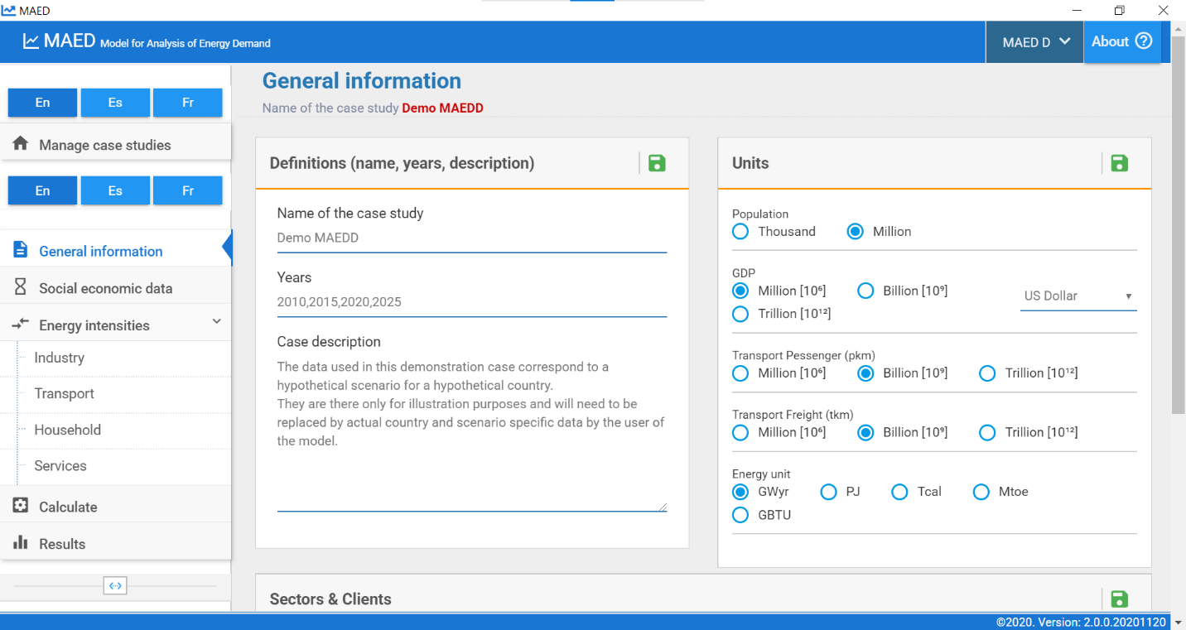
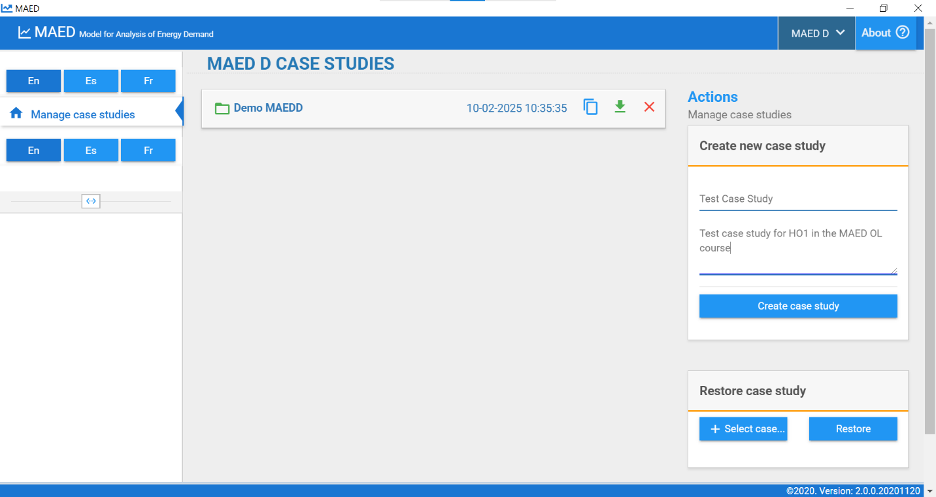
  - To create a new case study, simply define a name in the box on the right-hand side, add a description (this isn’t necessary but recommended), and click on “Create new case study”.

This will create a new case study, visible in the home page as follows:
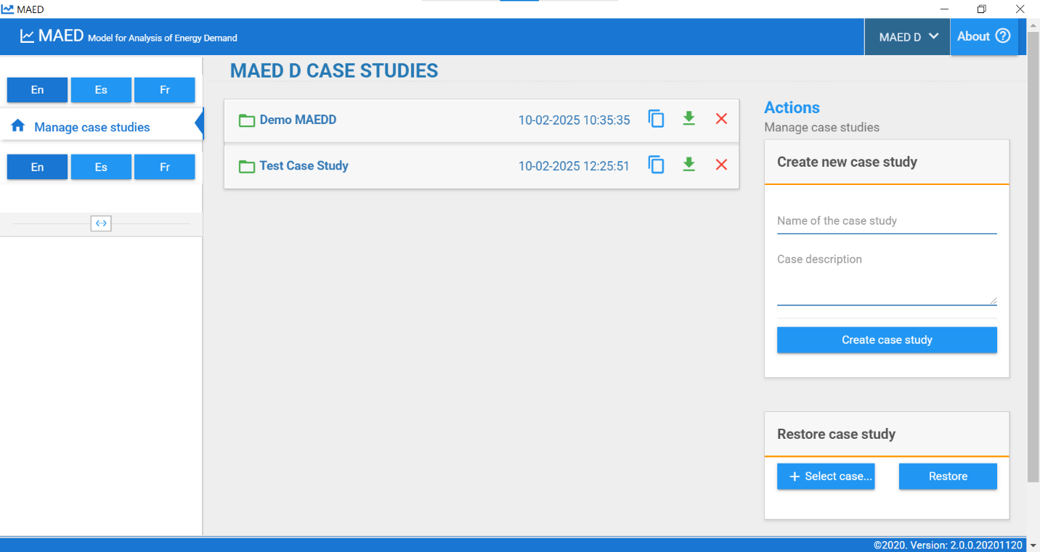
  - Finally, to restore an existing case study and visualize, edit, and run it in the UI, click on “+ Select case study”:
    - Select the case study you want to restore and click on “Open”:
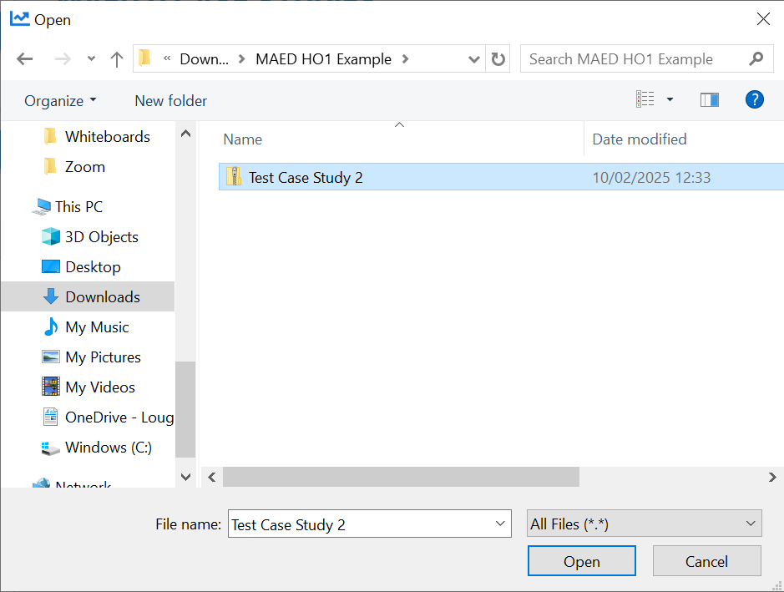
    - Now, click on “Restore”, and this case study will now be available for selection in the module home page:
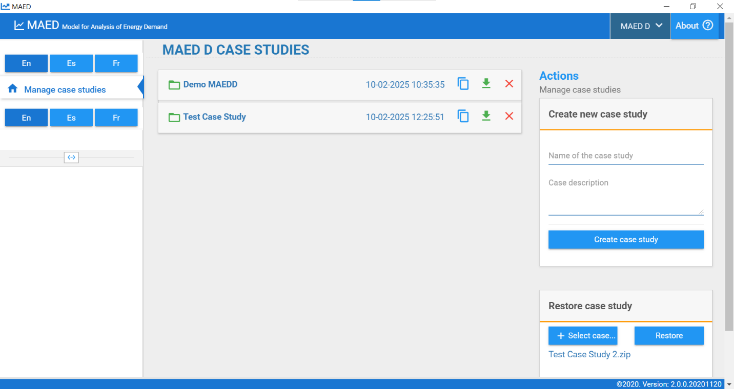
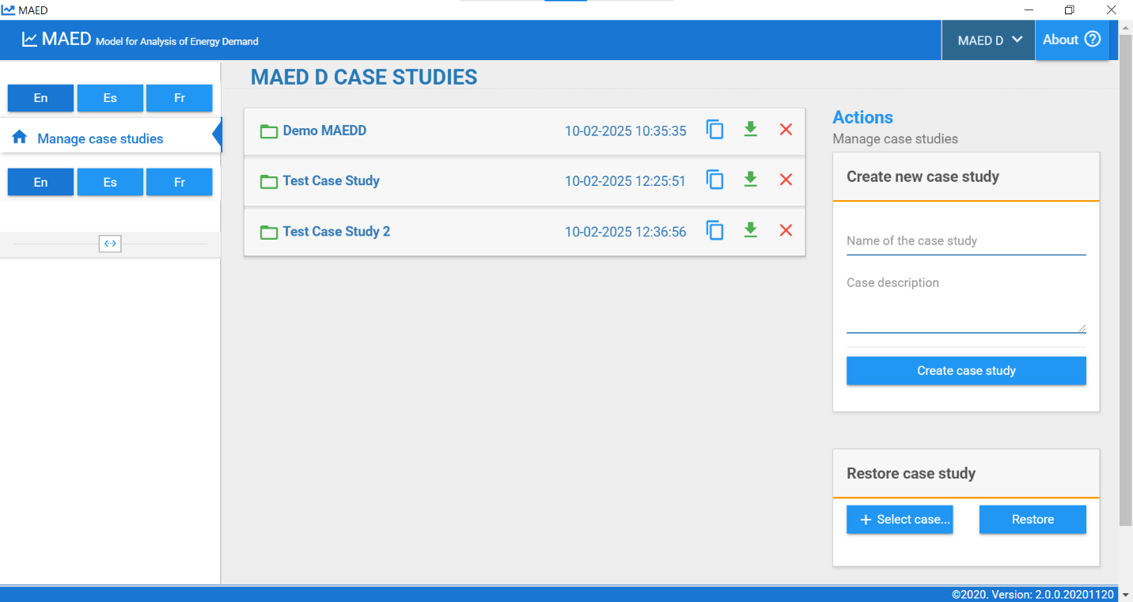

Congratulations, you can now access the MAED tool offline, select and edit existing case studies, create new ones, restore old ones, and can move on to the remaining hands-on exercises on MAED.
Note: There is also a MAED discussion forum for further support. Please sign up to the forum and ask or answer any MAED-related questions here.

