Energy System Modelling Using OSeMOSYS
Hands-on 14
Please use the following citation for:
- This exercise
Plazas-Niño, F. (2025, February). Hands-on 14: Energy System Modelling Using OSeMOSYS (Version 1.0.). Climate Compatible Growth. DOI: 10.5281/zenodo.14871610

- OSeMOSYS UI software
Climate Compatible Growth. (2024). MUIO (Version v5.0.0). GitHub. https://github.com/OSeMOSYS/MUIO/releases
____________________________________________________________________________

Learning outcomes

By the end of this exercise, you will be able to:
- Create scenarios using MUIO
- Develop assumptions to design various scenarios in an OSeMOSYS model

Creating scenarios in MUIO

In this hands-on exercise, we will not add new technologies or commodities.
IMPORTANT: Before proceeding, you must copy the model and rename it as you have done before (this time as OSeHO14).
As we discussed in Lecture 15, the scenario that we can run after calibrating our model represents the Least-cost scenario. Being said that, we already have that model done from our previous hands-on practice. We will complement the analysis by modelling three additional scenarios. We will explore the Business-as-usual scenario, Renewable target scenario, and Emission Limit scenario.
The first step is to create these scenarios in MUIO. Navigate to the Configuration tab and select the Scenarios section. Rename the default scenario from SC_0 to LC and update the description from 'Base scenario' to 'Least-cost scenario.' Next, click on +Add scenario on the right and create three additional scenarios. Rename the scenarios as shown in the image below. Finally, click on Update Model to save the changes.

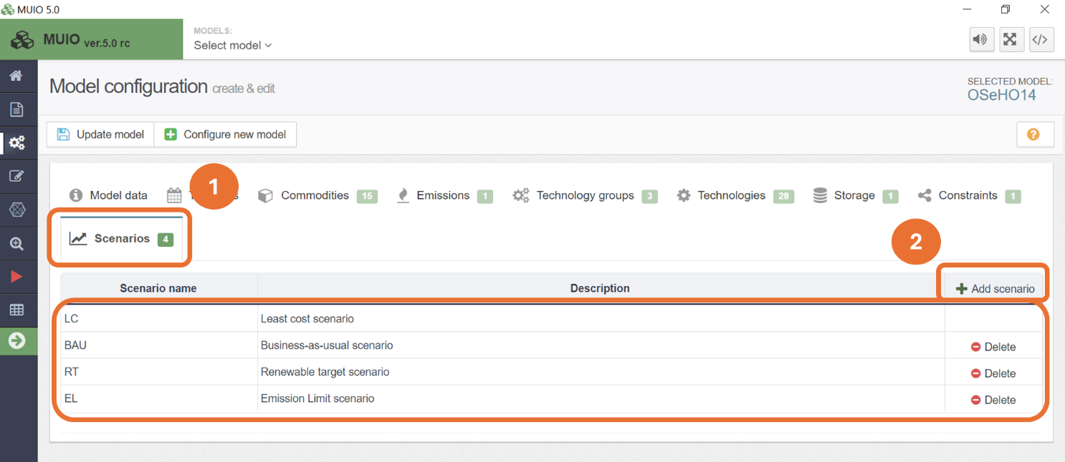

Next, we will define each scenario by adding the relevant parameters.

Business-as-usual scenario

In the BAU scenario, we assume that current trends, policies, and technologies are maintained in the long term. In OSeMOSYS, this scenario can be represented by constraining the energy supply to reflect the most representative technologies in each sector. Using the share of each technology in the last year of calibration (2023), we will maintain these shares from 2024 to 2030. From 2031 to 2035, we will allow a 10% share for new technologies to compete in meeting energy demands. These calculations will be added as parameters in the Total Technology Annual Activity Lower Limit. You can find these calculations in the Data Preparation file OSeHO14.

Try It: Add the Total Technology Annual Activity Lower Limit parameters for the BAU scenario.
- Click on the data entry button, and in the search bar, type ‘Total Technology Annual Activity Lower Limit.’ Then, navigate to that parameter.
- Click the line diagram button located next to the parameter name, as illustrated in the image below.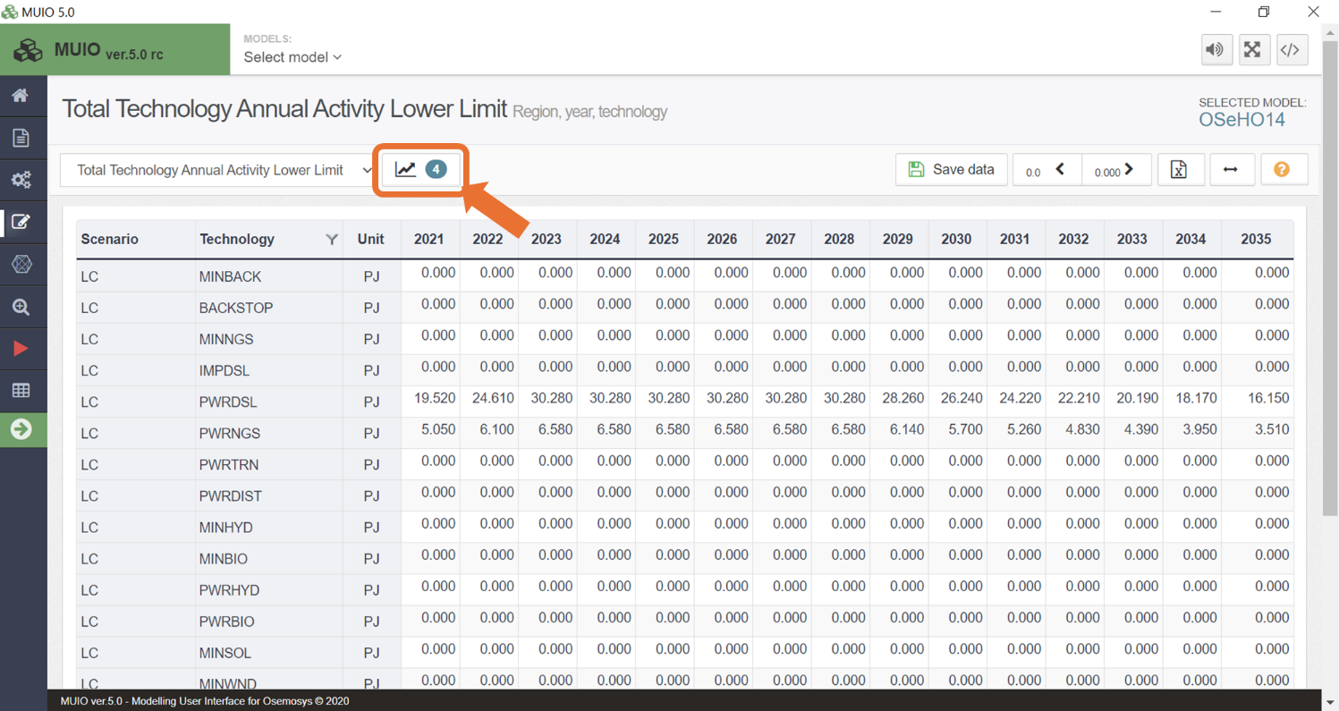
- Click on the folder icon to open the scenario data. By default, the BAU scenario will be selected in this case
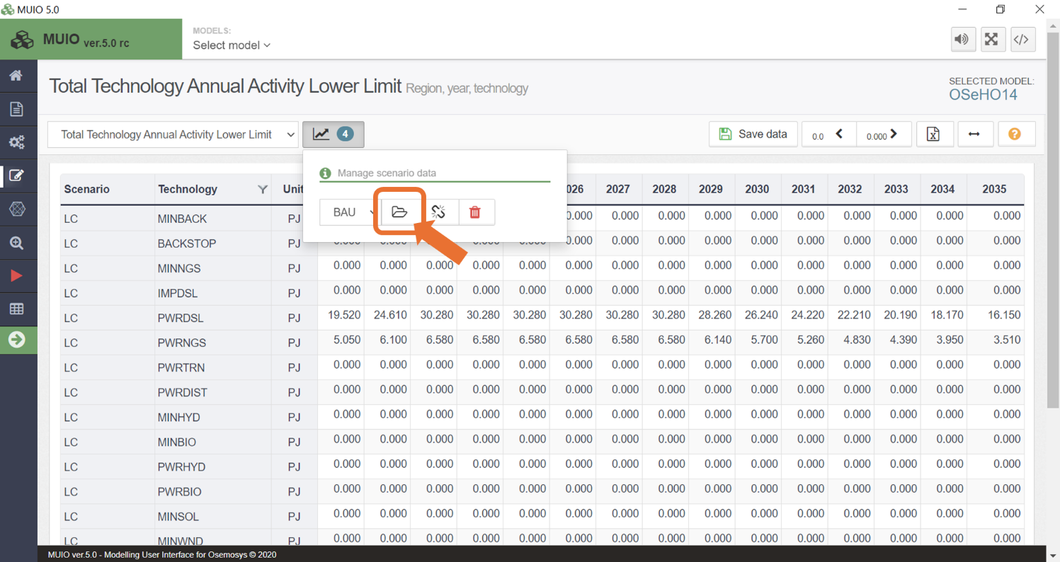

- Once the BAU scenario data is activated, the parameters for the second scenario will appear below those of the first scenario. To locate them, display additional rows and scroll down. By default, these parameters will be empty and marked as 'n/a.’
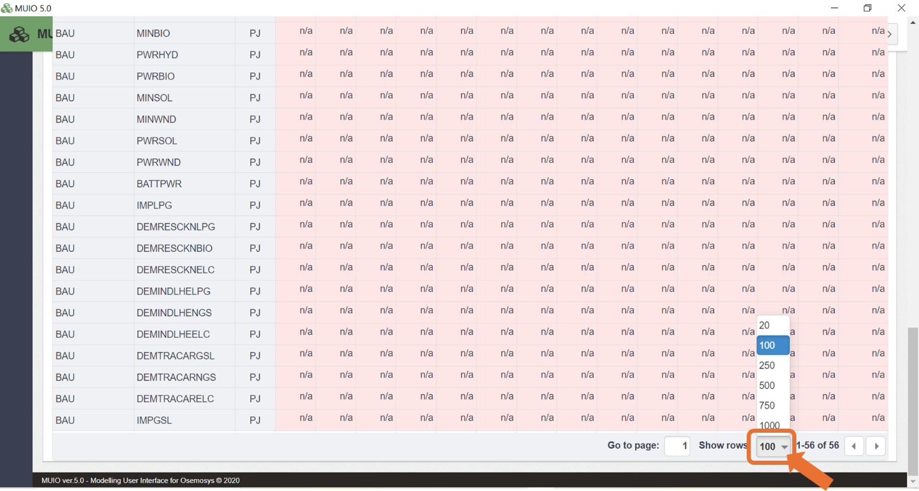

- Copy and paste the data for the years 2021–2035 for the corresponding technologies from the Data Preparation file OSeHO14. The input should resemble the image shown below.
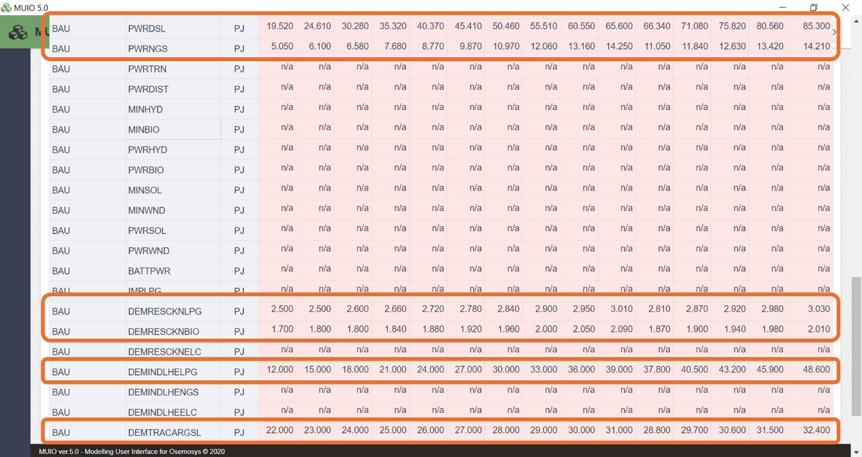

- Save the data and update the model.

Renewable target scenario

In the Renewable Target (RT) scenario, we will aim to achieve at least 50% of electricity production from renewable sources by 2030, progressively increasing to at least 80% by 2035. While this is an ambitious target, it provides an opportunity to explore how to set and implement such goals using OSeMOSYS. As discussed in Lecture 15, we can incorporate a renewable target by adding a User Defined Constraint (UDC). In this case, activity multipliers are used since we are dealing with electricity production (i.e., the activity of power plant technologies). The corresponding inequality is shown below.

$$Input Activity Ratio of Transmission*Percentage Target*Transmission Activity<\sum_{t=1}^{n}{{Renewable Technology Activity}_{t}}$$

$$Input Activity Ratio of Transmission*Percentage Target*Transmission Activity-\sum_{t=1}^{n}{{Renewable Technology Activity}_{t}<0}$$

The multiplication of the transmission activity by its input activity ratio gives the total electricity production feeding the transmission technology. By multiplying this total electricity production by the percentage target, we calculate the amount of energy required to be produced by renewable technologies. This amount must then be greater than or equal to the sum of electricity generated by renewable technologies (e.g., solar, wind, hydro, and biomass). By rearranging the equation and moving the terms to one side, we obtain the standard form of a UDC. In this form, the UDC constant becomes zero, the UDC activity multipliers for all renewable energy technologies are set to -1, and the activity multiplier for the transmission technology is set to the input activity ratio multiplied by the percentage target.

Try It: Add the UDC activity multiplier parameters for the RT scenario.
- First, let’s add a new UDC. On the model configuration page, navigate to the 'Constraints' tab and click on ‘+ Add Constraint.’ This constraint will be an inequality, as explained previously. Select the relevant technologies for this constraint, which include the renewable power plants and transmission: PWRHYD, PWRBIO, PWRSOL, PWRWND, and PWRTRN.
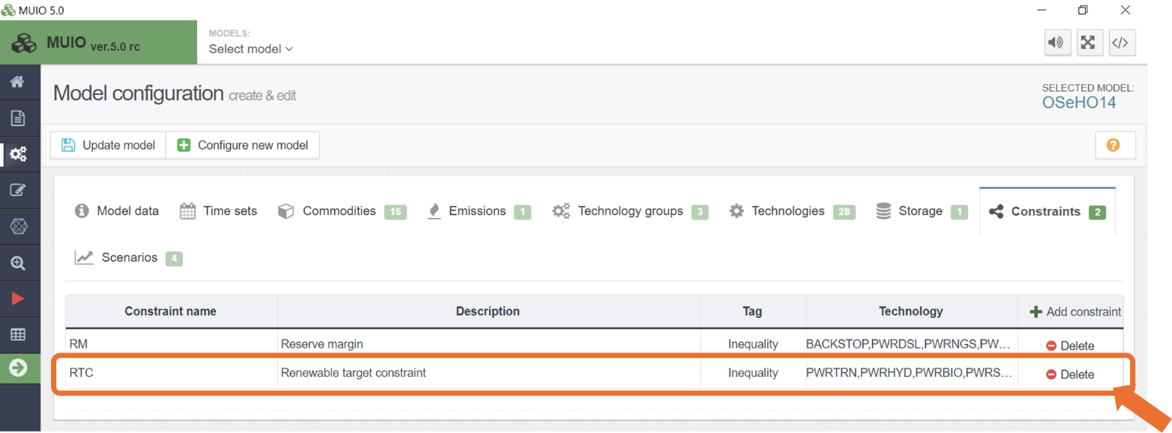
- Update the model.
- Click on the data entry button, and in the search bar, type ‘UDC Multiplier Activity.’ Then, navigate to that parameter.
- Click the line diagram button located next to the parameter name, as illustrated in the image below.
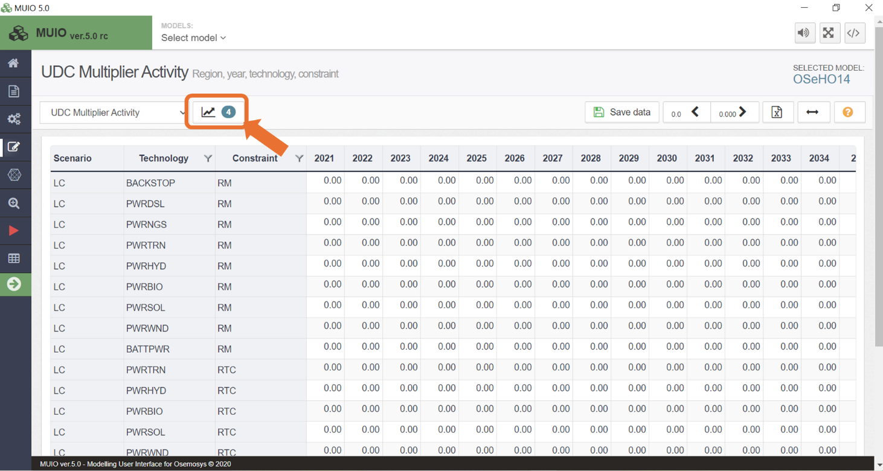
- Select the RT scenario in the drop-down list and click on the folder icon to open the scenario data.
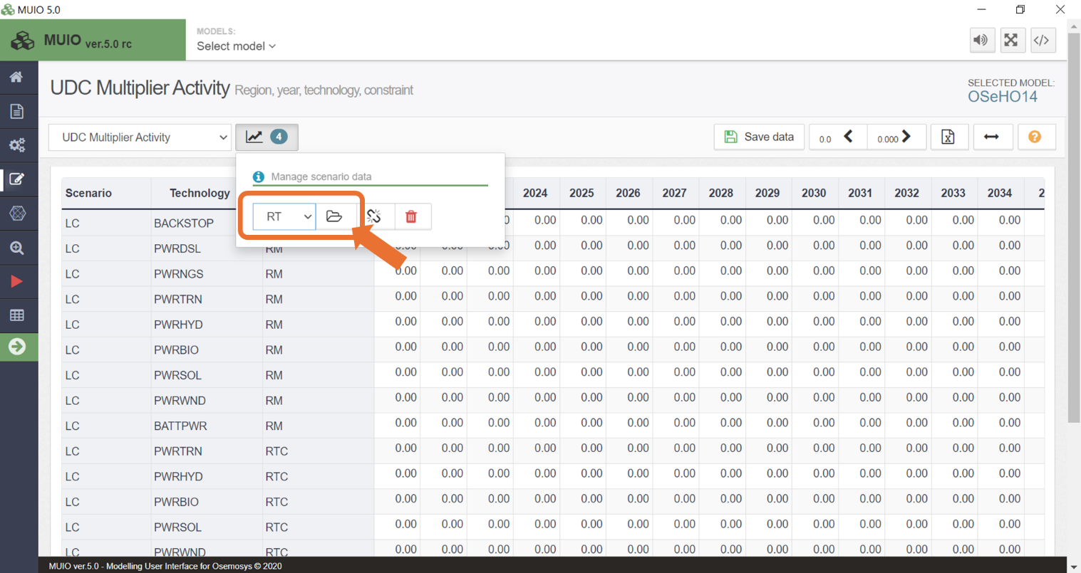

- Once the RT scenario data is activated, the parameters for this second scenario will appear below those of the first scenario. To locate them, display additional rows and scroll down. By default, these parameters will be empty and marked as 'n/a.’
- Copy and paste the data for the years 2021–2035 for the corresponding technologies from the Data Preparation file OSeHO14. The input should resemble the image shown below. Be careful with selecting the right scenario (RT) and constraint (RTC).
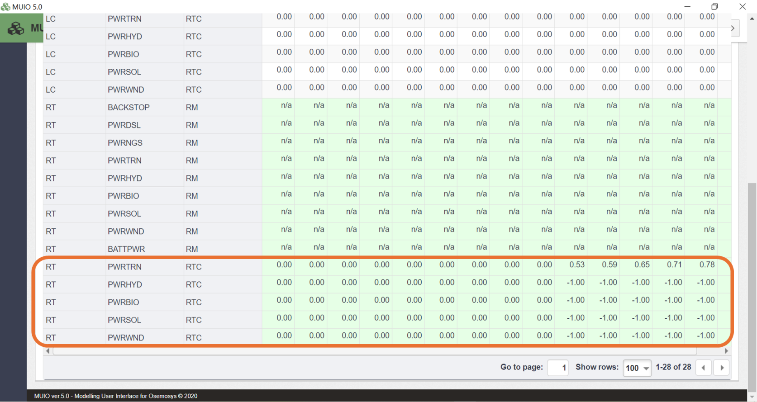
- Save the data and update the model.

Emission limit scenario

In the Emission Limit (EL) scenario, we will introduce a carbon budget to systematically reduce emissions. This type of scenario is commonly modeled in Nationally Determined Contributions (NDC) assessments. To create a carbon budget, the national emissions inventory for each country or region can be used to define the initial emissions level and determine the rate of reduction over time based on the desired level of ambition. In OSeMOSYS, this is achieved by defining the Annual Emission Limit parameter, which specifies the maximum allowable amount of a particular emission type for each year.

Try It: Add the Annual Emission Limit parameters for the EL scenario.
- Click on the data entry button, and in the search bar, type ‘Annual Emission Limit.’ Then, navigate to that parameter.
- Click the line diagram button located next to the parameter name, as illustrated in the image below.
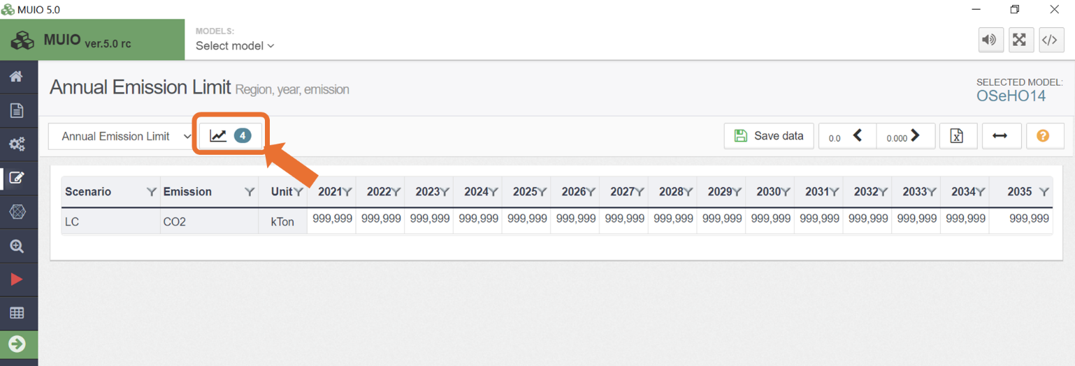
- Select the EL scenario in the drop-down list and click on the folder icon to open the scenario data.
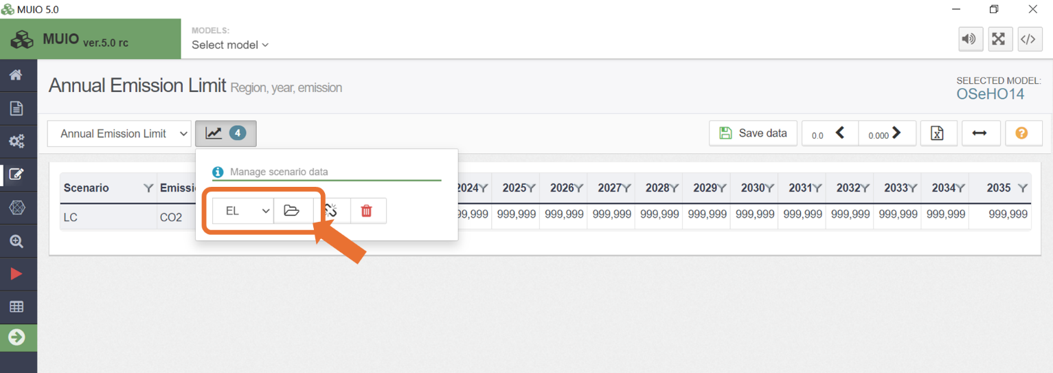

- Once the EL scenario data is activated, the parameters for this scenario will appear below those of the first scenario. By default, these parameters will be empty and marked as 'n/a.’
- Copy and paste the data for the years 2021–2035 from the Data Preparation file OSeHO14. The input should resemble the image shown below. The first years are unconstrained since they are the calibration years.
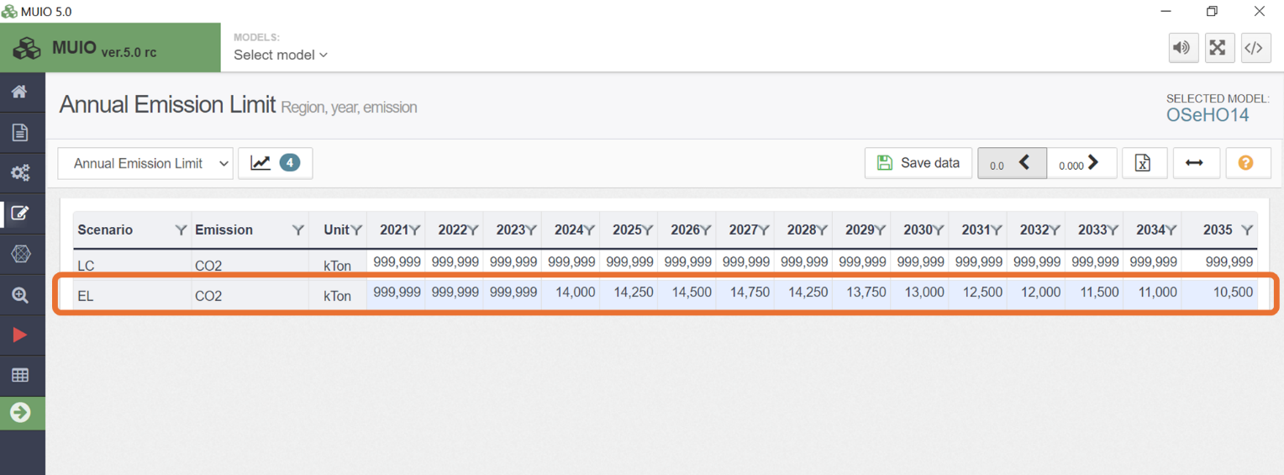
- Save the data and update the model.

Run the model and check the results

Running the model this time will differ slightly to incorporate scenarios. Follow these steps:

- Click the red play button as usual to start a case.
- Name the scenario "LC" and optionally add a description.
- Click the Scenarios button, as shown in the image below.
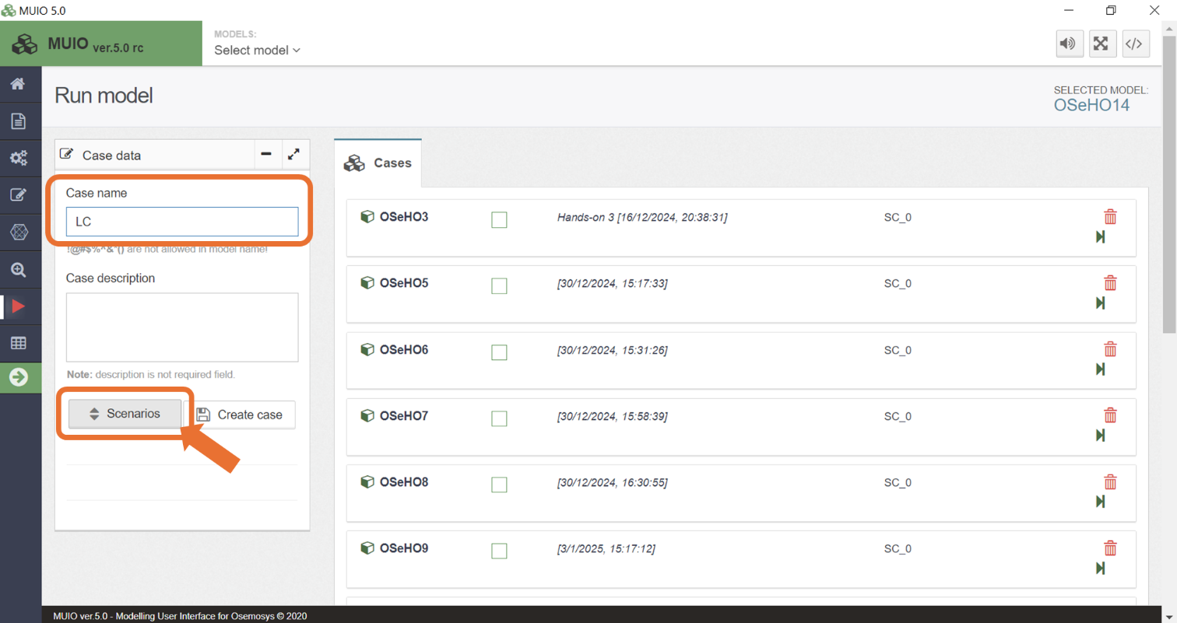

- Uncheck all scenarios except the LC scenario and click Save.

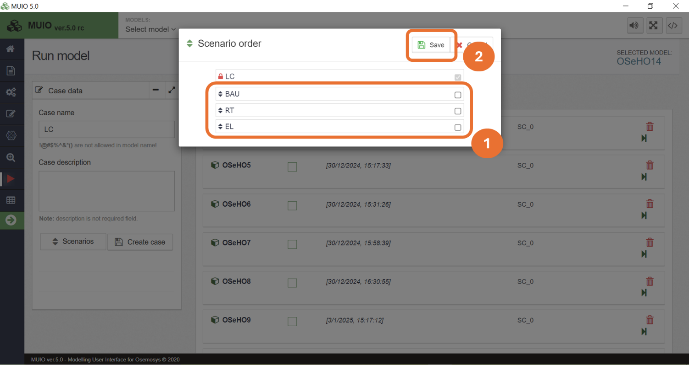
Note: All scenarios are selected by default, meaning the modified parameters in each scenario overwrite the baseline scenario.
Important: If two scenarios have different values for the same parameter, the values from the latest scenario in the list will take precedence.

- Follow the usual procedure by pressing the corresponding button to create a case. Then press the Data file button to generate the input data file for the optimization process. Finally click RUN MODEL.

Once this step is completed, the case for the LC scenario will be created. Next, we need to create three additional cases for the corresponding scenarios. Assign each case its respective scenario name (BAU, RT, and EL) and select the appropriate scenario from the scenario list.

For example, in the BAU scenario, the selection should match the example shown in the image below. Then, follow the previously reviewed steps for each case.
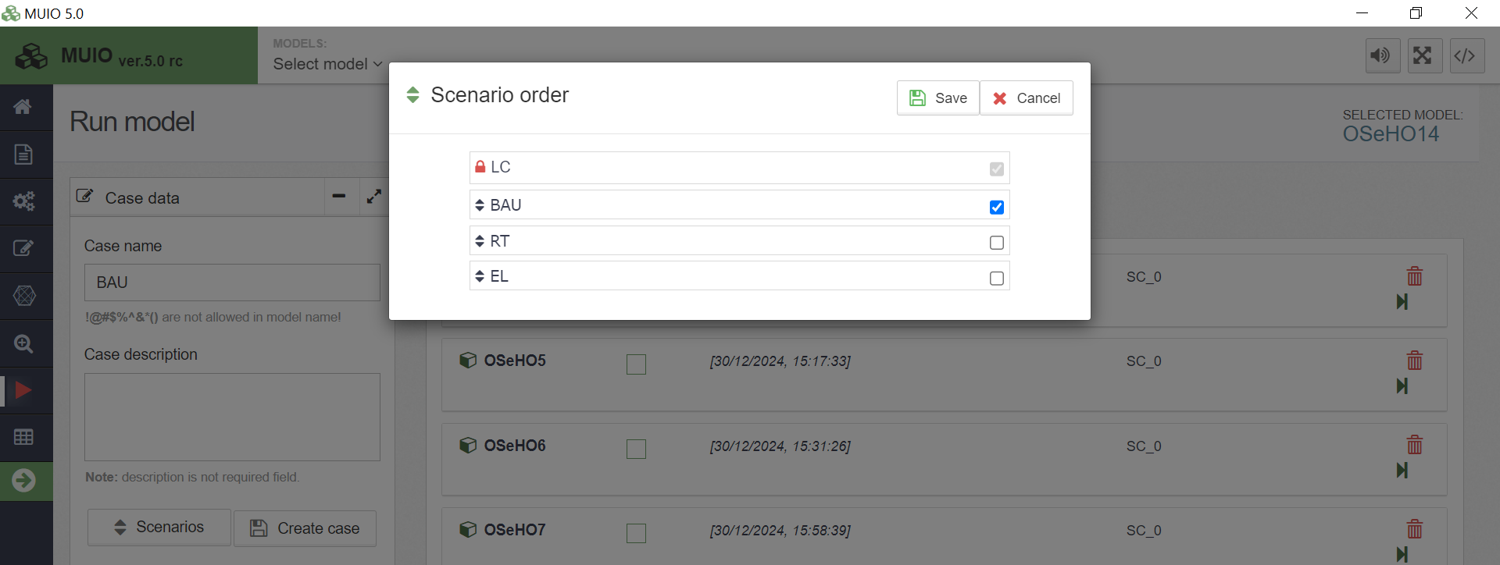

At the end of the process, you should have four successful runs in your data cases. The list should look similar to the image below.
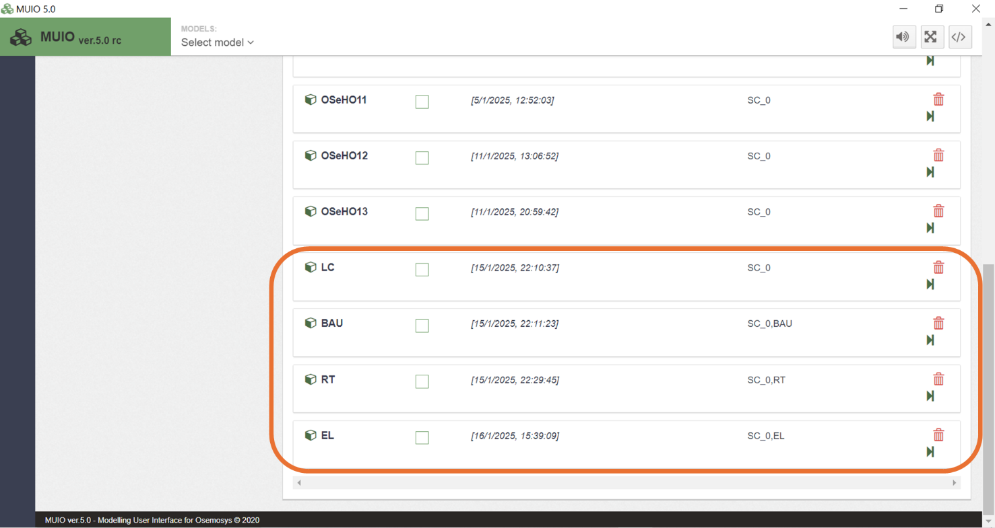

The results of Production By Technology By Mode are the following:

Energy production in the power sector
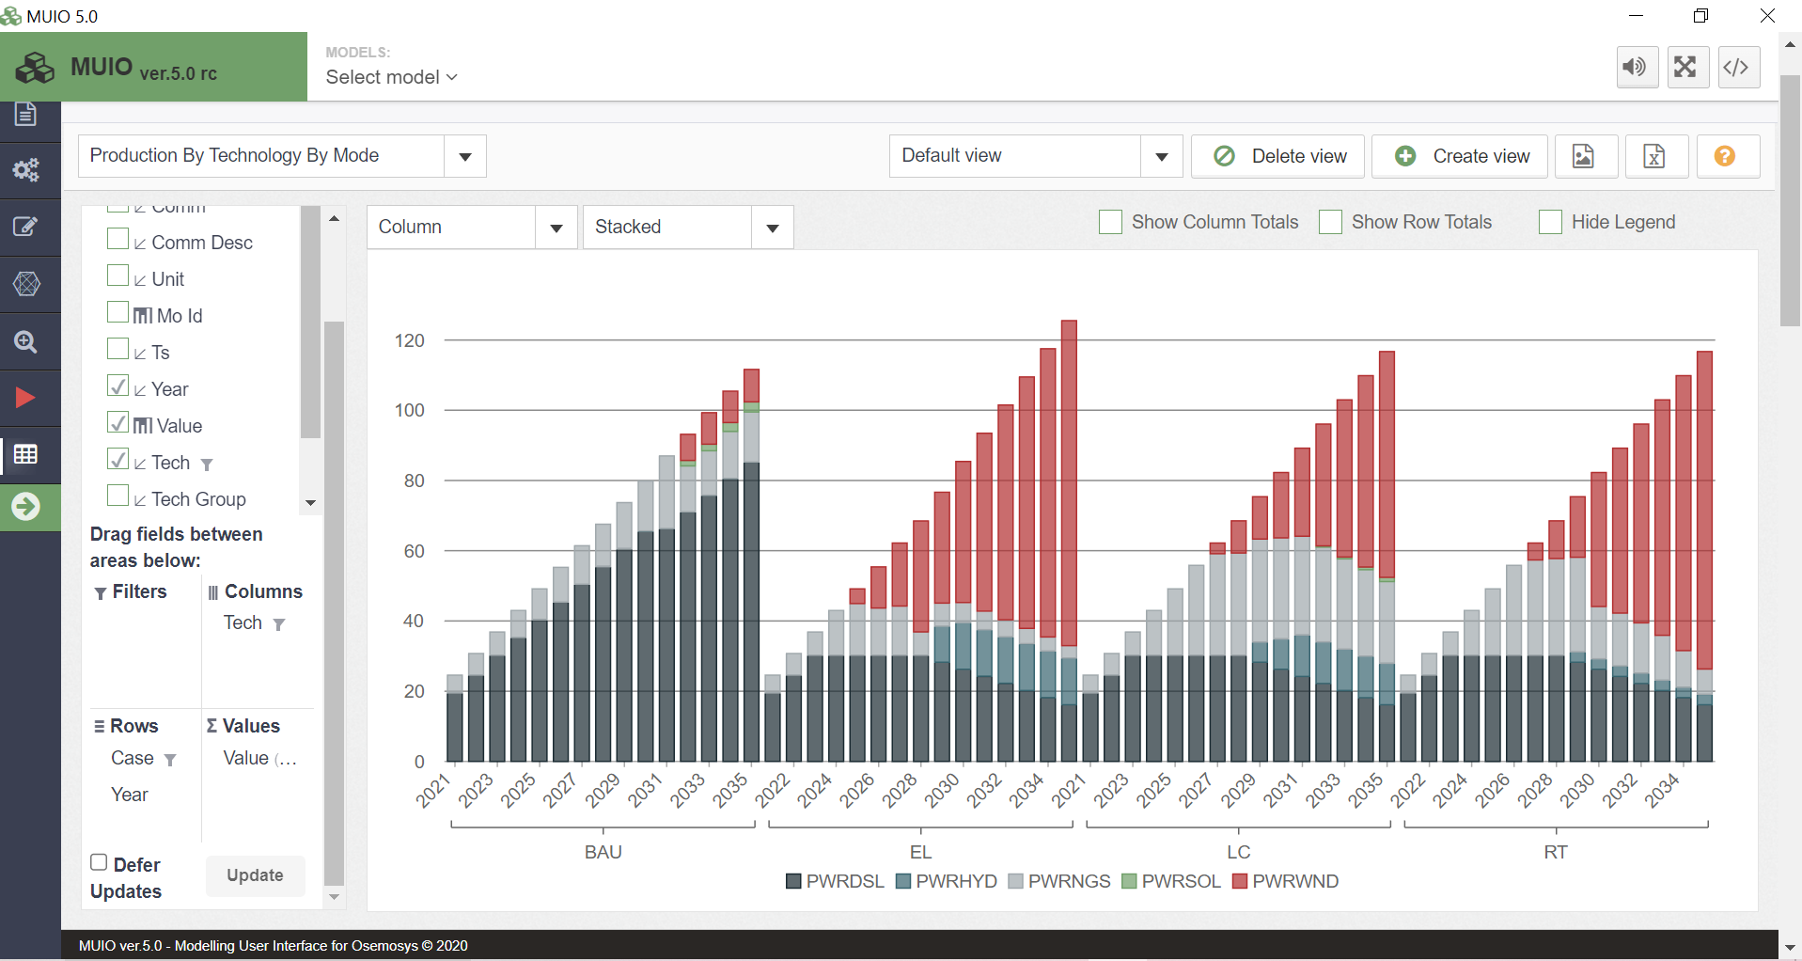

Energy production in the transport sector
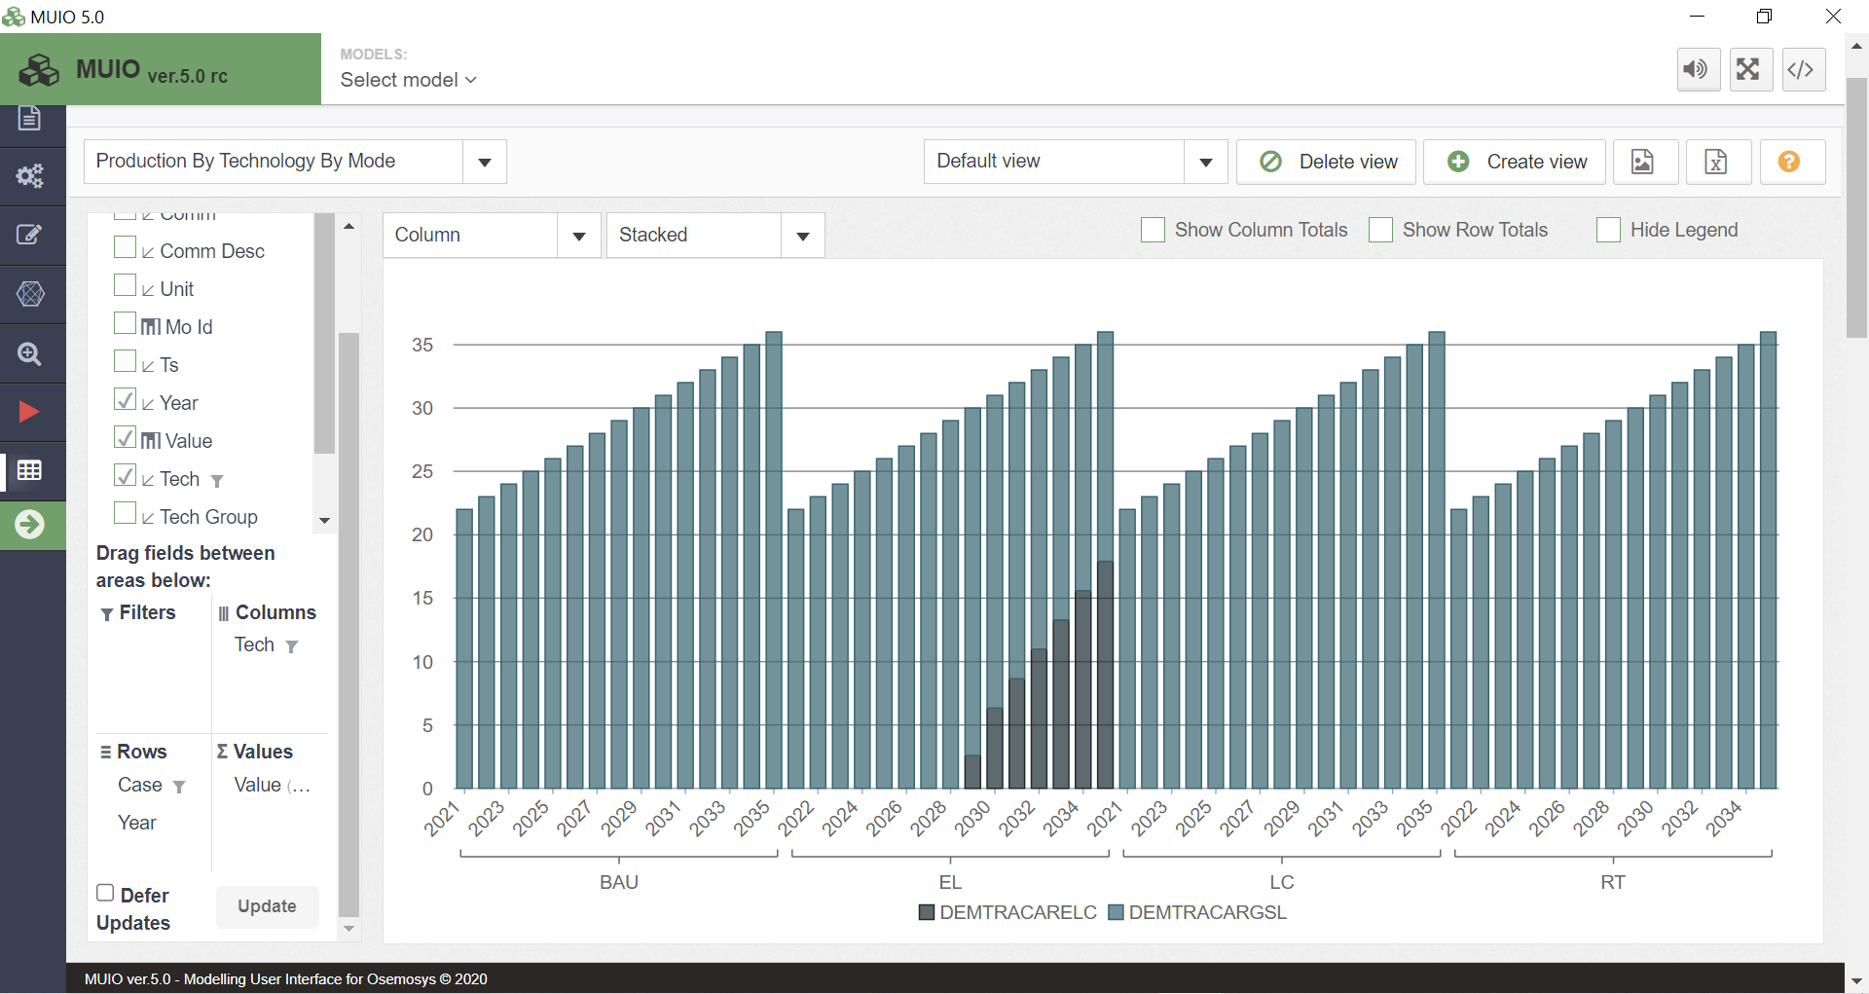
Energy production in the industrial sector
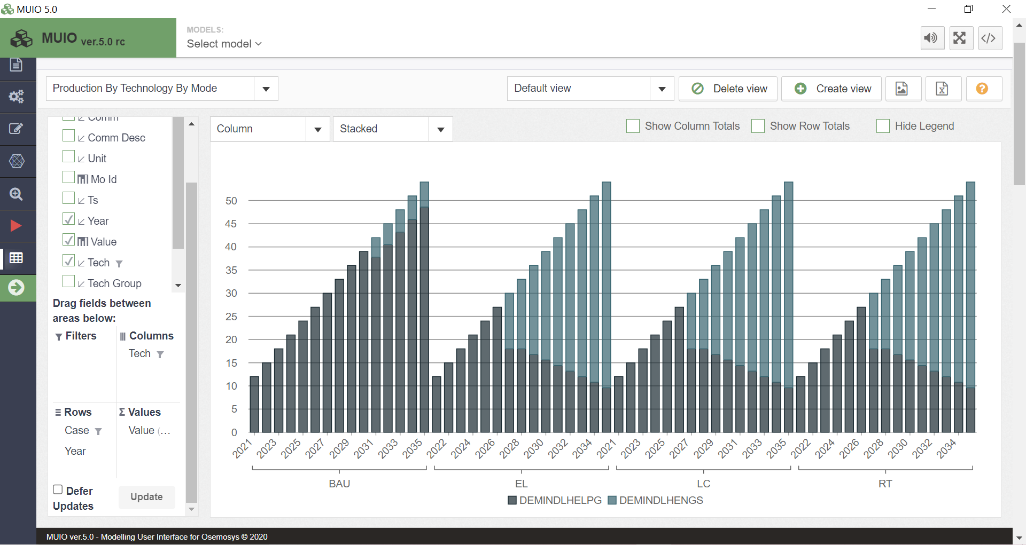

Energy production in the residential sector
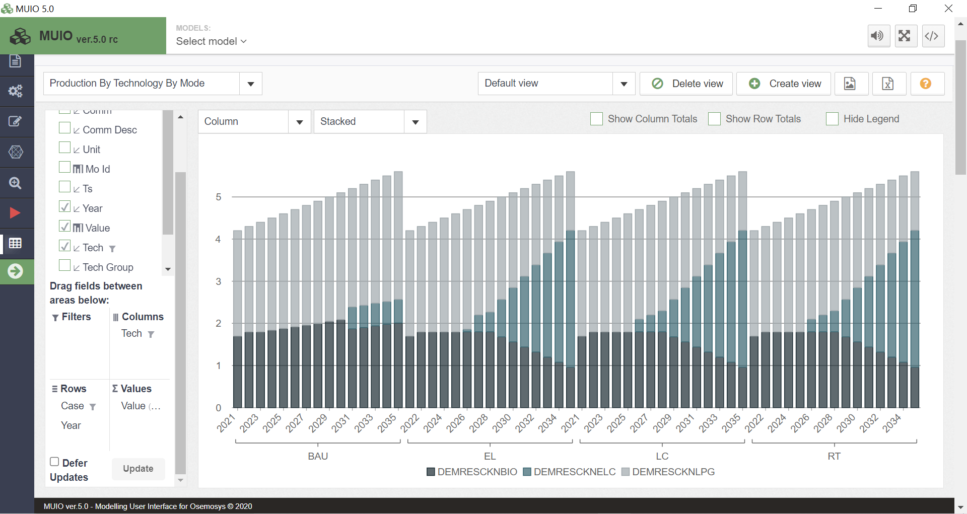
Question to consider: Based on the scenario results, could you provide a summary of key insights for energy planning?

