Energy System Modelling Using OSeMOSYS
Hands-on 13
Please use the following citation for:
- This exercise
Plazas-Niño, F., Barnes, T. (2025, February). Hands-on 13: Energy System Modelling Using OSeMOSYS (Version 1.0.). Climate Compatible Growth. DOI: 10.5281/zenodo.14871580

- OSeMOSYS UI software
Climate Compatible Growth. (2024). MUIO (Version v5.0.0). GitHub. https://github.com/OSeMOSYS/MUIO/releases
____________________________________________________________________________

Learning outcomes

By the end of this exercise, you will be able to:
- Calibrate installed capacities and energy production in an OSeMOSYS model.
- Incorporate technology penetration rates for different technologies.
- Review additional parameters from previous hands-on exercises to ensure an accurate representation of the energy system.

Calibrate existing capacities

In this hands-on exercise, we will not add new technologies or commodities.
IMPORTANT: Before proceeding, you must copy the model and rename it as you have done before (this time as OSeHO13).
For this case study, we will use the years 2021 to 2023 as calibration years. We will begin by calibrating the existing capacities using the Residual Capacity parameter. In previous exercises, we added the corresponding residual capacities for technologies, assuming these capacities remained constant throughout the entire modeling period.
In this activity, we will apply a simple approach to forecast the decommissioning of all technologies. Keep in mind that this is a basic exercise designed for teaching purposes. If detailed data is available, more sophisticated trajectories for residual capacities can be implemented. Additionally, sector-specific assumptions may be appropriate. For instance, hydropower plants have very long lifetimes, so assuming constant residual capacity during the modeling period might be reasonable.
For this exercise:
- Existing capacities are known for the calibration years (2021–2023).
- From 2024 to 2028, we will maintain the same existing capacities as in 2023.
- From 2029 to 2035, we will apply Equation 1 to decrease the existing capacity linearly.
$${Residual capacity}_{n}=Initial Capacity-\left(n-Starting year\right)*\frac{Initial Capacity}{Operational life}$$  $$Where n is a specific year after the starting year$$ | (1)

Try It: Update the data of Residual Capacity
- Click on the data entry button, and in the search bar, type ‘Residual Capacity.’ Then, navigate to that parameter.
- Copy and paste the residual capacity data for the years 2021–2035 for the corresponding technologies from the Data Preparation file OSeHO13. Note: We will keep the residual capacities of PWRTRN and PWRDIST constant.
- The input should resemble the image shown below.
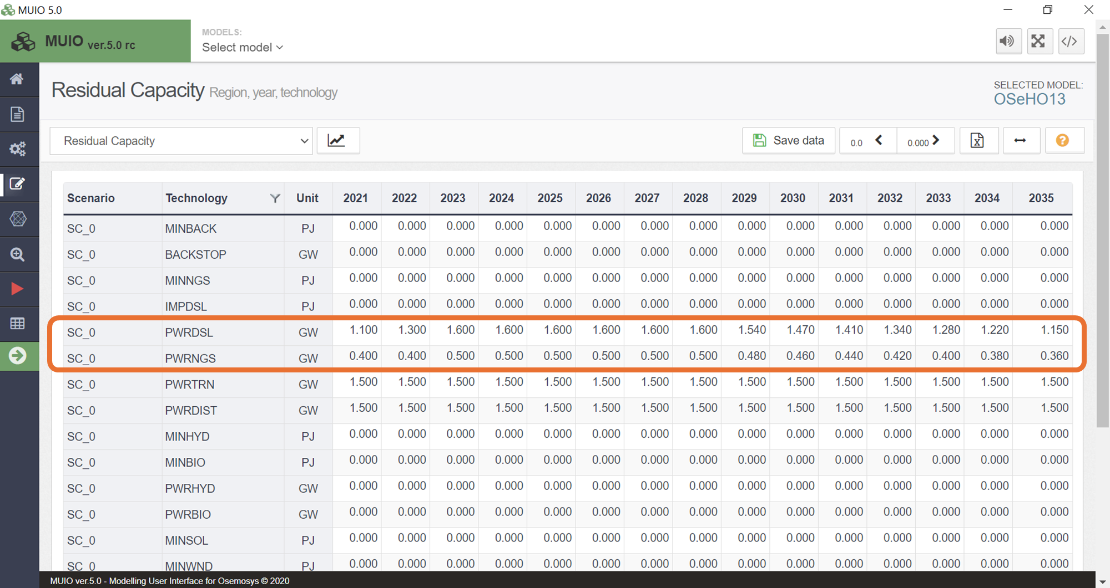
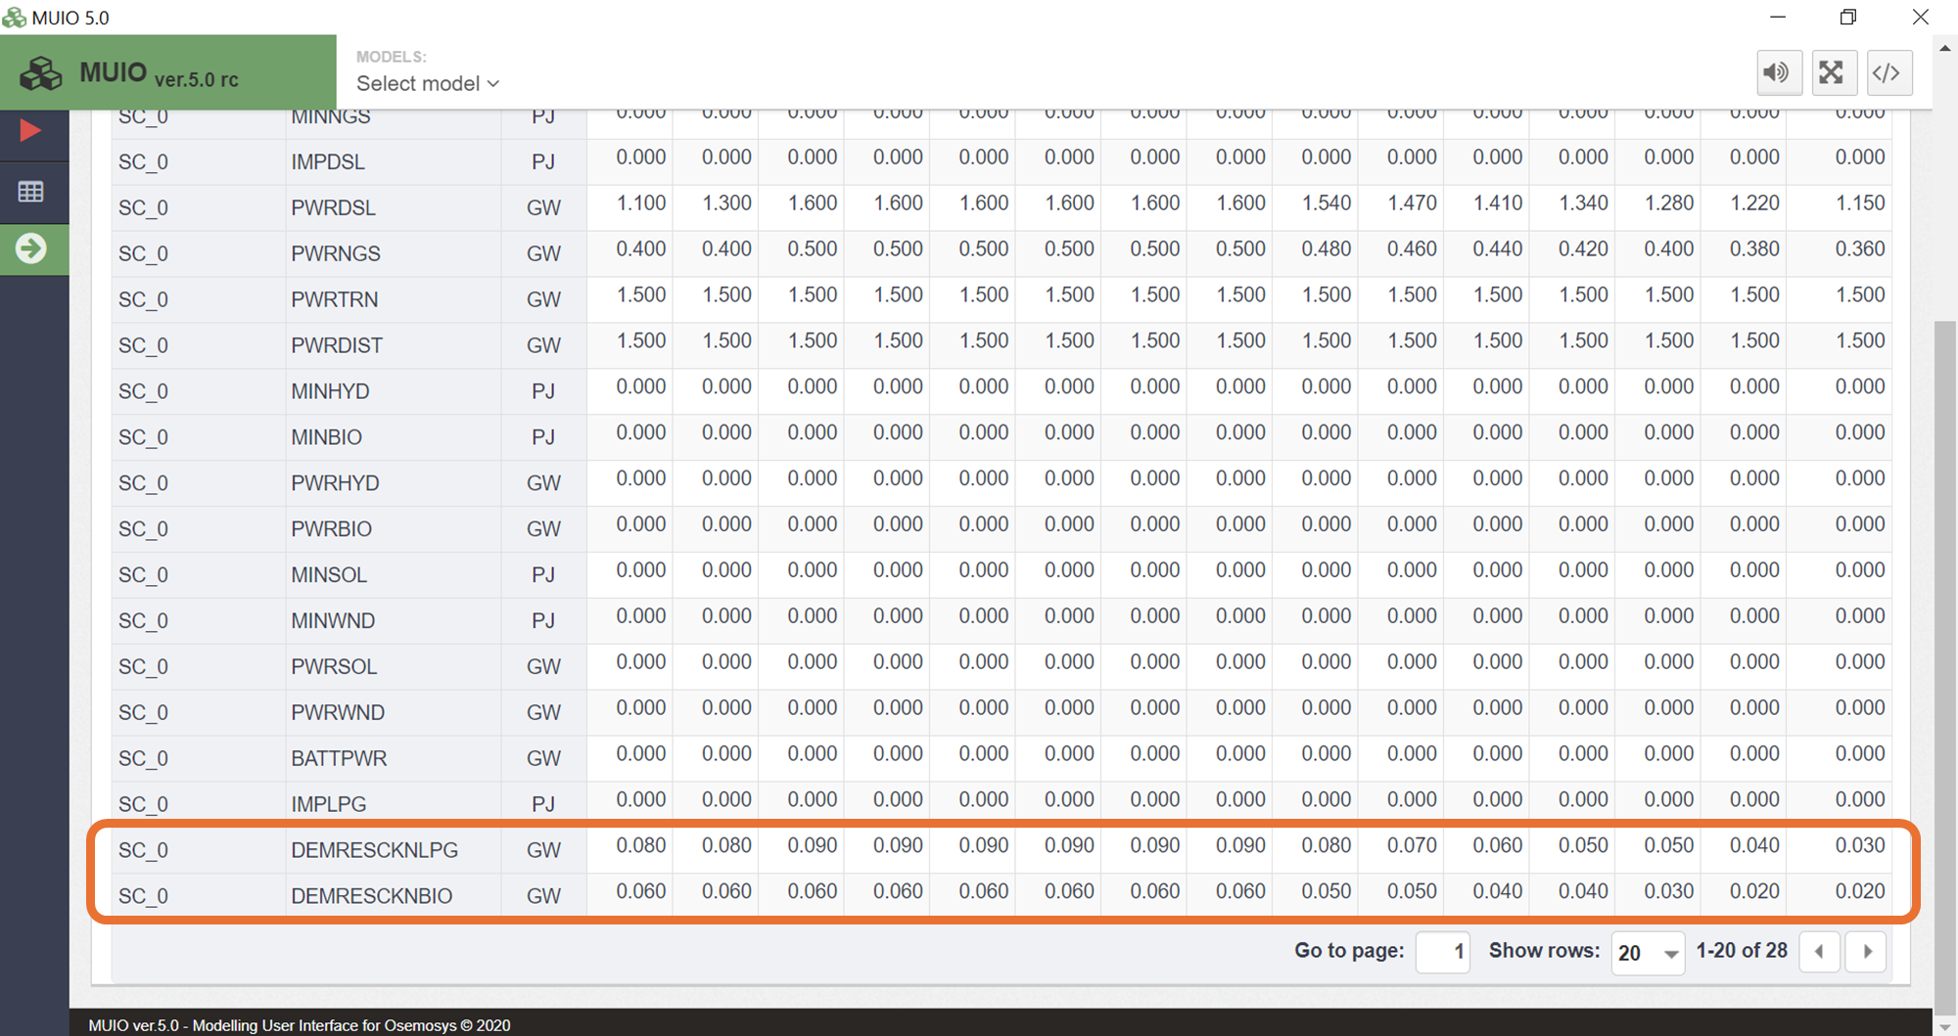
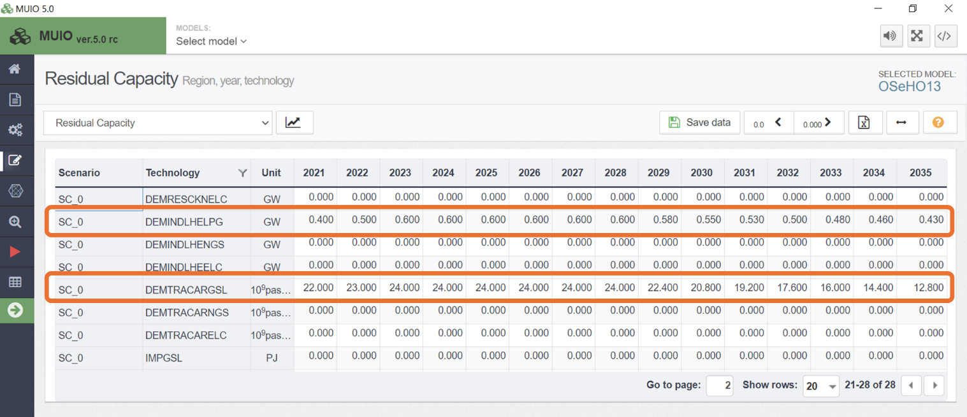
Note: Make sure to save the data and update the model each time you complete this process.

Calibrate energy production

The next step is to calibrate energy production using the Total Technology Annual Activity Lower Limit parameter. Based on data from energy balances and sectoral reports, we need to estimate the annual energy production for each technology during the calibration years.
Similar to residual capacities, we will make the same assumptions for energy production. For this exercise:
- Energy production per technology is known for the calibration years (2021–2023).
- From 2024 to 2028, we will maintain the same energy production as in 2023.
- From 2029 to 2035, we will apply Equation 2 to decrease energy production linearly.
$${Energy production}_{n}=Initial energy production-\left(n-Starting year\right)*\frac{Initial energy production}{Operational life}$$  $$Where n is a specific year after the starting year$$ | (2)

Let’s remember that the Total Technology Annual Activity Lower Limit defines the minimum level of energy that must be produced. However, the model can choose to produce above this limit when optimizing the energy system.
Try It: Add the data of Total Technology Annual Activity Lower Limit
- Click on the data entry button, and in the search bar, type ‘Total Technology Annual Activity Lower Limit.’ Then, navigate to that parameter.
- Copy and paste the energy data for the years 2021–2035 for the corresponding technologies from the Data Preparation file OSeHO13.
- The input should resemble the image shown below.
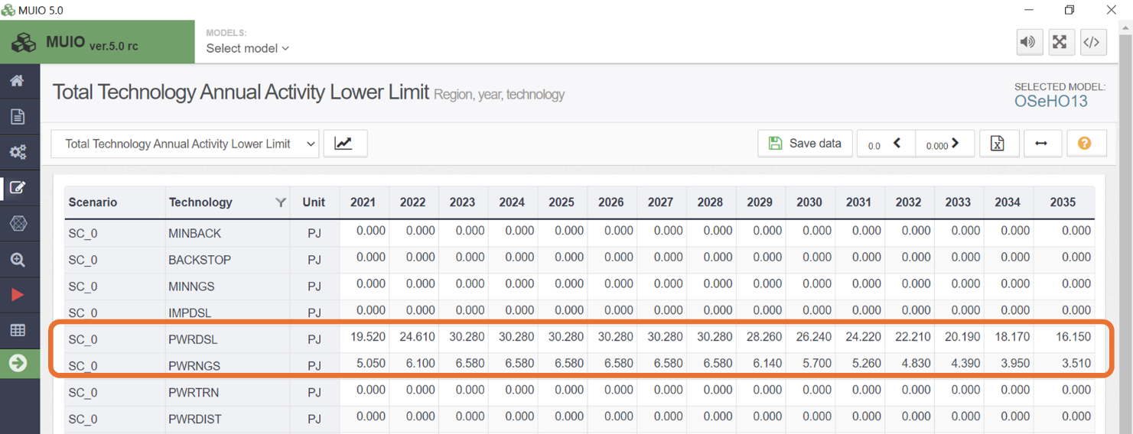
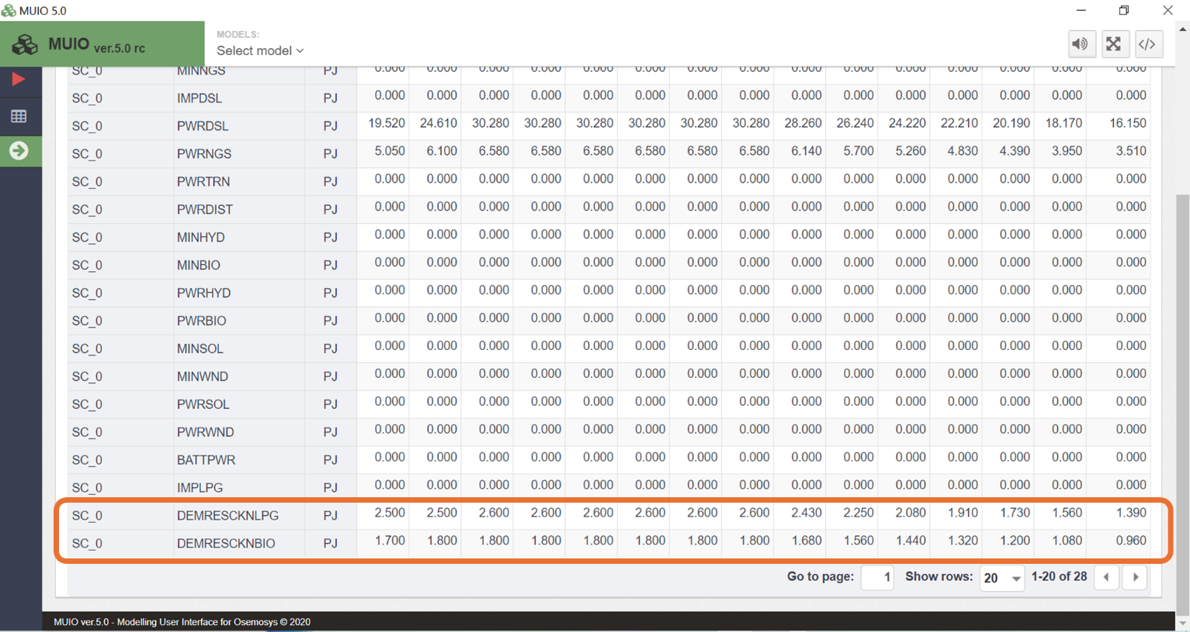
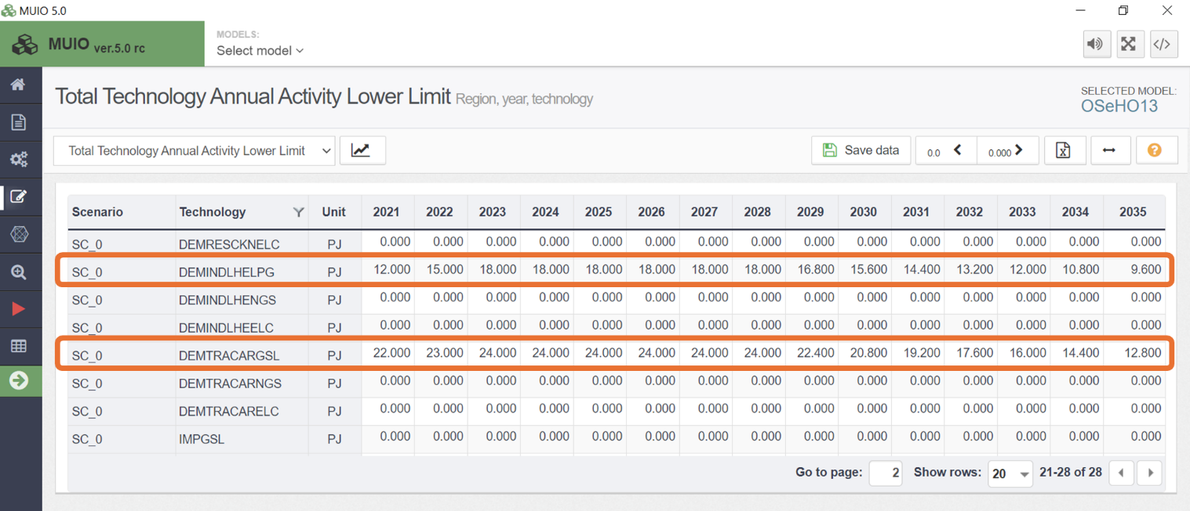
Note: Make sure to save the data and update the model each time you complete this process.

Deactivate technologies

As discussed in Lecture 14, we can deactivate technologies that are not part of the energy mix during the calibration years. This is achieved using the Total Annual Max Capacity Investment parameter, which sets the maximum new capacity allowed for a technology in a given year. By setting this parameter to zero, we effectively prevent any new capacity additions for the specified technology.
For this exercise, we will extend the Total Annual Max Capacity Investment parameter for certain years beyond the calibration years based on specific assumptions:
- 2024–2028 for PWRHYD: Reflecting the long construction times required for hydropower plants.
- 2024 for PWRBIO, PWRSOL, PWRWND, and BATTPWR: Allowing additional time for construction.
- 2024–2025 for DEMRESCKNELC: Providing time for potential policy design and building adaptation.
- 2024–2026 for DEMINDLHENGS and DEMINDLHEELC: Allowing for industrial adaptation.

Try It: Add the data of Total Annual Max Capacity Investment
- Click on the data entry button, and in the search bar, type ‘Total Annual Max Capacity Investment.’ Then, navigate to that parameter.
- Copy and paste the capacity data for the years 2021–2035 for the corresponding technologies from the Data Preparation file OSeHO13.
- The input should resemble the image shown below.

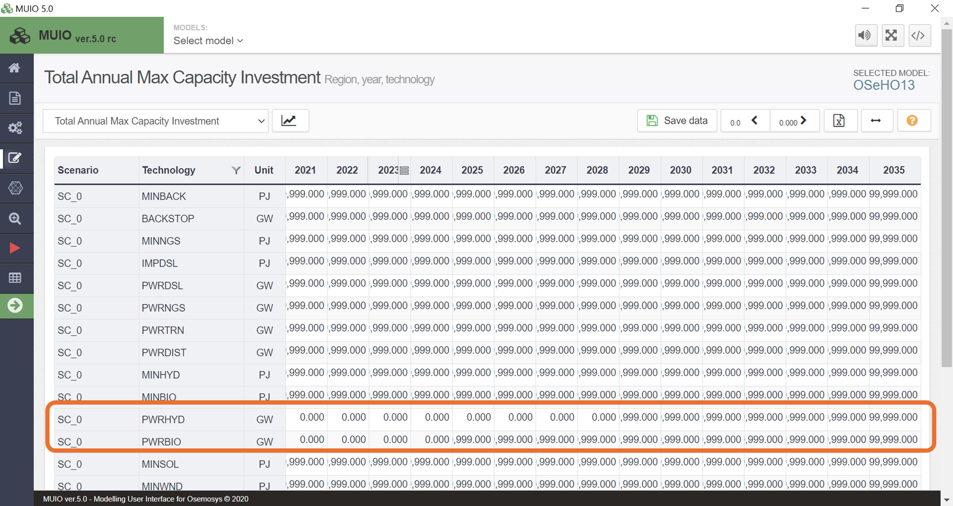

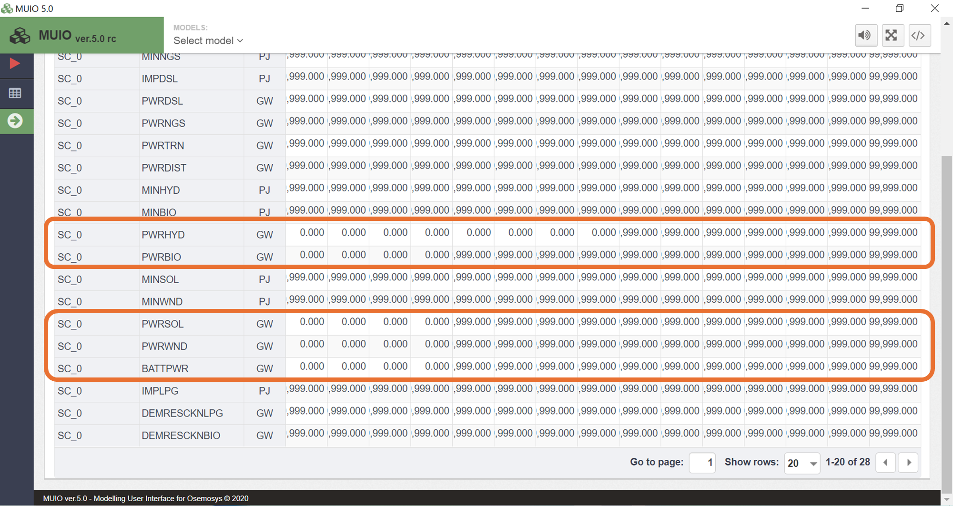

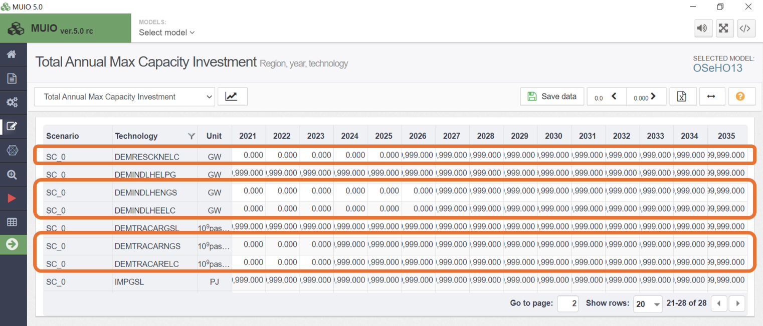

Introduce a technology penetration rate

As discussed in Lecture 14, we can incorporate technology penetration rates to control how quickly a new technology can contribute to meeting a demand. In this exercise, we will explore one approach to implement these rates using the Technology Activity Increase By Mode Limit parameter. This parameter defines the maximum percentage increase in activity that a technology can achieve each year.
For example, in the case of industrial sector electrification, technical studies indicate that the annual energy production for low-heat generation should not increase by more than 5% per year between 2027 and 2035.

Try It: Add the data of Technology Activity Increase By Mode Limit
- Click on the data entry button, and in the search bar, type ‘Technology Activity Increase By Mode Limit.’ Then, navigate to that parameter.
- Copy and paste the capacity data for the years 2027–2035 for DEMINDLHEELC from the Data Preparation file OSeHO13.
- The input should resemble the image shown below.

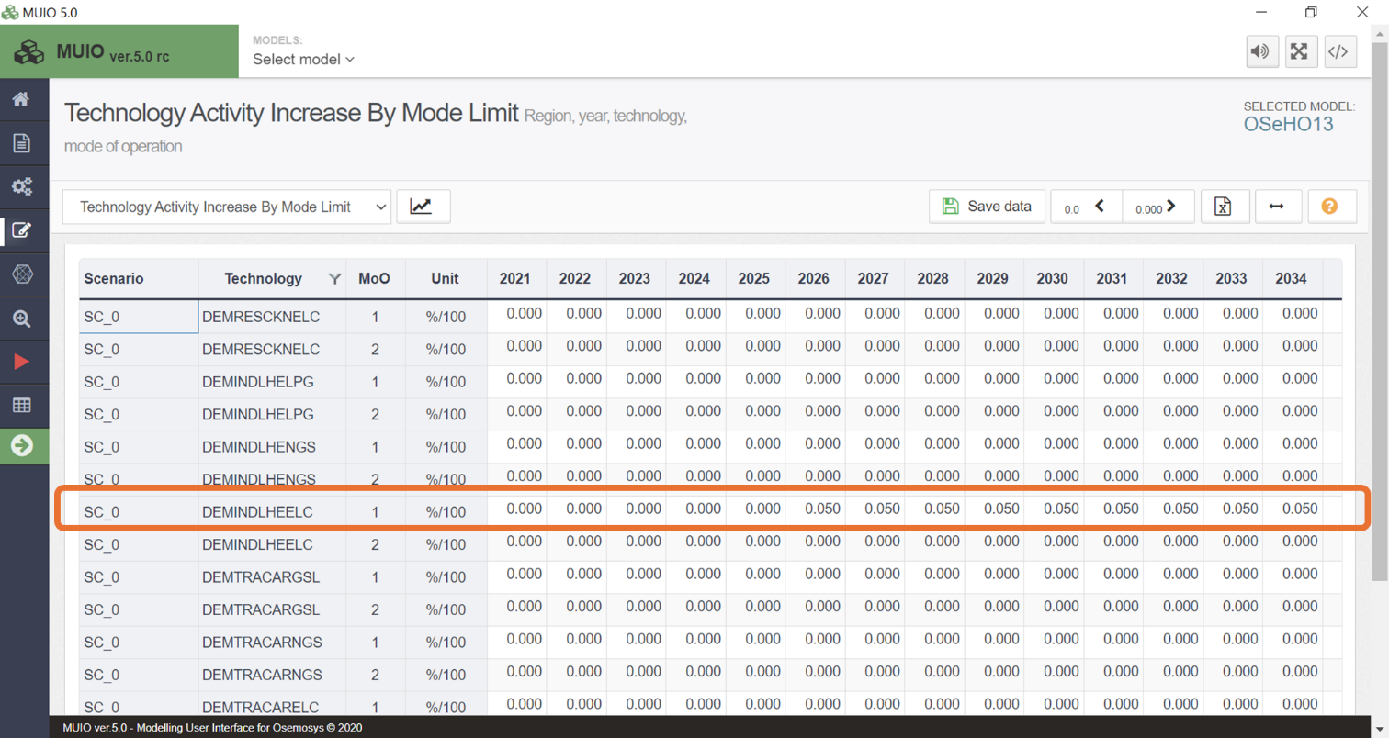

Review of additional parameters for calibration

There are additional parameters that are crucial for calibration, as they define the maximum potential for energy generation from both fossil fuels and renewable energy sources.

1. Defining Fossil Fuel Reserves
The Total Technology Model Period Activity Upper Limit parameter represents the total fossil fuel reserves. For countries or regions with proven or potential fossil fuel reserves, we must estimate the energy content of these resources. This parameter is applied to primary energy technologies, such as MINNGS (natural gas), MINOIL (oil), MINCOA (coal), and MINURN (uranium).
In our case study, we previously defined the total reserves for natural gas (MINNGS), estimated at 7,500 PJ. To verify this value, navigate to the Data Entry tab and locate the relevant parameter, as shown in the image below.
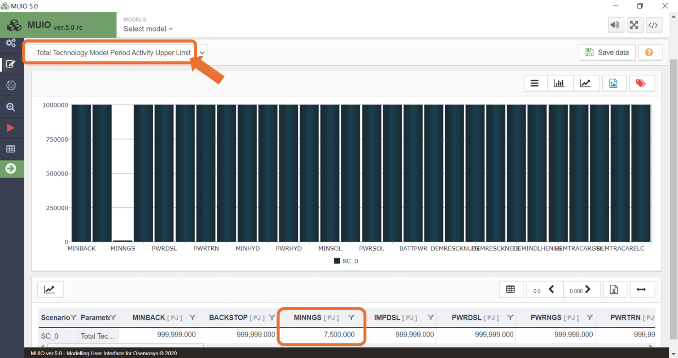

2. Defining Maximum Annual Energy Production
We can set the maximum annual energy production for each source using one of two approaches, depending on the type of data available:
a. Energy Terms
The Total Technology Annual Activity Upper Limit parameter defines the potential in energy units. For example, if biomass resources have an estimated annual production potential of 45 PJ, this parameter would be applied. This is primarily used for primary energy technologies, such as fossil fuels and biomass.
In previous exercises, we defined the Total Technology Annual Activity Upper Limit for natural gas production (MINNGS) and biomass extraction (MINBIO). To verify this value, navigate to the Data Entry tab and locate the relevant parameter, as shown in the image below.
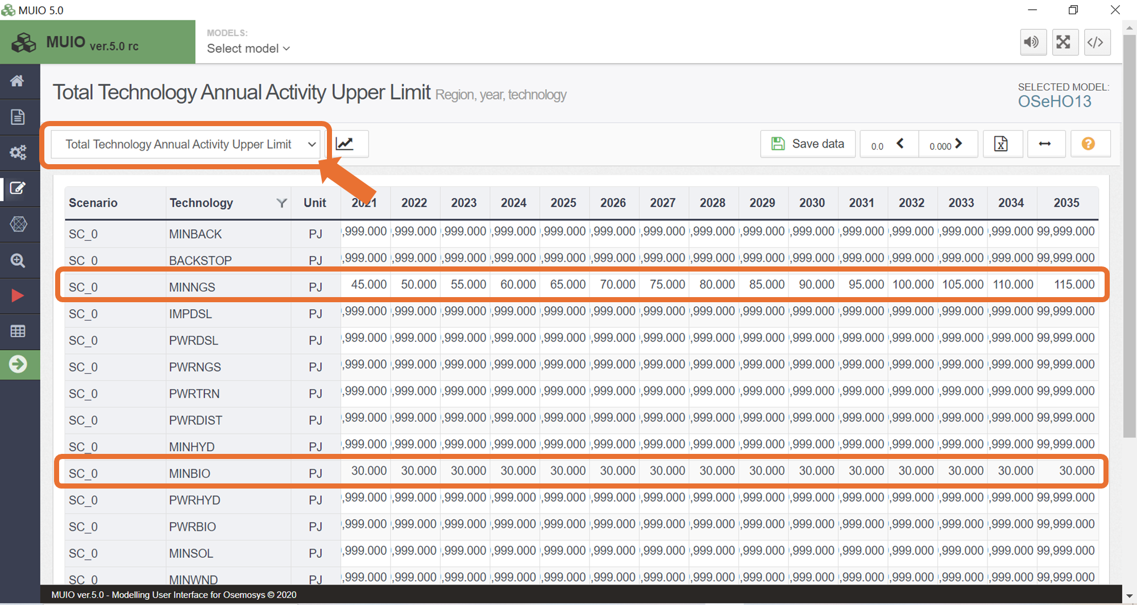

b. Capacity Terms
For renewable energy sources, the maximum potential is often given in capacity units. For example, the technical potential for onshore wind might be calculated as 7.3 GW. In these cases, we use the Total Annual Max Capacity parameter, which sets the maximum allowable installed capacity for a technology.
This parameter is typically applied to power generation technologies, such as PWRGEO (geothermal), PWRHYD (hydropower), PWRSOL (solar), and PWRWND (wind). In a previous hands-on exercise, we defined this parameter for solar, wind, and hydropower plants. To verify this value, navigate to the Data Entry tab and locate the relevant parameter, as shown in the image below.
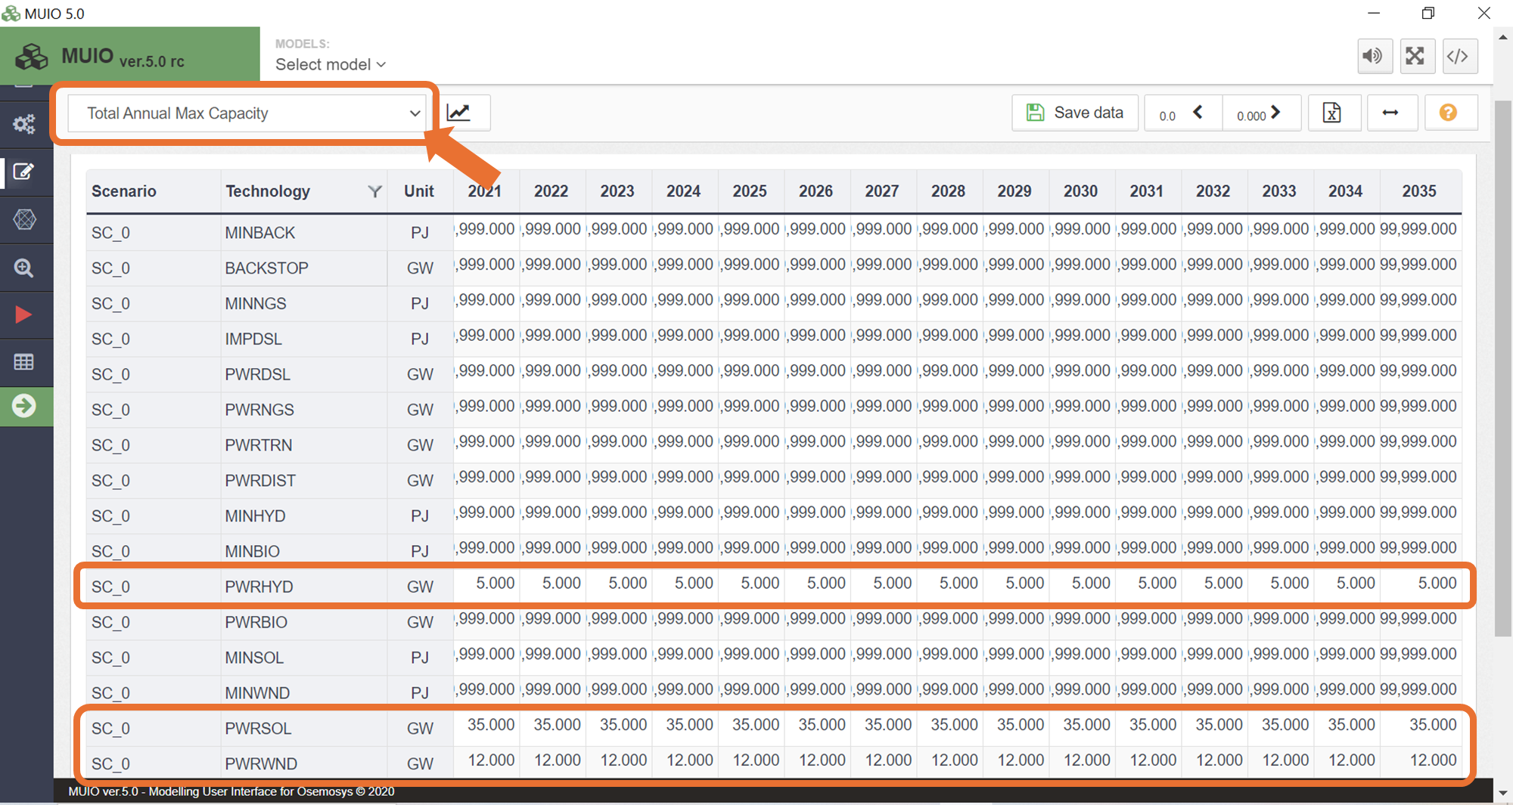

Run the model and check the results

Run the model in the user interface as demonstrated in previous exercises. Since we now have four energy demands, we need to be mindful of how we plot the results for Production by Technology by Mode (PJ). First, filter for the power plants, as done previously, and compare the results between HO12 and HO13. The graph should resemble the image shown below.

Energy production in the power sector
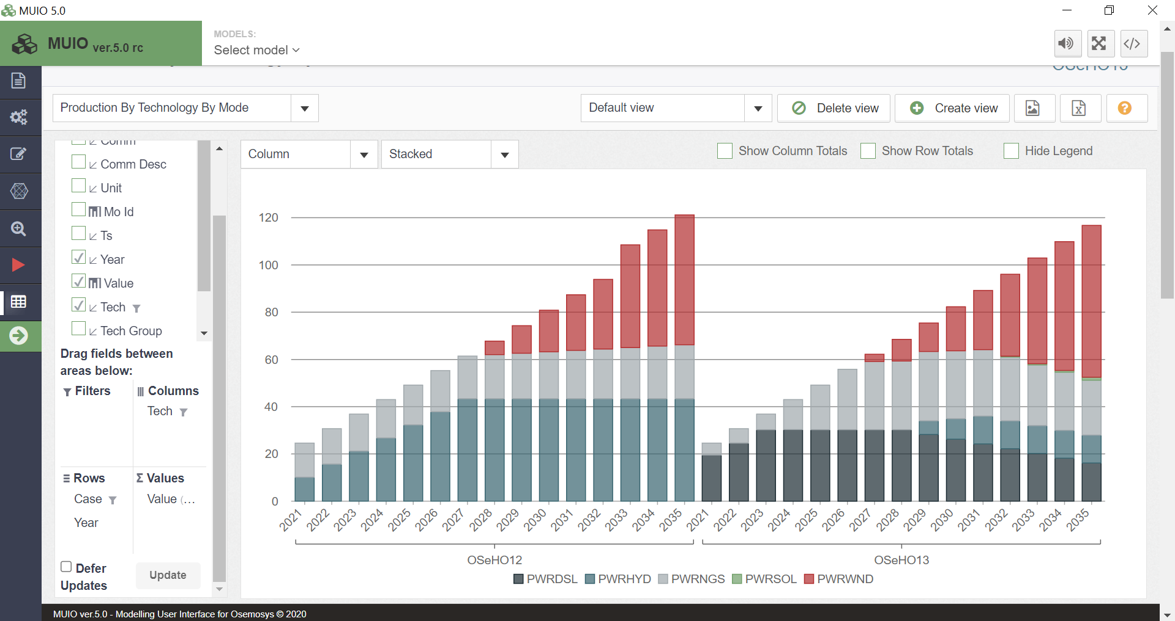

In this exercise, our model has been calibrated to reflect the system's behaviour during the calibration years. The results align with the defined residual capacities and lower limits, ensuring the expected use of diesel and natural gas power plants. Additionally, hydropower plant installations were successfully avoided in the first year, consistent with reality. As defined earlier, hydropower gradually penetrates the system until 2029.
Natural gas power plants account for a larger share of electricity generation, as natural gas becomes more available due to reduced industrial consumption for low heat generation in the initial years of the modelling period. Wind energy continues to dominate electricity generation in the latter part of the period, while a small amount of solar energy is produced in this calibrated scenario, unlike in Hands-on Exercise 12.

Energy production in the transport sector
There is no significant change in the transport sector, as gasoline cars remain the most cost-effective option throughout the modeling period.
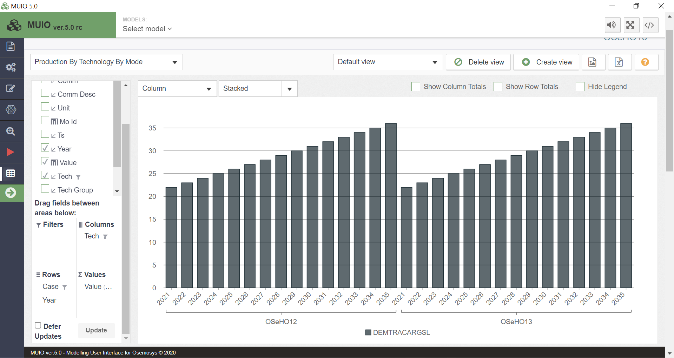

Energy production in the industrial sector
In the industrial sector, LPG is utilized at the beginning of the period due to residual capacities and lower limits. Over time, natural gas progressively replaces LPG as it becomes more competitive.

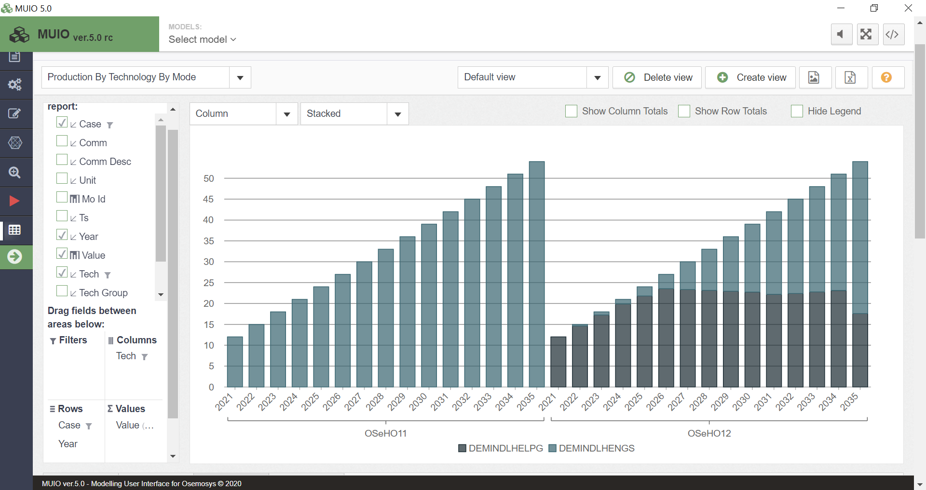

Energy production in the residential sector
In the residential sector, biomass and LPG are used in the initial years, reflecting historical data. From 2026 onward, there is a gradual electrification of the cooking service. This electrification process is noticeably smoother compared to Hands-on Exercise 12.

