Energy System Modelling Using OSeMOSYS
Hands-on 12
Please use the following citation for:
- This exercise
Plazas-Niño, F., Tan, N. (2025, February). Hands-on 12: Energy System Modelling Using OSeMOSYS (Version 1.0.). Climate Compatible Growth. DOI: 10.5281/zenodo.14871539

- OSeMOSYS UI software
Climate Compatible Growth. (2024). MUIO (Version v5.0.0). GitHub. https://github.com/OSeMOSYS/MUIO/releases
____________________________________________________________________________

Learning outcomes

By the end of this exercise, you will be able to represent the following in OSeMOSYS:
- An energy demand in the transport sector
- A set of technologies to supply an energy demand in the transport sector

Add a New Energy Demand

In this hands-on, we will add four technologies in total: three end-use technologies to represent car alternatives with gasoline, natural gas, and electricity (DEMTRACARGSL, DEMTRACARNGS, and DEMTRACARELC, respectively), and one primary supply technology to represent the imports of gasoline (IMPGSL). Two new fuels (commodities) will be added to the model: GSL and TRACAR (car demand in the transport sector). We will build the highlighted parts of the RES below. Note: Update your RES in diagrams.net.

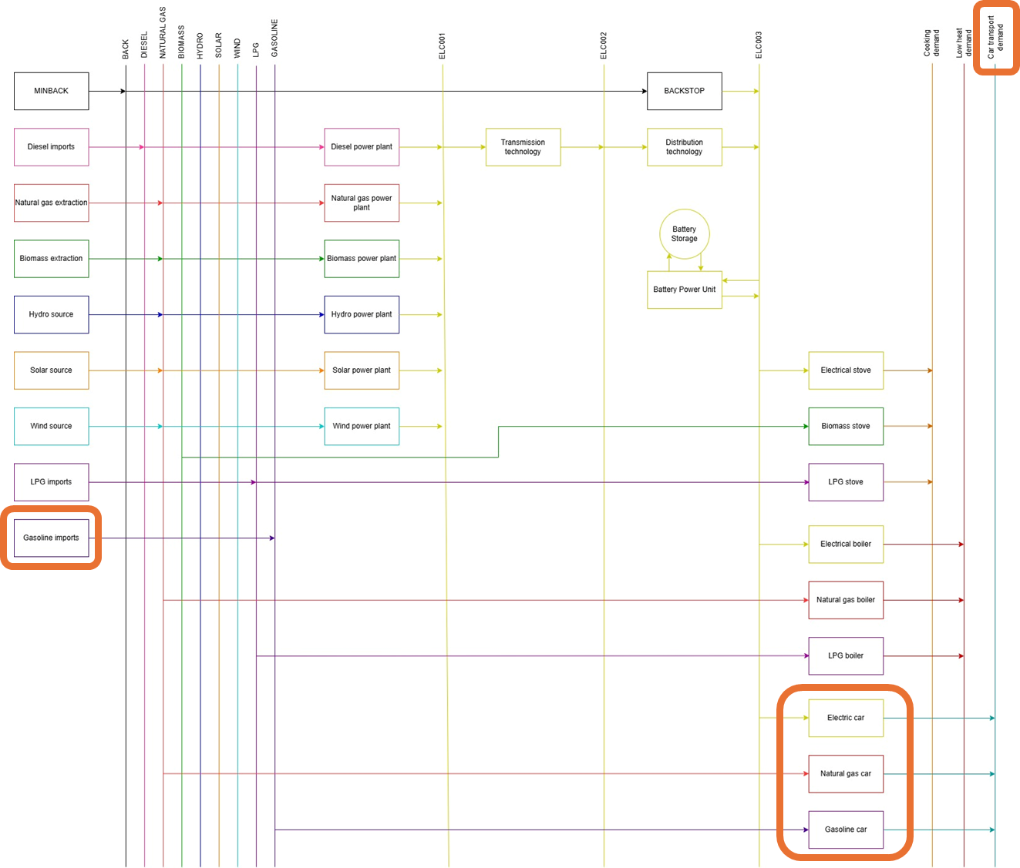

IMPORTANT: Before you can do anything else, you must copy the model and rename it in the same way you have before (OSeHO12 this time).

We will start by creating two new commodities: GSL and TRACAR. The units are PJ and 10⁹passenger-kms respectively.
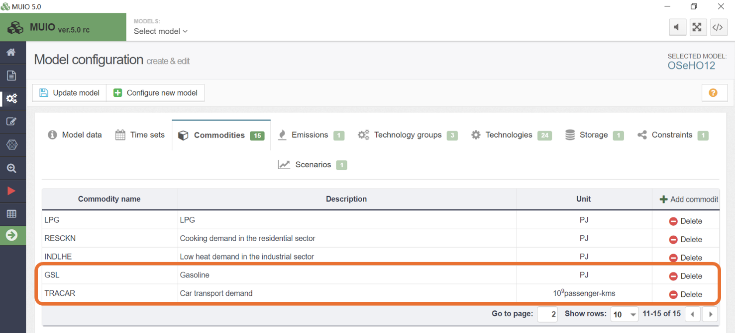

Next, we need to add the data for the demand of TRACAR. This time, we will use the parameter ‘Accumulated Annual Demand’ to specify the annual demand.

Try It: Add the demand for the car transport demand (TRACAR)
- Click on the data entry button, and in the search bar, type ‘Accumulated Annual Demand.’ Then, navigate to that parameter.
- Locate TRACAR in the parameter list. Copy and paste the demand data for the years 2021–2035 from the Data Preparation file OSeHO12.
- The input should resemble the image shown below.

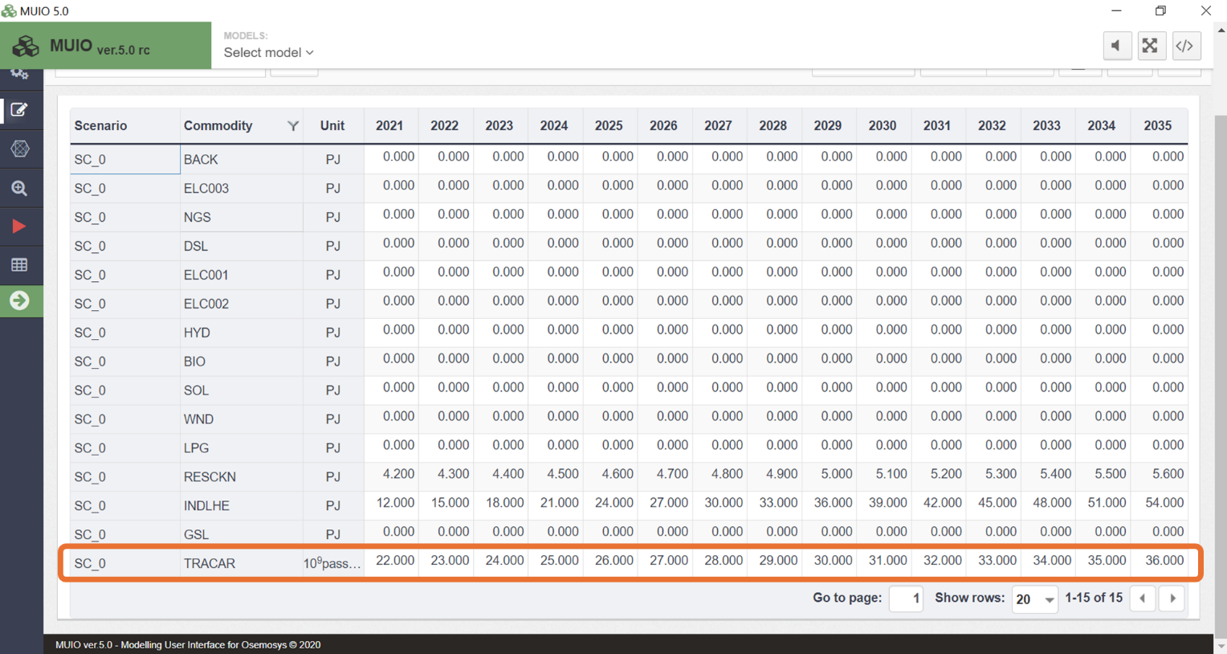
Note: Make sure to save the data and update the model each time you complete this process.

Add New Technologies

We will add the new technologies using the same steps covered in hands-on exercises 5 and 6.
Try it: Add 4 new technologies using the Data Preparation File OSeHO12.
- IMPGSL – Gasoline imports
- DEMTRACARGSL – Gasoline car in the transport sector
- DEMTRACARNGS – Natural gas car in the transport sector
- DEMTRACARELC – Electric car in the transport sector

Repeat the same steps shown for Primary Supply Technology and Power Plants in Hands-on 6. Don’t forget to add the emission activity ratio for the gasoline car and natural gas car. The new technologies should look like the image below.

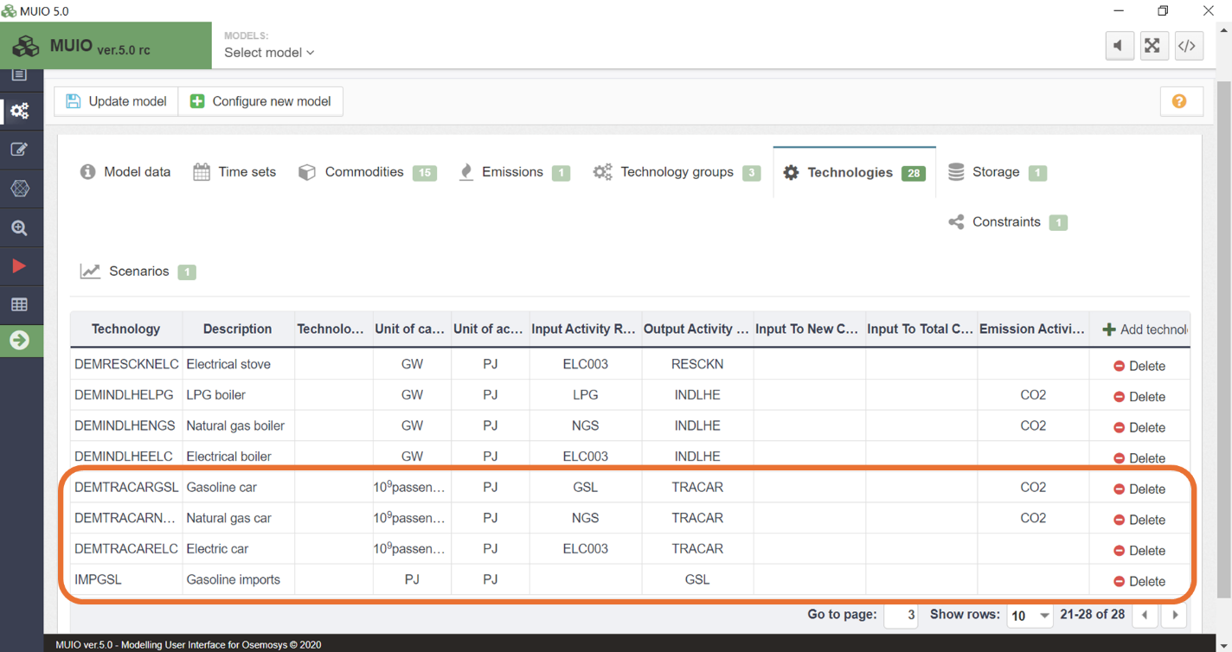

Run the model and check the results

Run the model in the user interface as demonstrated in previous exercises. Since we now have four energy demands, we need to be mindful of how we plot the results for Production by Technology by Mode (PJ). First, filter for the power plants, as done previously, and compare the results between HO12, HO11, and HO10. The graph should resemble the image shown below.

Energy production in the power sector
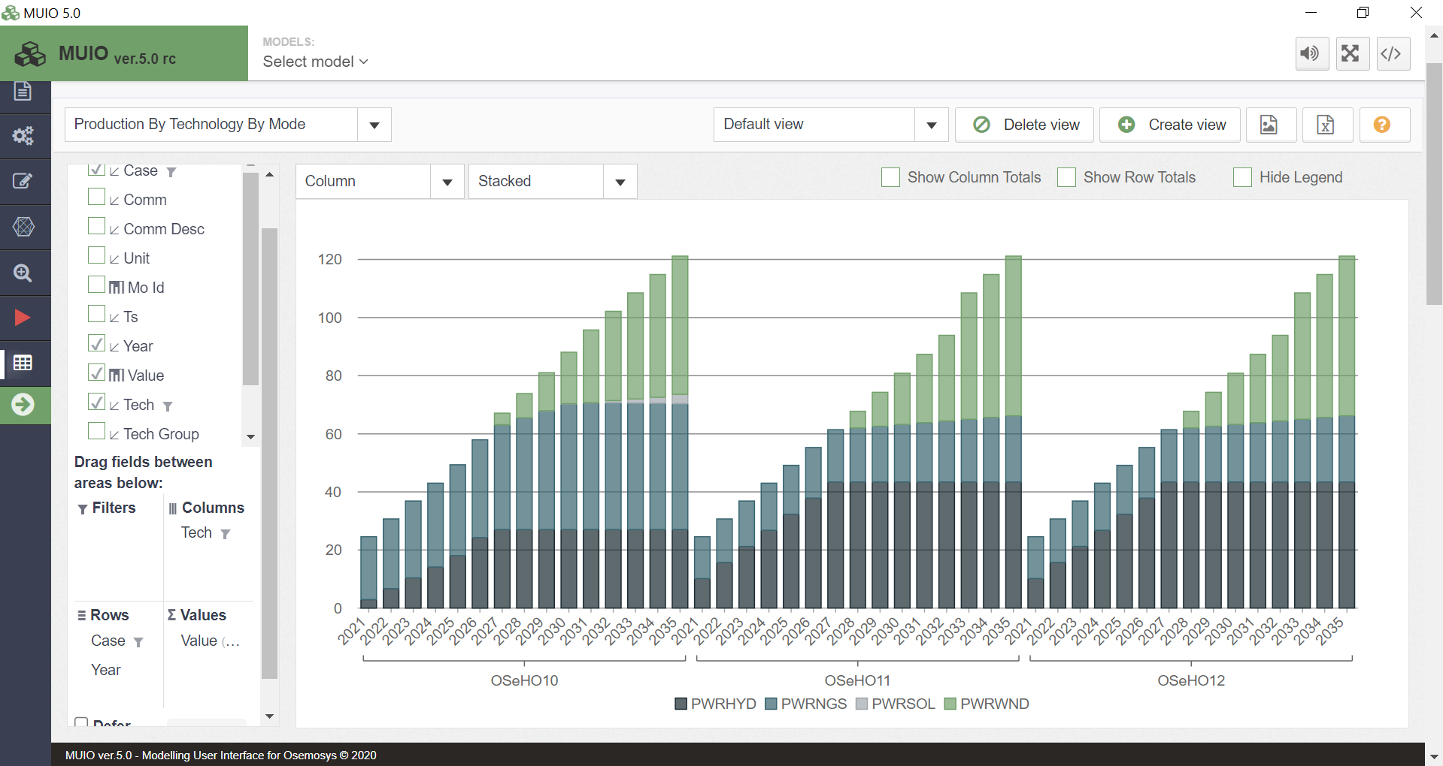

In this exercise, the behaviour of the power, residential, and industrial sectors is identical to that observed in Hands-On Exercise 11. The transport sector is entirely satisfied by gasoline cars throughout the entire modelling period.

Energy production in the transport sector
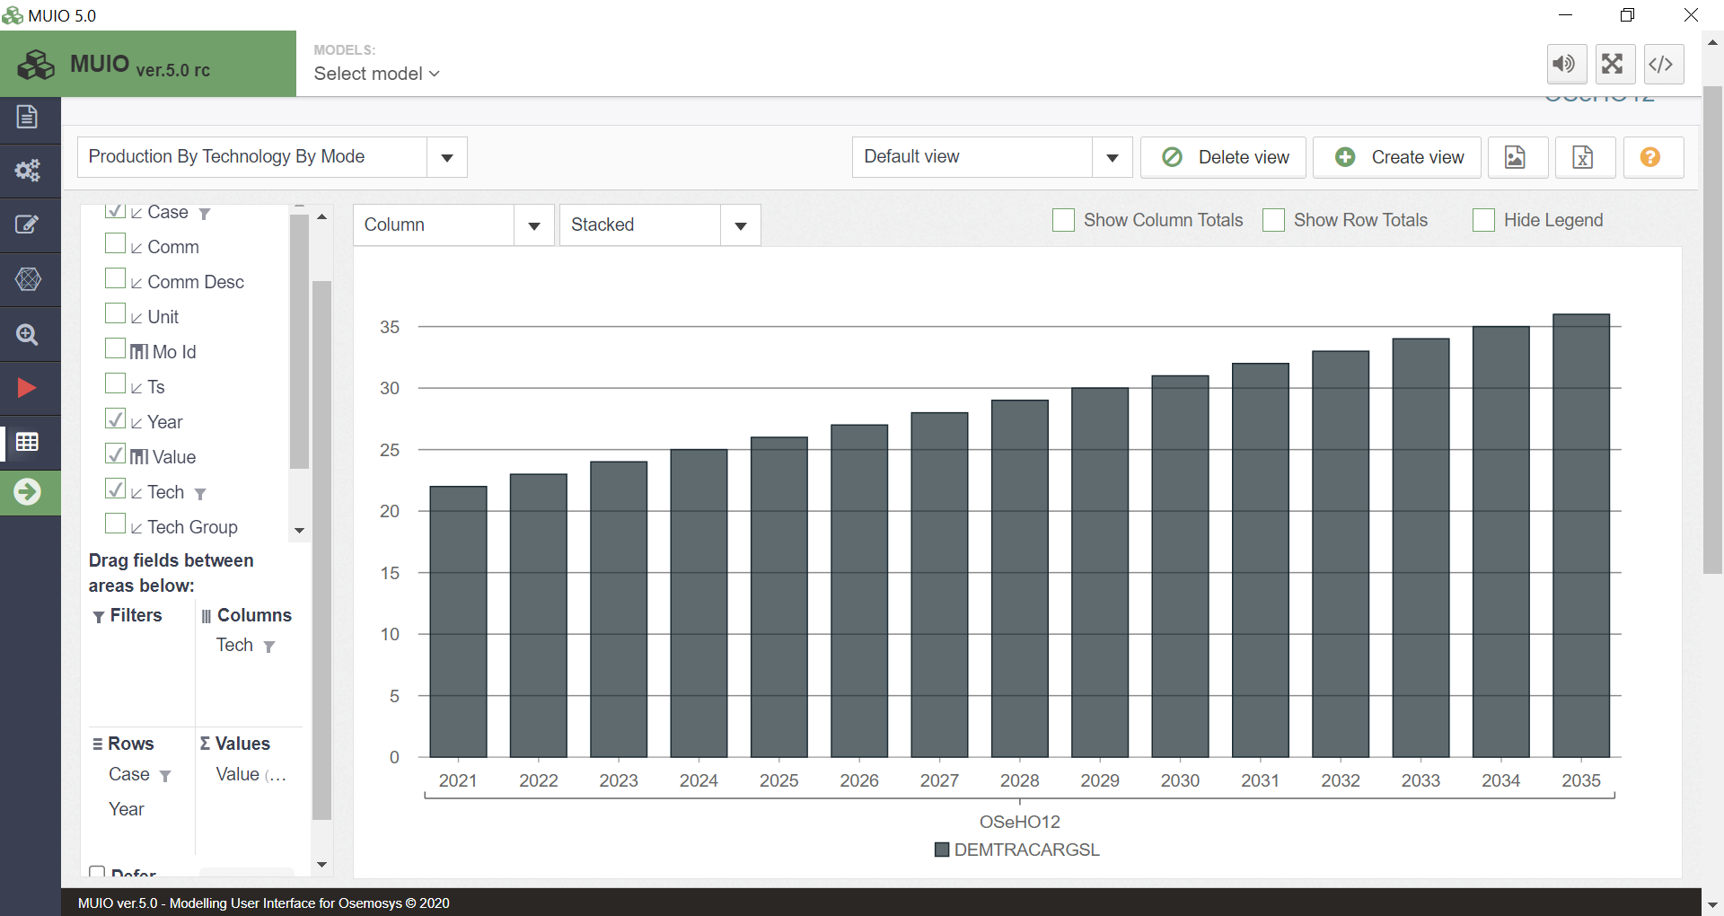
Energy production in the industrial sector
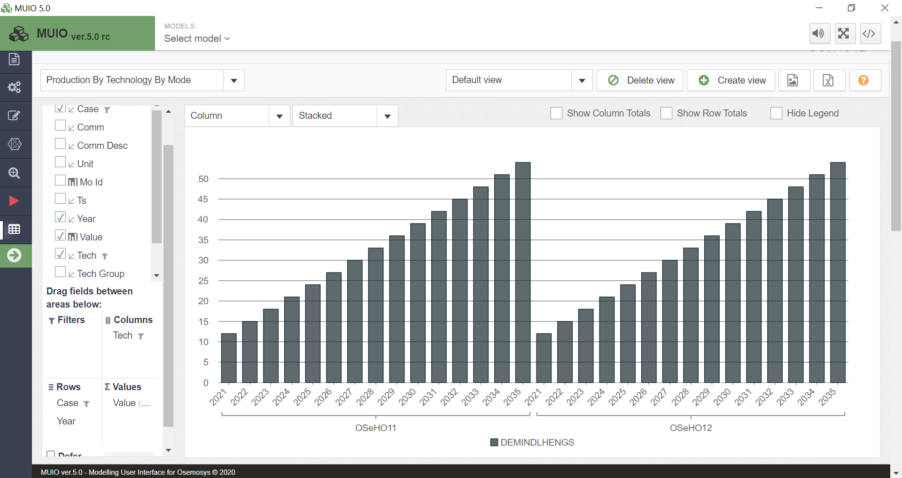

Energy production in the residential sector
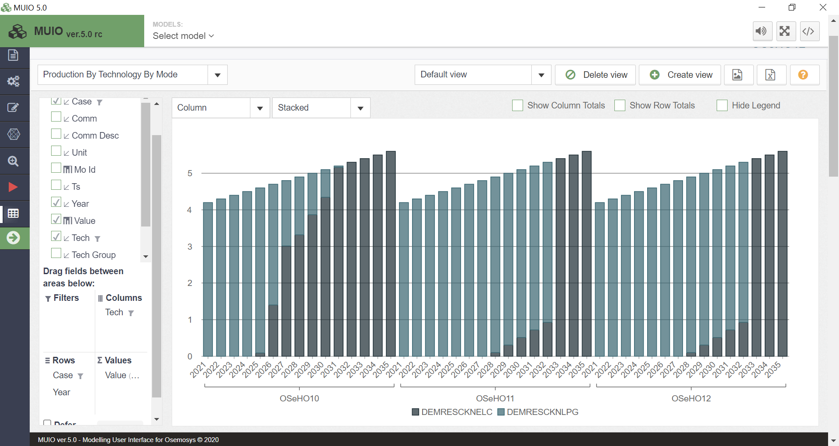

Question to consider: If gasoline was not available for the transport sector, what would be the impacts on other sectors? How could this situation be modelled?

