Energy System Modelling Using OSeMOSYS
Hands-on 11
Please use the following citation for:
- This exercise
Plazas-Niño, F., Alexander, K. (2025, February). Hands-on 11: Energy System Modelling Using OSeMOSYS (Version 1.0.). Climate Compatible Growth. DOI: 10.5281/zenodo.14871511

- OSeMOSYS UI software
Climate Compatible Growth. (2024). MUIO (Version v5.0.0). GitHub. https://github.com/OSeMOSYS/MUIO/releases
____________________________________________________________________________

Learning outcomes

By the end of this exercise, you will be able to represent the following in OSeMOSYS:
- An energy demand in the industrial sector
- A set of technologies to supply an energy demand in the industrial sector

Add a New Energy Demand

In this hands-on, we will add three end-use technologies to represent boiler alternatives with natural gas, liquefied petroleum gas (LPG), and electricity (DEMRESCKNBIO, DEMRESCKNLPG, and DEMRESCKNELC, respectively). One new fuel (commodity) will be added to the model: INDLHE (low heat demand in the industrial sector). We will build the highlighted parts of the RES below. Note: Update your RES in diagrams.net.

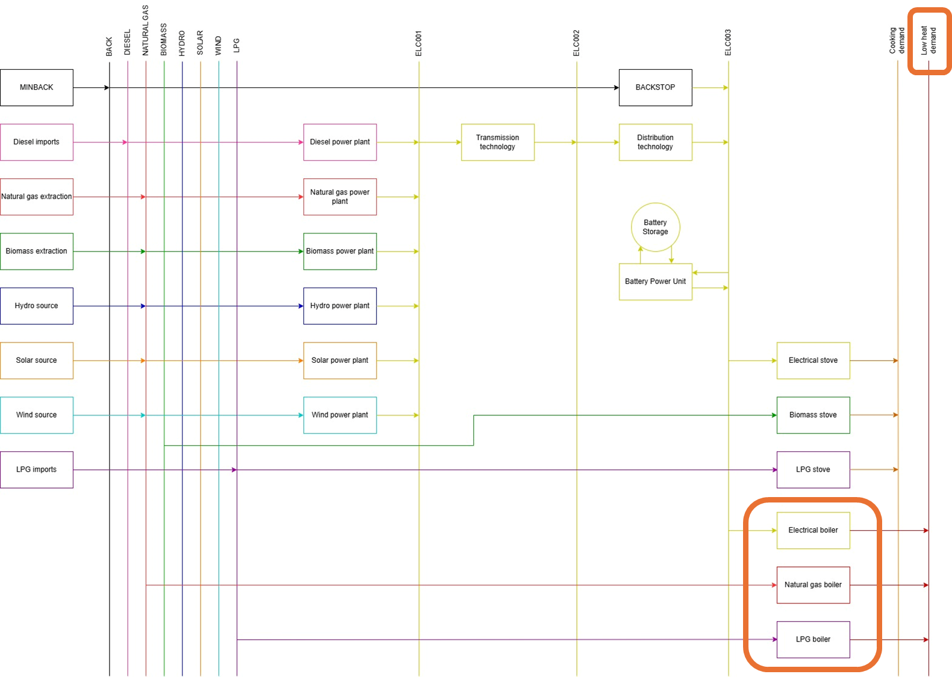

IMPORTANT: Before you can do anything else, you must copy the model and rename it in the same way you have before (OSeHO11 this time).

We will start by creating the new commodity INDLHE. The unit is PJ.
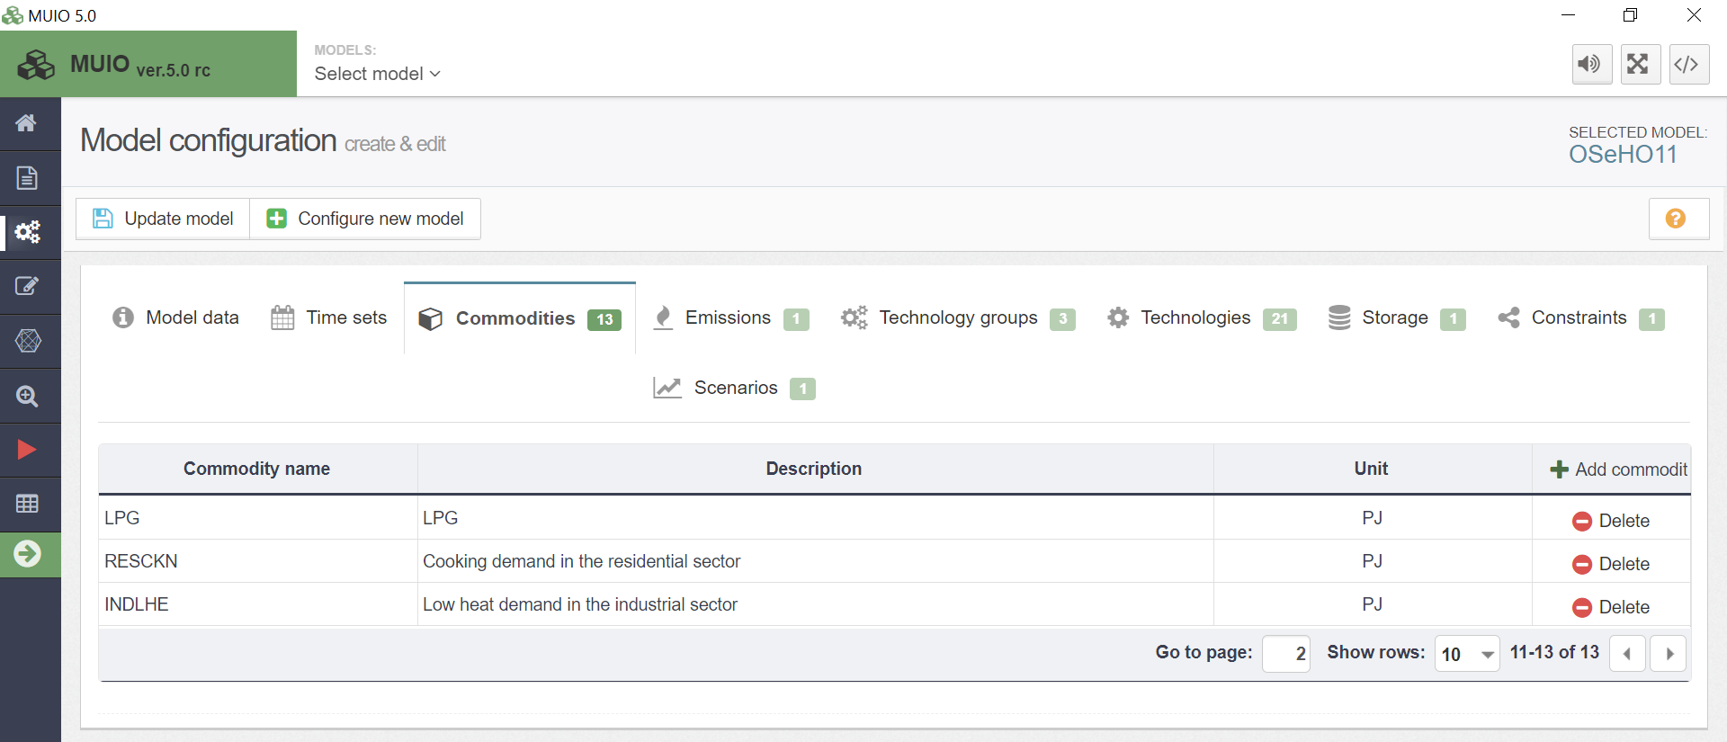

Next, we need to add the data for the demand of INDLHE. This time, we will use the parameter ‘Accumulated Annual Demand’ to specify the annual demand.

Try It: Add the demand for the low heat (INDLHE)
- Click on the data entry button, and in the search bar, type ‘Accumulated Annual Demand.’ Then, navigate to that parameter.
- Locate INDLHE in the parameter list. Copy and paste the demand data for the years 2021–2035 from the Data Preparation file OSeHO11.
- The input should resemble the image shown below.

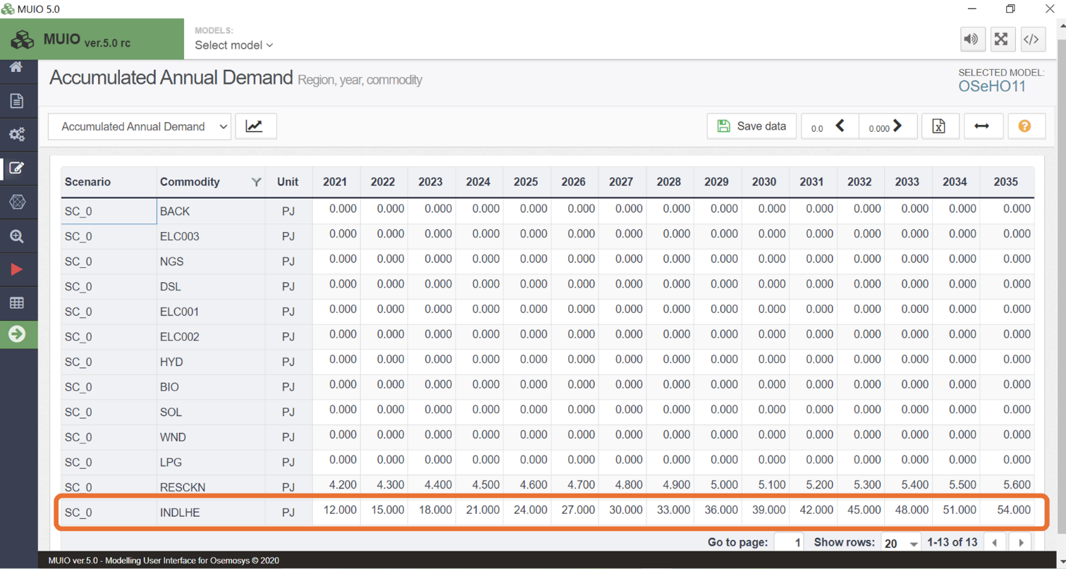
Note: Make sure to save the data and update the model each time you complete this process.

Add New Technologies

We will add the new technologies using the same steps covered in hands-on exercises 5 and 6.
Try it: Add 3 new technologies using the Data Preparation File OSeHO11.
- DEMINDLHELPG – LPG boiler in the industrial sector
- DEMINDLHENGS – Natural gas boiler in the industrial sector
- DEMINDLHEELC – Electrical boiler in the industrial sector

Repeat the same steps shown for Power Plants in Hands-on 6. Don’t forget to add the emission activity ratio for the natural gas boiler and LPG boiler. The new technologies should look like the image below.

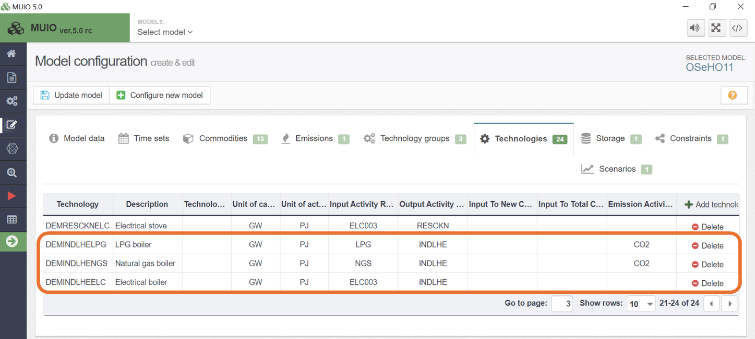

Run the model and check the results

Run the model in the user interface as demonstrated in previous exercises. Since we now have three energy demands, we need to be mindful of how we plot the results for Production by Technology by Mode (PJ). First, filter for the power plants, as done previously, and compare the results between HO9, HO10, and HO11. The graph should resemble the image shown below.

Energy production in the power sector
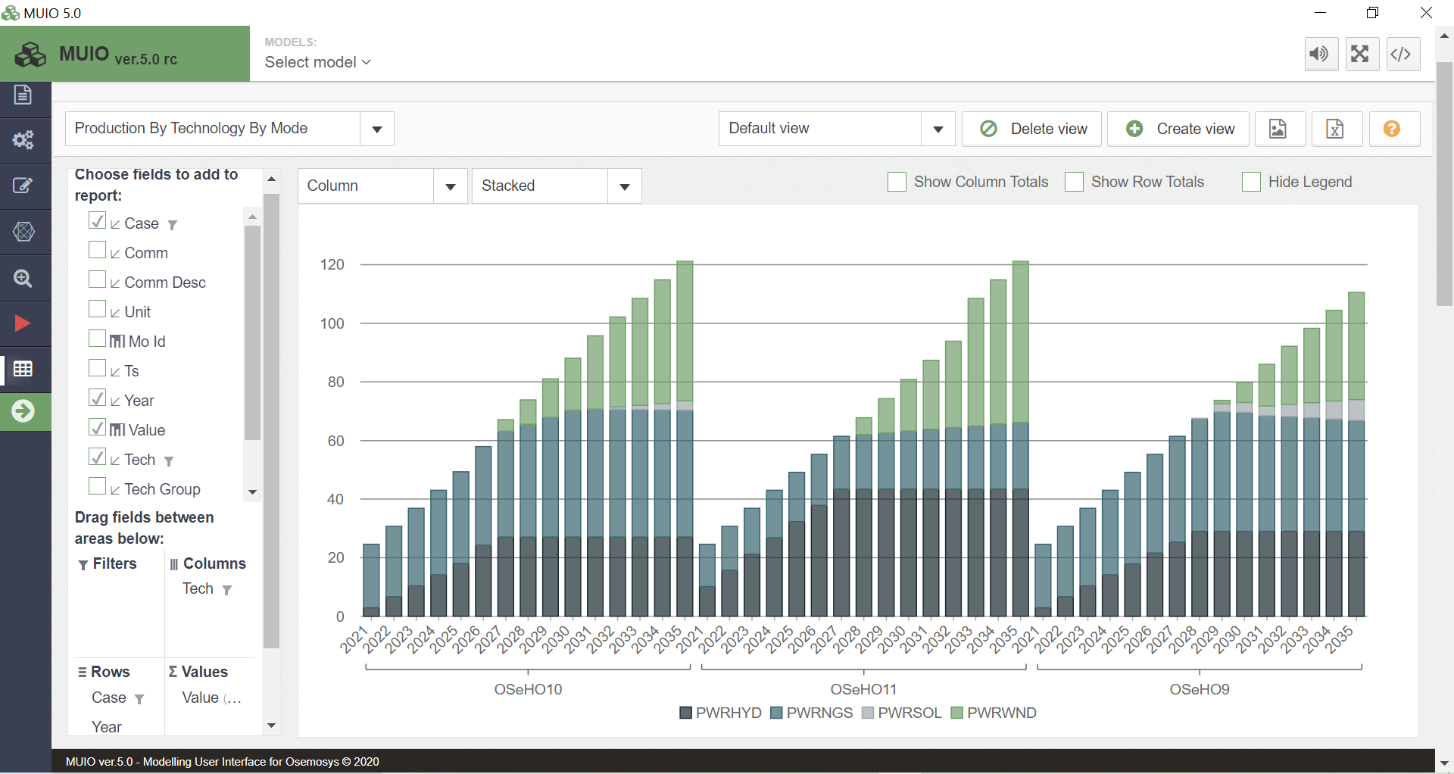

In this exercise, the system produces a similar amount of electricity as in hands-on 10, indicating that electrification is occurring only in the residential sector. If we change the filter to select the boiler technologies, we will see that DEMINDLHENGS is the only active technology. This indicates that natural gas is the most suitable option to meet the low heat demand. The use of natural gas in the industrial sector causes its use for power generation to decrease by almost half, as we can observe by comparing the graphs of OSeHO10 and OSeHO11. Hydropower and wind replace the share previously held by natural gas in the electricity mix and leading to the disappearance of solar from the mix. Notice that none of the residual capacity of the LPG boiler is utilized. Additionally, this new demand also affects the residential sector. As seen in the image below, electrification is delayed, and LPG remains the primary supplier of cooking demand in the early years of the modelling horizon. This type of result highlights the cross-sectoral impacts that can be analyzed when modelling integrated energy systems.

Energy production in the industrial sector
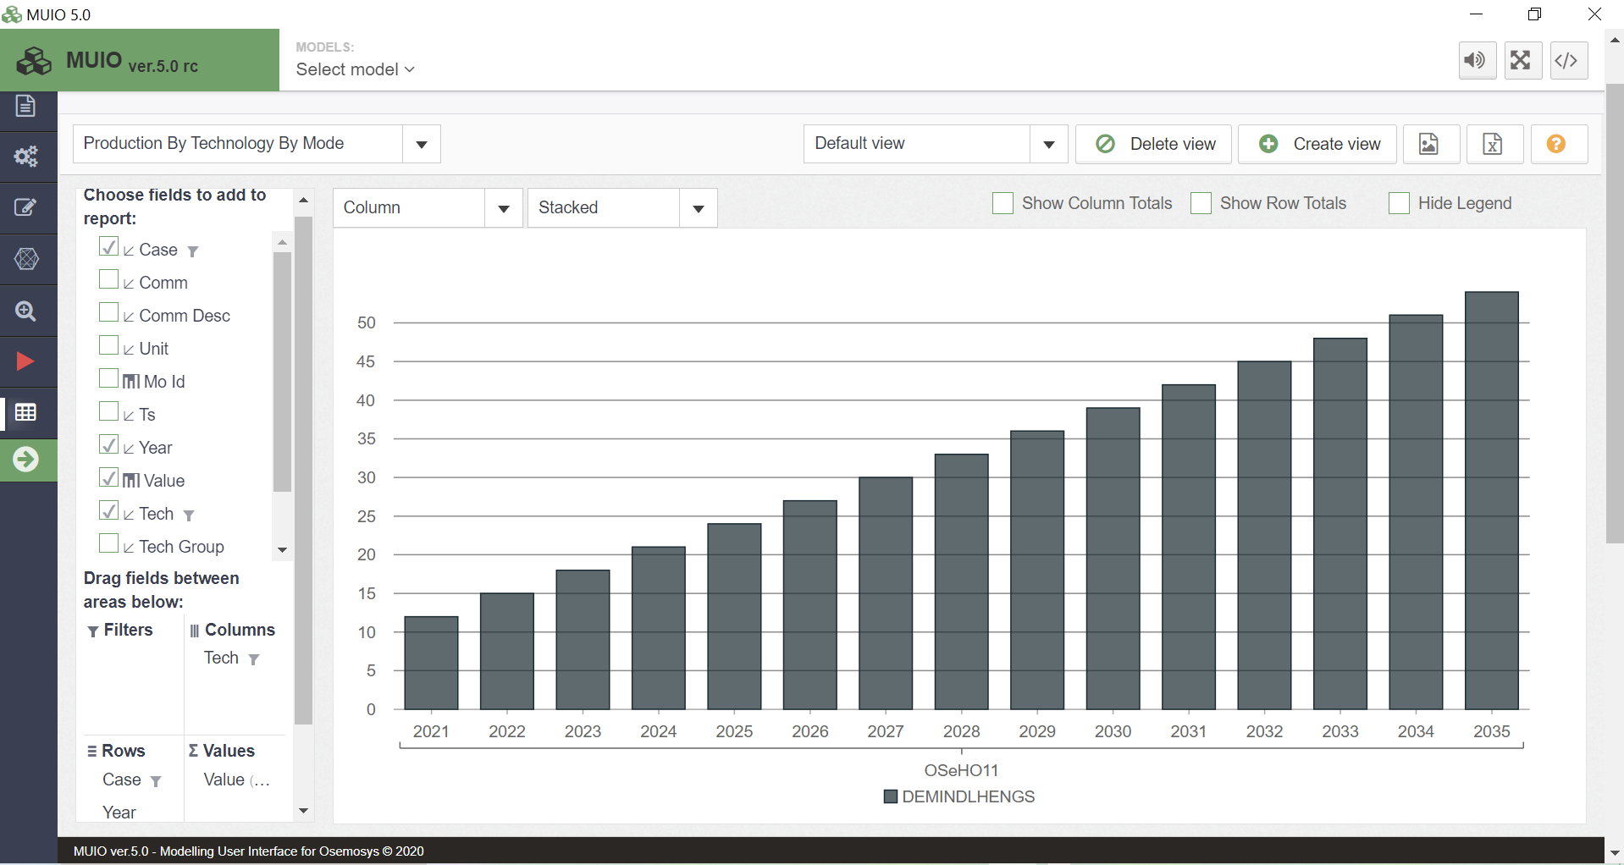

Energy production in the residential sector
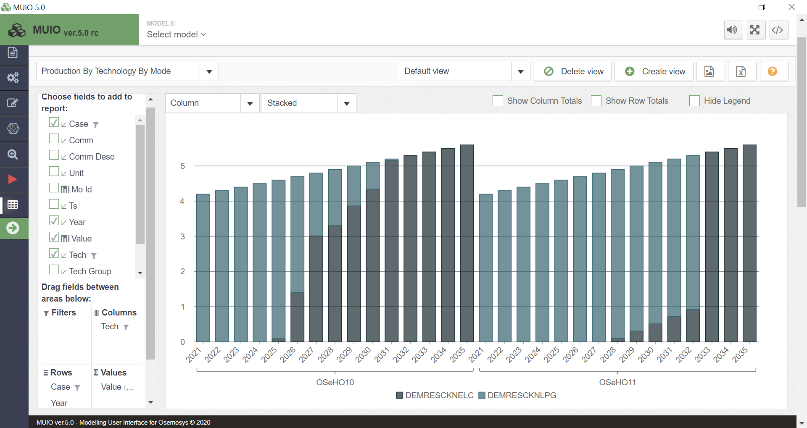
Question to consider: If we need to guarantee a minimum supply of 25 PJ of electricity per year from natural gas power plants between 2025 and 2035, what impacts will this have on the different sectors? How can we model this situation?

