Energy System Modelling Using OSeMOSYS
Hands-on 10
Please use the following citation for:
- This exercise
Plazas-Niño, F., Kiley, F. (2025, February). Hands-on 10: Energy System Modelling Using OSeMOSYS (Version 1.0.). Climate Compatible Growth. DOI: 10.5281/zenodo.14871470

- OSeMOSYS UI software
Climate Compatible Growth. (2024). MUIO (Version v5.0.0). GitHub. https://github.com/OSeMOSYS/MUIO/releases
____________________________________________________________________________

Learning outcomes

By the end of this exercise, you will be able to represent the following in OSeMOSYS:
- An energy demand in the residential sector
- A set of technologies to supply an energy demand in the residential sector

Add a New Energy Demand

In this hands-on, we will add four technologies in total: three end-use technologies to represent stove alternatives with biomass, liquefied petroleum gas (LPG), and electricity (DEMRESCKNBIO, DEMRESCKNLPG, and DEMRESCKNELC, respectively), and one primary supply technology to represent the imports of LPG (IMPLPG). Two new fuels (commodities) will be added to the model: LPG and RESCKN (cooking demand in the residential sector). We will build the highlighted parts of the RES below. Note: Update your RES in diagrams.net.

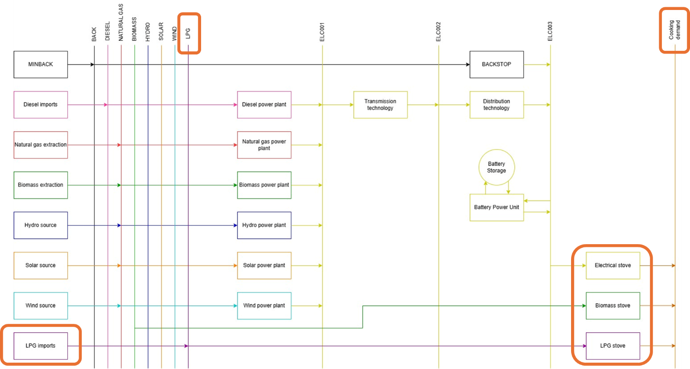

IMPORTANT: Before you can do anything else, you must copy the model and rename it in the same way you have before (OSeHO10 this time).

We will start by creating two new commodities: LPG and RESCKN. The unit for both is PJ.
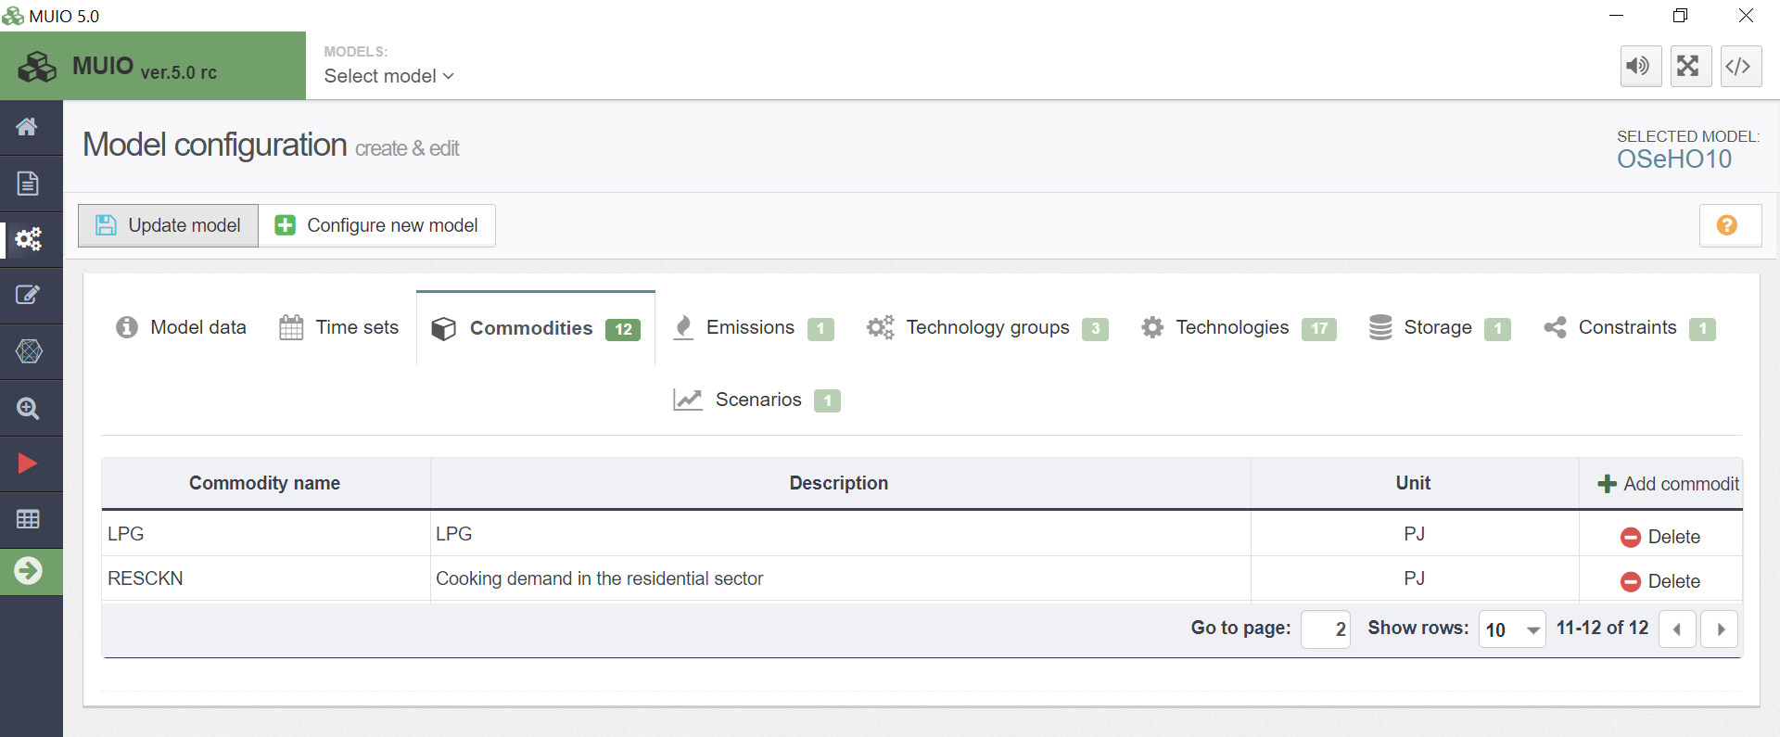

Next, we need to add the data for the useful energy demand of RESCKN. This time, we will use the parameter ‘Accumulated Annual Demand’ to specify the annual demand.

Try It: Add the demand for the cooking service (RESCKN)
- Click on the data entry button, and in the search bar, type ‘Accumulated Annual Demand.’ Then, navigate to that parameter.
- Locate RESCKN in the parameter list. Copy and paste the demand data for the years 2021–2035 from the Data Preparation file OSeHO10.
- The input should resemble the image shown below.

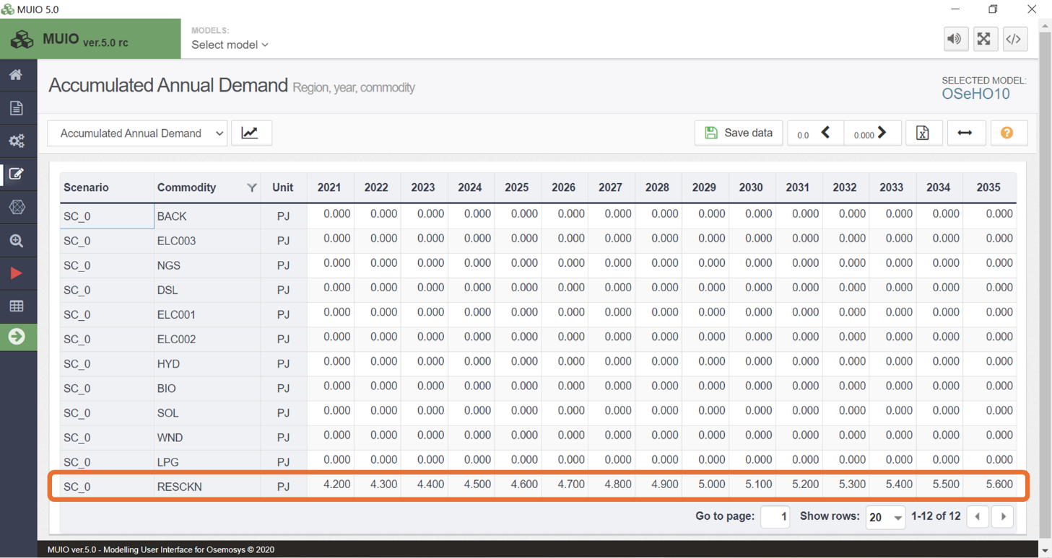
Note: Make sure to save the data and update the model each time you complete this process.

Add New Technologies

We will add the new technologies using the same steps covered in hands-on exercises 5 and 6.
Try it: Add 4 new technologies using the Data Preparation File OSeHO10.
- IMPLPG – LPG imports
- DEMRESCKNLPG – LPG stove in the residential sector
- DEMRESCKNBIO – Biomass stove in the residential sector
- DEMRESCKNELC – Electrical stove in the residential sector

Repeat the same steps shown for Primary Supply Technology and Power Plants in Hands-on 6. Don’t forget to add the emission activity ratio for the LPG stove. The new technologies should look like the image below.

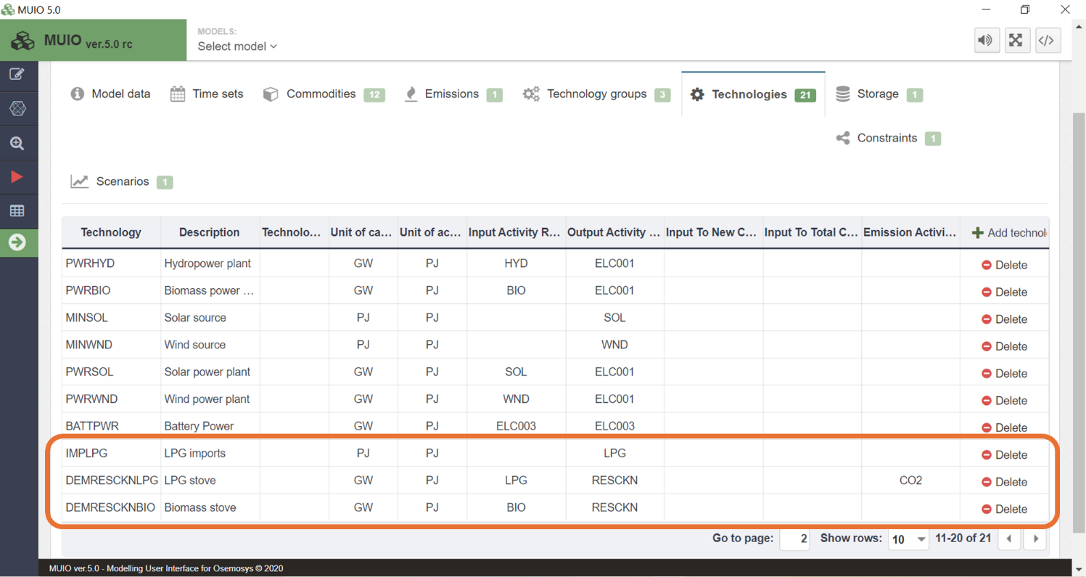

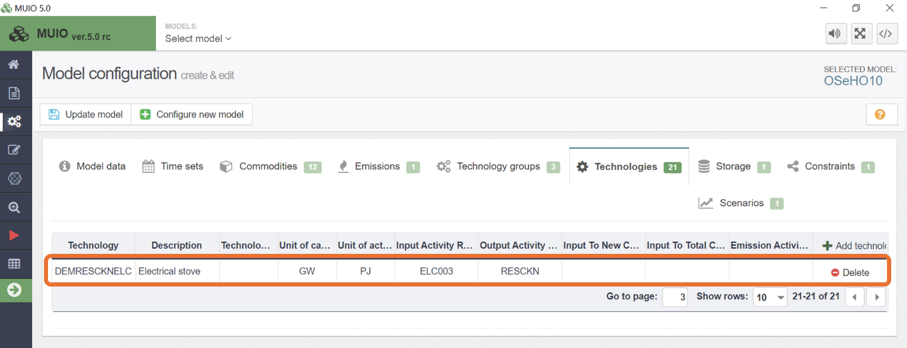

Run the model and check the results

Run the model in the user interface as demonstrated in previous exercises. Since we now have two energy demands, we need to be mindful of how we plot the results for Production by Technology by Mode (PJ). First, filter for the power plants, as done previously, and compare the results between HO9 and HO10. The graph should resemble the image shown below.
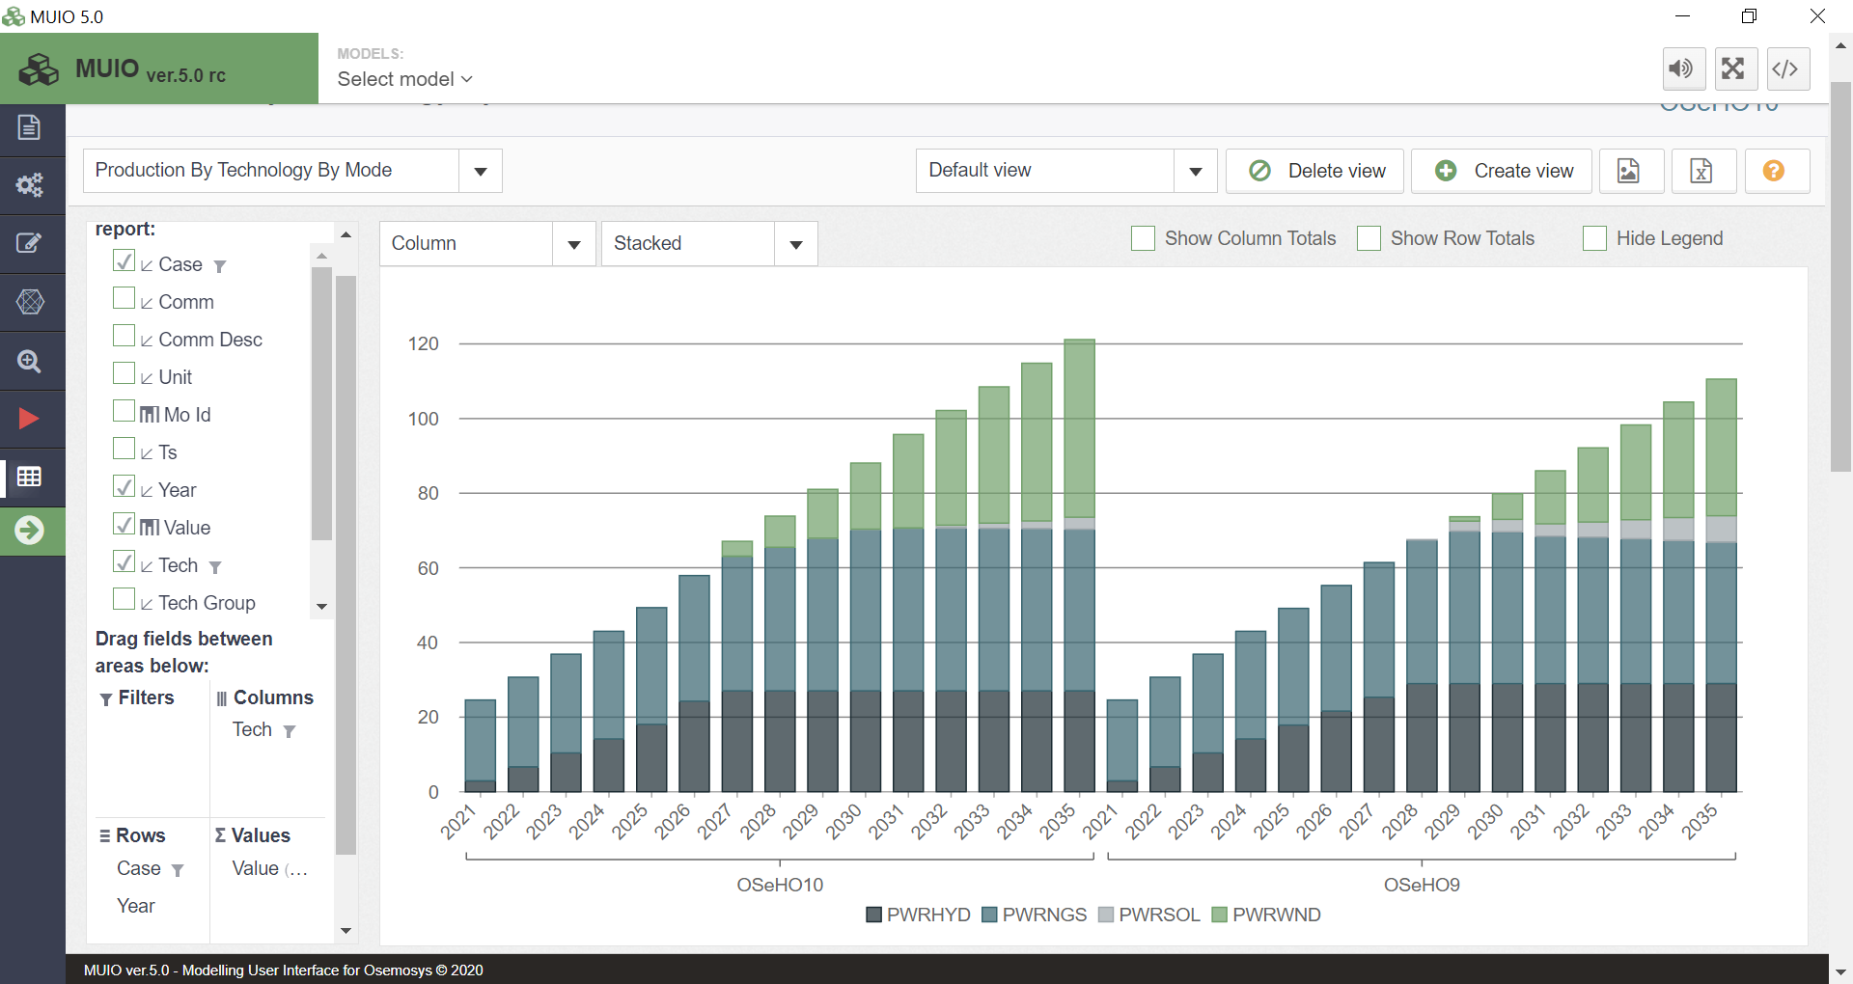

In this exercise, the system produces more electricity to meet the demand for electrical stoves. If we change the filter to select the stove technologies, we will see that DEMRESCKNELC increasingly supply cooking demand from 2025. This indicates that electrification becomes more cost-effective than relying on the residual capacities of LPG or biomass stoves. The underlying reason is that the variable costs of importing LPG or producing biomass are higher than the combined investment costs for electrical stoves and generating additional electricity. We will calibrate these results in hands-on 13.
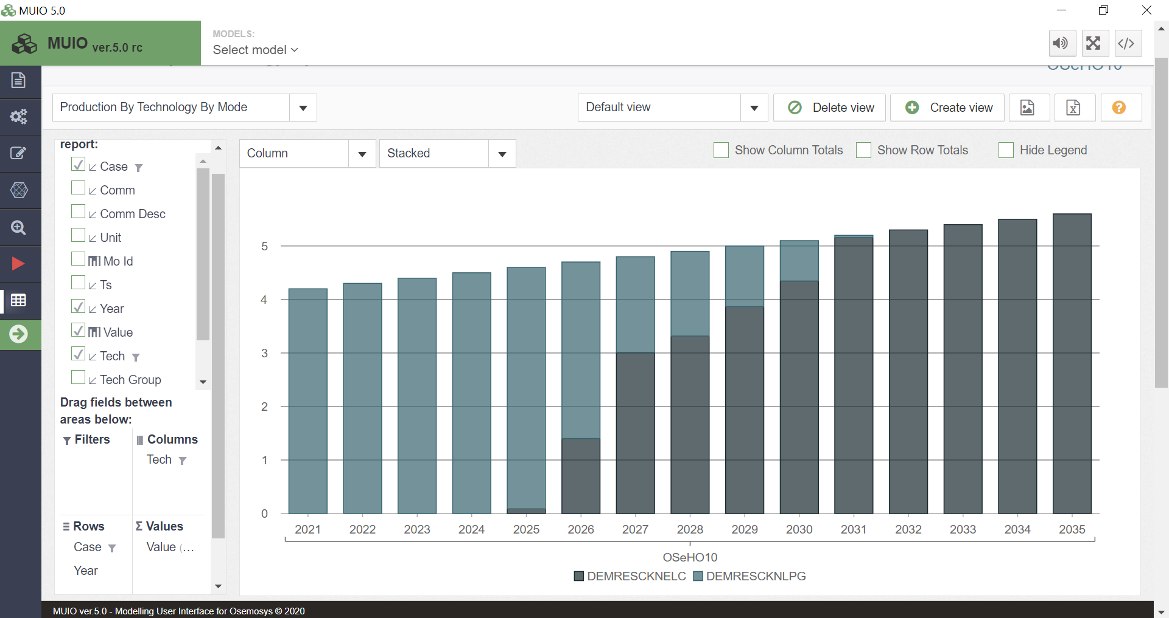

Question to consider: If electrical stoves were not available, which technology do you think would become the main cooking service supplier? How can we model this situation?

