Model for Analysis of Energy Demand (MAED)
Hands-on 10: Reviewing results and case study in MAED-EL
Licence:
This work is licensed under the Creative Commons Attribution 4.0 International License (CC BY 4.0). To view a copy of this license, visit https://creativecommons.org/licenses/by/4.0/.
Attribution:
Please cite as: Kiley, F. (2025) An Introduction to Simulating Energy Demand with MAED. Version 1. Climate Compatible Growth Teaching Kit Website, Climate Compatible Growth.

Learning outcomes
By the end of this exercise, you will be able to:
1) Check base year and future year results
2) Adjust scenario assumptions to match base year results with hourly demand data
3) Add projected years to the model
4) Explore the effect of changing scenario assumptions on hourly demand data

Activity 1: Reviewing base year results
This hands-on session will give you a brief introduction to results analysis, the final step of an hourly demand study in MAED-EL. This activity uses the Demo MAEDEL case study that we used in Hands-on session 8. After the last session, all the scenario data have been defined, so the next step is to check the base year results.
As we have seen in Hands-on 8, you can review the results after calculating them by clicking on the Results tab in the navigation menu on the left side of the page. Click on the Summary tab on the top of the page to view a table summarizing the demand for each year in the model.
To check the results of the base year, then compare the maximum load values with the statistical data. The maximum load in each season predicted in MAED-EL should match the statistical data within an acceptable margin. You should also check that the season in which the peak load occurs matches the base year data. Similarly, you should evaluate whether the load factors in each season are consistent with base year values.
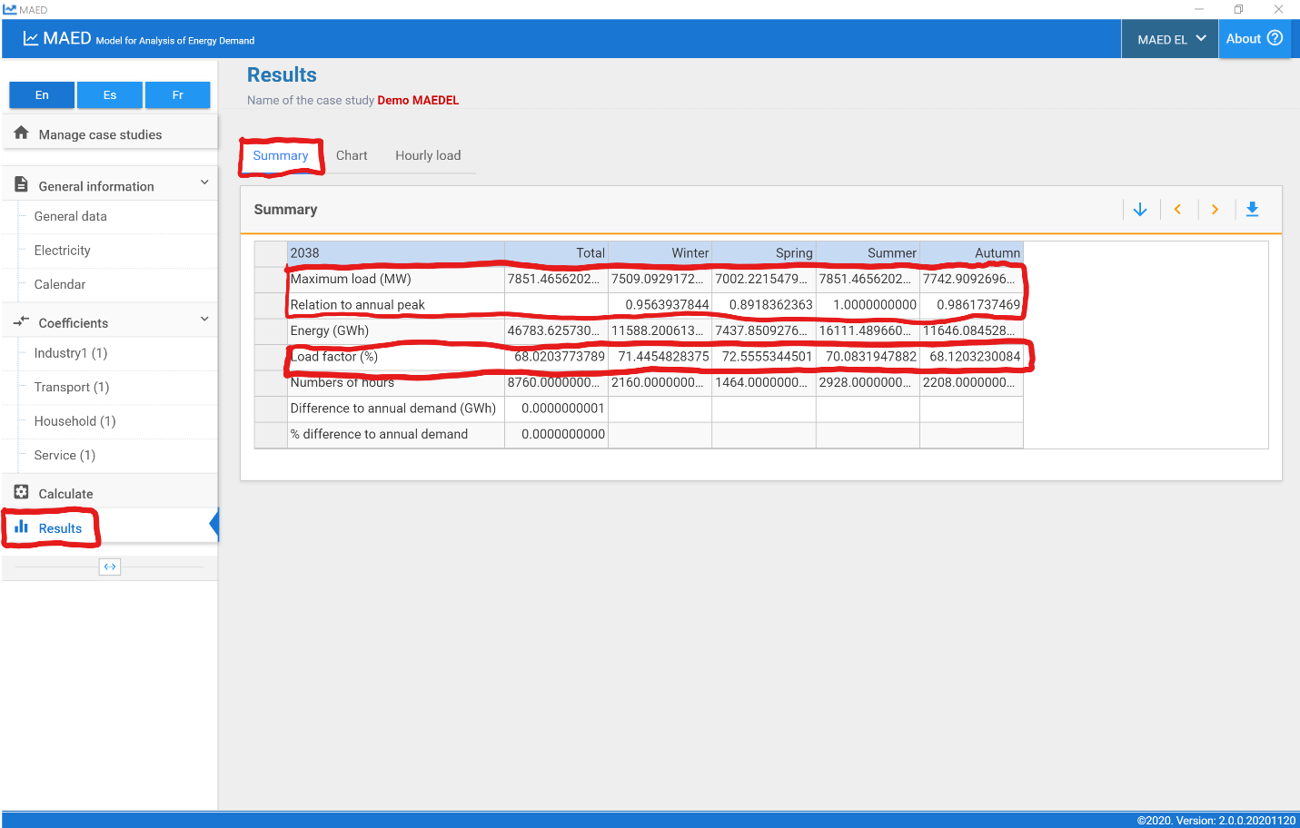If the base year results are satisfactory, you can analyze the results for the other years of the study to check their consistency with your expectations and other projections. Otherwise, you need to review the input data to find the differences and repeat this process until MAED-EL results match the base year data within an acceptable margin of error.
The scenario assumptions that most commonly lead to mismatch between the reference year data and the results are:
- annual demand
- percentage of electricity supplied by the grid
- clients
- transmission and distribution losses
- seasonal, daily, and hourly coefficients
Confirm these values and adjust them as needed so that the reference year data and results match. Review previous hands-on materials for how to set these values.

Activity 2: Adding years to case study
Now that you have reviewed the base year results provided with the Demo MAEDEL case study, we will add two projected years to the case study. Click on the General data tab under the General Information heading in the navigation menu on the left side of the page. In the Definitions box at the top of the page, add the years 2044 and 2050 to the study. Be sure to click the green Save data button on the top right of the box.
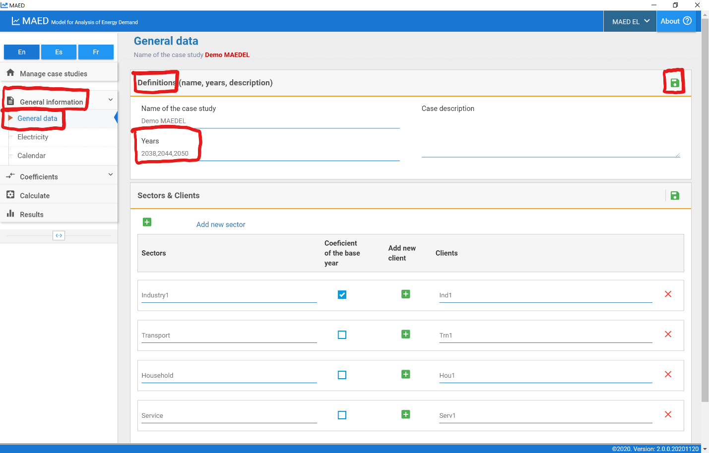
Next, click on the Electricity tab under the General information heading on the navigation menu on the left side of the page. Click on the Annual electricity demand tab at the top of the page. We assume that each sector has equal annual electricity demand in each year: 10,000 GWh in 2038, 12,000 GWh in 2044, and 15,000 GWh in 2050. Input each of these values into the chart.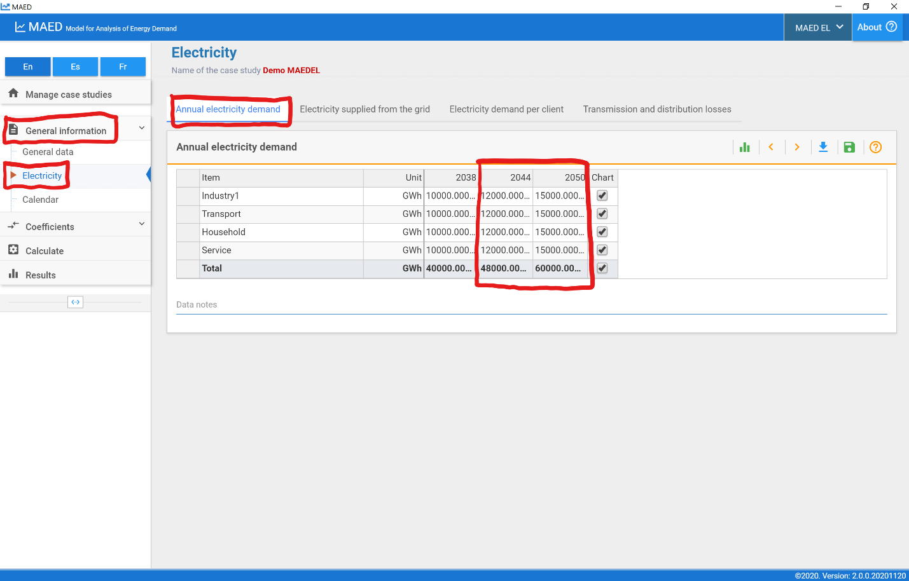
Click on the Electricity supplied from the grid tab at the top of the page. We assume that all sectors get 100% of their electricity from the grid in every year in the study, so input 100 in each cell of the table.
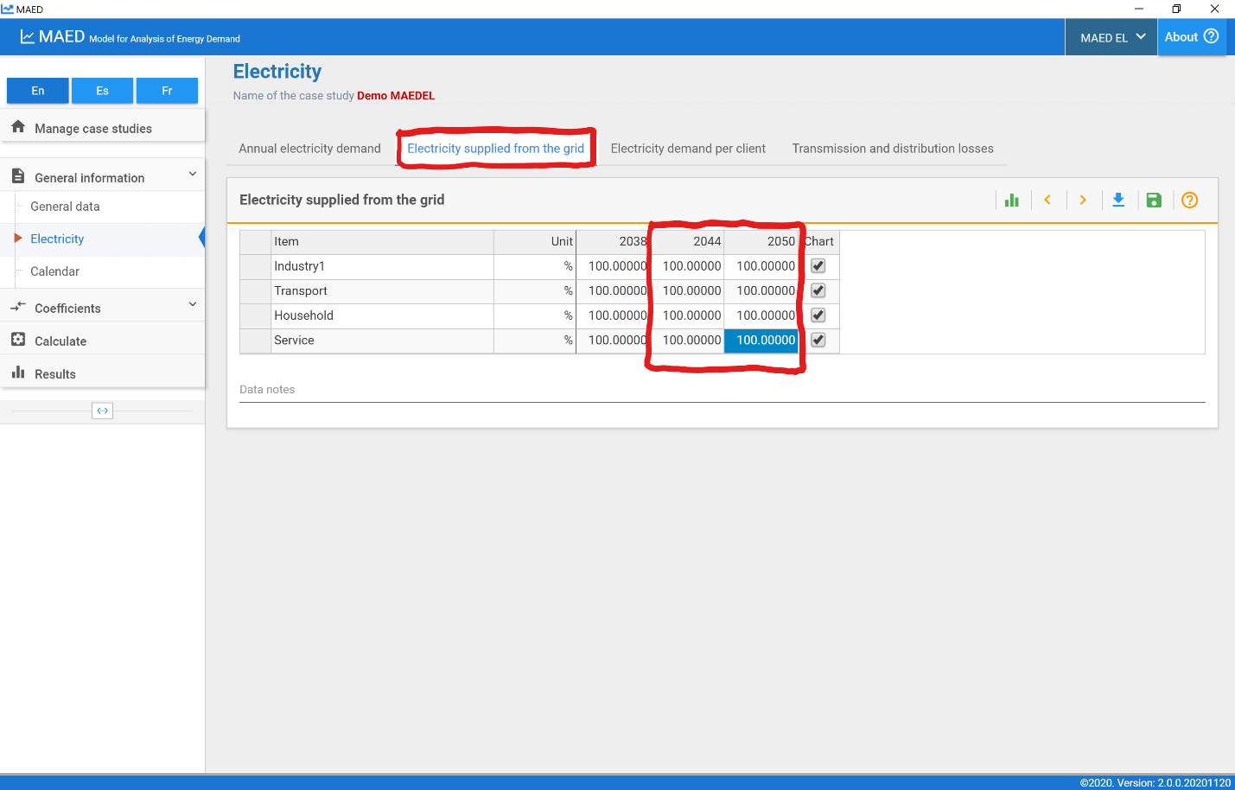
Click on the Electricity demand per client tab at the top of the page. We assume that every sector is comprised of a single client, so input 100% for each client in the 2044 and 2050 column.
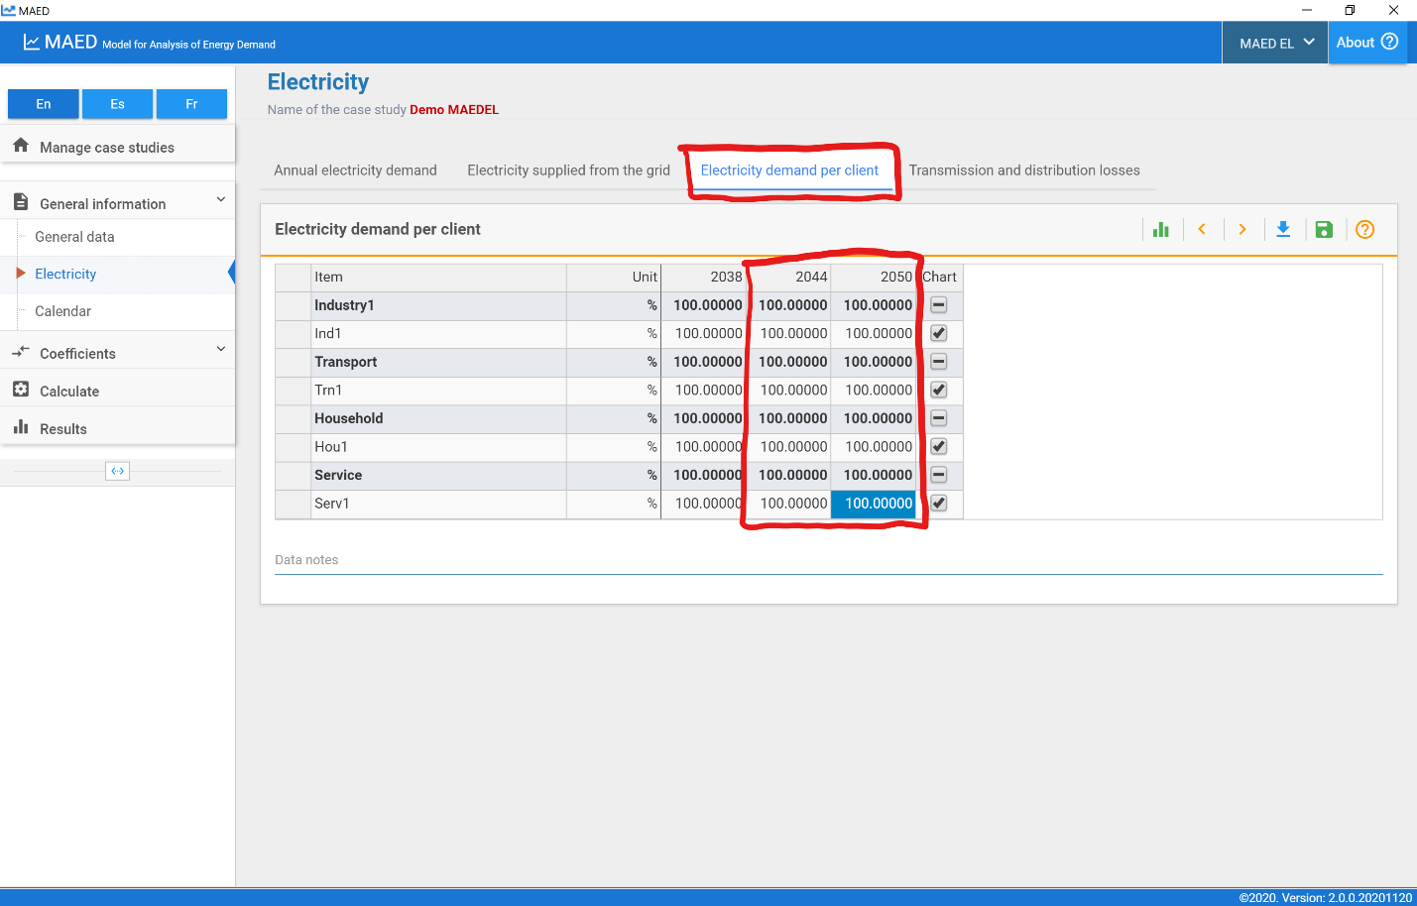
Click on the Transmission and distribution losses tab at the top of the page. We assume that the transmission and distribution losses will be kept constant throughout the study period, so you should input 5% for the transmission losses for each year and 10% for distribution losses in each sector in each year.
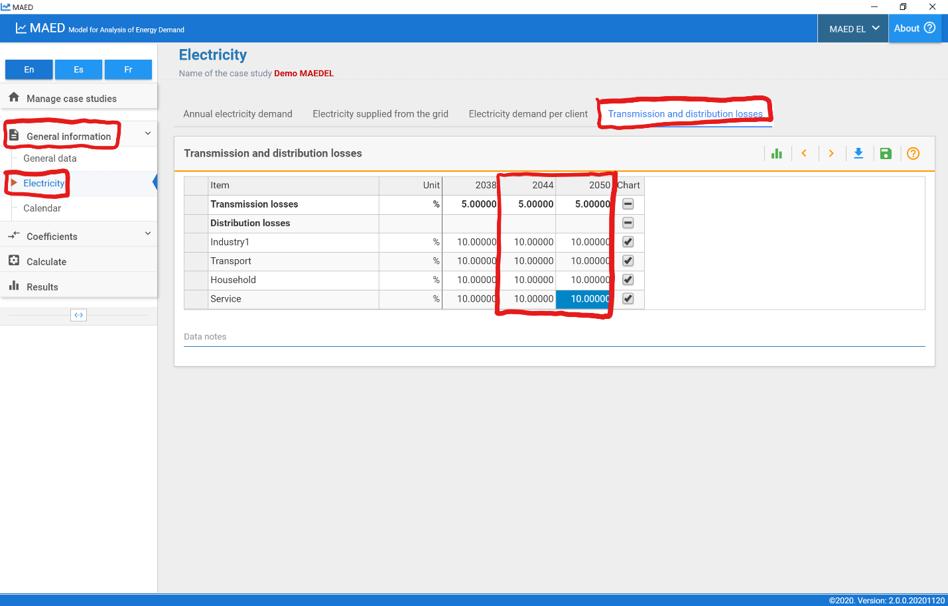
Next, click on the Industry tab under the Coefficients heading on the navigation menu on the left side of the screen. Select the Weekly coefficients tab at the top of the page. We assume that the base year modulating coefficients can be used to model hourly demand for the projected years, so should copy the weekly coefficients from the 2038 column and paste them in the 2044 and 2050 columns.
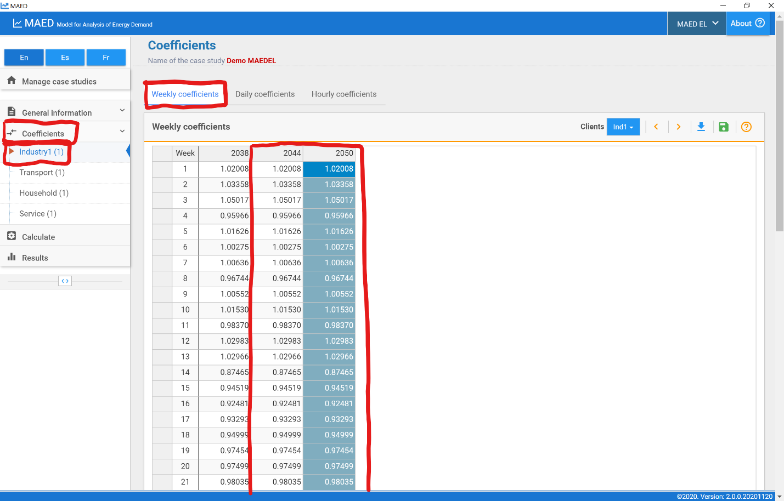
Repeat this procedure for the daily and hourly coefficients in the industry sector and for all the other sectors. Then click the Calculate tab on the navigation menu on the left side of the screen.
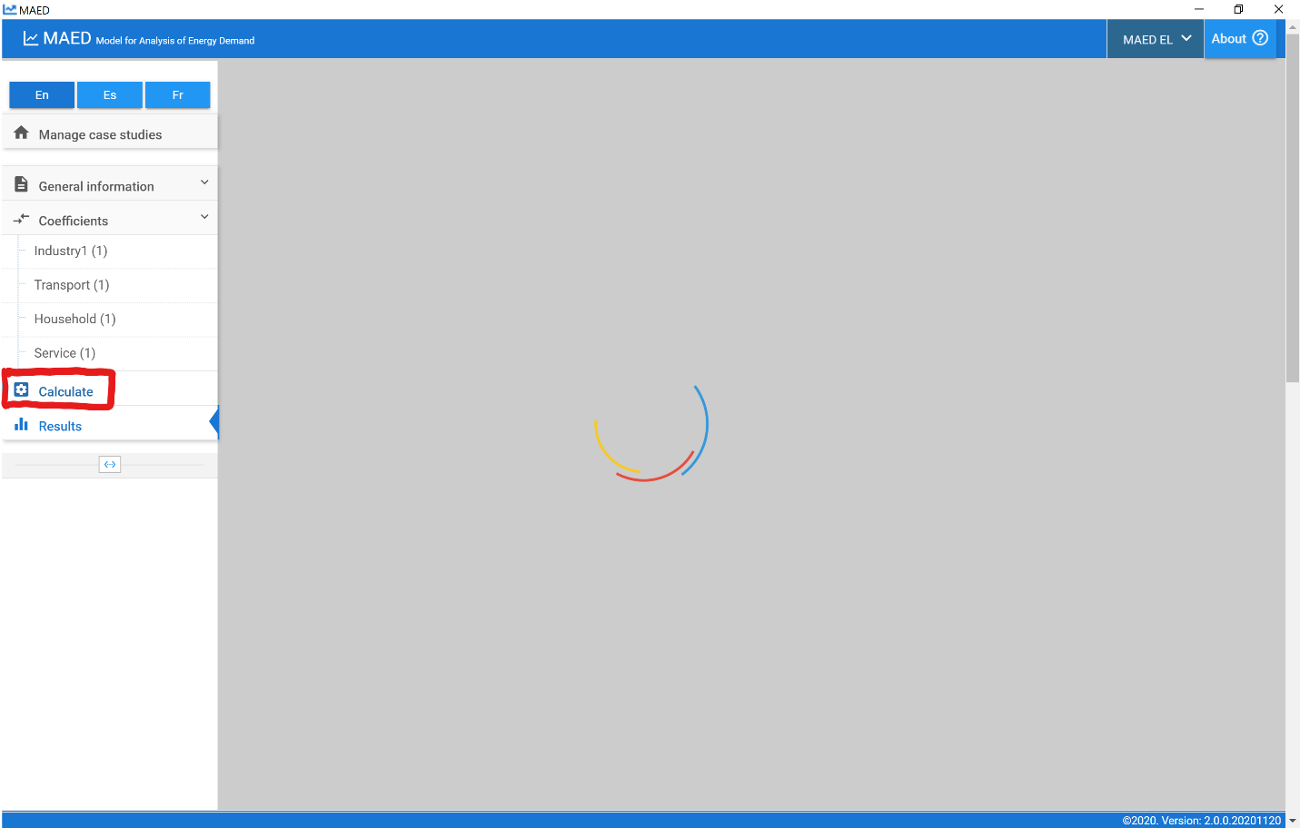
After the calculation is complete, the programme should automatically redirect you to the Results section. Click on the Summary tab at the top of the page and scroll down to view the summary tables for each year. As with the base year, you should check the maximum load in each season, the season in which the maximum load occurs, and the load factor in each season.
Because these results are for the future and there are no statistical data to compare with, you should rely on those with experience to assess the validity of the results. You can also compare the MAED-EL projections with the results from other models.
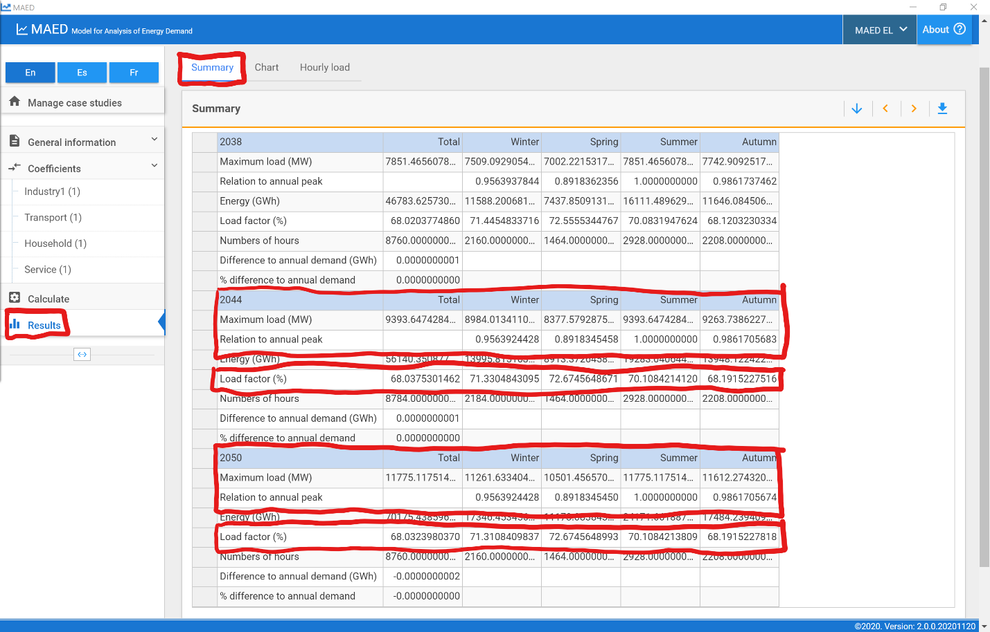
You can also quickly visualize how hourly demand changes by clicking on the Chart tab at the top of the page.
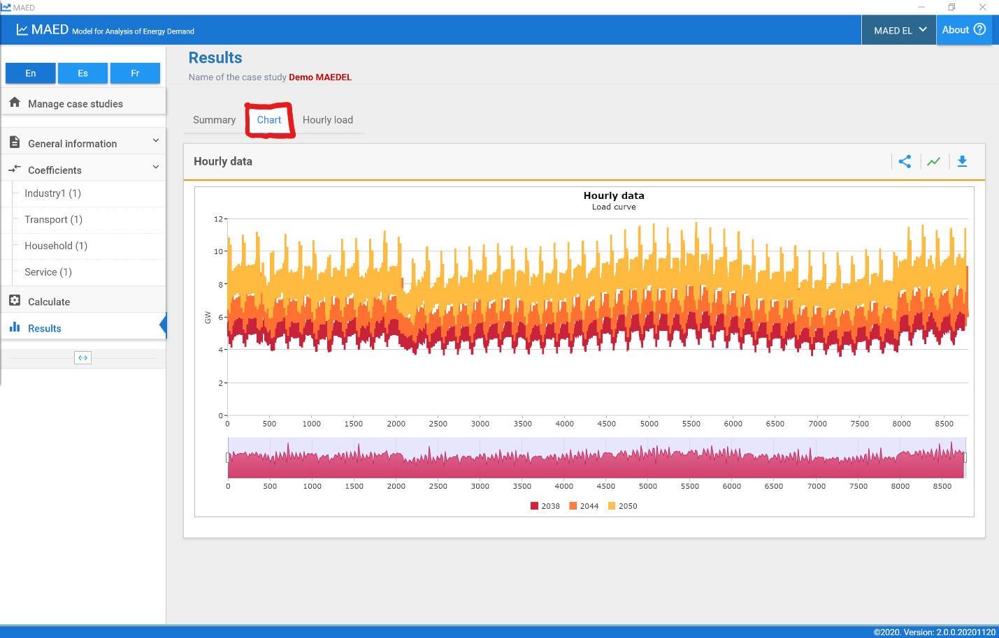
We can observe that hourly demand rises from 2038 and 2044 and again from 2044 to 2050, as we might expect because we increased the total annual electricity demand. Notice that the weekly and seasonal patterns of demand do not change because we kept the same modulating coefficients.

Activity 3: Developing an alternative scenario
Now we want to develop an alternative scenario to understand the impact of improvements in the transmission and distribution systems. New power lines will be built and the accuracy in metering and billing will be improved. These measures will reduce the transmission and distribution losses, respectively. The transmission losses at the end of the study period will be 3% while the distribution losses will be reduced to 5%. The improvements will occur gradually throughout the study period.
First, click on the Manage case studies tab at the top of the navigation menu on the left side of the screen. Find the case study named Demo MAEDEL that we have been using for the first part of this hands-on activity and click the icon with two overlapping blue rectangles that says Copy case to create a copy of this case. This copy will automatically be named Demo MAEDEL - Copy.
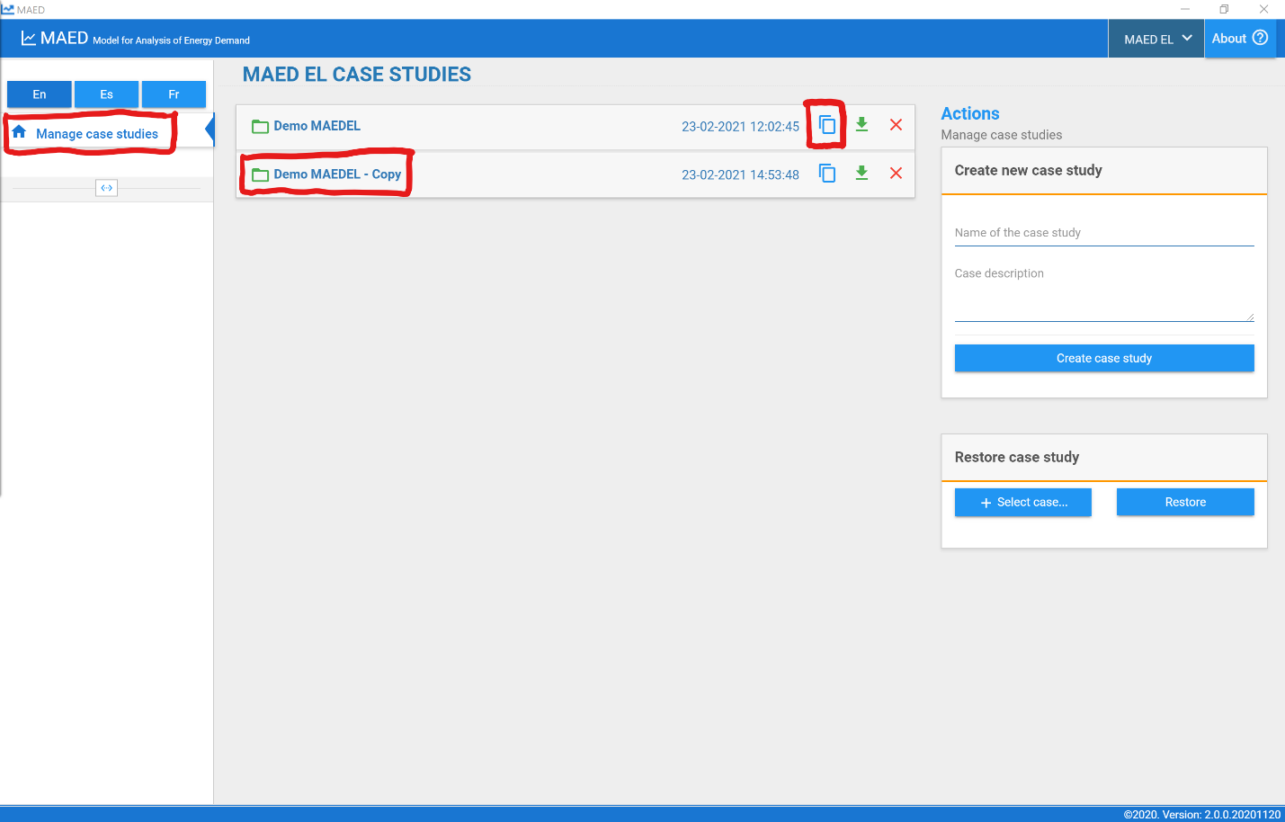
Click on the name of the new case study to open it. This action will open the General data tab. In the Definitions box at the top of the screen, in the field “Name of the case study”, rename this case study “Demo MAEDEL – TD Improvement.”
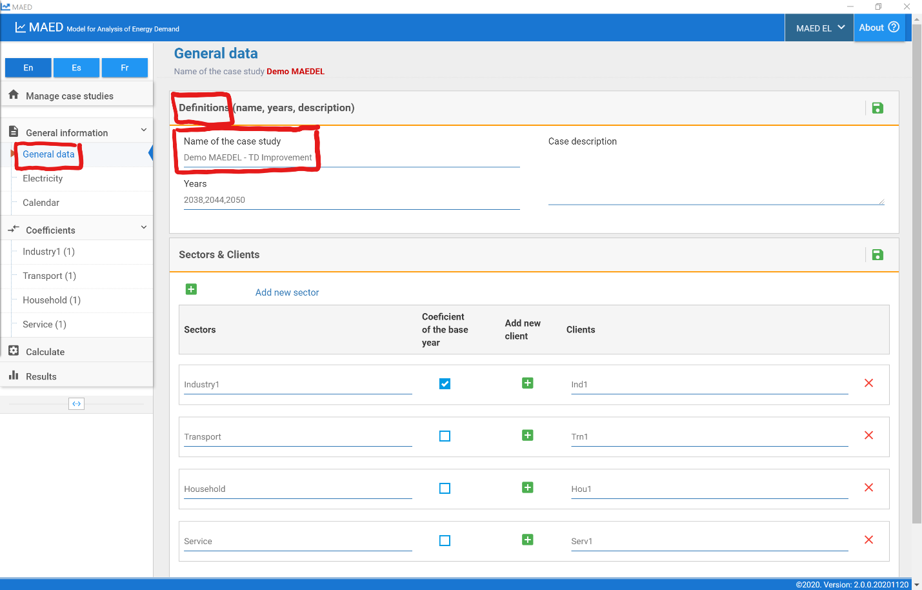
Because all the data from the MAEDEL Demo case study are copied, we only need to change the transmission and distribution losses. Click on the Electricity tab under the General information heading in the navigation menu on the left side of the screen. Click on the Transmission and distribution losses tab at the top of the page. Change the input data as follows:
- Transmission losses: 5%, 4%, 3%
- Distribution losses: 10%, 8%, 5%
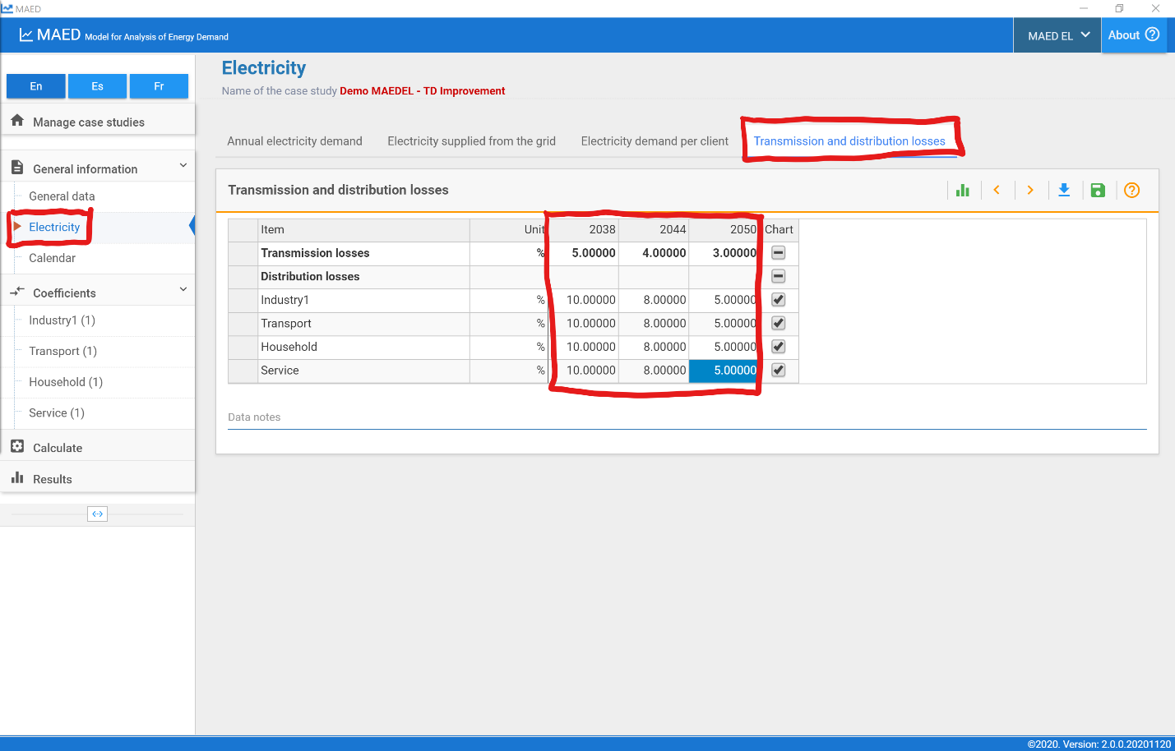
Then click the Calculate tab on the navigation menu on the left side of the screen.
After the calculation is complete, the programme should automatically redirect you to the Results section. Click on the Summary tab at the top of the page and scroll down to view the summary tables for each year. You should check the maximum load in each season, the season in which the maximum load occurs, and the load factor in each season for 2044 and 2050. Compare these key summary statistics for the case with transmission and distribution improvements with the demo case.
