Financial Modelling for Energy Transitions: Hands-on Lecture 10: Closing the Net Financing Gap
Section Title |  | Contents
 | Net Financing Gap (Incremental) | Introduction to the concept of a Net or Incremental Financing gap between less and more ambitious scenarios
1. | Net Financing Gap Instruments – Grants | Introduction to a grant-based approach to address the net financing gaps between two scenarios
2. | Net Financing Gap Instruments – Loans | Introduction to a loan-based approach to address the net financing gaps between two scenarios
3. | Net Financing Gap Instruments – Loans & Grants | Introduction to a blended grant and loan-based approach to address the net financing gaps between two scenarios
4. | Net Financing Gap Instruments – Softer Terms | Introduction to a concessional finance-based approach to address the net financing gaps between two scenarios
5. | Net Financing Gap Instruments – Carbon Credits | Introduction to a carbon credits-based approach to address the net financing gaps between two scenarios
6. | Net Financing Gap Instruments – Debt Write-Off | Introduction to a debt write-off  -based approach to address the net financing gaps between two scenarios

Learning Outcomes
By the end of this exercise, you will be able to:
- Determine the historic composition and terms of finance experienced within the sector from each source of financing
- Use the High-level Dashboard to understand how funding availability and financing requirements interact within the dashboard
- Implement various approaches to close gaps between funding availability and financing requirements, including blending several approaches within the sector
- Assess the outcomes of these approaches in the visualisation dashboard
Another approach to considering the financing gap in MINFin is what is defined here as the “net financing gap” or the difference between a Least Cost (or Business as Usual scenario) and a Net Zero scenario. This represents the additional burden applied to countries to meet climate goals. MINFin not only allows users to visualise this “incremental cost” of Net Zero beyond Least Cost scenarios, it also calculates methodologies that could zero the overall delta of this transition. These include:

- Grants
- Loans
- Combined Grants and Loans
- Softening Terms of Finance
- Carbon Credits
- Debt Write-off

The following Hands-On Exercise will discuss the implementation and approach for each of these methodologies within MINFin, as well as their benefits and challenges.

Net Financing Gap (Incremental)
To set the dashboard in MINFin to display the incremental financing gap, first, reset our terms, shares and growth rates of finance and funding sources to historic values as well as turning off cash injections. We must again ensure that the “Scenario” selection on MINFin’s High-Level Dashboard is set to “Net Zero” or our less ambitious scenario, as shown below.

After selecting this option, users should navigate to the “Financial Instruments” tab in MINFin and input assumptions for Discount Rates for both Capital Providers and Recipients. The Capital Provider Discount Rate represents the provider’s opportunity cost of capital or the return they could earn from alternative investments. This is the rate a donor could expect to receive if they did not commit their funds. It is typically benchmarked against the recipient country's government bond rates, reflecting the opportunity cost of public funds. Meanwhile, the Capital Recipient Discount Rate reflects the cost of capital they would face if borrowing or raising funds for the project. This accounts for the time value of money and alternative financing options. For this scenario, we will set the Capital Recipient Discount Rate to the Historic WACC of 5.33% and the Capital Provider Discount Rate to 4.00%. The resulting inputs should appear as follows:
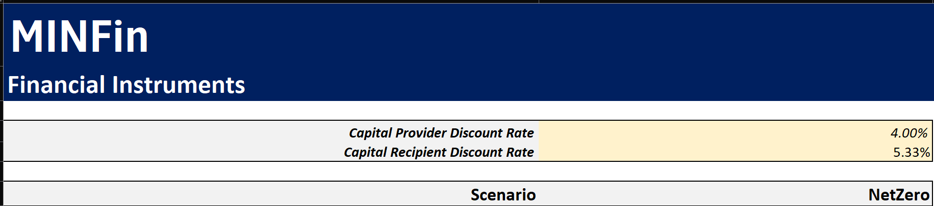
We can begin evaluating how financing instruments can "zero the delta," aligning the costs of our more ambitious Net Zero scenario with those of the less costly Least Cost scenario.

1. Net Financing Gap Instruments – Grants
The first approach we will evaluate is using grants to "zero the delta." Here, we assume that the international community will provide annual grant funding sufficient to align financing requirements of our Net Zero scenario with those of the Least Cost scenario. To implement this, select “Grant” from the drop-down menu under “Financial Instrument,” shown below.
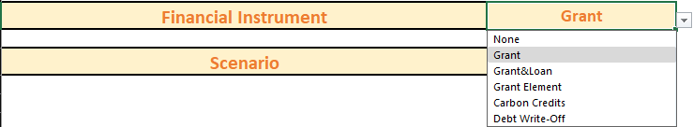
Once this has been selected, users can see how this amount changes and is quantified in the “Financial Instruments” tab in MINFin. This is calculated either alone as is shown in option 1a. below, this is broken down into New Power Generation, Stranded Power Generation, Variable Costs and Fixed Costs savings. Option 1b. includes all of the above, but also accounts for Fossil Fuel Savings, whilst option 1c. accounts for all of this, and Fossil Fuel Savings, and Carbon Credits revenues based on our user-defined carbon credits pricing input in the “OSeMOSYS (Inputs)” sheet. For each option we can see yearly values (highlighted in Red) and total Values (highlighted in Blue). Yearly and Total values will represented in the same columns throughout this Financial Instruments sheet as shown below:
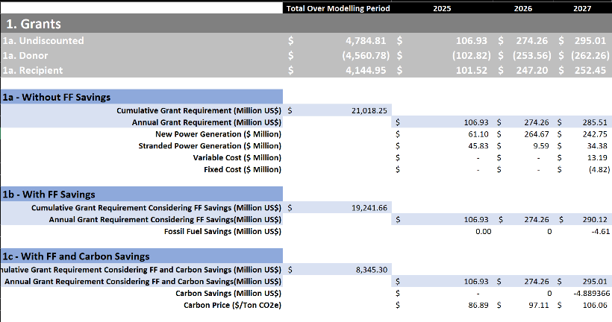

Once this has been selected, we can assess how this changes the balance between funding, financing and investment needs between Least Cost and Net Zero Scenarios. On the High-Level Dashboard, the graph labelled “MINFin Incremental Costs in Absolute Terms” helps to visualise these changes:

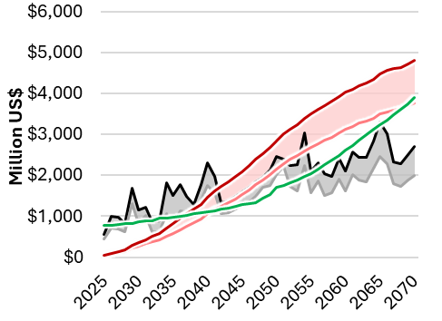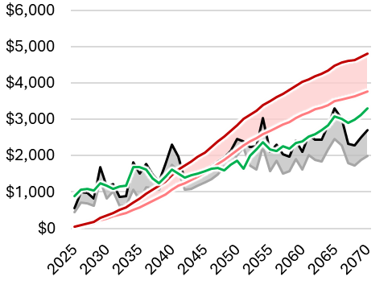
In this instance, Grant is added to the funding baseline on top of Fossil Fuel Savings and Carbon Credits in order to “Zero” the investment needs (represented by the gap between the Black “Net Zero” line and the Grey “Least Cost” line shaded in Grey). We can change this to exclude the Fossil Fuel Savings and Carbon Credits, either in the Financial Instruments Sheet by changing from 1c. to 1a. or 1b., respectively, or by setting Fossil Fuel Expenditure or Carbon Credits to 0 in the OSeMOSYS (Inputs) tab of MINFin.

2. Net Financing Gap Instruments – Loans
For the loan methodology, we must first set “Financial Instruments” to “None”. Next, we aim to implement a loan that provides capital covering the incremental investment costs. The repayments on this loan are anticipated to be derived from savings generated such as Fossil Fuel Savings and Carbon Credits. If the MIRR for this loan exceeds the WACC for the country, then this is considered profitable and a financially viable means to address this financing gap. If not then, without some grant element, this is not a feasible approach.
To implement this methodology within MINFin users navigate to the “Financial Instruments” tab of MINFin and locate section 2 labeled “2. Loans”. Here we can find the Modified Internal Rate of Return (MIRR) for the sector. For this we calculate the MIRR based on revenues from either Fossil Fuel Savings alone, or Fossil Fuel Savings and Carbon Credits revenues.
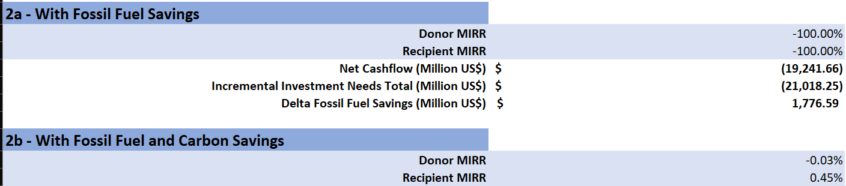
As we can see here, from both the perspective of the Donor and the Recipient, this is a poor investment as the MIRR is below both the Discount rate for both viewpoints. As such there may be some need for grants to supplement this approach.

3. Net Financing Gap Instruments – Loans and Grants
The next methodology we will assess is blending a combination of Grants and Loans. For this methodology, we will be calculating what minimum volume of grant will be needed annually in order for the rest of our financing requirements to be met through a loan that could be sustainably financed from the revenues generated from Fossil Fuel Savings and possible Carbon Credits. To implement this, first users must select “Grant & Loan” from the financial instrument’s options in MINFin’s dashboard as shown below.
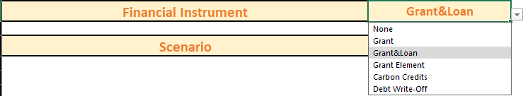
Next we must run a Goal Seek on the “Financial Instruments” tab. To do this, navigate the “Financial Instruments” in MINFin, and find section 3 labeled “3. Grant&Loan”. Here there will be 2 options, either “With Fossil Fuel Savings” or “With Fossil Fuel and Carbon Savings”. Here we will run this for option 3b - With Fossil Fuel and Carbon Savings.

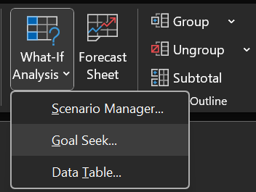
      - Select the Data Tab in the Excel Sheet
      - Select What-If Analysis from this tab
      - Select Goal Seek from the drop-down menu
      - Here we have the option to set cell X equal to a
defined value based on another cell.
      - For this we will be setting Doner MIRR under 3b equal to our defined discount rate for Doner Commitments, by changing the Grant Volume.

This can be input into the Goal Seek function as shown below. “Set Cell” and “By Changing Cell” options can be filled by clicking on the relevant cells shown here. The “To Value” option must be filled manually, which is set equal to our Capital Provider discount by typing in 0.04.
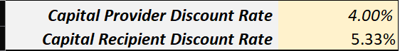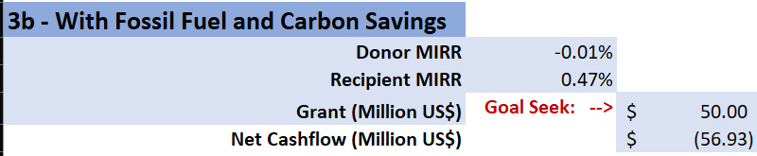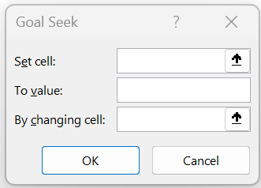
Once this has been input, select “OK”, this will find the Grant volume that sets MIRR equal to the Capital Provider’s Discount Rate. This should give us:
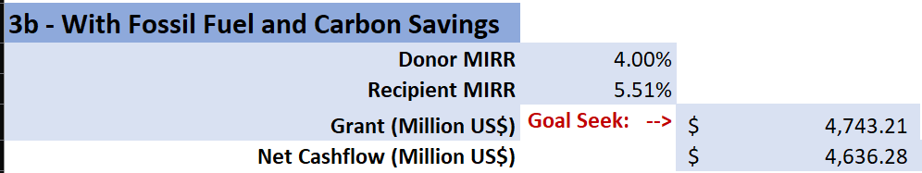
If your value for Donor MIRR is off by several percentages, this can be fixed by going to:
File > Options > Formulas > Calculations Options > set “Maximum Change” to 0.00000001
When implemented, this grant should look like this:

4. Net Financing Gap Instruments – Softer Terms
The next approach that will be assessed is softening the terms of financing by increasing the grant element within the financing of the sector. For this we select “Grant Element” from the Financing Instruments options as shown below.
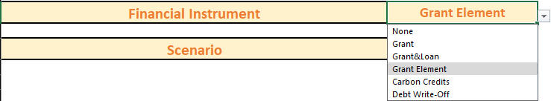
To implement this, we aim to find what share of concessional international financing (Conc IFI) is required to zero the financing requirements between our Net Zero scenario and Least Cost scenario. To do this, we must again use a Goal Seek function. Navigating to the Financial Instruments tab in the MINFin model and finding the heading “4. Grant Element”, here we can see a list of shares for the financiers, as well as a series of calculations for the delta in financing requirements between Least Cost under historic shares of finance, and Net Zero under our Goal Seek shares of finance. To run the Goal Seek, we will need to find the weighing of concessional international finance that makes the delta between these two sets of financing requirements equal to 0. To input this into Goal Seek, follow the steps outlined in the last section to open Goal Seek, and input the variables as shown below:
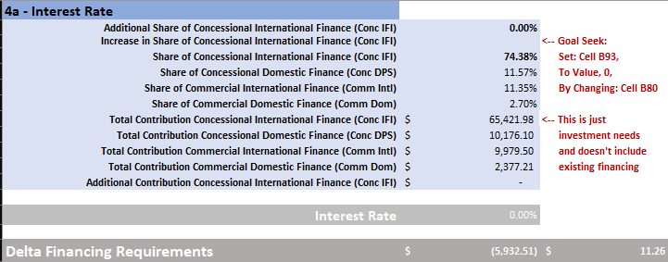
Set to = 0
Once this data has been input into our Goal Seek function, we select “OK” and let Goal Seek find the share of IFI financing required to make our Net Zero scenario equitable to the Least Cost scenario. If this is not possible and the share of concessional international finance needed exceeds 100%, Goal Seek will return an error.

Once this has been run, we should see something resembling this:
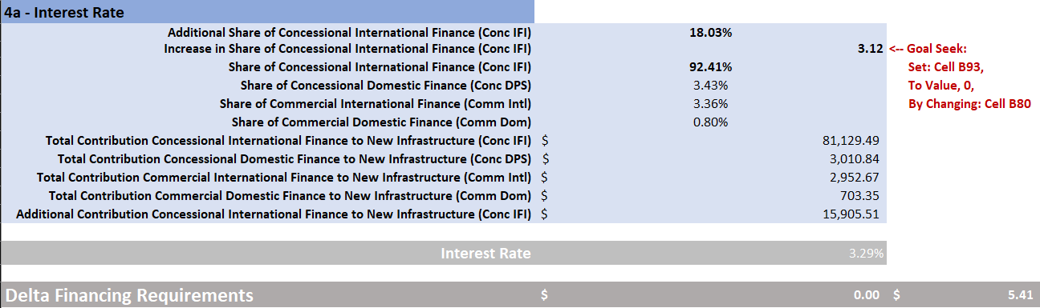
Here we can see that the increase in share of Conc IFI finance results in a final result of 92.41% Concessional IFI required to zero the delta between Least Cost and Net Zero transitions. This equates to an 18.03% in concessional financing in the sector, with Concessional Domestic, Commercial International and Commercial Domestic financing decreasing to 3.43%, 3.36% and 0.80% respectively. Overall, this results in a contribution of $81.13 Bn over our modelling period.
When visualizing this, we can turn to the Incremental costs graph on the High-Level Dashboard in MINFin where we should see this figure:
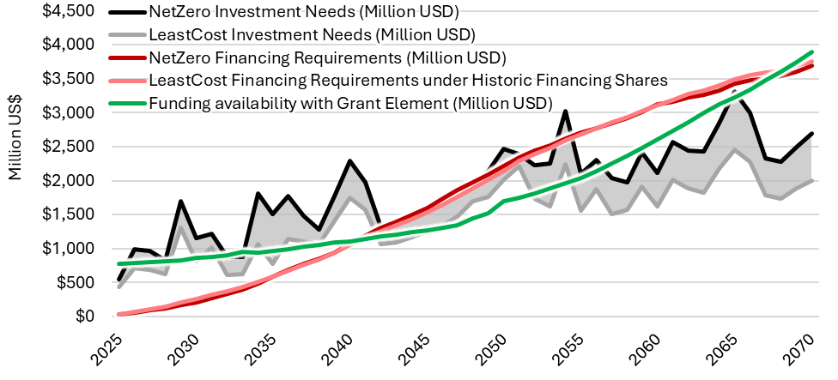
Here we can see that the Net Zero Financing requirement under our updated financing shares is almost perfectly aligned with the Least Cost financing requirements under historic shares, with an overall incremental cost of $0 as calculated based on the Financing Instruments optimization.

5. Net Financing Gap Instruments – Carbon Credits
For this penultimate financial instrument, we will consider Carbon Credits. This approach calculates the annual carbon credit pricing required to compensate for the additional burden of our projected transition. This is based on the yearly incremental financing cost, and annual emissions savings predicted from our energy system modelling. To implement this, we must again select our financial instruments from the High-Level Dashboard in MINFin and opt this time for “Carbon Credits” as shown below:
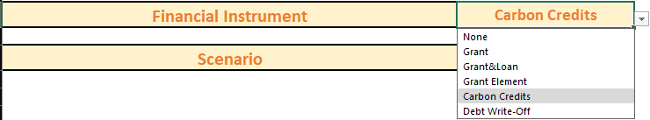
Once this has been selected, MINFin will calculate these year-on-year carbon prices, and apply this to the funding baseline as shown below:
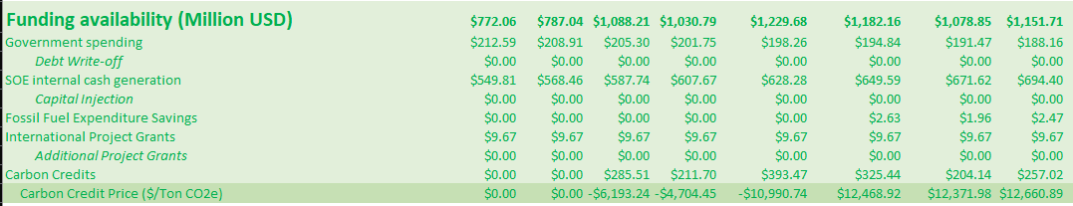
Once this has been calculated, this is shown in the overall funding baseline and shown within the graphs in MINFin’s dashboard. This results in:
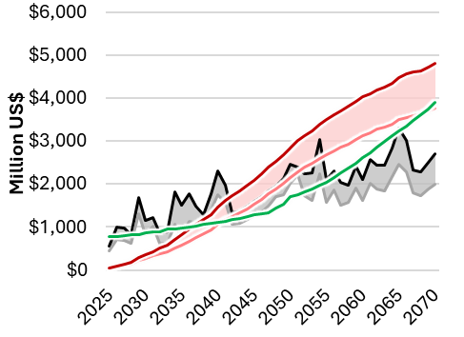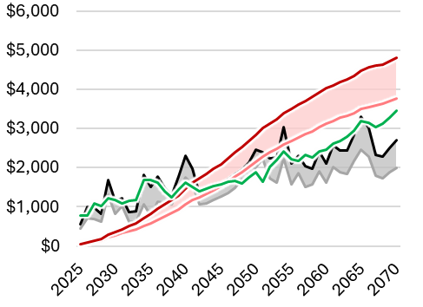

6. Net Financing Gap Instruments – Debt Write-Offs
The last financial instrument that can be implemented through MINFin’s High-Level dashboard is a Debt Write-off. This methodology calculates the size of debt write-off required for the savings generated from avoided debt repayments to equal the delta in financing requirements between our Net Zero and Least Cost scenarios. To implement this, we must again go to the High-Level Dashboard in MINFin and select “Debt Write-off” from the drop down menu as shown below.
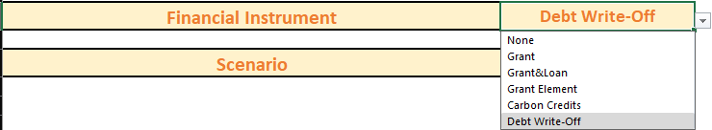
Once this is selected, MINFin automatically calculates the delta in financing requirements as annual payments based on historic loan terms, to calculate the principal. This principal can be found on MINFins Financial Instruments tab under the heading “6 – Debt Write-off” as shown below, here we can see the principal amount that must be written off.
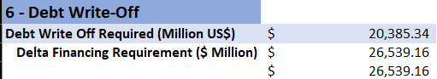
The repayments are then added into the funding baseline under the Debt Write-off as part of government spending. This is because these debt write-offs require public expenditure savings from these agreements to be redirected towards climate finance, in our case committed towards addressing the financing requirements of a Net Zero transition.
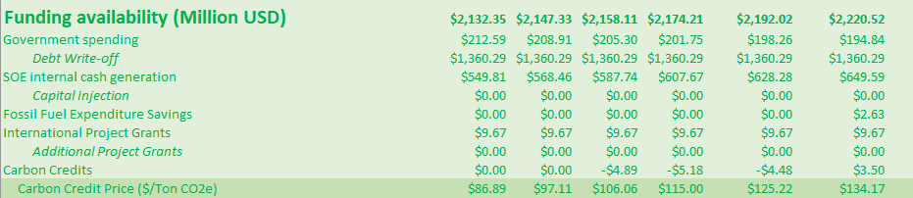

This can be seen as a boost to initial public funding availability across a period equal to the term of the written off debt within the funding baseline in MINFin, as shown in the figures below.
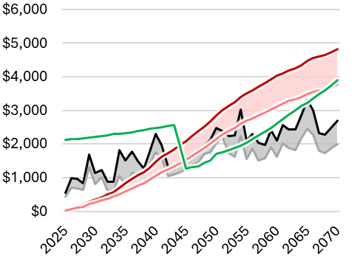

7. Visualising Financial Instruments in MINFin
Once this data is entered into MINFin, the Visualization Dashboard provides an initial view of the results. Cash flows are displayed from the donor's perspective in blue and the recipient's in orange. The results indicate similar outcomes across carbon credits, loans, and grants. However, adjusting the grant element proves to be the most cost-effective way to achieve a zero delta, while debt write-offs emerge as the most expensive solution.