Financial Modelling for Energy Transitions: Hands-on Lecture 9: Closing the Gross Financing Gap
Section Title |  | Contents
1. | Current Financing Gap | Defining a financing gap in relation to Financing Requirements and Funding Availability, and an introduction to MINFin’s High-Level Dashboard
2. | Closing the Gap – Financing Requirements | Methods in MINFin’s High-Level Dashboard to address the financing gap from a Financing Perspective
3. | Closing the Gap – Funding Availability | Methods in MINFin’s High-Level Dashboard to address the financing gap from a Funding Perspective
4. | Closing the Gap – Blending Approaches | Methods in MINFin’s High-Level Dashboard to address the financing gap using a blend of Financing and Funding approaches
5. | Closing the Gap – Visualisations | Description of the visualisations for assessing the Financing Gap in MINFin’s Data Visualisation Dashboard

Learning Outcomes
By the end of this exercise, you will be able to:
- By source, determine the historic composition and terms of finance in the sector.
- Use the High-level Dashboard to identify whether a financing gap exists.
- Implement various approaches to close the financing gap, including blending multiple approaches.
- Assess the outcomes of these approaches in the visualisation dashboard.
Now that the three pillars have been calibrated, we can assess the balance between financing requirement and available funding. Any short fall in funding relative to financing requirements is defined as the “gross financing gap”. MINFin allows users to adjust input parameters to explore how different strategies can help bridge these shortfalls. In this lecture, we will examine key strategies for addressing financing gaps, including the scale and feasibility of implementation. Lastly, we will look at how combining approaches may help the sector meet financial demands within achievable constraints.

1. Current Financing Gap
With all input parameters now defined for our MINFin Model, we can take an initial look at the sector's financial viability based on historical financing and funding patterns. To do this, navigate to the “High-Level Dashboard” tab in MINFin. First, ensure that the dashboard is set to display the Gross Financing Gap for the Net Zero Scenario. This can be done by locating the “Scenario” and “Financial Instruments” options at the bottom of the user interface and selecting “Net Zero” and “None,” respectively. While the “Least Cost” option under “Scenario” allows us to assess the gross financing gap for the least-cost approach, our focus for now remains on the Net Zero Scenario.
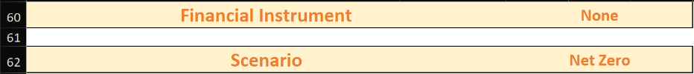
We can now see a graph of the trends in funding availability and financing requirements:
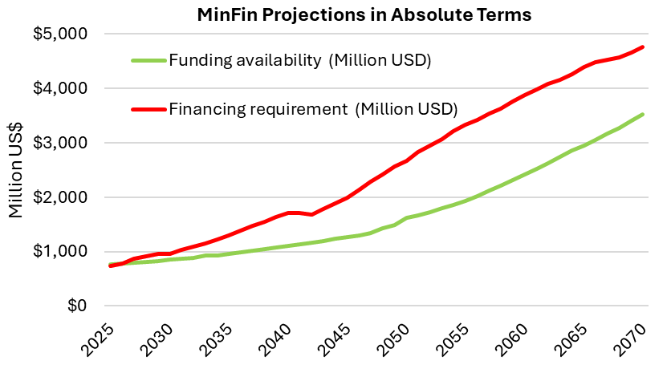
The data is presented both in absolute terms and as a percentage of GDP. However, to view it as a percentage, we must first input GDP projection assumptions. To do this, navigate to the “(Demo) Macroeconomic Data” tab in the MINFin Demo Data Publication Sheet found here. Locate the row labelled “Annual GDP (Million USD)” and copy this data into the GDP Projection table at the bottom of the High-Level Dashboard tab, as shown below.
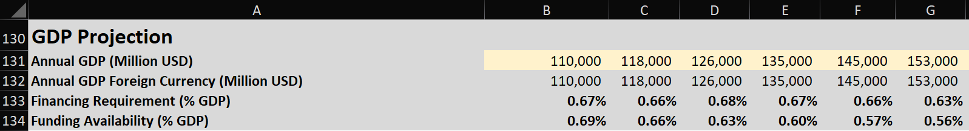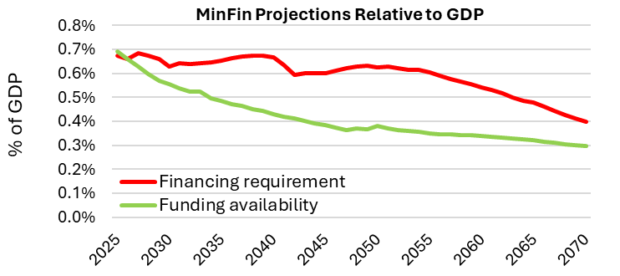
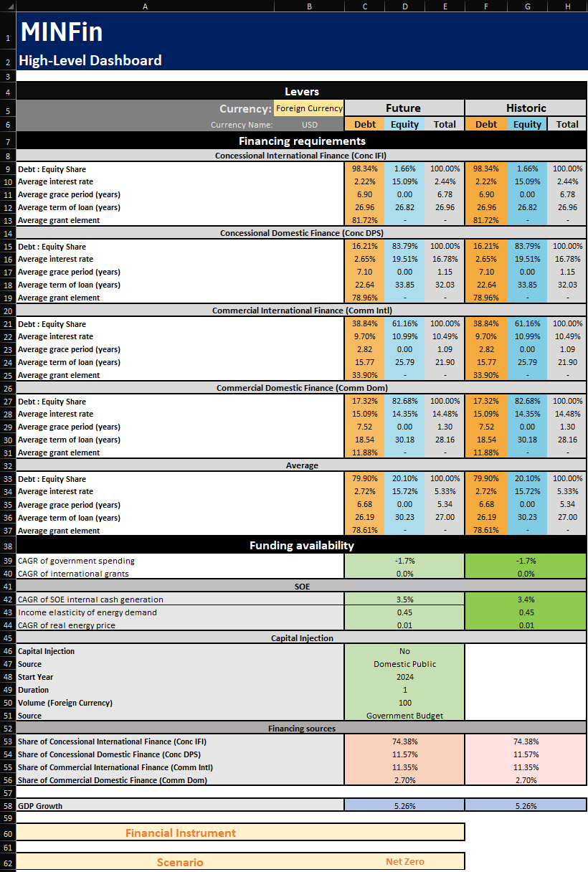
As we can see in the figure above, there is a shortfall between the financing requirements shown in red, and the funding availability (shown in green) needed to service this financing requirement. This occurs whenever the funding line falls below the financing line requirement line, indicating a funding shortfall. The extent of the gap is determined by the conditions under which financing and funding are projected. These conditions are controlled by the levers on the left side of the dashboard, which display historical and future terms and shares of financing in the power sector.
In the Financing Requirements section of this levers are the terms of finance for both Debt (Orange) and Equity (Blue) for each of the four sources of financing, with averages across these shown at the bottom of this section.
Below this is the Funding Availability section. This covers the compound annual growth rate (CAGR) for government spending and international grants, as well as parameters defining CAGR of SOE internal cash generation, which is dependent on income elasticity and CAGR of real energy prices.
Below this is the option for users to define a capital injection into the sector. MINFin allows users to define the volume committed, the source from which this volume comes, the year of the injection, the duration or period over which it is implemented, and implementing facility.
Below this is the shares that each financing source commits to the overall financing of the sector, these should sum to 100% of the sector finance. Lastly we have the Financial Instruments which will be covered in the final Hands-on Exercise. Whilst the historic should remain fixed, changing the terms under which the financing requirements and funding availability are projected will adjust these cash flows, allowing users to “close the gap” between funding and financing. Here we can set the GDP growth rate to 5.26%. We must now consider how to implement strategies to address this shortfall. The following sections will cover the two directions from which this problem can be approached.

2. Closing the Gap – Financing Requirements
The first perspective from which to address this funding shortfall, is to lower the costs associated with the financing of the power sector development, i.e. lower the financing requirements (red line) closer to the funding availability (green line). There are 3 main approaches covered here that may be used to close the gap from the financing perspective:
- Reducing WACC for Commercial Financing
Whilst the share of commercial financing within sectors may vary, it typically carries high costs of capital and has the largest scope for increasing concessionality. Looking at cost of debt from Commercial International and Commercial Domestic sources, we can see an interest rate of 10.49%% and 14.48%%, respectively, with 11.35% and 2.70% overall shares. We can change these to more concessional terms of finance under the “Future” heading to reflect more concessional terms of financing that may be achieved through market development and maturity or other risk mitigating measures, setting these to 4.00%:
When looking at this change on the graphs within MINFin’s Dashboard we see: 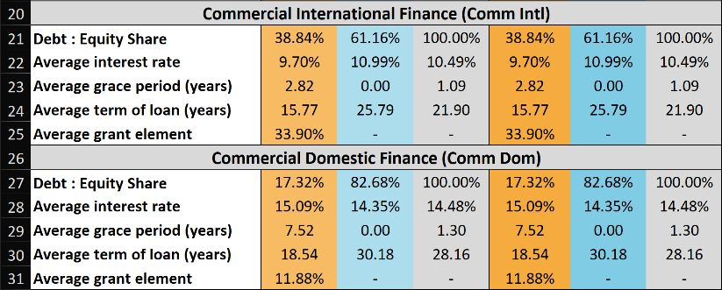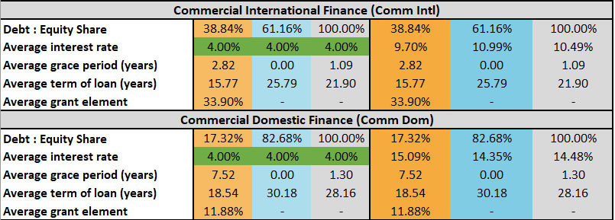
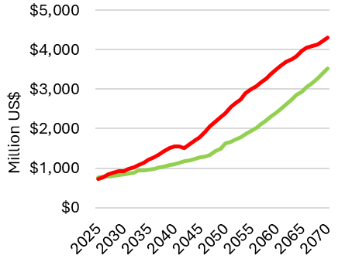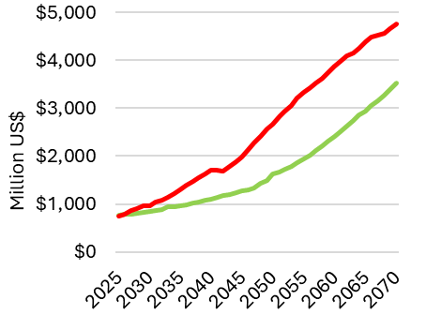
The change is small in this instance as the share of commercial financing is only 14.05% overall in this demo case study. As this has failed to close the financing gap, we must consider other approaches.
- Increase the Share of Concessional Financing
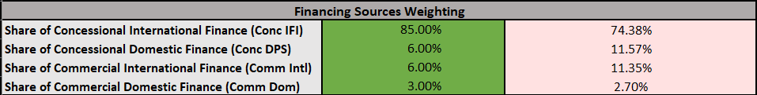
The second approach to reducing the financing requirements is to increase the share of concessional financing. Similar to lowering the cost of capital from commercial sources in the previous approach, this strategy aims to reduce the overall weighted average cost of capital (WACC) in the sector by shifting towards lower-cost financing sources. To achieve this, we need to increase the proportion of Concessional International and/or Concessional Domestic financing. In this scenario, we increase concessional international to 85%. To implement this, we must remember to reduce the shares of other sources of financing to sum to 100%; in this case, we will set Concessional Domestic to 6%, Commercial International to 6%, and Commercial Domestic to 3%. Once input, the High-Level Dashboard should look like this:

Once implemented into the Dashboard, the graph output by MINFin should shift towards:
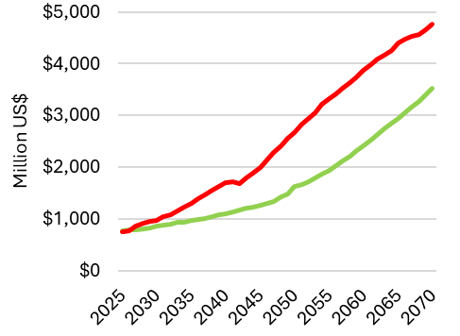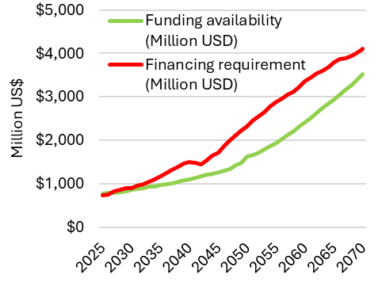
Whilst the impact of this change is far greater than that of the changes to commercial financing’s cost of capitals. This again is insufficient to close the financing gap fully within this MINFin case study.

- Setting Less Ambitious Climate Targets
The last approach to lowering the financing requirements is to adopt less ambitious climate targets While this is not ideal, it may be the only viable option if all other methods prove infeasible. To implement this, users must adjust their energy modelling scenarios in OSeMOSYS (or other energy models) by setting less stringent climate targets. For instance, the target often used in MINFin for the ambitious target is “Net Zero by 2050”, where sectoral emissions are constrained to reach zero by 2050. Changing this to “Net Zero by 2060” would likely result in a less capital-intensive development plan, improving the affordability of the sectoral investments.

3. Closing the Gap – Funding Availability
The second approach to addressing this funding shortfall is to increase funding availability (green line) to better align with the required financing levels. Several strategies can be implemented to achieve this:
- Raising Government Expenditure
The first funding-based strategy to enhance the affordability of this transition is to increase the growth rate of government expenditure. While this has historically represented a significant share of funding, its current compound annual growth rate (CAGR) is projected to decline slightly at -1.7% based on past trends. To address this, we can adjust the CAGR to align with the stated GDP growth rate of 5.26%. Although this may appear ambitious, it provides valuable insight into how this adjustment impacts the affordability of the transition without adding pressure to the government budget. The resulting outputs in the dashboard should appear as follows:

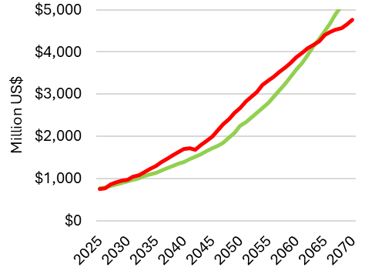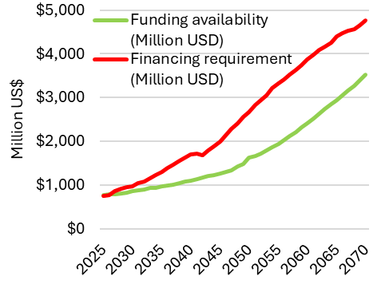
Once again, this has failed alone to close the financing gap, however, this is making significant progress towards closing the financing gap by increasing funding availability.
- Boosting Utility Cash Flows by Raising Energy Tariffs
The next approach to increasing funding availability is by increasing cash flows from state-owned enterprises (SOEs) within the sector. This can be achieved by raising the Income Elasticity of Energy Demand and/or the CAGR of real energy prices. Doing so boosts the growth rate of SOE revenues, increasing the cash generated by utility companies to support financing needs. In this scenario, we will adjust the Income Elasticity of Energy Demand from 45% to 55% and the CAGR of Real Energy Prices from 1.00% to 2.50%. The resulting outputs should appear as follows:
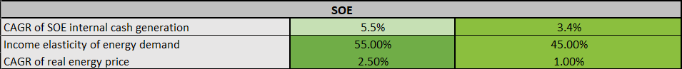
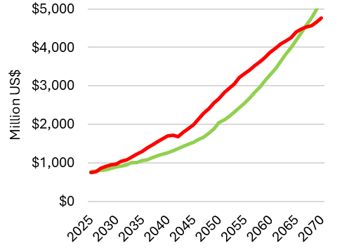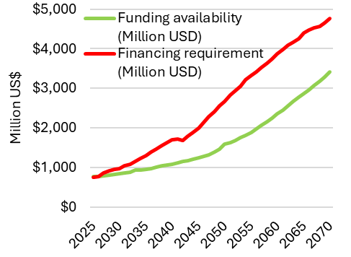
Again, improving the growth rates within the funding baseline dramatically improves the affordability of this scenario, however, there remains a significant financing gap between the funding availability and financing requirements, highlighting that under this growth scenario for SOE revenues, this remains financially unsustainable.
- Increasing SOE Investments
Another strategy to address funding shortfalls is to increase SOE investments. This can be achieved through two primary channels: securing international funding for SOE operations or reallocating government spending into SOEs. In this demonstration, we will focus on the latter by redirecting government budget allocations to SOE revenues. To implement this, we select “Yes” for Capital Injection, specify the source as “Domestic Public” expenditure, and define the start year as 2025. The commitment duration will be set to 3years, with a total injection of $120 million. Since this funding comes from the government budget, we designate the facility as “Government Budget”. Once these inputs are applied, the results should appear as follows:
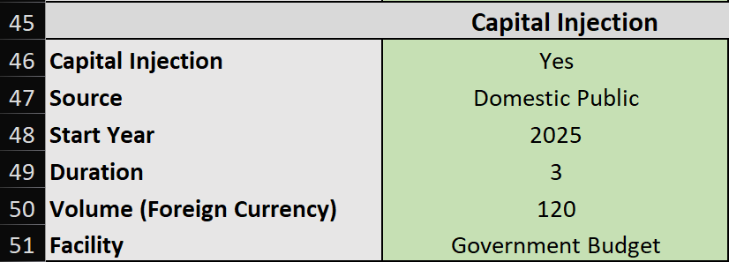
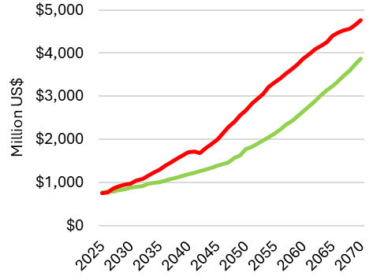
While this approach enhances SOE cash generation and brings funding availability closer to financing requirements, it relies on reallocating government spending to SOE budgets. Given the commitment of only $120 million over three years, it remains financially unviable as a standalone solution.

- Redistribution of Investment Obligations
Another possible solution that could be implemented in MINFin, if necessary, is redistributing the transition burden among SOEs based on their performance. This approach would maximize growth by allowing high-performing SOEs to contribute more to funding availability within the sector. However, since the current model does not disaggregate SOEs, this option will not be applied in the current Hands-On Exercise.

- Carbon Credits
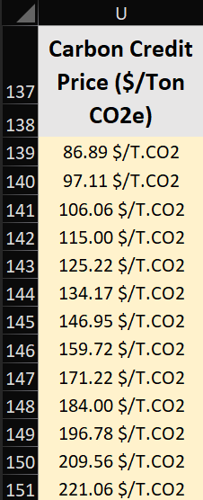
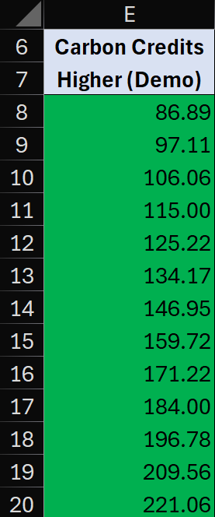
The final independent approach to increasing potential funding availability and meeting financing requirements is to use a higher projection for carbon credit prices. This is a forward-looking strategy that depends on the development of the carbon credit market. However, higher carbon credit prices for developing countries could help bridge funding shortfalls. To implement this, we need to define a new set of carbon credit prices. For detailed instructions on inputting these prices into MINFin, please refer to Hands-On Exercise 7 from Lecture 8 of this series.
In this scenario, we will use the MINFin Demo Data Publication Sheet. Within the “(Demo) Macroeconomic Data” tab, we locate the column labeled “Carbon Credits Higher (Demo)” and copy these values into the carbon credits section of MINFin, found in the “OSeMOSYS (Input)” tab. Once applied, the expected results should appear as follows:

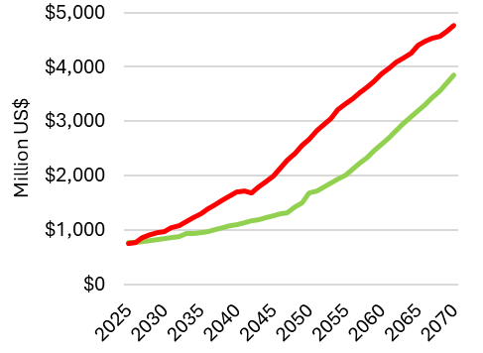
Again, this does help narrow the gap between funding availability and financing requirements, however, there remains a significant gap. Having tried all of the main means by which to address this, we must consider a combination of several of these approaches.

4. Closing the Gap – Blending Approaches
As we have seen above, within the constraints that we have used, no single approach has been sufficient to close the gap between financing requirements and funding availability; as such, we must consider blending several of these approaches. This blending of approaches also carries the benefit of lowering the possible burden on any one source of financing or funding. To demonstrate this, we will be blending the following approaches:
- Reducing WACC for Commercial Financing – as we are blending multiple approaches to address the financing gap in this approach, we can set less ambitious targets for increasing the concessionality of commercial finance. Whilst in the previous attempt, we set this to 4%, here we will set the cost of capital from commercial sources to 8%, a far more achievable reduction in comparison.
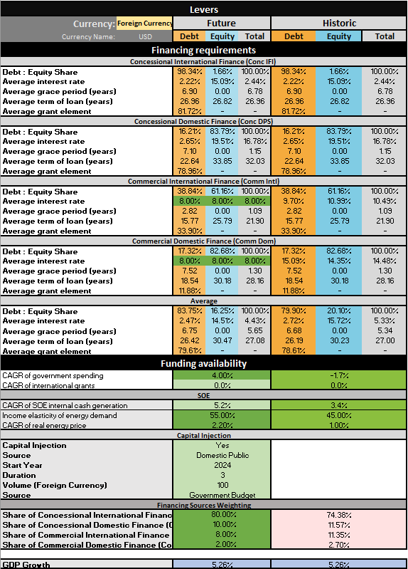





- Increase the share of concessional IFI financing – here, we will be more conservative than in the previous attempt, as blending approaches should lower the burden on any one portion. We will set Conc IFI to 80%, Conc DPS to 10%, Comm Intl to 8%, and Comm Dom to 2%.
- Increase the growth rate for government spending – here, we can be more conservative. Whilst previously it was set to 5.26% in line with GDP growth, we can set this to a lower rate such as 3.6%.
- Boosting utility cash flows by raising energy tariffs – for this instance, we will set the income elasticity of energy demand to 55% and the CAGR of real energy price to 2.2%, lower than our previous attempts to close the gaps through this method alone.
- Increase SOE Investments – here again, we will set this as a domestic public investment in 2025, we will set the duration spread across 3 years, with an investment amount of $100 million from the government budget
- Carbon Credits – here, we will stay with the last set of carbon credits that we input into the OSeMOSYS Input sheet in the previous section of this Hands-On Exercise.
Once these constraints have been implemented in the dashboard it should look like this:
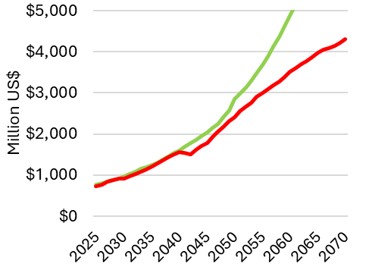
At this point, we can see that the gap between financing requirements and funding availability has been successfully closed. While this specific combination of approaches is one way to achieve this outcome, many other strategies could be implemented depending on the flexibility and capacity for change within each source of financing and funding. To gain a more comprehensive understanding of how these factors impact the overall affordability of our scenarios, we now turn to the Visualization Dashboard tab in MINFin.

5. Closing the Gap – Visualisations
Navigating to the Visualisation Dashboard tab in MINFin, under the “MINFin Projections” tab, we can find several useful visualisations that help us to understand the interactions of funding and financing within the MINFin High-level Dashboard. Including the financing gap across our modelling period as shown below:
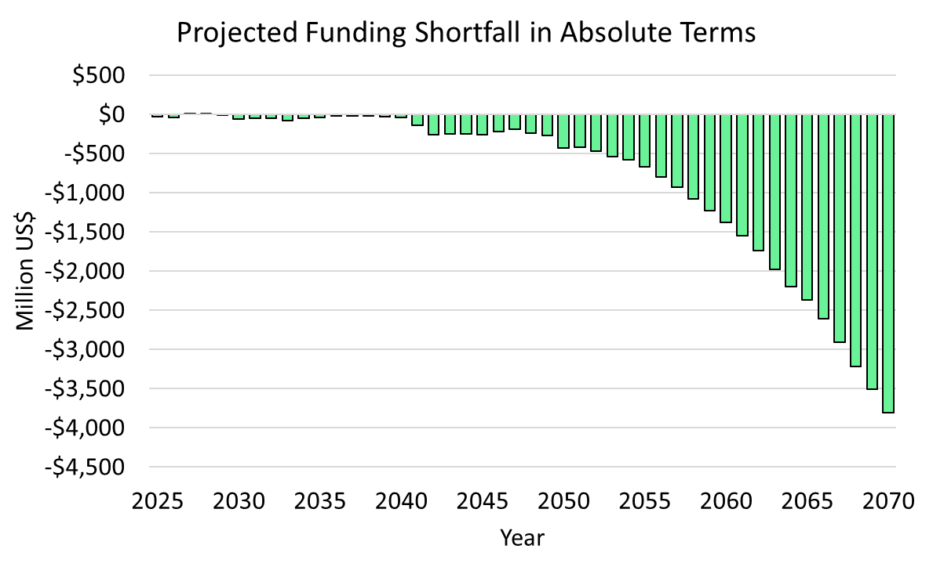
Here, we can explore various visuals that clarify the key contributors on both sides of our efforts to close the financing gap. On the left below, we see how different funding sources address financing needs at each stage. Notably, SOE internal cash generation emerges as the largest contributor, while government spending remains relatively low. Additionally, despite adopting a more optimistic outlook for carbon credit prices, their impact is primarily felt in the later stages of the transition, making them less influential in this particular scenario.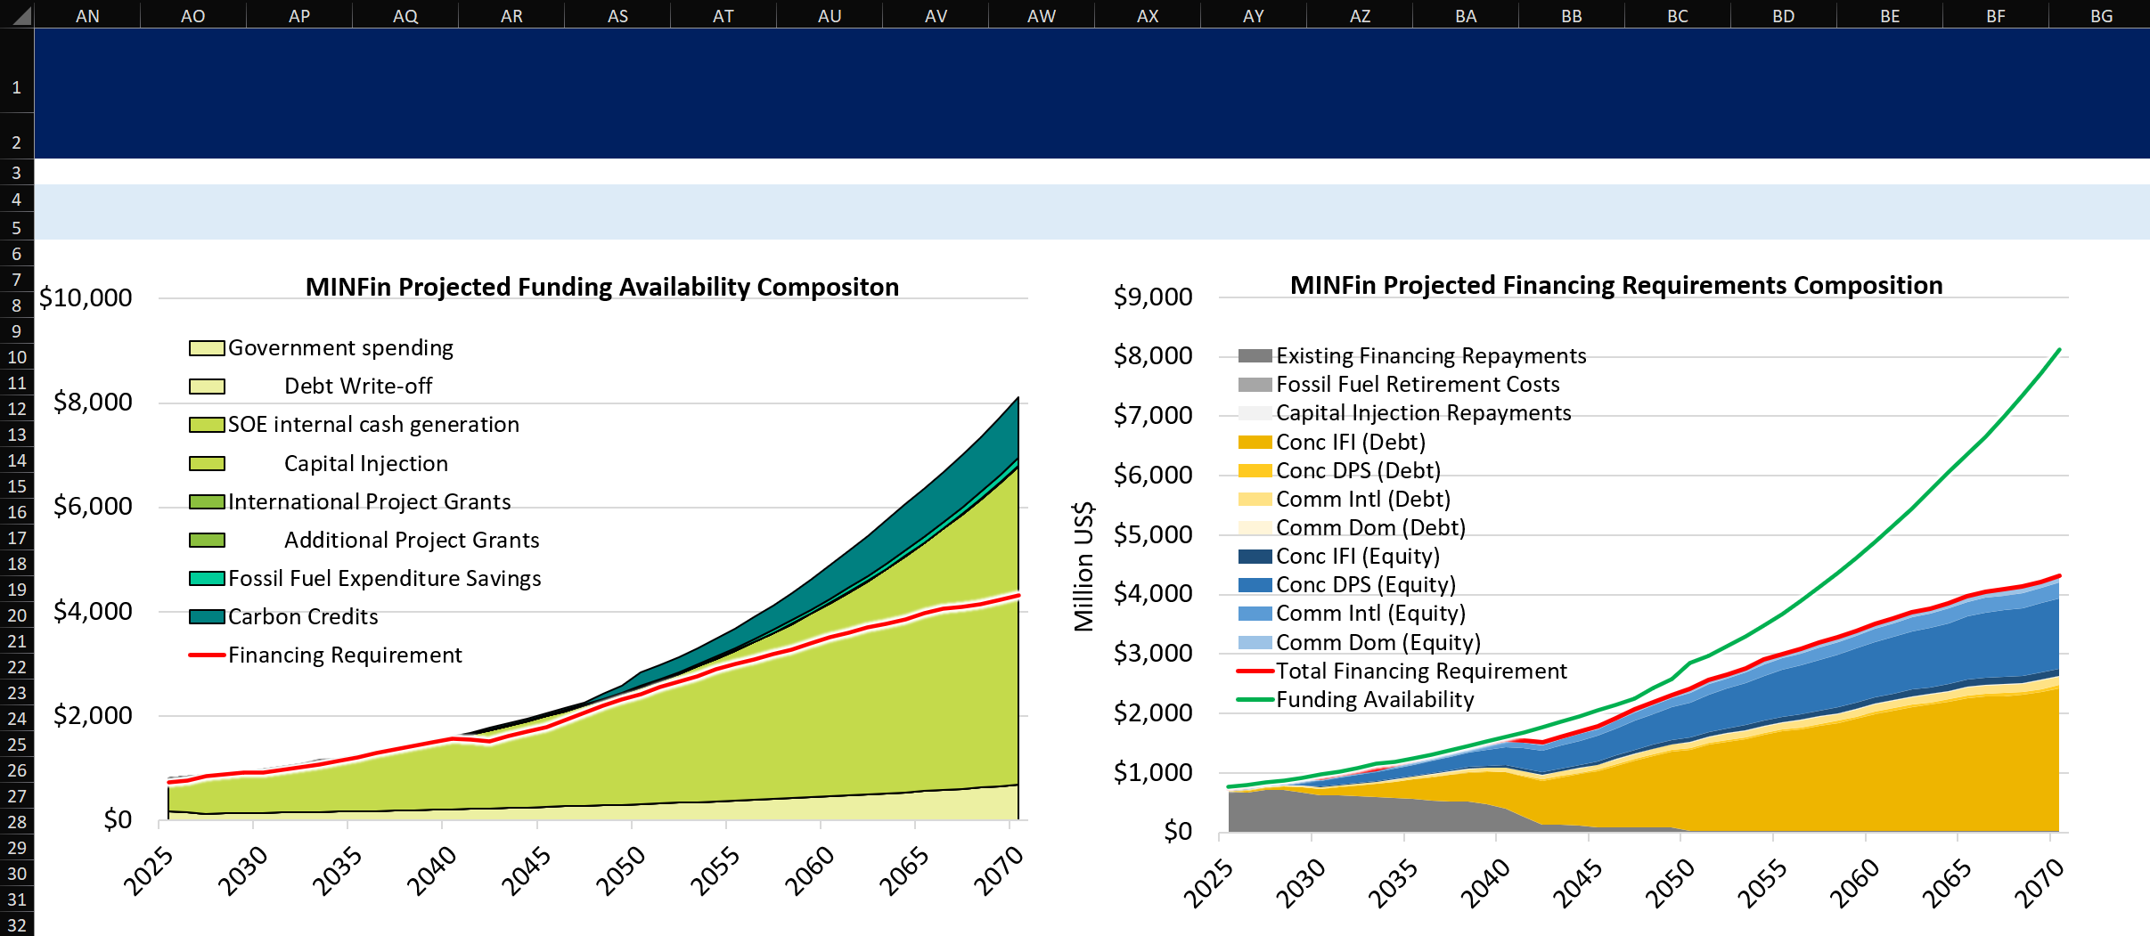
Shifting to the financing requirements on the right above, we can observe that the largest portions of financing repayments are attributed to Concessional International Debt and Concessional Domestic Equity. This underscores the fact that adjustments to the costs of capital and the shares of these sources are likely to have the greatest impact on the affordability of our scenarios. This insight can be leveraged to develop additional scenarios and optimise strategies based on the specific needs and constraints of each country.

