Financial Modelling for Energy Transitions: Hands-on Lecture 8: Funding Baseline
Section Title |  | Contents
1. | Calibrating Funding Availability (Data Publication) | Instructions for inputting Funding Availability from a data publication sheet into MINFin’s Financing Baseline
2. | Developing a new Funding Baseline | Instructions for collecting data to create a new Funding Baseline in MINFin without a data publication sheet
3. | Adding missing funding from project documents | Example walk through for collecting data from a project document, SOE Statement and Government Budget Report to inform Funding Availability in MINFin
4. | Visualising Historic Funding Availability in MINFin | Description of the initial visualisations of historic funding availability in MINFin’s Data Visualisation Dashboard

Learning Outcomes
By the end of this exercise, you will be able to:
- Use the MINFin Demo Data Publication Sheet to input funding baseline data into MINFin
- Understand the process and methodology behind developing a Funding Baseline
- Understand how funding availability is projected within the “High Level Dashboard”
- Locate the visualisation of relevant funding data on the “Data Visualisation” tab.
The funding baseline aims to take stock of the current flows of funding available within the countries power sector that can service the cost of financing an energy transition. The main sources of funding include Government budget spending on energy infrastructure, SOE internal cash generation from state owned power utilities and International Grant contributions towards power sector projects. In this Hands-on Exercise users will learn how to: (1) extract funding data from a demo data publication sheet, (2) develop a new funding baseline and (3) extract funding data from example sheets on project finance, government budget statements, and SOE annual financial statements.

1. Calibrating Funding Availability (Publication Sheet)
This section outlines the process of extracting data from the MINFin Demo Data Publication Sheet and inputting it into MINFin’s Funding Baseline sheet. Before proceeding, ensure you have downloaded the MINFin Demo Data Publication Sheet from the previous hands-on exercise. If you haven't, here is the link again.
- Once the MINFin Demo Data Publication Sheet is downloaded and opened, navigate to the tab labelled “Funding Baseline” as shown below, here users can find historic data on the annual volumes of financing committed to the power sector from each of the three funding sources (Grant, Budget and SOE Gen.). Here we find data covering the Source, Type, Year, Volume, Currency and Government Shares of each source of funds.

- Starting with the columns covering “Source” to “Currency” in the Demo Data Publication Sheet, copy the data into their respective columns in the MINFin model, avoiding the “Exchange Rate” Column. Again, remembering that grey cells () contain formulas that should not be edited, whilst yellow cells () are our data input cells.
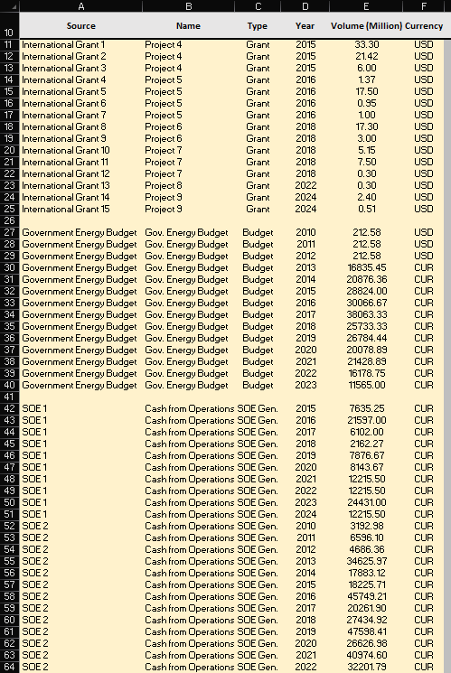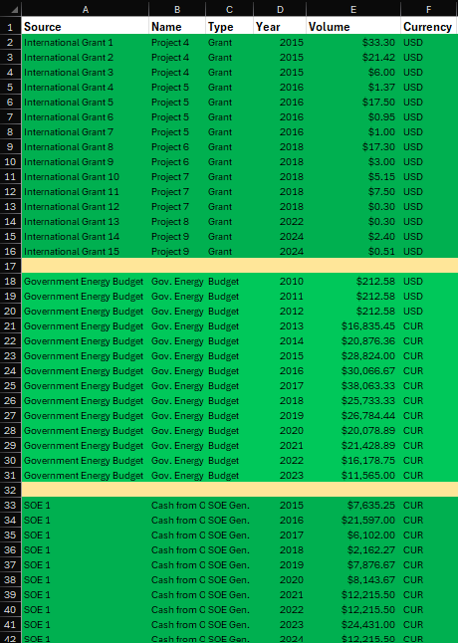
MINFin Model
MINFin Demo Data Publication Sheet
- Next we must copy across information regarding government shares in SOEs in order to calculate the percentage of these revenues that are available for public commitments to new power projects. These can be found in the Demo Data Publication Sheet under the heading “Govt Share” and should be copied across into the corresponding volume in the MINFin Model avoiding the “Exchange Rate” and “Volume in Currency” columns in grey.
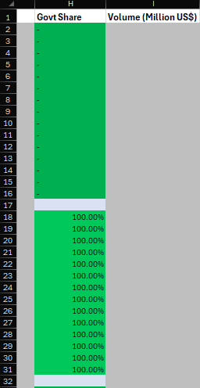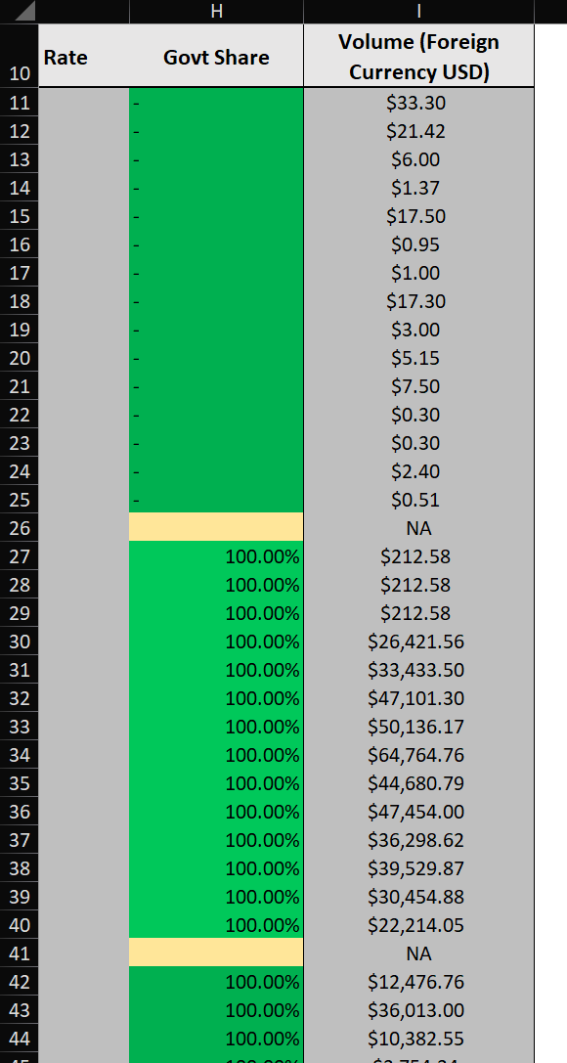
MINFin Model
MINFin Demo Data Publication Sheet

- Now that this has been translated across from the Demo Data Publication Sheet into the MINFin Model, this section focusing on extracting data from data publications for MINFin has been completed. The following sections will look at extracting data to generate your own funding baseline, including information as to the characteristics defining each of these funding flows, and finally an example of data extraction from our demo projects and annual statement sheets.

2. Developing a new Funding Baseline
- Users may need to develop a new funding baseline for their country of choice, in this instance there are 3 modes of funding that require addressing:
- Government Budget – This accounts for the volumes of financing available from government budgetary allocations to address the construction and financing of new power sector projects.
- SOE Cash Generation – This portion accounts for revenue generated by State-Owned Enterprises (utility companies) that is committed to financing new power projects and the debts associated with their development. For this we use Free Cash Flows to the Firm (FCFF).
- International Grants – This accounts for trends in international commitments towards the financing of power projects and is included in this section as, unlike loans and equity, grants do not require repayments and instead contribute directly towards funding available for projects.
- To collect information of governmental budget allocations, information can typically be found in publications from the Ministry of Finance (MoF) or Treasury. A useful resource for this is the World Bank’s BOOST database available here, which covers data on government budget and expenditure in many developing countries. However, it is still recommended to check this data against nationally published data and ensuring that this is not double counted as a project grant in our funding baseline.
- For SOE Cash Generation, we collect data from annual reports from each SOE on their current balance sheets and performance. This will include cash generated from operations, amortization, depreciation and tax rates. To account for the cash available for the development of the power sector, we aim to include Free Cash Flows (FCF) and cash currently being used to service existing debt obligations (amortization). A useful resource for this research is the World Bank’s UPBEAT database that can be found here, and covers utility performance and financial data for many of the world’s utilities. However, again it is recommended to check this data against publicly available utility publications. The following section will cover the extraction of this funding data from demo SOE balance sheets.
- Lastly, to collect data on International Grant commitments, whilst this is sometimes covered in government budgetary statements, the focus for this is to use data collected from our financing baseline, for which we should collect data on grant commitments towards the projects covered, and account for them here in our Funding Baseline. These grant amounts will often appear in project reports, alongside the information on debt and equity commitments.

3. Adding missing funding from project documents
In Section 3, you will learn how to calibrate a funding baseline using a demo document designed to closely reflect real-world documentation. This exercise will help you develop the skills needed to adjust your own baseline effectively. For this section we can refer back to the MINFin Demo Projects Sheet used in Hands-On Exercise 3, if this has not already been downloaded, a link to this document can be found here. For this section we will be using all 3 documents covered, starting with the Government Budget Sheet on page 3. of the Demo Projects Sheet.
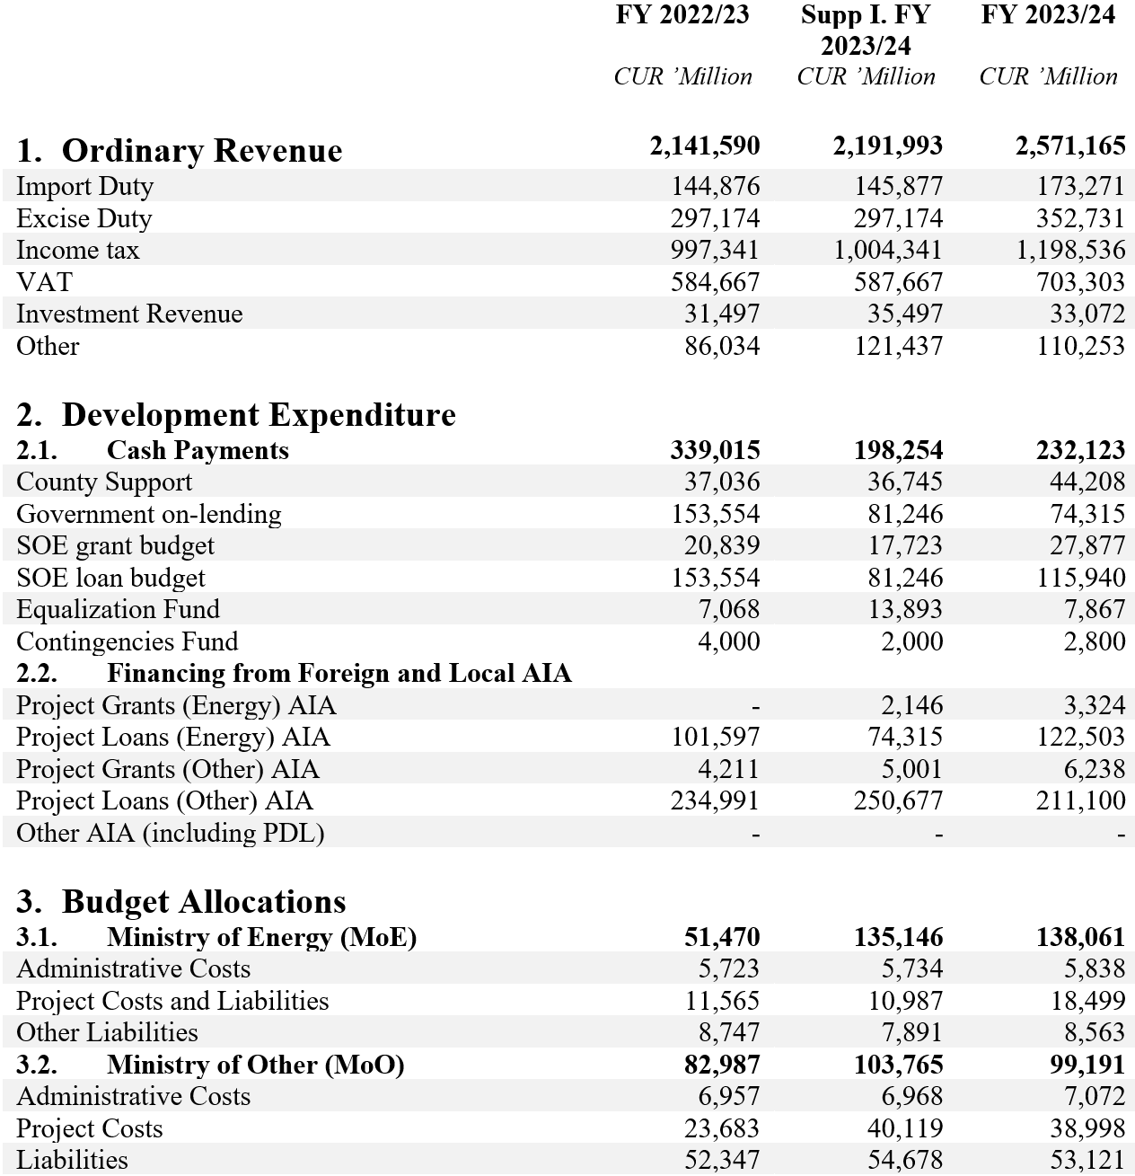
- Government Budget Data
  - First, we identify the target year. In our MINFin model, we observe a data gap for 2024, highlighted in yellow in the MINFin input data. This sheet allows us to fill that gap. Our primary focus is on collecting Government budget data for the year ending in 2024. The report includes a column of values for 2023 along with supplementary estimates for 2024. While these estimates can serve as useful approximations when annual data is unavailable, actual realized values should be used whenever available, as indicated in the red box above.
  - Scanning through the rows of this report, we find several potentially useful entries. However, while SOE budget information might seem relevant, it is too aggregated for our purposes, as we will be collecting this data directly from SOE statements. Likewise, information on Project Grants for power projects will be sourced from project documents, as not all grants are implemented through government engagements. This approach allows us to obtain a more detailed and precise perspective.
  - The data that we are looking for in this instance can be seen highlighted in the blue box. This row is stated as covering the project costs and liabilities for the Ministry of Energy’s power projects, which we can see is equal to CUR 18,499. Here users must be careful to take note of the currency and units of the reported value remembering that all currency calculations in MINFin are in millions. As this is already in “’millions” we can leave it in this order, however we must also include the currency in our MINFin model which in this instance is labelled as “CUR”. Volumes reported in “‘000” should be divided by a further 1,000, whilst absolute values should be divided by 1,000,000.
  - Inputting this data into MINFin should result in:
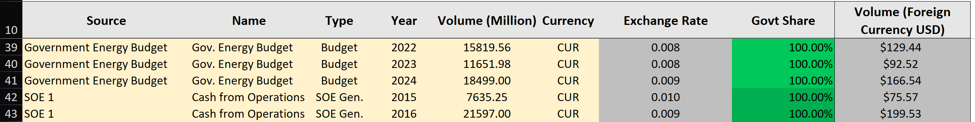
- SOE Cash Generation Data
  - Moving on to funding available from the operation of State-Owned Enterprises, we can see in our MINFin model that there is a gap in the year 2024 for our SOE 4 funding data. To establish this, we must take a look at financial statements from annual reports published by the SOE for this year, this can be found on page 5. of the MINFin Demo Projects Sheet.
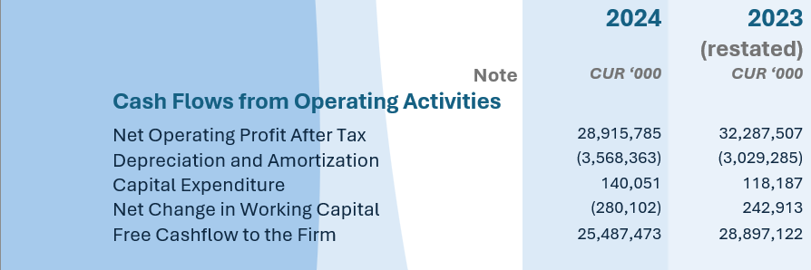
  - This annual report covers the SOE’s performance in both 2023 and 2024, for this gap filling we will be focusing on the reported terms for 2024 highlighted in the red box. In this instance, we will use Unlevered Free Cash Flow (UFCF), or Free Cash Flow to the Firm (FCFF) as a representative value of cash available to the sector from this source shown in the blue box. This is defined as:
$$Free Cashflow to Firm=NOPAT+D\&A -CAPEX - ∆NetWC$$
Where:
NOPAT = Net Operating Profit
D&A = Depreciation and Amortization
CAPEX = Capital Expenditure
$∆NetWC$ = Changes in Net Working Capital

This is equal to 25,487,473 based on the report. Here again users must be careful of the currency and units reported. Here the units are “CUR ’000” indicating thousands of CUR, as such this value is divided by 1,000 before being input into MINFin. Following the naming used in the rest of the data input under SOE 4, and noting the government shares in this SOE are 50.10%, the resulting input should look like this:
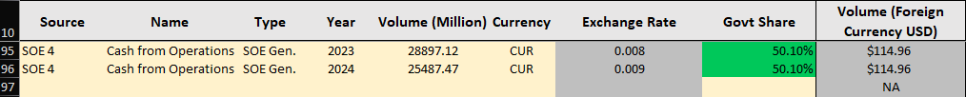

- International Grants
  - The final source of funding is International Grants. For this we will return to the Project Sheet on page 1. of the Demo Data Publication Sheet. Here we not only find information regarding the volumes and terms of financing for the project, but also information about a grant towards the development of the project committed by (CTF) Climate Fund 1. Based on the information in this document, namely the year of commitment, and currency and volume committed, we are able to fill in this row in the MINFin Model. Inputting this data into the sheet we should have something that looks similar to this:
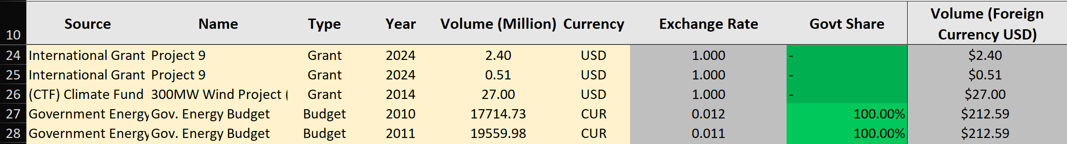
Once this data is input, we have completed the input side of MINFin’s Funding baseline. We can now see at the top of this “Funding Baseline” tab how MINFin pulls this data into a time series of funding available and calculates historic compound annual growth rate (CAGR) for these sources of funding to be projected.
- Other Sources of Funding
  - The two other sources of funding used in MINFin are:
- Fossil Fuel Expenditure Savings – these are calculated from the OSeMOSYS data input in Hands on Exercise 2 from Lecture 3 and are based on the delta or differences in national expenditure on fossil fuels between our ambitious and less ambitious transition scenarios.
- Carbon Credits – these are calculated based on the delta in emissions from the data input again from OSeMOSYS in in Hands on Exercise 2 from Lecture 3. This requires assumptions regarding the carbon credit pricing; hence we must define assumptions for this.
  - Whilst normally users must define their own assumptions regarding carbon credit pricing, this Hands On Exercise includes some demonstration carbon credit prices in order to help users visualise how this interacts within MINFin.
  - To find these, in the MINFin Demo Data Publication Sheet, navigate to the “(Demo) Macroeconomic Data” tab. Here we will find a table headed “Carbon Credit Pricing (Demo)”, to input this data into our MINFin model, navigate to the OSeMOSYS (Input) tab of MINFin and locate the table into which we have previously input “CO2 Emissions (Mt)” data. To the right of this we will see a column labelled “Carbon Credit Price ($/Ton CO2e)”, this represents the market price of carbon emissions through carbon credits. Into these cells we input assumptions regarding prospective carbon credit pricing to inform funding streams, here we can insert the data from our MINFin Demo Data Publication Sheet, this should look like:
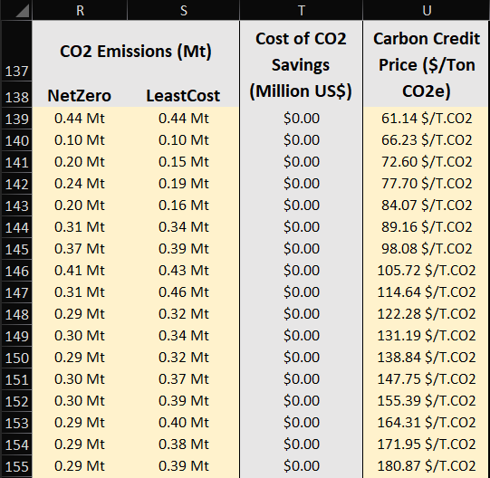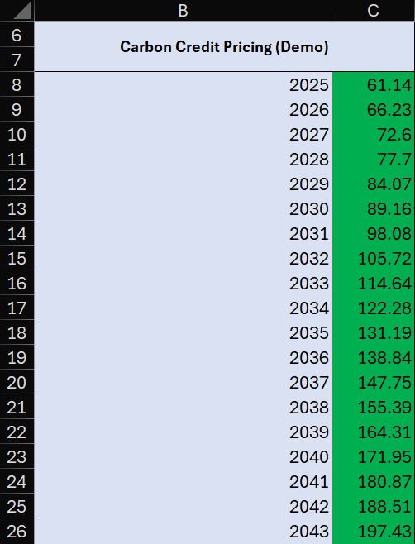
MINFin Model
MINFin Demo Data Publication Sheet

4. Visualising Historic Funding Availability in MINFin
Once this data has been input into MINFin we can see some initial visualisations of the trends in historic and future projections for funding availability within the country’s’ power sector. The graphs here highlight trends in fund availability, with government spending showing marginal declining trends, whilst SOE cash generation is forecast to grow substantially, becoming the main source of funding for the sector under current projection parameters, as well as modest contributions from Carbon Credits and Fossil Fuel Expenditure Savings.
