Financial Modelling for Energy Transitions:
Hands-on Lecture 6: FinCoRE

Learning Objectives
By the end of this exercise, you will be able to:
- Access the FinCoRE tool using the web dashboard
- Navigate FinCoRE’s dashboards and use it to create estimates of the cost of capital for a specified year and technology
- Explore future scenarios for a selected country and technology

Note: FinTrack is a web based model and requires a standard internet browser to run.

1. Access the FinCoRE online dashboard
- Navigate to https://wacc-forecaster.streamlit.app/: if the app is described as sleeping due to inactivity click yes and wait for the app to be restarted.





- Wait for a few seconds for the app’s background processes to finish running and setting up the webtool ready for use

2. Navigate the FinCoRE online dashboard

- Open the FinCoRE dashboard and select a given year and technology from the dropdown menus at the top of the screen e.g., Solar PV, 2023.
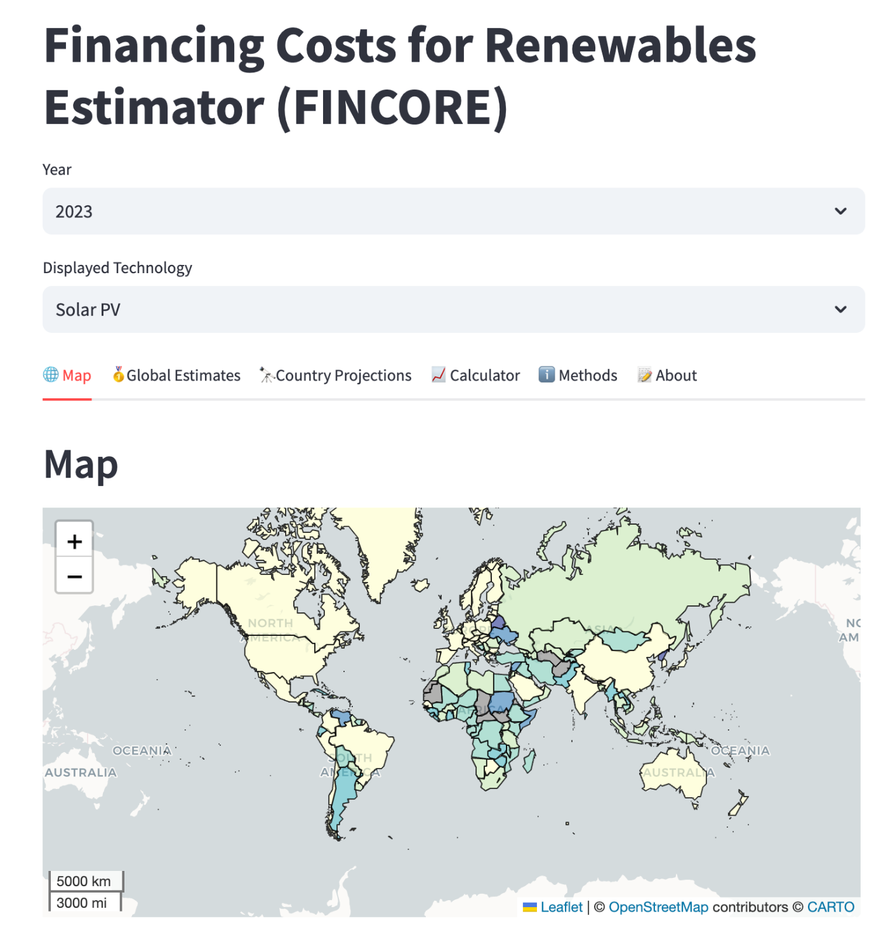

- Looking first at the Map tab on the left-hand side, use your mouse to zoom into the region or country of interest and hover your cursor over a specific country.
- Each country will display data on the tax rate, debt share, cost of debt, cost of equity and overall cost of capital for the technology and year selected.
- For example, in the screenshot below, the overall cost of capital for Russia for solar PV has been estimated at 14.94%, with a cost of debt and cost of equity of 18.39% and 15.79% respectively. Debt was calculated to make up 60% of the total investment, with equity accounting for the other 40%.
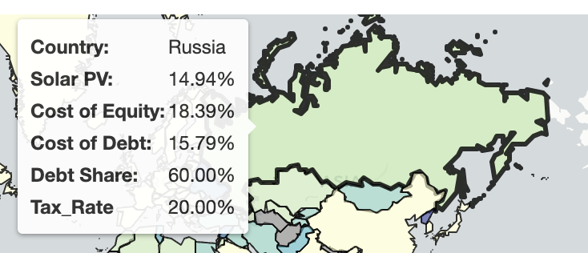
- Navigate to the Global Estimates tab, which allows you to compare the estimated cost of capital for a given year and technology across a range of different countries.


- A number of countries will have been preloaded for comparison. Remove these by clicking the white X in the tab next to their name, and using your keyboard enter the ISO code for countries of interest (e.g., VEN for Venezuela, MOR for Morocco). Complete mappings can be found here.
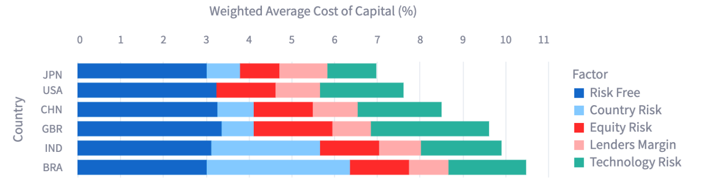
- Compare the range of cost of capitals for the year and technology specified at the top of the page (e.g., Onshore Wind, 2020). What is driving the cost of capital in the highest regions? Is it country risk or technology risk?

Navigate the FinCoRE online dashboard

- After selecting a given year and technology from the dropdown menus at the top of the screen (e.g., Onshore Wind, 2020), navigate to the Country Projections Tab, which allows you to explore how the cost of capital is likely to change over time under different scenarios.
- Using the dropdown input menu, specify the country that you are interested in exploring (e.g., KEN for Kenya) how the cost of capital is likely to change with time.

- Use the select boxes to specify the assumptions that you would like to change and compare how this changes the cost of capital compared to historical estimates. 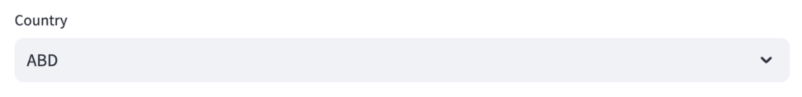
- Navigate to the Calculator tab, which allows you to specify the year and national inputs to the estimation model which FinCoRE is uses to calculate the cost of capital.
- Explore how modifying parameters under the four categories: Macro Environment, Renewable Development, Debt-Equity Premiums and Financing Structure changes the calculated cost of capital for the given country and technology, which is plotted at the bottom of the page.
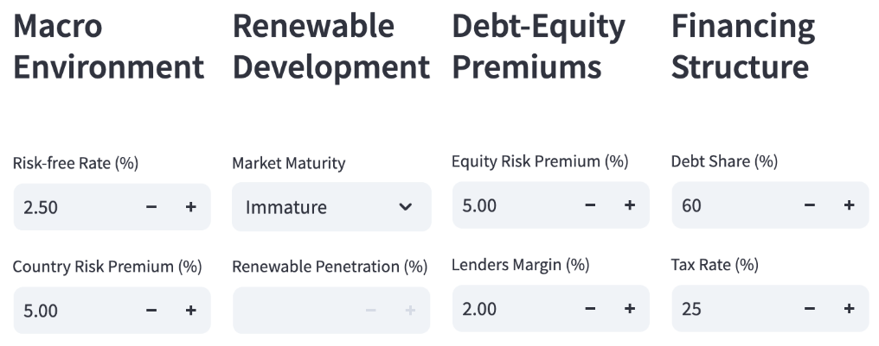

- Review the information in the Methods and About tab, if you have any questions on how the model functions.

