Financial Modelling for Energy Transitions:
Hands-on Lecture 5: FinTrack
Section Title |  | Contents
1. | Downloading FinTrack | Instructions for users to access and download the FinTrack Tool
2. | Building a portfolio of funds with FinTrack | Instructions for defining parameters to develop a portfolio of available climate funds within FinTrack

Learning Outcomes
By the end of this exercise, you will be able to:
- Download and access the FinTrack tool from Zenodo
- Navigate FinTracks Dashboard and understand the function of inputs for FinTrack
- Build in initial portfolio of development funds that may be used to address climate finance shortages in our chosen sector

Note: FinTrack is an excel based model and will be downloaded as a local file from Zenodo. This requires a windows license in order to use. However, can also be run on windows online.

FinTrack is a tool that aims to account for and track availability and terms associated with concessional public sector financing committed by climate funds and development funds towards climate finance. These values are normalized into annual values in order to highlight gaps between historic fund use, and the potential allocations that counties may be entitled to. This is compared to data on the accessibility and terms of finance from each fund to allow users to rank these funds by a number of characteristics in order to prioritize access to key funds. Lastly criteria for each fund are included to highlight challenges stakeholders may face when accessing these funds.
This data can be used to highlight sources of financing that are currently under-utilised and may be available to address financing shortfalls predicted by financial models such as MINFin and FinPlan.

1. Downloading FinTrack
- To download the FinTrack tool, follow this link, and download the excel file shown below:


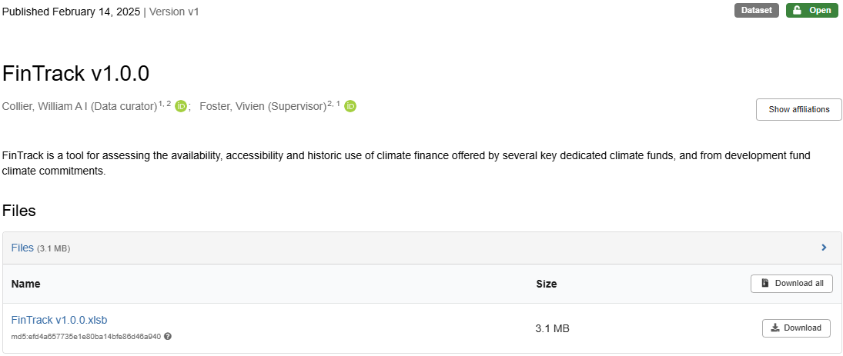

- Once downloaded, locate the file, and open the excel file. In the absence of a Microsoft account, this can be opened online using Microsoft Excel Online. However, some of the functionality of this sheet may be limited in this format.
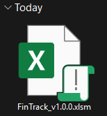

2. Building a portfolio of funds with FinTrack

- Open the FinTrack tool and navigate to the tab named “FinTrack Dashboard” as shown below.

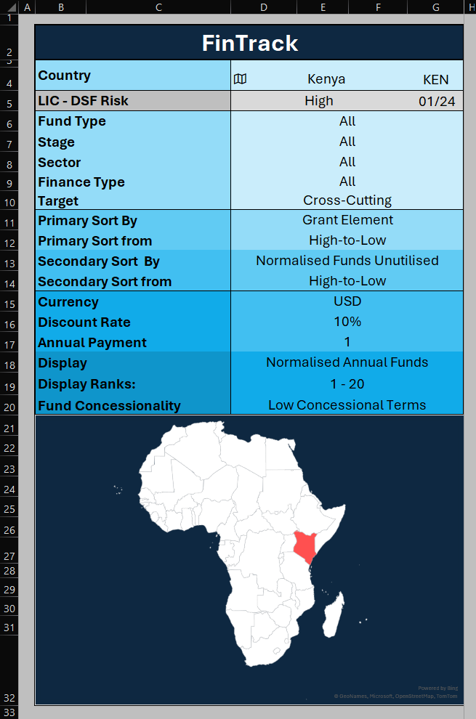
- Taking a first look at the FinTrack Dashboard, in the top right corner of the sheet is the User Interface. Here users input key parameters such as target country, target fund type, project stage and sector, financing type and climate targets.
- This is also where users define parameters by which to sort funds, including grant element, interest rate and volumes of finance.
- Users can also define the currency (although not all financiers offer loans in all currencies) and discount rate and annual payments used in calculating fund Grant Element.
- Users can also choose here between normalised annual funds, and maximum funds (based on funding cycles) and High and Low concessional terms depending on maturity-based pricing, or project specific pricing that occurs at a sub-national level.
- Lastly Display Ranks lets users move to the second page of funds if more than 20 funds are covered by the selected filters.

- Moving on to the outputs of FinTrack, we can see at the top of the output sheet, funds are ranked from 1 to 20 (with move funds covered in subsequent pages viewed by selecting “Display Ranks” > “21-30”). Below each rank is the column of data relating to the source of climate finance in that position.
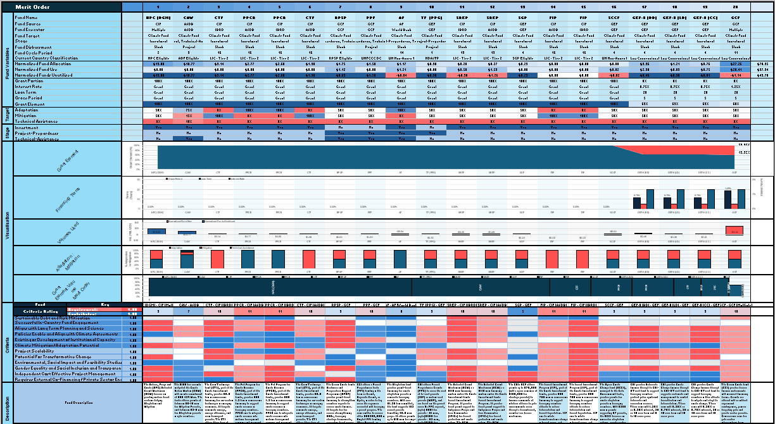
- Here we can see that by default FinTrack sorts primarily by Grant Element, and secondarily by the volume of finance allocated to the country. This prioritise grant amounts, followed by loan amounts sorted from most concessional to the least. The secondary sort will rank funds with the same primary characteristic (Grant Element) based on the secondary characteristic (Allocation Amount).
- In this instance we can see that the Nature People and Climate (NPC) fund from CIF is equal in grant element to other grant commitments, but as it has the highest volume committed, is ranked first.
- Looking at the characteristics of the fund, we can see a list of variables labelled for each row of the table. These describe the terms, volumes, targets and criteria for each fund. The table below summarises these characteristics, whilst the lecture for this exercise covers the criteria use in FinTrack in more depth.

Overview | Variable | Description
Fund Variables | Fund Name | The name of the fund or facility
Fund Variables | Fund Source | The name of the source of financing
Fund Variables | Fund Executor | The enacting agency of the financing
Fund Variables | Fund Type | Climate or development fund
Fund Variables | Stage | Project stage (Preparation, TA or Investment)
Fund Variables | Fund Disbursement | The mode by which the fund operates
Fund Variables | Fund Cycle Period | The period over which funding cycles occurs
Fund Variables | Country Classification | Current country classification name by the fund
Fund Variables | Fund Allocation | Assumed allocation volume from the fund
Fund Variables | Fund Use | Data on historic fund use
Fund Variables | Funds Unutilised | The delta between allocation and use
Fund Variables | Grant Portion | The portion of finance committed as grants
Fund Variables | Interest Rate | The standard annual interest rate charged by the fund
Fund Variables | Loan Term | The standard loan term applied to loans from the fund
Fund Variables | Grace Period | The standard grace period applied to loans from the fund
Fund Variables | Grant Element | The grant element calculated from the above terms
Target | Adaptation | Target allocations to climate adaptation efforts
Target | Mitigation | Target allocations to climate mitigation efforts
Target | Technical Assistance | Target allocations to Technical Assistance
Stage | Investment | Funds that target project investment finance
Stage | Project-Preparedness | Funds with facilities to help finance project preparedness
Stage | Technical-Assistance | Funds with facilities that address Technical Assistance issues
Visualisation | Grant Element | Graphical visualisation of shifts in Grant Element between funds
Visualisation | Financing Terms | Graphical visualisation of the fund’s terms of finance
Visualisation | Volumes Used | Graphical visualisation of use and allocation of funds
Visualisation | Adaptation : Mitigation | Visualisation proportions committed to Adaptation and Mitigation
Visualisation | Merit Order | Visualisation of the balance of Volumes and Grant Element
Criteria | Successful In-Country Fund Engagement
Criteria | Aligns with Long Term Planning and Science
Criteria | Policies Enable and Align with Climate Agreements
Criteria | Existing or Development of Institutional Capacity
Criteria | Climate Mitigation/Adaptation Potential
Criteria | Project Scalability
Criteria | Potential For Transformative Change
Criteria | Environmental, Social Impact and Feasibility Studies
Criteria | Gender Equality and Social Inclusion and Transparency
Criteria | Independent Cost-Effective Project Management
Criteria | Requires External Co-Financing / Private Sector Engagement
Description | Fund Description

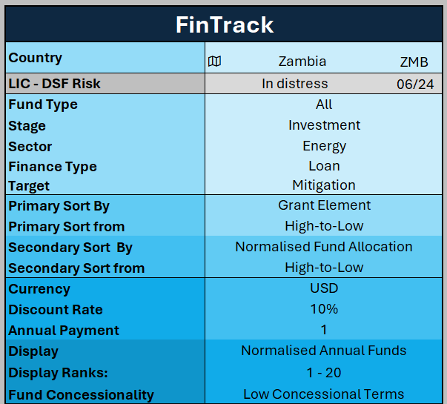
- In order to build a scenario, we must input values into the interface shown in Step 3. in the top right of FinTrack. In our example we will be financing a Power Project in Zambia. We are looking to find loans to finance the investment stage of the project, with a focus on climate mitigation. Once we input this information into the interface, our filters and selection should look like this:
- This will produce a ranking of the funds that meet these criteria, and their associated characteristics.
Whilst these climate funds are available to this project it is worth noting that there may be other project and sectoral demands on these funds, and so the entirely of this volume may not be purely for this sector. The outputs from these filters should look like this:
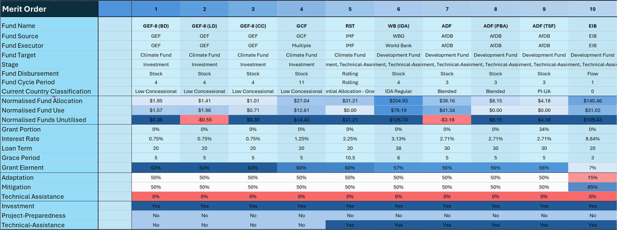
Here we can see that the total allocated financing that meets these criteria totals $458.50 million per year. As mentioned this is not exclusive to the power sector, however it does give us insights as to the volumes of finance potentially available to address financing gaps predicted by MINFin.
The graphs below help to visualise the costs of capital and terms of financing associated with each of these funds, we can that besides EIB, grant element remains relatively consistently around 60%, with EIB falling well below this. Looking at the terms of finance, interest rates do steadily climb across funds, but this is in part accompanied by longer loan terms, again with the exception of the EIB financing. The largest volumes available come from the World Bank IDA and the EIB, whilst the EIB has lower targets for Adaptation finance.
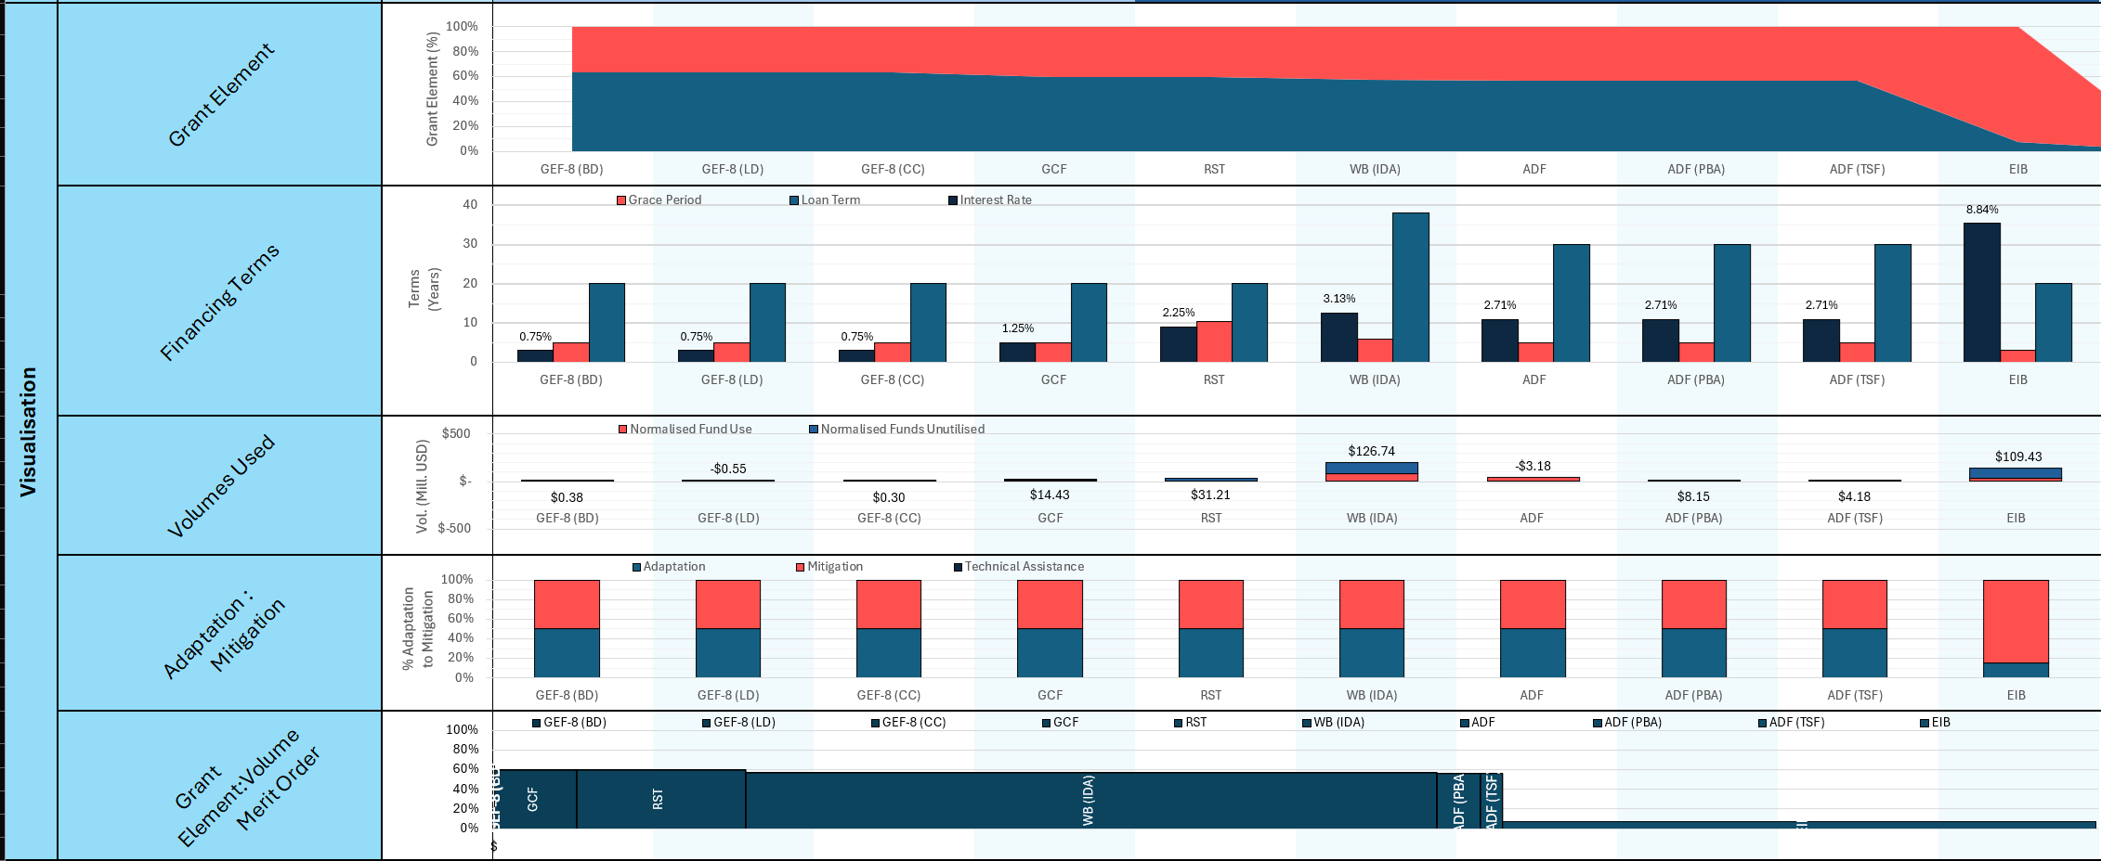
Moving on to the criteria to access, we can see that development funds such as the EIB, World Bank IDA and IMF’s RST have the lowest criteria to access. This is followed by the African Development Bank (AfDB), and the Global Environment Facility (GEF) Trust Fund. Lastly the Global Climate Fund (GCF) carries the most criteria to access. Concessional funds such as the World Bank’s IDA and International Monetary Fund (IMF)’s Resilience and Sustainability Trust (RST) that offer large volumes of financing under concessional lending terms, and with relatively low barriers to access should be prioritised when financing power projects.
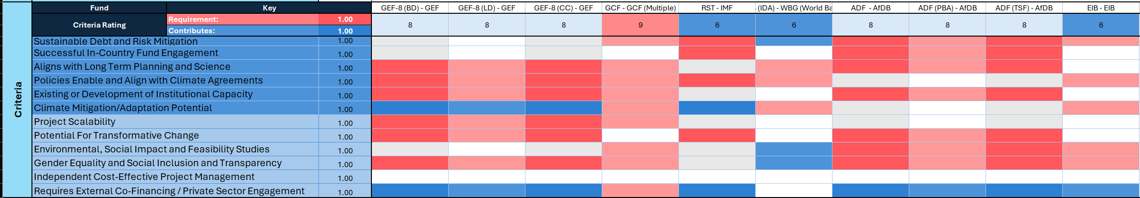
The information output but this tool can then be integrated into MINFin in order to inform projections of climate finance availability towards power projects, as well as possible terms of finance that may be expected with these commitments.

