Section Title |  | Contents
 | Introduction to Investment Needs | A brief introduction to MINFin’s investment needs, and modelling sources for this, focusing on OSeMOSYS
1. | Downloading MINFin Demo Data Publication Sheet | Instructions for users to access and download the MINFin Demo Data Publication Sheet that contain demonstration data for users to build a MINFin model
2. | Calibrating Investment Needs (Data Publication) | Instructions for users to input this demonstration data from a data publication sheet into the MINFin model
3. | Transferring FFRM | Instructions for users to transfer Fossil Fuel retirement data from a data publication sheet into the MINFin model
4. | Calibrating Investment Needs (OSeMOSYS) | Instructions for users to transfer their own data from OSeMOSYS results into MINFin (External)
5. | Visualising Investment Needs in MINFin | Description of the initial visualisations of Investment Needs data in MINFin’s Data Visualisation Dashboard

Financial Modelling for Energy Transitions: Hands-on Lecture 3: Calibrating Investment Needs

Learning Outcomes
By the end of this exercise, you will be able to:
- Download and access the MINFin Demo Data Publication Sheet from Zenodo
- Use data on investment needs from energy system optimisation tools such as OSeMOSYS as inputs for into the MINFin “OSeMOSYS Input” sheet including:
  - Capital Costs
  - Variable Costs
  - Fixed Costs
- Use data from fossil fuel retirement models such FFRM as inputs for MINFin’s “FFRM
- Assess the visualisation of this data within the Data Visualisation tab of MINFin

Introduction to Investment Needs
To estimate financing requirements, MINFin draws inputs from energy planning models such as OSeMOSYS to identify the optimal year-on-year investment plan needed to satisfy projected demand growth (Howells et al., 2011). Whilst any energy system model with sufficiently granular year-on-year investment needs projections may be used, OSeMOSYS is a widely used open-source systems optimisation linear model for long-term energy system planning. OSeMOSYS represents energy systems via sets of technologies and energy carriers, with the objective of identifying the lowest net present value (NPV) of an energy system that will meet specified demands for energy (Howells et al., 2011).
For MINFin, OSeMOSYS is used to develop optimal investment plans for two scenarios.
- First, a baseline scenario is established—typically representing a least-cost or business-as-usual approach—where OSeMOSYS selects the most cost-effective combination of projects required to meet projected demand, without accounting for carbon constraints. In some countries, this scenario may heavily rely on fossil fuels.
- The second scenario is usually more ambitious, focusing on decarbonization or adaptation. In this case, OSeMOSYS optimizes investments while imposing constraints, such as limiting carbon emissions from the power sector.
As noted, MINFin is flexible, allowing users to compare any set of scenarios they choose.
While OSeMOSYS focuses on the future development of the power sector, countries with substantial existing fossil fuel infrastructure face significant costs associated with phasing out these technologies. To address this, a Fossil Fuel Retirement Model (FFRM) is used in conjunction with OSeMOSYS. Incorporating data on the costs, technical characteristics, and contractual obligations of existing plants to optimise their phase-out strategy.
The MINFin input process is strategically structured around three key pillars, OSeMOSYS is a key input to two of these pillars.
- Firstly, investment needs, OSeMOSYS outputs provide data on the annual capital investment required to build new infrastructure.
- Secondly, funding availability, OSeMOSYS outputs include projections for Carbon Emissions and Fossil Fuel use. Savings from fossil fuels expenditure, and revenue from monetising carbon emission reductions through Carbon Credits can contribute to the funding baseline

(this will be covered in a further lecture and HOE).

1. Downloading MINFin Demo Data Publication Sheet
- To download the Demo Data Publication Sheet used in this Hands-on Exercise, follow this link, and download the excel. This is the document you will be using for the remainder of the model calibration exercises.
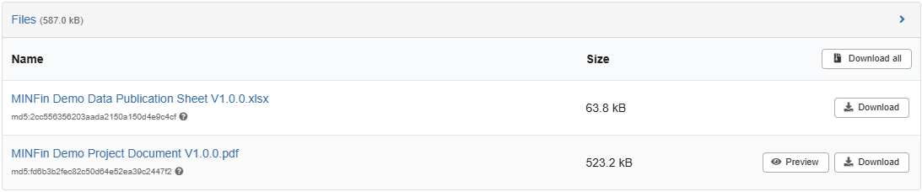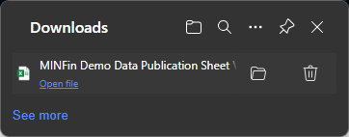

- Open the “MINFin Demo Data Publication Sheet” sheet and navigate to the tab named “OSeMOSYS (Input)” tab as shown below.

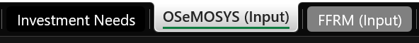

2. Calibrating Investment Needs (Data Publication)

2.1 Calibrating “OSeMOSYS (Inputs)” sheet
On this tab, users will find several data tables that serve as inputs to MINFin. Sections requiring user data inputs are coloured in light yellow (), while sections in grey () contain automatic calculations and do not require any modifications from users.
- Defining Technologies
  - The first step in the sheet is to ensure the scenario names are defined in the “Definitions” tab, this will be reflected at the top of the “OSeMOSYS (Inputs)” sheet.
  - The first step of process is defining the technologies used from OSeMOSYS or other energy system modelling through the “Definitions” Tab in MINFin. Here we use the “Technologies” table to define the technology abbreviation name, description and classification of the technology into more generic technology groupings from the dropdown list. Many of these technologies are standard in OSeMOSYS Starter Data Kits, however, users may add technologies within their model, hence we must define our specific list of technologies. For this case study we will use the Technologies found in the “Definitions” tab of the Demo Data Publication Sheet .
  - Navigating to the Definitions tab of our Demo Data Publication Sheet we will see a table similar to that found in the MINFin model’s Definitions tab. Here we can use our Demo Data Publication Sheet to input data into our model by copying the values from the publications sheet into MINFIN as shown below:
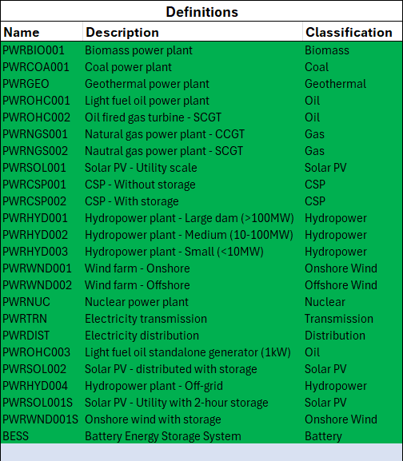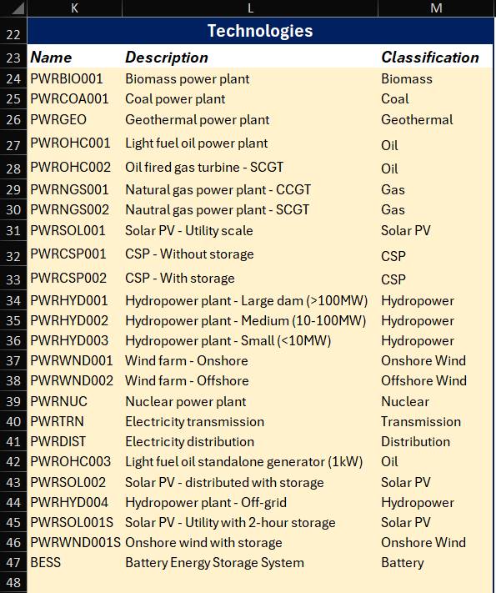
  - Other OSeMOSYS and energy models may have other technologies nomenclature, these must be defined below the standard OSeMOSYS technologies within this table. To understand the terminology used in these technologies in OSeMOSYS, please refer to the naming convention in this resource. Now that these technology names have been defined, they will be automatically added into the “OSeMOSYS (Input)” and “Investment” tabs. Next users must move on to the “OSeMOSYS (Input)” tab to input capital cost data and other investment needs.

- Scenario Names
  - The first step on this page is to define the Scenario Names – this is typically between a more financially ambitious scenario (Scenario Name 1) and a less financially ambitious scenario (Scenario Name 2) for MINFin analyse. In this scenario we have named them NetZero and LeastCost respectively, however this naming may depend on users’ choices of scenarios.
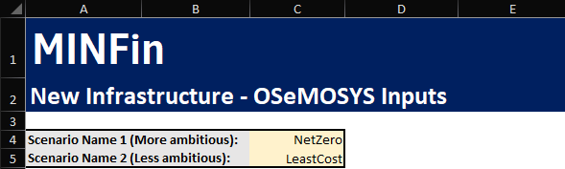
- Capital Costs
  - After defining the scenarios and technologies in the "Definitions" tab, and the scenario names, the next task on this sheet is to input data for the capital costs for each scenario. You will now see the heading “1) NetZero OSeMOSYS Parameter Inputs”, followed by a table titled “Capital Costs ($ Million)”, with a similar table for the second scenario below. Keep in mind that all financial outputs from OSeMOSYS are typically in Million US Dollars (US$M). To complete this section, go to the Demo Data Publication Sheet, copy the annual capital cost data, and paste it into the table.
When transferring data across from OSeMOSYS or the Demo Data Publication Sheet to MINFin, take note of the names of technologies in the first row of the table to ensure that the technologies listed in the column headers match the data being copied.
  - The process should look something like the image below, with each technology in OSeMOSYS represented in a column within the table in your MINFin table, remembering to only edit cells that are shaded yellow.

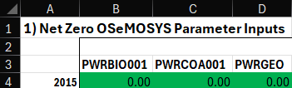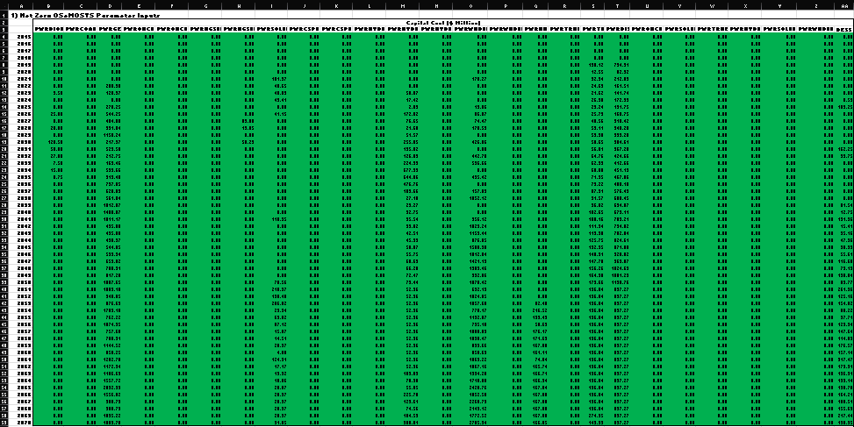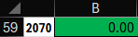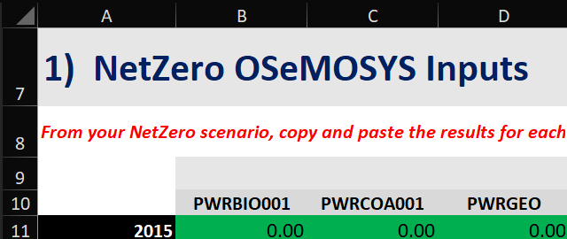
MINFin Model
MINFin Demo Data Publication Sheet
(Investment Needs - OSeMOSYS)
  - Now that the data for the first scenario is in place, repeat the process for the second scenario. The required data can be found directly below in the Demo Data Publication Sheet and copied under the heading “2) LeastCost OSeMOSYS Parameter Inputs”.

- Variable Costs, Fixed Costs, Generation and Emissions.
  - Moving on to Variable Costs and Fossil Fuel Expenditure, here Variable Cost refers to the total operation-dependent cost of a power plant, whilst Fossil Fuel Expenditure refers to the portion of this cost accounted for in purchasing of fuel for the power plant. Fossil Fuel Expenditure data is input for each scenario in the table to the right of the capital costs under each of our scenario headings, ensuring that the headings match those of the MINFin Model, and avoiding editing the Total column to the right. Remembering to do this for both scenarios, this should look like:

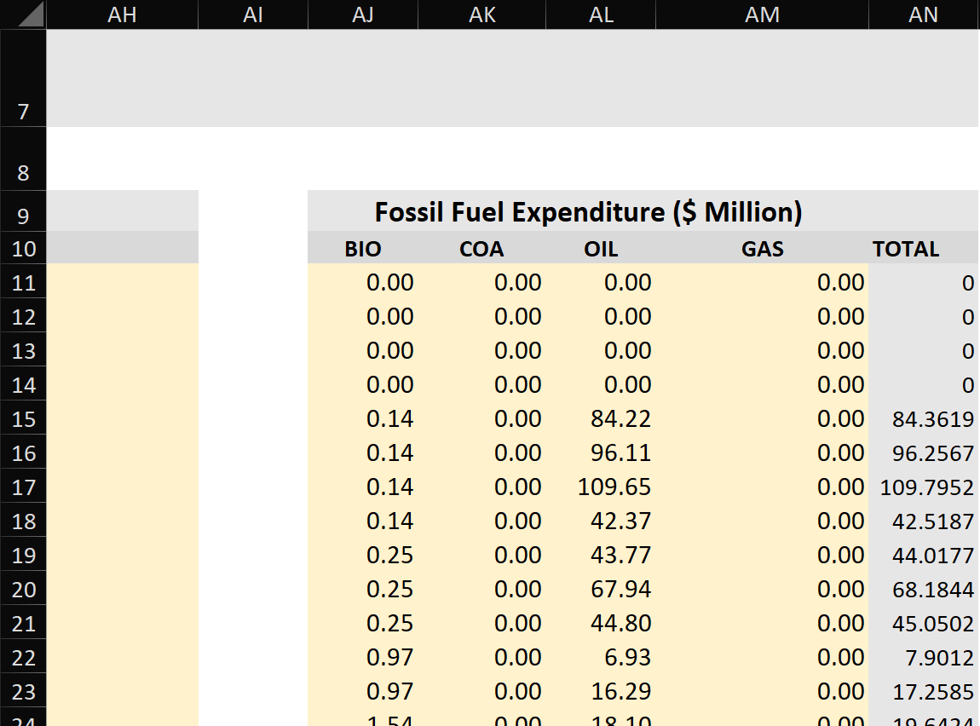
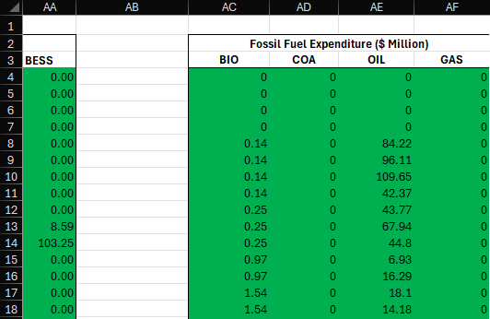

  - Having done this for capital costs and Fossil Fuel Expenditure, we can address the total Variable and Fixed Costs. These can be found on the same tab as the capital cost data, in columns below the LC Capital Cost table. In cells B123:E168 4 columns of data relate to Variable costs for both Least Cost. The first two columns from left to right relate to the “Total Variable Cost (Million US$)” which represents yearly values for the operation-dependent Operation and Maintenance (O&M) costs, with NZ scenario data in the left column, and LC scenario data in the right column. The second set of columns relate to the “Total Fixed Cost (Million US$)”, which represents yearly values for the operation-independent O&M costs. This data must be copied into the corresponding cells in MINFin in the “OSeMOSYS (Input)” tab in cells D139:G184 as shown below.

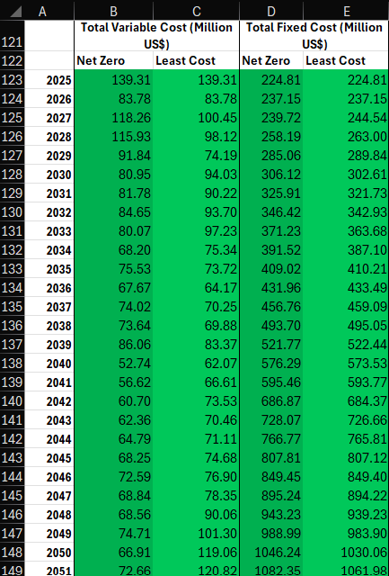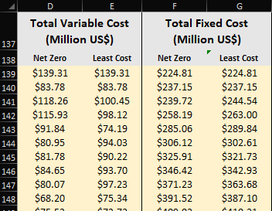

  - Lastly we must input data on Generation and Emissions. This data is found to the right of the Total Fixed and Total Variable Costs data under their respective headings of “Annual Electricity Production” and “CO2 Emissions (Mt CO2)”. Ensuring that the scenario headings match, copy this data across in the same way the rest of this data has been transferred. This should look like:
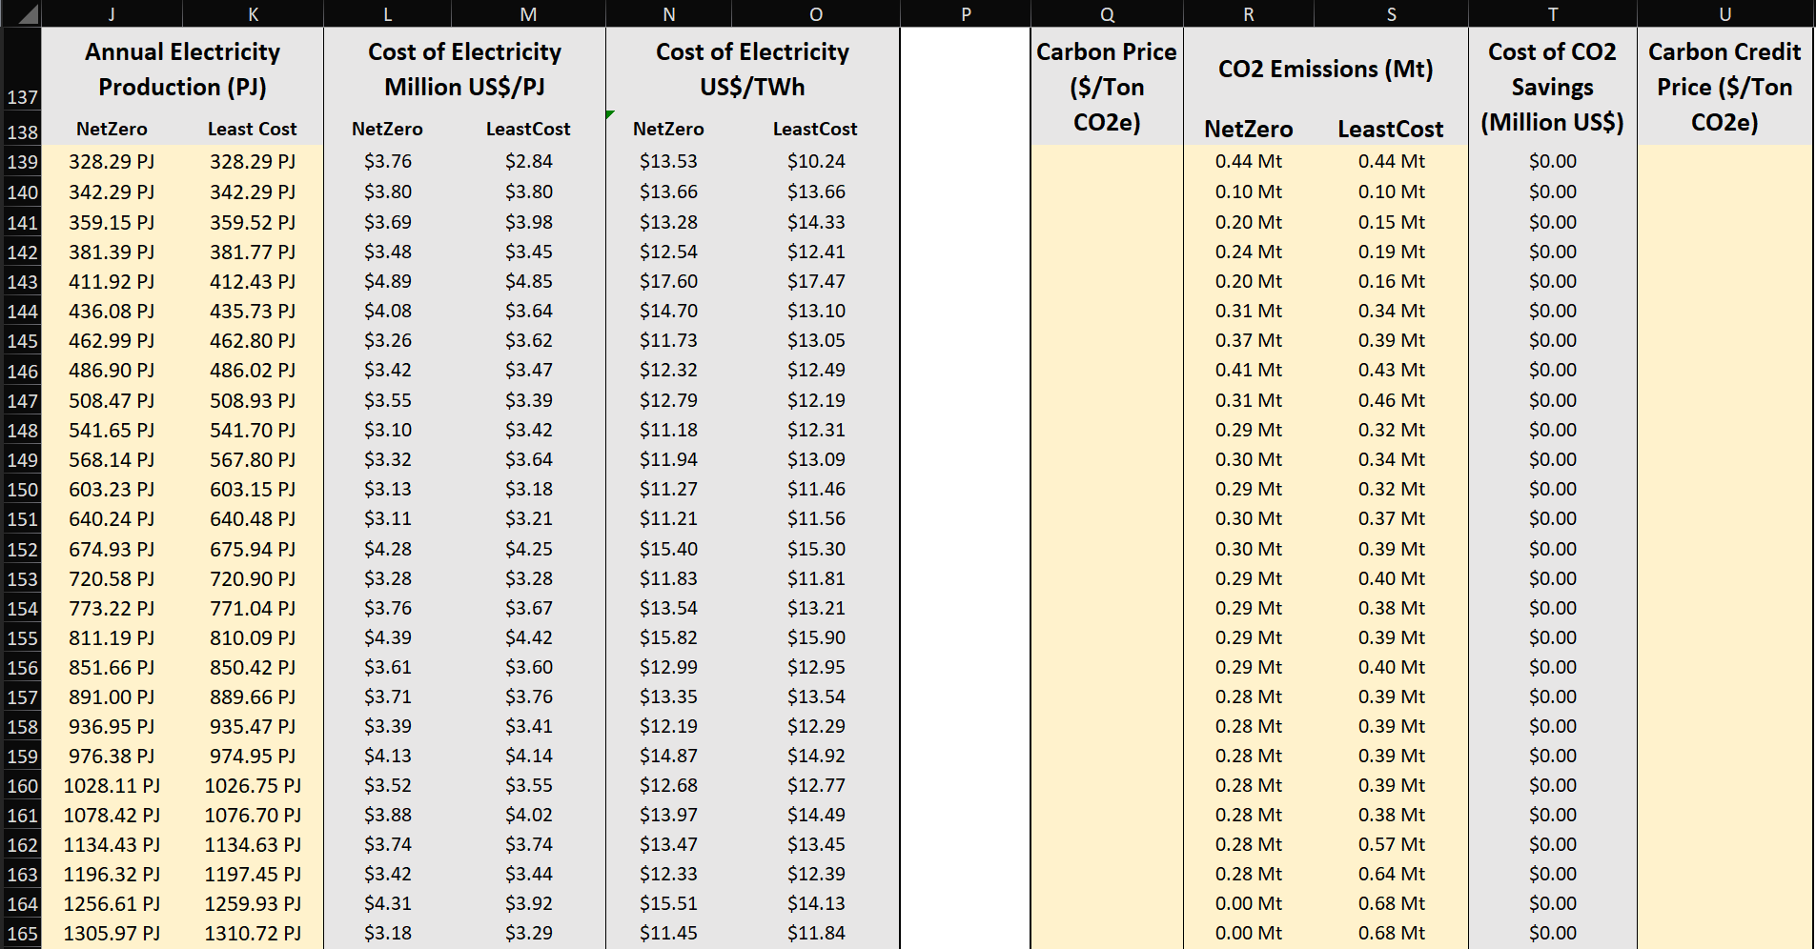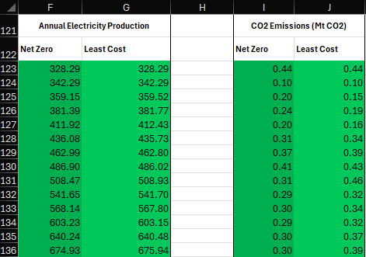
  - Once this is completed, OSeMOSYS investment needs data has been successfully implemented into you MINFin Case-study.

3. Transferring FFRM results from data publication sheets
- Now that we have done this for OSeMOSYS, we can move onto inputting Investment Needs data from the Fossil Fuel Retirement model into MINFin. To find this data we must navigate to the “FFRM (Input)” tab of the Demo Data Publication Sheet as shown below.
- The data on this tab corresponds to the data input sheet in MINFin labelled “FFRM (Input)” found to the right of the “OSeMOSYS (Input)” sheet. In this Demo Data Publication Sheet, the only installed fossil fuel technology requiring retirement is Oil. Therefore, only Columns B and C include data on revenue changes between LC and NZ. For Oil, users must transfer data from the Demo Data Publication Sheet while ensuring alignment between technologies and scenarios.

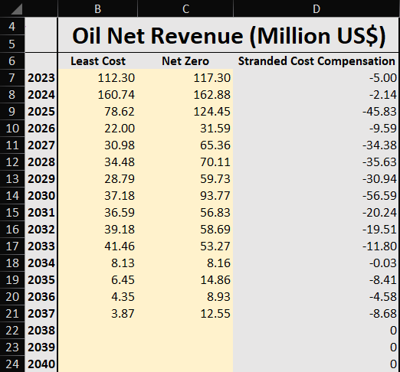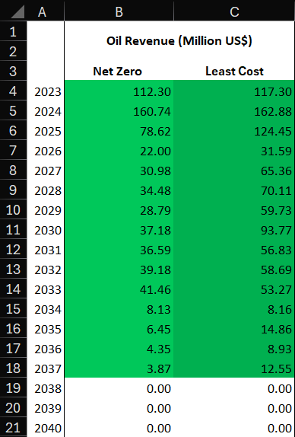

4. Calibrating Investment Needs (OSeMOSYS)
Users can populate the MINFin Investment Needs using the published data sheets OR by running specific scenarios in an alternative energy system model. In these instances, users must extract relevant data from their modelling outputs in a format, and to a level of granularity, that is suitable to be used with MINFin.

For OSeMOSYS, the extraction methodology depends on whether the model is a Power-Sector model (focusing only on power) or an Energy-System model (covering power, transport, cooking, and heating). A step-by-step guide for extracting OSeMOSYS results into a MINFin-compatible format is available at the following link.

5. Visualising Investment Needs in MINFin
Now that MINFin has data on Investment Needs, we can see some early visualisations of this data on the Visualisation Dashboard. To see this, we must navigate to the “Visualisation Dashboard” tab and find the “Financing Needs Projections” section. This section’s graphs compare investment needs between the two scenarios by year and technology, while also showing stranded costs from FFRM modelling as part of national future investment needs.
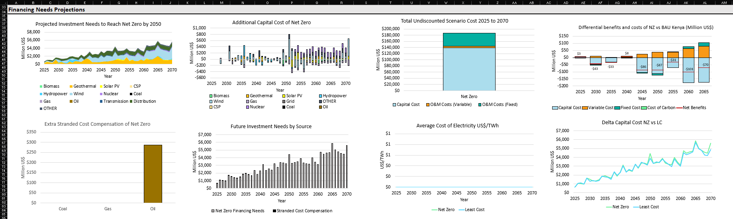
References
Howells, M., Rogner, H., Strachan, N., Heaps, C., Huntington, H., Kypreos, S., Hughes, A., Silveira, S., DeCarolis, J., Bazillian, M. and Roehrl, A., (2011). OSeMOSYS: the open source energy modeling system: an introduction to its ethos, structure and development. Energy Policy, 39(10), pp.5850-5870.

