Financial Modelling for Energy Transitions:

Hands-on Lecture 2: Downloading MINFin
Section Title |  | Contents
1. | Downloading MINFin | Instructions for users to access and download the MINFin Model
2. | Navigating MINFin’s Tabs | Overview of the purpose and function of each of the tabs within the MINFin model

Learning Objectives
By the end of this exercise, you will be able to:
- Download and access the MINFin model from Zenodo
- Navigate MINFin’s tabs, and have a basic understanding of the core purposes for each tab within the model
Note: MINFin is an Excel-based model and will be downloaded as a local file from Zenodo. This requires a Windows license in order to use. However, it can also be run on Windows online.

1. Downloading MINFin
- To download the MINFin model, you will need to follow this link. This will lead you to a survey where you can opt in or out of responding, this should look like:

If you opt out of the survey, you will be taken to the last page where you can download the model immediately. Once past this screen, and remembering to “Save my response” as highlighted in blue below, users will be able to select the tool that they would like to learn more about. This course will be focusing on the Introducing Model for Informed National Financing (MINFin), and as such we will select this from the list of options as shown below, which will lead users to a download page on GitHub.
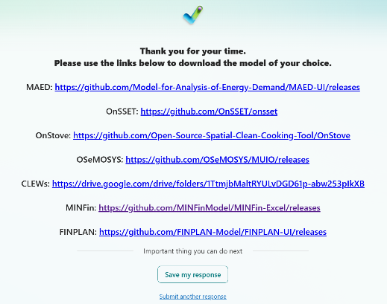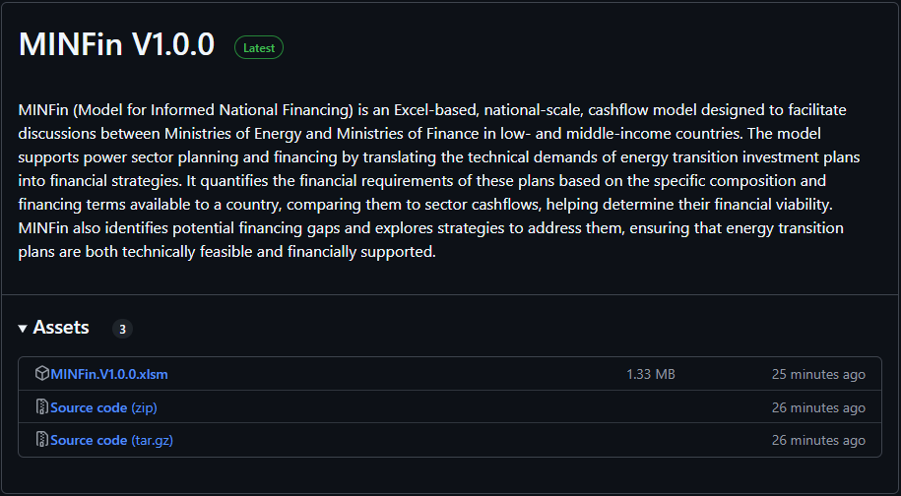

- Once on this page, you will find a file named “MINFin V1.0.0.xlsm.” Ensure you select the most recent version, then download the Excel file by clicking on the download option on the right-hand side.
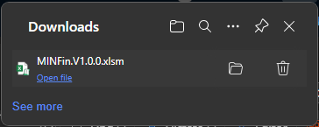
- This will appear in your downloads from your browser which should look like this. This option can also be found by using “Ctrl + J”. Select the icon shown above to open the file’s location within your device
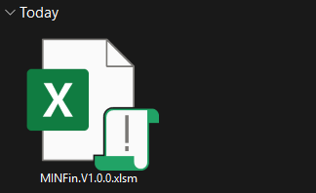
- Once downloaded and located, this file can either be opened locally, or via the free online Microsoft Office software available here.

2. Navigating MINFin’s Tabs
Now that you have downloaded MINFin, you can open the excel file to take a first look at the model and function of each tab. These tabs are colour coded in order to indicate their role within MINFin, the groupings are as follows:

Definitions

The first tab in MINFin, “Definitions”, provides an overview of definitions and a brief description of the model. The purpose of the sheet is twofold, firstly it serves to inform users about the meanings of the different inputs in MINFin, secondly this is where users will define the technologies and scenarios for the analysis.

Having reviewed the "Definitions" tab, the following section will proceed from the rightmost tab towards the first tab; please scroll to the last tab to begin.

Investment Needs
As covered in the lecture, the Investment Need Pillar is the amount of capital needed each year of the transition to both allow the construction of New Infrastructure and to provide compensation for early Fossil Fuel Retirement of old plant before the end of its life. This pillar is configured in MINFin through three tabs; “OSeMOSYS (Input)”, “FFRM (Input)” and “Investment Needs”.

FFRM (Input)
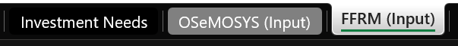
The second tab that informs MINFin’s Investment Needs Pillar is the “FFRM (Input)” tab. Here users will input results generated by the Fossil Fuel Retirement Model (FFRM), which optimises the phasing out of existing fossil fuel plants in line with generation constraints from OSeMOSYS. This process projects the foregone revenue and determines the required compensation for retiring fossil fuel plants prematurely, ensuring emissions targets are met based on plant characteristics and contractual obligations.

OSeMOSYS (Input)


Starting with “OSeMOSYS (Inputs)”, this tab takes helps to inform the Investment Needs Pillar. Users will input year on year invest investment needs data as projected by OSeMOSYS chiefly capital costs of infrastructural development, across the modelling period for two different scenarios.

The OSeMOSYS (Input) tab also includes data inputs from OSeMOSYS that contribute to informing the Funding Pillar of MINFin, such as variable costs (fuel costs), fixed costs (operation and maintenance), Annual Electricity Production and Carbon Pricing data.

It is worth nothing that whilst this references OSeMOSYS data, any energy system model that produces year-on-year investment needs data may be used as an input for this sheet.

Investment Needs

The last tab informing MINFin’s Investment Needs Pillar is the “Investment Needs” tab. This tab compares data entered into the “OSeMOSYS (Input)” and “FFRM (Input)” tabs, in order to calculate the investment needs delta between the two scenarios.

Financing Requirements

The Financing Requirement is the future repayment of Investment Needs that will be required year-on-year throughout the transition period, based on anticipated financing terms available to country.
The Financing Requirements Pillar of MINFin is informed using data in the investment needs tab, and terms of finance in the “Financing Baseline” tab. In the “Financing Baseline” tab, users will establish a baseline of historic investments in the sector, serving as the benchmark scenario for the forward-looking projections in later tabs. Weighted terms of finance are calculated, based on the historic investment baseline and applied to the investment needs from the “Investment Needs” tab to project year on year financing requirement data.

Funding Baseline

The Funding Availability is the future annual cashflow available to repay the Financing Requirement, based on the availability of Grants, Government Expenditure, Internal Cash Generation, Fossil Fuel Expenditure Savings, and Carbon Credit Revenues.

The Funding Pillar of MINFin is primarily informed by the “Funding Baseline” tab within the model, but also data inputs from the “OSeMOSYS (Inputs)” sheet as mentioned in part 2.2. Here users input yearly data on the volumes of funds available to the sector through International Grants, Government Expenditure and Internal Cash Generation (typically of State-Owned Enterprise (SOE) utility companies). Using growth rates calculated based on this data, MINFin is able to project the volumes of national funds available to address the financing requirements predicted by the model.

High Level Dashboard
The “High-Level Dashboard” tab in MINFin draws together each of the components mentioned previously from each of the three pillars in order to help visualise how the three pillars of Investment Needs, Financing Requirements and Funding Availability are balanced across the modelling period. Here users are able to change the future conditions impacting funding availability and financing requirements, to assess what changes are necessary to improve scenario affordability.

Financial Instruments
The penultimate tab “Financial Instruments” is a calculation sheet designed to explore various financial instruments that can help close financing gaps if needed. These instruments include grants, loans, increased grant elements, carbon credits, and debt write-offs. No data input is required in this tab, and the results are linked to the high-level dashboard.

Visualisation dashboard
The last tab in MINFin is the “Visualisation Dashboard” tab. This tab is designed for the visualisation of data in both tabular and graphical formats. It includes a set of predefined graphs to facilitate the analysis of key projections such as Investment Needs, Financing Requirements and Funding Availability.

