MAED: Manufacturing Base Year Reconstruction Workflow (Basic)
Reconstructing the base year for the Manufacturing sector in MAED – basic version
Kiley, F. (2025) MAED: Manufacturing Base Year Reconstruction Workflow (Basic). Zenodo. doi: 10.5281/zenodo.14678209

Licence: This work is licensed under the Creative Commons Attribution 4.0 International License (CC BY 4.0). To view a copy of this license, visit https://creativecommons.org/licenses/by/4.0/.
Useful Links:
- Industry Sector Modelling YouTube
- Industry Sector Modelling Slides
- UN Energy Balances
- UNIDO Data Browser

Learning outcomes

This exercise presents a workflow for reconstructing the base year for Manufacturing. By the end of this exercise, you will be able to do the following:
- Collect and process the necessary inputs for MAED to reconstruct the base year for the Manufacturing sub-sector of Industry.
  - Required data: GDP, sectoral shares GDP, final energy demand data (from a national energy balance), efficiencies, steel production, feedstock production.

Note that this Hands-On (HO) does not include the Steel or Feedstock function of MAED. Please refer to ‘MAED: Manufacturing Base Year Reconstruction Workflow (Advanced)’ for details on how to do this.

1. Overall Workflow

Figure 1 illustrates the overall workflow for deriving the various input parameters (GDP, GDP sectoral split, Energy Intensity, Efficiency, Penetration of Energy Forms) when reconstructing the base year in Manufacturing. The rest of the HO will guide you through the methodology for how to execute this workflow. It uses the example of Brazil, but the process is the same for any country.
When MAED simulates energy demand in the future, it takes the parameter in bold in Figure 1 and reverses this workflow i.e. National GDP, sectoral shares of GDP, energy intensities, penetration of energy forms, and weighted average efficiencies are used to derive final and useful energy demands. This is covered in more detail in the ‘MAED: Scenario Development’ HO.

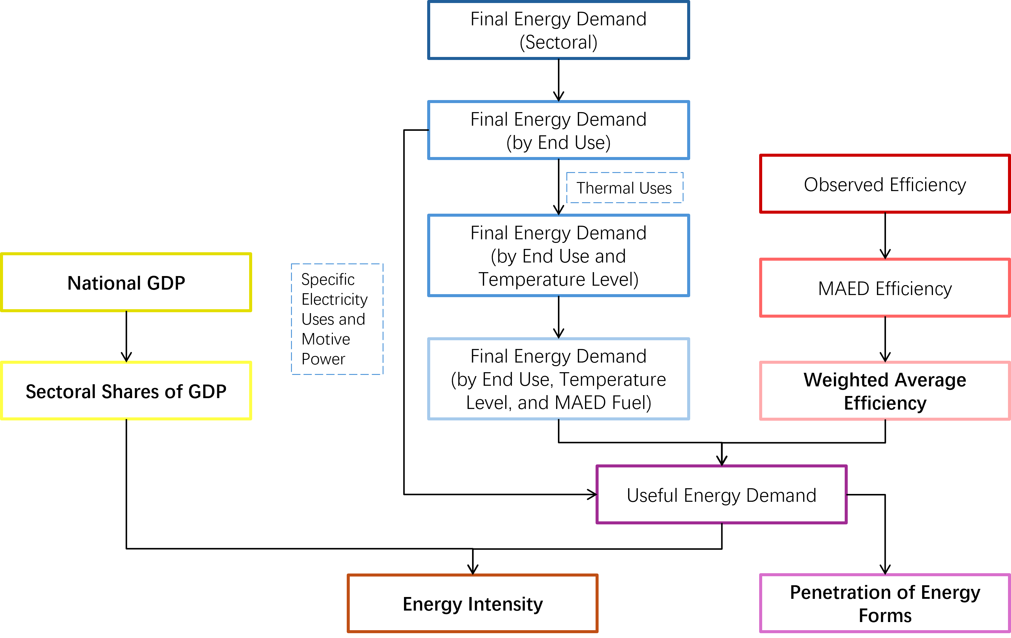
Figure 1: The workflow for reconstructing the base year in the Manufacturing sector. Parameters in bold are direct inputs to MAED. Other parameters are used to derive these direct inputs.

2. Base Year Selection

The first step is to select a base year. The base year is used as a baseline to project values for your various scenarios (e.g. for a Business-as-Usual you might use the values calculated for the base year for all years in the model period) and is used here to calibrate the model. It is important that the year selected represents a recent and standard year in which all the necessary data is available. This means we want a year in which no major geopolitical events impacted the economy, society, or energy sector. Recent examples of these are COVID, the Russian invasion of Ukraine, etc.
Once the base year has been selected, all relevant data must be collected for that year. For this example, 2018 was selected as it is pre-COVID (the first case in Brazil was reported in 2020) and there were no other events that would result in non-typical energy consumption.
A note on units: for this case study, GDP is presented in billion USD, and energy is presented in PJ. Consequently, Energy Intensity is given in MJ/USD. However, GDP can be presented in any currency and the energy unit can be GWyr, Tcal, Mtoe, or GBTU. Depending on which currency and energy unit you use, the units for Energy Intensity may differ from those presented here but the workflow remains the same.

3. Energy Balance

Depending on the source of your energy balance, it will need to be processed to obtain a Final Energy Demand (FED) for each end use (e.g. Specific Electricity Uses, Motive Power, and Thermal Uses), for different temperature levels (Low, Medium, and High) and for each MAED fuel category (e.g. Traditional Fuels, Modern Biomass, Electricity, Solar Thermal, Fossil Fuels, and Motor Fuels). This Hands-On exercise will use the UN energy balance format to illustrate the workflow as they are available for every country in the world.

The UN energy balances give a detailed breakdown of sectoral energy consumption but do not contain a detailed fuel disaggregation. Generally, it is advised to use energy balances provided by national agencies such as the Ministry of Energy. However, if one is not available, alternatives can be found at various regional international databases (e.g. AFREC for Africa, olade-sieLAC for South America and the Caribbean, and the EGEDA for Asia-Pacific Economic Cooperation).

A screenshot of an example UN energy balance is shown in Figure 2. The consumption section (the part relevant to MAED) is circled in red and the Manufacturing sector and sub-sectors are highlighted in yellow. Table 1 presents the relevant consumption data for Manufacturing.
N.B. The sectoral disaggregation shown here is selected based on the available data regarding energy balance and GDP. When developing a case study, the level of disaggregation is limited by the data available for energy and GDP. Also note that Mining and Construction have been omitted in Table 1 as they are represented in the ACM sector in MAED.

Table 1: Final Energy Consumption (Demand) for Brazil ion 2018. Taken directly from the energy balance.
Final consumption, TJ | Primary coal and peat | Coal and peat products | Primary oil | Oil products | Natural gas | Biofuels and waste | Nuclear | Electricity | Heat | Total energy | Of which renewables
Iron and Steel | 108341 | 369664 | … | 13228 | 46470 | 152399 | … | 91343 | … | 781445 | 152399
Chemical and Petrochemical | 10104 | … | … | 91370 | 95943 | 5765 | … | 81576 | … | 284758 | 5765
Non-Ferrous Metals | 27787 | 10718 | … | 44208 | 16470 | 37 | … | 89550 | … | 188770 | 37
Non-Metallic Minerals | 3011 | 1820 | … | 131087 | 17217 | 184 | … | 21193 | … | 174512 | 184
Transport Equipment | … | … | … | … | … | … | … | … | … | … | …
Machinery | … | … | … | … | … | … | … | … | … | … | …
Food and Tobacco | 2781 | … | … | 24885 | 34990 | 479431 | … | 93254 | … | 148589 | 1325
Paper, Pulp, and Printing | 5435 | … | … | 20506 | 38390 | 1985 | … | 86134 | … | 152449 | 1985
Wood and Wood Products | … | … | … | … | … | … | … | … | … | … | …
Textiles and Leather | … | … | … | 2912 | 9140 | … | … | 23011 | … | 36062 | …
Industries n.e.s | 4312 | 0 | … | 31396 | 57465 | 594933 | … | 189101 | … | 877207 | 594933

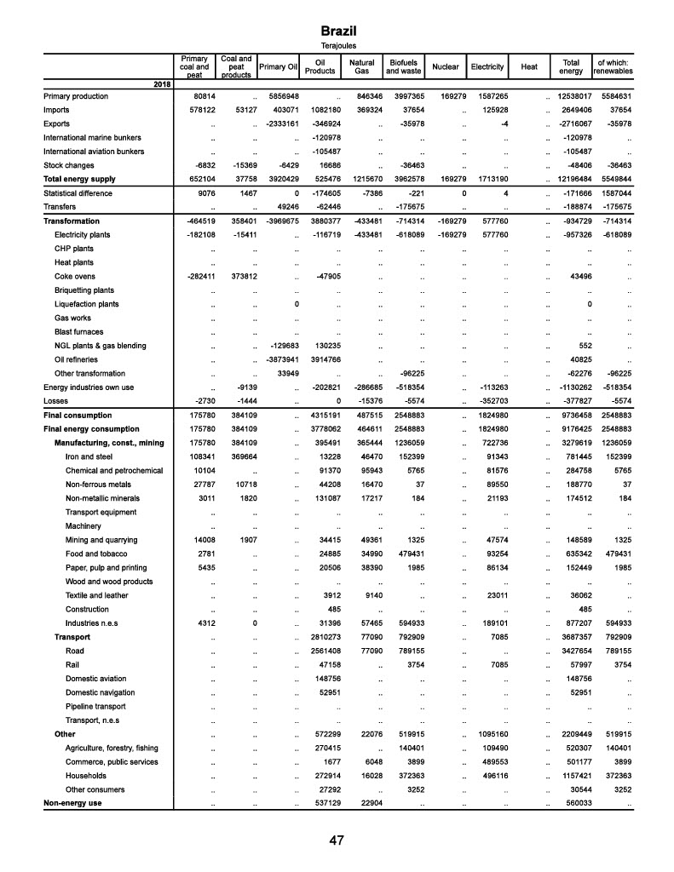
Figure 2: Example energy balance for Brazil in 2018. Consumption section enclosed in red box. Relevant Manufacturing sub-sectors highlighted in yellow.

- The First step is to split FED into the three end uses: Specific Electricity Use, Motive Power, and Thermal Uses. The proportions used can be derived from national statistics office, census data, and/or expert judgement.

Only the Iron and Steel sub-sector is presented below as the methodology is identical for the remaining sub-sectors.

Table 2 shows the workflow which uses Equation [1] to obtain Final Consumption by End Use.

$Final Consumption by End Use=Final Consumption by Sector×Proportional Split by End Use$ [1]

Table 2: Tables showing the workflow going from (a) Final Energy Consumption in Iron and Steel through (b) proportional splits for different end uses to (c) Final Energy Consumption in Iron and Steel by End Use
(a)
Final Consumption, TJ | Primary coal and peat | Coal and peat products | Primary oil | Oil products | Natural gas | Biofuels and waste | Nuclear | Electricity | Heat
Iron and Steel | 108341 | 369664 | 0 | 13228 | 46470 | 152399 | 0 | 91343 | 0
(b)
Proportional Split (End Uses), % | Primary coal and peat | Coal and peat products | Primary oil | Oil products | Natural gas | Biofuels and waste | Nuclear | Electricity | Heat
Specific Electricity Use | 0 | 0 | 0 | 0 | 0 | 0 | 0 | 90 | 0
Motive Power | 0 | 0 | 0 | 50 | 0 | 0 | 0 | 0 | 0
Thermal Uses | 100 | 100 | 0 | 50 | 100 | 100 | 0 | 10 | 0
(c)
Final Consumption by End Use, TJ | Primary coal and peat | Coal and peat products | Primary oil | Oil products | Natural gas | Biofuels and waste | Nuclear | Electricity | Heat
Specific Electricity Use | 0 | 0 | 0 | 0 | 0 | 0 | 0 | 82208.7 | 0
Motive Power | 0 | 0 | 0 | 6614 | 0 | 0 | 0 | 0 | 0
Thermal Uses | 108341 | 369664 | 0 | 6614 | 46470 | 152399 | 0 | 9134.3 | 0

- Now, we need to split up the Thermal Uses end use into different temperature levels, Low, Medium, and High, using Equation [2]. The proportions used can be derived from national statistics office, census data, and/or expert judgement.
$Final Consumption by Temp Level=Final Consumption_{Thermal Uses}×Proportional Split by Temp Level$ [2]

Table 3: Final Consumption in Thermal Uses split by temperature level
(a)
Final Consumption by End Use (Thermal Uses), TJ | Primary coal and peat | Coal and peat products | Primary oil | Oil products | Natural gas | Biofuels and waste | Nuclear | Electricity | Heat
Thermal Uses | 108341 | 369664 | 0 | 661400 | 46470 | 152399 | 0 | 913430 | 0
(b)
Proportional Split, %
Low | 0 | 0 | 0 | 10 | 0 | 50 | 0 | 0 | 0
Medium | 0 | 0 | 0 | 40 | 100 | 50 | 0 | 0 | 0
High | 100 | 100 | 0 | 50 | 0 | 0 | 0 | 100 | 0
(c)
Final Consumption in Thermal Uses by Temperature Level, TJ
Low | 0 | 0 | 0 | 661.4 | 0 | 76199.5 | 0 | 0 | 0
Medium | 0 | 0 | 0 | 2645.6 | 46470 | 76199.5 | 0 | 0 | 0
High | 108341 | 369664 | 0 | 3307 | 0 | 0 | 0 | 9134.3 | 0

- Now, we need to group the fuels as presented in the energy balance into the fuel categories represented in MAED. These are Traditional Fuels, Modern Biomass, Electricity, Solar Thermal, Fossil Fuels, and Motor Fuels.

For the purposes of this Hands-On exercise:
- Electricity for Specific Electricity Uses maintains its classification as Electricity.
- Oil Products for Motive Power have been reclassified as Motor Fuels.
- Primary Coal and Peat, Coal and Peat Products, Oil Products, and Natural Gas for Thermal Uses have been combined and classified as Fossil Fuels.
- Biofuels and Waste for Thermal Uses has been classified as Modern Biomass.
- Electricity for Thermal Uses maintains its classification as Electricity.
Table 4: Final Energy Consumption by End Use with fuels grouped into MAED-compatible fuel categories
Final Consumption by End Use (MAED Fuels), TJ | Traditional Fuels | Modern Biomass | Electricity | Electricity (of which heat pumps) | Solar Thermal | Fossil Fuels | District Heating | Cogeneration | Motor Fuels
Specific Electricity Use | 0 | 0 | 82208.7 | 0 | 0 | 0 | 0 | 0 | 0
Motive Power | 0 | 0 | 0 | 0 | 0 | 0 | 0 | 0 | 6614
Thermal Uses:
Low | 0 | 76199.5 | 0 | 0 | 0 | 661.4 | 0 | 0 | 0
Medium | 0 | 76199.5 | 0 | 0 | 0 | 49115.6 | 0 | 0 | 0
High | 0 | 0 | 9134.3 | 0 | 0 | 481312 | 0 | 0 | 0

- To transform our Final Energy Demand to Useful Energy Demands, we need to derive efficiencies associated with each fuel for Thermal Uses. To do so, we need to find Real Efficiencies (i.e. efficiencies observed in reality), then we transform these to derive MAED Efficiencies and finally we derive Weighted Average Efficiencies (WAE) due to fuel groupings.
N.B. By default in MAED, FED for Specific Electricity Use and Motive Power is equal to UED. This is because those end uses are met by non-substitutional energy form (i.e. no competition between other energy forms for a specific end use, e.g. Electricity -> Specific Electricity Uses, Motor Fuels -> Motive Power).

  - Real Efficiencies: the efficiencies represented here are supposed to represent those observed in reality and will come from literature and/or government statistic agencies/Ministry of Energy. The efficiencies represented in this table are used for illustrative purposes and should not be used when developing a case study.
Table 5: Real Efficiencies for thermal uses as derived from literature.
Real Efficiency for Thermal Uses, % | Primary coal and peat | Coal and peat products | Primary oil | Oil products | Natural gas | Biofuels and waste | Nuclear | Electricity | Heat
Low | n/a | n/a | n/a | 65 | n/a | 50 | n/a | n/a | n/a
Medium | n/a | n/a | n/a | 60 | 73 | 50 | n/a | n/a | n/a
High | 74 | 62 | n/a | 71 | n/a | n/a | n/a | 93 | n/a

  - MAED Efficiencies: we then adjust the Real Efficiencies to account for the assumption built into MAED that Electricity for Thermal Uses is 100% efficient. Equation [3] is used to get from Table 5 to Table 6.
$MAED Efficiency_{x}=\frac{{Real Efficiency}_{x}}{{Real Efficiency}_{electricity}}, where x=a specific fuel$ [3]
Table 6: MAED adjusted efficiencies
MAED Efficiency, % | Primary coal and peat | Coal and peat products | Primary oil | Oil products | Natural gas | Biofuels and waste | Nuclear | Electricity | Heat
Low | 0 | 0 | 0 | 70 | 0 | 54 | 0 | 0 | 0
Medium | 0 | 0 | 0 | 65 | 78 | 54 | 0 | 0 | 0
High | 80 | 67 | 0 | 76 | 0 | 0 | 0 | 100 | 0

  - Weighted Average Efficiencies (WAE): we now need to account for the fact that we have grouped some fuels as represented in the Energy Balance into fuel categories that are represented in MAED (step 3). Equation [4] illustrates how to do this for two fuels x and y while Equation [5] presents a more generalised formula for any number of fuels.
$WAE=\frac{\left(Efficiency_{x}×{FED}_{x}\right)+\left(Efficiency_{y}×{FED}_{y}\right)}{\left(FED_{x}+{FED}_{y}\right)}$ [4]
$WAE=\frac{\sum_{x=1}^{n}{FED_{x}\left(Efficiency_{x}\right)}}{\sum_{x=1}^{n}{{FED}_{x}}}, where x=a specific fuel$ [5]
Table 7: Weighted Average Efficiency for MAED grouped fuels in Thermal Uses
WAE, % | Traditional Fuels | Modern Biomass | Electricity | Electricity (of which heat pumps) | Solar Thermal | Fossil Fuels | District Heating | Cogeneration | Motor Fuels
Low | 0 | 54 | 0 | 0 | 0 | 70 | 0 | 0 | 0
Medium | 0 | 54 | 0 | 0 | 0 | 78 | 0 | 0 | 0
High | 0 | 0 | 100 | 0 | 0 | 70 | 0 | 0 | 0

- The next step is to derive Useful Energy Demand (UED) for Thermal Uses from FED (Table 4) and WAE (Table 7). See Equation [6].
$UED={FED}_{x}×{WAE}_{x} , where x=specific fuel$ [6]
Table 8:Useful Energy Demand for Thermal Uses
UED for Thermal Uses, TJ | Traditional Fuels | Modern Biomass | Electricity | Electricity (of which heat pumps) | Solar Thermal | Fossil Fuels | District Heating | Cogeneration | Motor Fuels
Low | 0 | 40967 | 0 | 0 | 0 | 462 | 0 | 0 | 0
Medium | 0 | 40967 | 0 | 0 | 0 | 38183 | 0 | 0 | 0
High | 0 | 0 | 9134 | 0 | 0 | 335174 | 0 | 0 | 0

- We now have our UED for Thermal Uses and FED for Specific Electricity Uses and Motive Power in the base year (remember that MAED considers FED = UED for Specific Electricity Uses and Motive Power). Now, we want to calculate the Penetration of Energy Forms (PEN) in the base year from the total of these demands. See Equation [7]. We also want to convert the units into MJ (Table 10) to account for the units used in calculating Energy Intensity (MJ/USD).
$PEN_{x, i}=100\left(\frac{UED_{x,i}}{\sum_{x}{{UED}_{i}}}\right), x=fuel, i=end use$ [7]
Table 9: Useful/Final Energy Demand for all end uses in TJ
Useful Energy Demand for all end uses, TJ | Traditional Fuels | Modern Biomass | Electricity | Electricity (of which heat pumps) | Solar Thermal | Fossil Fuels | District Heating | Cogeneration | Motor Fuels | Total
Specific Electricity Use | 0 | 0 | 82208.7 | 0 | 0 | 0 | 0 | 0 | 0 | 82208.7
Motive Power | 0 | 0 | 0 | 0 | 0 | 0 | 0 | 0 | 6614 | 6614
Thermal Uses: |  |  |  |  |  |  |  |  |  | 0
Low | 0 | 40967 | 0 | 0 | 0 | 462 | 0 | 0 | 0 | 41429
Medium | 0 | 40967 | 0 | 0 | 0 | 38183 | 0 | 0 | 0 | 38183
High | 0 | 0 | 9134 | 0 | 0 | 335174 | 0 | 0 | 0 | 344308

Table 10: Useful/Final Energy Demand for all end uses in MJ
Useful Energy Demand for all end uses, MJ | Traditional Fuels | Modern Biomass | Electricity | Electricity (of which heat pumps) | Solar Thermal | Fossil Fuels | District Heating | Cogeneration | Motor Fuels | Total
Specific Electricity Use | 0 | 0 | 8.22E+10 | 0 | 0 | 0 | 0 | 0 | 0 | 8.221E+10
Motive Power | 0 | 0 | 0 | 0 | 0 | 0 | 0 | 0 | 6.61E+09 | 6.614E+09
Thermal Uses:
Low | 0 | 4.10E+10 | 0 | 0 | 0 | 4.62E+08 | 0 | 0 | 0 | 4.143E+10
Medium | 0 | 4.10E+10 | 0 | 0 | 0 | 3.82E+10 | 0 | 0 | 0 | 7.915E+10
High | 0 | 0 | 9.13E+09 | 0 | 0 | 3.35E+11 | 0 | 0 | 0 | 3.443E+11

Table 11: Penetration of Energy Forms for the different fuel categories as derived from the Useful Energy Demand
Penetration of Energy Forms, % | Traditional Fuels | Modern Biomass | Electricity | Electricity (of which heat pumps) | Solar Thermal | Fossil Fuels | District Heating | Cogeneration | Motor Fuels
Specific Electricity Use | 0 | 0 | 100 | 0 | 0 | 0 | 0 | 0 | 0
Motive Power | 0 | 0 | 0 | 0 | 0 | 0 | 0 | 0 | 100
Thermal Uses:
Low | 0 | 99 | 0 | 0 | 0 | 1 | 0 | 0 | 0
Medium | 0 | 52 | 0 | 0 | 0 | 48 | 0 | 0 | 0
High | 0 | 0 | 3 | 0 | 0 | 97 | 0 | 0 | 0

- We also need to calculate the share of useful thermal energy demand by temperature level in manufacturing (in this case just for the sub sector Iron and Steel). This can be done using Equation [8].
$SHARE_{x}=100\left(\frac{UED_{x}}{\sum{UED_{low}+\sum{UED_{medium}+\sum{{UED}_{high}}}}}\right), x=temperature level$ [8]

Table 12: Share of useful thermal energy demand by temperature
Share of useful thermal energy demand by temperature level, % | Iron and Steel
Low | 9
Medium | 17
High | 74

4. GDP Data

To derive Energy Intensities for End Uses in Manufacturing, we need to derive a national GDP and a sectoral and sub-sectoral breakdown of that GDP. For the purposes of this Hands On, we will be looking at GDP data derived from UNIDO’s Data Browser. However, this is not the only source of this data, various national institutions (Ministry of Finance, National Statistics Bureau, etc.) might provide this in greater detail. It is very important that the base year is the same for both GDP and Energy Balance data.
- First, we need to compile the relevant data from UNIDO’s database. In this instance, we are only interested in the Total GDP the Sectoral Share of Manufacturing, and the sectoral share for Iron and Steel. However, when building up a full Industry model in MAED, you will also need to define sectoral shares for Agriculture, Construction, Mining, and the other sub-sectors for Manufacturing (see Table 1).
Table 13: GDP data taken directly from source.
Parameter | 2018
GDP (constant 2015 USD) | 1.798E+12
Manufacturing (value added, 2018 USD) | 2.216E+11
Iron and Steel (value added, 2018 USD) | 1.186E+10

- From here we need to ensure that the units used are the same as those used in MAED and the values align (e.g. 2015 USD -> 2018 USD). We also need to derive sectoral and sub-sectoral shares from their absolute values.
Table 14: GDP data presented in units suitable for MAED.
Parameter | 2018
GDP (billion 2018 USD) | 1905.6
Manufacturing Share of GDP (%) | 11.63
Iron and Steel Share of Manufacturing Value Added (%) | 5.35

5. Energy Intensity

We now have the required data to calculate the energy intensities for the different end uses in Manufacturing.
- Energy Intensities (EI) in Industry are calculated by dividing total useful/final energy demand for a specific end use (Table 10) by the share of GDP for the sector (Table 13). See Equation [9].
N.B. Units for UED/FED are in MJ and for GDP are in currency units (not million or billion currency units)

${EI}_{i}=\frac{{UED}_{i}}{GDP_{x}}, where i=a specific end use and x=a sector or subsector$ [9]
Table 15: Energy Intensities for the different end uses in Agriculture.
 | Energy Intensity, MJ/USD
Specific Electricity Use | 6.9312
Motive Power | 0.5576
Thermal Uses | 39.1957

6. Model Input and Results Validation

We are now ready to input the calculated data into the model and validate our results.
- First, we need to input the results. The following parameters need to be defined for the base year to enable the successful calculation of results:
  - National GDP (billion monetary units), Table 12:
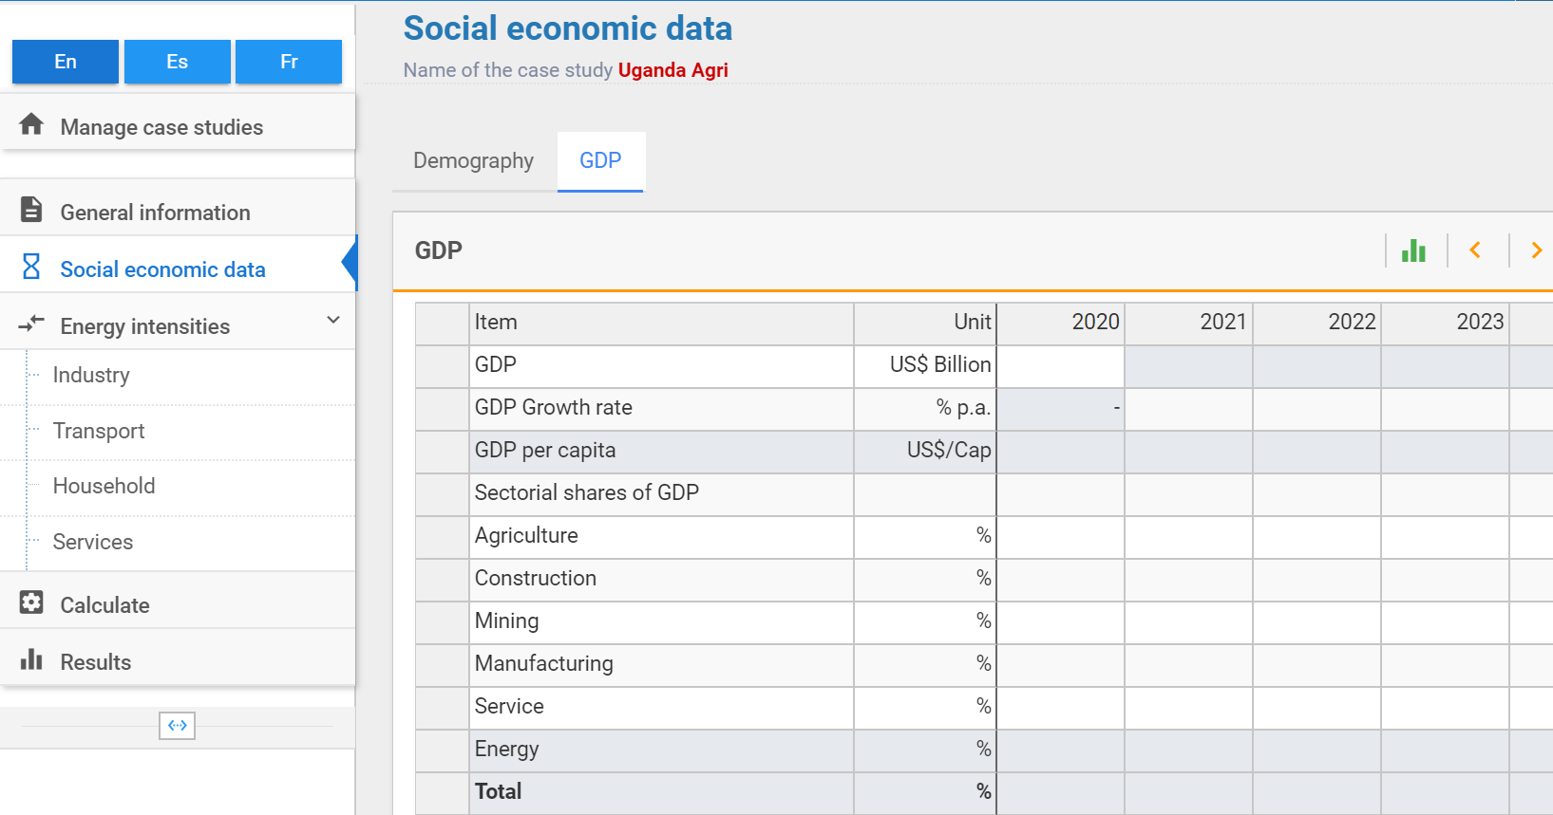
  - Sectoral share of GDP (%), Table 12:
  - Efficiencies for Thermal Uses (%), Table 6:
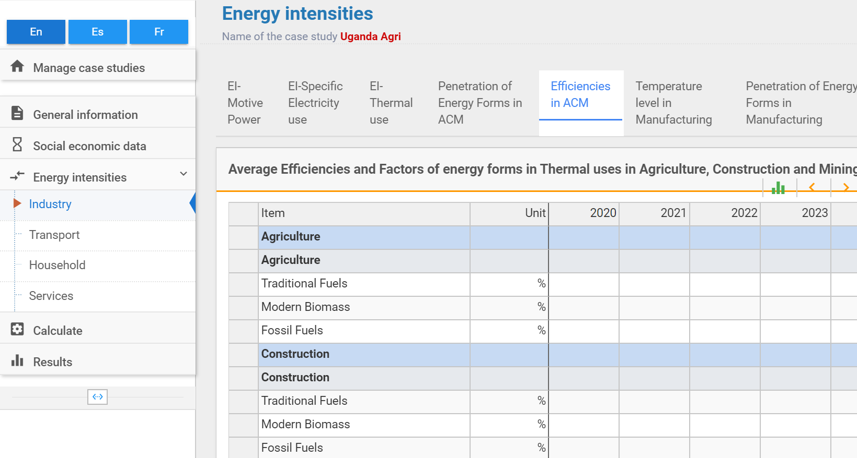
  - Penetration of energy forms for Thermal Uses (%), Table 10:
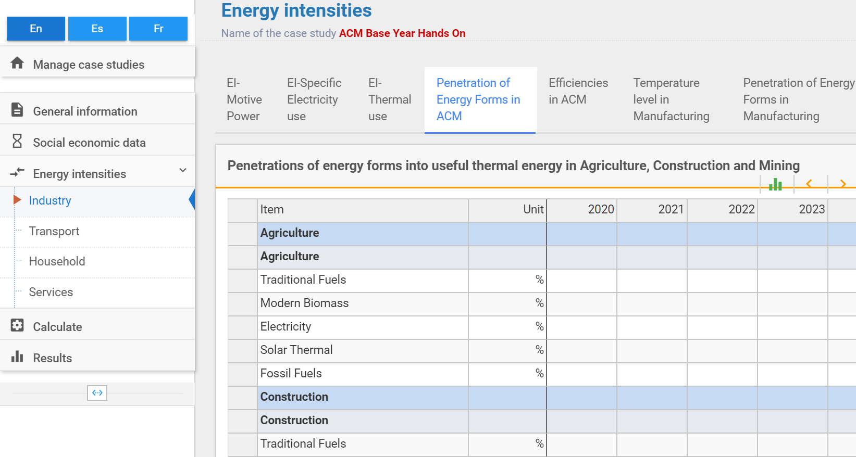
  - Energy Intensities for Specific Electricity Uses, Motive Power, and Thermal Uses (energy units/monetary unit), Table 13:
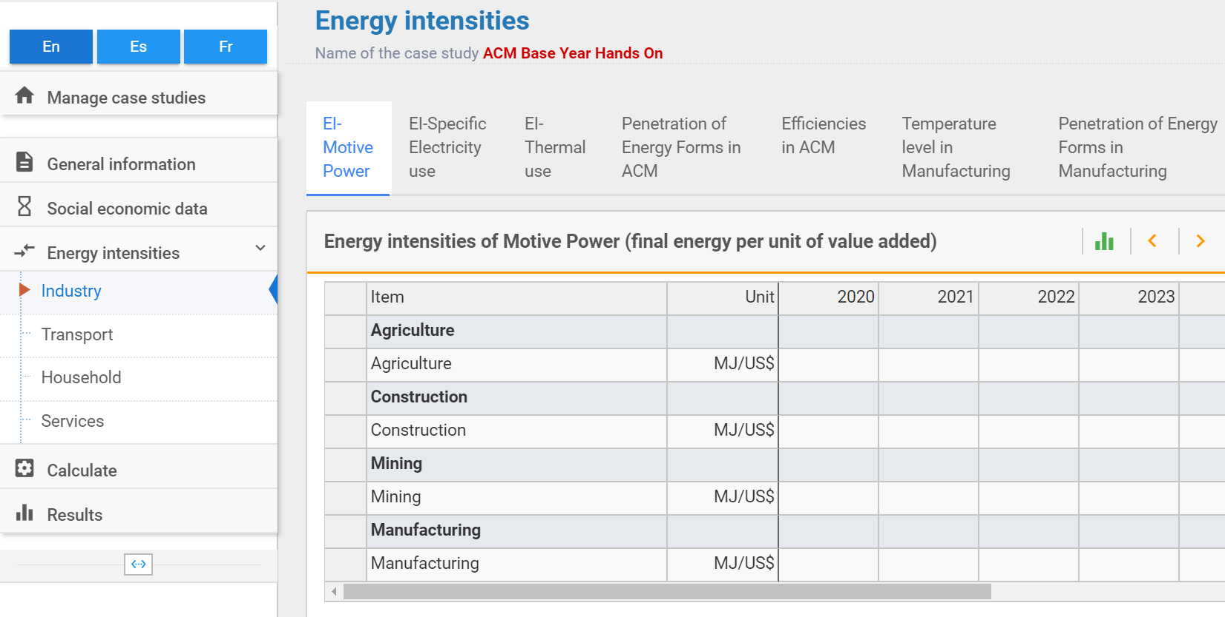
- We then calculate the results and visualise the Final Energy Demand results in the User Interface. We compare these results to the known values obtained from the Energy Balance. If they are roughly equal (<1% difference), then we have reconstructed the base year successfully. If they are not equal (>1% difference), then we have made an error in our calculations and we need to revisit them. A common error is not using the correct units, so pay attention to this.
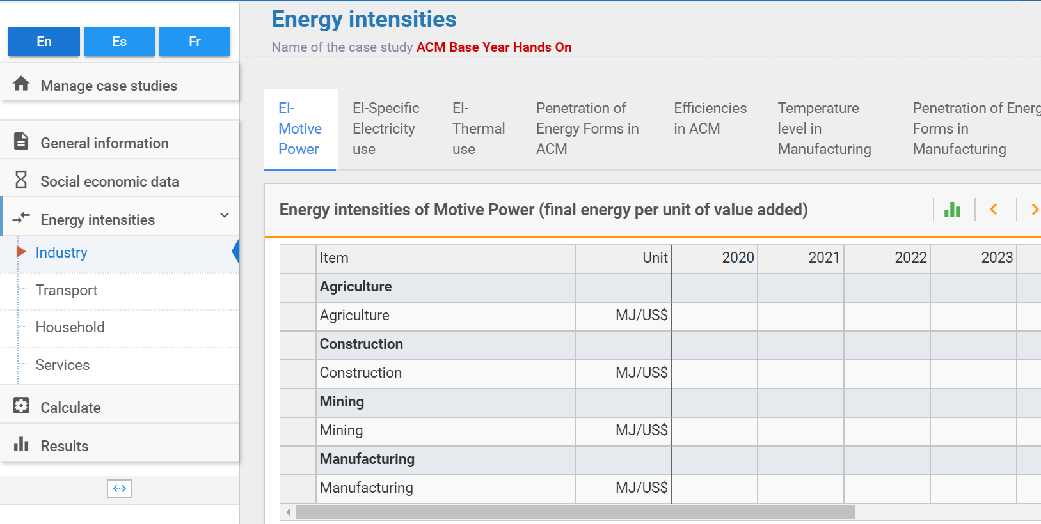
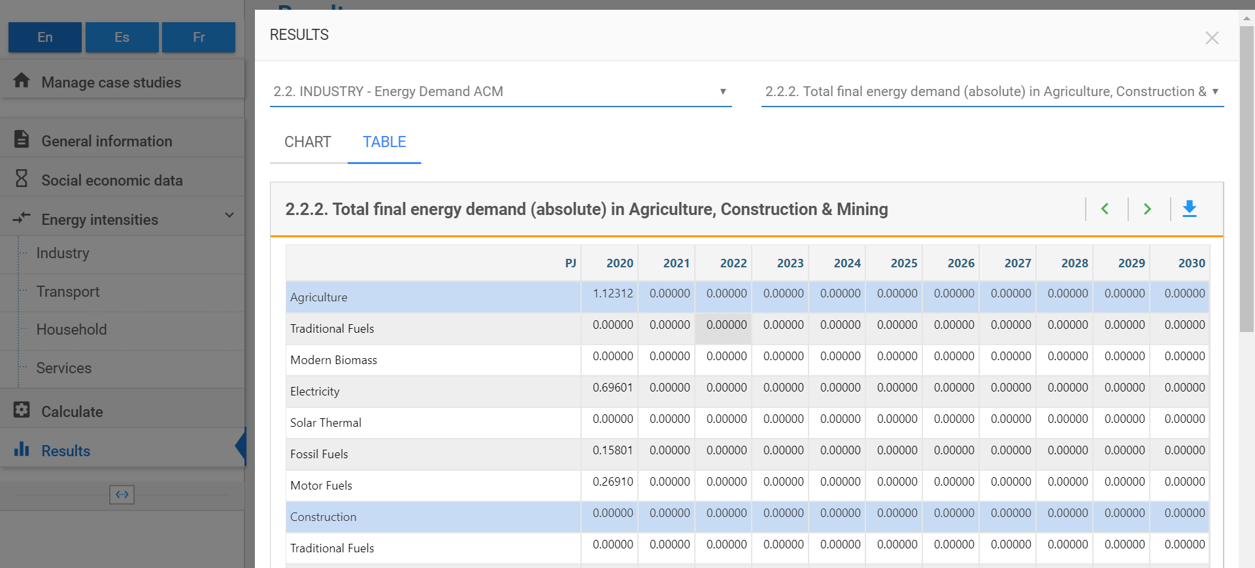
Comparing the calculated value of 781.44 PJ with the value found in the energy balance of 781.45 PJ we can see that there is a 0.06% difference. Thus, we have successfully reconstructed the base year!

