MAED: Agriculture, Construction, and Mining Base Year Reconstruction Workflow
Reconstructing the base year for the ACM sectors in MAED
Kiley, F. (2024) MAED: Agriculture, Construction, and Mining Base Year Reconstruction Workflow. Reconstructing the base year for the ACM sectors in MAED. Zenodo. doi: 10.5281/zenodo.13810008

Licence: This work is licensed under the Creative Commons Attribution 4.0 International License (CC BY 4.0). To view a copy of this license, visit https://creativecommons.org/licenses/by/4.0/.
Useful Links:
- Industry Sector Modelling YouTube
- Industry Sector Modelling Slides

Learning outcomes

This exercise presents a workflow for reconstructing the base year for agriculture, construction and mining. By the end of this exercise, you will be able to do the following:
- Collect and process the necessary inputs for MAED to reconstruct the base year for the agriculture, construction, and mining sub-sectors of Industry.
  - Required data: GDP, sectoral shares GDP, final energy demand data (from a national energy balance), efficiencies.

1. Overall Workflow

Figure 1 illustrates the overall workflow for deriving the various input parameters (GDP, GDP sectoral split, Energy Intensity, Efficiency, Penetration of Energy Forms) when reconstructing the base year in the ACM sectors. The Rest of the HO will guide you through the methodology for how to execute this workflow. It uses the example of Botswana, but the process is the same for any country.

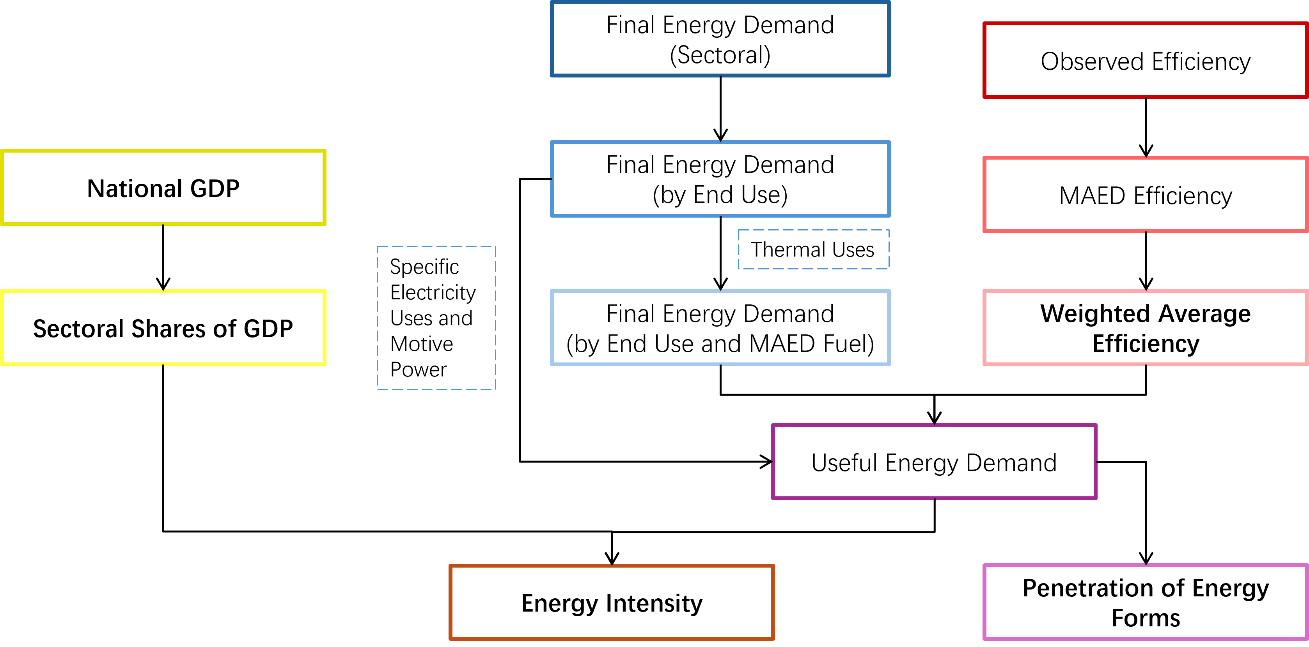
Figure 1: The workflow for reconstructing the base year in the ACM sectors. Parameters in bold are direct inputs to MAED. Other parameters are used to derive these direct inputs.

2. Base Year Selection

The first step is to select a base year. The base year is used as a baseline to project values for your various scenarios (e.g. for a Business-as-Usual you might use the values calculated for the base year for all years in the model period). It is important that the year selected represents a recent and standard year in which all the necessary data is available. This means we want a year in which no major geopolitical events impacted the economy, society, or energy sector. Recent examples of these are COVID, the Russian invasion of Ukraine, etc.
Once the base year has been selected, all relevant data must be collected for that year.
A note on units: for this case study, GDP is presented in billion USD, and energy is presented in PJ. Consequently, Energy Intensity is given in MJ/USD. However, GDP can be presented in any currency and the energy unit can be GWyr, Tcal, Mtoe, or GBTU. Depending on which currency and energy unit you use, the units for Energy Intensity may differ from those presented here but the workflow remains the same.

3. Energy Balance

Depending on the source of your energy balance, it will need to be processed to obtain a Final Energy Demand (FED) for each end use (e.g. Specific Electricity Uses, Motive Power, and Thermal Uses) and for each MAED fuel category (e.g. Traditional Fuels, Modern Biomass, Electricity, Solar Thermal, Fossil Fuels, and Motor Fuels). This Hands-On exercise will use the UN energy balance format to illustrate the workflow as they are available for every country in the world.

The UN energy balances give a detailed breakdown of sectoral energy consumption but do not contain a very detailed fuel disaggregation. Generally, it is advised to use energy balances provided by national agencies such as the Ministry of Energy. However, if one is not available, alternatives can be found at various regional international databases (e.g. AFREC for Africa, olade-sieLAC for South America and the Caribbean, and the EGEDA for Asia-Pacific Economic Cooperation).

A screenshot of an example UN energy balance is shown in Figure 1. The consumption section (the part relevant to MAED) is circled in red and the ACM sectors are highlighted in yellow. Table 1 presents the relevant consumption data for Agriculture, Construction, and Mining.

Table 1: Final Energy Consumption (Demand) taken directly from the energy balance.
Final consumption | Primary coal and peat | Coal and peat products | Primary oil | Oil products | Natural gas | Biofuels and waste | Nuclear | Electricity | Heat | Total energy | Of which renewables
Agriculture | 128 | - | - | 299 | - | - | - | 696 | - | 1124 | -
Construction | - | - | - | 645 | - | - | - | 21 | - | 666 | -
Mining | 1611 | - | - | 4020 | - | - | - | 2459 | - | 8090 | -

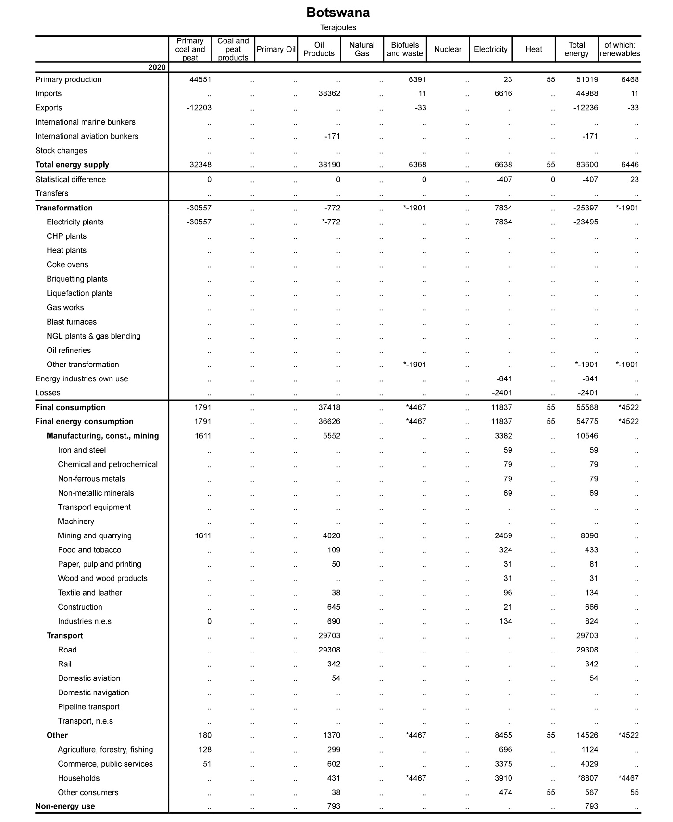
Figure 2: Example energy balance for Botswana. Consumption section enclosed in red box. ACM sectors highlighted in yellow.

- The First step is to split FED into the three end uses: Specific Electricity Use, Motive Power, and Thermal Uses. The proportions used can be derived from national statistics office, census data, and/or expert judgement.
Only the Agriculture sector is presented below as the methodology is identical for Mining and Construction.
Table 2 shows the workflow which uses Equation [1] to obtain Final Consumption by End Use.

$Final Consumption by End Use=Final Consumption by Sector×Proportional Split by End Use$ [1]

Table 2: Tables showing the workflow going from (a) Final Energy Consumption in Agriculture through (b) proportional splits for different end uses to (c) Final Energy Consumption in Agriculture by End Use
(a)
Final Consumption, TJ | Primary coal and peat | Coal and peat products | Primary oil | Oil products | Natural gas | Biofuels and waste | Nuclear | Electricity | Heat
Agriculture | 128 | - | - | 299 | - | - | - | 696 | -
(b)
Proportional Split, % | Primary coal and peat | Coal and peat products | Primary oil | Oil products | Natural gas | Biofuels and waste | Nuclear | Electricity | Heat
Specific Electricity Use | 0 | - | - | 0 | - | - | - | 90 | -
Motive Power | 0 | - | - | 90 | - | - | - | 0 | -
Thermal Uses | 100 | - | - | 10 | - | - | - | 10 | -
(c)
Final Consumption by End Use, TJ | Primary coal and peat | Coal and peat products | Primary oil | Oil products | Natural gas | Biofuels and waste | Nuclear | Electricity | Heat
Specific Electricity Use | 0 | - | - | 0 | - | - | - | 626.4 | -
Motive Power | 0 | - | - | 269.1 | - | - | - | 0 | -
Thermal Uses | 128 | - | - | 29.9 | - | - | - | 69.6 | -

- Now, we need to group the fuels as presented in the energy balance into the fuel categories represented in MAED. These are Traditional Fuels, Modern Biomass, Electricity, Solar Thermal, Fossil Fuels, and Motor Fuels. For the purposes of this Hands-On exercise, we are going to group ‘Primary coal and peat’ and ‘Oil products’ for Thermal Uses into Fossil Fuels while electricity will be classed as electricity and ‘Oil products’ for Motive Power is classed as Motor Fuels.
Table 3: Final Energy Consumption by End Use with fuels grouped into MAED-compatible fuel categories
Final Consumption by End Use, TJ | Traditional Fuels | Modern Biomass | Electricity | Solar Thermal | Fossil Fuels | Motor Fuels
Specific Electricity Use | 0 | 0 | 626.4 | 0 | 0 | 0
Motive Power | 0 | 0 | 0 | 0 | 0 | 269.1
Thermal Uses | 0 | 0 | 69.6 | 0 | 157.9 | 0

- To transform our Final Energy Demand to Useful Energy Demands, we need to derive efficiencies associated with each fuel for Thermal Uses. To do so, we need to find Real Efficiencies (i.e. efficiencies observed in reality), then we transform these to derive MAED Efficiencies and finally we derive Weighted Average Efficiencies (WAE) due to fuel groupings.
N.B. By default, in MAED, FED for Specific Electricity Use and Motive Power is equal to UED. This is because it is a non-substitutional energy form (no competition between other energy forms for a specific end use).

  - Real Efficiencies: the efficiencies represented here are supposed to represent those observed in reality and will come from literature and/or government statistic agencies/Ministry of Energy. The efficiencies represented in this table are used for illustrative purposes and should not be used when developing a case study.
Table 4: Real Efficiencies as derived from literature.
Real Efficiency, % | Primary coal and peat | Coal and peat products | Primary oil | Oil products | Natural gas | Biofuels and waste | Nuclear | Electricity | Heat
Thermal Uses | 30 | 40 | 45 | 50 | 60 | 40 | 0 | 90 | 0

  - MAED Efficiencies: we then adjust the Real Efficiencies to account for the assumption built into MAED that Electricity for Thermal Uses is 100% efficient. Equation [2] is used to get from Table 4 to Table 5.
$MAED Efficiency_{x}=\frac{{Real Efficiency}_{x}}{{Real Efficiency}_{electricity}}, where x=a specific fuel$ [2]
Table 5: MAED adjusted efficiencies
MAED Efficiency, % | Primary coal and peat | Coal and peat products | Primary oil | Oil products | Natural gas | Biofuels and waste | Nuclear | Electricity | Heat
Thermal Uses | 33 | 44 | 50 | 56 | 67 | 44 | 0 | 100 | 0

  - Weighted Average Efficiencies (WAE): we now need to account for the fact that we have grouped some fuels as represented in the Energy Balance into fuel categories that are represented in MAED (step 2). Equation [3] illustrates how to do this for two fuels x and y while Equation [4] presents a more generalised formula for any number of fuels.
$WAE=\frac{\left(Efficiency_{x}×{FED}_{x}\right)+\left(Efficiency_{y}×{FED}_{y}\right)}{\left(FED_{x}+{FED}_{y}\right)}$ [3]
$WAE=\frac{\sum_{x=1}^{n}{FED_{x}\left(Efficiency_{x}\right)}}{\sum_{x=1}^{n}{{FED}_{x}}}, where x=a specific fuel$ [4]
Table 6: Weighted Average Efficiency for MAED grouped fuels in Thermal Uses
WAE, % | Traditional Fuels | Modern Biomass | Electricity | Solar Thermal | Fossil Fuels | Motor Fuels
Thermal Uses | 0 | 0 | 100 | 0 | 37.36 | 0

- The next step is to derive Useful Energy Demand (UED) for Thermal Uses from the FED (Table 3) and WAE (Table 6). See Equation [5].
$UED={FED}_{x}×{WAE}_{x} , where x=specific fuel$ [5]
Table 7:Useful Energy Demand for Thermal Uses
UED, TJ | Traditional Fuels | Modern Biomass | Electricity | Solar Thermal | Fossil Fuels | Motor Fuels
Thermal Uses | 0 | 0 | 69.6 | 0 | 59.0 | 0

- We now have our UED for Thermal Uses, Specific Electricity Uses, and Motive Power in the base year (remember that MAED considers FED = UED for Specific Electricity Uses and Motive Power). Now, we want to calculate the Penetration of Energy Forms (PEN) in the base year from the total of these UEDs. See Equation [6]. We also want to convert the units into MJ (Table 9) to account for the units used in calculating Energy Intensity (MJ/USD).
$PEN_{x, i}=100\left(\frac{UED_{x,i}}{\sum_{x}{{UED}_{i}}}\right), x=fuel, i=end use$ [6]
Table 8: Useful Energy Demand for all end uses in PJ
UED, TJ | Traditional Fuels | Modern Biomass | Electricity | Solar Thermal | Fossil Fuels | Motor Fuels | Total
Specific Electricity Use | 0 | 0 | 626.4 | 0 | 0 | 0 | 626.4
Motive Power | 0 | 0 | 0 | 0 | 0 | 269.1 | 269.1
Thermal Uses | 0 | 0 | 69.6 | 0 | 59.0 | 0 | 128.6

Table 9: Useful Energy Demand for all end uses in MJ
UED, MJ | Traditional Fuels | Modern Biomass | Electricity | Solar Thermal | Fossil Fuels | Motor Fuels | Total
Specific Electricity Use | 0 | 0 | 626,400,000 | 0 | 0 | 0 | 626,400,000
Motive Power | 0 | 0 | 0 | 0 | 0 | 269,100,000 | 269,100,000
Thermal Uses | 0 | 0 | 69,600,000 | 0 | 59,000,000 | 0 | 128,600,000

Table 10: Penetration of Energy Forms for the different fuel categories as derived from the Useful Energy Demand
PEN, % | Traditional Fuels | Modern Biomass | Electricity | Solar Thermal | Fossil Fuels | Motor Fuels | Total
Specific Electricity Use | 0 | 0 | 100 | 0 | 0 | 0 | 100
Motive Power | 0 | 0 | 0 | 0 | 0 | 100 | 100
Thermal Uses | 0 | 0 | 54.1 | 0 | 45.9 | 0 | 100

4. GDP Data

To derive Energy Intensities for End Uses in ACM, we need to derive a national GDP and a sectoral breakdown of that GDP. For the purposes of this Hand On, we will be looking at GDP data derived from the World Bank’s World Development Indicators. However, this is not the only source of this data, various national institutions will provide this in greater detail. It is very important that the base year is the same for both GDP and Energy Balance data.
- First, we need to compile the relevant data from the World Bank’s database. In this instance, we are only interested in the Total GDP and the Sectoral Share of Agriculture. However, when building up a full Industry model in MAED, you will also need to define sectoral shares for Construction, Mining, and Manufacturing.
Table 11: GDP data taken directly from source.
Parameter | 2020
GDP (constant 2015 USD) | 14,796,883,501
Agriculture, forestry, and fishing, value added (% of GDP) | 2.21

- From here we can change units, so the values are ready for MAED input and define a value for Sectoral Share of GDP in constant 2015 USD.
Table 12: GDP data presented in units suitable for MAED.
Parameter | 2020
GDP (billion 2015 USD) | 14.796883501
Sectoral Share of GDP (%) | 2.21
Sectoral Share of GDP (billion 2015 USD) | 0.327011125
Sectoral Share of GDP (2015 USD) | 327,011,125

5. Energy Intensity

We now have the required data to calculate the energy intensities for the different end uses in Agriculture.
- Energy Intensities (EI) in Industry are calculated by dividing total useful energy demand for a specific end use (Table 9) by the share of GDP for the sector (Table 12). See Equation [7].
N.B. Units for UED are in MJ and for GDP are in currency units (not million or billion currency units)

${EI}_{i}=\frac{{UED}_{i}}{{GDP}_{i}}, where i=a specific end use$ [7]
Table 13: Energy Intensities for the different end uses in Agriculture.
 | Energy Intensity, MJ/USD
Specific Electricity Use | 1.9156
Motive Power | 0.8229
Thermal Uses | 0.3933

6. Model Input and Results Validation

We are now ready to input the calculated data into the model and validate our results.
- First, we need to input the results. The following parameters need to be defined for the base year to enable the successful calculation of results:
  - National GDP (billion monetary units), Table 12:
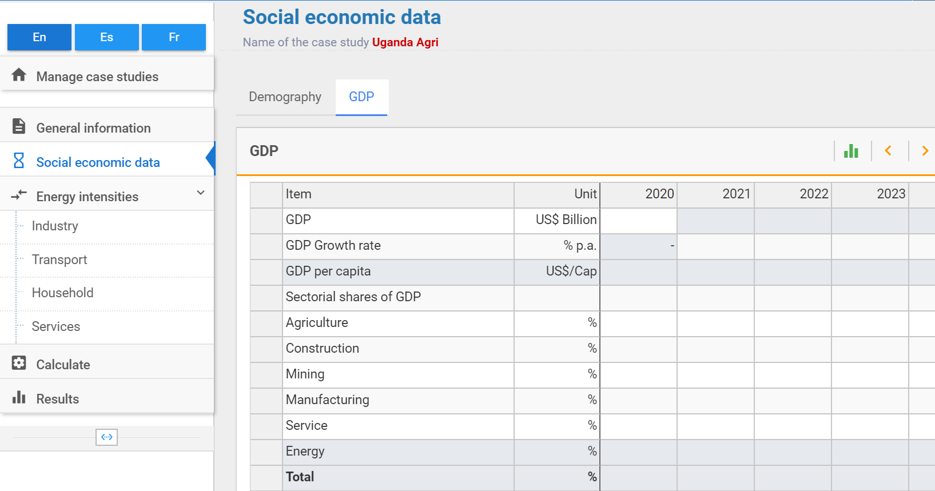
  - Sectoral share of GDP (%), Table 12:
  - Efficiencies for Thermal Uses (%), Table 6:
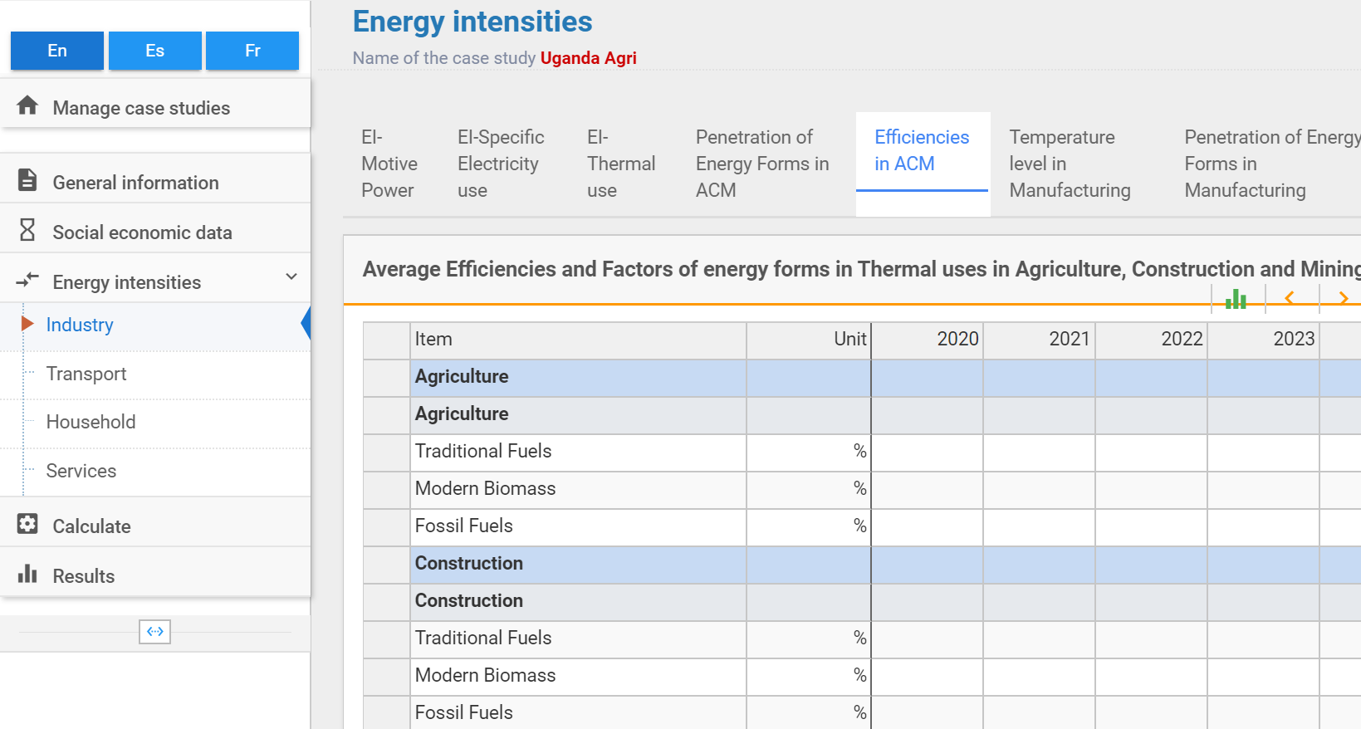
  - Penetration of energy forms for Thermal Uses (%), Table 10:
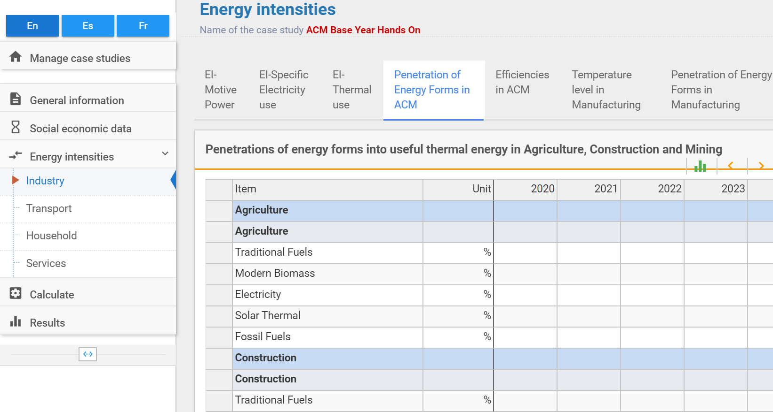
  - Energy Intensities for Specific Electricity Uses, Motive Power, and Thermal Uses (energy units/monetary unit), Table 13:
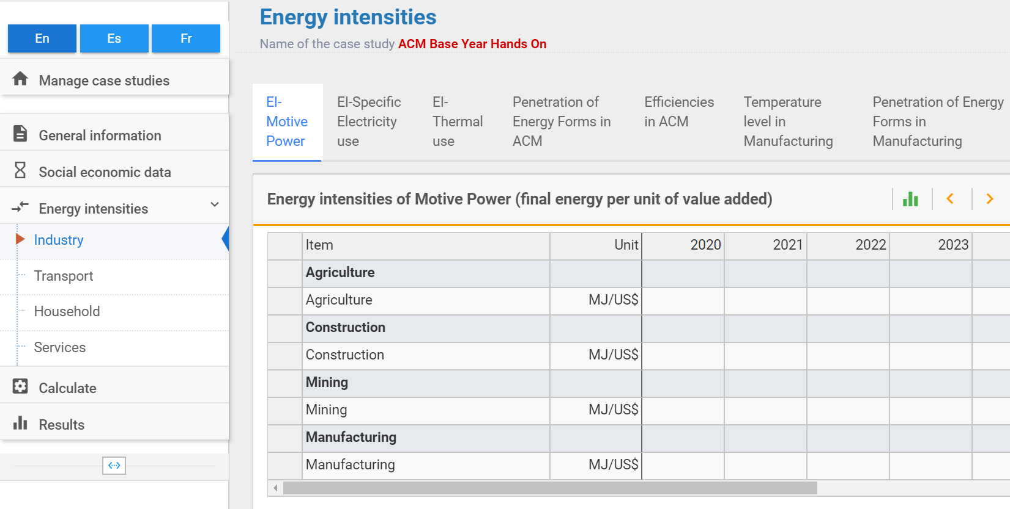
- We then calculate the results and visualise the Final Energy Demand results in the User Interface. We compare these results to the known values obtained from the Energy Balance. If they are roughly equal (<1% difference), then we have reconstructed the base year successfully. If they are not equal (>1% difference), then we have made an error in our calculations and we need to revisit them. A common error is not using the correct units, so pay attention to this.
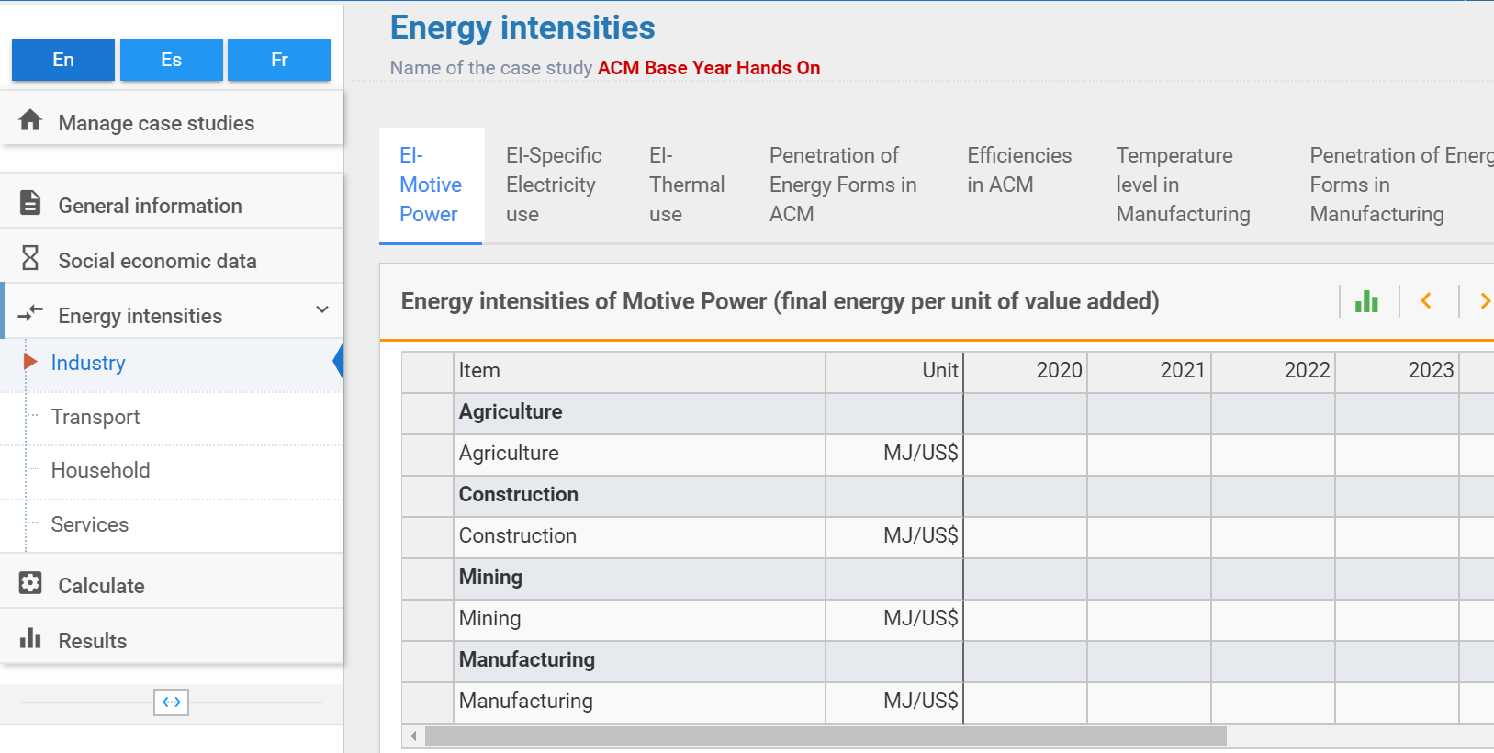
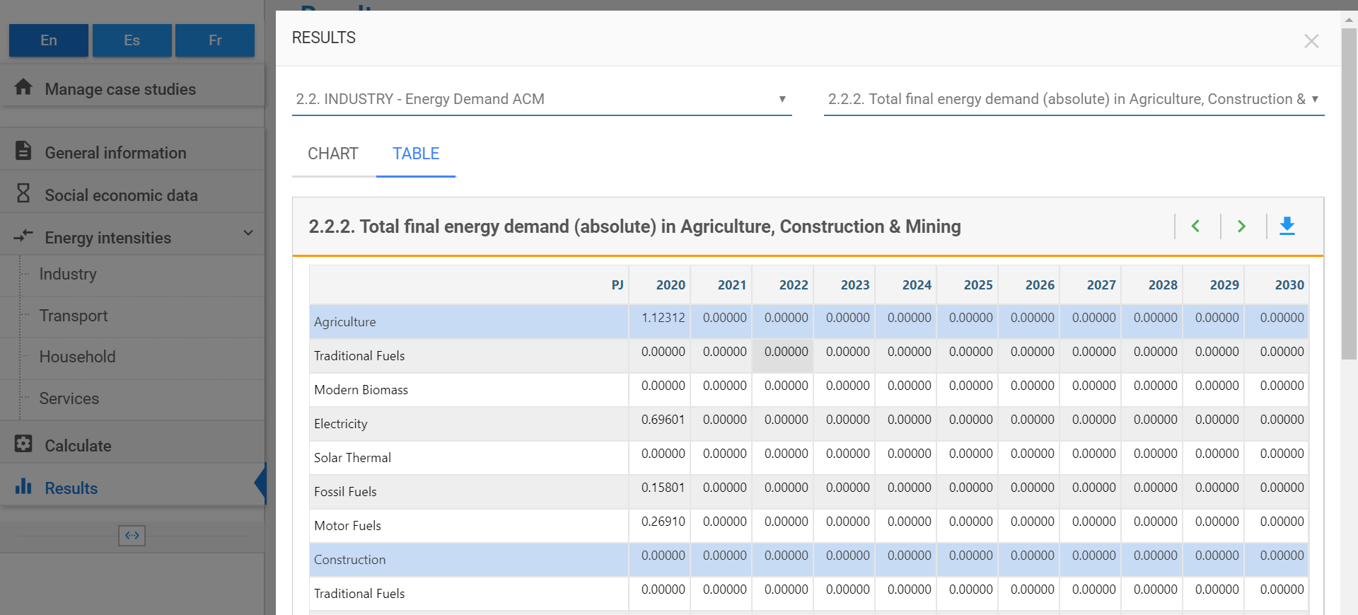
Comparing the calculated value of 1.12312 PJ with the value found in the energy balance of 1.124 PJ we can see that there is a 0.07% difference. Thus, we have successfully reconstructed the base year.

