FINPLAN
Hands-on 6: Setting up a case study for a single combined cycle power plant
Useful references:
- Download the FINPLAN software
- FINPLAN Manual
- Completed Hands-on 6 case study (before financially balancing the case study)
- Completed Hands-on 6 case study (after financially balancing the case study)
- Video Tutorials
- FINPLAN Discussion Forum

Learning outcomes
This exercise will help you obtain some hands-on experience on how to use the FINPLAN interface by creating a complete case study to analyze the financial viability and structure of power projects.
In this exercise, you will learn how to set up and assess a single combined cycle power plant.
By the end of this exercise, you will be able to:
- Set up a new case study in FINPLAN and interpret the results
- Adjust a case study to be financially balanced
- Export FINPLAN results
- Check Intermediate results
- Create the Cash Flow Statement
- Check the Operating Account
- Check the Balance Sheet
- Calculate Financial Ratios
- Estimate the Shareholder’s Return

Activity 1

Set up a new case study in FINPLAN
Background information, economic and financial data on the power plant are below.
Background information
A utility would like to assess the financial viability of a single combined cycle power plant from 2015 – 2040, financed with a mix of equity and debt instruments in both local currency and US Dollars. After a construction time of 3 years, the 300 MW plant will generate 2,000 GWh from imported gas from 2020 onwards until the end of its lifetime in 30 years. The plant will cost 300 million USD, with expenditures distributed 25%, 50% and 25% over the construction time. A debt-to-equity rate of around 70:30 is envisaged. It is depreciated linearly over 20 years. Electricity can currently (2015) be sold at 0.24 local currency units (LC) per kWh, increasing with inflation. O&M costs are expected to amount to 29.44 million LC. Gas import costs amount to 109 million USD.
Economic information
- Inflation USD: 1%
- Inflation Local Currency: 5%
- Exchange rate: 3 units of local currency per USD for 2014, 3.2 for 2015; exchange rate reflects inflation rates
- Income tax: 20%, losses to be carried forward, no losses in start year.
Financial information
- Initial Balance Sheet: 80 million as short-term deposits; 80 million equity
- Sources of financing - USD: 60% export credit over 12 years with uniform principal and interest repayment at an interest rate of 5.5%.
- Equity: 80 initially, 100 million LC in 2017 and 130 million in 2019. No limit to dividends being paid out.
- New Commercial Loans: 60 mil. USD in 2018, 10 mill. in 2019, over 8 years, interest: 3% over inflation
- Bonds: 10 million USD in 2018 over 5 years. Expected rate: 5%
- Short term deposits: interest rate -1% over inflation
- Stand-by facility: interest rate 4% over inflation.
- Shareholder’s targeted return data: disposal year 2040 (in which the assets are assumed to be sold), discount rate: 6%
- Terms of project finance loan: 6% discount rate (to calculate the net present value of the cash available in the future), 12 years average loan term, 1.4 security ratio for loan period, 30 years expected life, 1.6 security ratio for project life, 2020 first year of debt service
There is a lot of data to go through, but don’t worry – this hands-on will guide you to input all the data from above.
First, we need to create a new case study on FINPLAN. From the background information section, we know a few things about the project to create a new case study.
Try it:
- Create a new case study and name it “CCGT Demonstration”.
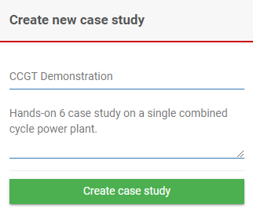
- Fill in the “New Case Study” page with information from the background information paragraph. Reading through it, we know the following:
  - Starting year: 2015
  - Ending year: 2040
  - Study type: Single plant
  - Local currency: Local currency
  - Foreign currency: US Dollar
- Don’t forget to “Save”.
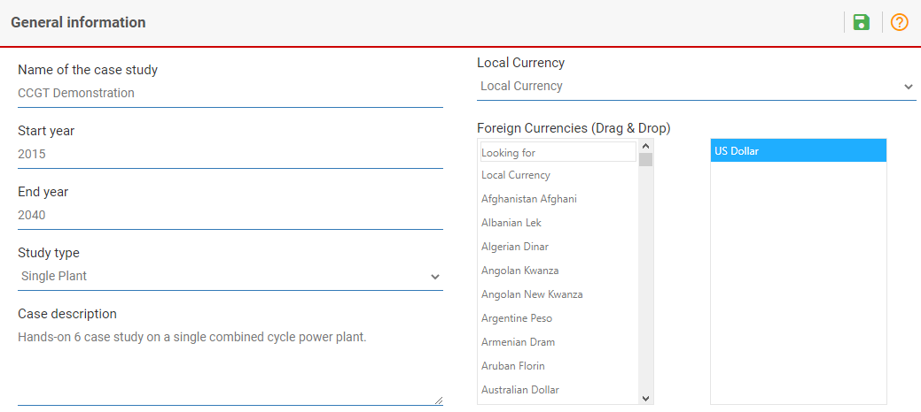
Now, we need to add information for the remaining Case Data (General Data, Taxation Data, etc.). Remember to save your data after each step!
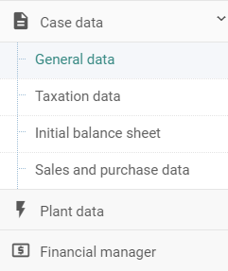
Try it:
- In the “Inflation Information” tab, enter the inflation values for both US Dollar and Local Currency. Follow the information from the economic information section.
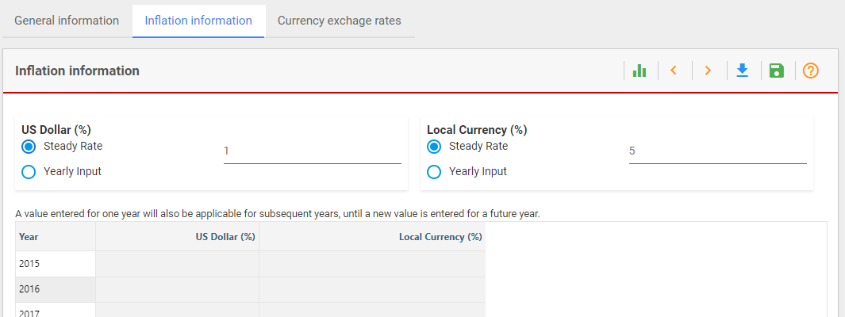
- In the next page, “Currency exchange rates”, input the data for Local Currency (US Dollar) for the years 2014 and 2015.
- Tick the “Exchange Rate Reflects Inflation Rates box”, as this is also instructed in the economic information section at the top of the document.
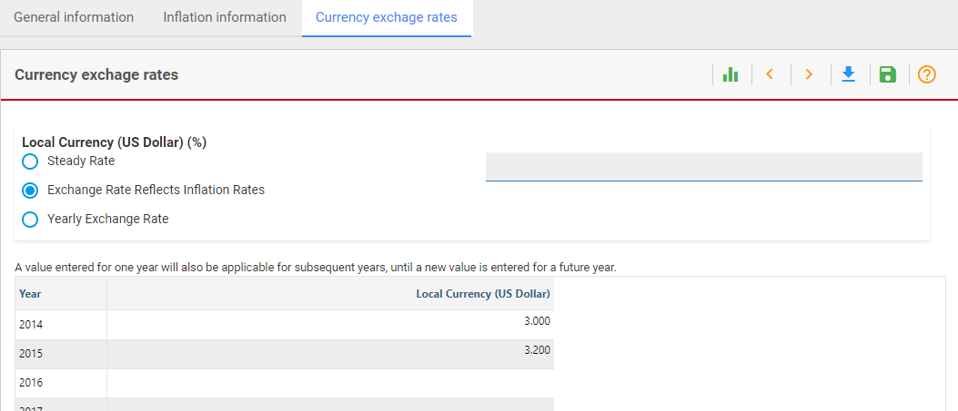
- Click on “Taxation data” from the menu pane, add in the values for “Tax and depreciation information” following the economic information section.
- We will leave the “Declining Balance Depreciation Rate for Assets of 2014” and “Value Added Tax” sections blank as we were not provided with this information in the description of this case study at the beginning of Activity 1.
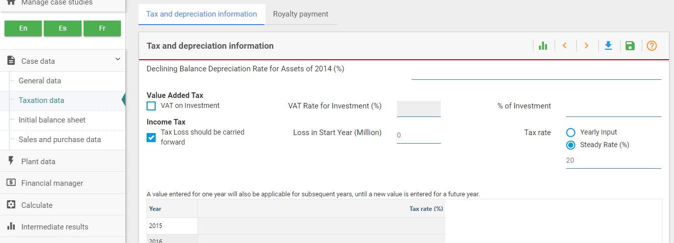
- Now click on “Initial Balance Sheet” from the menu pane. “Assets & Liabilities” should come up. Input the data for Short Term Deposits and Equity from the financial information section. This section tells us that short-term deposits and equity are both at 80 million.
- We will leave the rest empty as we were not provided with more information.
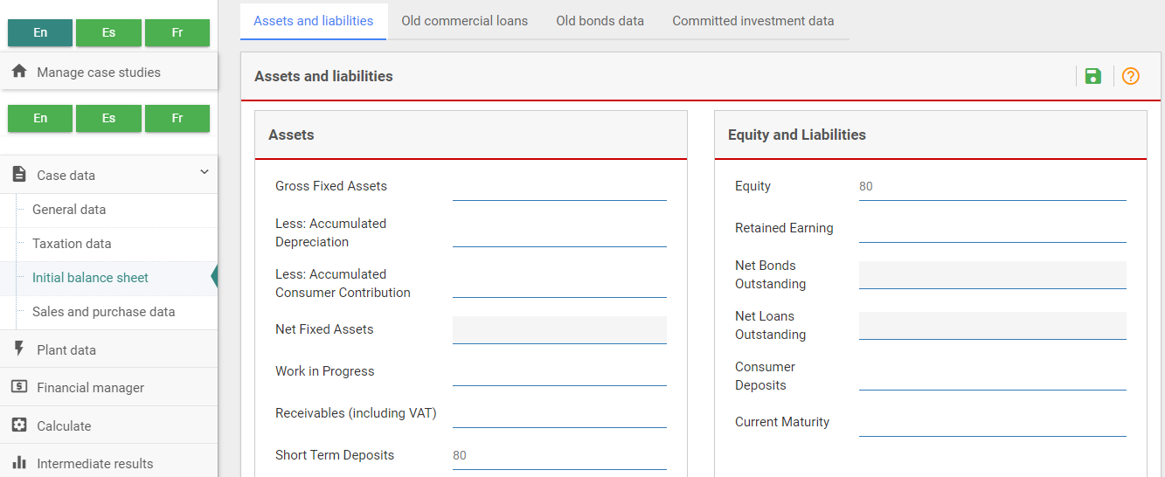
- Now go to “Sales and purchase data” on the left menu pane. This will take you to “Sales Data”. Click on the + symbol to add data.
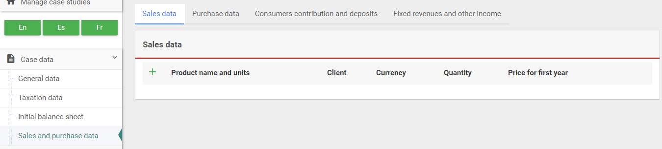
- From the background information section, we know that:
  - The power plant will be selling electricity for a client.
  - Electricity can currently (2015) be sold at 0.24 Local Currency units per kWh.
  - Prices will increase with inflation.
  - The plant will generate 2,000 GWh from 2020 onwards.
- Fill the above information in their respective boxes. We will name the client “Utility” for this case study.
- To represent a price increase with inflation, we will input 0 into the “Standard Change in Addition to Inflation” box. This will ensure the value is increasing with inflation.
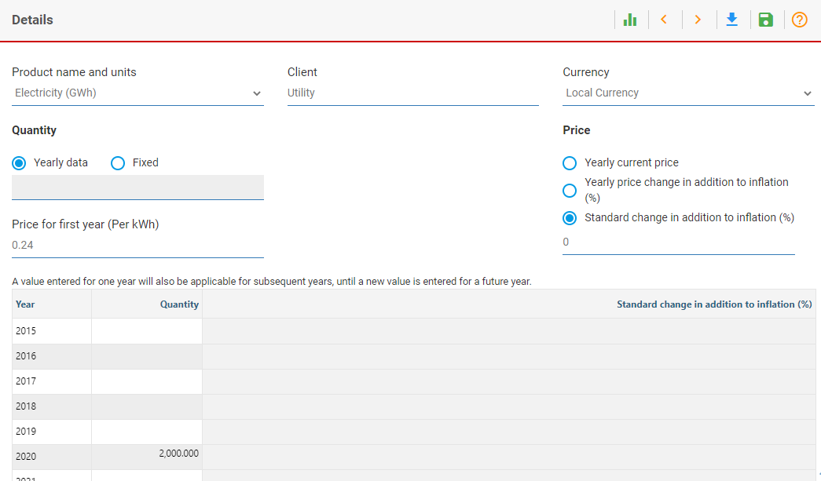
Well done! You have now added in all the Case Data.
We now must add in Plant Data.
Try it:
- Click on “Plant Data” from the menu pane. Now click on the + symbol to add in data.
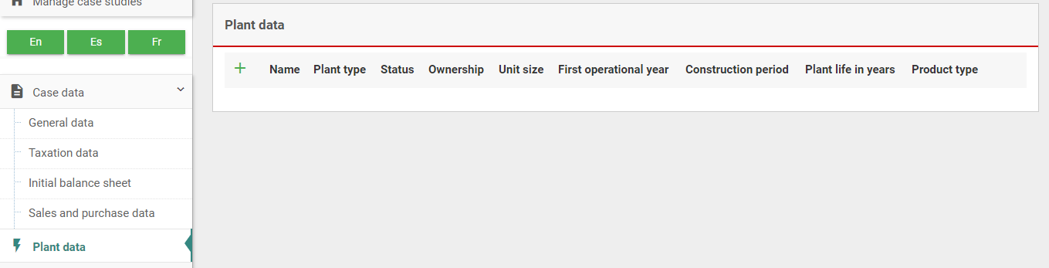
- Name your plant. For this case study, let’s go with “CCGT”.
- From the background information section, we know the following information:
  - Plant type: Imported gas
  - Status: Future
  - Ownership: Utility
  - Unit size: 300 MW
  - First operational year: 2020
  - Construction time: 3 years
  - Lifetime: 30 years
  - Product: Electricity
- Add the above information accordingly.
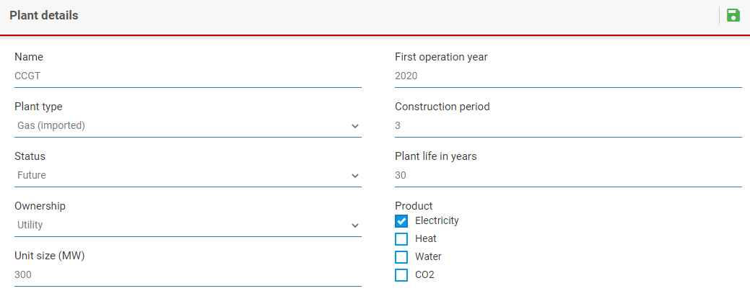
- Now click on the pencil icon to add more information on the plant (plant data, plant production, O&M costs etc.).
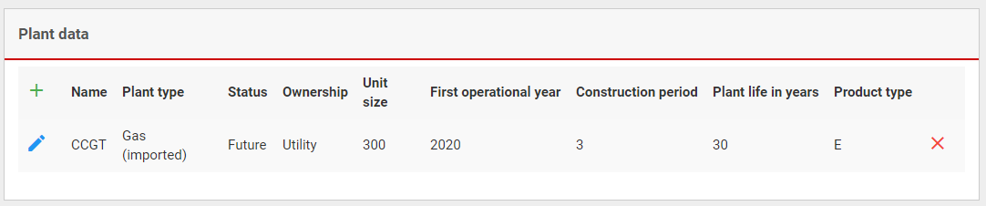
- Enter the amount of electricity the power plant will generate in “Plant production”. You can find this in background information.
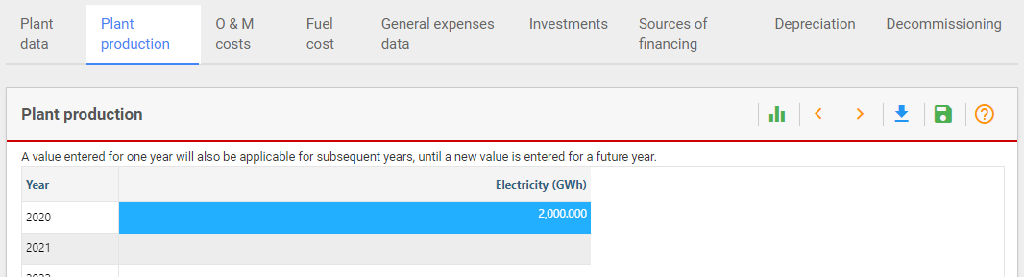
- Go to “O&M costs”. Fill in the associated O&M cost following the background information.
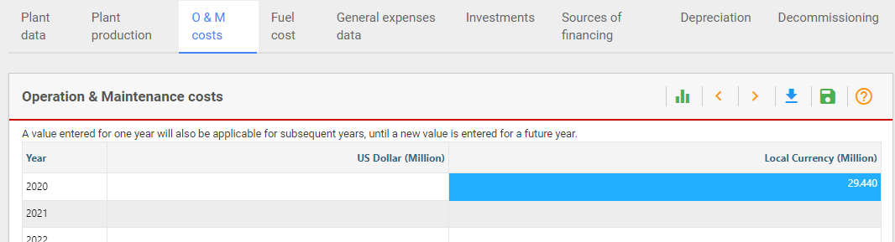
- Go to “Fuel cost”. Now fill in the associated fuel cost following the background information.
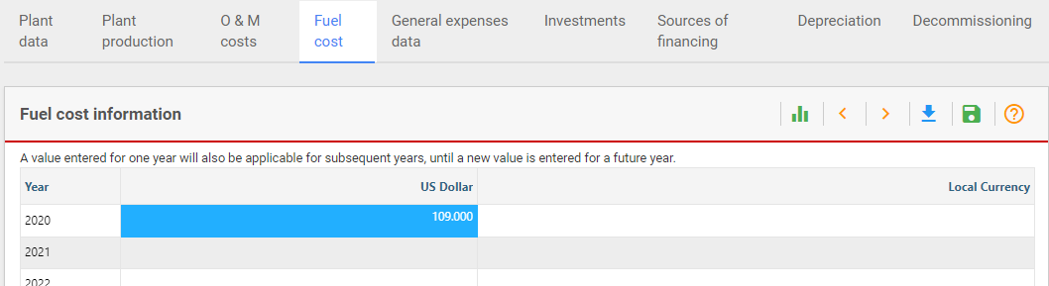
- We will skip “General expenses data” as we have no information on this.
- Now we need add in information on investments. Click on “Investments”.
- Complete this section. You will find the input values in the background information section.
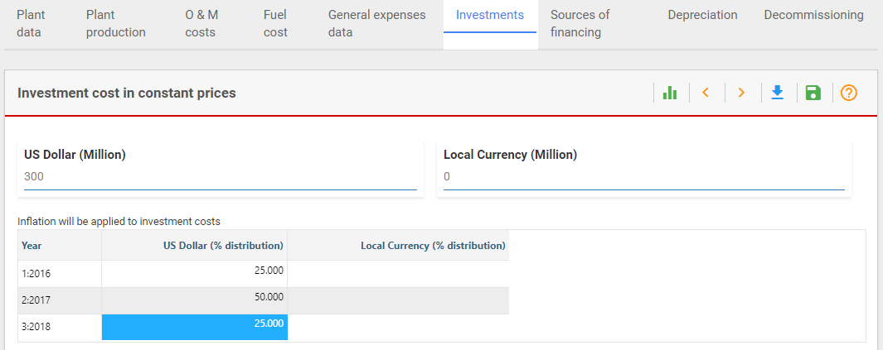
- Now go to “Sources of financing”. Click on “US Dollar” in the drop-down box.
- Fill in this page following the financial information.
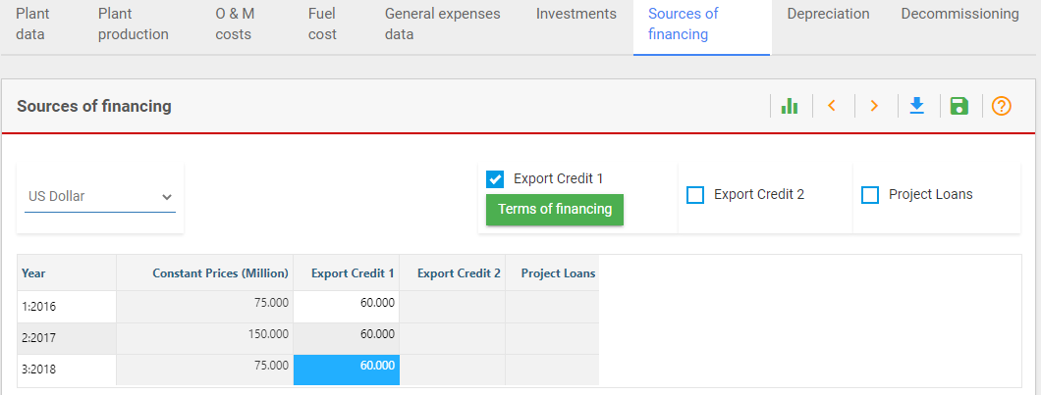
- Now we move on to “Terms of financing”. Click on this box, underneath “Export Credit 1”.
- Fill in the values by following the financial information at the top of this document.
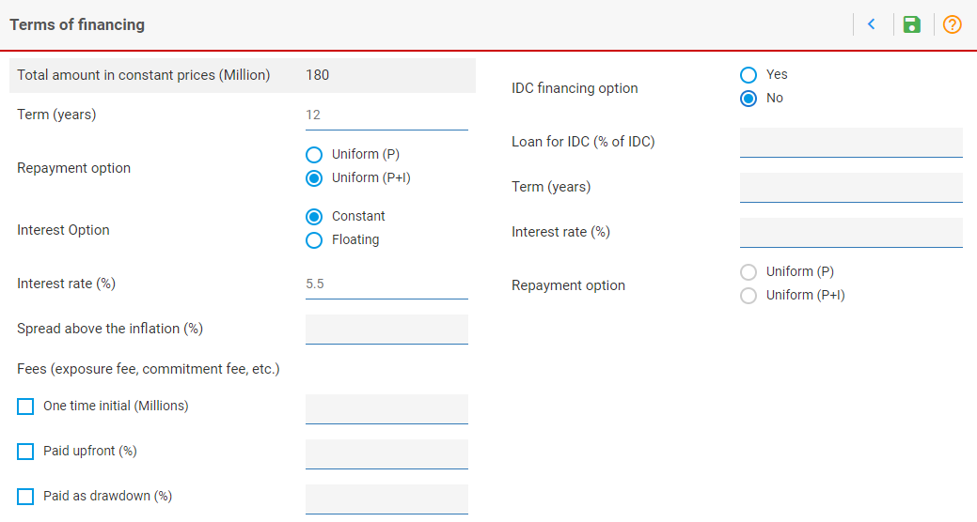
- Now we move to Depreciation Data & Decommissioning. Click on “Depreciation”.
- Fill in the depreciation information from the background information.
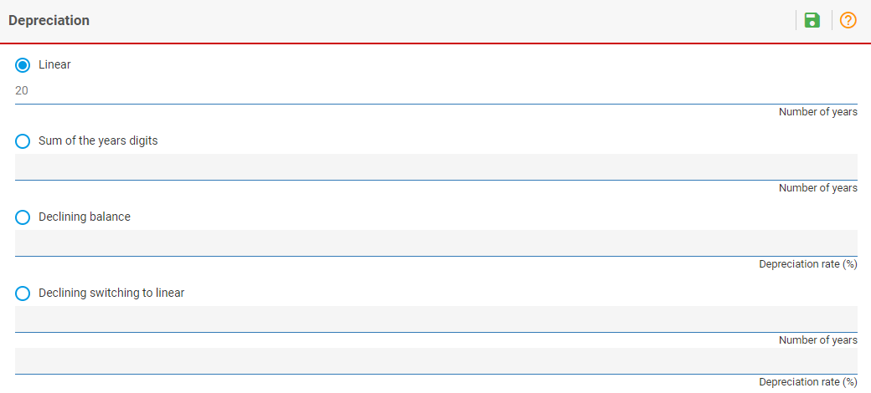
- We will leave “Decommissioning” empty as we do not have information on this.
Well done! You have now inputted all Plant Data.
We will now have to move on to the Financial Data i.e., “Financial manager” tab.
Try it:
- Click on the “Financial manager” tab on the left menu pane. The first page will be on “Equity”.
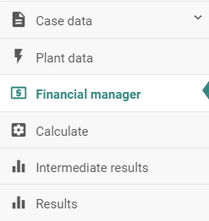
- From the financial information section, we know that there is no limit to dividends being paid out. Therefore, we will put in a large number i.e., 999 for “Maximum Dividend”. This large number will ensure that whatever profit is made will be released in the form of dividends.
- From the financial information section, add in the values for equity.
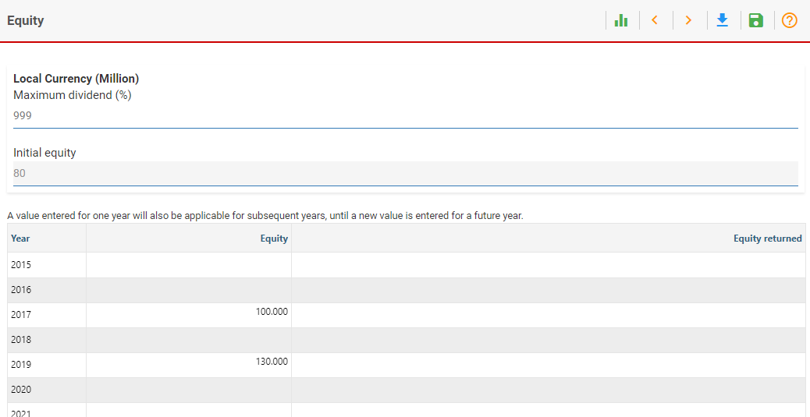
- Now go to the next page, “New commercial loans”.
- Follow the financial information and input the values for new commercial loans.
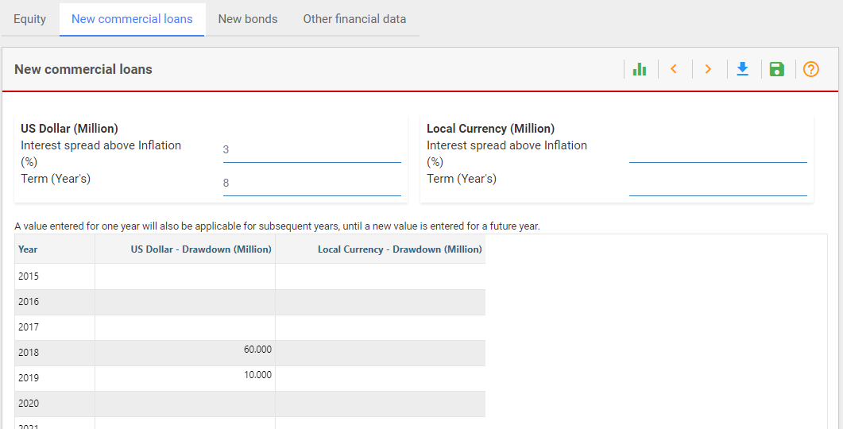
- Now go to “New Bonds”.
- Follow the financial information and input the values for bonds.
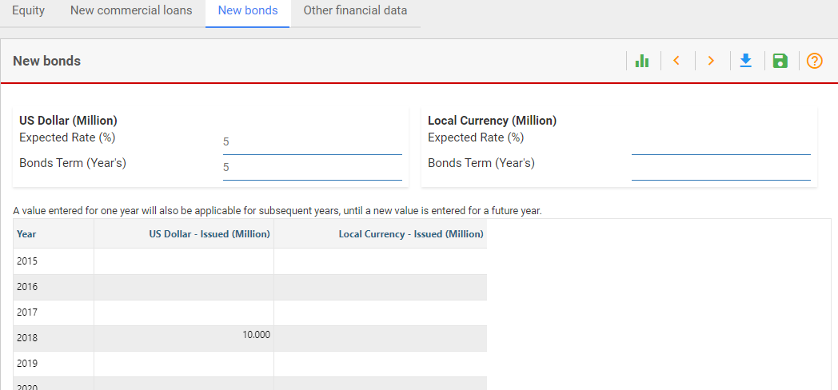
- Now go to the next page, “Other financial data”.
- Fill in the first box, “Other financial data”, from the financial information section.
- As we are not given information on “Short Loans”, we will input this as 0.
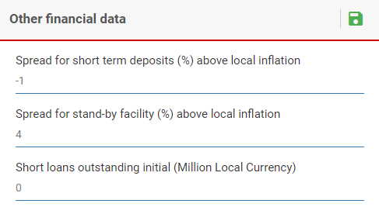
- Fill in the second box, “Shareholders’ return data”.
- Input the values as shown in the financial information section.
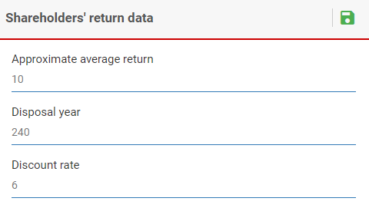
- Now go to “Terms of project finance loan”.
- Input the values as shown in the financial information section.
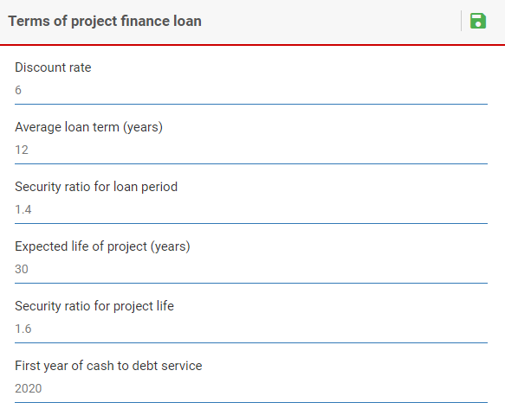
Well done! You have now added in all the financial data on FINPLAN.
Now we need to run our model and read our results.
Try it:
- Click on “Calculate”.
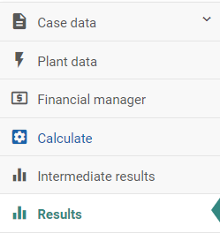
- Once results are generated, click on “Cash inflows and outflows in local currency” from Results.
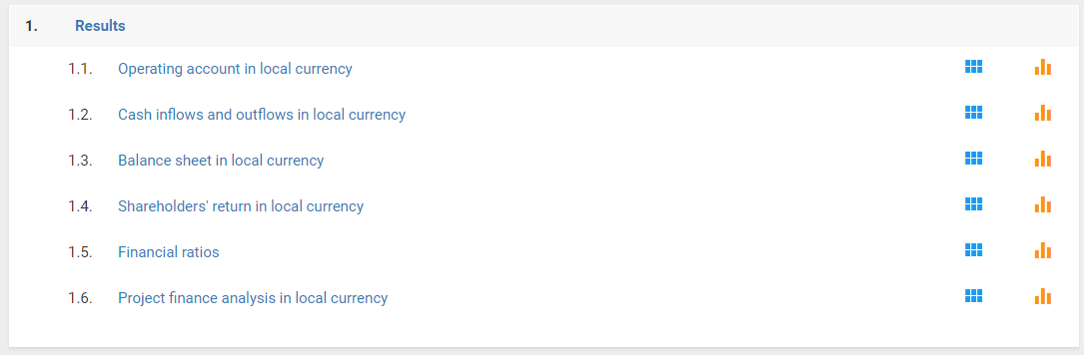
- Ensure that the power plant is under construction at the correct time. To double-check, make sure that there are values for “Investment” from 2017 to 2019. Also double-check that “Sales” only appear after the year 2019.
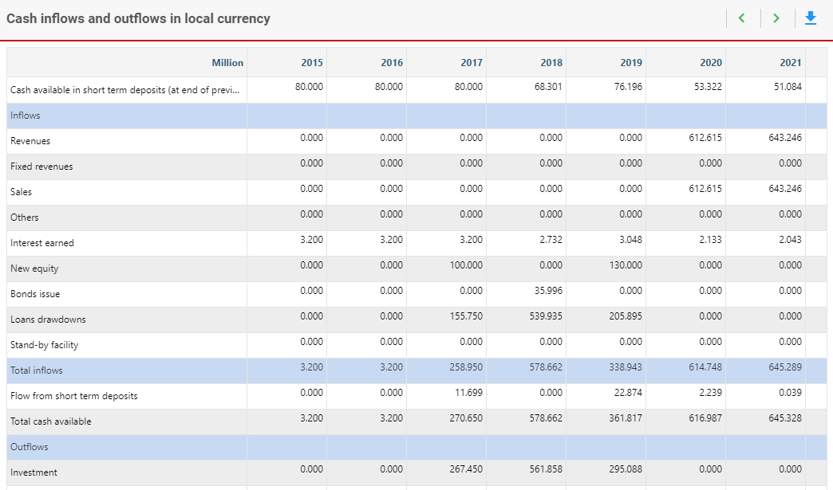
- Check the Cash Available in Short Term Deposits. As a short-term deposit has a low interest rate, it should be emptied as quickly as possible. However, our results show that this is not the case: cash is available throughout.
- Check the Stand-by facility. It should be rarely used. This is the case.
- Check flows from the Short Term Deposits. As mentioned, it should be emptied as soon as possible. However, we can see that there are substantial Flows from the Short Term Deposits during several years.
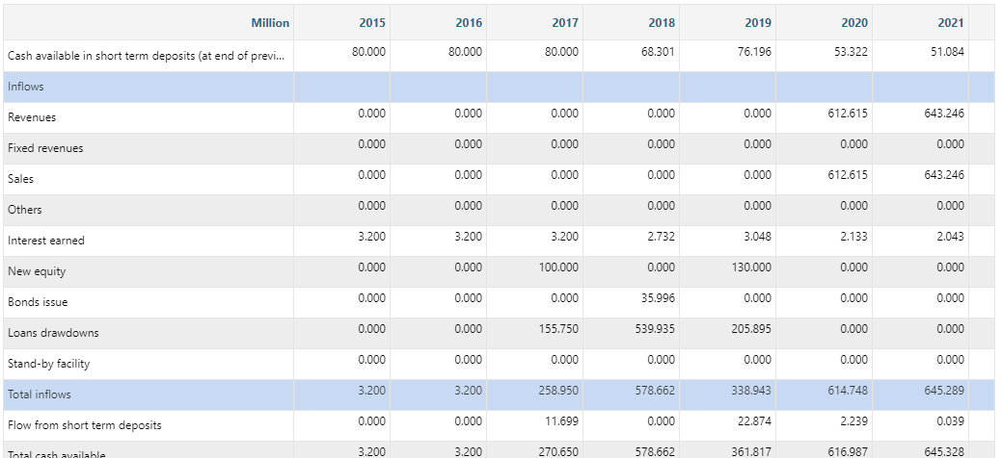
- From the results above, we can conclude that this case study is not balanced. We have too much cash available. We added new equity and new bonds in this case study, which could be an explanation as to why we have too much money.

Activity 2

Adjust a case study to be financially balanced
We need to adjust the input data for the CCGT case study so that it is financially balanced.
Try it:
- Create a copy of your “CCGT Demonstration” case study and name it “CCGT Demonstration - Balanced”. You can rename it in General data > General information. We will use this new file to make some changes.
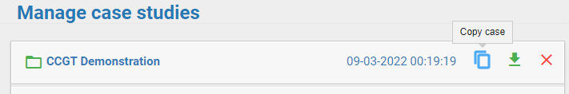
- 2017: Looking at our results, cash is available in the Short-Term Deposit in 2017, yet further equity is injected, which is not required. The equity should therefore be reduced to 30 million LC in 2017 and results should be recalculated.
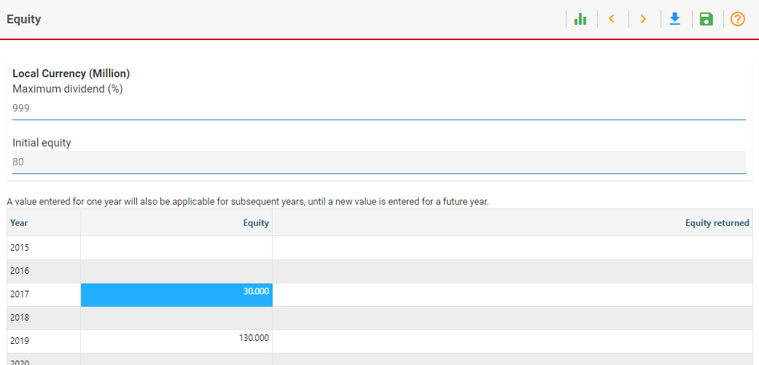
- 2018: The high Debt Equity Ratio of ~0.9 in 2018 (check this under Results > Financial ratios) may not be acceptable to a lender. Furthermore, the capital markets may only be accessible once the plant has been in operation. Therefore, the 10 million USD bond issued in 2018 should be removed. The commercial loan in 2018 should also be reduced to 30 million USD. The missing amount of equity for 2018 should be replaced with 140 million LC. This also improves the debt equity ratio during construction.
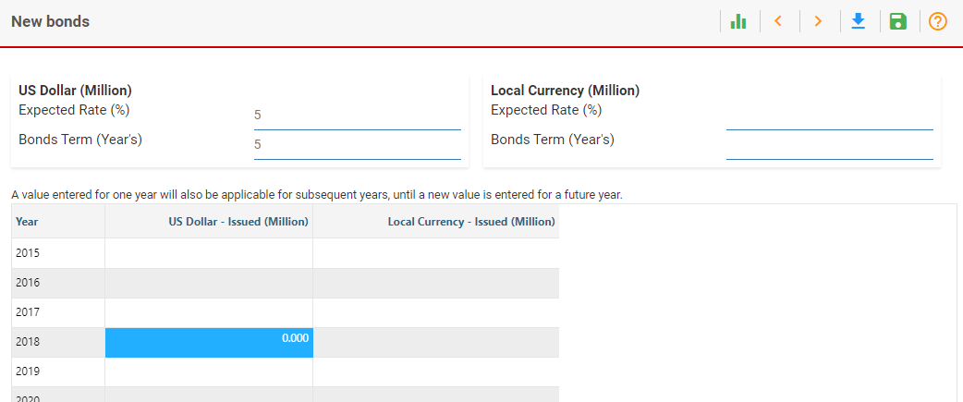
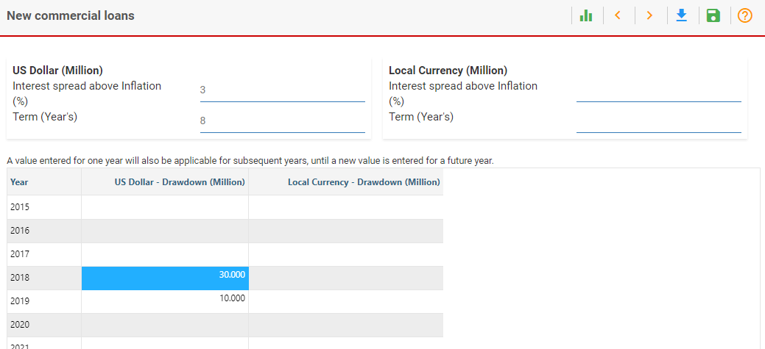
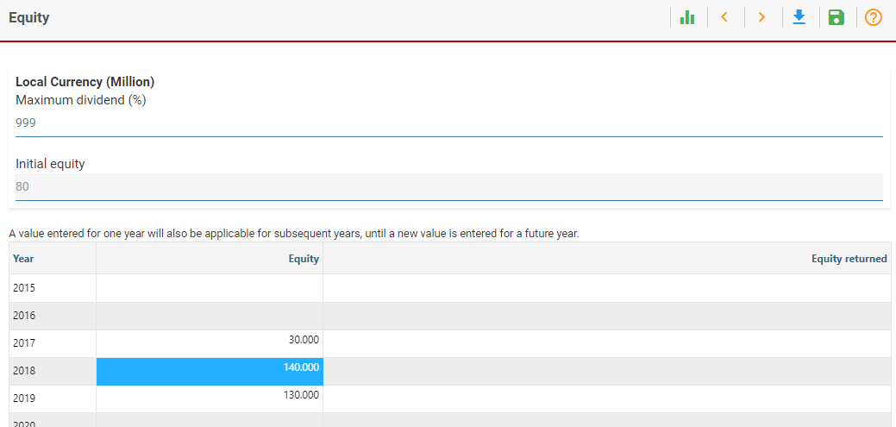
- When looking at the results after recalculating, our short-term deposit is emptied as soon as possible, i.e., in the first year of construction. Also the stand-by facility is barely used compared to the overall investment costs and our financial ratios have improved. Our debt service coverage ratio is still quite low, which we accept for the time being. We assume that this is not our only project and that we have cash reserves available within our company. In reality, we would of course have to demonstrate to the financiers that this cash is available and reserved for this project. (Alternatively, we could increase the equity or debt further to have extra cash available, but this would just end up in the short-term deposit at a low interest rate. Further, we could of course increase the electricity price if this was a realistic option.)
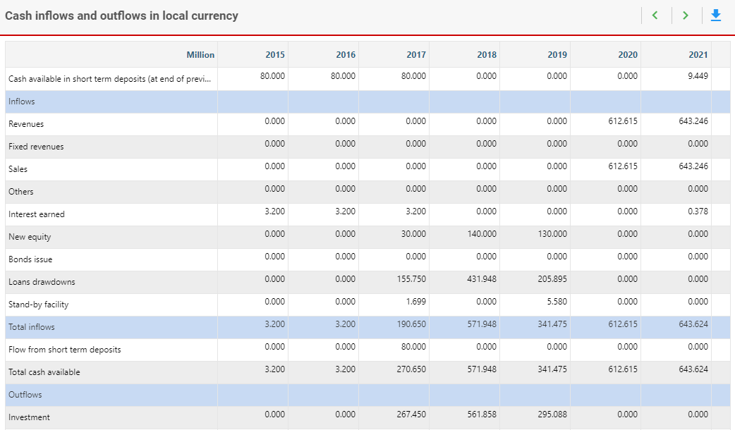
Well done! You now know how to adjust data to achieve a balanced financial model.

Activity 3

Export FINPLAN results
It will be easier to compare results if you export them to Excel. It is also suggested that you then print out the Operating Account, the Cash Inflows and Outflows and the Balance Sheet.
You can do this by clicking on “Results” and the “Export all …” button in the top right corner.
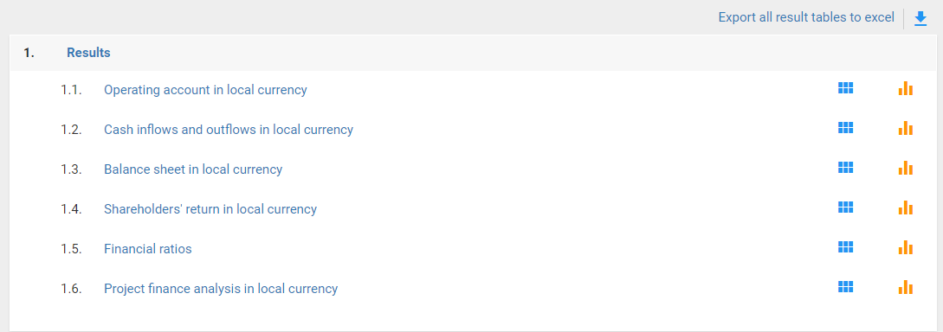
Before going through the following questions, please take some time to compare the different statements (Operating account, Cash inflows and outflows, Balance sheet) and see how they are linked. Try to think of the purpose of each of them.

Activity 4

Intermediate results
Sometimes you will look at your Financial Statements and see unexpected results. Often, the intermediate results allow you to check if the data you entered is used by FINPLAN as you expect it.
Example:
Let’s say the sales are zero in the “Results – Cash inflows and outflows” throughout the project period, even though you entered an electricity price. In the intermediate results, you can check under “Sales” what quantity of electricity is being multiplied with which electricity price, and you can maybe find out that the quantity was zero (e.g., because of forgetting to press the “save” button when entering data).
Please take some time to go through the Intermediate Results and familiarize yourself with what you find there. The following questions can be a starting point.

Activity 5
Now take your time to go through the following statements. If you are unsure about their definitions and terms used, check the section in the document ‘Introduction to FINPLAN’ explaining the results. For more detailed explanations, check the definitions on pages like investopedia.com.
- Cash Flow Statement
- Operating Account
- Balance Sheet
- Financial Ratios
- Shareholder’s Return
The questions in the online quiz will relate to these statements. It is thus suggested that you keep FINPLAN open on your computer while answering the quizzes.
Should you want to compare your results with the correct solution, simply restore the FINPLAN case using the link provided at the beginning of this document. Refer to the previous hands-on exercise to see how this is done.
Note: There is also a FINPLAN discussion forum for further support. Please sign up to the group and ask or answer any FINPLAN-related questions here.

