FINPLAN
Hands-on 5: FINPLAN Results Interpretation
Useful references:
- Video Tutorials
- FINPLAN Discussion Forum

Learning outcomes
By the end of this exercise, you will be able to:
1) Run a complete model using FINPLAN.
2) Understand the outputs of FINPLAN:
a) Operating Account
b) Cash Inflows & Outflows
c) Balance Sheet
d) Shareholder’s Return
3) Understand selected financial ratios:
a) Leverage
b) Exchange Risk Ratio
c) Debt Service Coverage
4) Restore a case study file.

Activity 1
Run a complete model using FINPLAN
Now that you have entered all data required for the financial analysis of the coal power plant, we can run the model.
Try it:
- Click on the “Calculate” button on the left menu pane. FINPLAN will calculate your model automatically. Once the calculation is done, you will see the screen below.
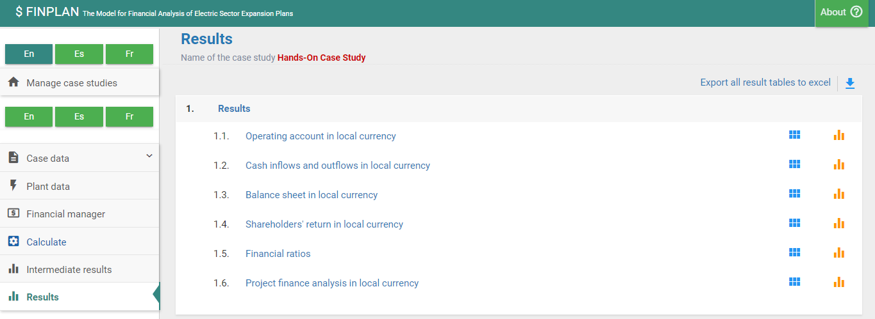
- FINPLAN provides two sets of results, one is “Intermediate results” and other one is “Results”. You can see this in the left menu pane.
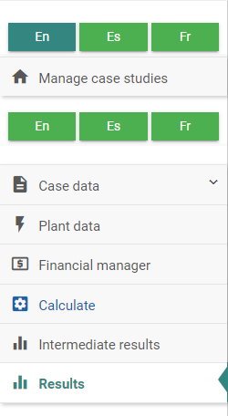
- “Intermediate results” can be useful to understand the values used to calculate the final “Results”. However, we will first explain the final “Results”. If you click the button “Results”, the following screen appears. It has six items:
- “Operating account in local currency”,
- “Cash inflows and outflows in local currency”,
- “Balance sheet in local currency”,
- “Shareholders’ return in local currency”,
- “Financial ratios”, and
- “Project finance analysis in local currency”.
We will explain each of these items one by one in the following sections.
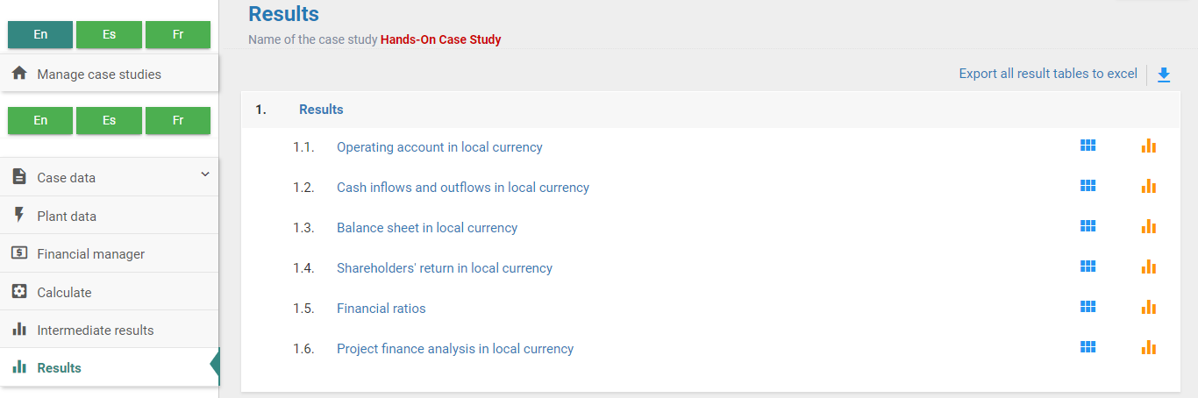
- Have a look at Activity 4 in case your results don’t match what you see in the following screenshots.

Activity 2a
Understand the Outputs of FINPLAN - Operating Account
The operating account summarises the yearly income and expenses and shows whether the project is profitable and if dividends can be paid out to its shareholders. This is explained in more detail in the lectures. Let’s look at the operating account of our Malaysian coal power plant.
Try it:
- Click on “Operating account in local currency”. The following table will appear.
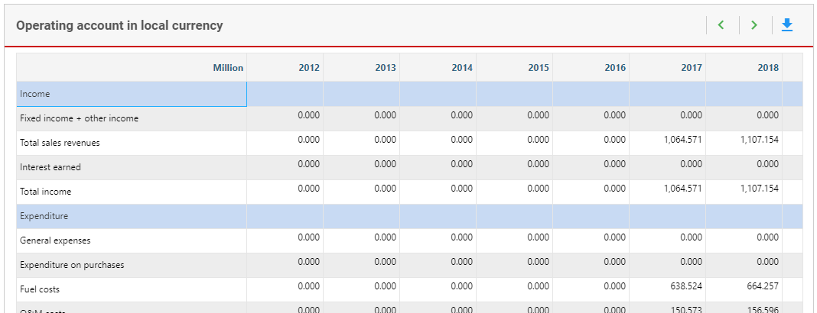
- You will see that you can export your results to Excel with the button at the top right.
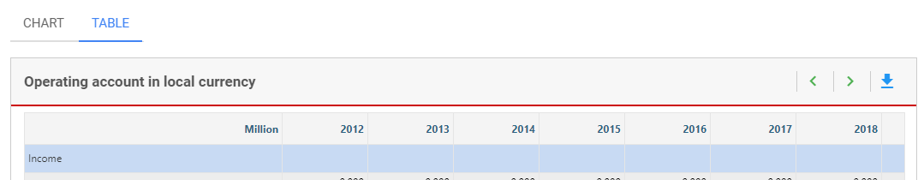
- You will also see that you can swap from a “Table” layout to a “Chart” layout. You can download this as an image, too.
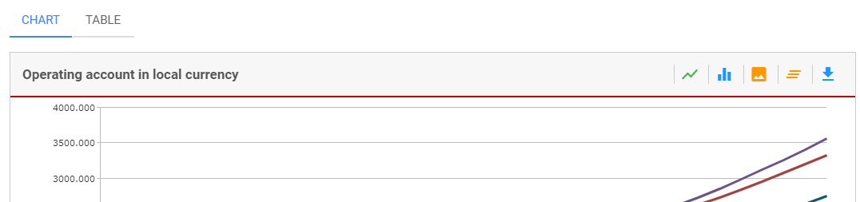
- We will look at the “Table” option in this exercise. This table summarises the yearly income and expenses due to the operation of the project and shows whether the firm is making a profit from its operation. It should be noted that all results are in million Ringgit, and at current prices.
- The top five rows present the income by year. The only income from this project are revenues from electricity sales. As its operation starts in the year 2017, so do the sales of electricity. This is reported in the third row at the top. The amount of electricity to be sold remains constant. However, as prices increase over time due to inflation, revenues increase too.
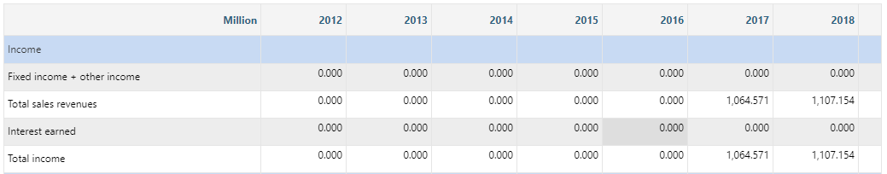
- Let us focus on the expenditure block now. The plant has only two operational expenses: fuel costs and O&M costs. Other expenses are financing-related including interest payment, foreign exchange loss and depreciation.
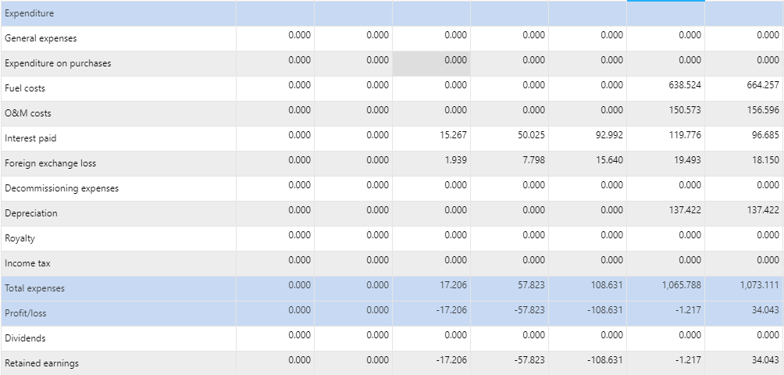
- Foreign exchange loss occurs due to currency depreciation. For example, suppose in the year 2014 you borrowed 100 US Dollars and the exchange rate was 3.5 Ringgit per Dollar. Converting it into local currency, you would have received 350 Ringgit. You must return those 100 Dollars in the year 2016. By that time the Ringgit depreciates, and the exchange rate is now 4 Ringgits per Dollar. So, you need 400 Ringgit to repay 100 dollars. Therefore, in 2014 you received 350 Ringgit, but when you return you need 400 Ringgit. 400 minus 350 is 50 Ringgits, and that is the foreign exchange loss. In our case, we have assumed that the Malaysian Ringgit is stable, so the foreign exchange loss is not substantial.
- Depreciation expenses are 137.4 million Ringgit every year, starting from the year 2017, when the plant starts to operate, and goes on for 20 years (i.e., the depreciation period we defined).
- Looking further down in the table, we see that total expenses are calculated and reported in the row called “Total Expenses”.
- Subtracting total expenses from the total revenue in a particular year results in the net income. It is reported here as “Profit or Loss” – profit when it is positive, and loss when it is negative (depicted by red brackets in Excel in subsequent screenshots). You may notice that the plant makes losses till the year 2017, and thereafter, there is a profit. The project needs to pay taxes only when there is a profit. However, if you notice carefully, it started paying taxes only from the year 2021, although profits start from 2018. This is due to selecting the tax loss carried forward provision when defining our case.
Tax Loss Carried Forward
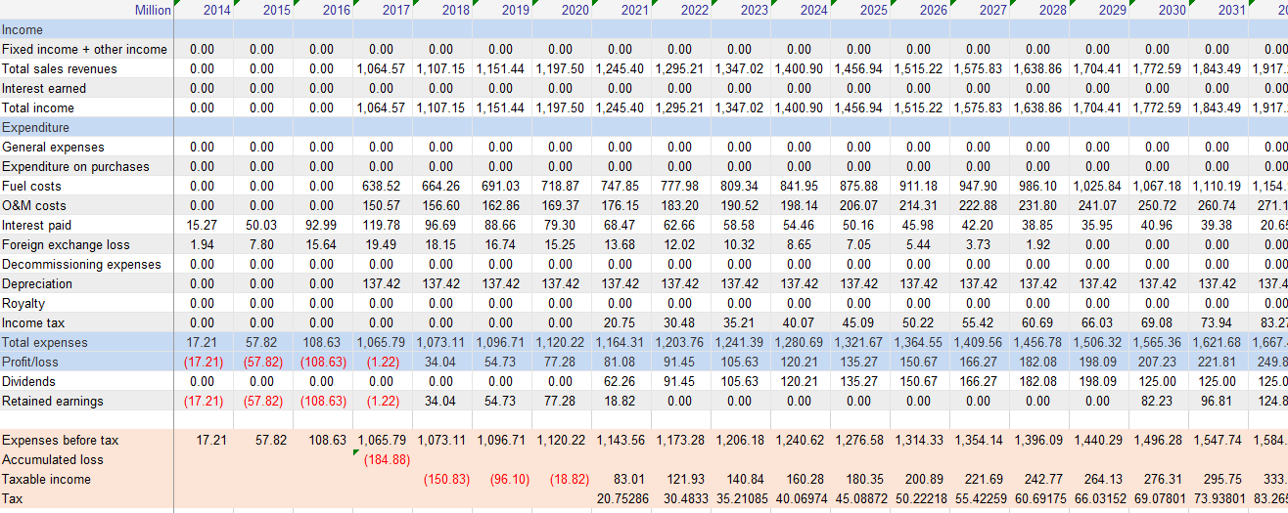
- We will now look at taxes in more detail. Download the table and open it in Excel.

- Looking at taxes, we have added a couple of rows at the bottom to show the tax calculations.
- Looking at the row Profit/loss we can see that from the year 2014 till 2017 the plant incurs losses. In 2014 the loss was 17.2 million, in 2015 the loss was 57.8 million, and so on. Thus, till the year 2017, the accumulated loss of the firm was 184.9 million Ringgit.
- By selecting the tax loss carry forward option (as selected under Case data – Taxation data), this accumulated loss can be carried forward to the successive years, to calculate the taxable income. In 2018, expenses before tax were 1073.1 million. When subtracted from the total income, we get net income as 34 million, which is positive, but if the accumulated loss is carried forward, then the firm’s taxable income is minus 184.9 plus 34, which is a loss of 150.8 million. So, there is no need to pay taxes. Similarly, in 2019, the net income before tax is 54.7 million, but when the accumulated loss of 150.8 million from the previous year is added, the firm’s taxable income is minus 96.1 million. Again, there is no need to pay taxes.
- Continuing this way, in 2021, for the first time the firm makes a positive taxable income of 83 million, so the firm needs to pay taxes. Applying a tax rate of 25%, taxes in that year are 20.8 million. From then onwards, the taxable income is positive every year and the firm needs to pay taxes.
Dividends and Retained Earnings
- Now have a closer look at the same table focussing on dividends and retained earnings. Look at the screenshot below.
- The net income (i.e., Profit/loss) is divided into two: dividends, which will be paid to the shareholders, and the remaining amount is kept within the project as retained earnings.
- Dividends can be paid only when there is no accumulated loss any longer, i.e., when also taxes need to be paid. Therefore, the dividend payments start from 2021. As the taxable income is negative until 2020, no dividend will be paid, and the entire profit is kept in the project as retained earnings.
- But how are dividends calculated in FINPLAN? You may remember, you have used the dividend rate as 50% in the equity screen. Dividends in a particular year are limited to a maximum of 50% of the equity.
- You can check this. Unit the year 2028, equity is 650 million, therefore 50% of the equity, is 325 million. Up to 2028, profit is always less than 325 million, so the entire profit is distributed as dividends. In 2030, equity is reduced to 250 million because part of the equity is returned in 2029 and 2030 (see cash-flow statement). 50% of the equity is 125 million. However, the profit is higher than this amount in 2030, so only 125 million is distributed as dividend, and the remaining amount is kept within the project as retained earnings.
Well done! You now know how to interpret the operating account.

Activity 2b
Understand the outputs of FINPLAN – Cash Inflows and Outflows
We now move to the next item, cash inflows and outflows.
Try it:
- Click on “Cash inflows and outflows in local currency”. You will see this page.
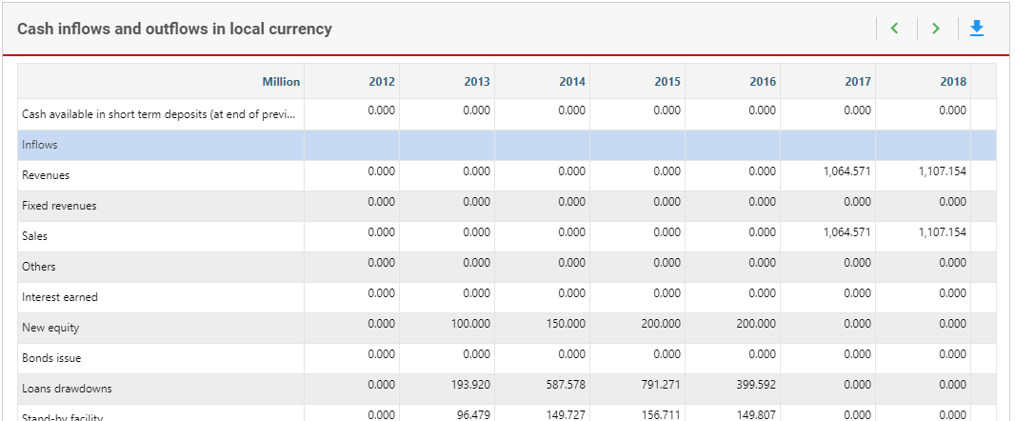
- The table shows all sources of cash coming into the project account in a certain year and cash flowing out as expenses. Clicking at the top left corner, this table can be exported to Excel as well. Here, the Excel table is used for calculations.
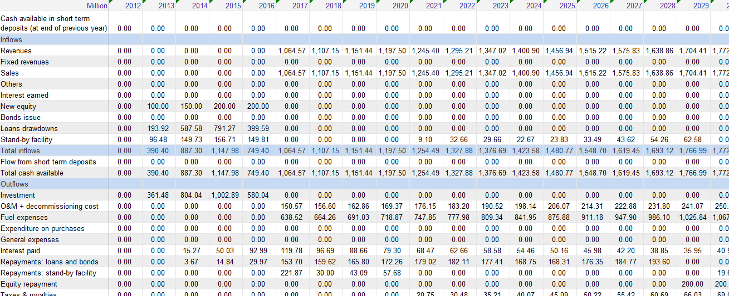
- The top part shows cash “Inflows” by sources. During the construction years, the sources of cash include equity, loans and the stand-by-facility. The company borrows from export credit agency and uses as well as a project loan. However, they are added up and reported as “Loans drawdowns”. This money will be spent to pay the bill of the plant construction. There is a shortage of funds during the construction years; therefore, the model withdraws from the stand-by-facility to meet the expenses.
- From 2017, the only cash inflows are the revenues. However, between 2021 and 2029, the stand-by-facility is used again to meet a short fall.
- Let us now look at the lower part, which presents the cash “Outflows”, between 2013 and 2016, the major expenses are construction related. Other expenses are interest payments and loan repayments. From 2017, outflows include operating expenses, such as fuel and financing expenses, including interest payments and loan repayments.
- In the last row, cash outflows for VAT payments and cash inflows of VAT reimbursements are reported. VAT repayment is reported in negative terms as minus 219.8 million Ringgit in 2017, which is used to repay the stand-by facility, that paid the VAT.
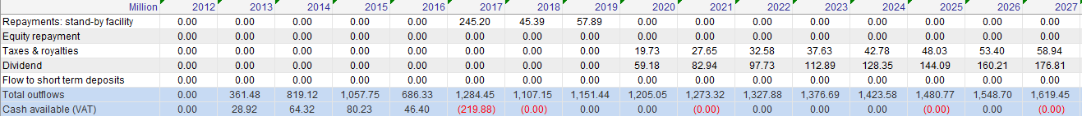
- From the year 2033 onwards, large amounts of cash are deposited as short-term deposit, as shown in the topmost row. However, this is not a good use of cash, as the short-term deposit provides a low interest.
- Therefore, we can conclude that this is not a good financial plan. A better financial plan could have been developed, e.g., by repaying equity or releasing more money as dividends to shareholders.
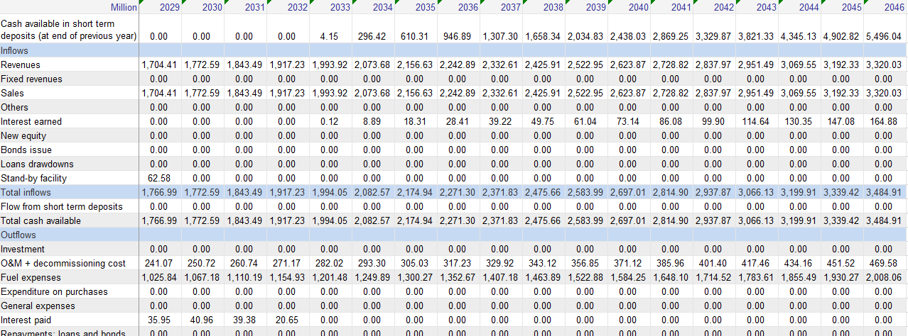
Well done! You now know how to interpret cash inflows & outflows.

Activity 2c
Understand the outputs of FINPLAN – Balance Sheet
Next, we will have a closer look at the “Balance sheet in local currency”. It is explained in more depths in the lectures. The balance sheet provides a snapshot of the financial health of a project or company by reporting the sum over the years of what it owns and what it owes at a certain point of time.
Try it:
- Click on “Balance sheet in local currency”. You will see the below.
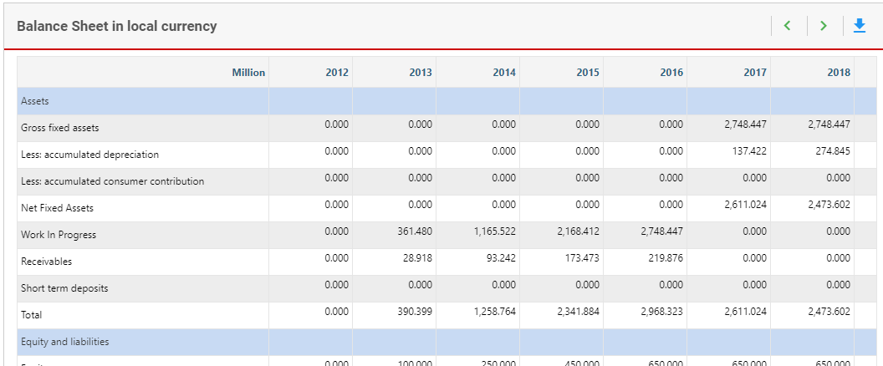
- What a company owns is called assets, reported in the upper half of the table. What it owes is called liabilities, reported in the lower half of the table. Again, by clicking at the top right corner, we can export this table to Excel.
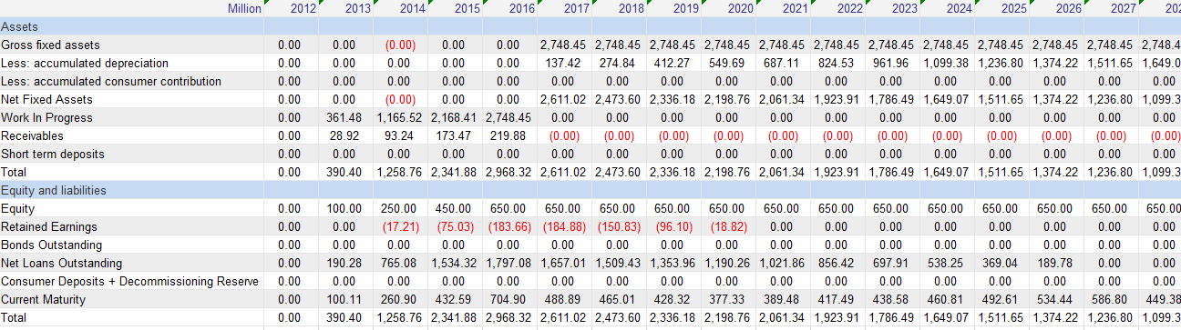
- Let’s discuss the asset portion first. When construction is completed, the asset value is reported as the total construction value, 2748 million. Depreciation starts from the same year at the rate of 5% per year as we have assumed straight line depreciation over 20 years.
- Receivables are short-term assets, which would be encashed soon. In this case, this is the VAT, or value added tax, which has been paid during the construction, and will be refunded in the year the plant starts selling electricity. The short term deposit starts accumulating from year 2032.
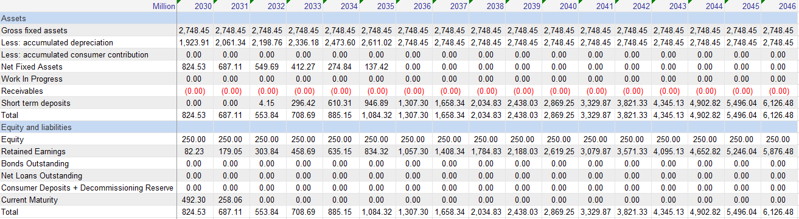
- We will now investigate the liability portion. Investor’s equity is liability to the project company, which is reported in the first row. Cumulative retained earnings reported in the operating account are transferred to the balance sheet and reported under the heading “Retained Earnings”.
- Outstanding loans from export credits and other sources, net of principal paid in that year, are reported under net loans outstanding. Current maturity includes amounts due next year, i.e., the accumulated stand by facility plus the loan amount due next year.
Well done! You now know how to navigate through the balance sheet.

Activity 2d
Understand the outputs of FINPLAN – Shareholders’ Return
The next output from the model we will look at is the “Shareholders’ return in local currency”.
Try it:
- Click on “Shareholders’ return in local currency”.
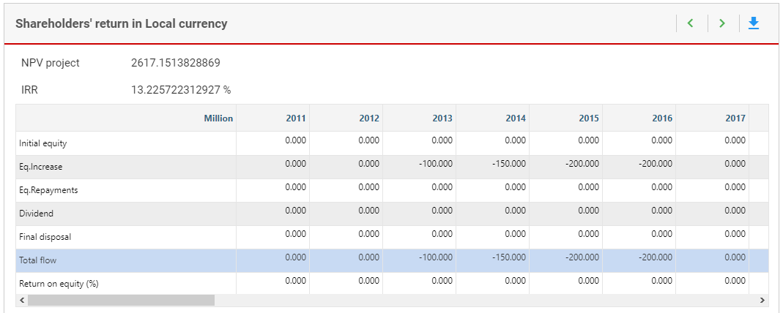
- At the top, it provides shareholders NPV and equity IRR. The concepts of NPV and IRR are explained in the lectures. In this calculation, only the shareholders’ contribution, which is equity, is considered as cost. Benefits include any equity repayments, shareholders earnings (i.e., dividends) and the disposal value of the plant, which is basically the value of selling the project in a specified year. The NPV is positive and the IRR is 13.23%. Both are good, and the project is attractive for the investors.
- The model also calculates the return on equity on annual basis by dividing the dividends in that year to the total equity outstanding. Equity was injected for four years, starting from the year 2013. After 2016, no equity was injected. Therefore, equity outstanding in the year 2017 and onwards is 650 million. The dividends in the year 2021 are 62.3 million Ringgits and equity is 650 million Ringgits. The return on equity is 62.3 divided by 650, which is 9.58%. Next year the dividends increases to 91.5 million Ringgit. However, outstanding equity remains the same at 650 million. Therefore, the return on equity is 14.1%.
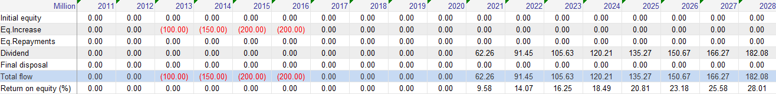
Well done! You now know to interpret the Shareholder’s return sheet.

Activity 3
Calculate the results of the model using financial ratios
A power project has many stakeholders, including the owners, investors, lenders, government and regulators. FINPLAN calculates many financial ratios, which will be interesting for the various stakeholders. We will now have a look at these ratios.
Try it:
- Click on “Financial ratios”. This table will appear.
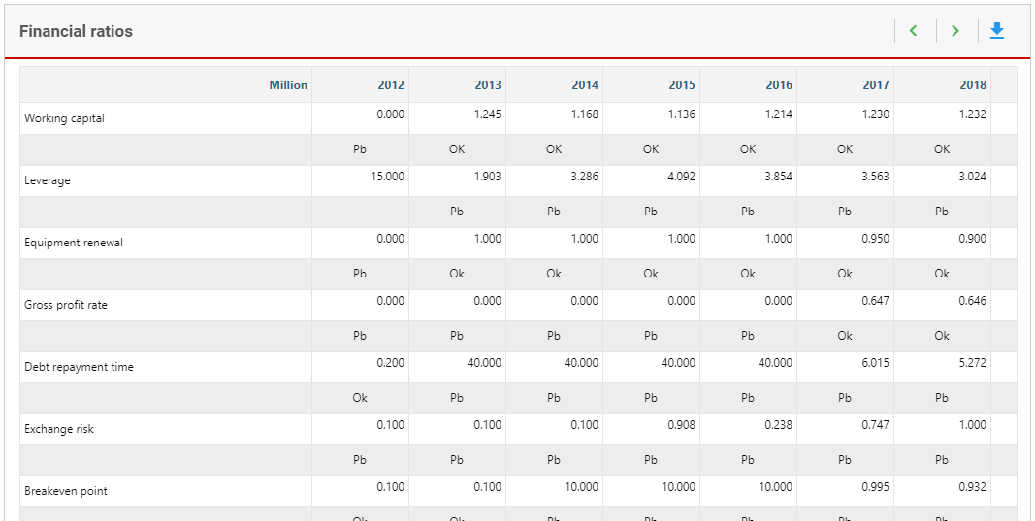
- These ratios determine the financial viability of the project from the viewpoint of different stakeholders. Click on the top right button to export the table to Excel. We explain three ratios: Leverage, Exchange Risk, and Debt Service Coverage. The meaning behind these ratios is explained in the lectures.
- FINPLAN has a default value for each of these ratios and judges the computed value from the project relative to that. If it is less than the default value, then it reports “Pb”, otherwise “OK”. We will explain these ratios one by one.

Activity 3a
Calculate the results of the model using financial ratios – Leverage
Leverage is also known as debt equity ratio. It is especially important during the construction phase and is a key indicator to evaluate the financing of a project from the point of view of a lender. A lender will use this ratio to check if there is sufficient equity as an indication if the shareholders are committed to the project and are covering some of the risk with their own money.
It is simply calculated by dividing debt in a particular year by the equity outstanding in that year. The higher this value, the worse the financial condition of the project from a lender’s perspective, as the assets of the project depend more on debt, indicating a higher danger of bankruptcy. The ratio is especially important during the construction phase, but also interesting during the loan repayment stage.
In FINPLAN, the default debt equity ratio is 60:40, or 1.5. If the leverage in any year is greater than 1.5, it reports it as “Pb” (problematic) and “OK” if it is less than 1.5. If it is problematic, then equity could be increased to bring the ratio down. However, what is acceptable to a lender will very much depend on the type of project and the associated financial risks. The modeller thus needs to judge what he or she thinks is acceptable to the lender. For example, 75 to 25, or 3. Debt and equity would need to be adjusted accordingly to result in this ratio.
If we assume a debt-equity ratio for this project of 75 to 25, then we can see from the table that it is not complied between the years 2014 and 2018. Therefore, this plan may not be acceptable. More equity needs to be injected during the construction years. This will however influence many other financial aspects of the project, for example the NPV or IRR.

Activity 3b
Calculate the results of the model using financial ratios – Exchange Risk Ratio
The principal and interest of a foreign loan due in a year need to be repaid in foreign currency. The company thus needs enough local currency to buy the required foreign currency based on that year’s prevailing exchange rate. The exchange rate varies over the years and may lead to foreign currency risk. This ratio allows checking if in any particular year enough local cash is available to repay a foreign loan and interest, applying that year’s exchange rate.
FINPLAN assumes the default value as 1.2 or a security margin of 20%. That means the local cash available in a particular year should be 20% higher than the local cash needed to buy the required foreign currency to repay foreign loans and interest.
This ratio is important during the loan repayment period. It is clear that the financial plan of our project is not acceptable to the lender, as the exchange risk ratio is less than 1 in 2017, and 1 thereafter. It can be improved by increasing the revenues, that means the electricity price, or replacing some foreign loans or bonds with debt in local currency.
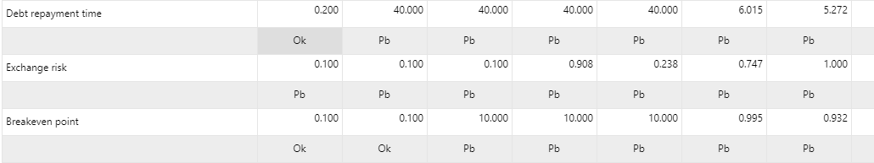

Activity 3c
Calculate the results of the model using financial ratios – Debt Service Coverage
Debt service coverage ratio (DSCR) is important for the lenders. They want to be sure that there is enough cash on the account so that the principal and interest due in any particular year will be repaid.
The default value in FINPLAN for this ratio is 1.3. Therefore, the security margin is 30%. That means cash available in a particular year to repay debt (which is net income before paying interest, plus new equity if there is any) should be 1.3 times or 30% higher than the debt payment (which is the total of interests and principal amount due in that year).
Lenders monitor this indicator during the loan repayment period. If it is less than 1.3, then the modeller should consider if adjustments are required. For example, an option is to increase the price or inject new equity. The DSCR of our project as shown in the table is below this threshold between 2017 and 2022. Thus, the current financial plan of the coal power project may not be acceptable to the lenders.
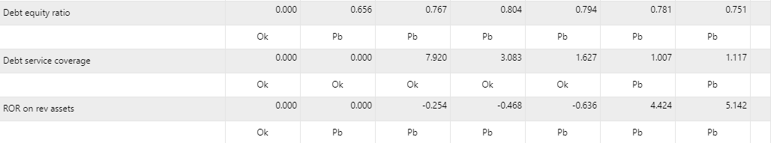
Well done! You now know how to interpret the results of different financial ratios.

Activity 4
If you are not getting the same results as shown in the above screenshots, you may want to download a completed FINPLAN case study for this exercise from this link and restore it to compare the values one-by-one.
Try it:
- Open this link and download the .zip file.

- Navigate to the “Manage case studies” page. Your screen should look like this.
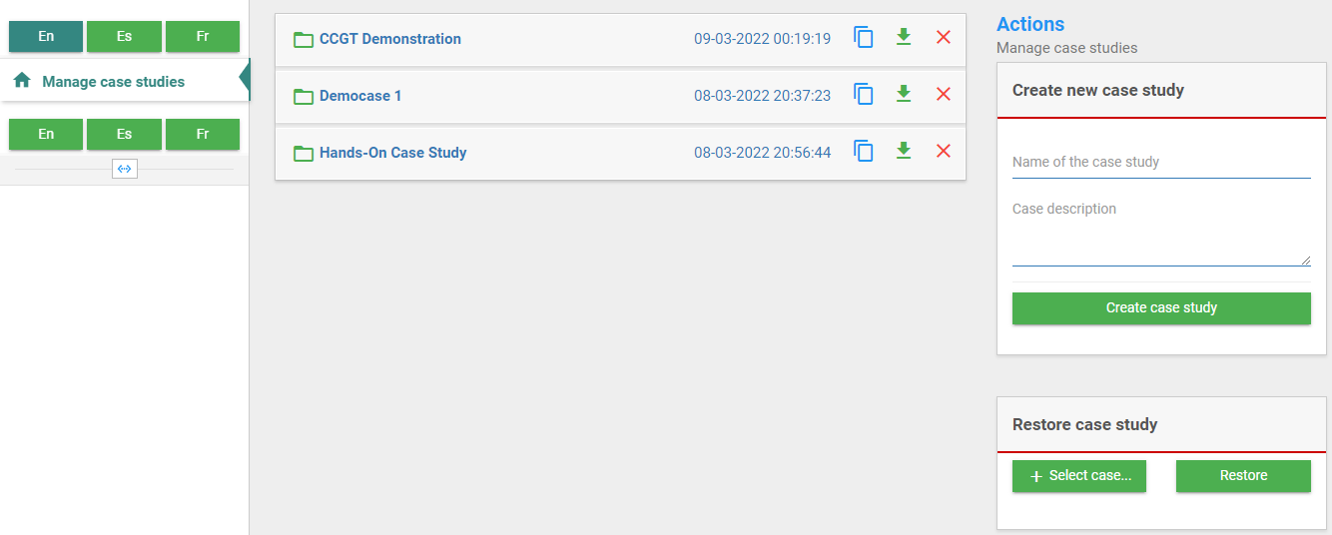
- Go to the “Restore case study” box and click on the green “+ Select case…” box.
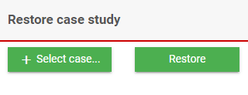
- Double-click on the .zip file that you have just downloaded.
- Click on the green “Restore” box.
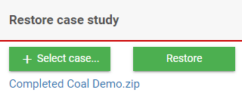
- The completed hands-on exercise case study is now in your FINPLAN software. You can now open it and go through the input data.
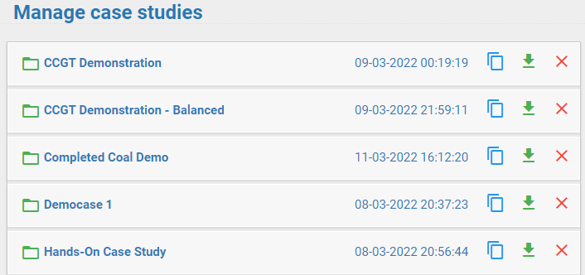
Well done! You now know how to restore case study files.
We have now finished our Malaysian coal power plant case study. In Hands-on 6, we will look into a new combined cycle gas turbine (CCGT) case study.

