FINPLAN
Hands-on 4: FINPLAN Interface

Learning outcomes
By the end of this exercise, you will be able to:
1) Introduce financial data:
a) Equity
b) New Commercial Loans
c) New Bonds
d) Other Financial Data
e) Shareholder’s Return
f) Terms of Project Finance Loan

Activity 1a
Introduce Financial Data – Equity
We will continue with the case study file you were working on in Hands-on 3. First, we will enter data related to equity. Remember to save your data accordingly!
Try it:
- Open the “Hands-On Case Study” file you used in Hands-on 3.
- Click on “Financial manager” on the left menu pane. The “Equity” page will show up, like below.
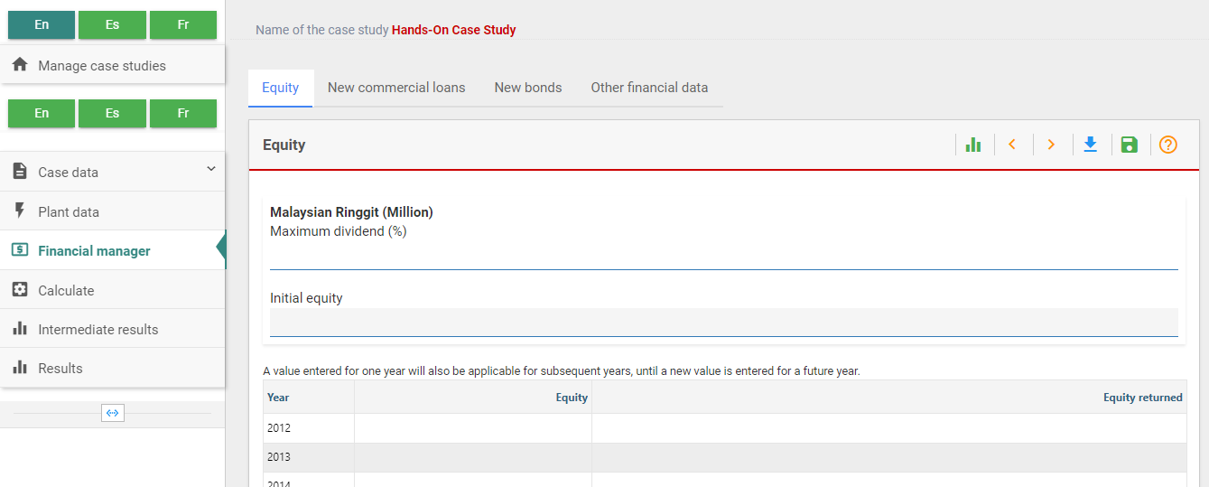
- On this page, we can enter a “Maximum Dividend”. The dividend rate is the dividend paid as percentage of the outstanding equity. We will assume that the maximum dividend that FINPLAN can pay is 50%.
- Equity amounts can be entered for different years whenever needed. It should be noted that equity is always in local currency, i.e., million Ringgit in this case. FINPLAN does not allow foreign equity. We will put some arbitrary numbers, 100 for the year 2013, 150 for 2014 and 200 each for 2015 and 2016.
- Note: If there is a shortage of cash inflows (e.g., when constructing the plant) the model will be withdrawing money from the so-called stand-by-facility to cover the shortfall. If there is a surplus of cash inflows, the model will deposit excess funds to a short-term deposit. See Activity 1d for more information.
- FINPLAN also allows share buy-back, equity withdrawal or equity return, which can be done when a project has enough surplus money after loans are repaid. We will put the number 200 for the years 2029 and 2030, as loan repayment will be completed by the year 2028.
- Save your data.
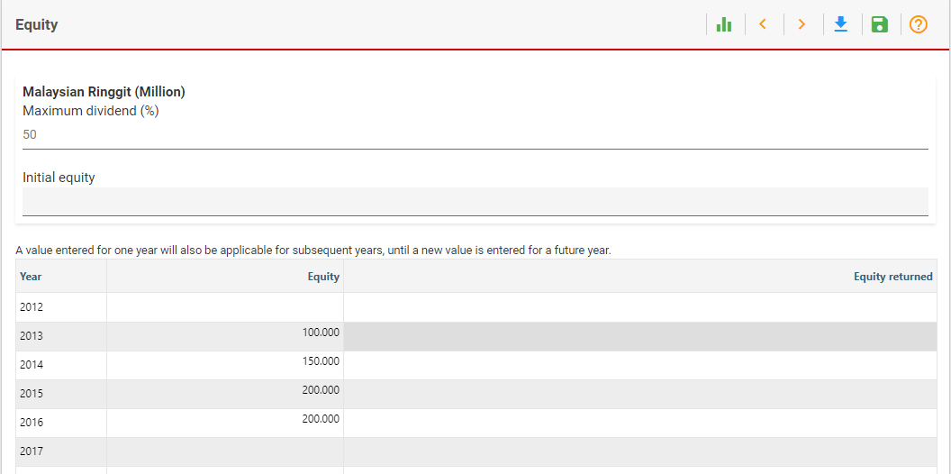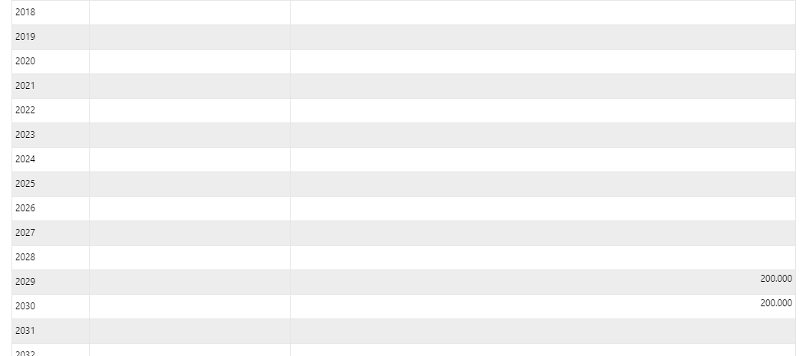

Activity 1b
Introduce Financial Data – New Commercial Loans
Another source of financing are new commercial loans. Click on “New commercial loans” in the top bar. This option allows entering loans from commercial banks in foreign currency, local currency or both. It requires information on interest spread above inflation, term (loan repayment period in years) and loan drawdown (amount of loan to be withdrawn over the years).
For this case study, we will not use new commercial loans, so leave this page blank.
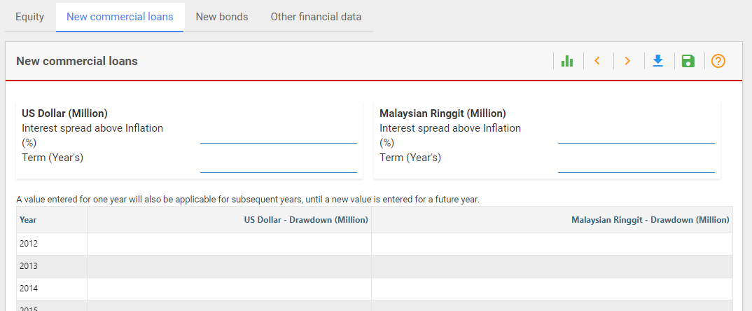

Activity 1c
Introduce Financial Data – New Bonds
FINPLAN allows the owner company to issue new bonds as an option for financing. Click on “New bonds” in the top bar. The owner can issue new bonds in foreign currency, local currency, or both. Data required are the interest rate (“Expected Rate”) and maturity period (“Bonds Term”). Also, the owner can issue bonds several times during the project life. The year of issuance and the amount to be issued can be entered in the time series column.
For this case study, bonds as an option for financing are not used, so leave this page blank.
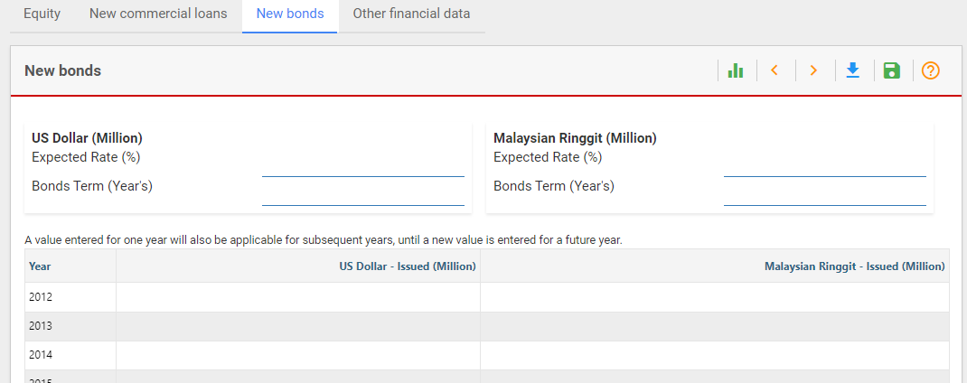

Activity 1d
Introduce Financial Data – Other
FINPLAN offers two possibilities to manage the shortfall and surplus cash: short term deposits and a stand-by facility.
If the project has excess cash in a given year, then the model deposits it in the short-term deposit. A short-term deposit offers a low interest rate. Therefore, it is an inefficient use of cash. Users should always try to minimise the amount in short-term deposits by reducing the available of financial resources or increasing the cash outflows, e.g., by increasing dividends or repaying equity.
If the project has a shortfall of cash, then the model withdraws money from the stand-by facility to bridge the gap. A stand-by facility has a high interest rate and should be avoided whenever possible, e.g., during construction by using alternative sources of finance which have lower costs such as loans, bonds or equity.
We will now provide data related to the short term deposit and stand-by facility.
Try it:
- Click on “Other financial data” in the top bar.
- Here, we can see 3 separate boxes: “Other financial data”, “Shareholder’s return data”, and “Terms of project finance loan”. We will first look at the “Other financial data” box.
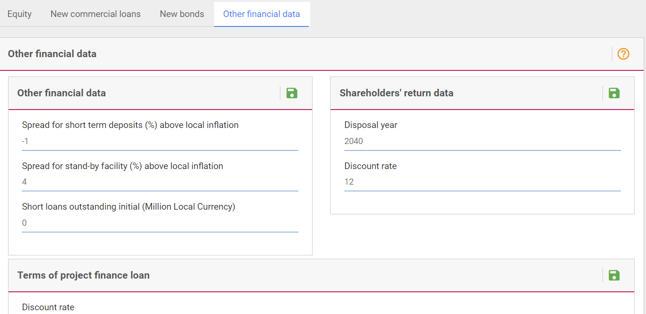
- The first entry is “Spread for short term deposits above local inflation”. Since a short-term deposit provides a very small interest, we will enter -1. This means the interest rate on a short-term deposit is 1 percentage point lower than the inflation rate.
- “Spread for stand-by facility above local inflation”: Since the interest rate for the loan from a stand-by facility is high, we will assume, e.g., 4. This means the interest rate for the stand-by facility loan equals the inflation rate plus 4%. As the inflation rate is 4%, the interest rate on the stand-by facility will then be 8%.
- Last in this box is “Short Loans Outstanding Initial” for the existing company, which is irrelevant here, as we consider project financing without any outstanding loans at the start of the project. We will therefore leave this as 0.
- Save
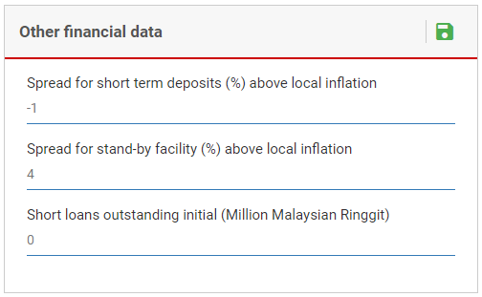

Activity 1e
Introduce Financial Data – Shareholders’ Return
We move to the next item – “Shareholders’ Return”. This data is exclusively used for calculating the Internal Rate of Return (IRR) and the Net Present Value (NPV) for the shareholder's equity.
Try it:
- We will be on the same page as before, but adding data to the box on the right, “Shareholder’s Return Data”.
- The “Disposal year” determines the time period for analysing the return to the shareholders, and the year when all remaining equity will be repaid. Here, we will enter 2046, the last year the project is still in operation.
- To calculate the NPV, a “Discount Rate” is required. We will use 4% for this case study.
- Save
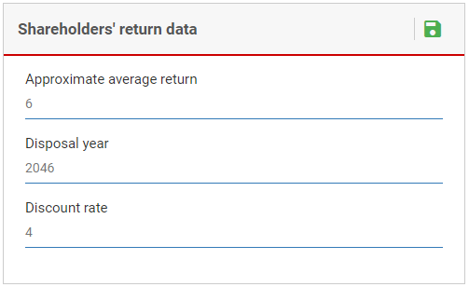

Activity 1f
Introduce Financial Data – Terms of Project Finance Loan
As lending on project financing is completely based on the future cash flow of the project and no collateral (i.e., security for a loan) is involved in it, lenders take extra scrutiny on the project cash flow and the debt servicing capacity of the project is checked. “Terms of project finance loan” provides required information on that.
For safety purposes, lenders require the cash in the project account be a certain percentage higher than the cash needed to pay for the interest and principal amount. The riskier the project is, the higher this percentage needs to be. FINPLAN also calculates the present value of the project cash flow and the maximum project finance loan that can be sustainable for the loan repayment period, as well as the project life for the given security ratio.
Try it:
- We are still on the same page as before, but now looking at the “Terms of project finance loan” box at the bottom of the page.
- We used a discount rate of 4% in the previous section (“Shareholder’s return data”). Therefore, we will continue and use 4% in the “Discount rate” box.
- In Hands-on 3 (“Export Credit 1), we entered a loan term as 12 years. We will therefore continue and use 12 years in “Average Loan Term”.
- Security ratio defines the extra cash requirement of the lender in percentage. Here, we will take “Security Ratio for Loan Period” and “Security Ratio for Project Life” as 1.3, which means cash in the project account at any year should be 30% higher than the cash requirement for debt servicing.
- In Hands-On 3 (“General plant data”), we noted the life of the coal power plant is 30 years. We will therefore use this value for “Expected life of project”.
- “First year of cash to debt service” will be the commissioning year of the plant, which is 2017.
- Save your data.
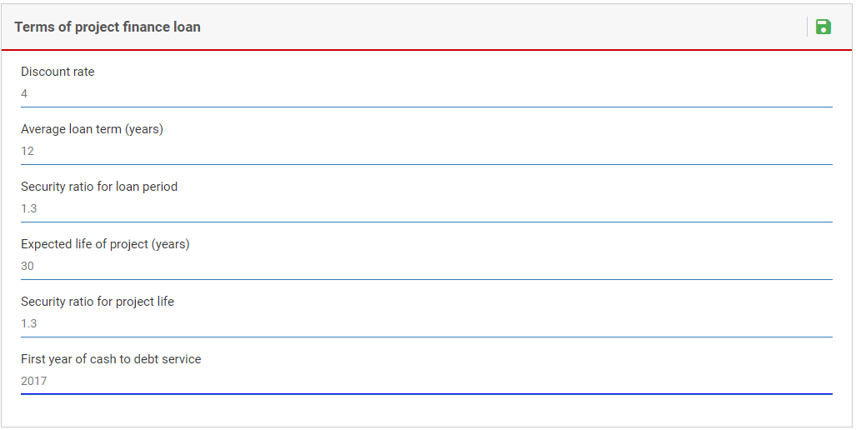
Well done! You have now inputted all the required data in FINPLAN. In the next Hands-on material (Hands-on 5), we will explain running the FINPLAN model and reading results.

