FINPLAN
Hands-on 3: FINPLAN Interface

Learning outcomes
By the end of this exercise, you will be able to:
1) Introduce general plant data
2) Introduce plant data:
a) Production
b) Operation & Maintenance Costs
c) Fuel Costs
d) Investments
e) Sources of Financing
f) Terms of Financing
g) Depreciation
h) Decommissioning

Activity 1
Introduce General Plant Data
We will continue with the file you created in Hands-on 2. After opening it, we need to add data on plant description, such as plant name and plant type.
Try it:
- Click on “Manage case studies” on the left. Now click on your “Hands-On Case Study” that you created in Hands-on 2.
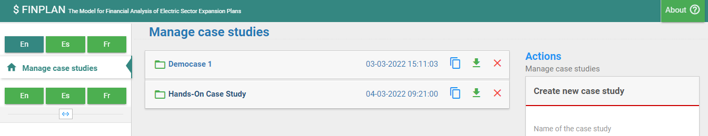
2
1
- Once in your case study, click on “Plant Data”. Your screen will look like the one below. Click on the green + symbol.
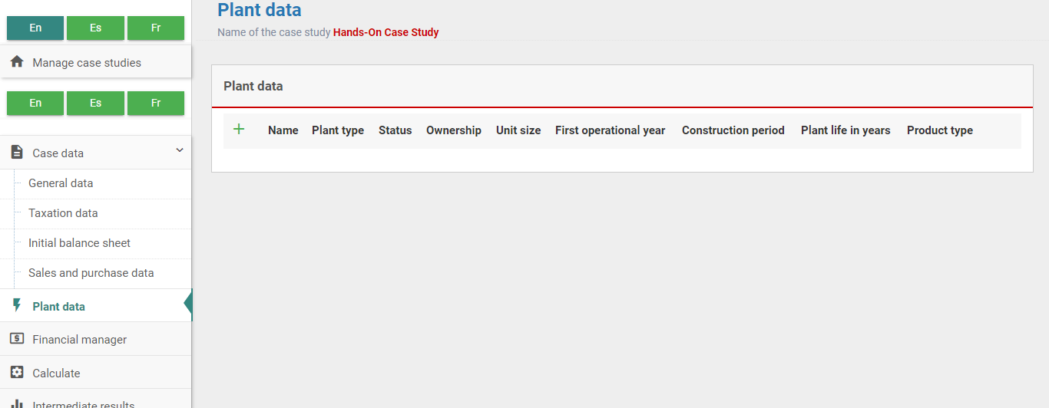
- The following screen will appear. We will use this to add the required plant data.
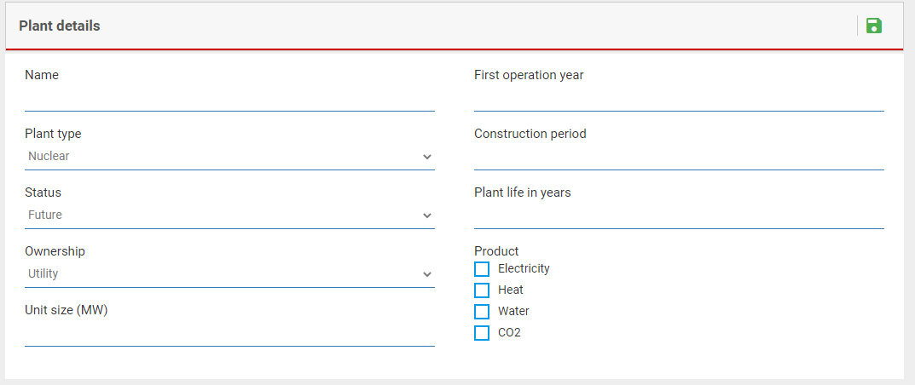
- For “Plant Name”, type in “MCPP” (Malaysian Coal Power Plant).
- In FINPLAN power plants are characterised by the fuel they use, such as nuclear, gas and hydro.. As we are modelling a coal power plant, we will choose “Coal Imported”. Note that for each power plant, a separate data record must be made.
- The status of the plant could be “Existing”, “Future”, or “Committed”. Here, we choose “Future”. If you choose “Existing”, the screen related to capital costs will not appear because capital costs for existing plants are treated as sunk costs. “Future” and “Commited” plants on the other hand are treated equally.
- FINPLAN allows considering both project as well as corporate (or balance sheet) financing. By selecting ‘utility’ under ownership, corporate financing is considered. In this case the new plant is constructed as an asset of an existing company. By selecting ‘IPP’ project financing is considered, assuming the plant is built by an independent power producer (IPP). Our Malaysian power plant will be based on project financing, so “IPP” will be selected under “Ownership”.
- In our case, the unit size considered is the size of the power plant, i.e., 500 MW.
- The first operational year is the commissioning year of the plant, which is 2017.
- The construction period for the coal plant is 4 years.
- The plant life is the lifetime of the plant over which a cash flow will be generated – 30 years in our case.
- It is possible to model a plant selling multiple products like electricity and heat, or electricity and water etc. Here, we will only choose “Electricity”.
- Save your data!
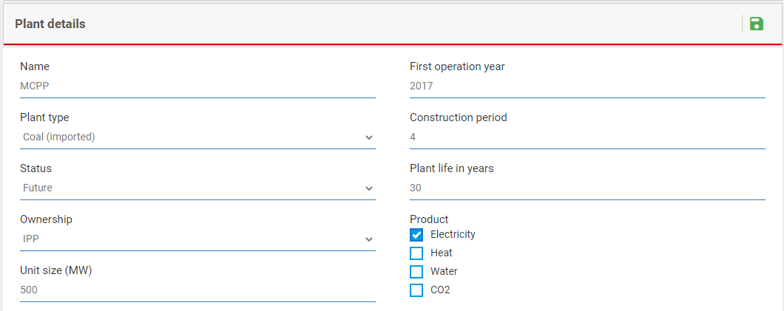
Well done! You now know how to input general plant data.

Activity 2a
Introduce Plant Data – Production
We now need to add data relating to production. Remember to save your data along the way!
Try it:
- In “Plant data”, click on the pencil symbol to edit the data we inputted before.
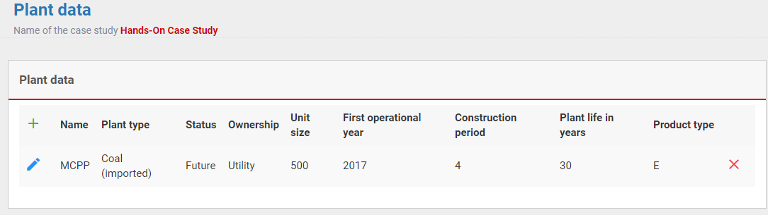
- A menu bar will show up, like below. As we have already filled in information for “Plant data”, we will click on the next tab, “Plant production”.
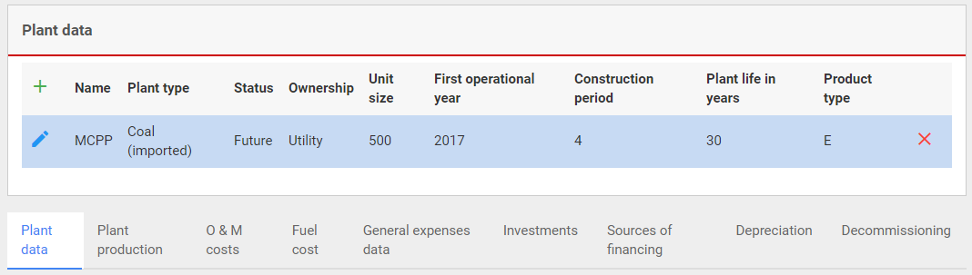
- We assume the plant will produce the same quantity of electricity throughout its lifetime. Therefore, we will enter the annual electricity production data as 3723 GWh for 2017. The model will assume the same number for all other years.
- Save your data.
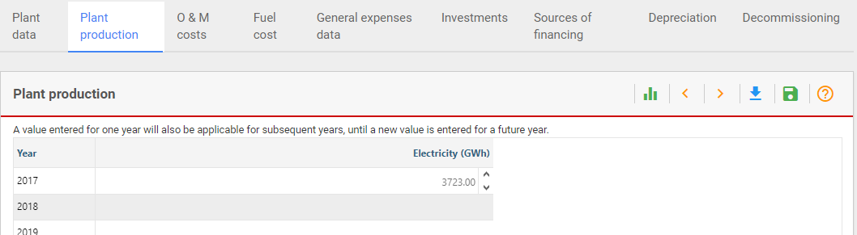

Activity 2b
Introduce Plant Data – Operation and Maintenance Costs
We now need to enter data on operation and maintenance costs. Note that FINPLAN does not treat the variable and fixed operating costs separately. However, it allows the discrimination between the foreign and domestic component of the operating cost, if there is any. For example, sometimes spare parts need to be imported.
Try it:
- Click on “O&M costs” from the top bar.
- We will assume operating and maintenance costs will be paid in local currency and amount to 119 million Ringgit per year, and this will remain the same for the entire project life.
- Save your data.
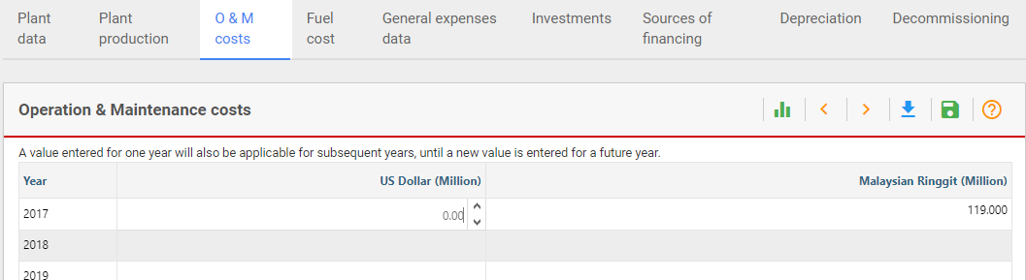

Activity 2c
Introduce Plant Data – Fuel Costs
Next, we will enter data on fuel costs. Like the operating and maintenance costs, FINPLAN allows the discrimination between a foreign and domestic component of the fuel costs.
Try it:
- Go to “Fuel cost” in the top bar.
- Since this power plant uses imported coal, we enter the fuel cost in foreign currency. The annual fuel cost is 159 million US dollars. Put this in the 2017 box.
- Save your data.
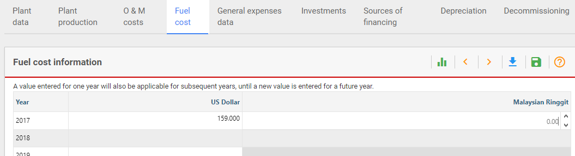

Activity 2d
Introduce Plant Data – Investments
We will now need to enter data on foreign and local components of the investment cost, as well as the annual disbursement of the local and foreign investment costs over the construction period.
Try it:
- Go to “Investments” in the top bar.
- You may recall, we have defined the construction period in the general plant data screen as 4 years with 2017 as the commissioning year, i.e., the first year of operation. Therefore, the construction years are 2013, 2014, 2015 and 2016, which are shown on the screen.
- Data on investments and their percentage distribution over the construction years are noted in the table below. We will enter these data on the screen.
Phasing of the investment | Foreign (%) | Local (%)
2013 | 10 | 30
2014 | 30 | 30
2015 | 40 | 20
2016 | 20 | 20
Phasing of the investment | Foreign (Million US Dollar) | Local (Million Ringgit)
2013 | 60 | 144
2014 | 180 | 144
2015 | 240 | 96
2016 | 120 | 96
Total | 600 | 480
- Save your data.
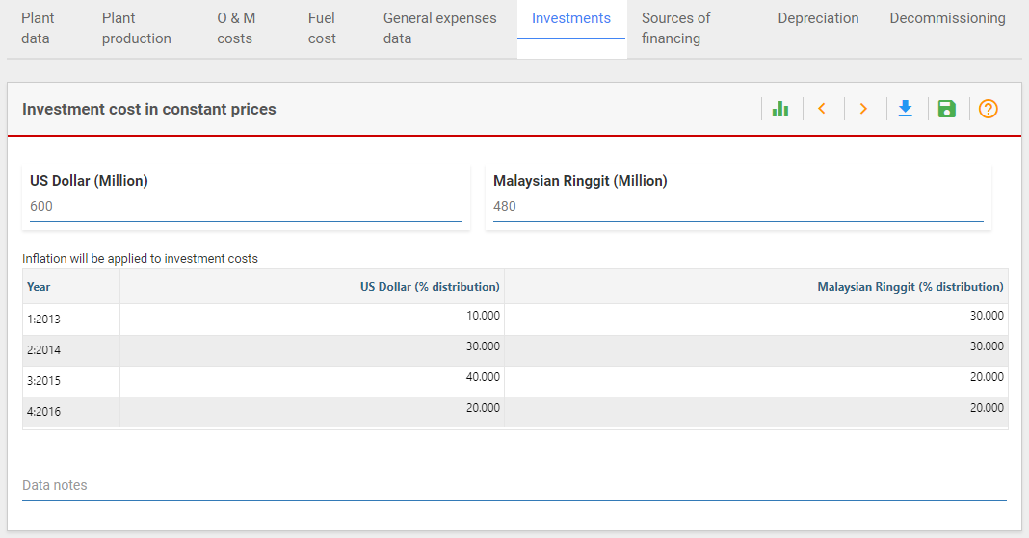

Activity 2e
Introduce Plant Data – Sources of Financing (a)
Next, we need to provide data on “Sources of Financing” i.e., how these local and foreign investments will be financed. Investment expenditures are entered in local currency as well as foreign currency.
Try it:
- Click on “Sources of financing” in the top bar. You will see that there is a drop-down option to choose “US Dollar”, our foreign currency, and “Malaysian Ringgit”, our local currency. We will first go through our foreign currency. Choose “US dollar”.
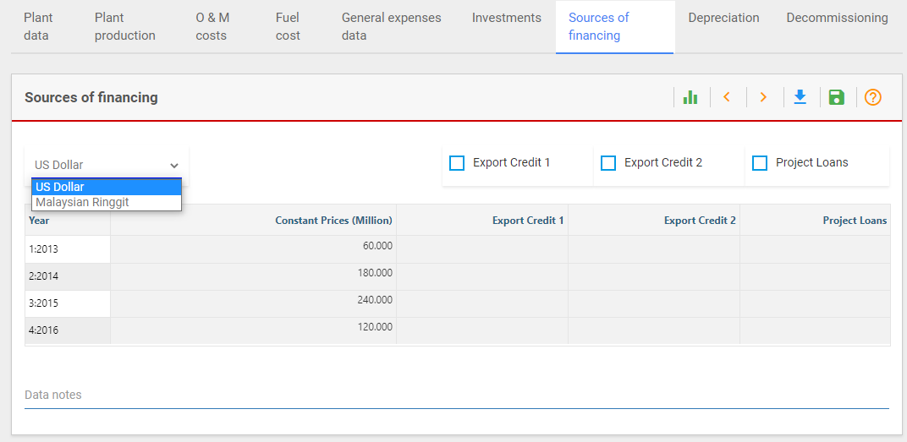
- The page shows annual US Dollar needs over the construction years. For example, in 2013, the foreign currency requirement is 60 million US Dollars.
- On this screen there are three options to finance the projects foreign expenditures: two types of “Export Credit Loans” and one type of “Project Loans”. In this case study, we assume one export credit facility which will supply 85% of the foreign currency requirement. Tick the “Export Credit 1” box at the top and enter the data.
- In our case, the remaining 15% will be met by the project loan. Tick the “Project Loans” box and enter the data. Note that foreign expenditures could have also been financed through commercial loans or bonds as entered on other screens.
- Save your data.
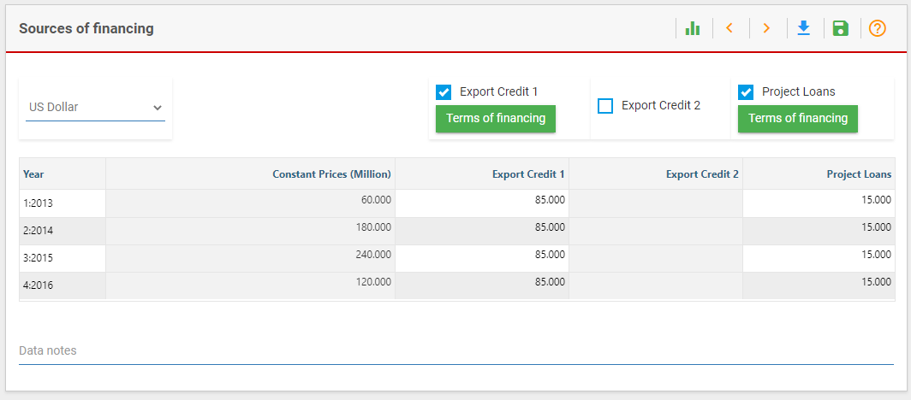

Activity 2e
Introduce Plant Data – Sources of Financing (b)
Next, we must define the sources of supply of the local currency i.e., Malaysian Ringgit. Go back to the drop-down bar and click on “Malaysian Ringgit”.
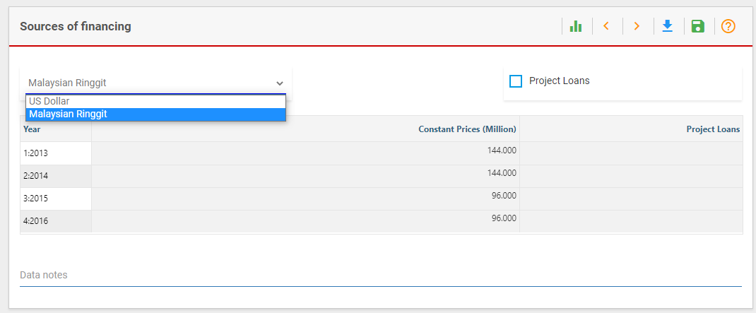
This shows the local currency needs to make the payment for local costs during the construction period. For example, in the year 2013, 144 million Ringgit are needed to cover the local construction related expenses. This screen provides only one option, “Project Loans”, as a source of meeting local investment related costs. However, local needs can also be met through the project sponsor's equity, commercial loans or bonds, which are entered on other screens. For this project, we will use equity to pay for the local construction related expenses, and we will leave the project loan option blank.

Activity 2f
Introduce Plant Data – Terms of Financing (a)
In this part, we will define the various terms related to export credit financing and project loan.
Try it:
- In the “Sources of financing” tab, choose “US Dollars” from the drop-down menu. Click on the “Terms of financing” button under “Export Credit 1”.
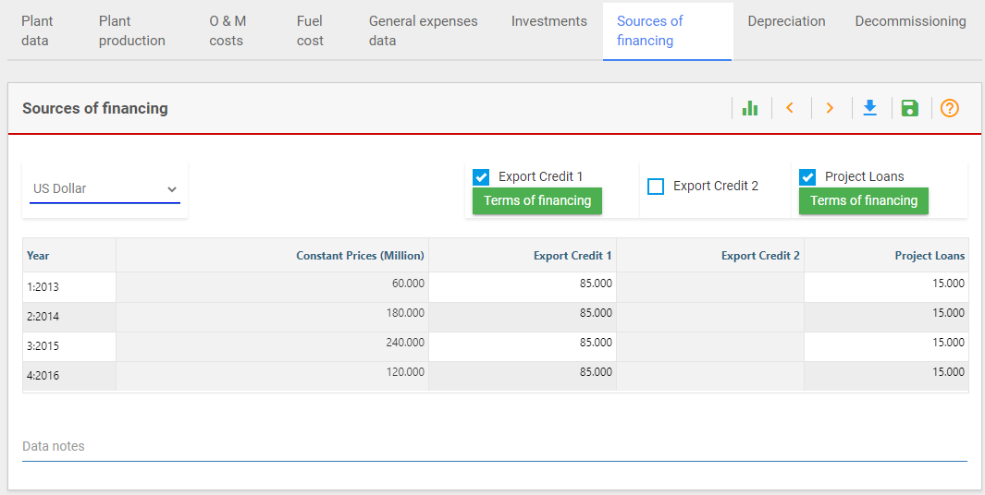

- The following window will appear. We can see that the amount to be financed through export credit financing is 510 million US Dollars.
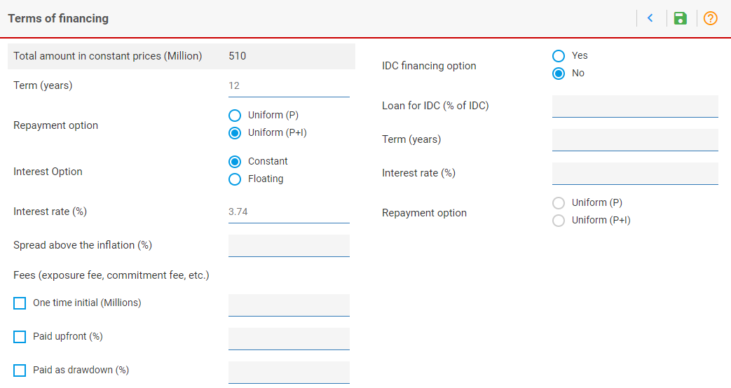
- “Term” implies the maturity period or repayment years over which the loan will be repaid. Loan repayment starts only when the project goes online and generates revenues, in our case 2017. We will enter the loan term as 12 years.
- FINPLAN allows two types of loan repayment options: “P+I” and “P”. “Uniform (P+I)” deducts a constant amount every year, which includes both principal and interest. “Uniform (P)” means every year a constant amount of the principal will be repaid. In this example, we will choose “Uniform (P+I)”.
- FINPLAN allows two types of interest options: fixed rate (“Constant”) and variable rate (“Floating”). “Interest Rate” is used for entering the fixed rate to be applied for the entire loan period. “Spread Above the Inflation” is the spread amount when selecting “floating”. Note that in this case the interest rate in a particular year is the inflation rate in that year plus the spread. In this case, we will choose a fixed rate (“Constant”). of 3.74%, which is 100 basis points (i.e., 1%) higher than the commercial interest reference rate or CIRR.
- Save your data.

Note: “Export Credit 2” is defined in the same way as “Export Credit 1”. However, in this case, we are only using one export credit option, so we will ignore “Export Credit 2”.

Activity 2f
Introduce Plant Data – Terms of Financing (b)
We now need to add more data on financing.
Try it:
- Click on the back symbol in the top right corner to go back to the previous page.
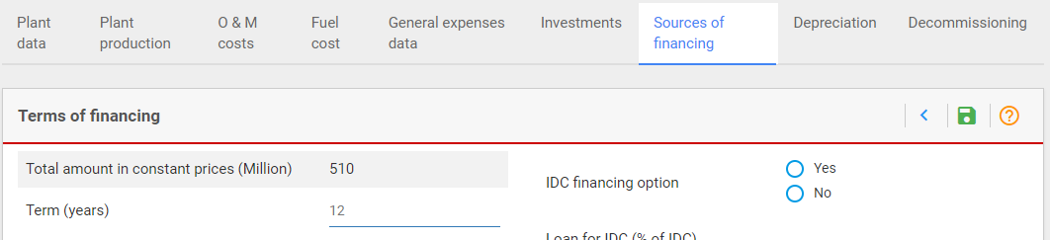
- Now click on the “Terms of financing” box under “Project Loans”.
- We can see that 90 million US dollars will be financed through project loans.
- Term is again the number of years for repaying the loan. We will assume its 8 years.
- Two types of interest rates are allowed: fixed rate and variable. In this case, we will choose the variable rate (“Floating”), with a spread of 150 basis points, or 1.5%, over the inflation rate.
- Save your data.
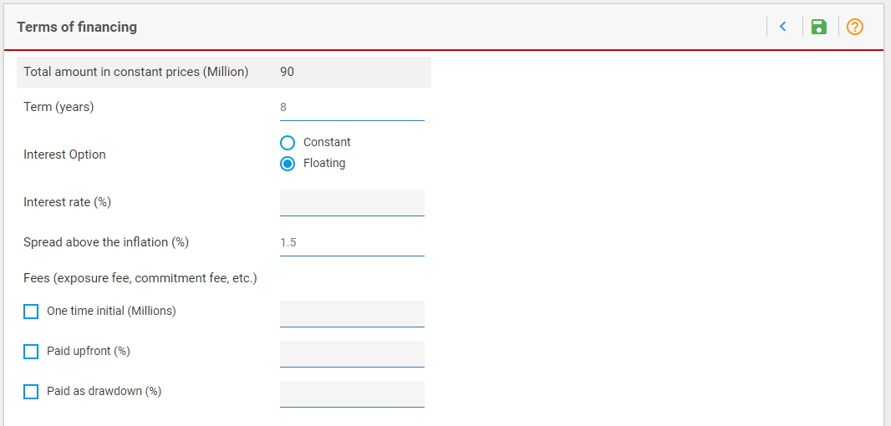

Activity 2g
Introduce Plant Data - Depreciation
We will now enter data on depreciation.
Try it:
- Click on “Depreciation” in the top bar.
- FINPLAN allows four different types of depreciation, explained in the lectures. For this case study, we will choose “Linear” depreciation.
- We assume the plant will depreciate over 20 years.
- Save your data.
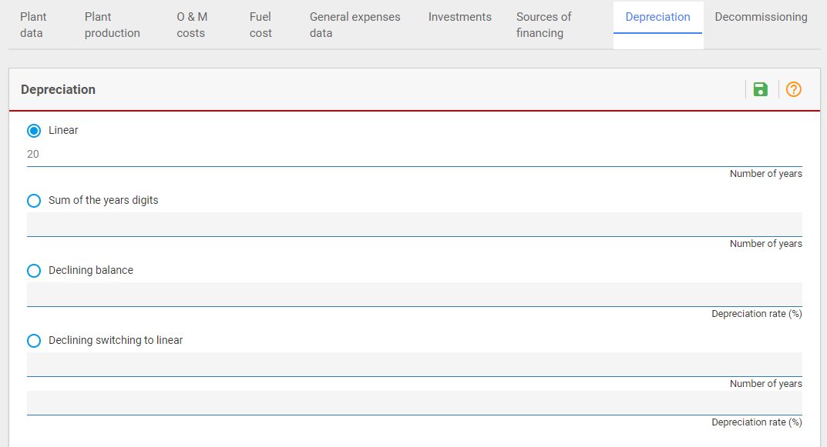

Activity 2h
Introduce Plant Data – Decommissioning
Click on “Decommissioning” and then “Edit”. FINPLAN allows two ways of depositing decommissioning cost: as “Trust” or “Fund”. For “Trust”, decommissioning cost will be collected from the owner and deposited with a trust. For “Fund”, decommissioning money which is collected stays within the company, and will appear in the company account, in the balance sheet, and so on.
“Start Year of the Fund Raising” is the first year when the collection of costs starts. “Year of Decommissioning” is the first year when decommissioning of the plant starts. The decommissioning fund can be collected in foreign or local currency, or both.
In our example, we will not apply a decommissioning cost to our coal power plant. We will therefore leave this blank.
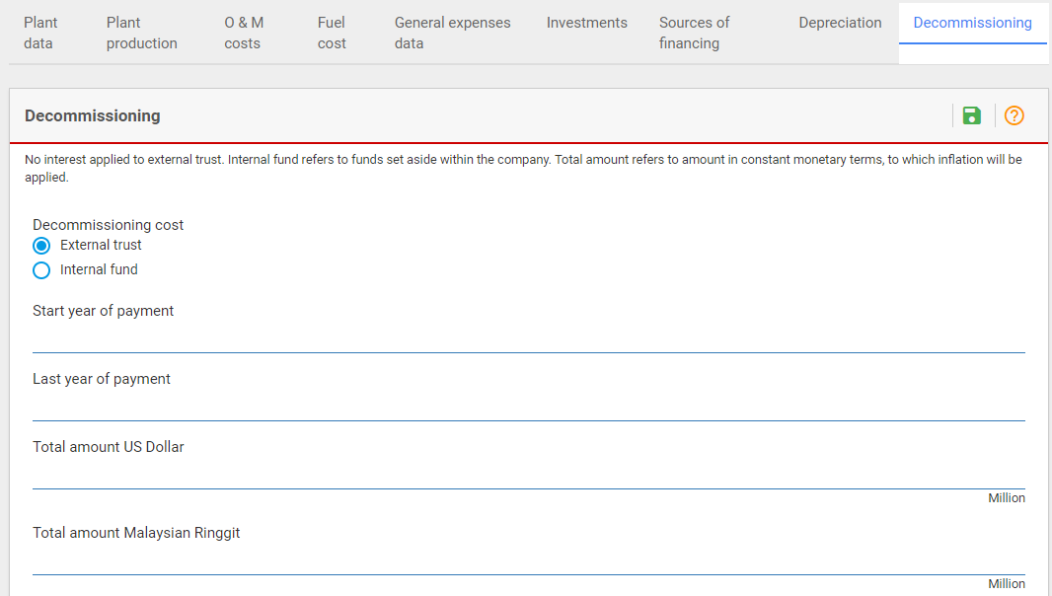
Well done! You have now inputted all the required plant data for our illustrative coal power plant. We will continue with this FINPLAN case study in Hands-on 4, where we will input financial data.

