FINPLAN
Hands-on 2: FINPLAN Interface
Useful references:
- Video Tutorials
- FINPLAN Discussion Forum

Learning outcomes
By the end of this exercise, you will be able to:
1) Create a new case study in FINPLAN
2) Describe a case study in FINPLAN
3) Introduce data for a case study in FINPLAN, specifically:
a) Inflation
b) Currency Exchange Rate
c) Tax & Depreciation
d) Royalty Payment
e) Initial Balance Sheet & History
f) Sales & Purchase Data

Activity 1
Create a New Case Study in FINPLAN
- Open FINPLAN on your desktop and click on the “Manage case studies” button.
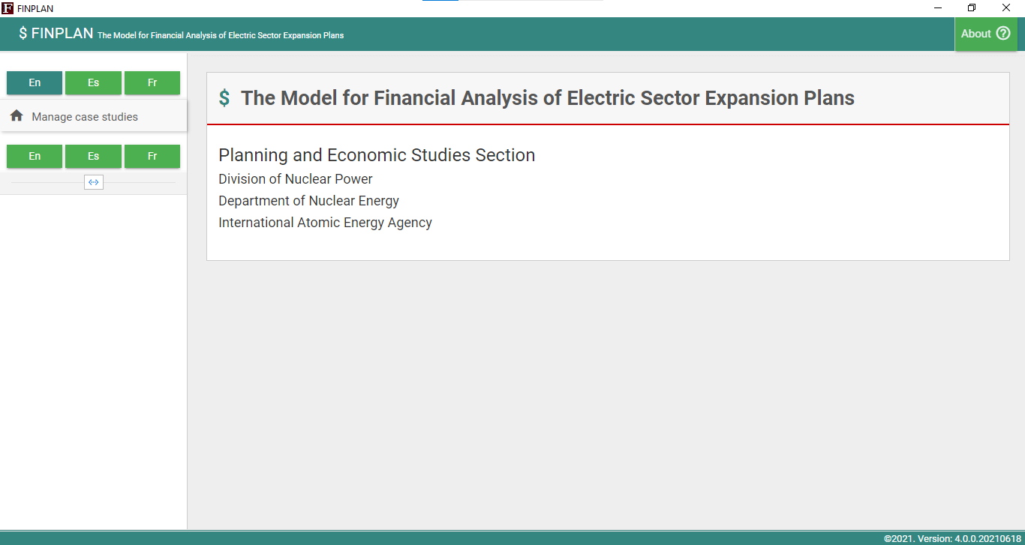
- The following screen will appear. As we want to build a new case study, we will go to “Create new case study” on the right.
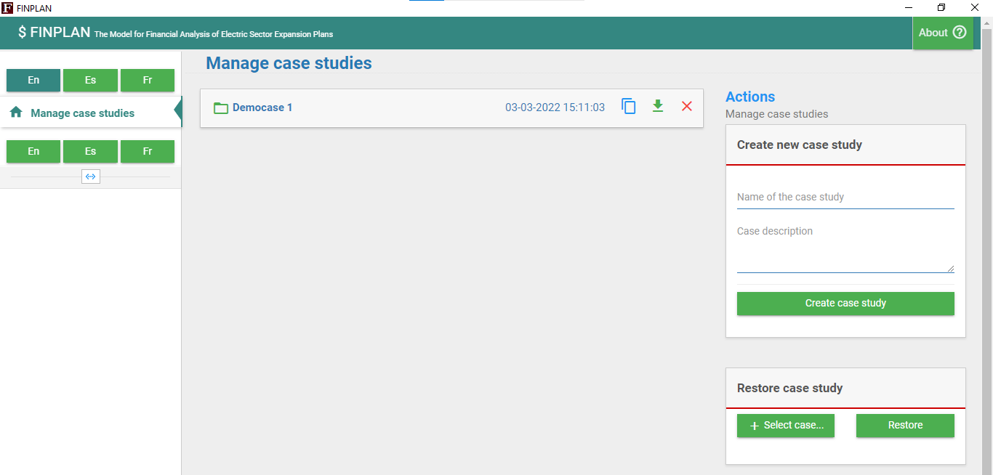
- For “Name of the case study”, we will write “Hands-On Case Study”.
- In “Case description”, we will write “Demonstration of the FINPLAN interface with an illustrative coal-based power plant project in Malaysia”.
- Now click on “Create case study”.
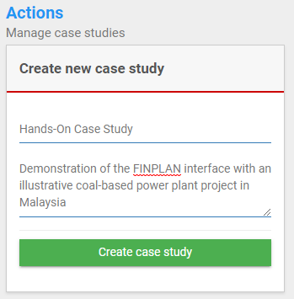
- You have now created a new case study! Your new case study file can now be found under “Manage case studies”. Note that you can also “copy”, “backup” (export as a .zip file), and “delete” your case studies.
Backup
Delete
Copy
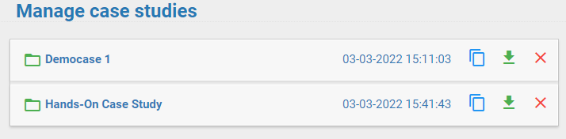
Well done! You now know how to create a new FINPLAN case. We will look at how to input specific case study information in the following sections.

Activity 2
Describe the New Case Study in FINPLAN
We will need to provide general information such as plant type, start year and end year in this new FINPLAN case study.
Try it:
- “Name of the case study” has been pre-filled for us from when we created the file in the previous section. Therefore, we will not change it.
- We will need to choose the first year of the study, that is the year of the analysis, which is also the base year. Here, we will type “2012”. The base year should preferably be a normal year, free from any major macro-economic and financial events.
- We will need to define the study horizon by choosing the last year of the analysis period. We will choose “2046” as the last year of the plant life.
- The next box is “Study type”, you can choose between “Single Plant”, “Utility” or “Power System”. This is just for information purposes and will not affect the FINPLAN model. In this hands-on, we will choose “Single Plant”.
- “Case description” has been pre-filled for us, from when we created the file in the previous section. Therefore, we will not change it.
- As our illustrative coal power plant is in Malaysia, we will choose “Malaysian Ringgit” as our “Local Currency”.
- Next, we specify “Foreign Currencies”. Most of the developing countries import major components of a power plant and need foreign currency to pay for that. Foreign currencies are obtained from foreign sources through loans or other means and need to be repaid in foreign currency. For this example, we will choose “US Dollar”. Do this by dragging the currency to the box on the right. Note that it is possible to select multiple foreign currencies.
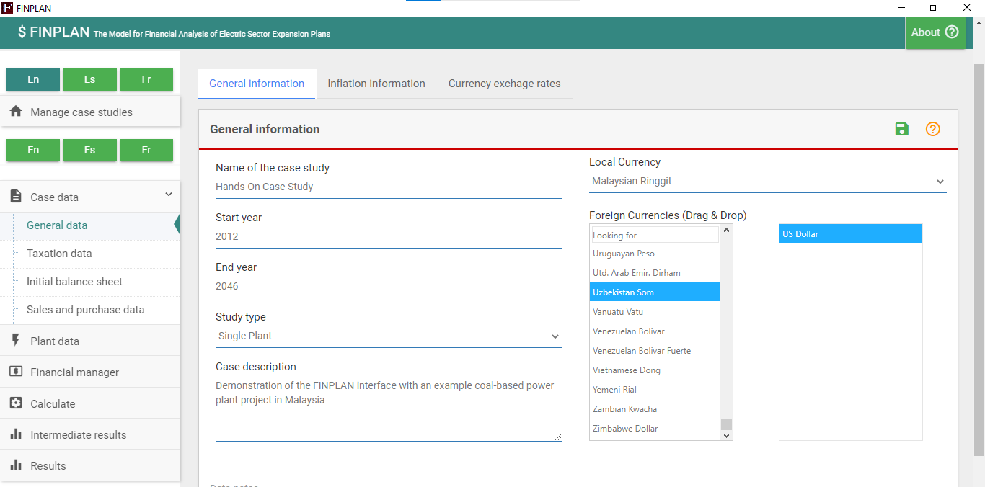
- Once done, click on the “Save” button at the top right to go to the next page. Do not forget to click this button after each edit, otherwise you will lose your data.
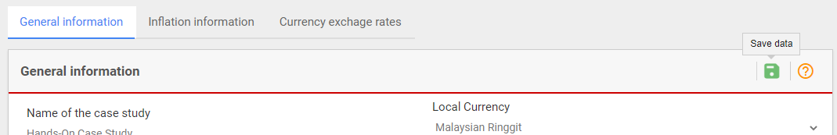
Well done! Now you know how to provide general information to a new case study.

Activity 3a
Introduce Case Data – Inflation
We now need to add data such as current and future inflation information for the domestic currency and all foreign currencies.
Try it:
- We will move onto the next section. Click on “Inflation information” at the top ribbon. Your page should look like this. Here, we see our foreign currency, US dollar, and our local currency, Malaysian Ringgit. It should be noted that the calculations in FINPLAN are based on the domestic currency and on current prices using inflation data.
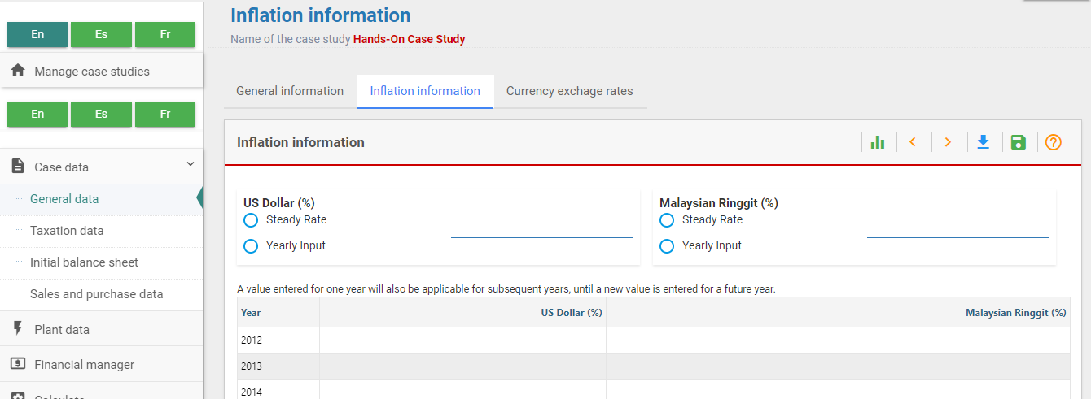
- For defining the future inflation rate, there are two options. Choose the “Steady Rate” option if the future inflation rate remains constant over the study period. If the future inflation rate varies every year over the study period, select “Yearly Inflation Rate”. With this option, you can fill the future annual data on inflation rate in the empty boxes further below. For this example, we will choose the “Steady Rate” option, with the future US dollar inflation rate remaining constant at 3% per annum and 4% per annum for the domestic currency.
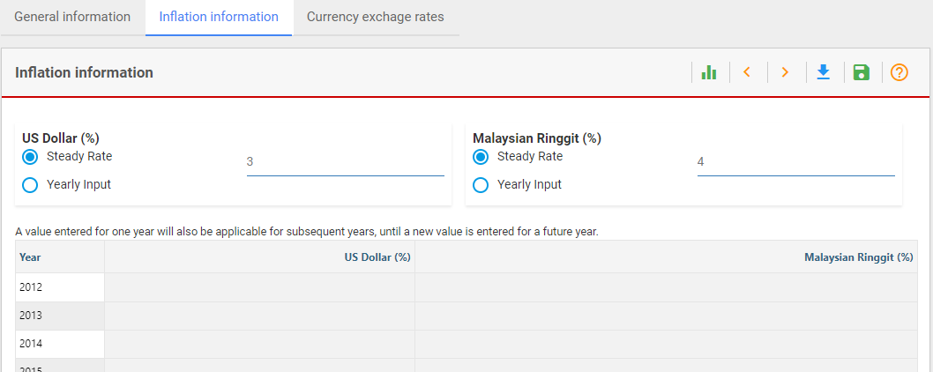
- Remember to click on “Save” at the top right of the page.
Well done! You now know how to include inflation rates in a case study.

Activity 3b
Introduce Case Data – Currency Exchange Rate
We now need to include data to specify the currency exchange between US dollar and Malaysian Ringgit. FINPLAN will do all calculations in the domestic currency using this data.
Try it:
- Click on “Currency exchange rates” in the top ribbon. Your page should look like the one below.
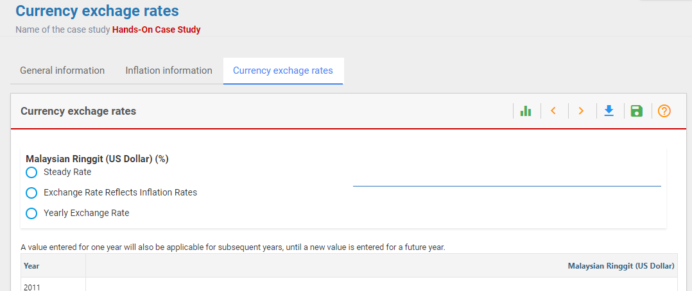
- Exchange rate information for US dollar to the domestic currency Malaysian Ringgit needs to be provided for the base year, as well as for future years. The exchange rate for the base year 2012 is 3.2.
- There are three options for defining data on future exchange rates:
  - “Steady Change”: the foreign currency exchange rate will change at a constant percentage rate per year.
  - “Exchange Rate Reflects Inflation Rates”: exchange rate will appreciate or depreciate at the rate of difference between the inflation rates of foreign currency and domestic currency.
  - “Yearly Exchange Rate”: if projections for exchange rates for future years are available, the user can use this option.
We will choose “Exchange Rate Reflects Inflation Rates”. In this case, future inflation rates for Dollar and Ringgit are assumed constant at 3% and 4% per annum, respectively (as stated in the previous section). Therefore, domestic currency will depreciate at the rate of 4 minus 3, that is 1% per year.
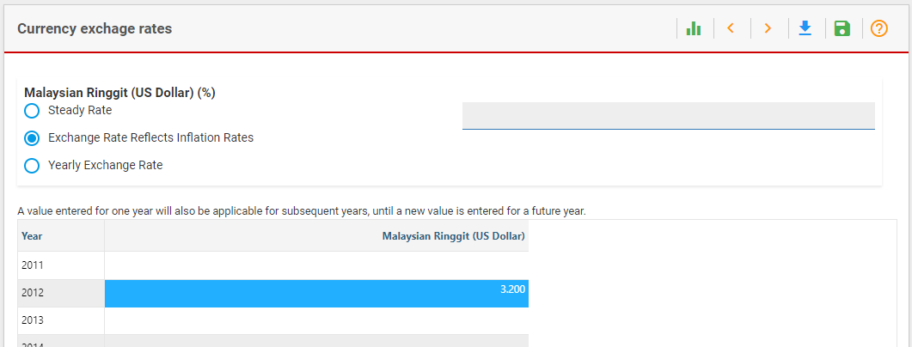
Well done! You now know how to add a currency exchange rate. Remember to click “Save”!

Activity 3c
Introduce Case Data – Tax and Depreciation
We now need to add data on taxation.
Try it:
- Click on “Taxation data” on the left menu pane. You should now be in the “Tax and depreciation information” page.
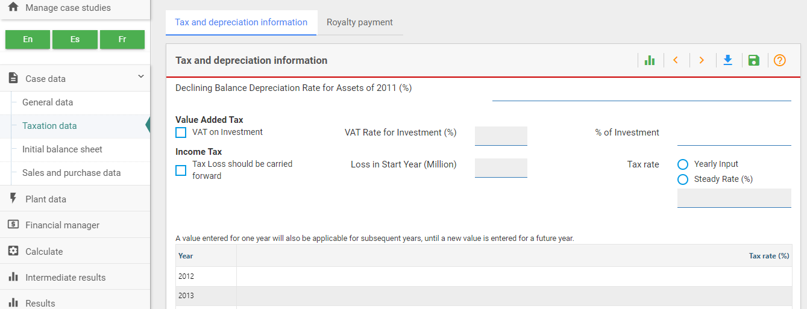
- In case of balance sheet financing (project is part of a company’s balance sheet), data on the yearly depreciation rate of existing assets can be defined. However, for project financing, this is not needed as the company is new and there are no existing assets.
- Most countries impose value added tax on the purchase of equipment, materials, etc., when constructing a new power plant. If VAT is applicable, tick the “VAT on Investment” box and provide the data on VAT rate. We will assume 10% as VAT rate for Malaysia.
- It is possible that VAT is not applicable to the entire investment amount. For example, some components can be exempted from VAT by the country's tax policy. In that case, please mention the percentage of investment under VAT. We will assume VAT is applicable to 80% of the total investment expenses.
- Tick “Tax Loss should be carried forward” if your country allows this. We will tick this for this hands-on.
- There are two options for the input of data on income tax or corporate tax: “Yearly Input”, when the tax rate varies from one year to another, and “Steady Rate”, when the tax rate remains constant for all years. “Yearly Input” will allow you to fill the year-wise tax rate data. We will choose the “Steady Rate” option for this example, and enter a corporate tax rate of 25% for Malaysia.
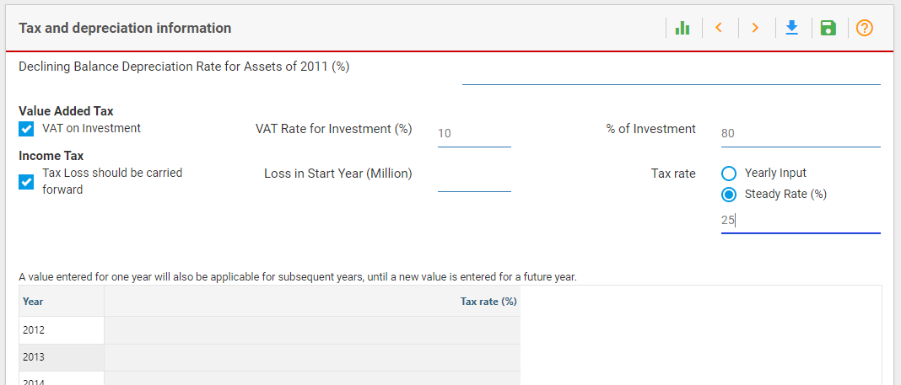
Well done! You now know how to add tax and depreciation data. Remember to press “Save”!

Activity 3d
Introduce Case Data – Royalty Payment
Go to “Royalty Payment” using the ribbon at the top of the page. Royalties are usage-based payments made by one party, the "licensee", to another, the "licensor", for the right to the ongoing use of an asset, sometimes an intellectual property, patent, trademark, copyrights, or even resource. Royalties are typically agreed upon as a percentage of gross or net revenues, derived from the use of an asset; or as a fixed price per unit sold, but there are also other modes and metrics of compensation.
FINPLAN allows two modes for royalty calculation. When only “Royalty Rate” is entered, FINPLAN calculates royalties using the royalty rate as a percentage of total revenues.
FINPLAN also allows to subtract a certain percentage of total operating costs from the revenue to calculate net revenues. Then, the royalty rate is applied to the net revenue to calculate the amount of royalties to be paid. In that case, in addition to royalty rate, data on the percentage costs are required. For this power plant, we assume royalty is not applicable.
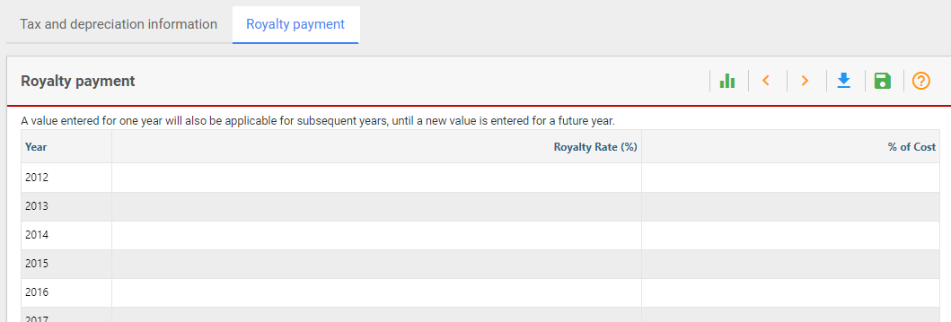

Activity 3e
Introduce Case Data – Initial Balance Sheet and History
We will now go through the “Initial Balance Sheet”. Locate this page from the menu pane on the left. Since we are developing a project finance case without an existing balance sheet, we will skip this.
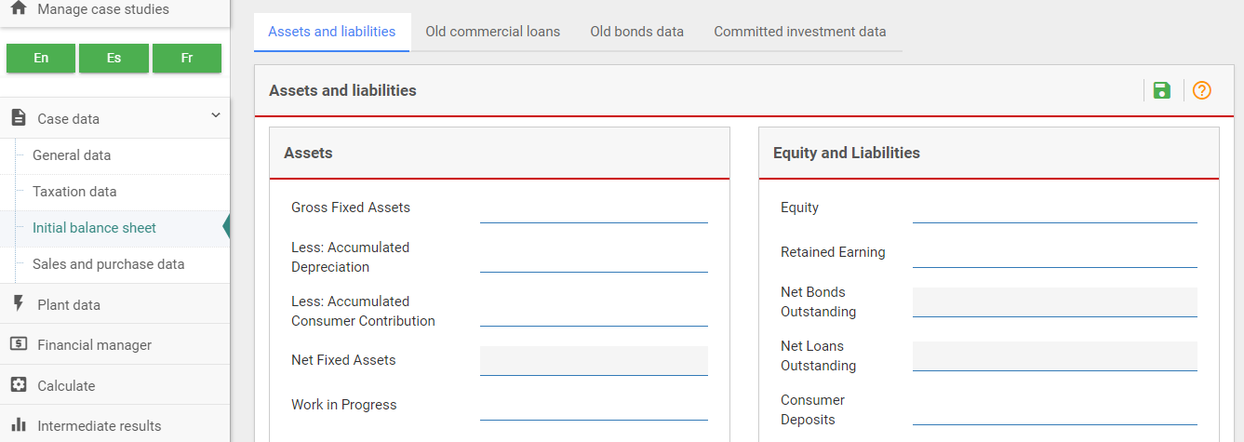

Activity 3f
Introduce Case Data – Sales and Purchase Data
We will now need to add data regarding sales.
Try it:
- Go to “Sales and purchase data” on the left menu pane. The first page you will see is the “Sales data” page. Click on the green + symbol.
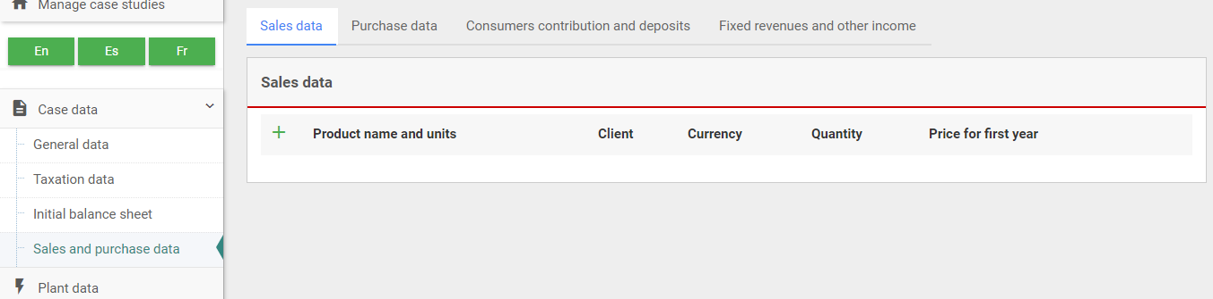
- The following screen will appear. In “Product Name & Units”, the user can choose the various products associated with the power plant: electricity, heat, water, and CO₂. For each of these products, a data screen needs to be defined. In this example, we will only choose electricity from the list.
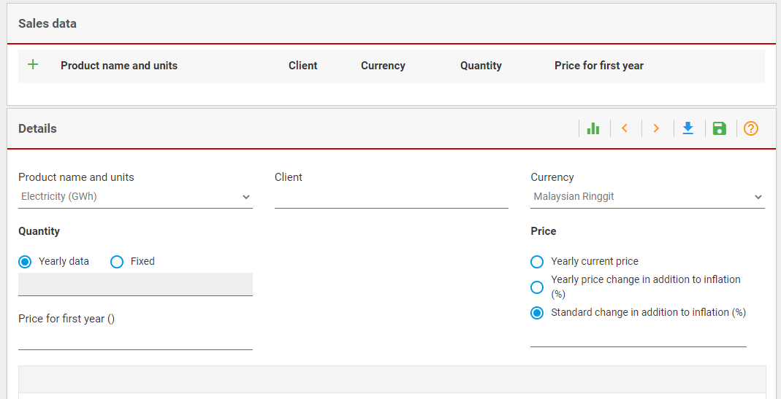
- FINPLAN also allows to sell electricity to different customers at different quantities and prices. For each customer, a separate data screen needs to be defined. In this example we will only select one customer, Malaysian Utility Company (MUC).
- To reduce the exchange rate fluctuation risk, IPPs sometime demand an electricity price in foreign currency. Therefore, FINPLAN can represent electricity prices in local as well as foreign currency. We chose the local currency Ringgit.
- The quantity of electricity to be sold can be presented as a fixed quantity or as yearly data (when quantities vary from year to year). We suggest not to choose the fixed quantity, as this would mean electricity is being sold from the first modelling year onwards, when the plant is not yet built. Instead, use yearly data. Enter the number for a year and FINPLAN will apply this quantity for all subsequent years until a new value is entered. Here, we will define the quantity for 2017, which is the first year of the plant’s operation.
- Data on the annual quantity of electricity to be sold needs to be entered. Here, the base price of electricity is 0.25 Ringgit per kWh.
- In the box “Price for First Year”, input this price for the first year. Regarding the future price development, FINPLAN provides three options:
  - “Yearly Current Price”: if projections for a yearly future price are available.
  - “Yearly Price Change in Addition to Inflation”: price grows at a rate equal to inflation plus an additional percentage which can be defined for each year. Entering a negative value will result in a price increase lower than inflation.
  - “Standard Change in Addition to Inflation”: price grows at a rate equal to inflation plus a constant percentage defined once for all years. Entering a negative value will result in a price increase lower than inflation.
For this example, we will choose “Yearly Price Change in Addition to Inflation”, but without actually entering any price change. In this case, FINPLAN will increase the electricity price with the inflation rate. Alternatively, we could have also selected “Standard Change in Addition to Inflation”, entering 0% in the field just below.
- The annual quantity of electricity to be sold is 3500 GWh. This will be entered in 2017, which is the first year the plant operates.
- Remember to press “Save”!
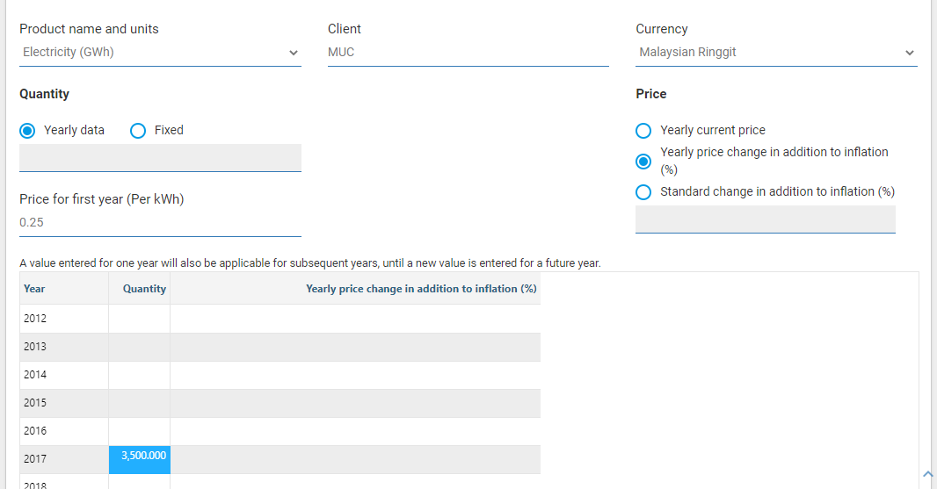
- You will also find another tab called “Customers Contribution & Deposits”. In some countries, (industrial) consumers contribute to the cost of constructing a plant. Existing utilities may also require consumer deposits as a security for their connection. In the FINPLAN model data to specify consumer contributions and deposits are entered under "Consumers Contribution and Deposits”. However, since the current plant is built as an IPP under a new project company and does not sell electricity directly to the consumers, the consumer's contribution is ignored. Plants may have sources of revenue other than from the electricity sales which could be included. However, in our case we do not consider such revenues.
- We also ignore the other tabs (Purchase data, Fixed revenues and other income) for this hands-on exercise.
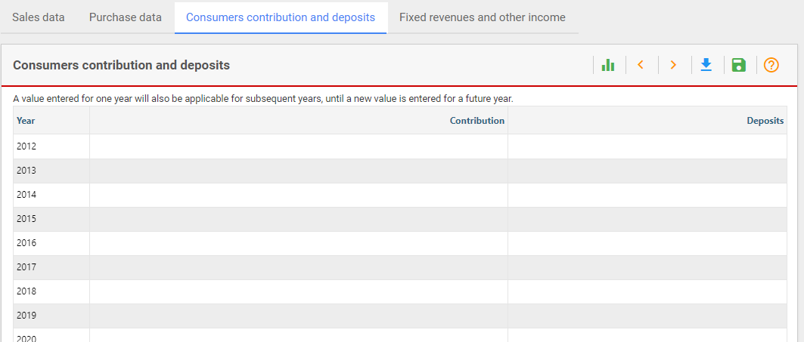
Well done! You have now added all the required Case data. We will continue with this exercise in the next hands-on, where we will look at plant data.

