FINPLAN
Hands-on 1: Installing FINPLAN
Useful references:
- Video Tutorials
- FINPLAN Discussion Forum

Learning outcomes
By the end of this exercise, you will be able to:
1) Install FINPLAN
2) Access additional FINPLAN information
Note: The current FINPLAN software is only compatible with a Windows 10 machine. The software is not compatible with iOS/Mac operating systems.

Activity 1
Install FINPLAN: To download the software, click on this link.
Try it:
- Click on the link. You will see the following page, which is a survey.
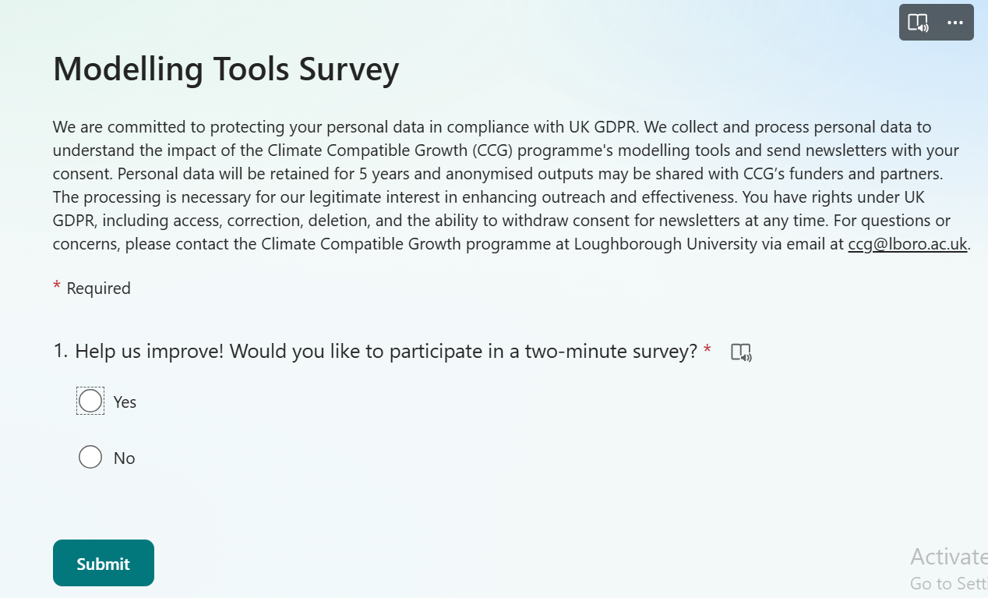
- The purpose of the survey is for CCG to understand the impact of the modelling tools. As mentioned on the survey, your data will be collected for reporting purposes only and will not be shared. If you would like to complete the short survey, click on “Yes”. If you do not want to complete the survey, click on “No”.
- If you click on “Yes”, 10 more questions will appear. Answer all the questions accordingly and click on “Submit” at the bottom of the page. The link to FINPLAN will then be provided immediately.
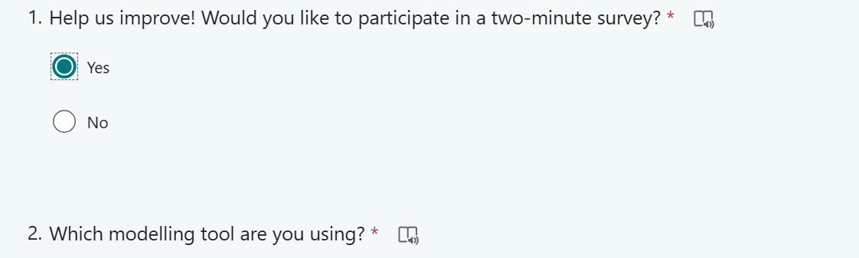
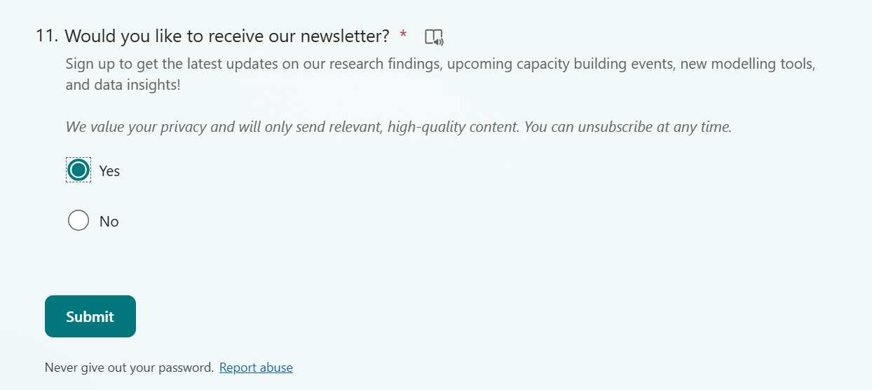
- If you click on “No”, click on the “Submit” button below it. The link to the FINPLAN executable will be provided straight after.
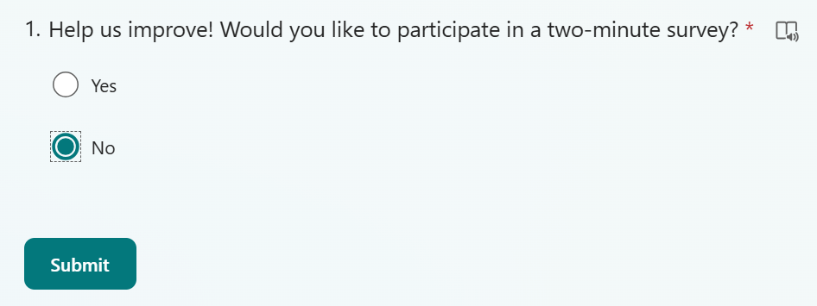
- Upon clicking on the respective FINPLAN link, you will be directed to GitHub, where you can see the FINPLAN executable (FINPLAN.4.0.5.exe). Download this file onto your machine by clicking it.
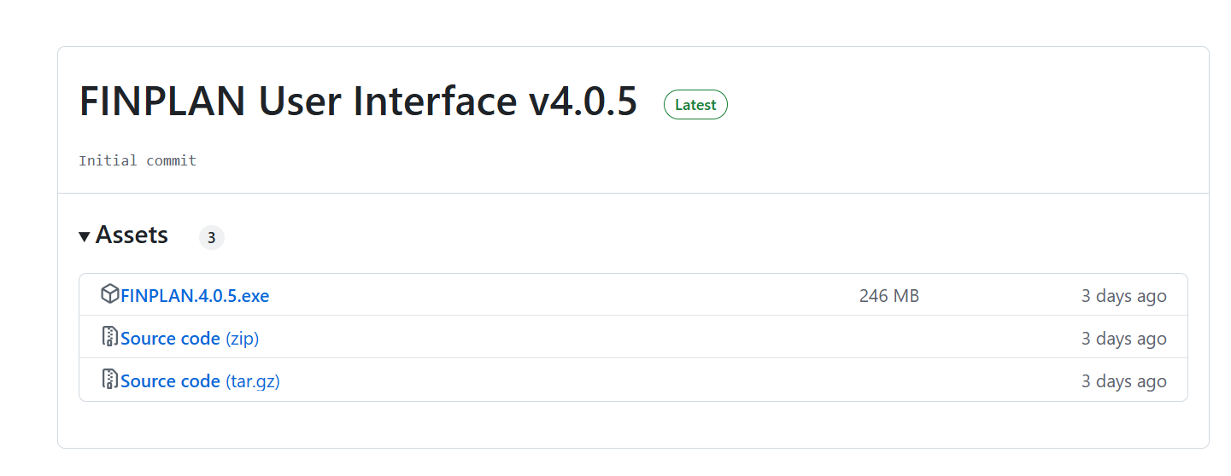
- A prompt may show up. Click on “Download Anyway”.
- Once downloaded, you will see the FINPLAN executable file in your “Downloads” folder. Double click on it.
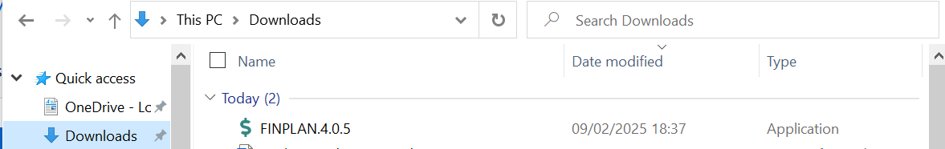
- A pop-up will show. Click on “More info”, then click on “Run anyway”. This will install FINPLAN on your computer.
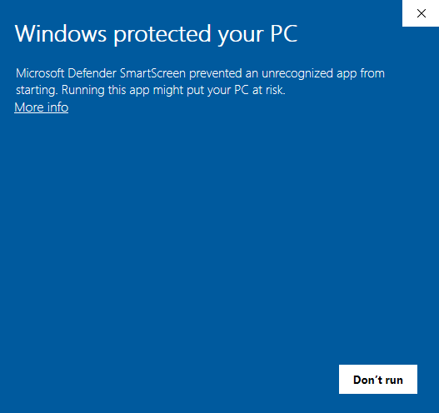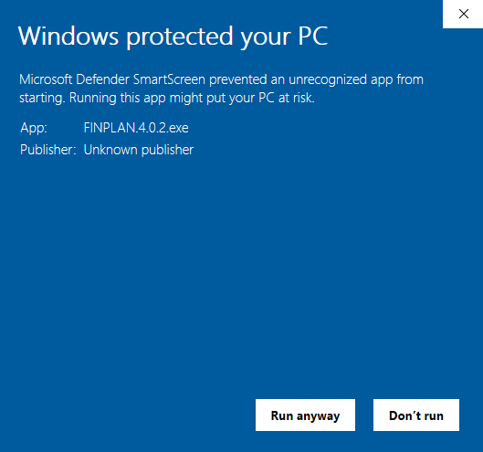
2
1
- FINPLAN will now be ready to run. A window like the one below will appear.

- Ensure your page is maximized to full screen to view all the contents of FINPLAN.
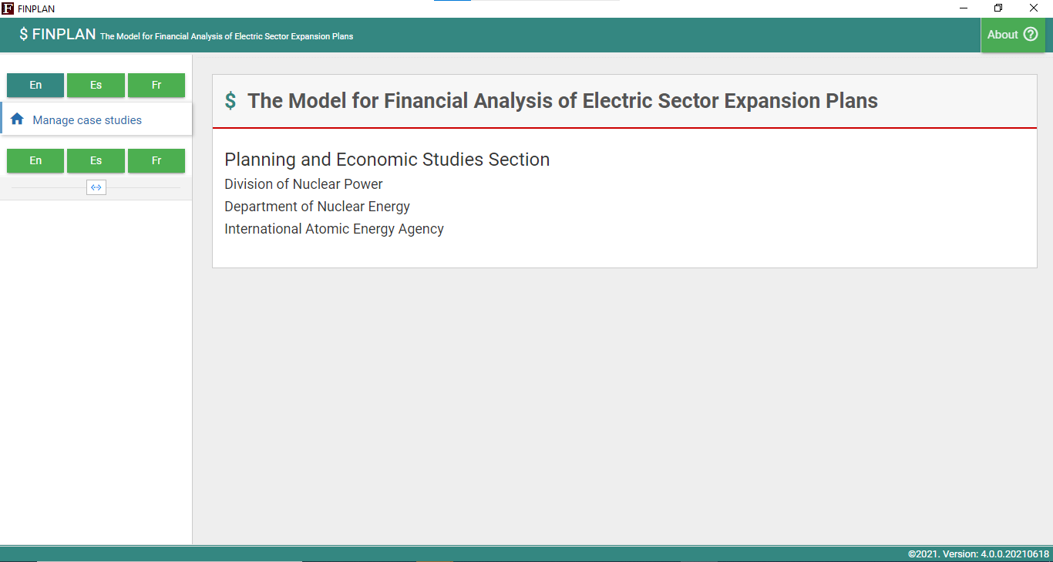
- A shortcut to FINPLAN has also been automatically created on your desktop, like below. Make sure you always start FINPLAN by clicking on this shortcut (and not the installation file you downloaded). It is recommended to delete the installation file from your Download folder.
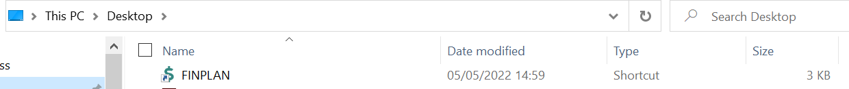
Well done! You now know how to install FINPLAN and open it.
Note: every time you download FINPLAN, your previous data files will be deleted. Thus, should you reinstall FINPLAN, do not forget to export your case studies to somewhere easily accessible, like your Desktop.

Activity 2
In addition to this hands-on, there are two other documents that are available for more information on FINPLAN. They are:
- Introduction to FINPLAN
- Glossary of Financial Terms
Please download these files, have a look at them and keep them accessible, as you will also need them for the upcoming hands-on exercises.
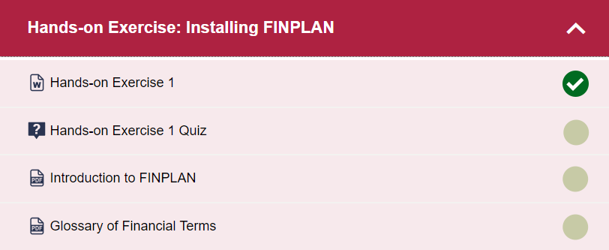

Note: There is also a FINPLAN discussion forum for further support. Please sign up to the forum and ask or answer any FINPLAN-related questions here.

