CW2 Baseline Model ‘Report’
Country:

OSeMOSYS Cloud Email:

OSeMOSYS Cloud Run Number: (for complete baseline model)
Run Status: (Successful, Infeasible, Failed)

Model Completion Level: (i.e. ‘Complete’ or ‘Interlinkages Step 2’ or ‘Land Step 7’ etc.):

Data-in-Brief
When creating an academic report based on a modelling methodology, it is important to provide data for someone to follow in your research footsteps; to enable them to build the same model to validate your results. Thus, it is good practice to summarise the most important data that was required to set up the model – this is often referred to as ‘data in brief’. For each ‘sector’ please provide the key data in a tabular format.
Energy (for example)
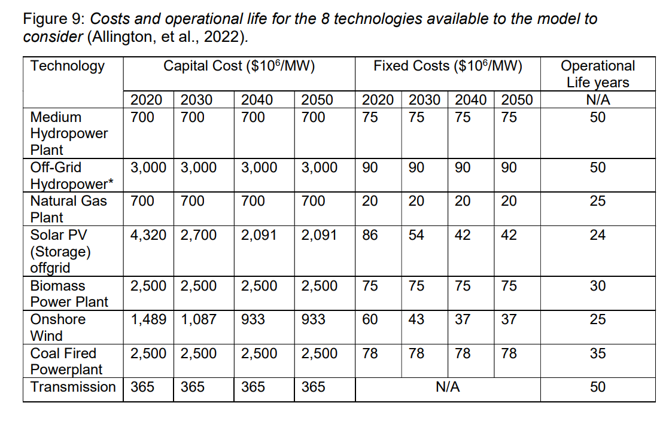

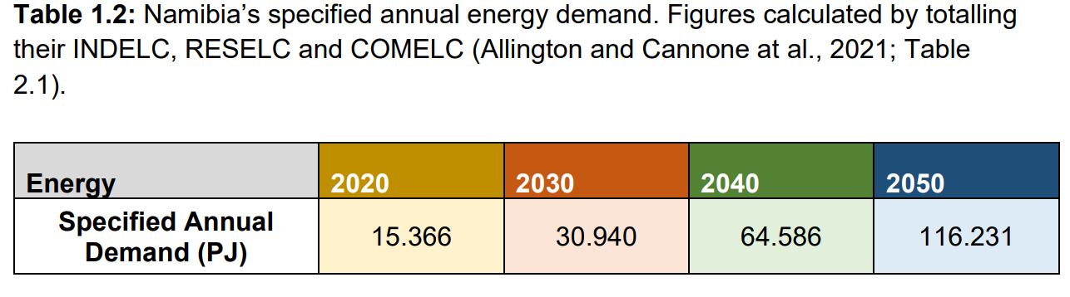

Land (e.g.)
Zambia | Crop Name | Naming Convention | Area Harvested 10³km² | Production Quantity (mTon) | Output  Activity Ratio | Capital Costs  Million Dollars per 10³km² | Operational Life (Years)
Crop1 Rainfed | Maize | CRPMAIHR | 8.42 | 2 | xx | 10 | 15
Crop 1 Irrigated | Maize | CRPMAIHI | 8.42 | 2 | xx | 80 | 15
Crop 2 Rainfed | Groundnut | CRPGROHR | 2.1 | 0.13 | xx | 10 | 15
Crop 2  Irrigated | Groundnut | CRPGROHI | 2.1 | 0.13 | xx | 80 | 15
Crop 3 Rainfed | Sugarcane | CRPSGCHR | 0.5 | 4.69 | xx | 10 | 15
Crop 3 Irrigated | Sugarcane | CRPSCGHI | 0.5 | 4.69 | xx | 80 | 15
Crop 4 Biofuel | Sunflower | CRPSUNHR | 0.6 | 0.03 | xx | 10 | 15

 | Accumulated Annual Demand (MTon)
Crops | 2020 | 2030 | 2040 | 2050 | 2060 | 2070
Maize
Groundnut
Sugarcane
Sunflower

Water
E.g.
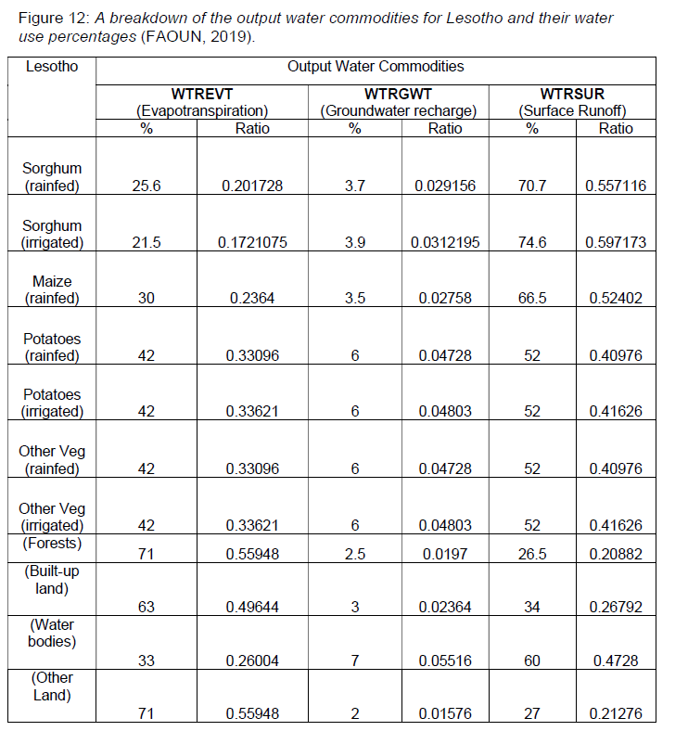
 | Accumulated Annual Demand - 10*9m3
Year | 2020 | 2030 | 2040 | 2050 | 2060 | 2070
Water Demand
 | Water System Inputs - 10*9m3
Precipitation
Water for Irrigation

