The submission for CW1 has two elements:
- Open Learn Course Theory: Certificate (50%)
- Open Learn Course 'Hands-On' exercises: Model run number for Hands-On 11 part 2 (50%)
For example:
1.
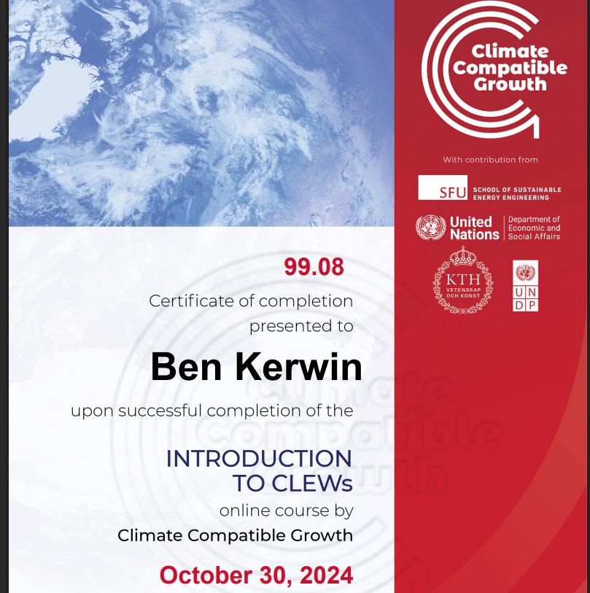
2.
OSeMOSYS cloud runs (https://www.osemosys-cloud.com/users/sign_in)
Run Number: 66558 - Hands On 11 Act 2

