OnSSET/Global Electrification Platform
Hands-on 6: How to run an electrification analysis using GEP Scenario Generator
Installation:
- First, go here and click Code > Download zip to download the GEP scenario generator.
- This exercise has a prerequisite that you have Anaconda/Python and the OnSSET package installed. To install these, follow the instructions here.

Learning outcomes
By the end of this exercise, you will be able to:
1) Run a scenario for Benin in the GEP scenario generator
2) Perform different key processes in the GEP scenario generator
3) Create maps in QGIS to visualize the results.

GEP Scenario Generator (OnSSET)
The objective of this session is to learn how to use the GEP Scenario Generator (OnSSET) tool to run an electrification scenario. This covers the basic operations of the Jupyter Notebook, how to enter input data, and where to find them.

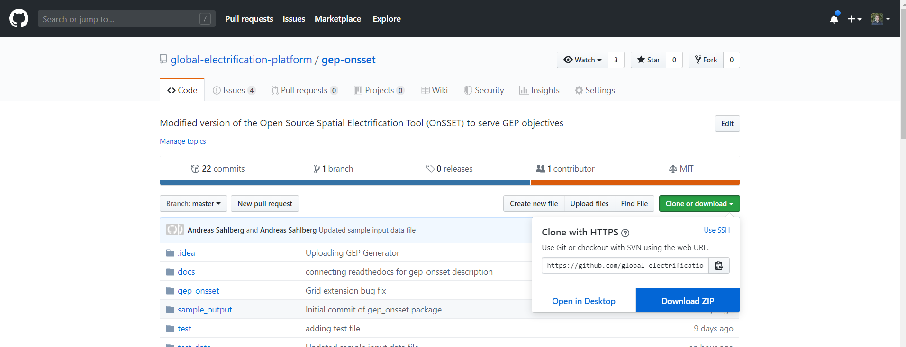
Figure 1
(Picture source: gep-onsset GitHub page https://github.com/global-electrification-platform/gep-onsset/tree/v1.1 license under MIT)
Save and un-zip the folder, which will be named gep-onsset-1.1. This contains all of the code required to run the electrification analysis. Also, create a folder named Results where you want to save the results of your analysis. Apart from this, you will need the csv-file containing the extracted GIS data from last week’s exercise. Go to the gep-onsset-1.1 folder and open Jupyter Notebook.

Exercise 1: Data acquisition and insertion to the electrification model
Click on the GEP_generator.ipynb file, which is the interface for running the electrification tool.

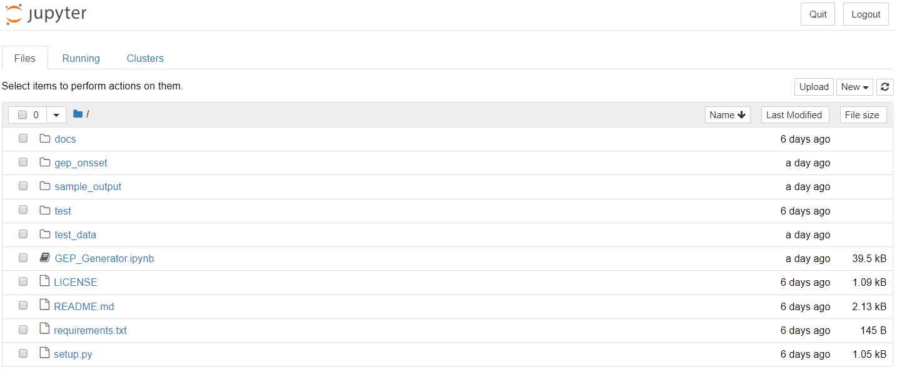
Figure 2
Next, select the first cell with the Welcome to the GEP Generator header. When selected, the cell should be surrounded by a border with a blue line to the left.
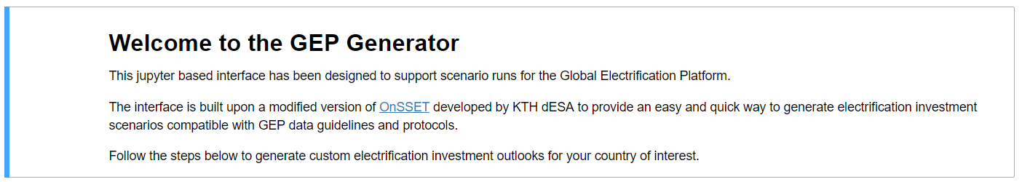
Figure 3

Click the run button to run the cell. While running a code cell, the mode circle in the upper right corner is full while the process is running, and empty again once the process is finished. Note that this may go very quickly for some cells, while others take longer time.
Once a process is finished, the selection automatically moves on to the next cell.
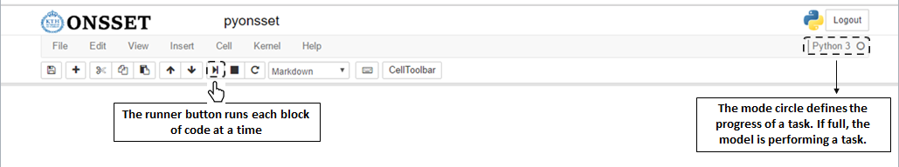
Figure 4

Run the first cell to load the code.
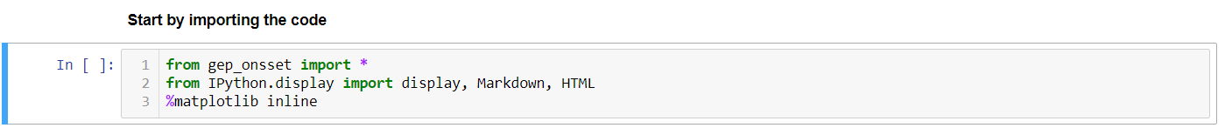
Figure 5

Step 1. GIS data selection.
Run the next cell. This opens up the window below, click OK to open the browser. Browse to where the input file with all the extracted GIS data is located and select it.

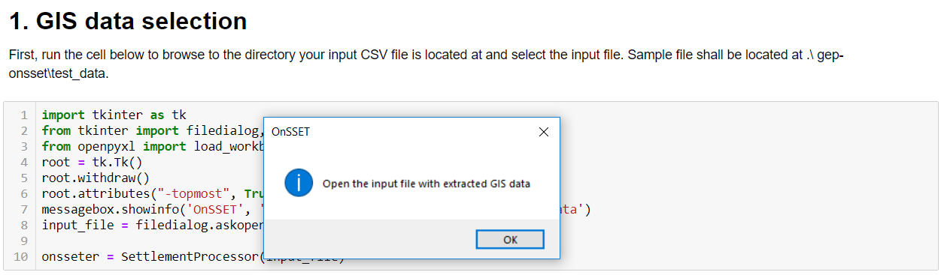
Figure 6

Step 2. Modelling period and target electrification rate.
First, enter the start year and end year as well as the target electrification rate by the end year. Then run the cell. For the intermediate year of 2025 leave the default values as they are.

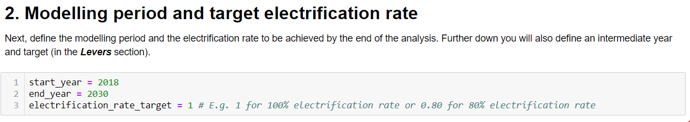
Figure 7

Step 3. Levers
Move on to the lever section. In each of the cells, follow the description of the lever and enter the value of your choice. Remember to run each cell before moving on to the next one.
For population by 2030 enter 15507000
For Prioritization choose 5 for Nationwide least-cost approach.

Step 4. Enter country specific data
In addition to the levers above, the user can customize a large number of variables describing the social, economic, and technological environment in the selected country. In total ~100 variables can be adjusted in this section.
For Benin you should collect the data from different sources. These can be, but not limited to, data.worldbank.org, dataportal.opendataforafrica.org, esa.un.org/unpd/wup, UN Household Size and Composition Around the World 2017 etc., and national statistical offices. If you cannot find all of the input data, then keep the default value.
NOTE that you need to at least collect the population (start and end year), urbanization rate (use the same at end year as 2018 if you do not find any other data), national electrification rate, and household size for this exercise.
For the social input parameters, under a. Demographics and Social components enter:
- the population in 2018 (e.g. 10870000”)
- the urban population share in 2018 (e.g., “0.44” for 44%)
- the projected urban population share in 2030 (e.g., “0.51”)
- the number of people per household in urban areas by 2030 (e.g., “3.1”)
- the number of people per household in rural areas by 2030 (e.g., “3.6”)
- the national electrification rate in 2018 (e.g., “0.4” for 40%)
- the national urban electrification rate in 2018 (e.g., “0.65” for 65%)
- the national rural electrification rate in 2018 (e.g., “0.17” for 17%)
In case no other values have been collected then the default values can be used.
Continue with Step 4 and run all the cells there.

Step 5. GIS data import and processing
Run the first cell in Step 5. This calibrates the population and provides some additional basic information based on the GIS data. If successfully run, a preview should appear with a preview of the GIS input data. If this table does not appear, or does not appear correctly, this may be caused either by an error in the csv-file or the code.
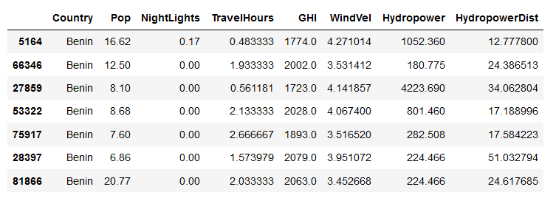
Figure 8
Based on the input data in the previous steps, in the next cell the code now creates some additional layers that are useful for the electrification analysis. This can be an iterative process which requires calibration from the user. One of the most important steps in the electrification analysis is the identification of the currently electrified settlements. Based on their location, the model then decides how easy it is to extend the grid to neighbouring cells, or rather choose an off-grid technology.
The model calibrates which settlements are likely to be electrified in the start year, to match the national statistical values defined above. A settlement is considered to be electrified if it meets all of the following conditions:
- Has more night-time lights than the defined threshold (this is set to 0 by default).
- Is closer to the existing grid network than the distance limit.
- Has more population than the threshold.
First, define the threshold limits. Then run the calibration and read the message on the bottom to check if the results seem okay. Else, redefine these thresholds and run again.

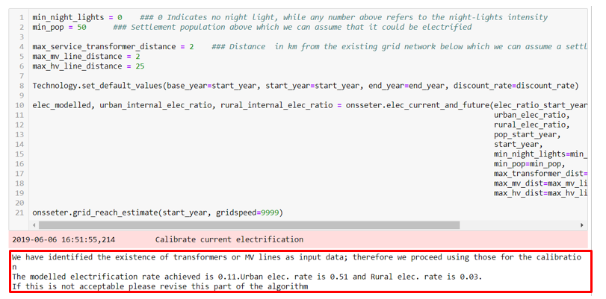
Figure 9
Run the next cell to plot the settlements that are calibrated as electrified (blue) and unelectrified (yellow) in the previous step.
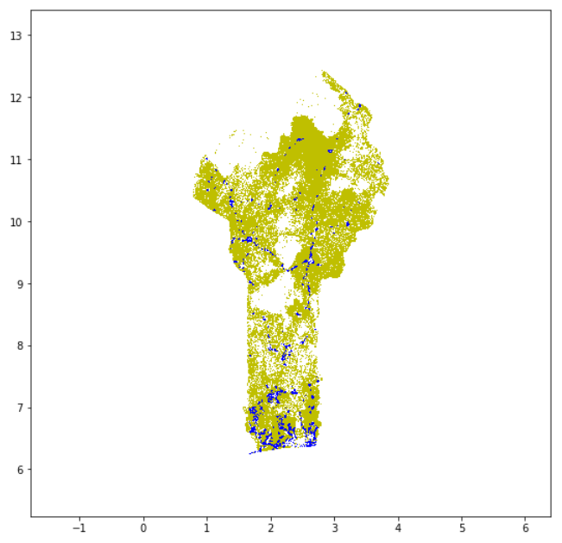
Figure 10

Step 6. Define the demand
Here you can adjust the demand in the scenario further. You may change the number of kWh/household/year a Tier represents or add demand for productive uses of electricity. Note that there is no pre-defined method of estimating the demand for productive uses in the model. Run both cells and move on to the next step.

Step 7. Start a scenario run
This step runs the algorithm to calculate the least-cost electrification technology in every settlement of the country. Note that this will take some time (from minutes to a couple of hours depending on your country).

Step 8. Results, Summaries and Visualization
After completing steps 1–7 the analysis is completed. Run all the cells in Step 7 to retrieve the results. These are presented as summary tables and a simple map.
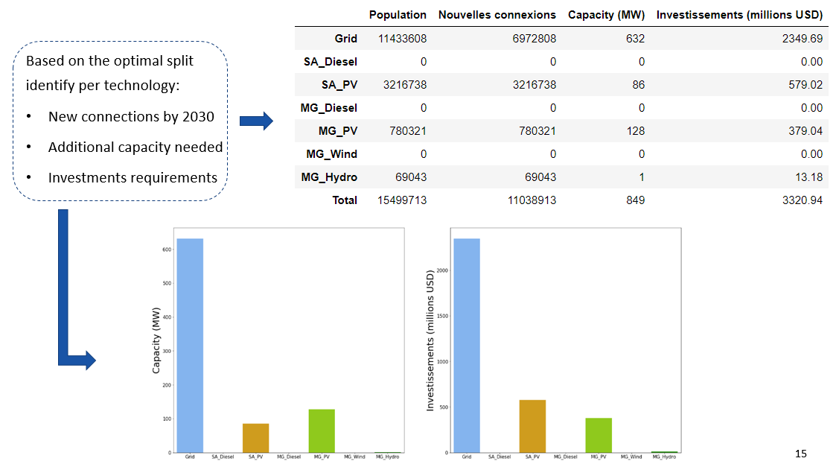
Figure 11
(Picture source: OnSSET teaching material: https://doi.org/10.5281/zenodo.457403 licensed under CC-BY 4.0)

Step 9. Exporting results
In the first cell, name your scenario. In the next cell, run it and click OK in the box that appears, and browse to the folder where you want to save your results. Run the final cell to save the csv-files with information for each settlement and summaries for the whole country. The csv-file named “Results” can be used to generate maps in QGIS.

Visualization of electrification results in GIS
All images in this section are screenshots from QGIS 3.10, which is licensed under Attribution-ShareAlike 3.0 Unported (CC BY-SA 3.0) unless stated otherwise.

The following section provides a guide to the basic steps one must take in order to visualize the results of the electrification in a QGIS environment. Please follow the step-by-step process and in case you have further questions you can use the OnSSET forum.

Step 1. Importing the .csv file with the results
After running your OnSSET analysis you will have a csv-file with the results. If you simply import this csv-file into any GIS software you will get a point layer. When visualizing your results, we would, however, like to visualize the clusters that you have used for the population layer. The instructions below will explain how to visualize your csv-file with your population clusters.
- Start with importing your csv by going to Layer 🡪 Add Layer 🡪 Add Delimited Text Layer.
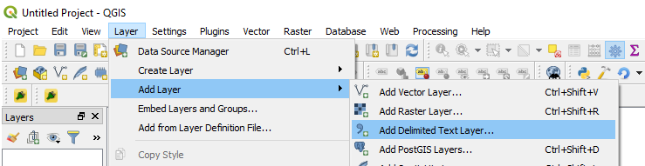
Figure 12

- The following window will open up:
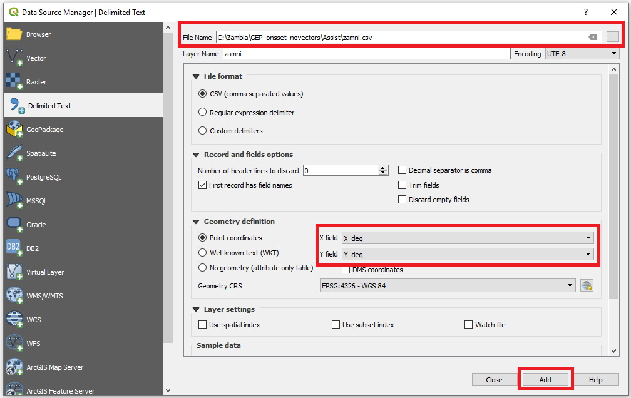
Figure 13

- Under File format make sure that CSV (Comma separated values) is checked. A preview of the file is seen in the bottom of the window. Click Ok. Next, the coordinate system of the layer must be defined. In the Geometry CRS box, select WGS84. Also, in the X field and Y field select X_Deg and Y_Deg. Finally, click Add to load the layer. When the file is loaded (which might take some time) you should be able to see the file in the Layers Panel at the bottom left of your screen.

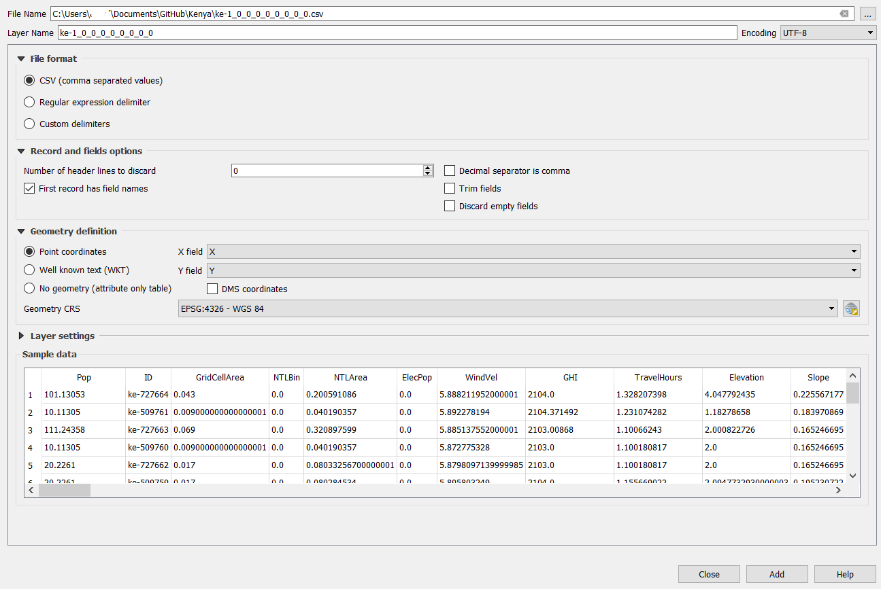
Figure 14

- After clicking on Add you will see that you have added a point layer to your map canvas.
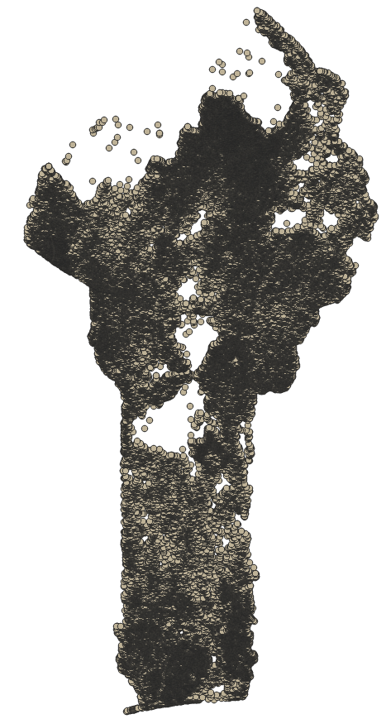
Figure 15

- Now add the clusters that you used as your population layer during the extraction process by going to Layer 🡪 Add Layer 🡪 Add Vector Layer or simply drag it onto your map canvas.
- Now we will merge the layers. Open the toolbox and search for “Join attributes by field value”.
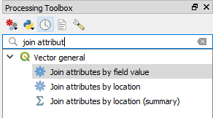
Figure 16

- The following window opens up:

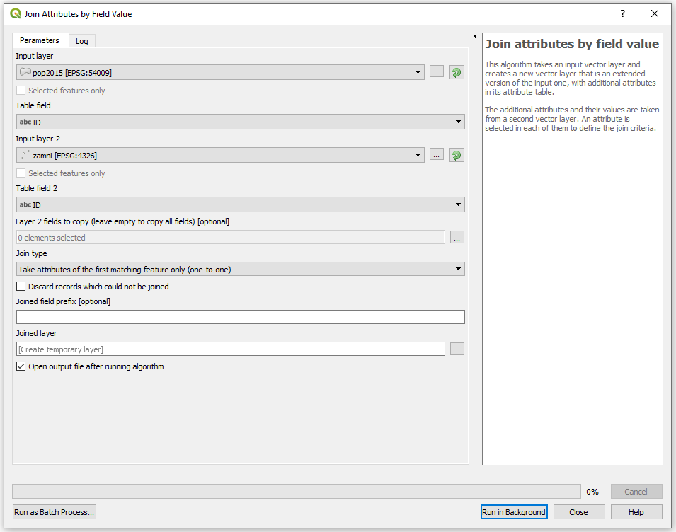
Figure 17

The idea behind this tool is to take the attribute table of one layer and add it to the attribute table of another layer using a field in each layer as identifier.
The field Input layer defines the layer that you will see. Since we want to see clusters and not points, we will choose the population clusters in this field.
Table field is the name of the field in the attribute table that will be used as identifier during the merge. Choose the file named “id” (will be displayed as “123 id”).
The field Input layer 2 defines the second layer. Select the point layer defined by your .csv file.
The field named Table field 2 is the name of the field in the attribute table of the second layer that will be used as the identifier during the merge. Choose the field named “id”. This means that all the rows with the same ID in your population clusters and your input file will be matched to one another.
Do not change any of the other options.
When finished click on Run.

Step 2. Displaying useful information in QGIS
The map of the imported csv-file does not convey much information at first. Change this by right-clicking on the joined layer in the Layer Panel and choose Properties. Select the Symbology tab and at the top change from Single symbol to Categorized.
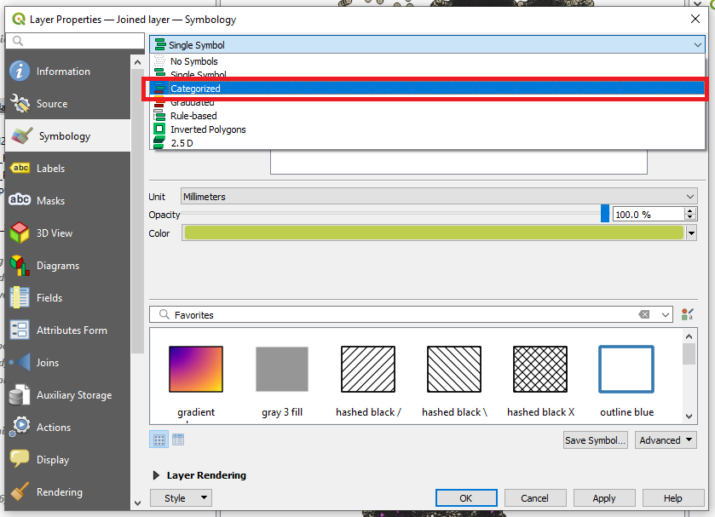
Figure 18
Next, choose the Value option, and from the drop-down list scroll down and choose MinimumOverall2030 to display the technology option that can provide electricity at the lowest LCOE in each cell in 2030. Next, click on Classify to show all technology options that are utilized in the results.
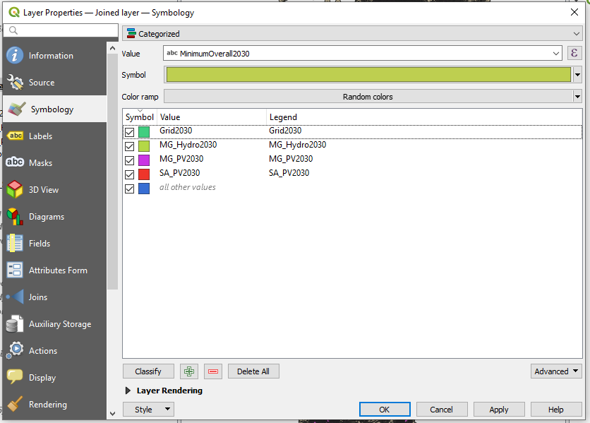
Figure 19
After choosing what to display, one must also make sure that the information can be understood clearly. The first step is to change the appearance of the symbols. Click anywhere on the colored bar next to the Symbol field and then on Simple marker, then on Stroke style select No Pen and press Ok. Finally click Apply. It will take some time for the map to draw in QGIS.
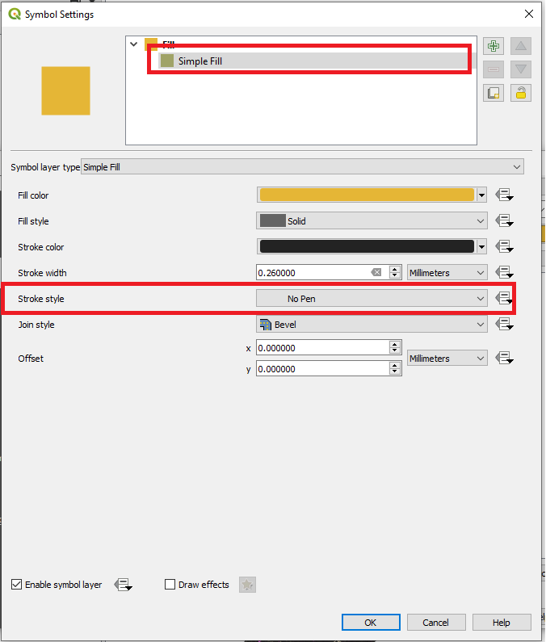
Figure 20

The next step is to add some informative text and figures to the map. In QGIS this can be done in the Print Layout view. Open it by selecting Project > New Print Layout
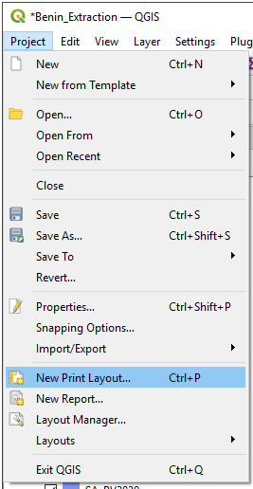
Figure 21
This will prompt you to choose a name for your map. Choose a name and click OK or leave it blank to use a random name.
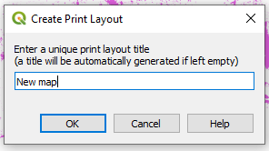
Figure 22
At this stage the map canvas opens.
- First set the properties of your map. This you can do through the Layout menu at the top of the screen and go to Page setup. Set Page size to A4 and choose Orientation as Portrait (these settings may already be in place, then leave it as is).
- On your left-hand side you have a number of different tools that you can use for opening maps and preparing your map.
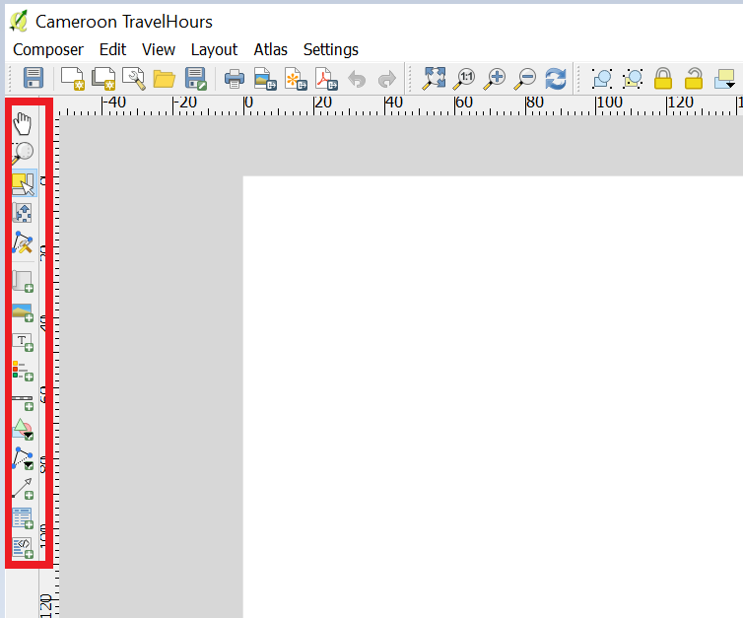
Figure 23
- Click on Add new map on the left-hand side of the window to start creating a map.
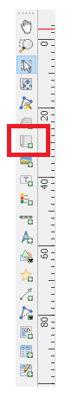
Figure 24

- Next, put the cursor in one corner of the paper and click and drag to define the area the map should extend to. The display of the normal QGIS window will appear in this area.
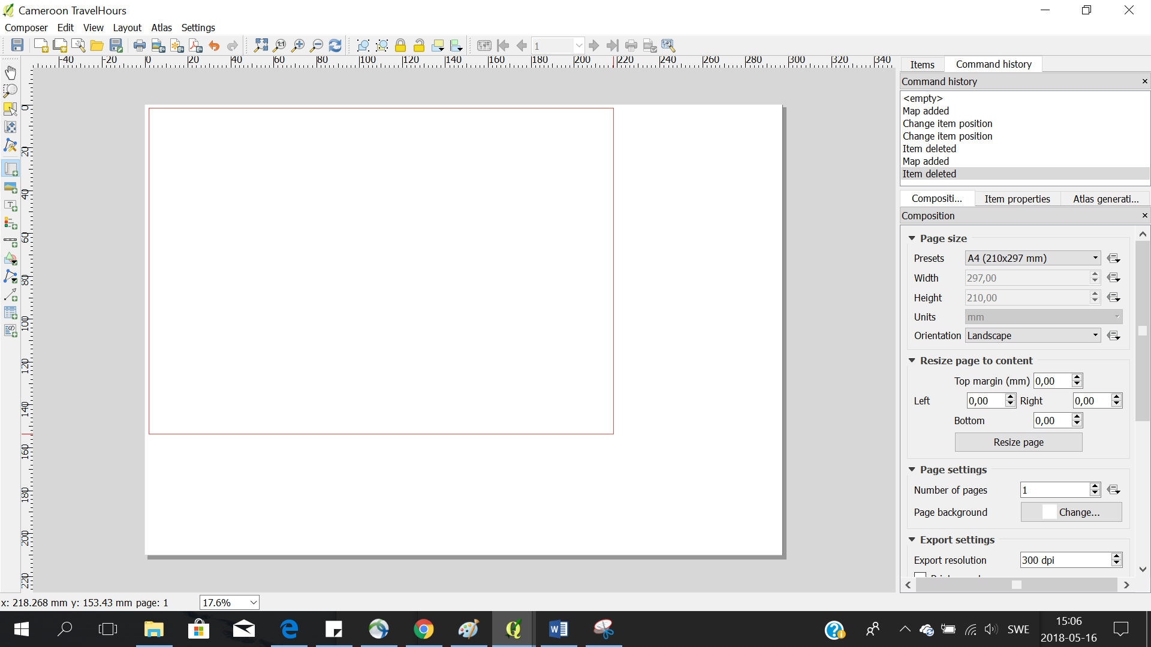
Figure 25
- In the QGIS map composer every item (e.g., Legend, Title, Scale bar) may be edited by clicking on the item and then choosing the Item Properties tab on the right. This includes the size, scale, position, extent, and other attributes.
- Add Title, Legend, and Scale bar from the menu to the left. Adjust their position and style to create an informative map.
- Finally, export the map as a picture by going to clicking the 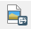 icon (top menu on the screen), and save it in the Results folder.
Once the map of technology split is satisfactory and saved in the Results folder, close the Composer window. Open the Properties window of the layer and go to the Style tab once more. On the top, change from Categorized to Graduated. Now, choose the MinimumOverallLCOE2030 column on the top to display the LCOE achieved in each cell. Press Classify, Apply and OK to draw the LCOE map.
Open the Composer window and insert a Title, Legend and Scale bar and save the new map once satisfied with the layout.

Congratulations for completing the hands-on exercises! If you have questions or want to contribute to the OnSSET community please go to onsset.org to find out more!

This exercise is an exercise developed by Korkovelos, A., Sahlberg, A., Khavari, B., 2019. Exercise 6: How to run an electrification analysis using GEP scenario generator [WWW Document]. OnSSET Teaching Kit. URL https://onsset.github.io//teaching_kit/courses/module_2/Excercise%206/ (accessed 2.18.21). All images are screenshots from gep-onsset in Jupyter notebook unless stated otherwise, which is licensed under MIT license.

