OnSSET/Global Electrification Platform
Hands-on 2: Working with vector data
NOTE1: These exercises are supposed to be done in QGIS 3.10. If you use any other version there may be issues. Please follow the instructions in the link to install QGIS 3.10.
- Follow the instruction “QGIS 3.10 Installation Instructions” to install QGIS 3.10 to your computer if do not have this version of QGIS.

Learning outcomes
By the end of this exercise, you will be able to:
1) Import vector data to QGIS
2) Perform different key processes (such as projecting, clip) with vector data
3) Georeference an image

Data Acquisition
Download the folder named “Benin_vector”, available here, and save it on the desktop. Unzip and open this folder, in it there is a number of additional folders and files. For this exercise make sure that the following files/folders are included:
- An image named “Benin_transmission_lines”.
- A folder named “Transmission_lines”. Within this folder there should be files named “transmission_lines”.
- A folder named “Administrative_Boundaries”. Within this folder there should be files named “Administrative_Boundaries”.
- A folder named “Administrative_Boundaries_Points” containing the administrative boundaries of Benin in point format named “Administrative_Boundaries_Points”.
Note! It is good practice to use underscore (_) when naming folders or datasets in GIS (instead of space) in order to avoid unexpected errors while processing.

Working with vector data
Open QGIS Desktop 3.10.X with GRASS 7.X.X.
NOTE: An extensive tutorial of QGIS is available here.
Import:
- Importing vectors can be done in two different ways; either simply drag the vector file onto your map canvas or go to the top roll-down menu and click on Layer → Add Layer → Add Vector Layer…
- Import the “Administrative_Boundaries.shp” layer and the “transmission_lines.shp” layer that you have received (when using vector layers we search for the files with .shp extension).

Vector properties
Next, we will examine the properties of different vector files. By right-clicking on one of the layers you will be able to examine and/or change properties of your vector files.

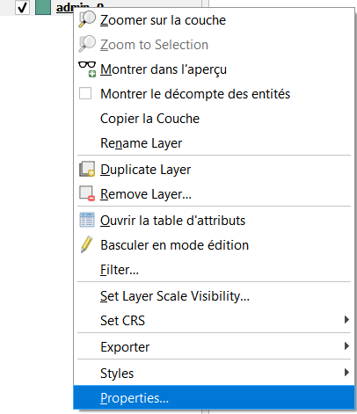

- First, click on the Information tab. Here you will find information about your layer.
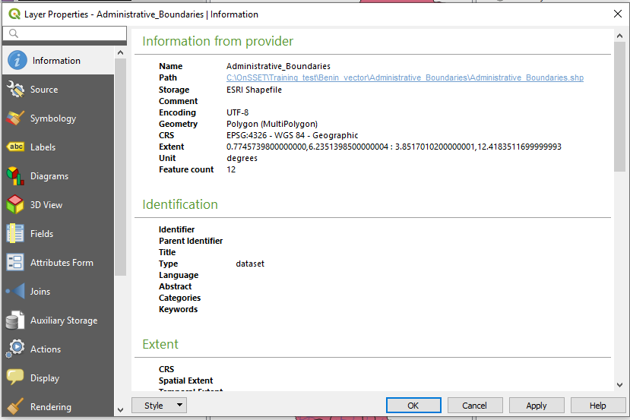

- The most important tab for the visual appearance of your dataset is the Symbology tab. Here you can change many different aspects of the dataset. You can change the color, style, and size of the vectors.
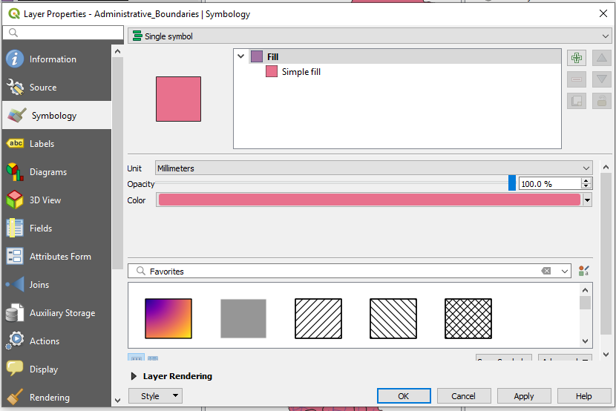

- Next, we will move on to the tab named Fields. Here you will be able to examine the fields in your data in more depth, which can help you identify the type of data that exist in your dataset. This may be very useful when you use a dataset that is created by someone else. If you have editing toggled, you will also be able to add/delete columns in this tab (see what toggle editing means here).
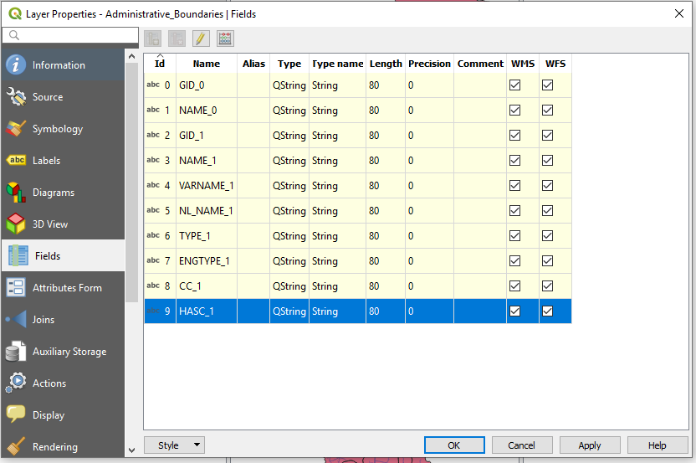

Clipping vector layers
In many cases the dataset that you are using spans across an area larger than your study area. In these areas it can be useful to delimit the dataset so that it is restricted to the area you are working with. For all types of vector files, we will use the tool Clip. We will use this tool to ensure that the transmission lines we work with are within the borders of Benin.

- Make the toolbar visible by going to the menu on the top of the screen and click on Processing → Toolbox.
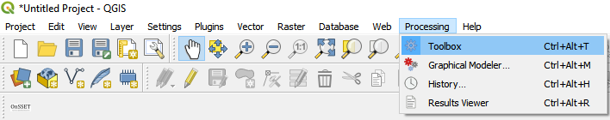

- This will open up the toolbox on the right-hand side of the QGIS interface. In this toolbox you can search for all the tools that you need.
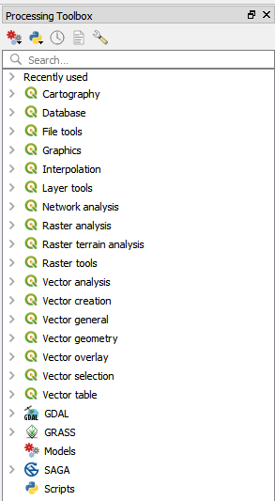

- Now, search for “clip”, this will show all the tools including the word “clip”.
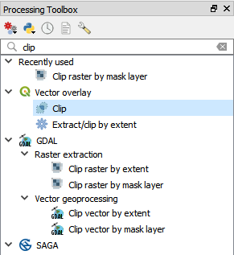
- In this exercise we will choose the clip tool within the QGIS-package (the one highlighted in the image above).
- In the window that opens up, choose the dataset that you wish to clip in the field that says “Input layer”, and in the field that says “Clip layer” choose the dataset that you wish to clip by. As the input layer choose transmission_lines, and as the clip layer choose administrative_boundaries to clip the transmission line vector that you received by the administrative boundary polygon. Click Run and close the Clip window.

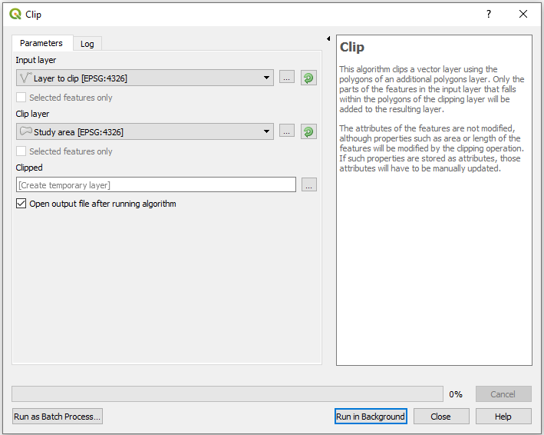

Export
Now it is time to export the clipped transmission lines to the appropriate folder. This is a very important step. When you use a tool in QGIS, e.g., “Clip”, the output file will be saved as a temporary file if you do not explicitly state that you want it saved on your computer. This means that next time you open QGIS your layers will be lost even if you save the project. To avoid this you can export your layers.
- Right-click on the clipped layer and click on Export → Save Features As...

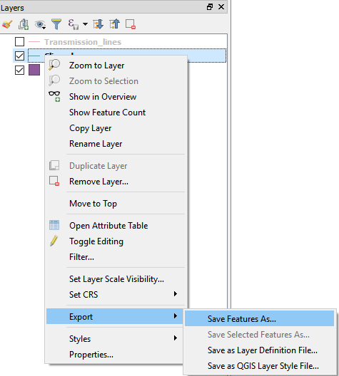
- Choose to export your vector files as ESRI shapefiles. Click on three dots next to filename, and navigate to the folder you wish to save the layer in (see image below).

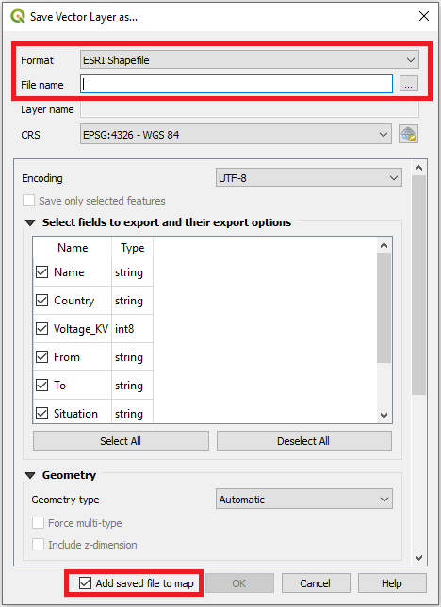

- Name your layer “transmission_lines_Benin” and navigate to the folder named Transmission_Lines that you have received. Click “OK” (make sure that “Add saved file to map” is checked). Now you can remove the temporary file named “Clipped”, by right-clicking and selecting Remove Layer…

Projecting vectors
The coordinate system is very important when representing data. When projecting an area onto a map there will always be a certain distortion. When choosing the coordinate system, it is important to make compromises and choose the system that gives the least distortion. For this exercise, since we are working with Benin we will have to choose a coordinate system that works well for the country. In this case, we are choosing a coordinate system named ”WGS 84/UTM zone 31N”.
We will reproject the transmission lines that we clipped and exported.
- In the toolbox search “Reproject layer” and double-click on it to use the tool.
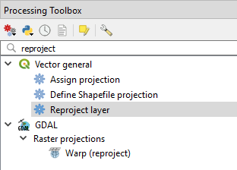

- First, choose the dataset that you wish to project (the clipped transmission lines).

NOTE: When you choose the dataset you will be able to see the current coordinate system within brackets (see image below).

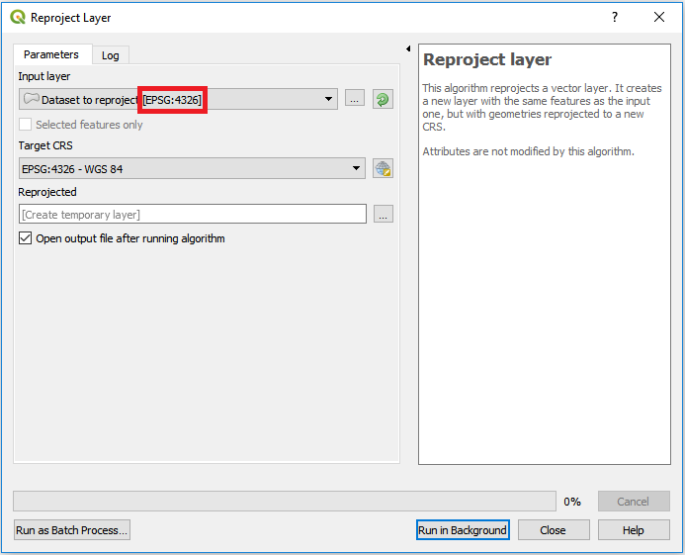
- Next, click on the icon next to the field that asks for Target CRS and choose your target coordinate system.

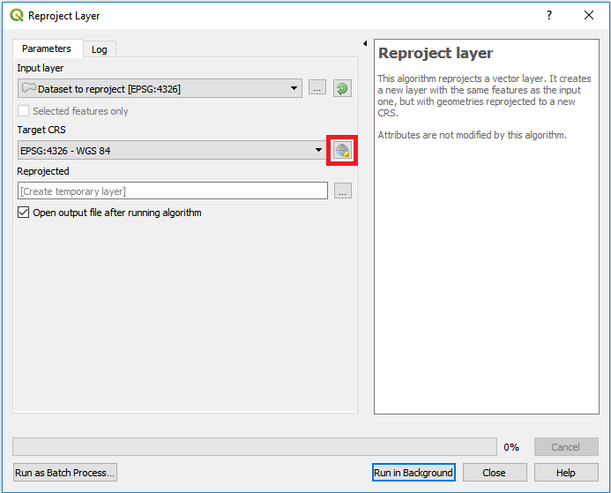

This will open the following window
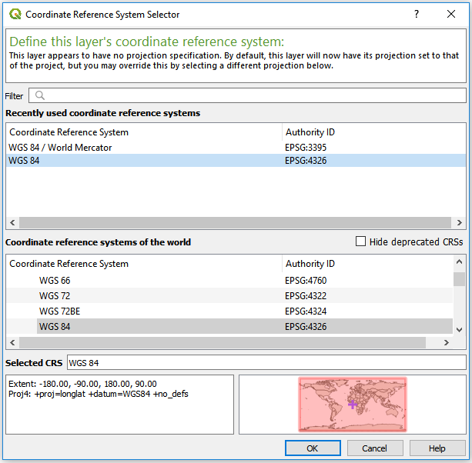
In the filter field start typing the name of the coordinate system you want to use (UTM zone 31N).

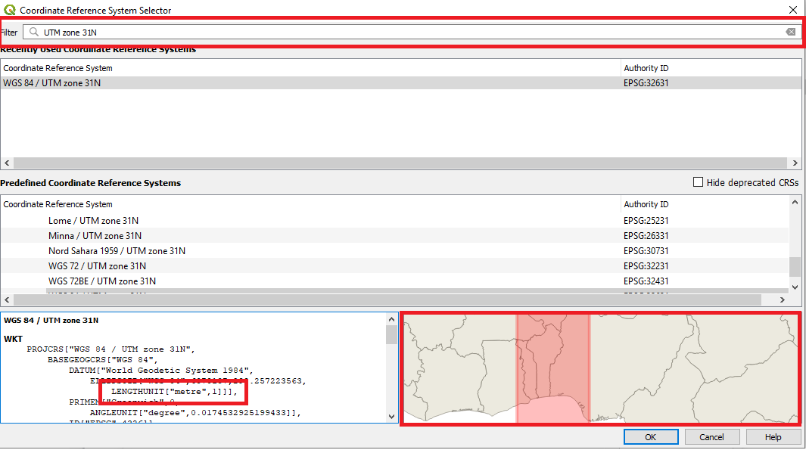
NOTE: The unit is in metres and the red box on the map in the lower right corner covers Benin.

- Click on OK and Run to execute the tool. When finished, export as “transmission_lines_Benin_reprojected” to the “Transmission_Lines” folder.
NOTE: For future studies, the following site https://epsg.io/ can be used to determine which coordinate system you should use. On this webpage you simply search for the name of your study area and take the coordinate system best suited for your study.

Georeferencing
In this part, we will first georeference a map of Benin and use this in order to finish the missing transmission lines. In many cases you will come across outdated or incomplete GIS data, and this is a useful way of generating correct data when these cases occur.

Georeferencing

How to enable georeferencing:
Georeferencing can be a powerful tool when identifying certain datasets such as roads, transmission lines, or locations of substations. If these data points are not available as geo-spatial datasets, they can be imported as an image and then fitted to the study area.
- First you may need to enable georeferencing. In many cases georeferencing is disabled when you install QGIS. This is done by going to Plugins → manage and install plugins… at the top of your screen.
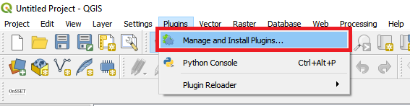

- In the window that opens up, start typing “georeferencer” and select “georeferencer GDAL” when it appears by checking the box next to it.
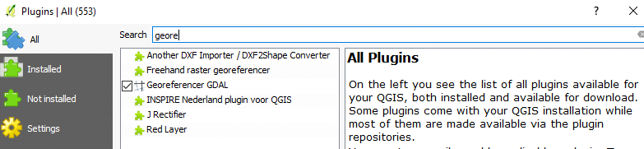

- Now if you go back to the main screen and open the Raster menu you should have the option to do georeferencing.
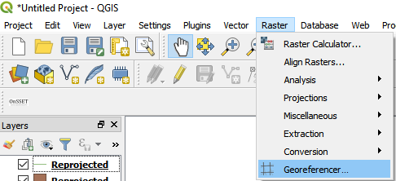

How to georeference

- First open the Georeferencer by double-clicking on it from the Raster menu in the image above. On the top of the screen click on File → Open Raster.
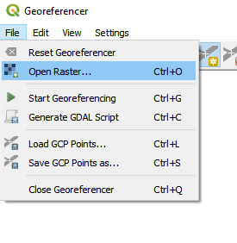
- Next, navigate to the image named “Benin_transmission_lines.jpg” in the Benin folder you have downloaded. If you are prompted to choose a coordinate system choose WGS 84 (EPSG:4326).
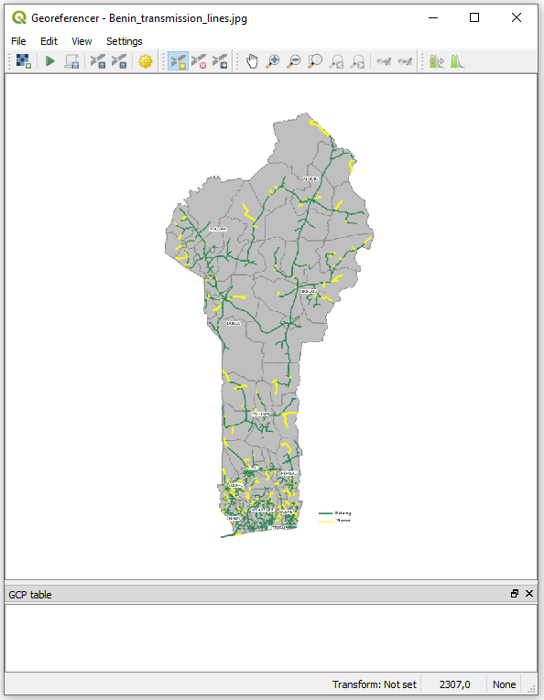
- Now you will be able to add some control points to your map. These control points will be used in order to line your image up with the rest of your datasets. Use your mouse wheel or the icons at the top to zoom in and out of the picture. When you have zoomed in to your liking you can click on the map to add a control point. This will open the window below.

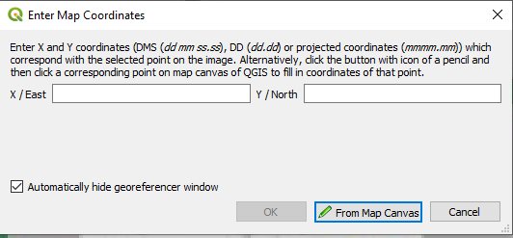
Here you can choose to enter the control points using the map canvas directly, using the “From map canvas” by just clicking on the corresponding point in your canvas. The more points the better. The idea is to fit known areas of you image to known areas of the administrative boundaries that you have imported.

- As you add points you will see that there are rows being added to the window named “GCP table”. Each row represents a control point that you have added. The more points the better, and you should make sure that your points are covering the entire study area. For this exercise please add between 6 and 8 points (in general the number of points should increase as the size of your study area increases).
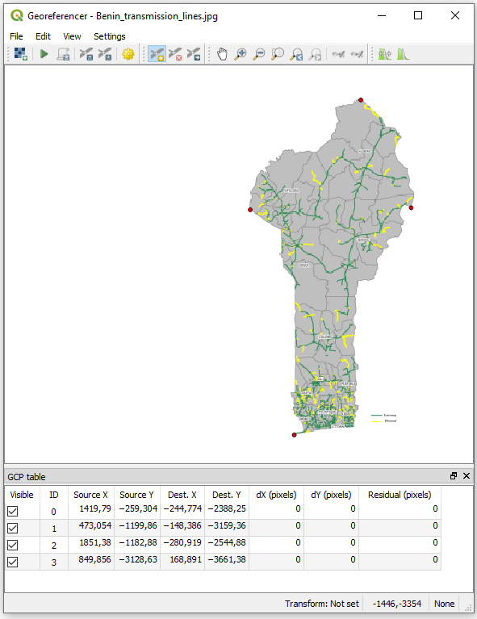

- After entering all of the control points click on Settings → Transformation settings…
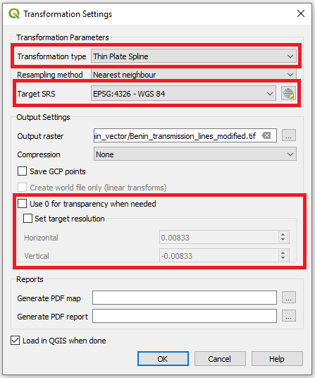
Set Transformation type to Thin Plate Spline.
Select the right coordinate system in Target SRS (WGS 84).
In the field for Output raster find the folder that you want to use for saving your raster (choose the “Benin_vector” folder provided to you).
In set target resolution set the size of each cell. Set 0.0083 with minus sign as in the figure above. This is in degrees and corresponds to approximately 1 km. NOTE: in order to change the resolution from the default you have to check the box named “Set target resolution”; if you have to change the coordinate system manually make sure to uncheck the box before the next step. Having the box checked can cause errors.
Check the box “Load in QGIS when done”.
When this is done click on “OK” to close the window.
- Finally go to File and click on Start Georeferencing.
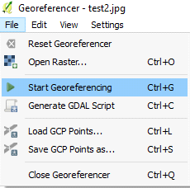
This might take some time. When it is done, the map should be in the same place as the administrative boundaries.
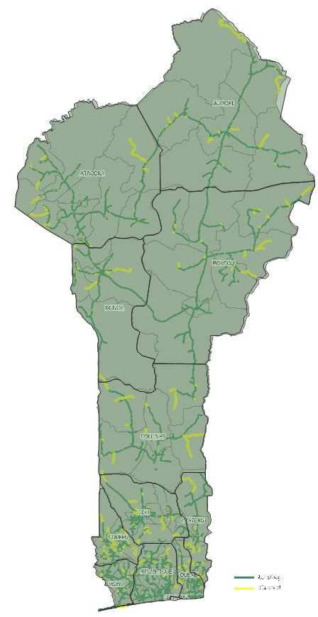
(The map above has been created by putting the administrative boundaries on top of the georeferenced image and turning its transparency to 50%. You can turn the transparency to 50% on the first window of the symbology tab in properties. This is a good practice if you want to make sure that the dataset falls in the right spot and for the following steps).

- Close the georeferencing window and “Save”.
NOTE: If your map ends up completely wrong this might be due to discrepancies in the coordinate systems.

Edit vector files
Sometimes it is of interest to either add points/lines/polygons to an existing dataset or create a new vector dataset from scratch. Here we will go through the first option.
- Move the reprojected transmission lines dataset to the top in the Layers Panel.
- In the Symbology tab (in Properties) make the lines black and increase the Width to make the lines clearly visible.
- Right-click on the dataset and click on “Toggle Editing”.
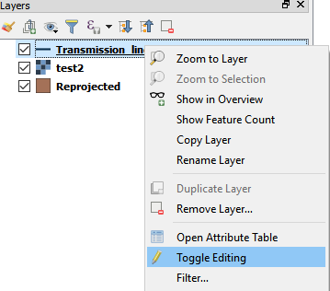

- This will enable some different options depending on what type of vector file you are working with (if you are working with points, you will be able to add points; if you are working with lines, you will be able to draw lines; if you are working with polygons, you will get the chance to draw polygons).
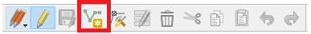

- Now you can simply click/draw your cursor wherever you want to add data by clicking on the V-shaped line(marked in the image above). After clicking on this you will able to draw your lines by clicking on the map. The first click will define your starting point, and thereafter you can add as many points as you like.
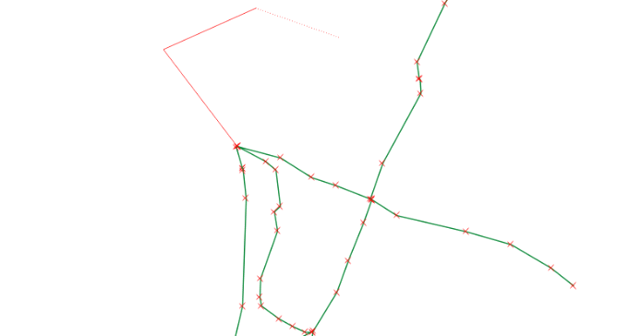
When you are finished with a line, right click on the last spot. This will open the following screen:
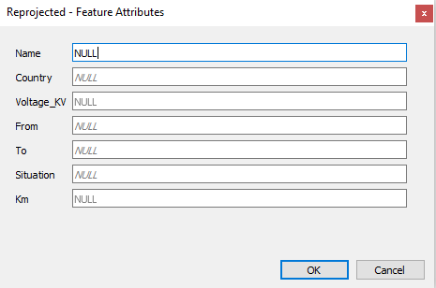
Here you attribute data. In this exercise we will not worry about this and just click “OK”
Use the editor and the georeferenced map to fill in the missing transmission lines (only existing lines, according to the legend at the bottom (green lines) of the georeferenced map) in the reprojected transmission line layer that you have created

- Click on Save Layer Edits and then disable Toggle Editing.
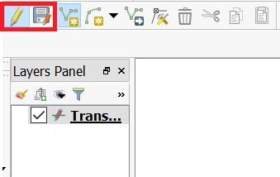

NOTE: The accuracy of your lines and points depends on the scale in which they were created; if you zoom in further after drawing your lines you will see discrepancies. One of these might be that the lines do not connect to one another. To fix this go to Project → Snapping Options…
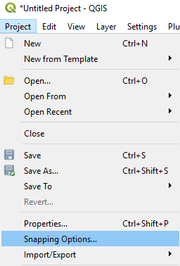
Here you set the variables as shown below.
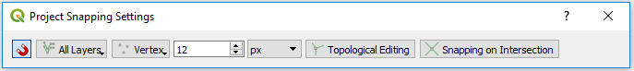
Now when you are close enough to a line QGIS will make sure that the new line is connected to the old one.

Determining distance
In this part we will determine the distance to the transmission lines. When planning an energy system it is crucial to know the distances to different infrastructure in order to be able to take informed decisions.

Creating distance maps
When calculating distances in QGIS we need to use two point layers. This means that we cannot simply determine the distance from the modified transmission lines without first converting it to points.

Convert the transmission lines to points
- To convert the transmission lines to points we are going to use a tool named "convert lines to points" from the SAGA package.
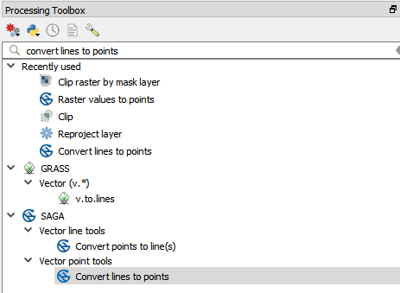
- Clicking on the tool will open the following window.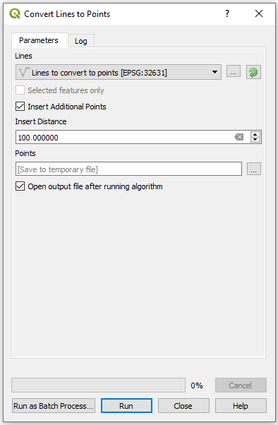

For lines you choose the transmission lines that you edited at the end of the Part 2.
The Insert distance will determine the distance between the points. This distance will be in the same unit that the coordinate system is in. Since we have projected the transmission lines to a coordinate system measured in meters, this distance is in meters. Enter 100 to create points spaced with 100 meters in-between. Click on Run.

Create a distance map
- Import the Administrative_Boundaries_Points layer of Benin and reproject it using Reproject layer into ”WGS 84/UTM zone 31N” as done previously in this exercise. This is done since it is important to have the map in a coordinate system that takes linear units, else the distances may be skewed. Furthermore, if the coordinate systems are different between two maps used to determine distances the distances will be wrong.
- To create a distance map we use the QGIS tool Distance to nearest hub (points). Search for it in the Processing Toolbox.
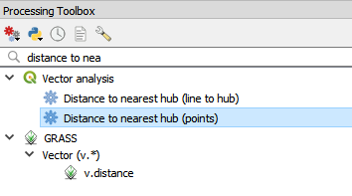
- You will then see the following screen:
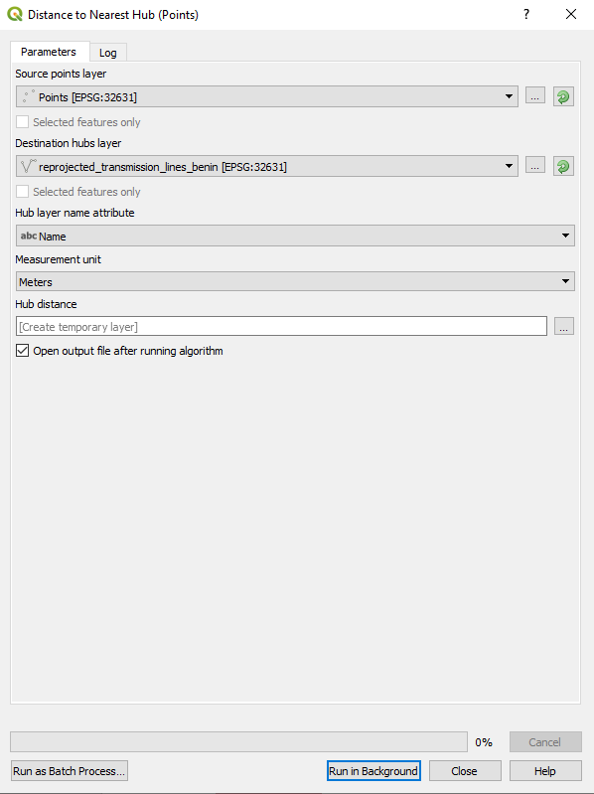
As Source point layer, put the layer that you want to determine the distance to, in this case the country point file (reprojected as mentioned in the step above).
As Destination hub layer, put the layer that you want to determine the distance from. In this case this is the point layer we generated previously from the transmission lines: transmission_lines_Benin_reprojected.
NOTE: The layers should have the same coordinate system.
For Measurement unit, you have the choice between some different types of length units. In this case, choose Meters.

- Now run the tool. The results will be a point layer with the same colour across the country. This can however be changed in the Style tab in Symbology. Change the style to make the map display as below. You can do this by clicking on the symbology tab in properties, setting the style to graduated, and choosing to display the distance column.

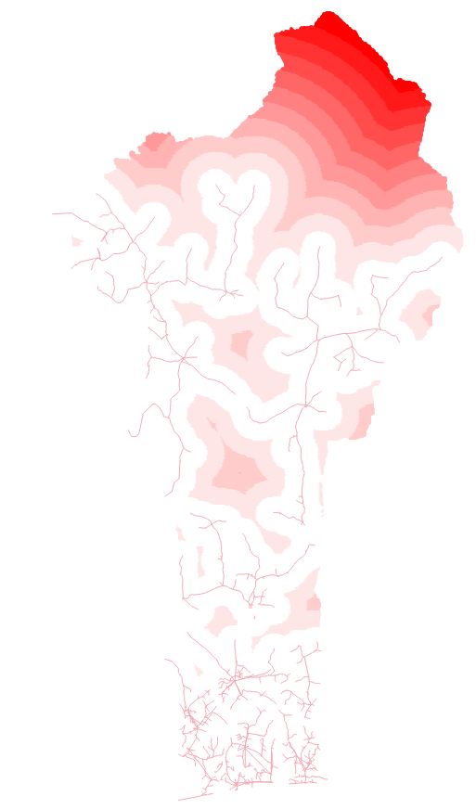

NOTE: Export the distance map, as it will be used in the raster exercise as well. Save the distance map under the name “transmission_lines_distance” in the “Benin_vector” folder. This is important as you need the layer in the next exercise.

This hands-on is an exercise developed by Khavari, B., 2019 Exercise 2: Working with vector data [WWW Document]. OnSSET Teaching Kit. URL https://onsset.github.io/teaching_kit/courses/module_1/Excercise%202/ (accessed 2.18.21). All images are screenshots from QGIS 3.10, which is licensed under Attribution-ShareAlike 3.0 Unported (CC BY-SA 3.0).

