Geospatial Clean Cooking access modelling using OnStove
Hands-on 6: GIS processing with OnStove

Learning outcomes
By the end of this exercise you will be able to:
1) Perform basic operations in Jupyter Notebooks and Python
2) Perform simple geospatial operations with python.

Opening up Jupyter Notebook
- Ensure that you have downloaded the file named E6 - GIS processing.zip. Put this file somewhere on your computer where it is easily accessible and unzip it.
- Open up your start menu, search for Anaconda Prompt and click on it to open up a prompt window.
- In your prompt window type: conda activate onstove. Note that the (base) in the beginning of the line of the prompt changes to (onstove). This means that OnStove is active and you now have access to the tool.
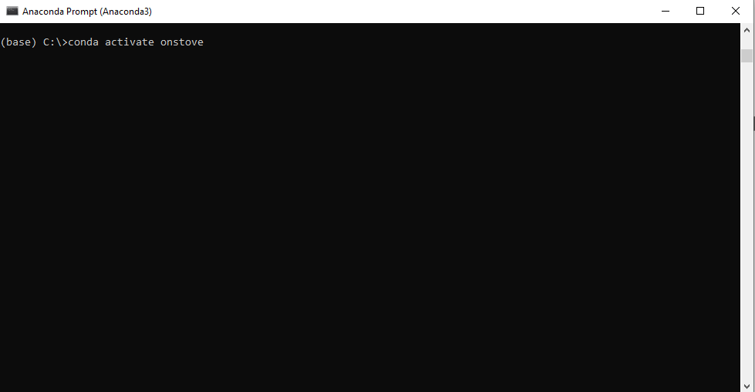
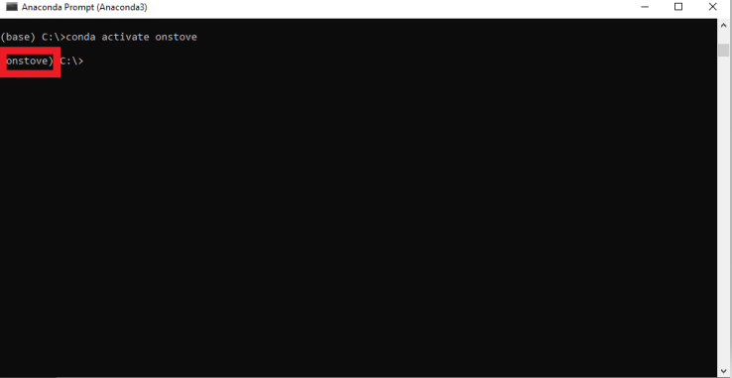

- Open the folder where you saved the file called E6 - GIS processing.ipynb. Copy the path and paste it in the anaconda prompt with “cd” in front of it (cd PATH, see images). Press enter.
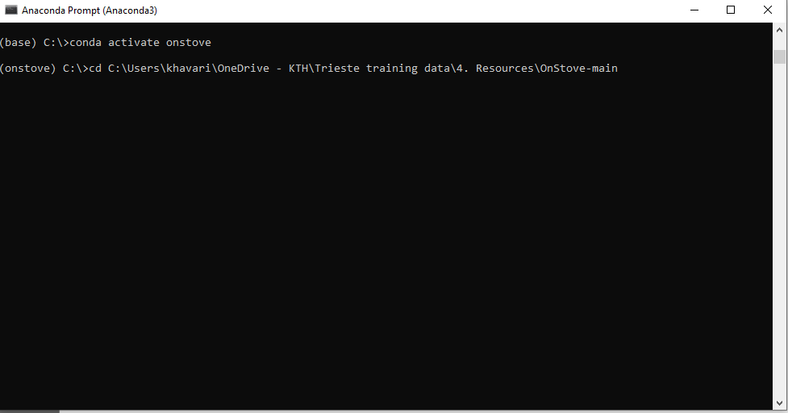

- Next type “jupyter lab” in anaconda.
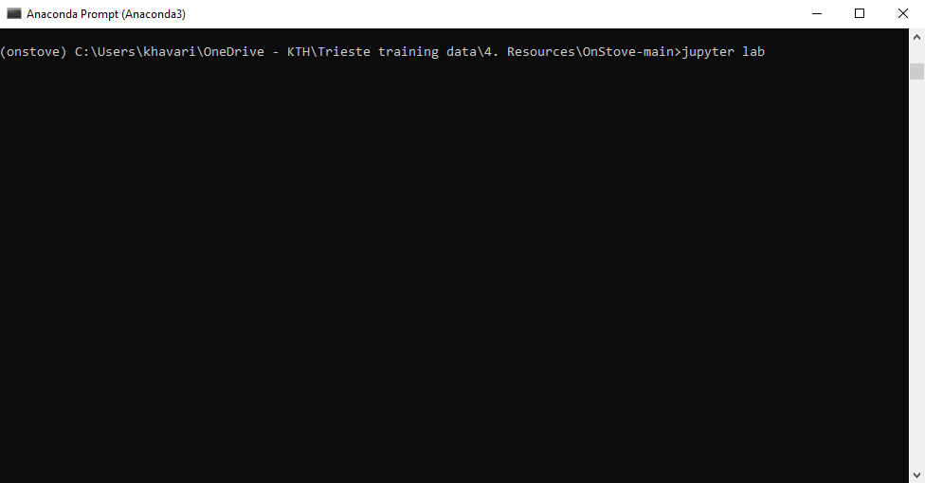
- This will open up an instance of jupyter lab on your computer. Note that while it opens up in your web-browser the jupyter lab instance is ran completely offline and does not require an internet connection.

- Double click on the file called E6 - GIS processing.ipynb in the file browser. Follow the instructions given in the file. If you can not see the file, it may be because you are in the wrong path (check step 4), or because your file browser is closed (see next image for how to open it).
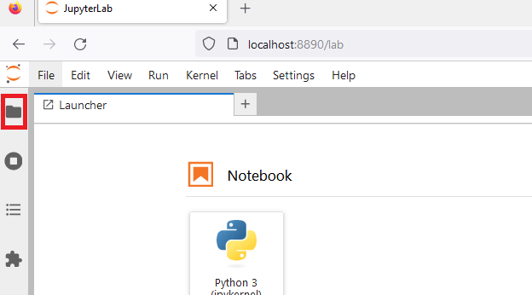
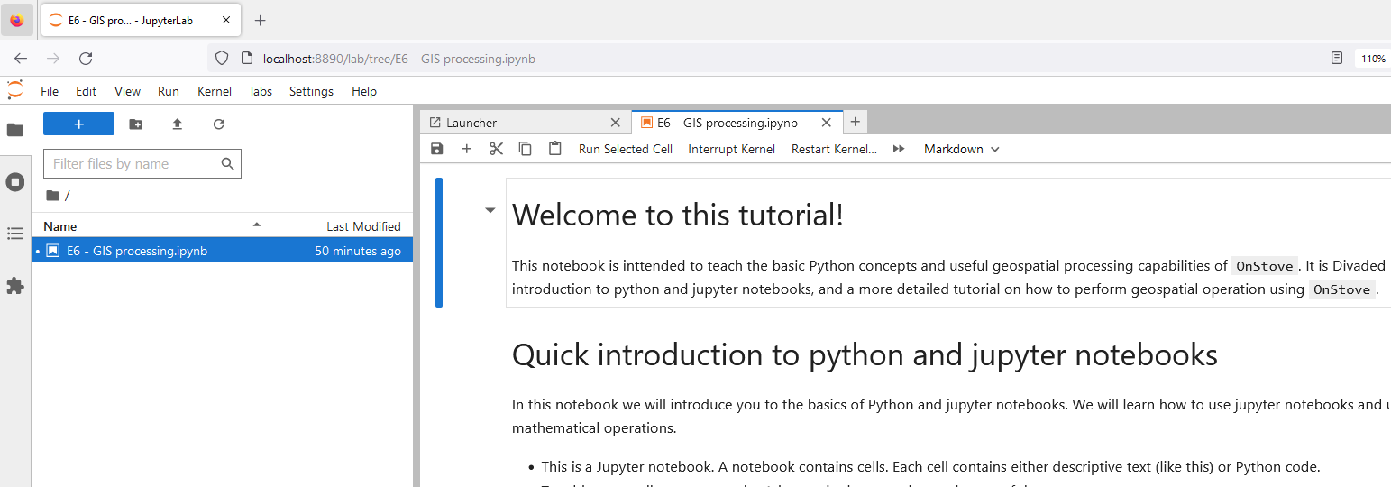
- To finalize the exercise follow the instructions given in the notebook.

