Installation of Anaconda package for python
Python - Anaconda package
OnStove is written in python, an open source programming language used widely in many applications. Python is a requirement for the OnStove tool to work.
Programming in python usually relies on the usage of pre-defined functions that can be found in the so called modules. In order to work with OnStove, certain modules need to be installed. The easiest way to do so is by installing Anaconda, a package that contains various useful modules. Anaconda includes all the modules required to run OnStove.
To download Anaconda, go to https://www.anaconda.com/download/ and download version 3.7.
- Please make sure that you download the version that is compatible with your operating


- Once downloaded, open the installation file and click “Next” to start.
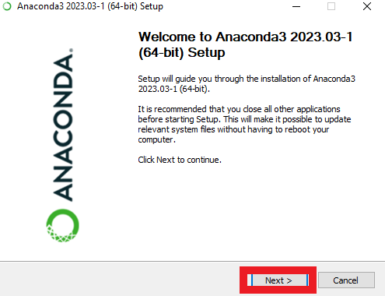
- First you have to agree to the License Agreement.

- Next, select to install Anaconda for “Just Me” and click “Next”.
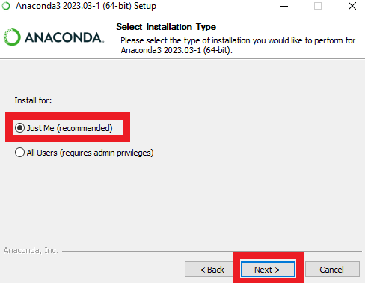
- Select the location where to install Anaconda on your computer and click “Next”.
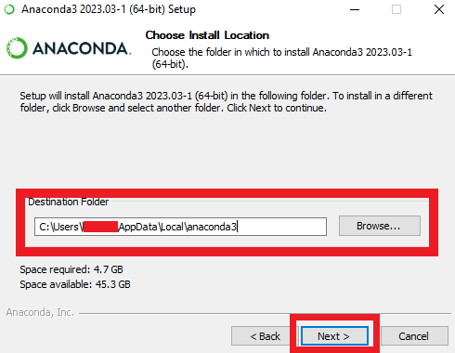
- Select “Register Anaconda3 as my default Python 3.10”, the rest you can leave unchecked and click “Install”.
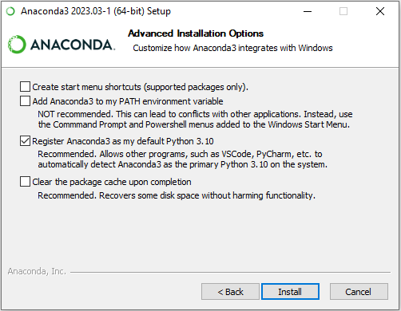
- After the installation you can use the Anaconda command line (search for “Anaconda Prompt”) to open the anaconda prompt.
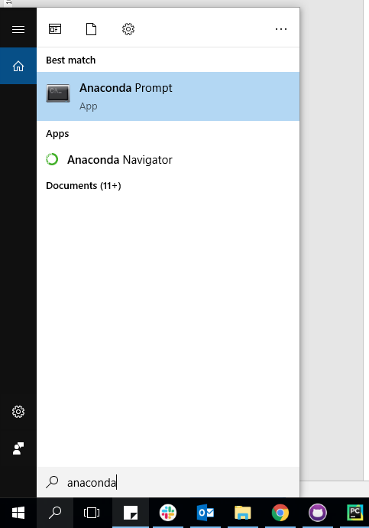
- In order for OnStove to work correctly on your computer you will have to install it. Do this by simply typing conda create -n onstove -c conda-forge onstove in the anaconda prompt, then press Enter. This will install OnStove (this may take some time). At a certain point anaconda will list the packages that are needed for installation and ask you to confirm, press y to confirm.

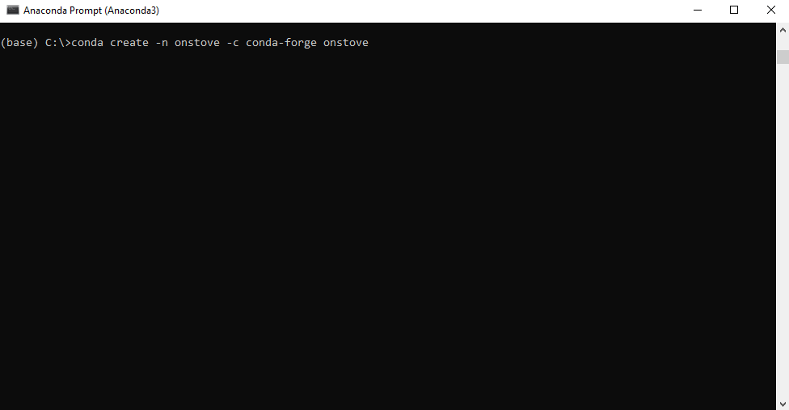

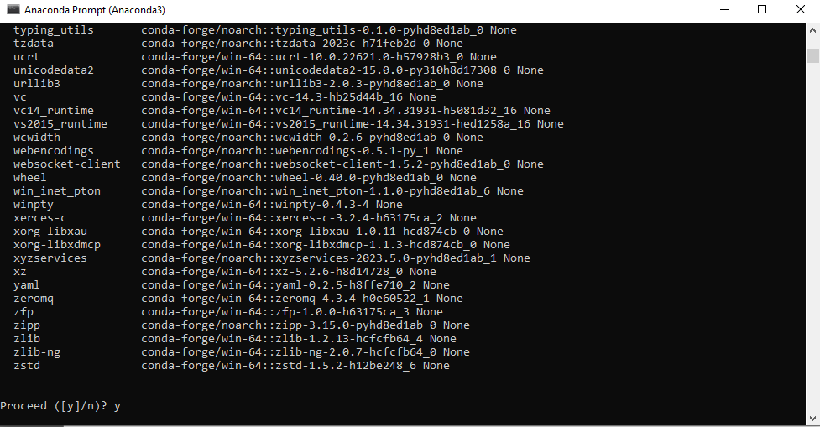

- Once the installation is finished you type conda activate onstove . Note that the (base) in the beginning of the line of the prompt changes to (onstove). This means that OnStove is active and you now have access to the tool.

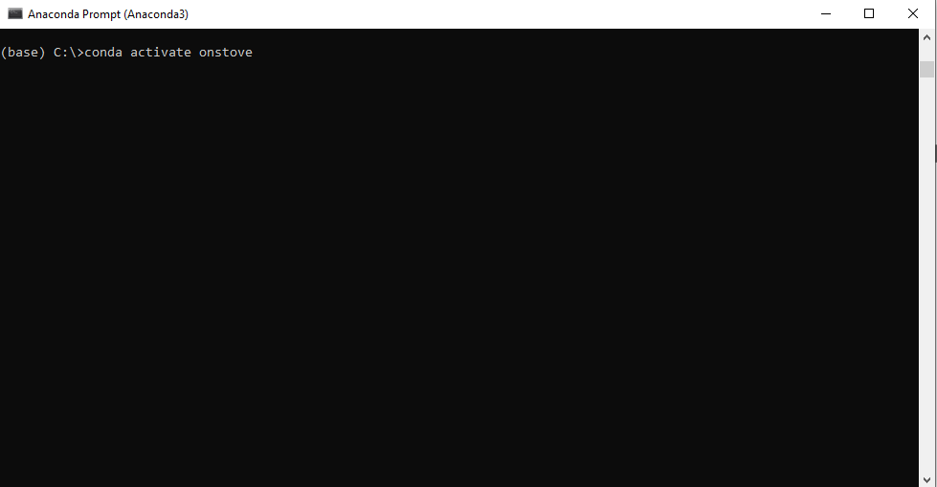

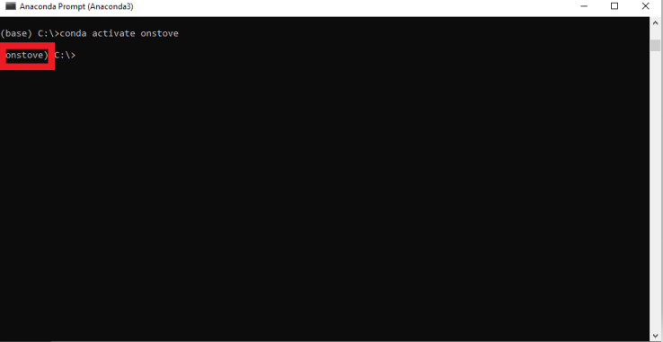

- The last step needed to run OnStove is a functioning code. For this we will utilize the Jupyter Notebook version of the code available on the official OnStove github repository. Click on the following link to do so: https://github.com/Open-Source-Spatial-Clean-Cooking-Tool/OnStove/archive/refs/heads/main.zip. This will download a zipped folder, once the download is finished unzip the folder somewhere on your computer.

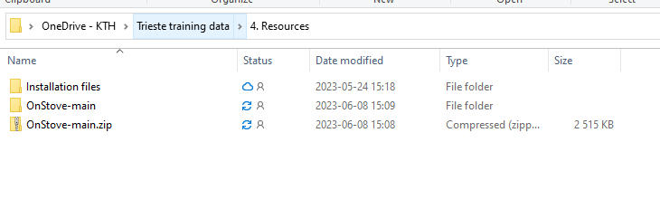
- Open the unzipped folder called OnStove-main. Copy the path and paste it in the anaconda prompt with “cd” in front of it (cd PATH, see images). Lastly press enter.

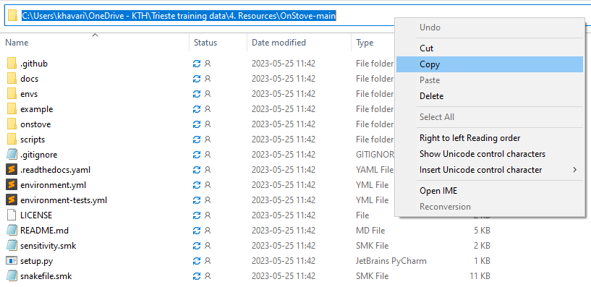
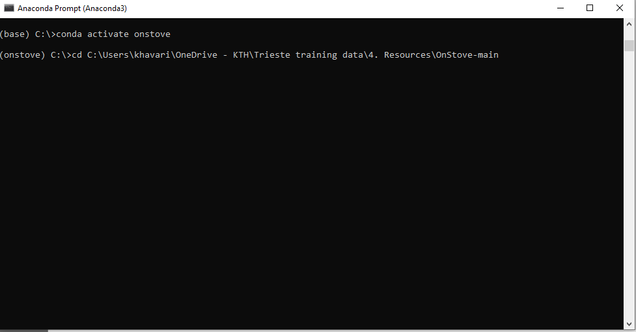

- Next type “jupyter lab” in anaconda.
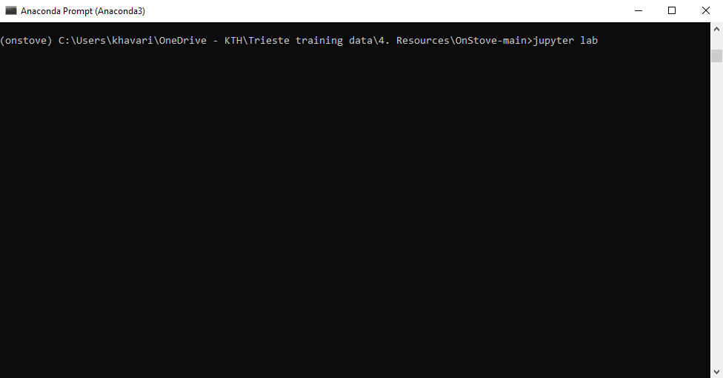
- This will open up an instance of jupyter lab on your computer. Note that while it opens up in your web-browser the jupyter lab instance is ran completely offline and does not require an internet connection.
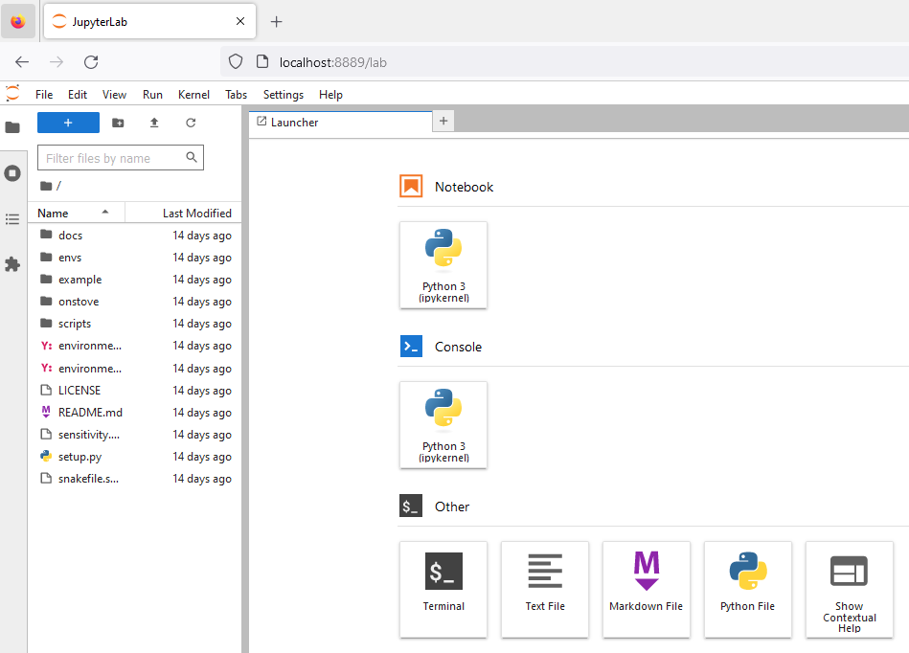
- If you click on the folder called example (highlighted in the image below) you can start and run OnStove (the .ipynb-file).
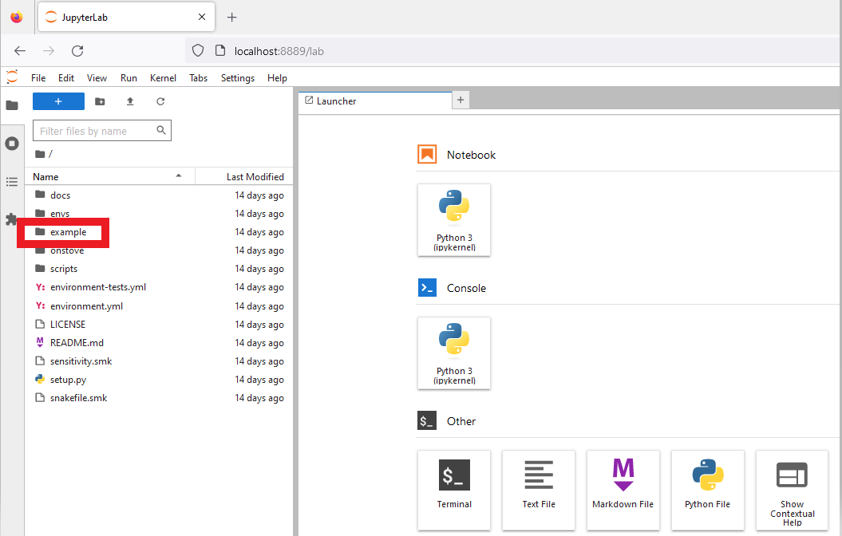
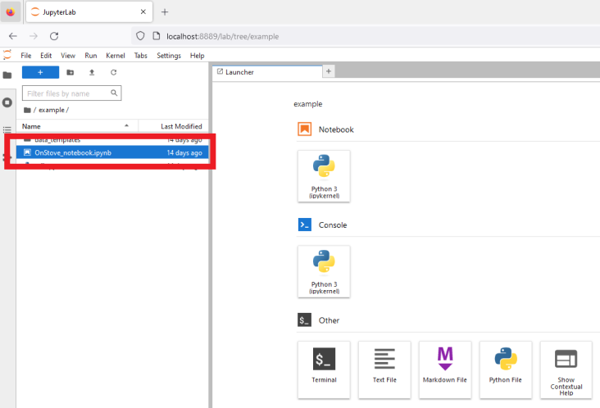
- A jupyter notebook is a version of the code where you can run different parts of it separately from others (you run one cell at time). To run a cell you click on the play button at the top of the screen. While the code is being ran the circle is filled in and there is an asteriks (*) in the cells that are either running or are in queue. We will look at how to run the Jupyter notebook in the subsequent exercises.
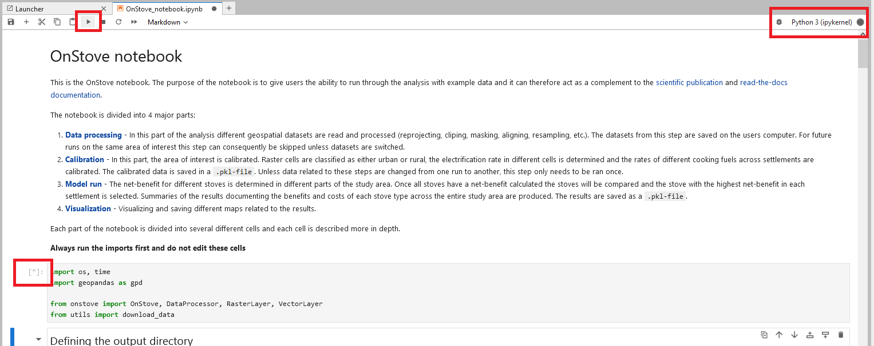

Note: If you close the notebook and wish to continue running the code at a later time you can do so by repeating step 7, 9 11, 12, 13, 14 and 15 again in order.

