Geospatial Clean Cooking access modelling using OnStove
Hands-on 4: Working with raster data

Learning outcomes
By the end of this exercise you will be able to:
1) Import raster data to QGIS
2) Perform different key processes (such as projecting, clip) with raster data
This exercise includes screenshots to guide you through the exercise. Note that the screenshots may differ slightly from what you see when working with QGIS depending on the version that you have downloaded, which should not be a problem.

Data Acquisition
Download and unzip the folder named “Benin_raster” available here. Within this folder there is a number of additional folders and files. For this exercise make sure that the following files/folders are included:
- A folder named “Administrative_Boundaries”. Within this folder there should be files named Administrative_boundaries.
- A folder named “Wind_Capacity”. In this folder there are two wind capacity maps named Benin_windcap_north and Benin_windcap_south.

Note: It is good practice to use underscore (_) when naming folders or datasets in GIS (instead of space) in order to avoid unexpected errors while processing.
Note2: The folder you have just downloaded is also used for the OnSSET course given through the OpenLearn page. You will notice that there are some datasets in that folder that will not be used in this exercise.

Working with rasters
NOTE : An extensive tutorial of QGIS is available here.
Import
- In the initial step of the exercise, you will import the two wind capacity maps.
- Importing rasters can be done in two different ways; either simply drag the raster file onto your map canvas, or go to the top roll-down menu and click on Layer Add Layer Add Raster Layer… (For rasters we usually work with the .tif-file)
For now you will need only the wind capacity maps, so leave the administrative boundaries.
Raster properties
- Next, it is time to examine the properties of the rasters.
- By right-clicking on your raster layer you will be able to examine and/or change properties of your raster files.
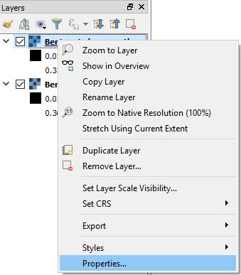
- First, click on the Information tab. Here you will find general information about your layer, which can provide more in-depth knowledge of the data that you are working with.
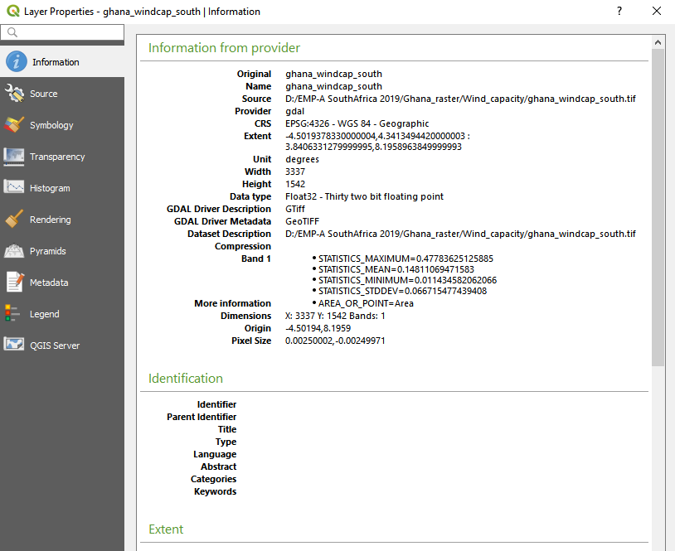
- One of the most important tabs for the appearance of your dataset is the Symbology tab. Here you can change many different aspects of the dataset. You can change the colour, style and legend range of the raster, which is very useful when you wish to highlight different aspects of your data.
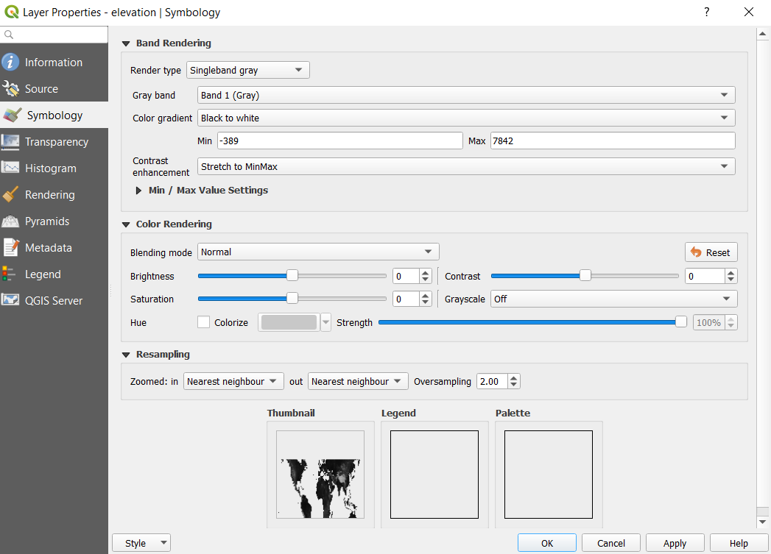

- Next, we will move on to the tab named Histogram. Here you will be able to examine the number of occurrence for the different values in your data. This may be very useful when you want a summary of your raster data or identify outliers.

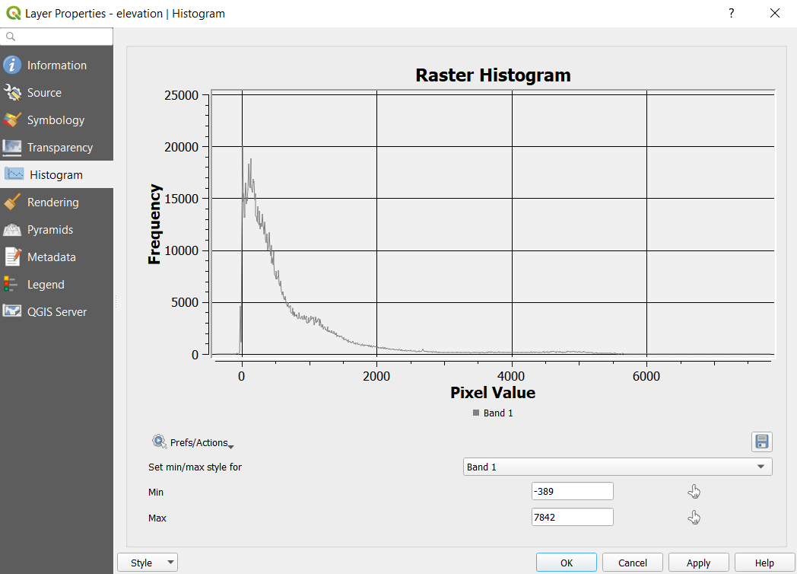

Merging Raster layers
Sometimes you have several rasters that are representing the same type of data in different parts of your study area. In these situations, it is often useful to merge the rasters into one dataset. To do this, you can use a tool called Merge. The wind capacity map for Benin has been given to you in two pieces. Now, you will use the Merge tool to merge these datasets into one raster.

- Make the tool bar visible by going to the roll-down menu and click on Processing Toolbox.

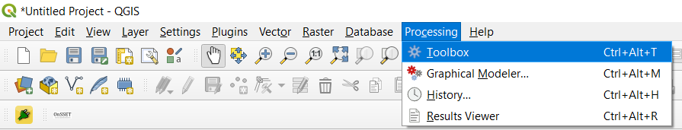
This opens up the toolbox on the right-hand side of the QGIS interface. In this toolbox you can search for all the tools that you need.
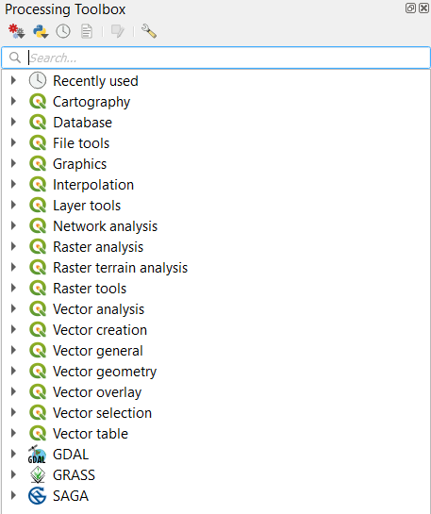
- Now, search for “merge”. This will show all the tools containing the word “merge”.
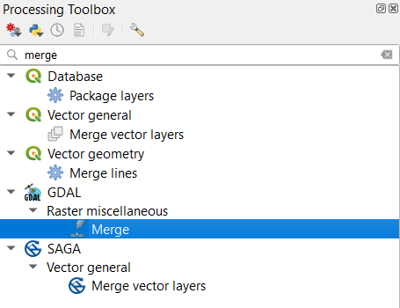
- Select the merge tool within the GDAL-package (the one highlighted in the image above).

- In the window that opens up, choose the two datasets that you wish to merge in the field that says “Input layer” by clicking on the three dots at the right-hand side of the field. The rest you can leave as it is. Click “Run” to execute the tool. When your layers have been successfully merged you can remove the two original maps from the QGIS interface.
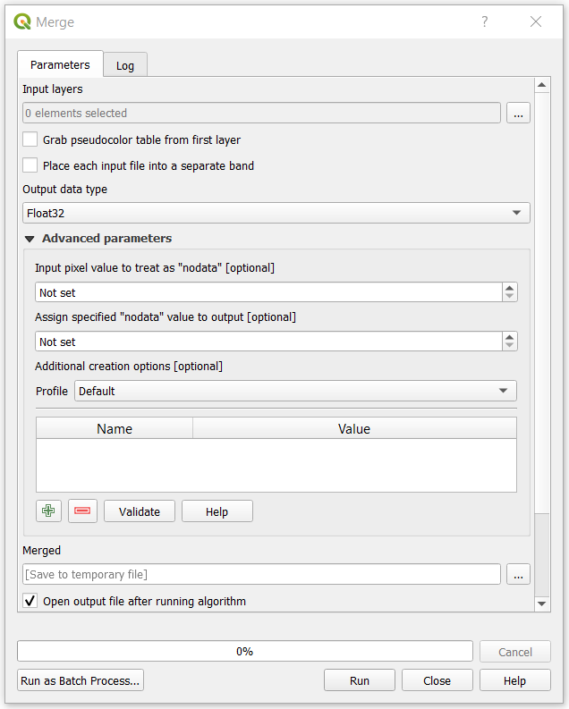
Clip
You will now notice that the dataset covers an area much larger than the study area. We will fix this by clipping this raster with the administrative boundaries of Benin. In order to do so we are using the Clip Raster by Mask Layer.
- Import the administrative boundaries of Benin that you were given in the Benin_raster folder. Do this by directly dragging the .shp file onto the map canvas.
- Search for Clip Raster by Mask Layer in the Toolbox. Select the tool included in the GDAL-package (the one highlighted below).
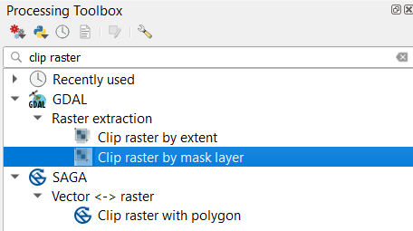

- As “Input layer” enter the raster that you want to clip (in this case the merged wind capacity map you created in the previous step). As “Mask layer” enter the polygon you want to clip by. Since we want the wind capacity in Benin we choose the administrative boundaries of the country. In the field that says “Assign a specified nodata value to output bands”, enter “0”. This will make sure that all the values that are not a part of Benin are set to no data. The rest you can leave as it is. Click on “Run in Background” to run the tool.
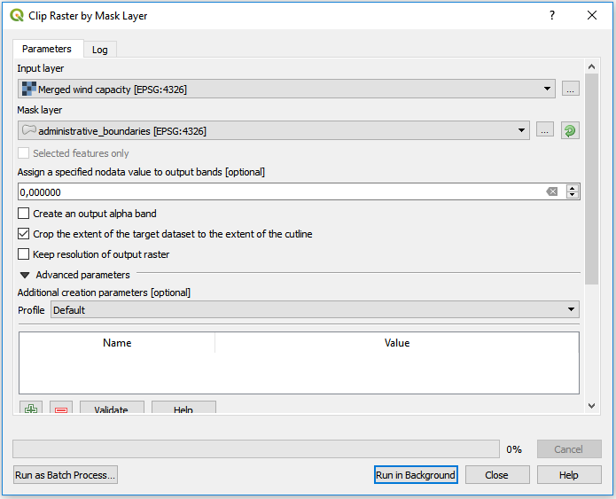
NOTE: In order to see your clipped wind capacity map uncheck all of the other layers in the table of contents.
Projecting rasters
The coordinate system is very important when representing data. When projecting an area onto a map there will always be a certain distortion. When choosing the coordinate system it is important to do compromises and choose the system that gives the least distortion. For this exercise you will have to choose a coordinate system that works for Benin, as that is the current study area. In this case, choose the coordinate system named WGS 84/UTM zone 31N. Now, you should project the wind capacity map that was clipped in the previous step. To reproject raster files you can use a tool called “Warp”
- In the toolbox search for “warp” and double-click on it to use the tool (in the GDAL-package).

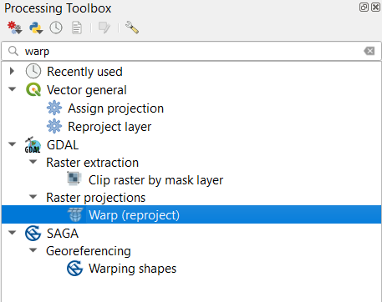
- First, in the “Input layer”-field choose the dataset that you wish to project (this will be the clipped wind capacity map from the previous step).
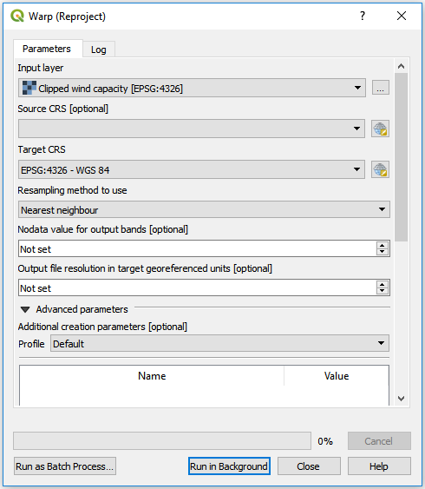
- You do not need to specify the current projection system used for the raster, so the second field (“Source CRS [optional]”) can be left empty.
- Now, click on the button next to the field named “Target CRS”.
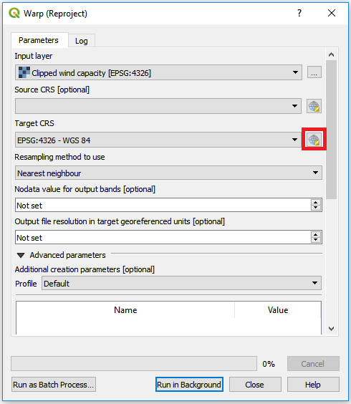
This will open the following window, make sure to select Predefined CRS:
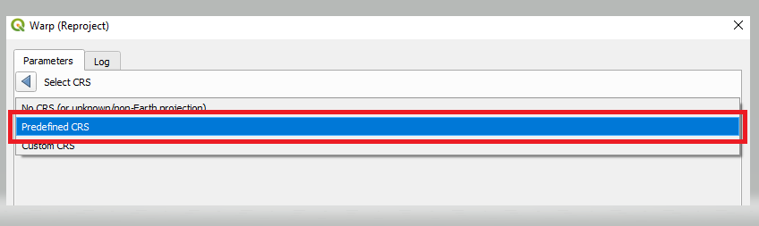
Which will bring you to the following screen
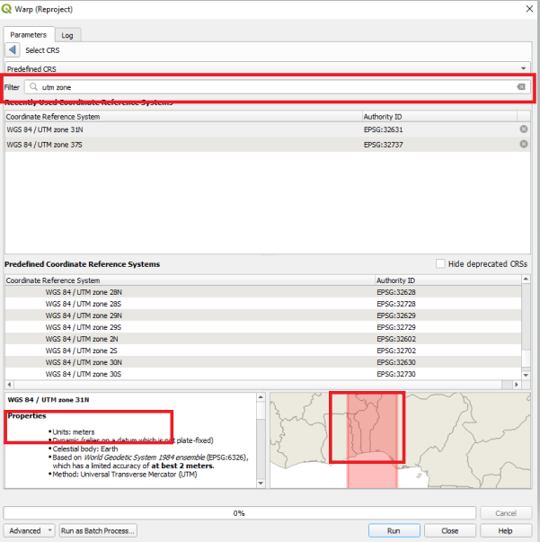
In the filter field start typing the name of the coordinate system you want to use (”WGS 84/UTM zone 31N”):
Click on OK to pick this coordinate system
NOTE: For future studies the following site https://epsg.io/ can be used to determine which coordinate system to use.

- Execute the tool by clicking “Run”

Export
- You will now export the reprojected wind capacity layer to the folder named wind_capacity. This is necessary when you want to save manipulated data on your computer for usage in other programs, or at a later point.
- Right-click on the wind capacity layer that you just projected and click on Export Save As…
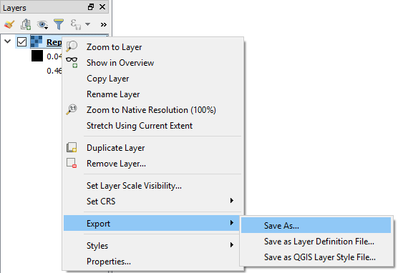
- Choose to export your raster file as GeoTiff and click on “Browse” next to filename and navigate to the wind_capacity folder that you received. Name your layer “Wind_capacity”. Make sure that the box saying Add saved file to map is checked (see figure below).

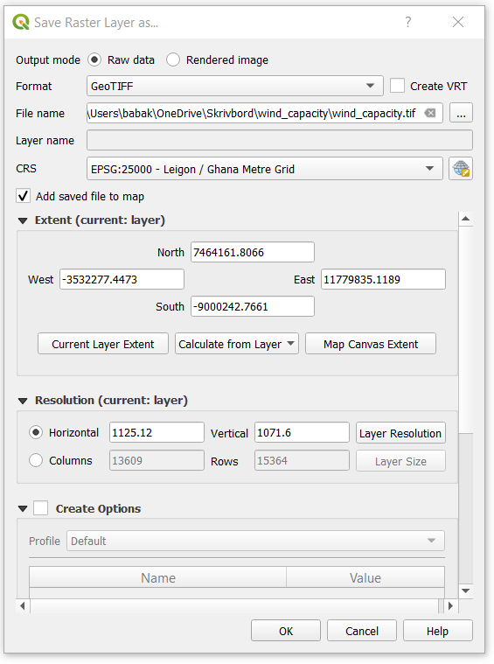
- Keep the rest as given in default
NOTE: As in the case of vectors, if you do not export the maps they will only be saved in memory and not exist next time you restart the program.

